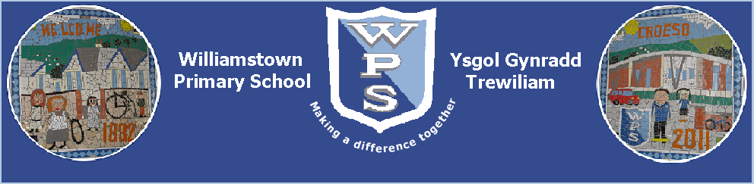
‘Making a difference together’

Following on from parent’s week last week and parental feedback each FP year group has put together a small booklet of ways you can help your child further develop their Literacy and Numeracy skills.

We hope you find these booklets informative and helpful and would like to thank you for any additional work you do with your child at home, it has a huge impact on their progress.
I would also like to thank the Foundation Phase staff for their time and work in creating these booklets and ensuring pupils are well supported.
Thank you for your continued support,

Mrs L Brown (DHT and Foundation phase Lead)

Helping your child in Reception

Reception is a critical year for learning, it is well children become more self -aware of their choices and begin to play more with others rather than in parallel or by themselves. They begin to build stronger bonds with their peers and usually this is the year group when pupils not only begin to recognise sounds but begin to read words.

Literacy

Phonics/ reading- ways you can help:

We follow the ‘Letters and sounds’ phonics scheme from nursery to learn the sound names and recognise them. As time has gone on we have realised that this does not provide pupils with support in forming their letters and formation of letters was an underdeveloped area. We have strengthened this by introducing the READ, WRITE INC rhymes for forming letters correctly. You would have received a sheet during the Autumn Term with all of these on. If you have not or require a replacement please let staff know.

Pupils begin to bring home books; these books often just have pictures and then develop into simple words and sentences.

To help:

- Point out letters in words and see if the children can say the sound in books, magazines, shop signs, posters in places you visit.

- Explore picture books sent home with your child (they are beginning to read) they are reading pictures and characters. Ask your child questions such as:

How do you think dad is feeling?
What do you think might happen next?
Which was your favourite page? Why?
What can you see in the picture?
Can you see anything in the picture that begins with the letter d?

- Don’t feel you need to keep exploring and reading the book sent home, reading any book to your child is very educational. They begin to listen carefully, make predictions and notice your voice tones and expression. Listening to familiar and tradition tales gives the children a wide variety of vocabulary and storylines to use when they become writers themselves.

- Play the game ‘Gotcha’- give the child a sound they need to find on the page, when they find it they shout out ‘Gotcha!’.

- When high frequency and tricky words start coming home with your child learn them in variety of orders, cut them up and maybe decorate them. Put them around the house for the children to fond- they can only keep them if they can sound them out and read them. If they can’t you keep the card- children respond well to a bit of competitiveness.

Beginning to write:

Children begin to form letters and written word by first ‘Mark Making’. Allow children to start off with large paper so they can then move to smaller pieces and refine their fine motor skills.
Initially young children find it very hard to control their pencils to form letters but the more practise with their pencil grip and finer motor skills the better. They can use a variety of writing equipment, highlighter pens, felts, pencils etc.

To help:

- Allow your child access to a range of sized paper and writing materials.

- Practise the writing of their name- model it to them, they can write in underneath yours or initially trace over the top of your writing.

- When your child is first forming letters on paper say the READ WRITE INC rhymes to help them visualise the formation of the letter. Sometimes children do know where to start to form the letter so the rhyme will help. You could also draw a small dot on the page to show them where to start.

- Try not to correct spelling errors unless it’s a word you know they spell correctly usually. Any phonetic attempt at a word is great, they have sounded it out and we do not want them to feel writing always has to be perfectly accurate. Children need to make mistakes, take risks and feel comfortable with that.

Numeracy:

Number- ways you can help?

In reception we focus on recognising, careful counting and forming the numbers 1-5, however many children will be able to do higher numbers than this and we do explore these if the children are ready.

- Any number formation practise will be very helpful, the more the children see the numbers and the visual representation the easy it will be for them.

- Explore the signs of + and – and use associated vocabulary of add, adding, plus, altogether and then minus, subtract, take away.

- Counting and putting numbers in order
Use old magazines, comics or greetings cards.
Cut out pictures of animals, or anything else your child is interested in. Label the animals 1 to 5.
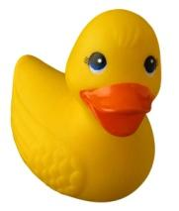
Shuffle the animals. Put them in order from 1 to 5.
Remove one animal. Ask your child which number is missing. Repeat with other numbers and more than one missing number. Ask your child to say what number comes before or after a number you choose. When your child can do this, repeat with numbers 1 to 10.
Games you can play:

Collections
You need something to collect, e.g. sticky shapes, dried pasta.
- In turn, one player claps 1, 2, 3, or 4 times while the other player closes his eyes and listens.
- How many claps did you hear? Take that number of shapes.
- After 4 goes make a pattern with your shapes or pasta.
Build a tower
For this game you need a dice and some building blocks or Lego bricks.
Take turns.
Roll the dice.
Collect the number of bricks to build your own tower. The first to 10 wins!
For a change, start with 10 blocks or bricks each. Take away the number on the dice. First to exactly zero wins.
Roll a shape
Cut out 12 shapes.
Make 3 triangles, 3 squares, 3 rectangles and 3 circles.
Take turns to roll a dice and collect a shape that has that number of sides, e.g. roll a 4, collect a square.
The first to have four different shapes wins.
If you can name each shape you go first next time!


Dicey counting
Take turns to roll a dice and count back to zero from the number thrown. For example:
Four, three, two, one, zero!
Cupboard maths:
Ask your child to help you sort a food cupboard out, putting heavier items on the lower shelf and lighter items on an upper shelf. 
Rhymes
Teach your child any number rhymes or songs that you know, particularly ones that involve holding up a number of fingers, like Five little speckled frogs. Practise them regularly, with actions. You can get counting songs on audio tape.
Spot the difference
Draw a row of six big coloured spots.
- In turn, one player closes his or her eyes.
- The other player hides some of the spots with a sheet of paper.
- The first player looks and says how many spots are hidden.
- Try with other numbers of spots, e.g. five or seven.

One more, one less
For this game you need a dice, a coin and some building blocks or Lego bricks.
- Take turns to roll the dice.
- Build a tower with that number of blocks or bricks.
- Then toss the coin. Heads means take one brick off. Tails means add one on.
- If you can guess how many bricks there will be after this, you keep them!
- The first to collect 20 bricks or more wins!
Recognising numbers
Choose a number for the week, e.g. 2.
Encourage your child to look out for this number all the time.
- Can your child see the number 2 anywhere?
at home (in the kitchen, on pages in a book)
in the street (on doors, on car number plates, on buses) while out shopping (on the shop till, on shelves, in shop windows)
- Find two apples, toys, spoons, straws, sweets, etc.
- Make patterns, such as two knives, two forks, two spoons, two knives, two forks, two spoons...

Happy Learning at home…………………………….

