Hello everyone,
I’ve put a couple of activities together for you to work through at home this week. I hope you ‘re all keeping safe and trying to keep up with your learning. Remember to read every day and practise your high frequency words too, reading is so important. Ask a grown up to read to you every day too, a story book or an information book and make sure they ask you a Who? What? Why? When? Where? And How? question too about the book and maybe you could ask them a quality question (or 2) too!
You could start trying to write some of your high frequency words too, this will help tremendously with your writing back in class. A simple spelling challenge of 5 to 10 words only if you feel ready for a little extra challenge.
Keep practising your phase 3 sounds by playing games, our Sound of the week is
er

How many words can you think of that have this digraph in it? Can you write them down in a list?

I’ve copied some math, phonic and art activities below. There’s no need to print them out, simply write the answers in your busy book / chalk board. Happy learning x
Parents- Don’t worry if the numbers are too high for your child in the reasoning card activities. I simply choose smaller numbers for different abilities and repeat with different numbers over a period of days to enable children to develop confidence with the style of questioning.

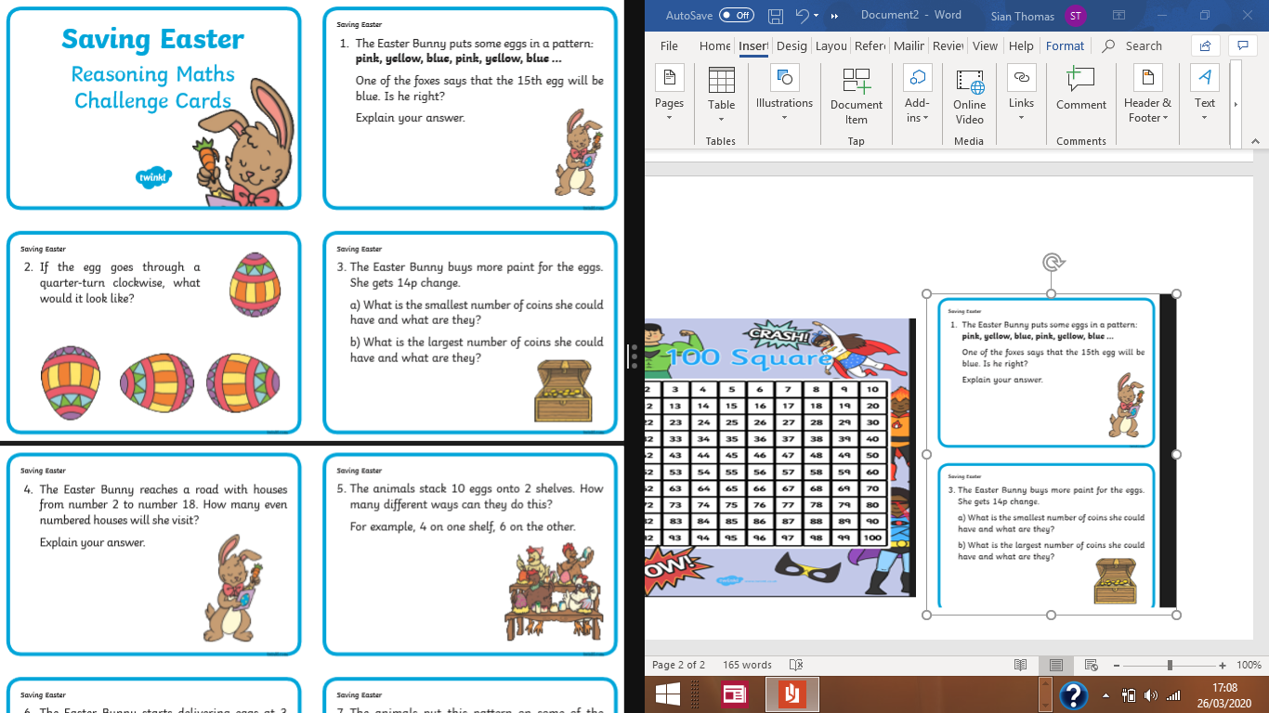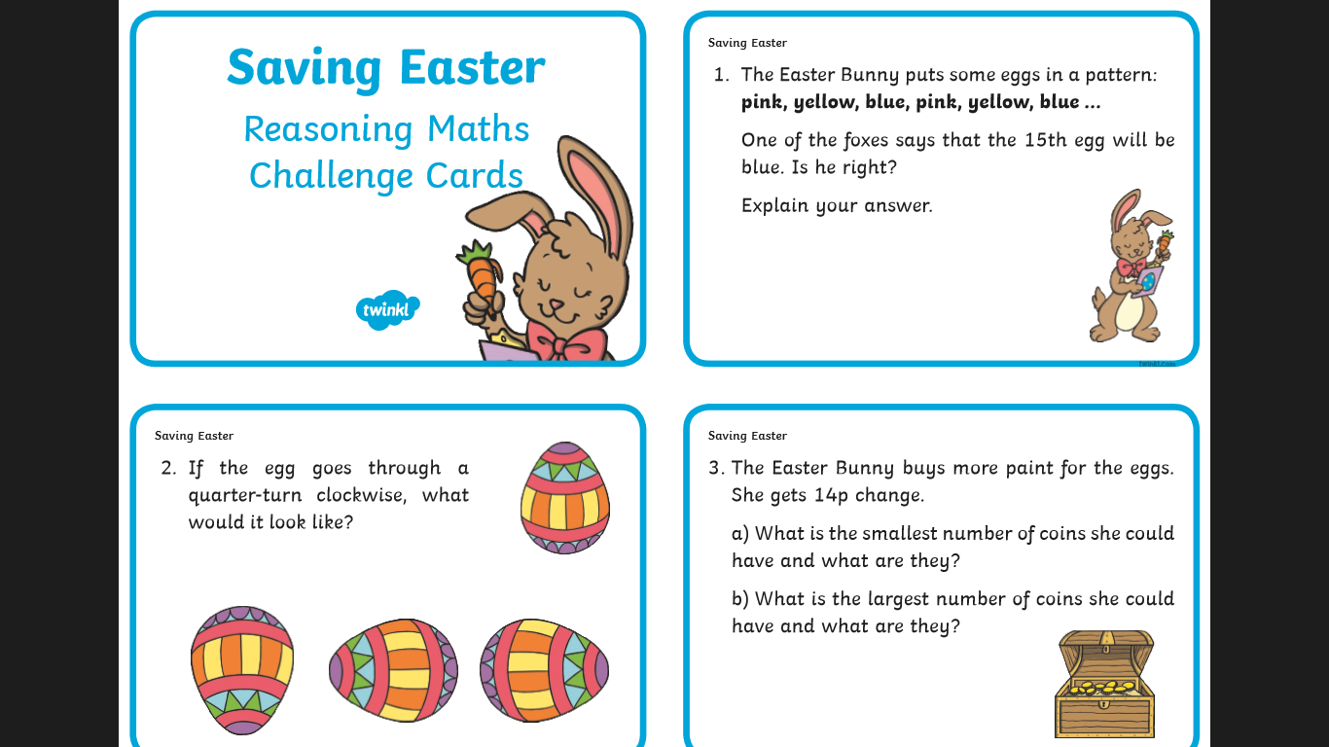
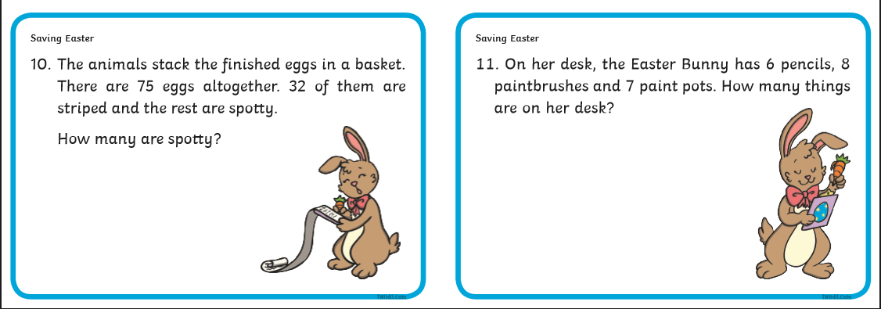

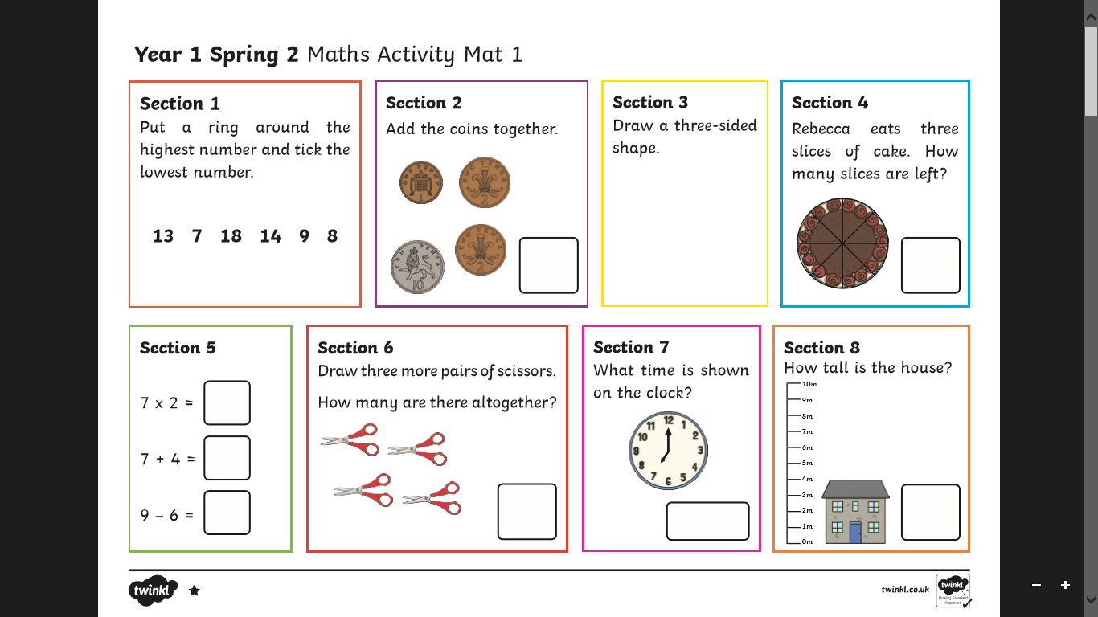
** Please note we do not use the symbol x at present, I simply say 7 lots/towers of 2
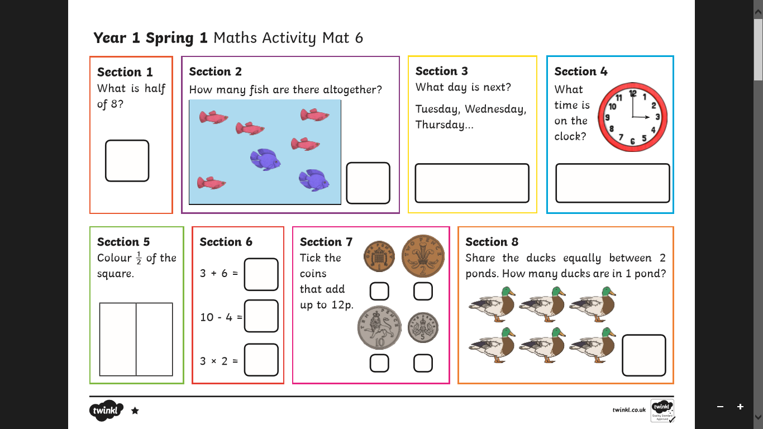
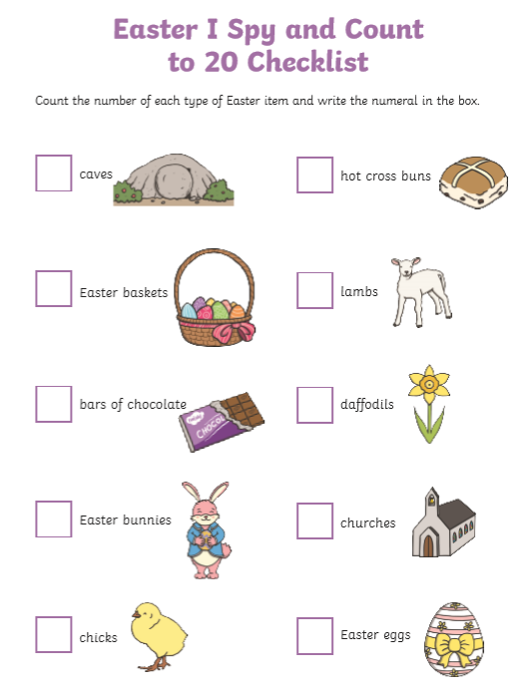
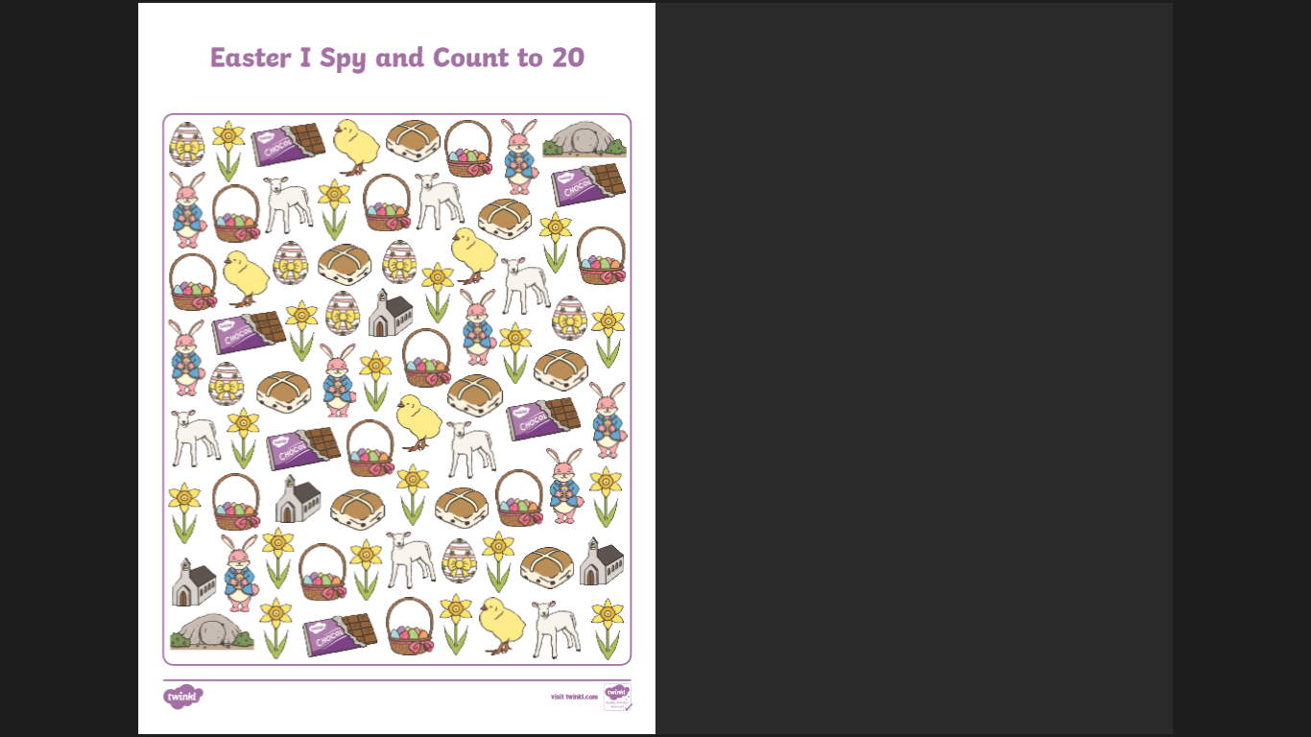

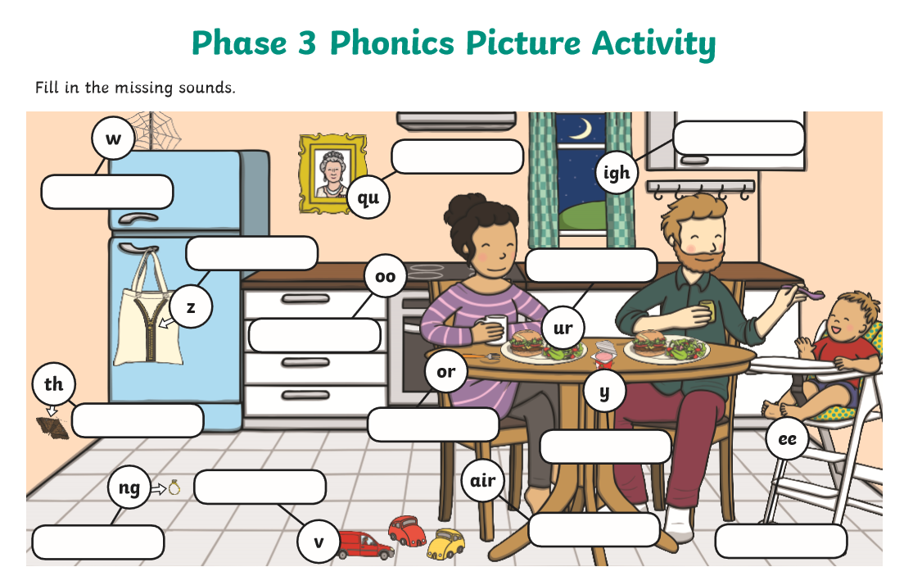
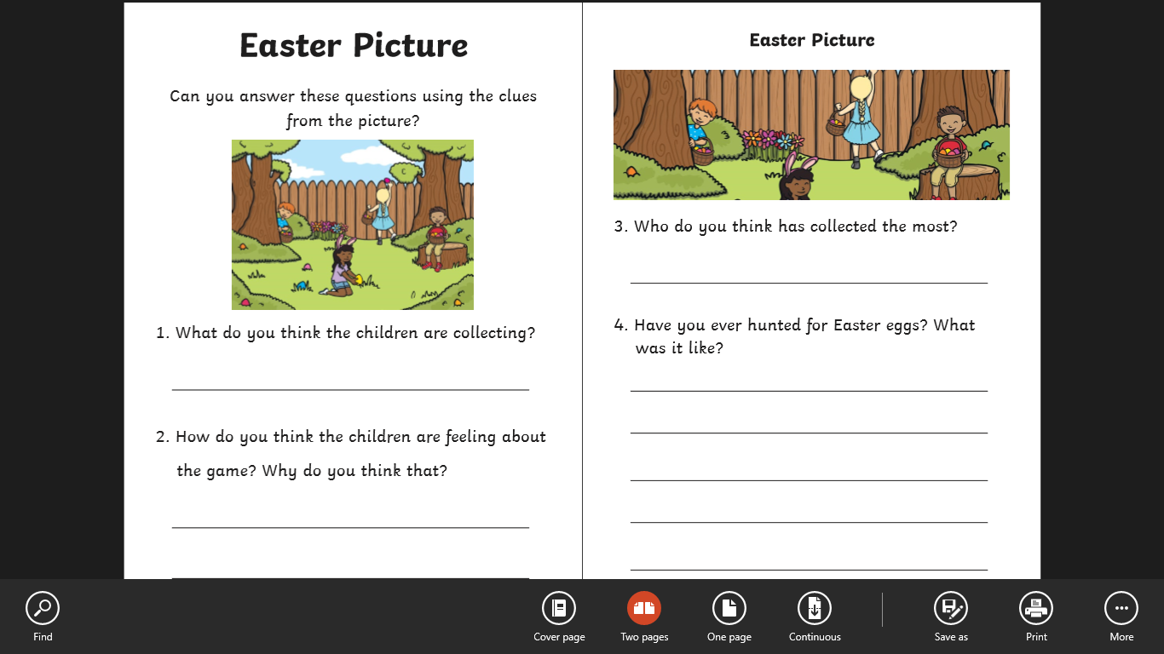

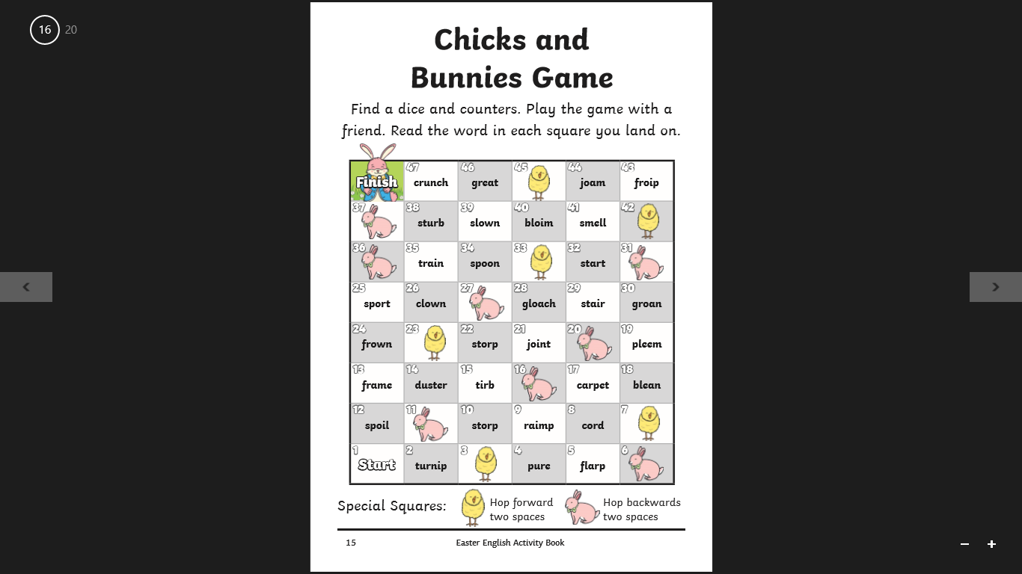

** You could screen shot this and play it via a screen with counters/ buttons and a dice
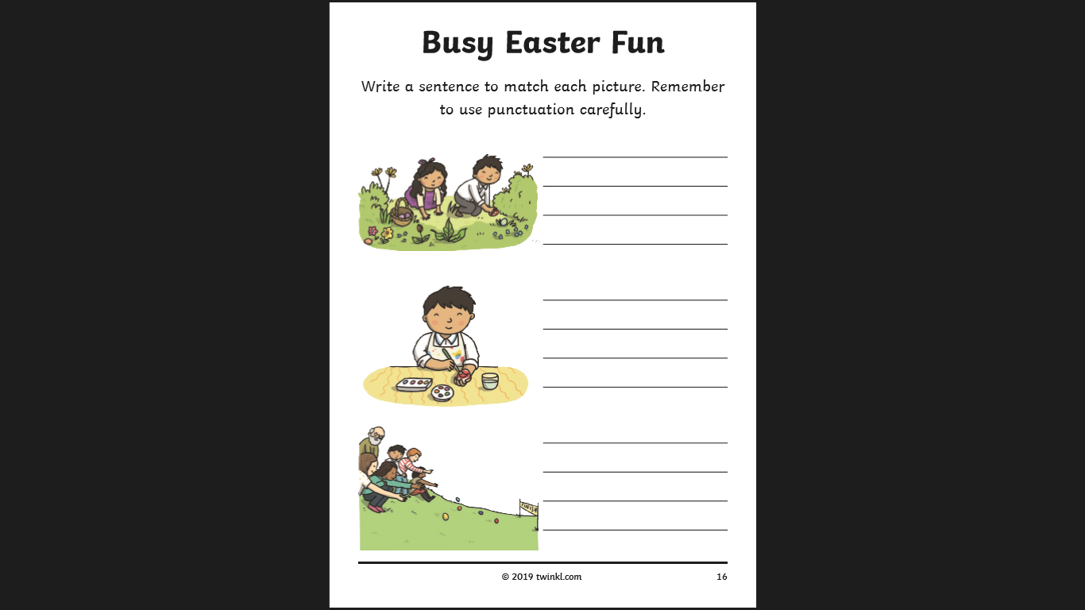

Can you make an Easter character with Lego/ mega blocks?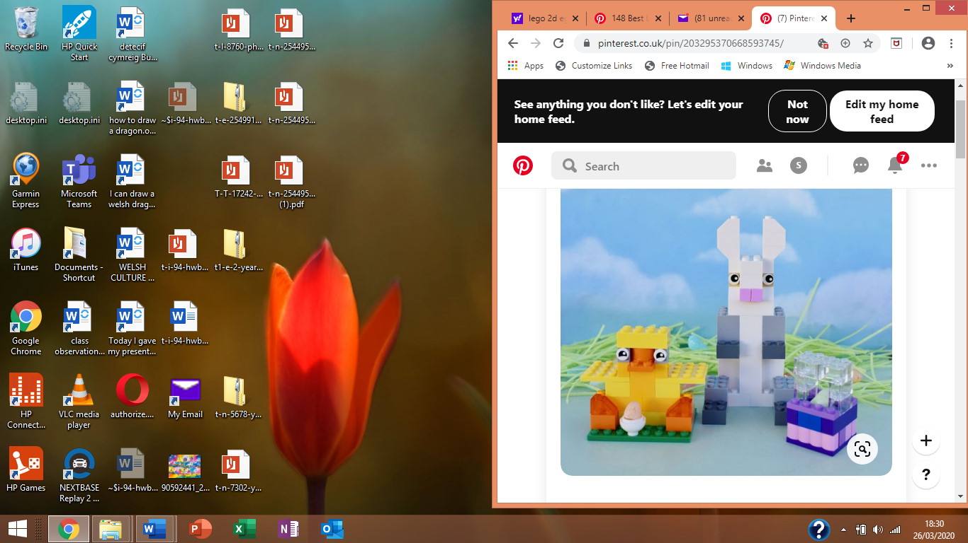

Look at this picture by the Welsh artist Rhiannon Roberts.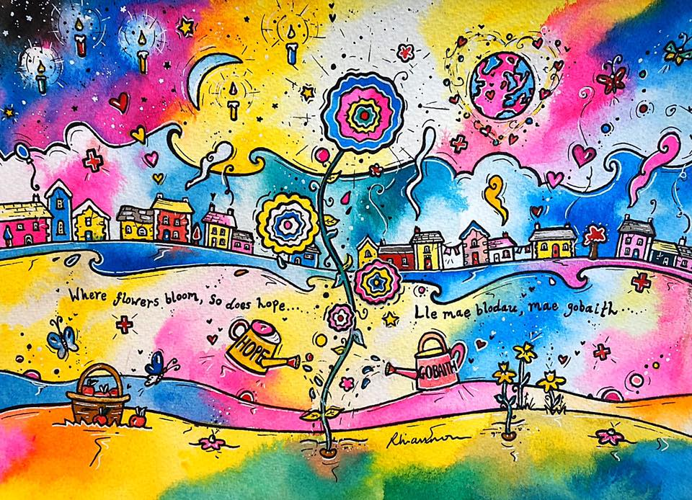
Look closely what can you see? How many love hearts? How many different colours has she used? How does this picture make you feel? What do you like about this picture? What would you change? Or add?
Now, try drawing a similar picture using images from the original picture. What words will you put on your picture? Colour/ paint/ crayon in a similar style (remember artists don’t finish their work in one day, do a little bit over several days to create your masterpiece!) Post your images on Twitter @Williamstown1_2 for me to see or bring them in when we return to class. You could watch her video on youtube (youtu.be/hnpzwYd5ncA) ‘Creating a colourful painting in just 10 steps! By Rhiannon Art Ltd for top tips before you begin.

Keep listening to your parents and learn a little every day until we manage to get back to class. Love to you all,
Mrs Thomas and Miss Galliford x (Keep safe! )

