Williamstown Primary

Home School Learning Pack Year 3 W-C 30/3/20

Literacy, Numeracy and Topic.

Useful Websites
TWINKL- free code 1 month = PARENTSTWINKLHELPS
BBC BITESIZE TOPMARKS- Hit the button
SCHOLASTIC HWB
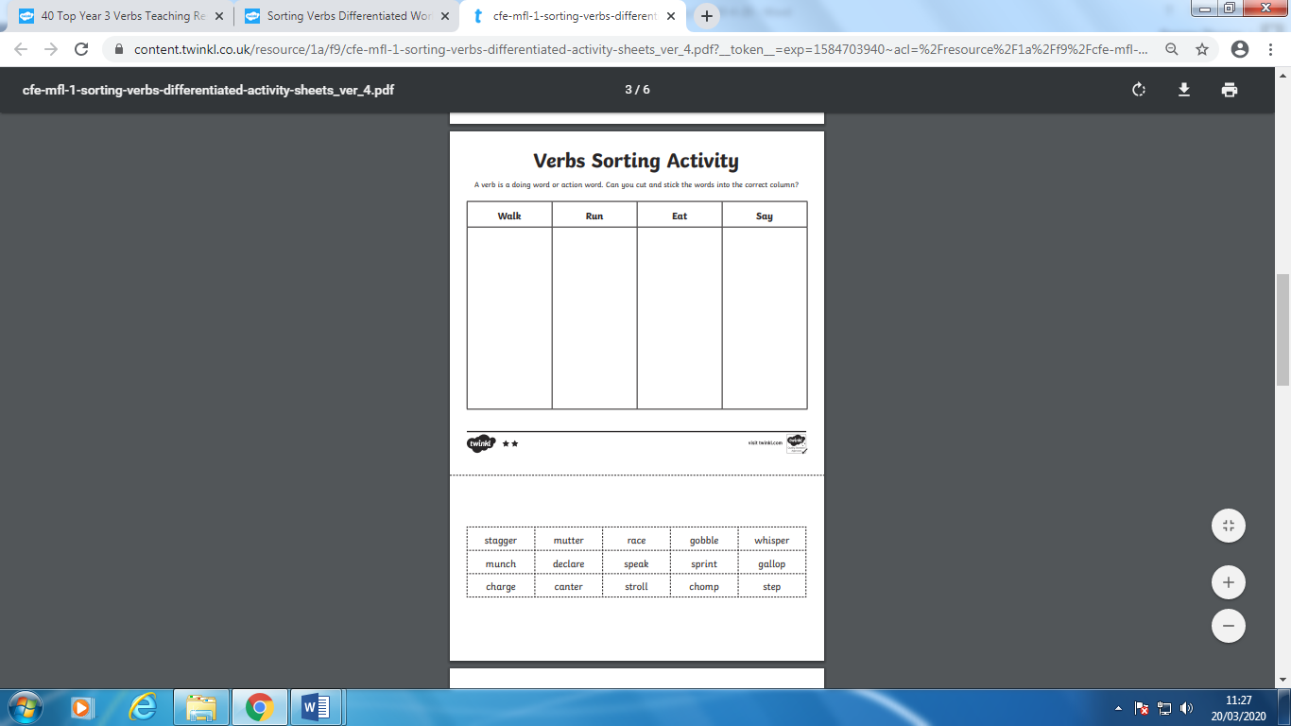
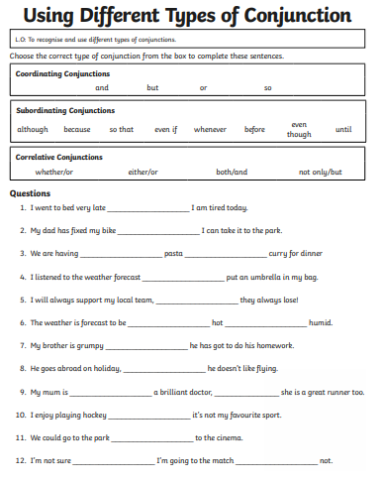
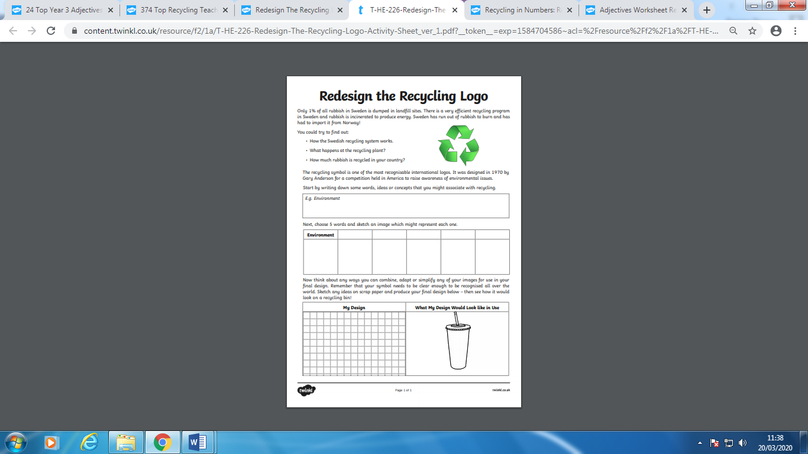
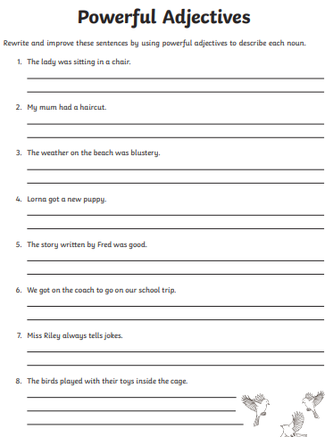
Recycling Poster Challenge
Think about the work we have done on posters and recycling in class. Using your knowledge of recycling and your independent research, design your own recycling poster!
Remember to include:
A Title
Slogan
Short Snappy Sentences
Interesting Pictures
A good layout
Reward/Offer
A final reminder
Spelling Challenge
Remember to keep practising your spellings at home. Use your spelling books to help you. Choose some words of your own to practise independently. Try each letter of the alphabet!


