School Closure Home Learning Pack
Miss Kear & Miss Thomas’ Year 6 class.

Hello Year 6!
In this pack we have included different activities we would like you to try. You will find various Maths and English activities in this pack as a small Science experiment at the end (don’t worry if you are unable to do this experiment).
You should all have your HWB usernames and passwords at home. You can use Just 2 easy to practice your coding and math skills.

We have included a list of websites that might help.
Top marks https://www.topmarks.co.uk/
Hit the button https://www.topmarks.co.uk/maths-games/hit-the-button
Maths is fun - https://www.mathsisfun.com/
Maths Zone - https://mathszone.co.uk/
BBC Bitesize - https://www.bbc.co.uk/bitesize
HWB - https://hwb.gov.wales/
IXL (Maths and English mini tests) - https://uk.ixl.com/math/year-6
Twinkl for extra worksheets and activities - https://www.twinkl.co.uk/resources/wales-school-closures-cymru-wales/school-closures-classroom-management-english-medium-schools-cymru-wales/year-5-and-year-6-school-closures-classroom-management-english-medium-schools-cymru-wales
David Walliams free audio books - https://www.worldofdavidwalliams.com/elevenses/?fbclid=IwAR3puyLPfhDFMKNssHqk2ywv4edydJ92QbSq6ArRYTd8vcIdNrt-8ZLT9u0

Hopefully we will see you soon!
Miss Thomas and Miss Kear

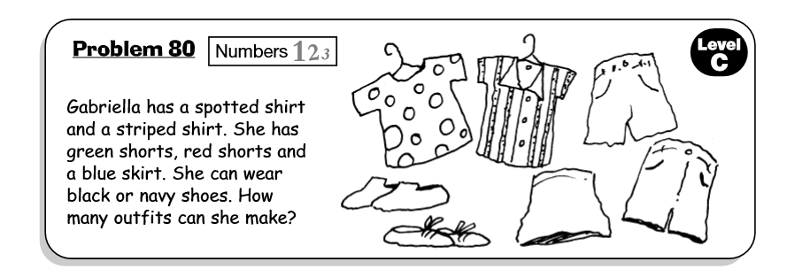
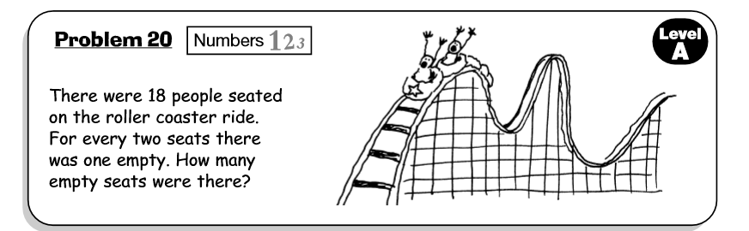
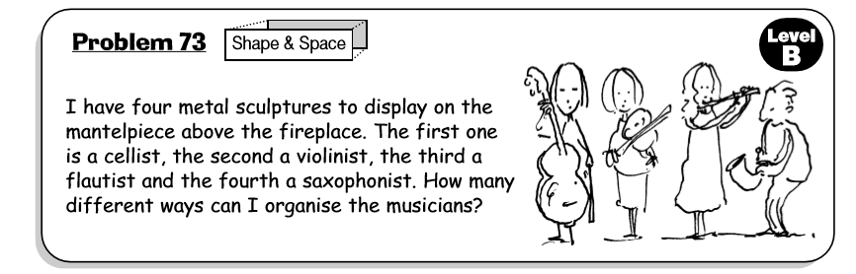

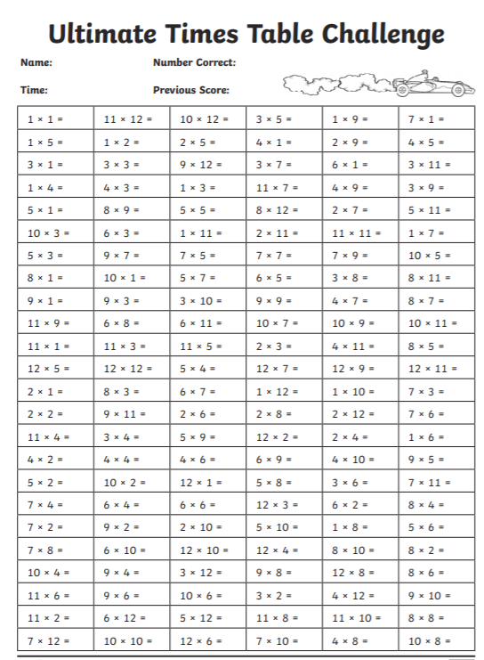
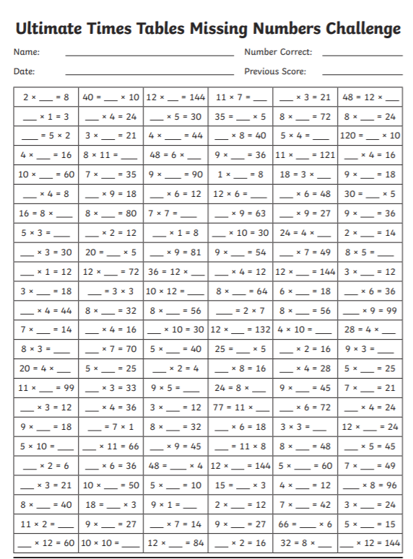
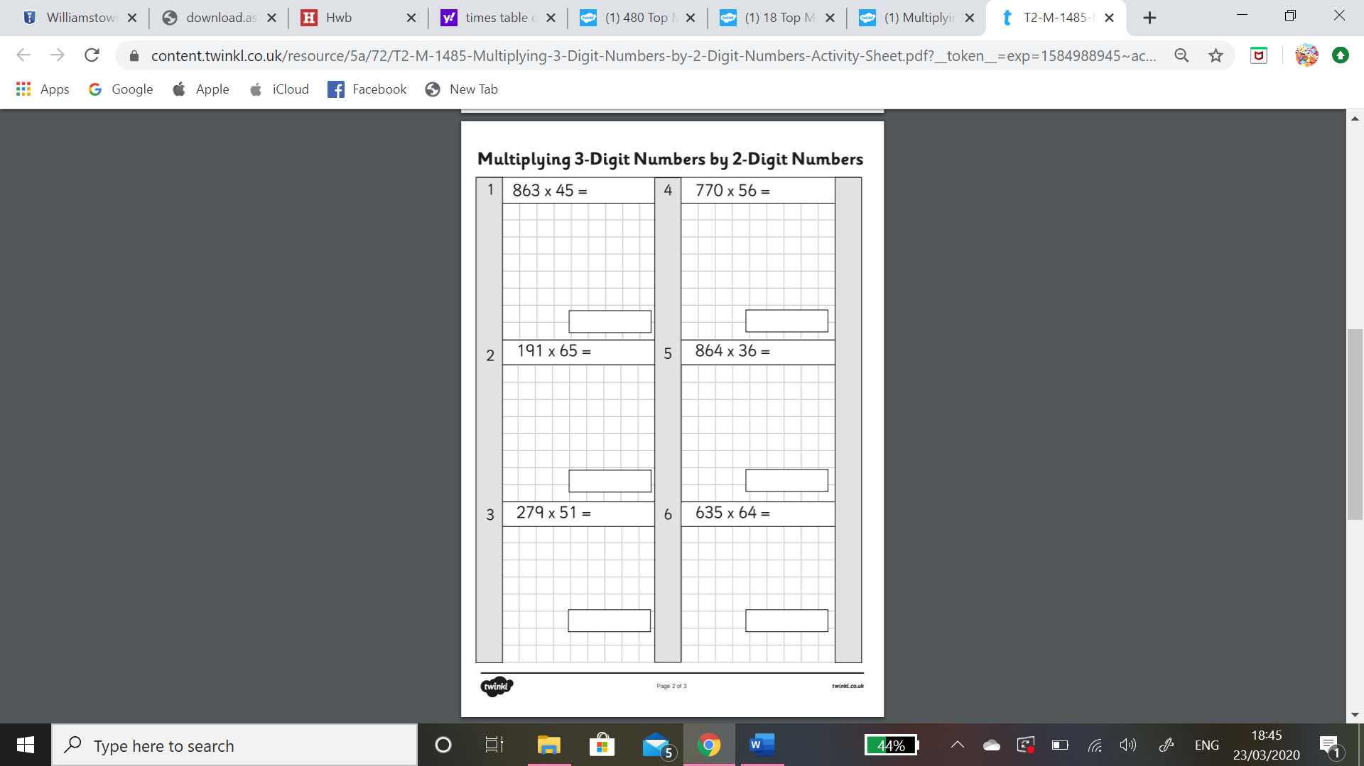
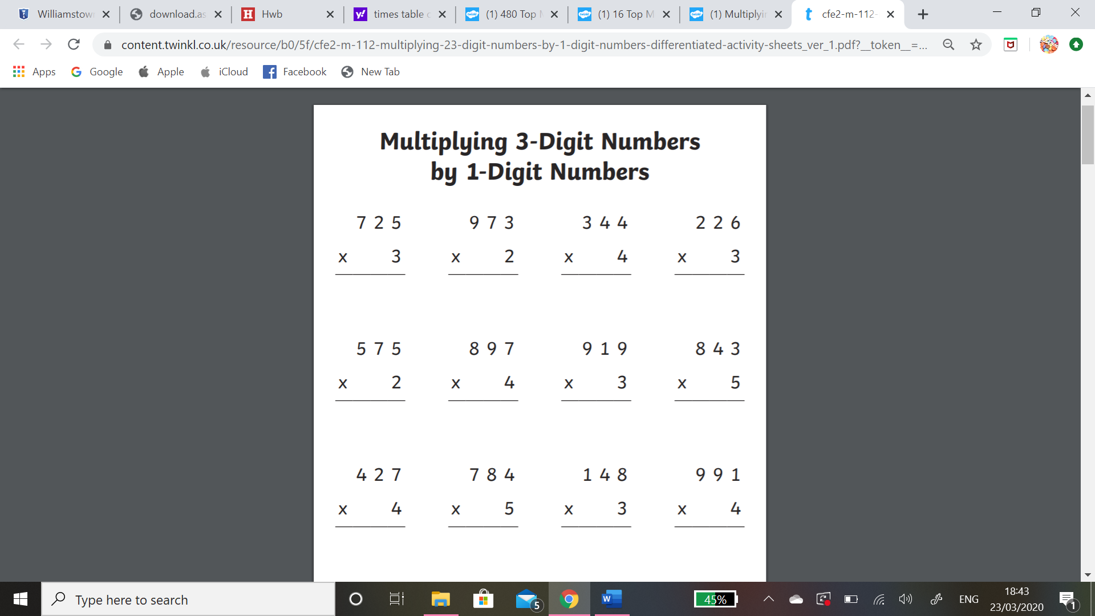
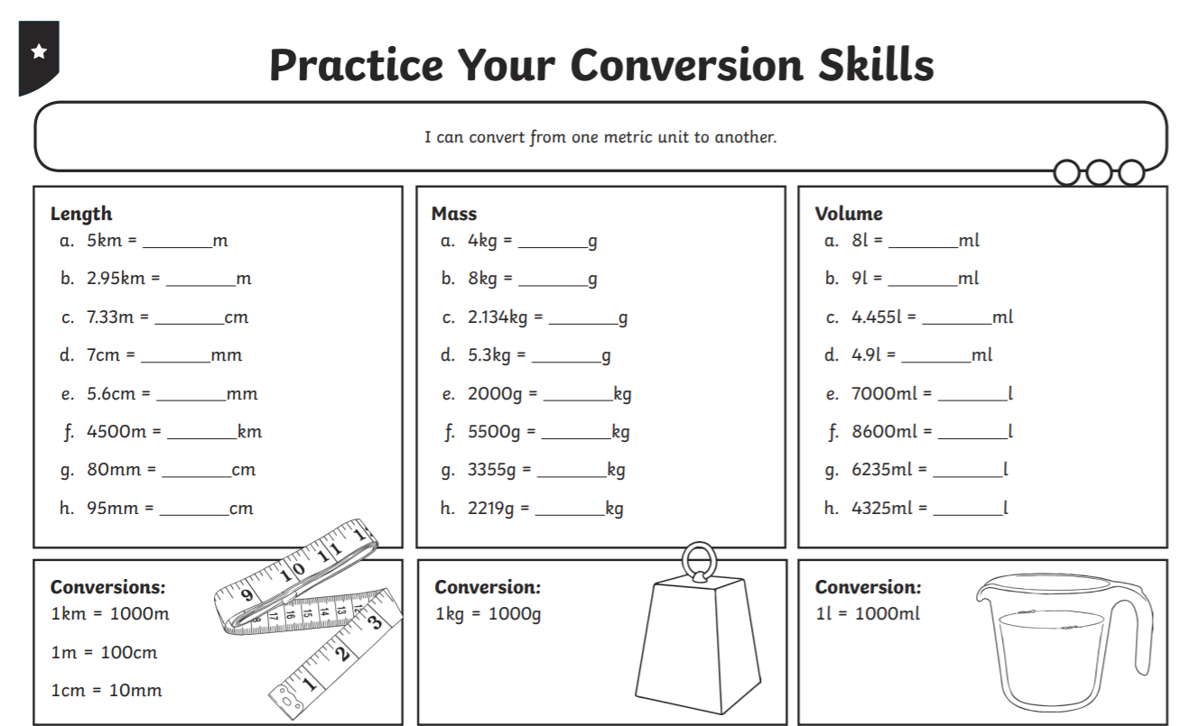
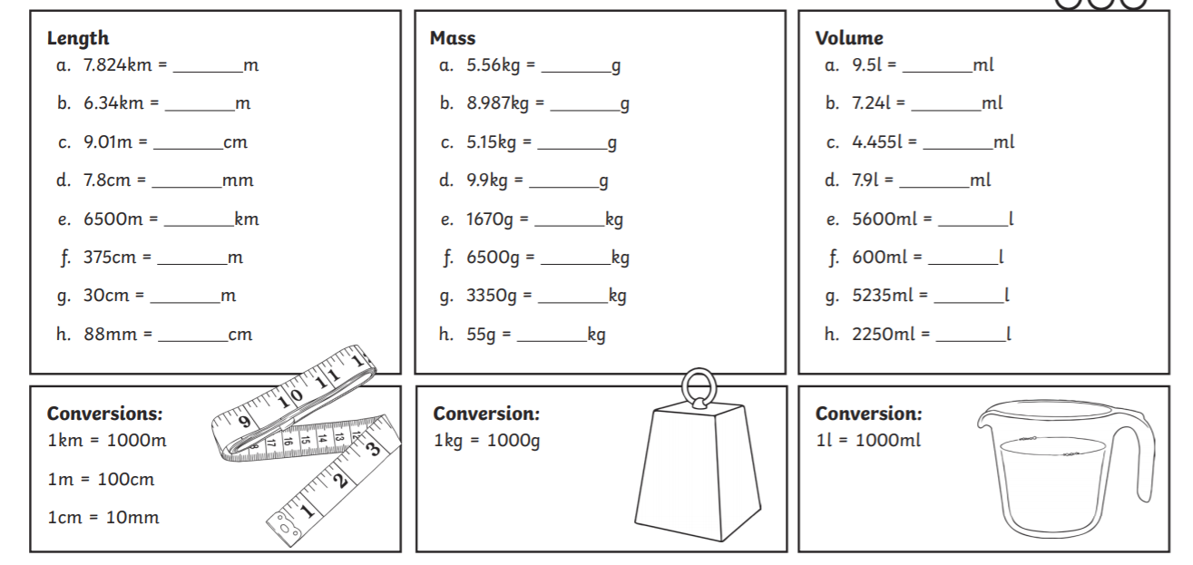

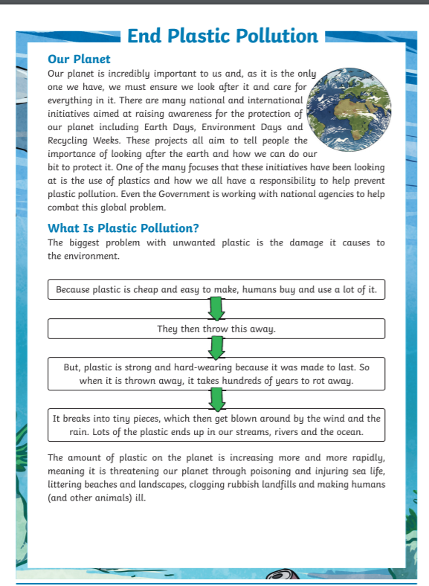
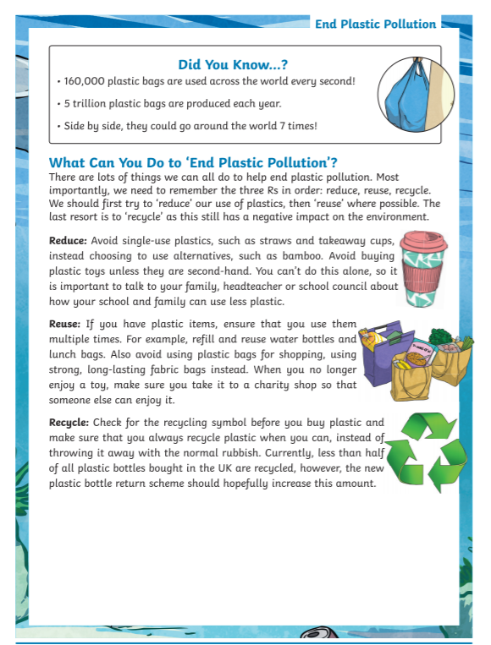
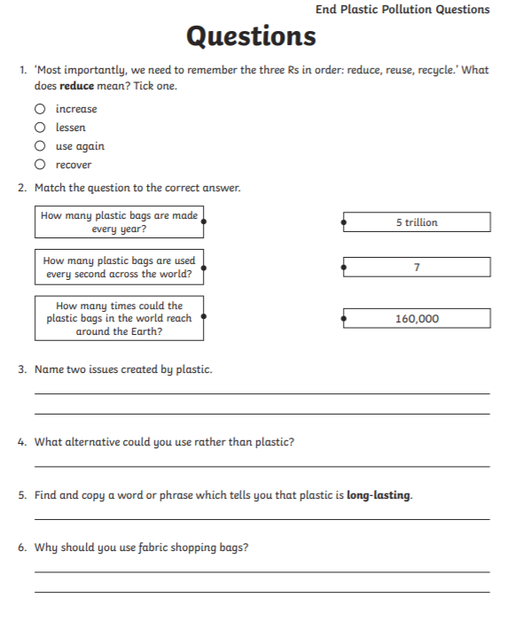

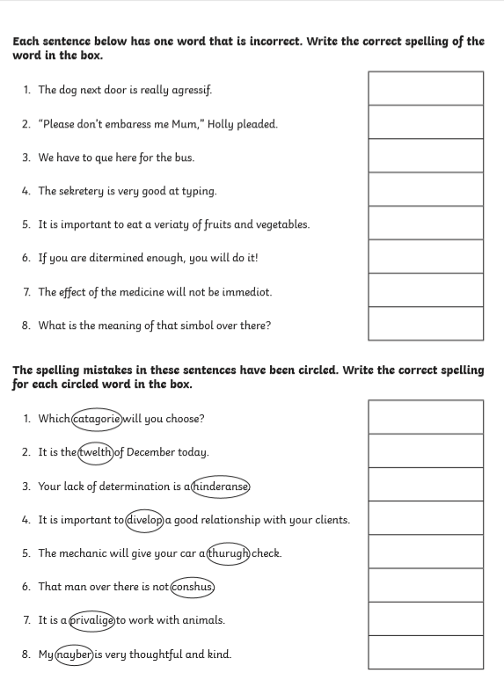
LO: To create a Balanced argument on whether packed lunches should be banned.

WIN List:
- Three reasons for
- Three reasons against
- Use connectives – e.g furthermore and additionally

Use the WIN list above and the research we conducted in class to create a balanced argument on whether packed lunches should be banned or not.

Remember to begin your argument by stating the topic or issue.
Your second paragraph should be your arguments for banning packed lunches.
Your third paragraph should be your arguments against banning packed lunches.
Your last paragraph should be your conclusion. What do you think and why?

Use the table on the next page to help organise your ideas.

My opening statement (what is my argument about?:

Reasons for: | Reasons against:
1. | 1.
2. | 2.
3. | 3.
Conclusion:

Creative writing
An author called Eloise Williams from Saundersfoot has uploaded some activities on her website, to assist you in writing your own story! Click the link below and it should take you to her website with all the activities.
https://padlet.com/joanna_suvarna/Get_Creative_With_Eloise
This task may take you longer than a week, so please don’t rush to finish.

Warm up activity
Eloise has given you four pictures; she wants you to choose one and write about it for five minutes without stopping. Don’t worry about your spelling or grammar, just be creative! She has given some tips to help you.

Activity 1 – thinking of a location.
During this activity, you will need to think of a location for your story, what kind of story you are interested in writing, and if will you include any pictures?

Activity 2 – creating a character.
On the website Eloise has included a list of questions she asks herself when creating characters. Use these to help you, when creating your own character.

Activity 3 – where does the character live?
Here, Eloise has given you some information about where characters live in books she’s already written.

Once you have finished these three activities, you are ready to start writing! Maybe before you start you could create a WIN list. What do creative stories need to make them interesting?

Eloise has also provided her email at the bottom of activity 3, so when you are finished, you can send your work to her and maybe she will give you some feedback!

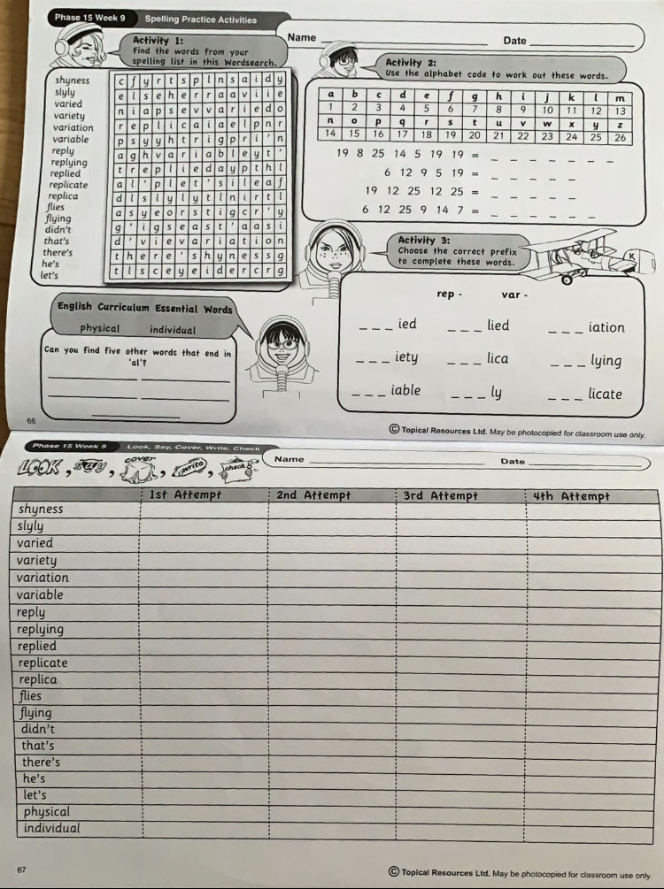
Phase 15 Week 9 Spelling

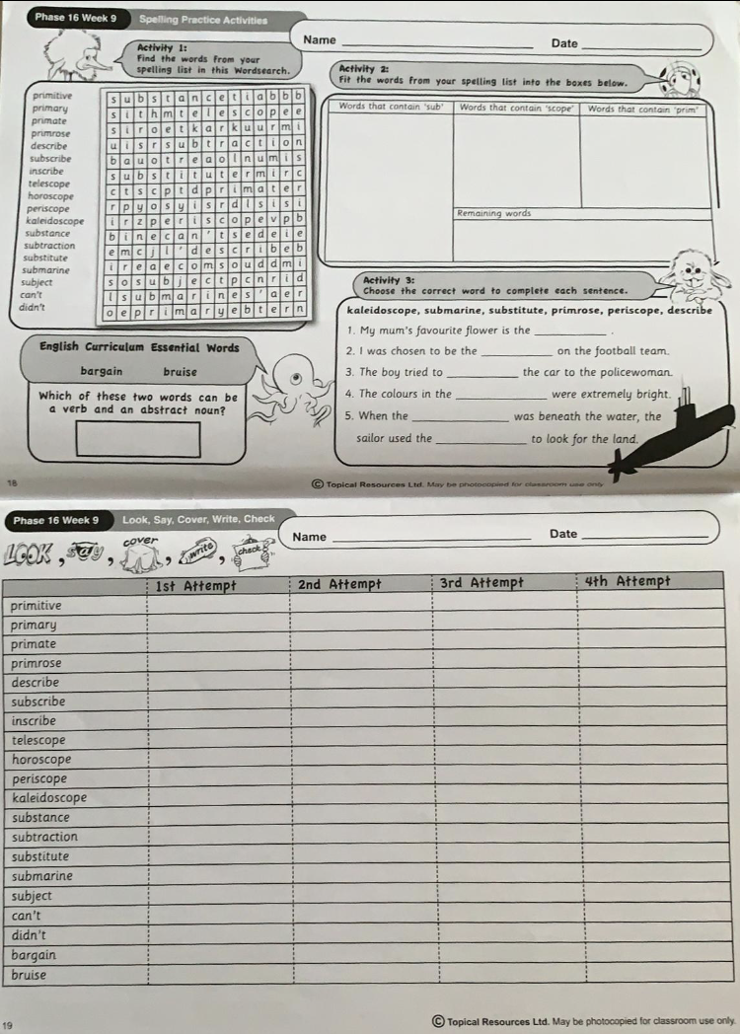
Phase 16 Week 9 spellings.


