

Year 5 – Mr Stagg
Name:
School Closure
Work Pack 2


Hello again, you brilliant bunch!
I hope you’ve all had a good (if slightly boring) first week at home! It has been an absolute pleasure seeing some of your pictures on Twitter showcasing your hard work – keep ‘em coming!
In this pack, you’ll find a few more activities to keep your brains exercised. If you haven’t finished the tasks from last week, don’t be afraid to complete those before you move on to this pack. Don’t forget – if you’re in Miss Densley’s Maths class, look through her work pack on our School Website for your Maths activities.
Lots of you have accessed Hwb which is great! Try using J2Blast if you haven’t already done so. You can compete across the school using your times table or spelling knowledge! Also, if you remember how to use it, try J2Data where you can create data cards (like Top Trumps) – we used this in class a few weeks ago.
Again, a small reminder, if you would like to tweet us showing yourselves working, our Year 5 and 6 Twitter account is @williamstown5_6.
Lastly, below is a new list of websites that will continue to help you with your learning.

Keep working hard, even if the activities make you pull this face – it will all pay off in the end!
Mr Stagg

Useful Websites:
- Hwb - https://hwb.gov.wales/
- To practise your Welsh skills -https://hwb.gov.wales/repository/resource/777581cd-597a-44db-929a-1379f742c275/en
- Sumdog is a website where you can practise your Numeracy and Literacy skills through games. Free to sign up! – www.sumdog.com
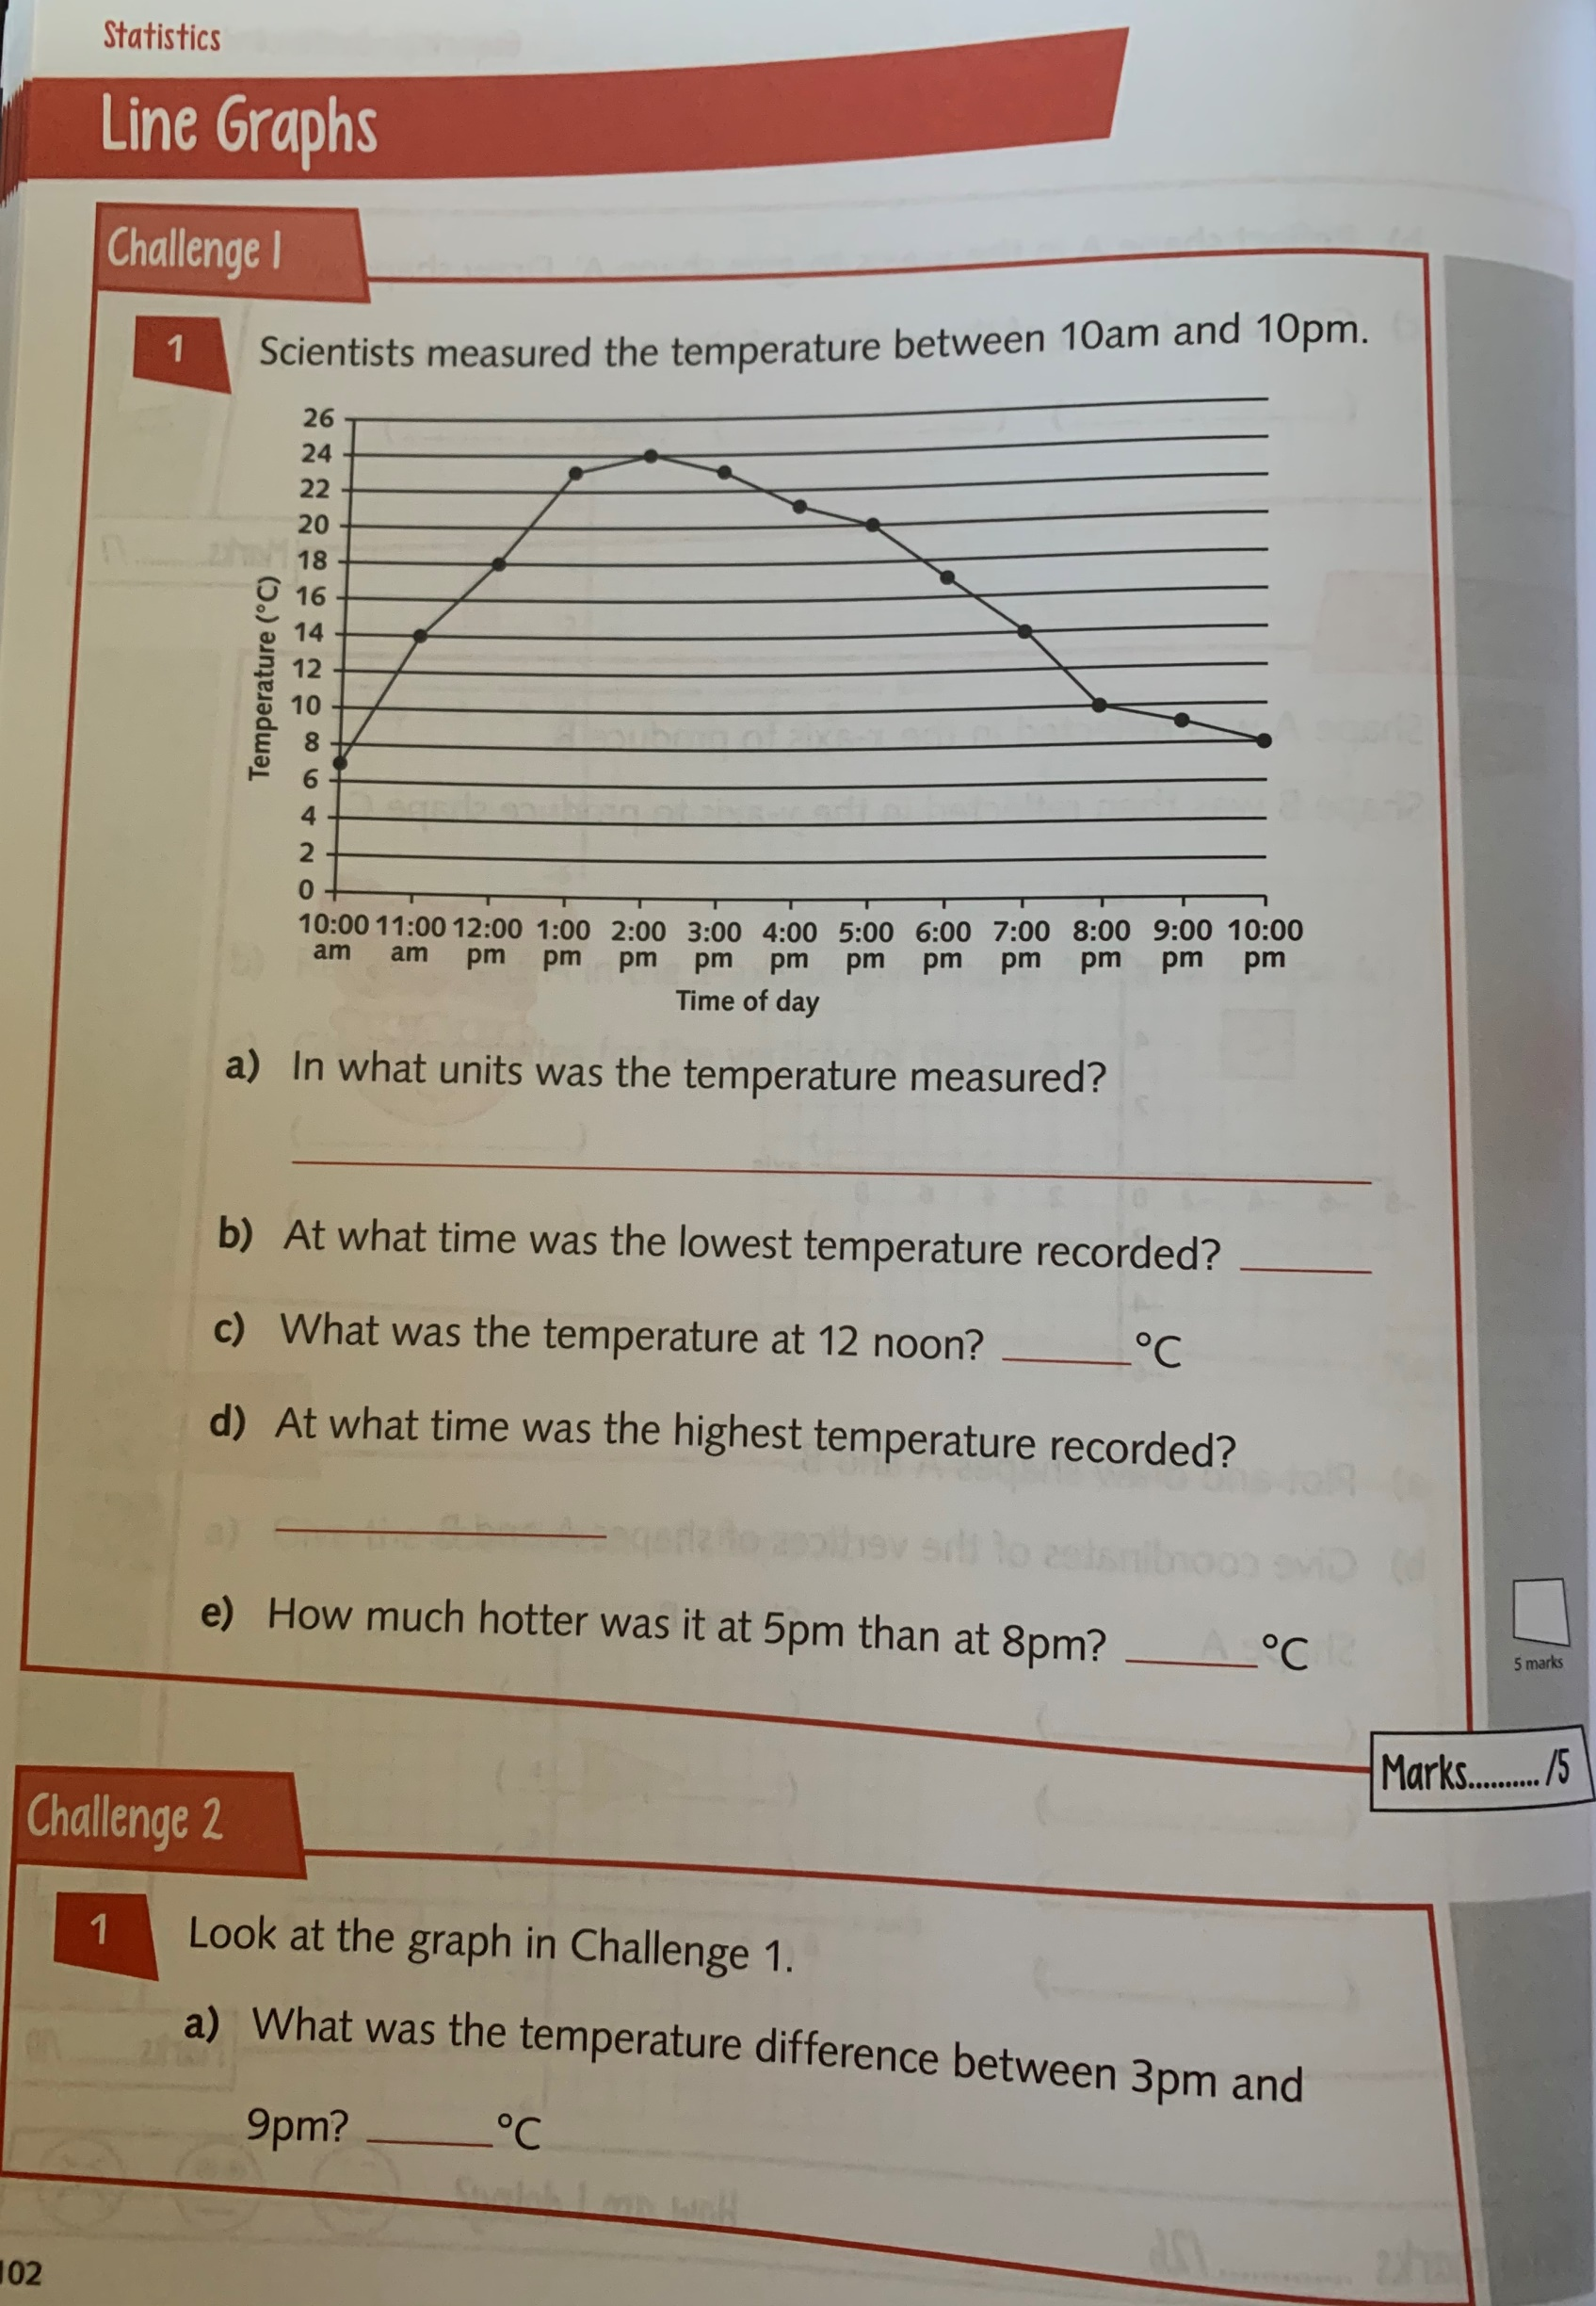

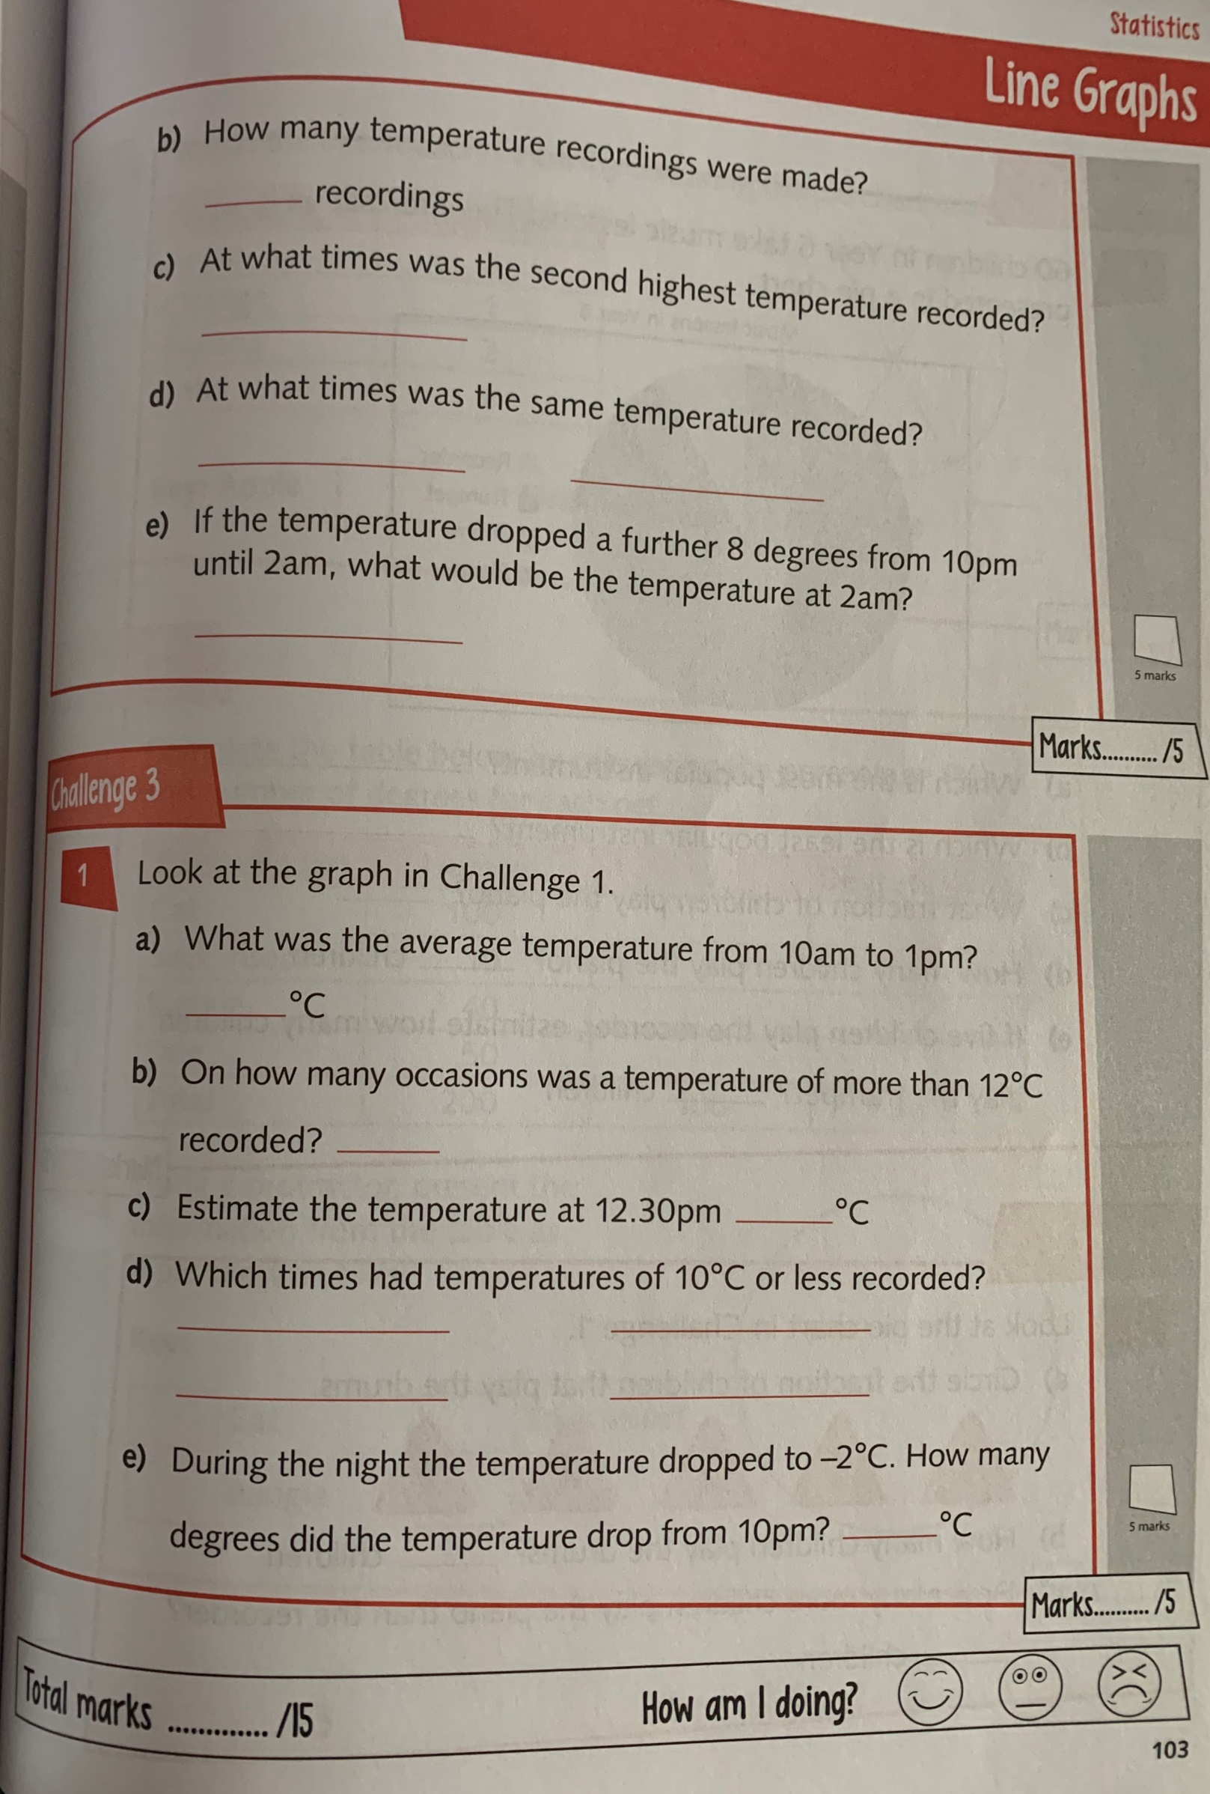

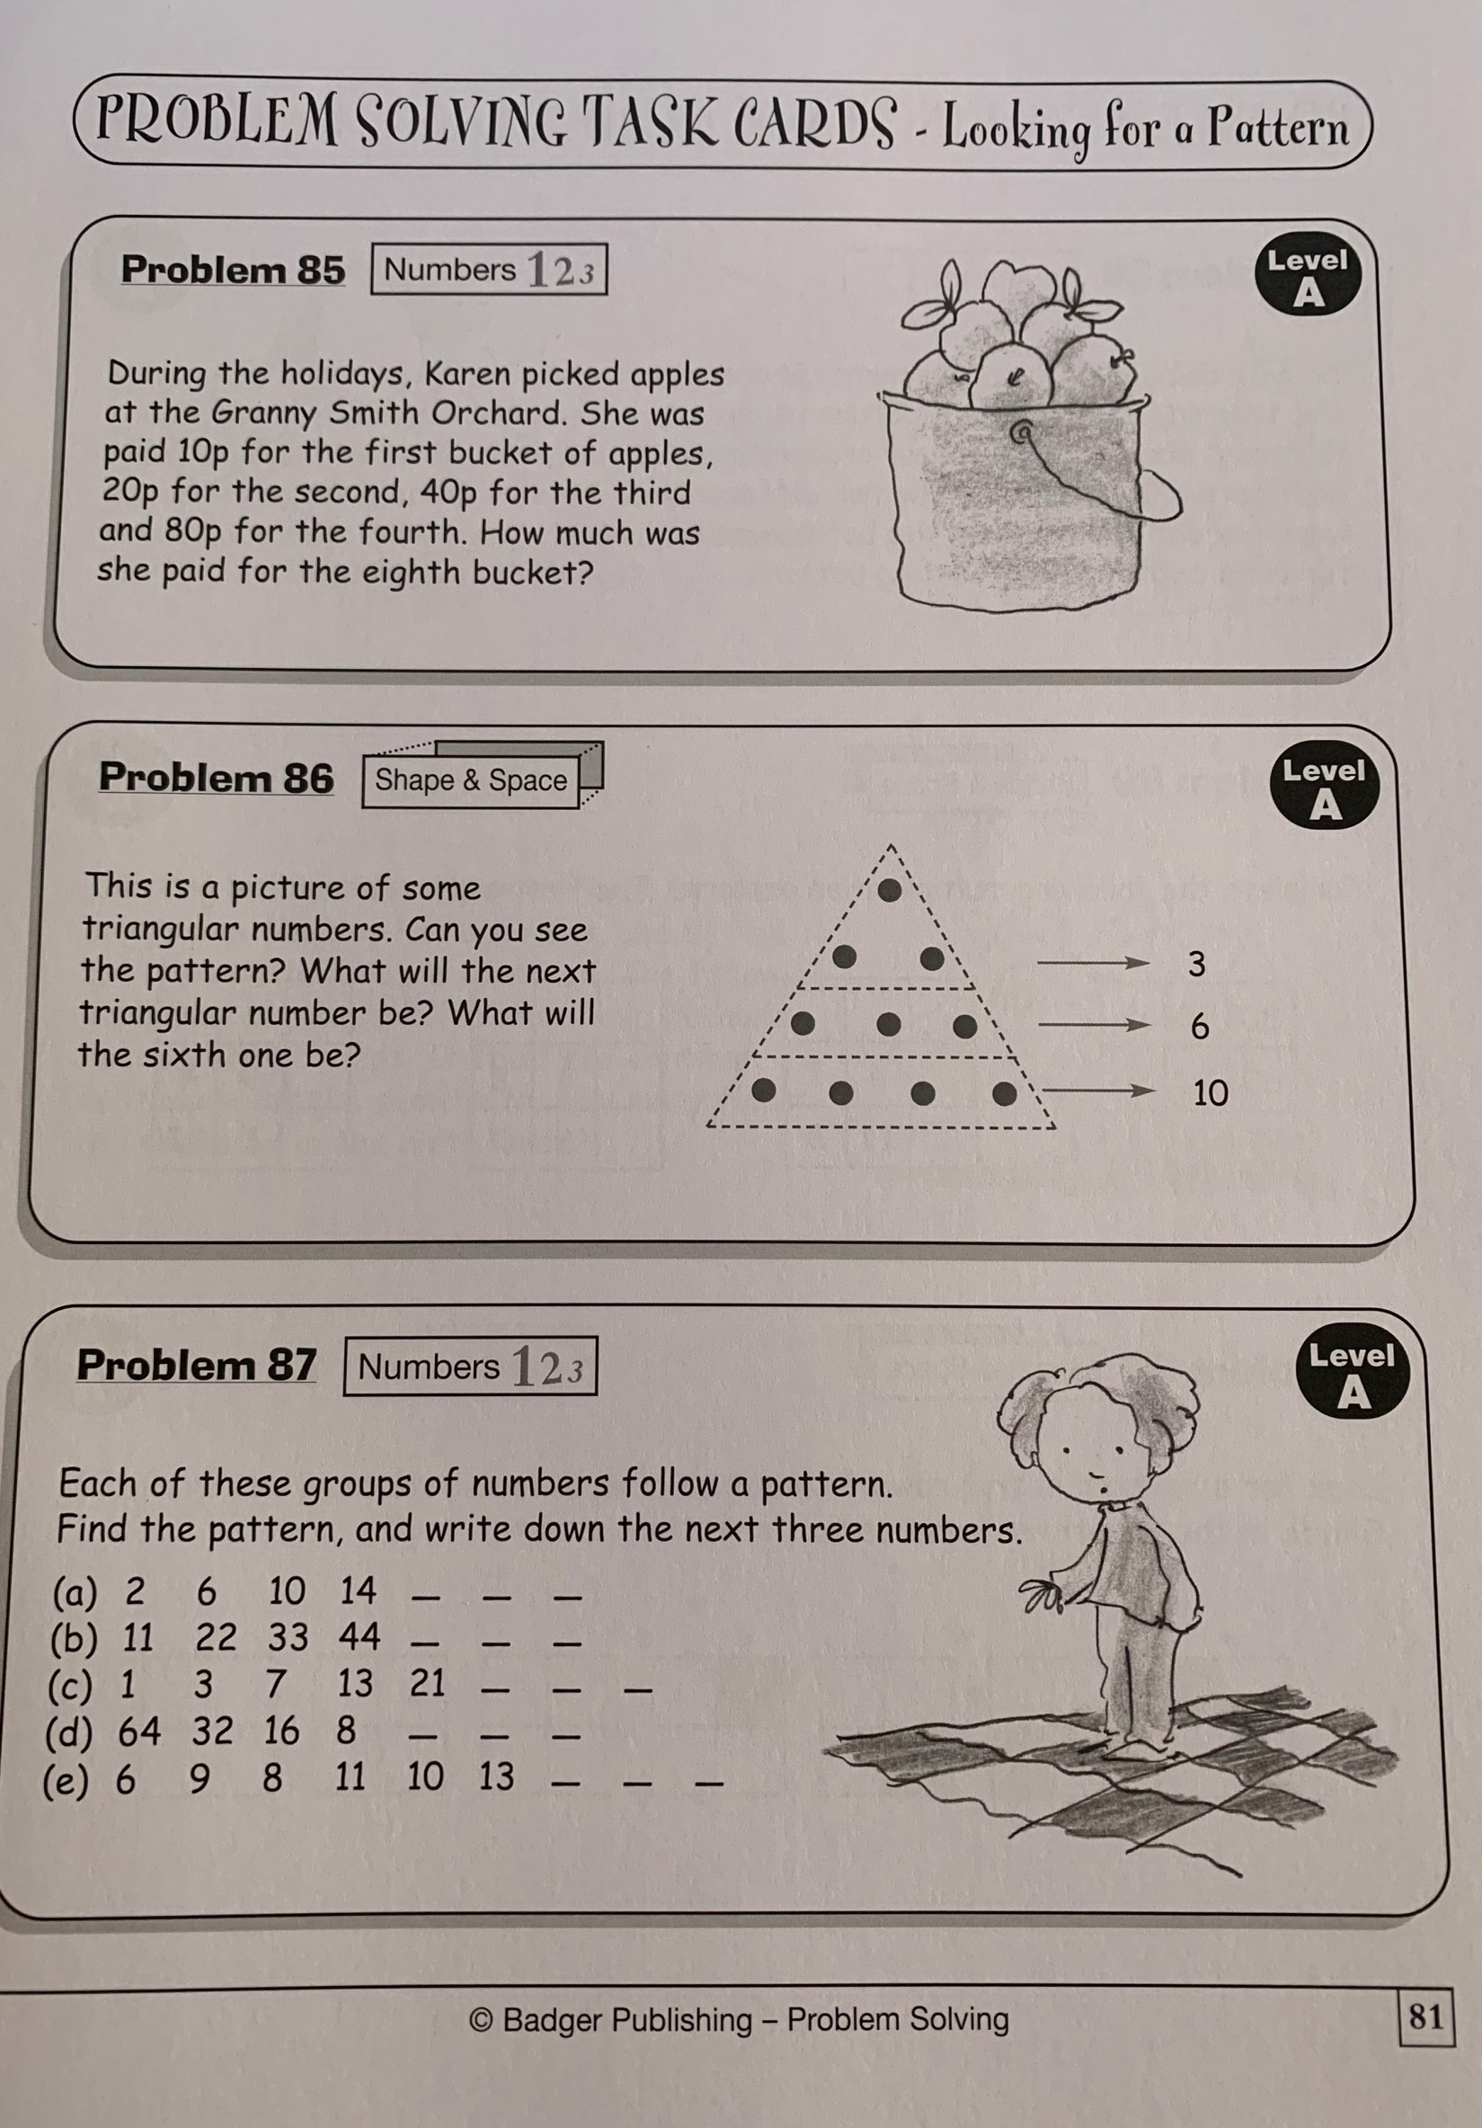

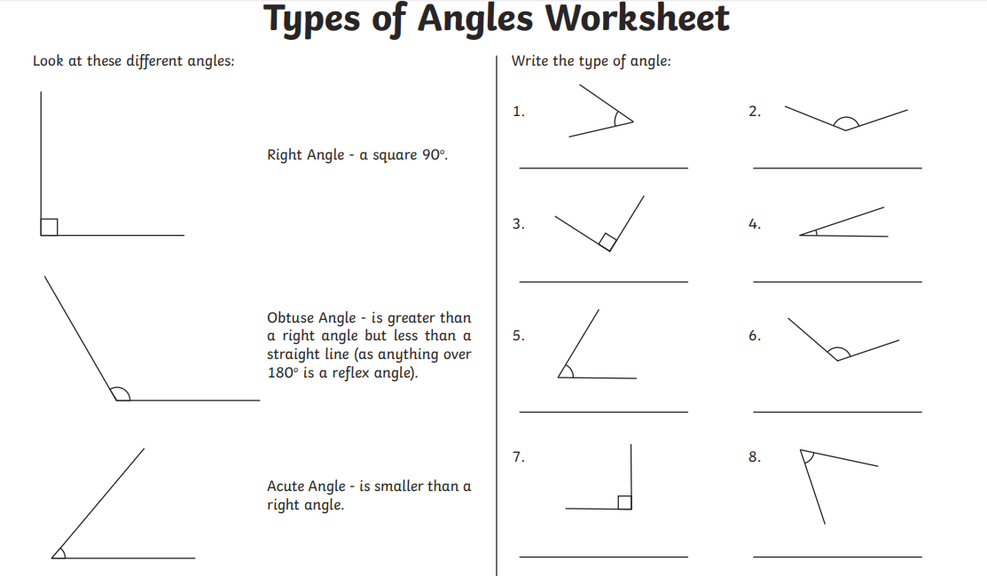

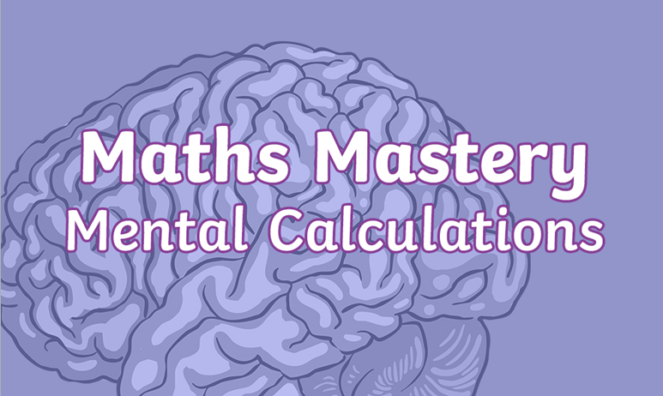

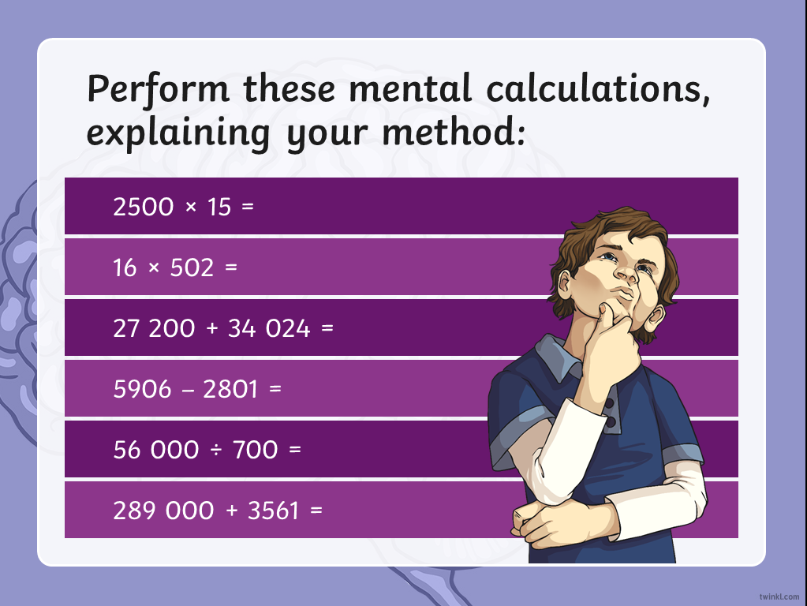

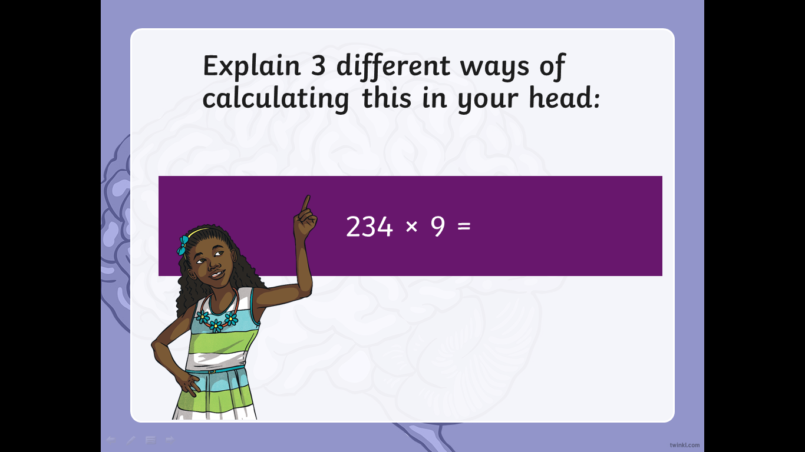
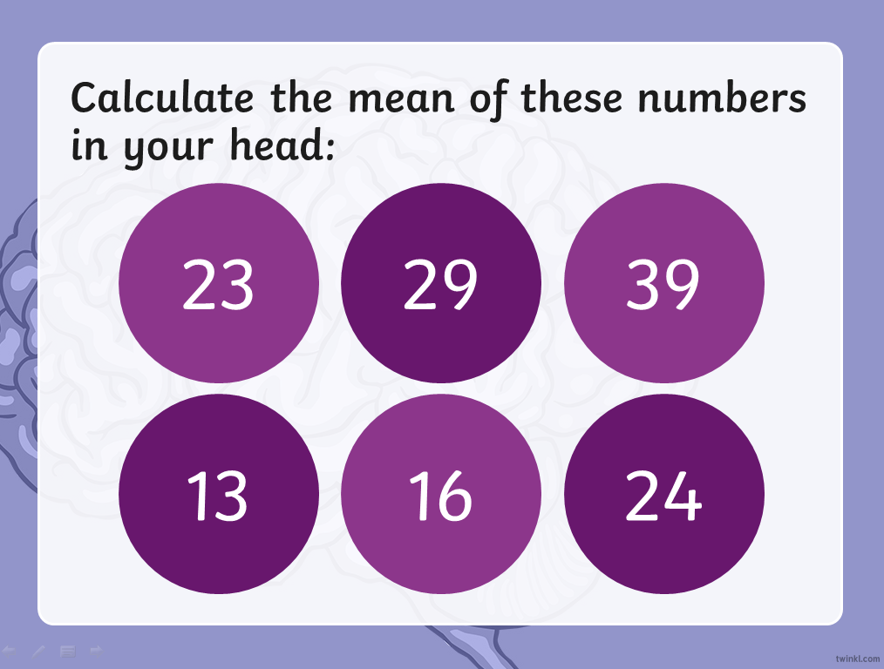

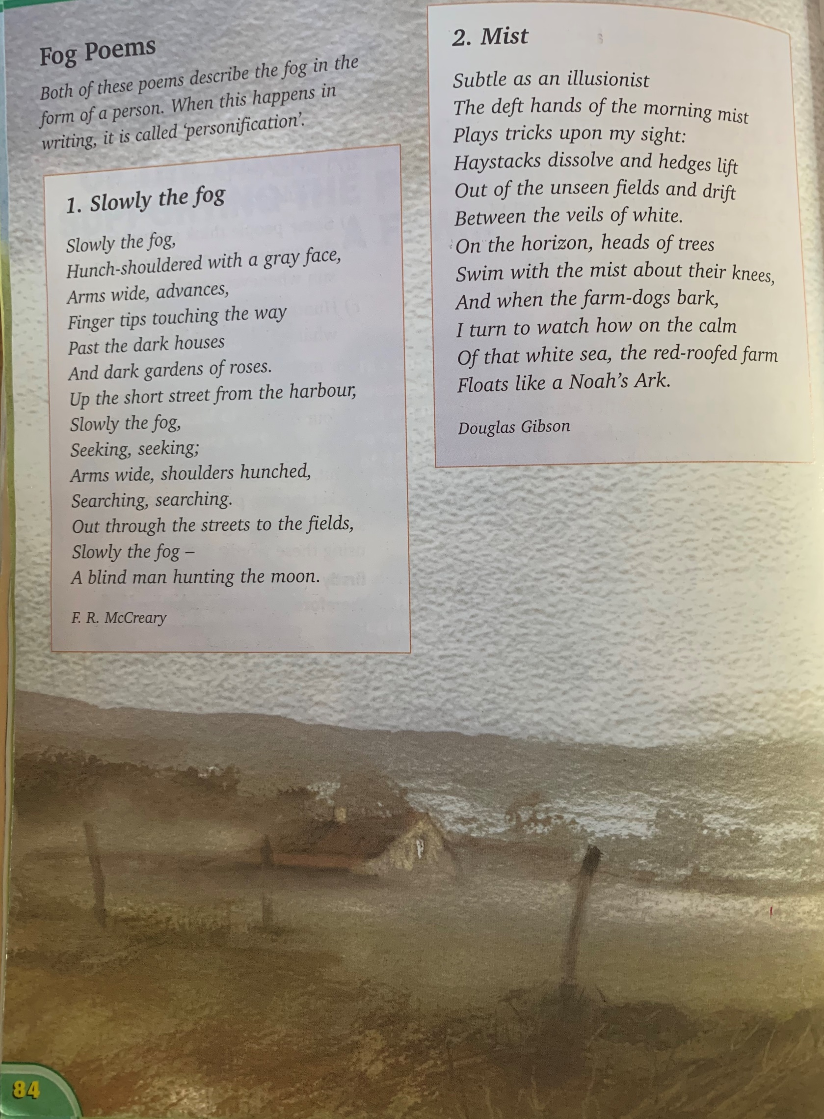

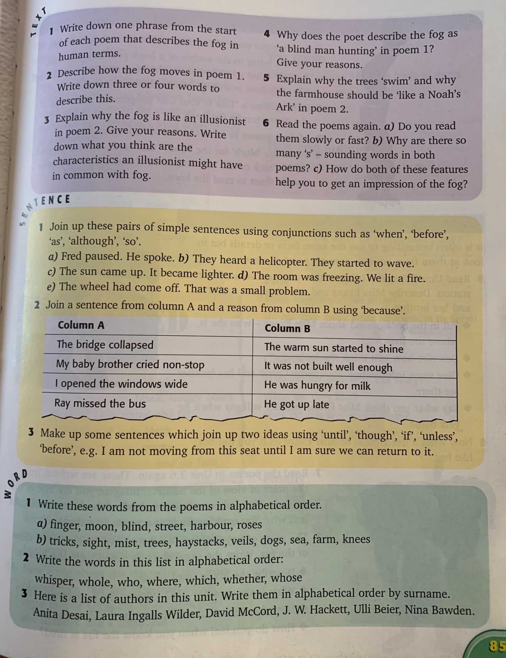

Read the short poem below and answer the questions that follow.
Don’t forget to use full sentences.
Perhaps you could complete this task using J2Write on Hwb?

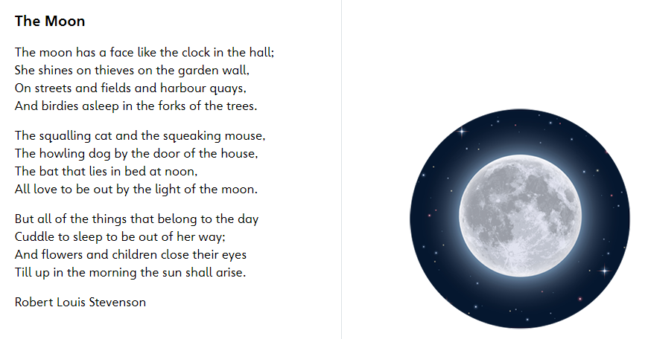

________________________________________________________________
Higher Order Thinking Skills

- What animals does the moon shine down on?
- What things 'belong in the day' according to the poet?
- What does the moon see that the sun will not?
- Why do you think the poet wrote about thieves in this poem?
- Do you think it is accurate that the moon has a face like a clock? Give reasons for your answer.

As there has been so much of it recently, write a poem about the sun. Use the poem above about the Moon to help you. Think about the poetry skills we talked about and used at the beginning of this year.
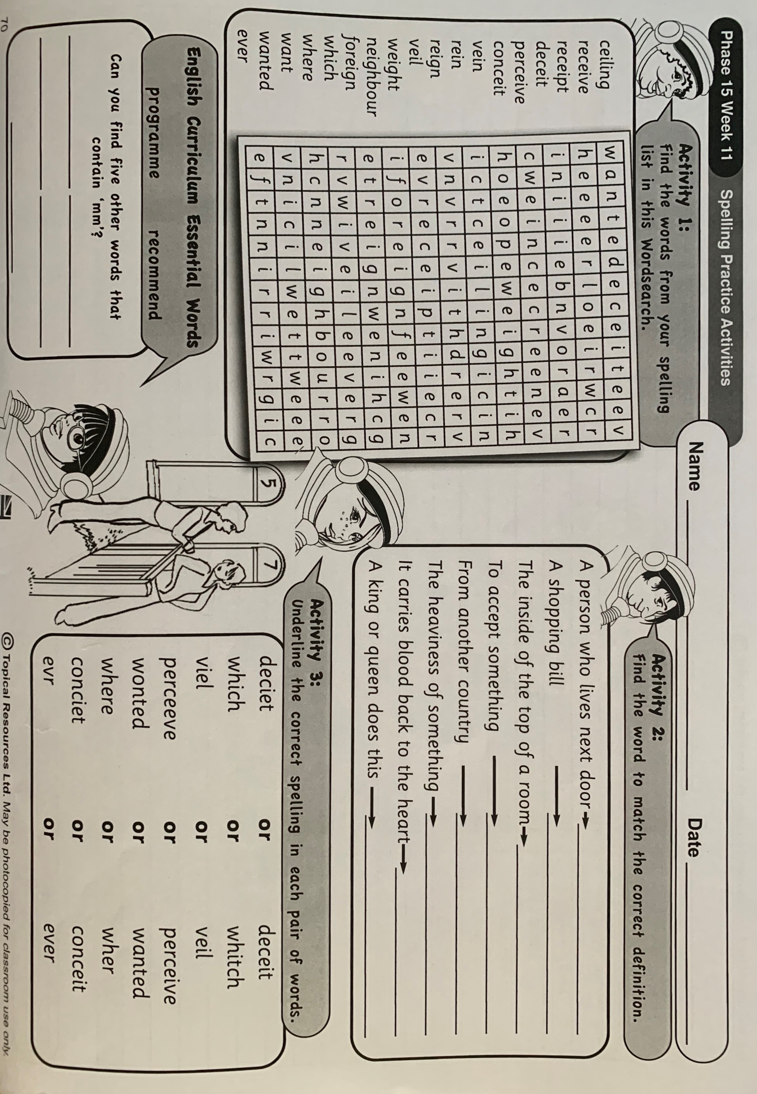

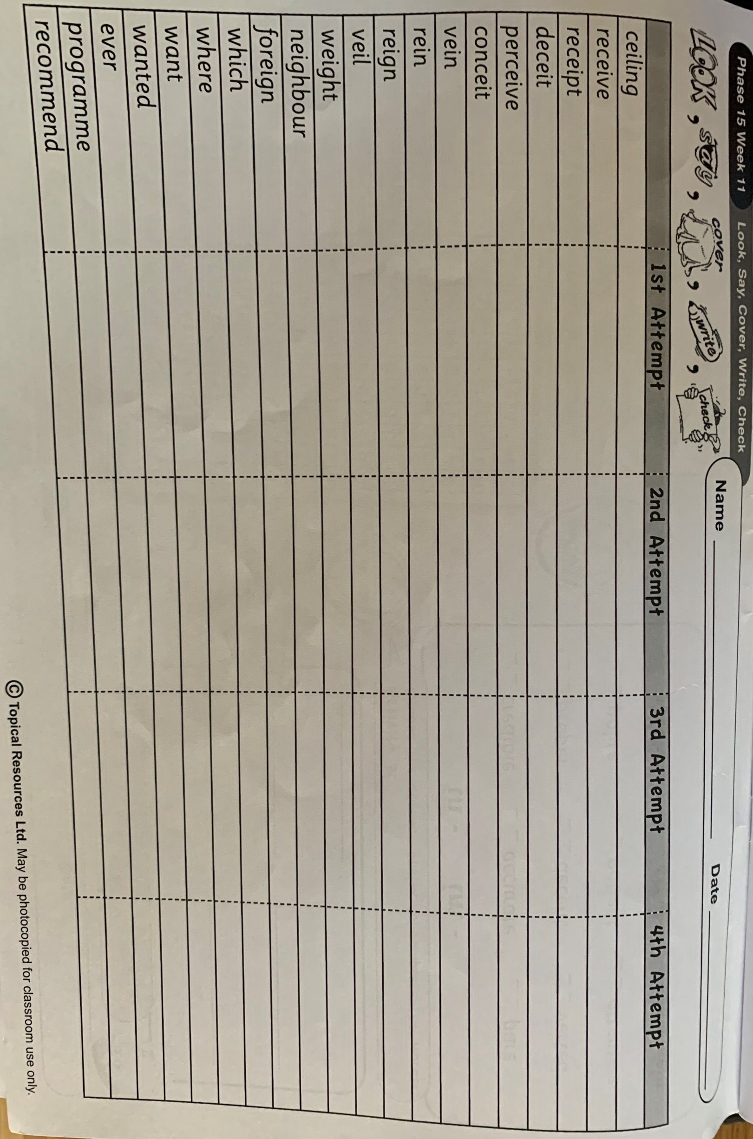

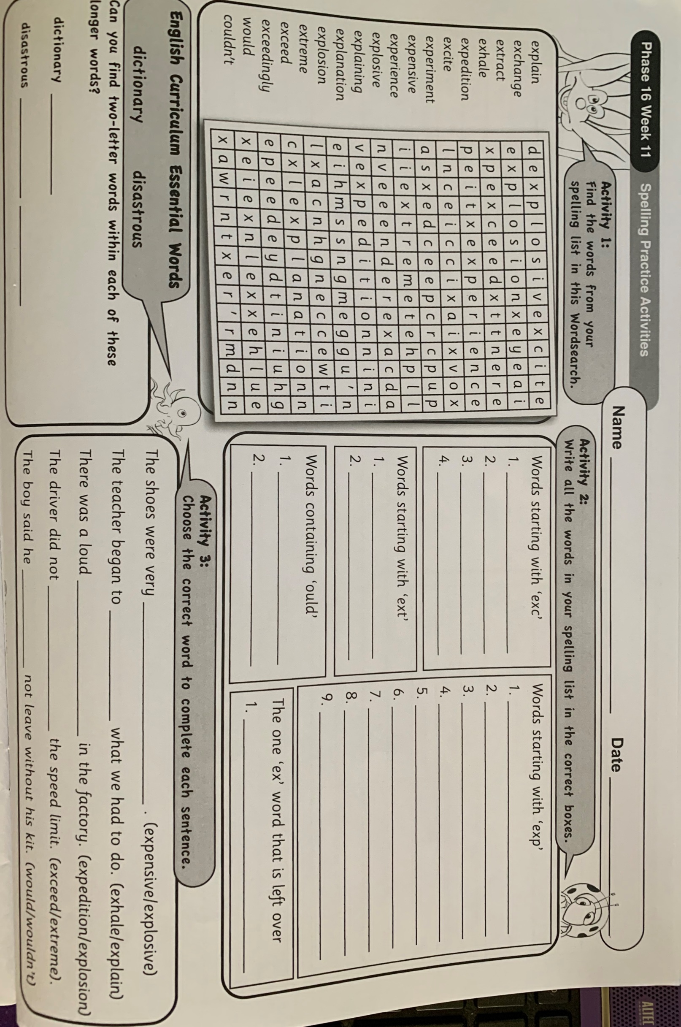

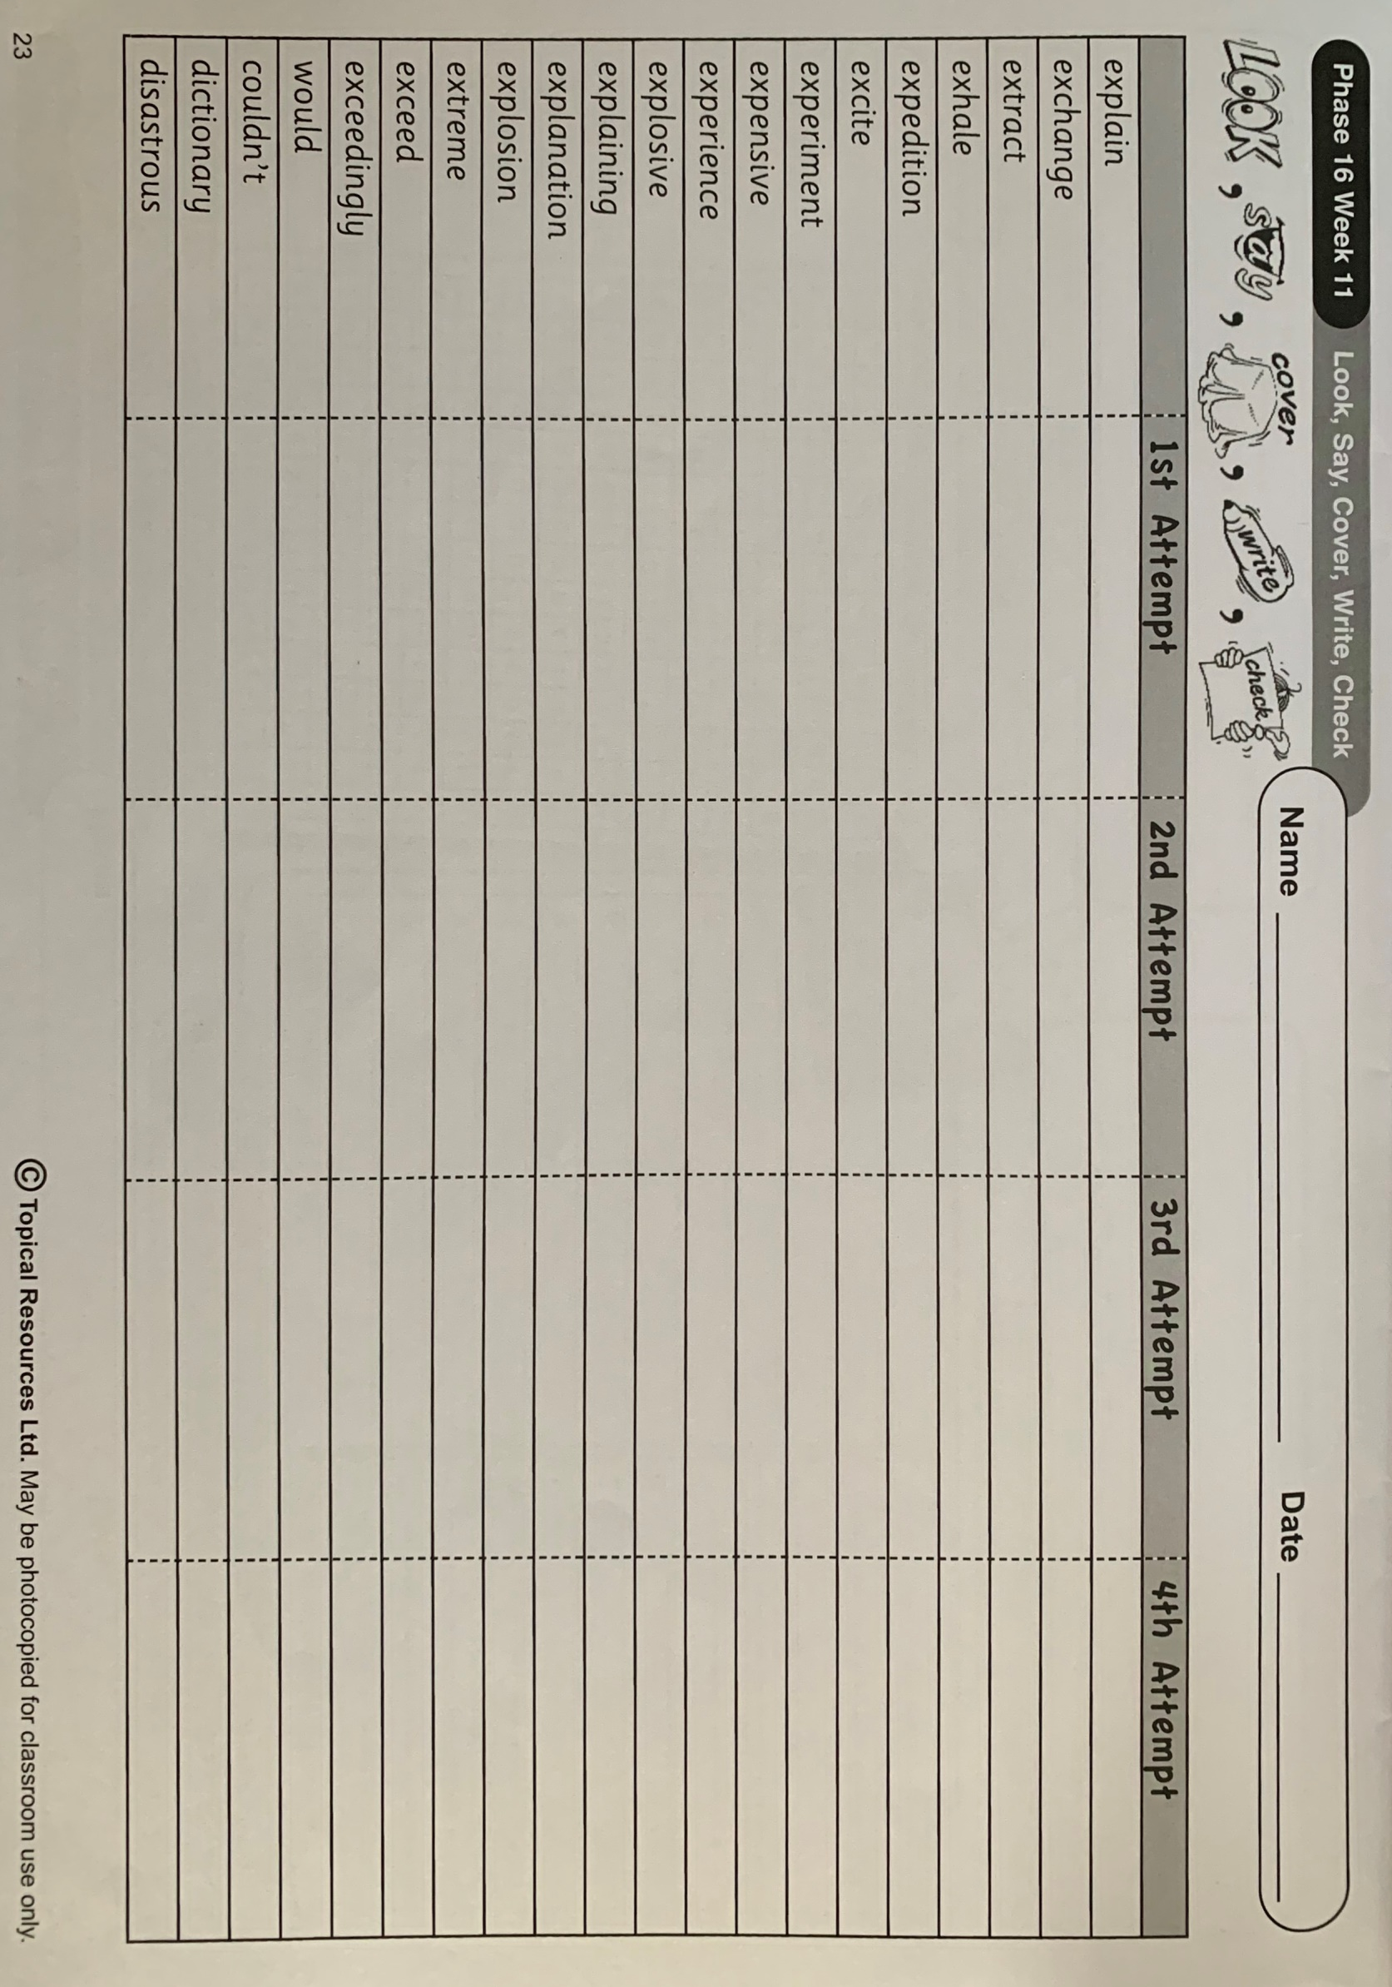

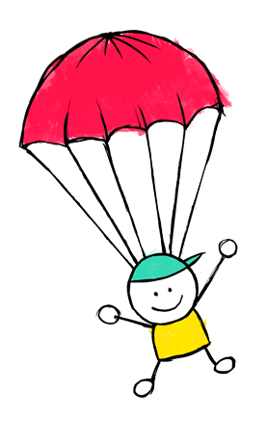
What you'll need:
- A plastic bag or light material
- Scissors
- String
- A small object to act as the weight, a little action figure would be perfect

Instructions:
- Cut out a large square from your plastic bag or material.
- Trim the edges so it looks like an octagon (an eight sided shape).
- Cut a small whole near the edge of each side.
- Attach 8 pieces of string of the same length to each of the holes.
- Tie the pieces of string to the object you are using as a weight.
- Use a chair or find a high spot to drop your parachute and test how well it worked, remember that you want it to drop as slow as possible.
What's happening?
Hopefully your parachute will descend slowly to the ground, giving your weight a comfortable landing. When you release the parachute the weight pulls down on the strings and opens up a large surface area of material that uses air resistance to slow it down. The larger the surface area the more air resistance and the slower the parachute will drop.

Cutting a small hole in the middle of the parachute will allow air to slowly pass through it rather than spilling out over one side, this should help the parachute fall straighter.

This week you are going to learn about air resistance while making an awesome parachute! Design one that can fall slowly to the ground before putting it to the test, making modifications as you go.
Mini Science Investigation – Parachutes!

