School Closure Home School Pack
Miss Densley’s Class
Week beginning 20.4.20
I’ve added some more ideas for another week of home learning. I’ve left the ongoing spelling/reading/times tables on there.
Literacy
- Practice the reading/spelling of high frequency words – you can do this in creative ways using different materials (e.g. paint, magnetic letters) and try timing yourself
- Carry on with your reading books – make sure someone asks you lots of questions about them and if you are reading Dockside practice those cover words
- I have included a sheet of general literacy activities and some paper to complete them on
- Here is a link for Oxford Owl’s free ebook library (you will have to create a login but it should all be free): https://www.oxfordowl.co.uk/for-home/find-a-book/library-page/?view=image&query=&type=book&age_group=Age+9-11&level=&level_select=&book_type=&series=#

- For this week’s main activity, I have scanned in a comprehension activity on “The Clock Strikes Thirteen” (see below). If you get time you can have a go at the Sentence and Word work as well. Over the next few weeks we will be looking at creative writing so try to read some stories this week to get your creative juices flowing.

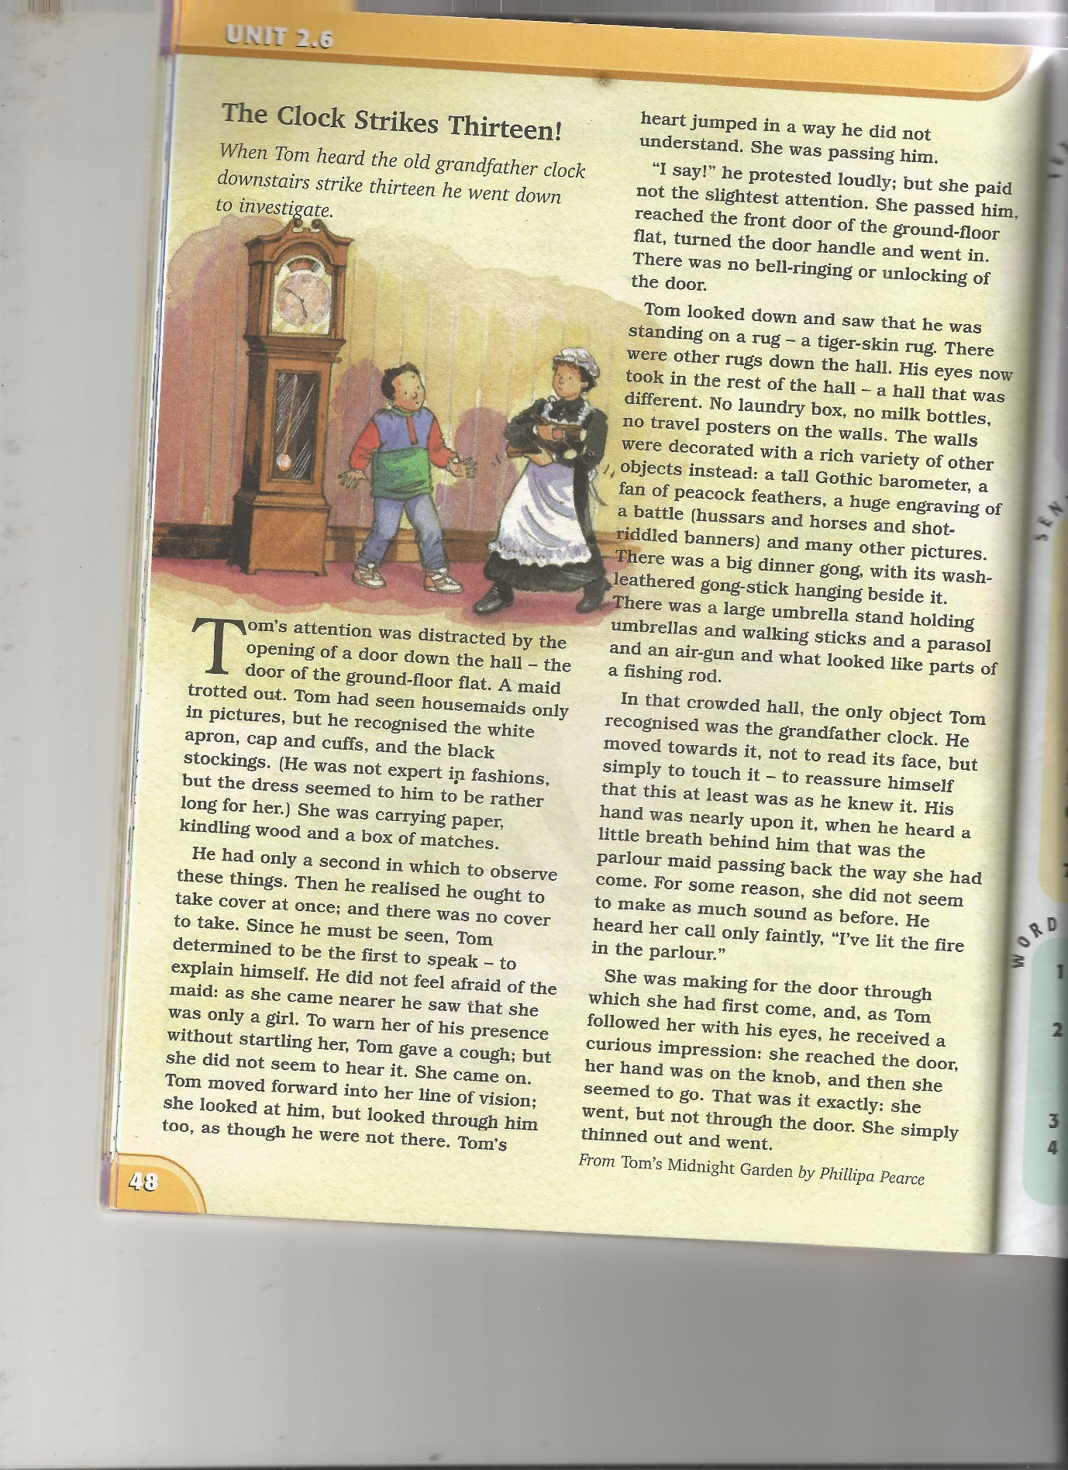
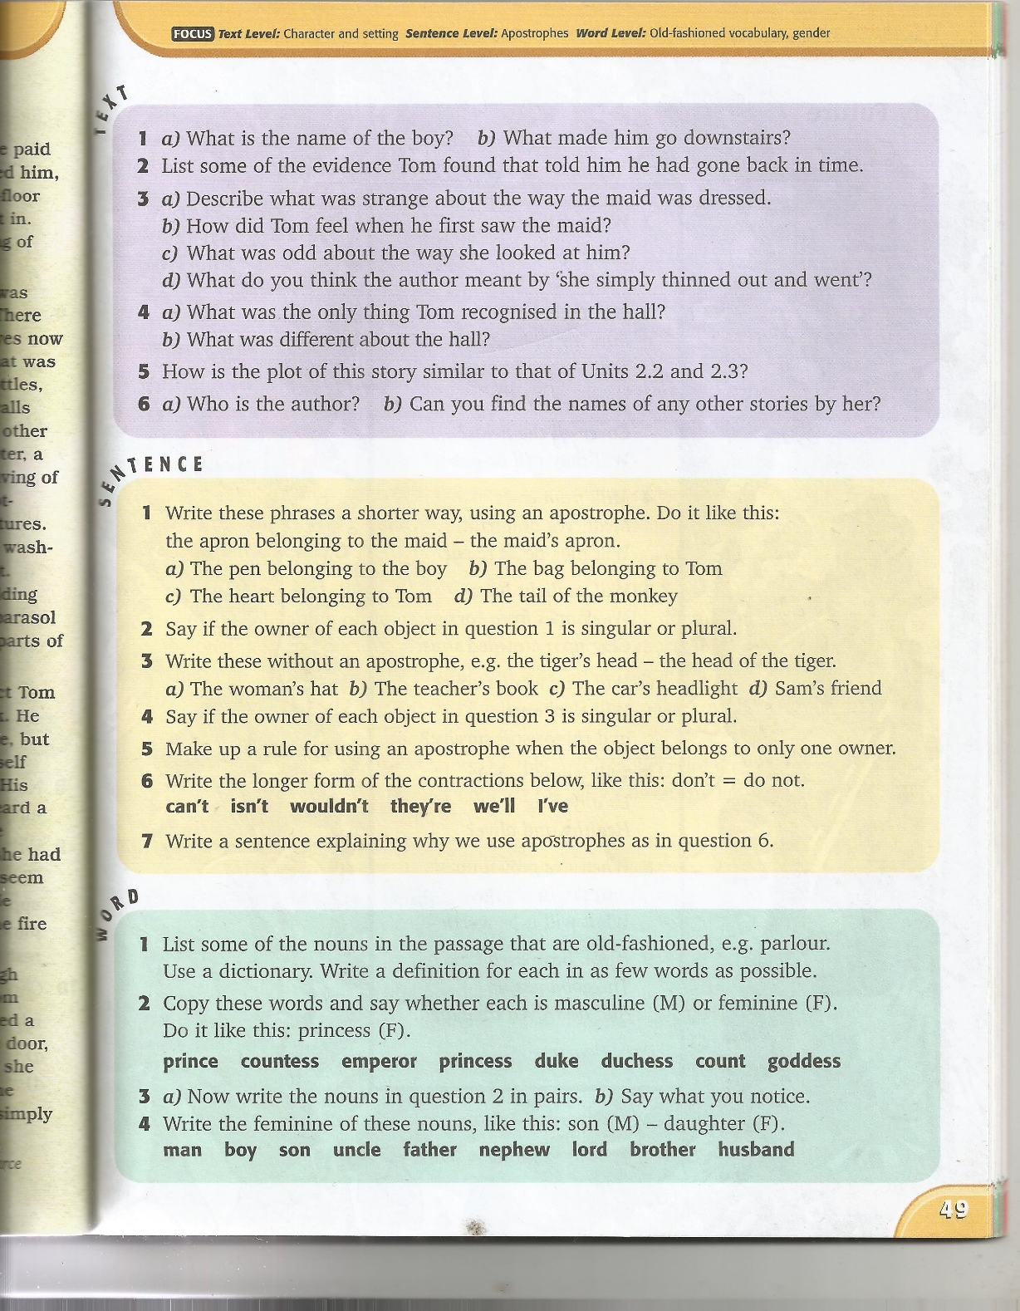

Maths
- Practice your times tables (in class we have practised the 2, 5, 10, 3, 4, 6, 8 and 9). A great tool for this is J2Blast on Hwb (I can see some of you have already had a go at this!)
- Practice telling the time on analogue (clock faces) and digital clocks
- Topmarks is a fantastic website to help with both of these

- This week’s topic is recognising acute and obtuse angles. I have included a sheet (see below) to complete – if you don’t have a protractor at home don’t worry about measuring the angles. If you do, you may also like to have a go at drawing your own example of each type of angle and labelling them. I have also attached some slides from a Powerpoint explaining more about angles.

Good websites to help with any of the above include Letters and Sounds for phonic practice, Topmarks, Crickweb for problem solving practice, Twinkl, Espresso, Hwb, BBC Bitesize and Primary Resources.

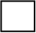
Acute angles are less than 90°.
Acute
Key
Obtuse angles are more than 90°, but less than 180°.
Choose 3 colours, fill in the key, then colour the angles as appropriate.
Obtuse
Use a protractor to measure the angles.
Right angle
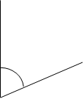
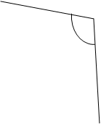

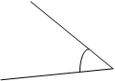
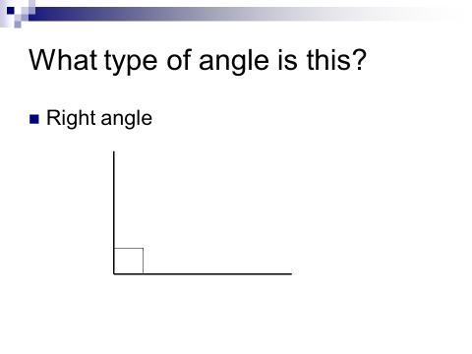
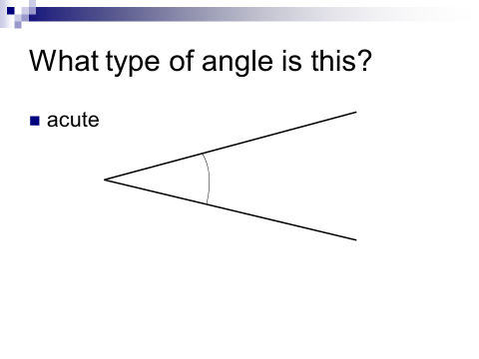
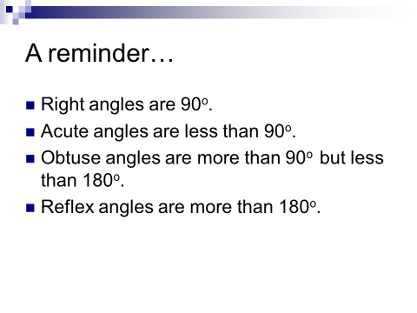

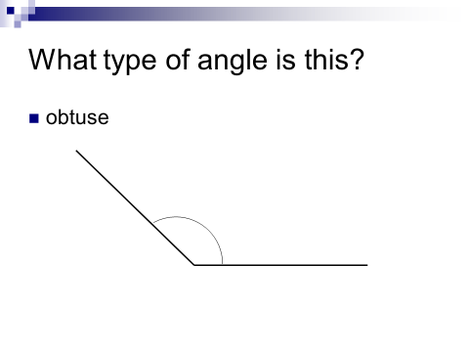

History
If the Olympics were still going ahead, this is what our topic would have focused on in school so over the next few weeks I will be setting you some work on the Ancient Greeks. All the resources for this can be found on Twinkl. I have uploaded a Powerpoint for you to have a look at to the website and have attached a timeline for you to have a go at below if you would rather a hard copy. You can check your answers on the Powerpoint.

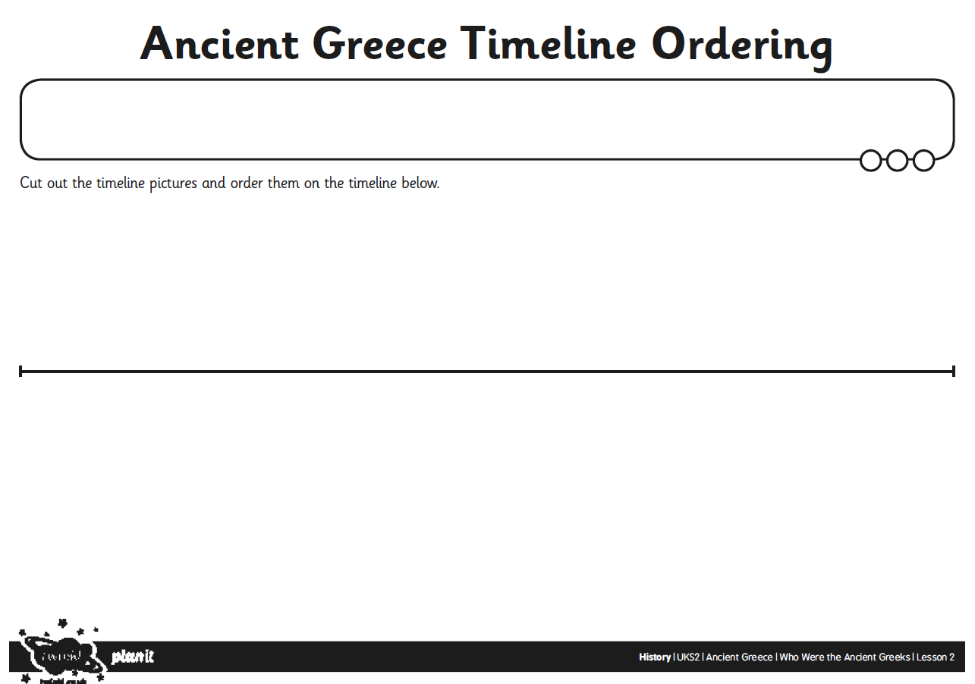
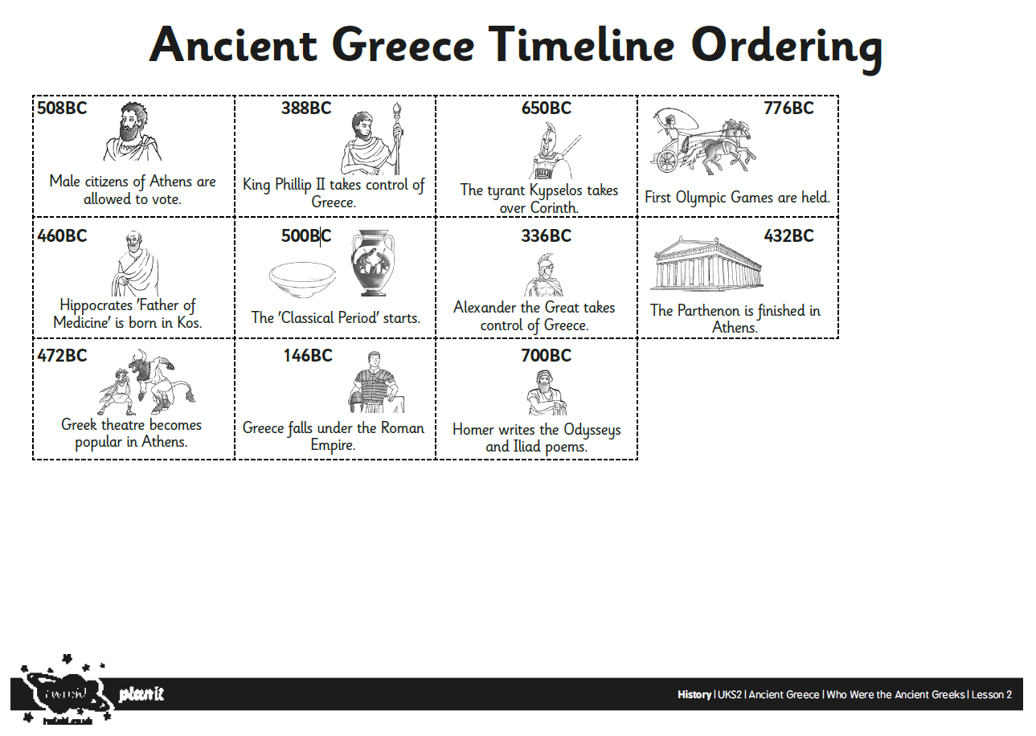

Welsh
Our topic for the summer term would have been ‘Y Dref’ (‘The Town’). I have attached some vocabulary for you to practice below. Below that is a picture with some questions attached. Have a go at answering them. If you find them tricky the translations are underneath.
Also here’s the link for the Cyw website where there are lots of activities for you to explore: https://cyw.cymru/en/

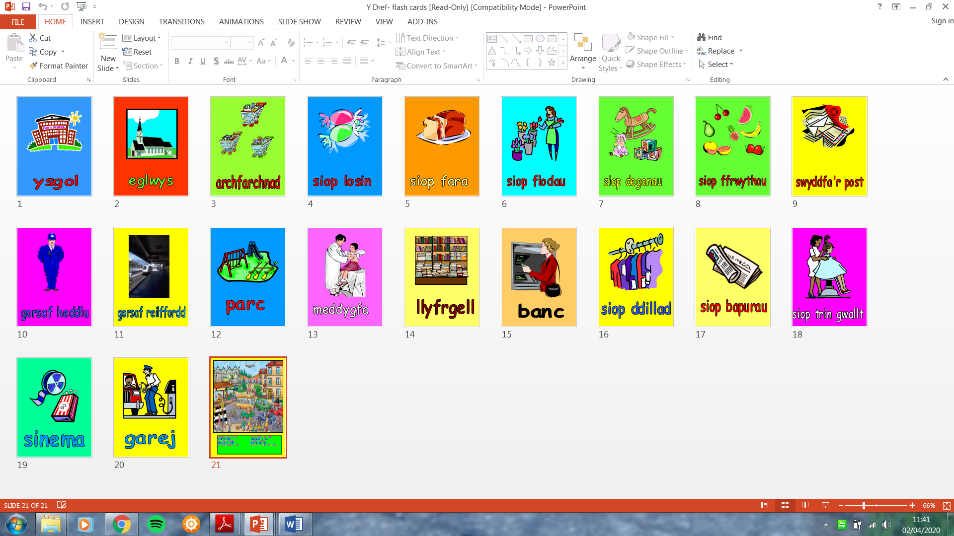
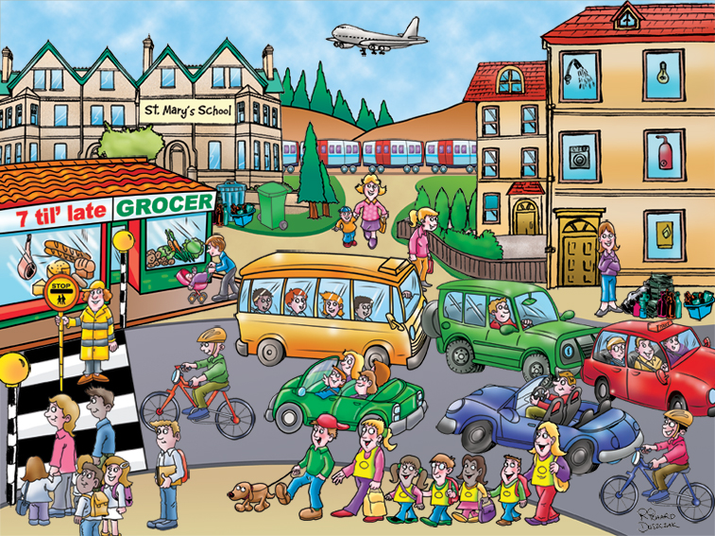

Ble mae’r plant yn mynd? Faint o blant sy ar y bws?
Pa liw ydy’r bws? Sawl car sy yn y llun?
Ydy’r plant yn hapus? Sut mae’r tywydd?
Sawl awyren sy yn yr awyr? Beth ydy enw’r ysgol?
Oes anifail anwes yn y llun? Beth sy yn ffenest y siop lysiau?

Where are the children going? How many children are on the bus?
What colour is the bus? How many cars are in the picture?
Are the children happy? What is the weather like?
How many aeroplanes are in the air? What is the name of the school?
Are there any pets in the picture? What is in the window of the
vegetable shop (Grocers)?

ICT
Here is a link to refresh your knowledge about charts: https://www.bbc.co.uk/bitesize/topics/zf2f9j6/articles/z83wjxs
I would like you to enter a list of numerical data into a spreadsheet on Microsoft Excel then create a suitable graph from the data set and format the graph appropriately adding labels to each of the axis and a title. Here is a link for parents to help with this: https://www.youtube.com/watch?v=ne-ElOPan5M&feature=youtu.be
You could use the data provided in the video or come up with your own e.g. favourite fruits, favourite subjects. This is similar to the numeracy mission you completed a while ago when you created a graph about how people travelled to school.

Happy home learning! Hope you are all keeping safe and well,

Miss Densley

