Week 3
Our theme this term is Animals Past and Present.
To start the term, we will be looking at different dinosaurs:
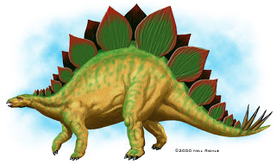
The stegosaurus:
Herbivore

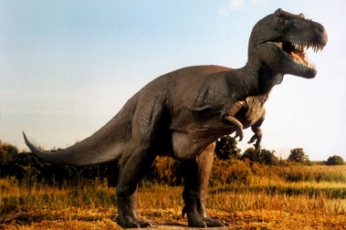
The Tyrannosaurus Rex :
Carnivore

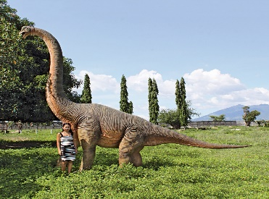
The brachiosaurus:
Herbivore

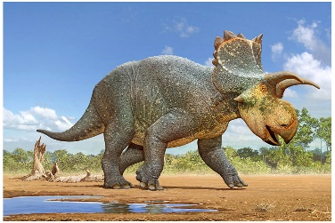
The triceratops:
Herbivore

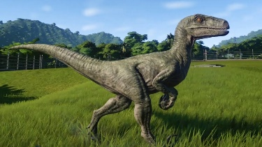
The velociraptor:
Carnivore
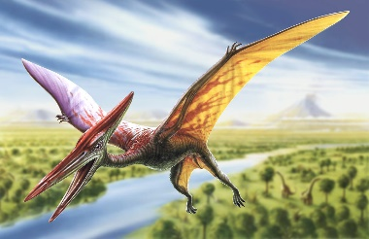
The Pterodactyl
Carnivore

Please can you help by showing your child different kinds of dinosaurs and discuss their different features, eg claws, horns, spikes, tails etc. Also what the dinosaurs liked to eat, whether they were herbivores who loved plants or carnivores who loved meat.
(there are lots more images available online).
How many different kinds can they find?

Here is a fun matching activity.
If you read the description on the card, can your child find the matching Dinosaur?
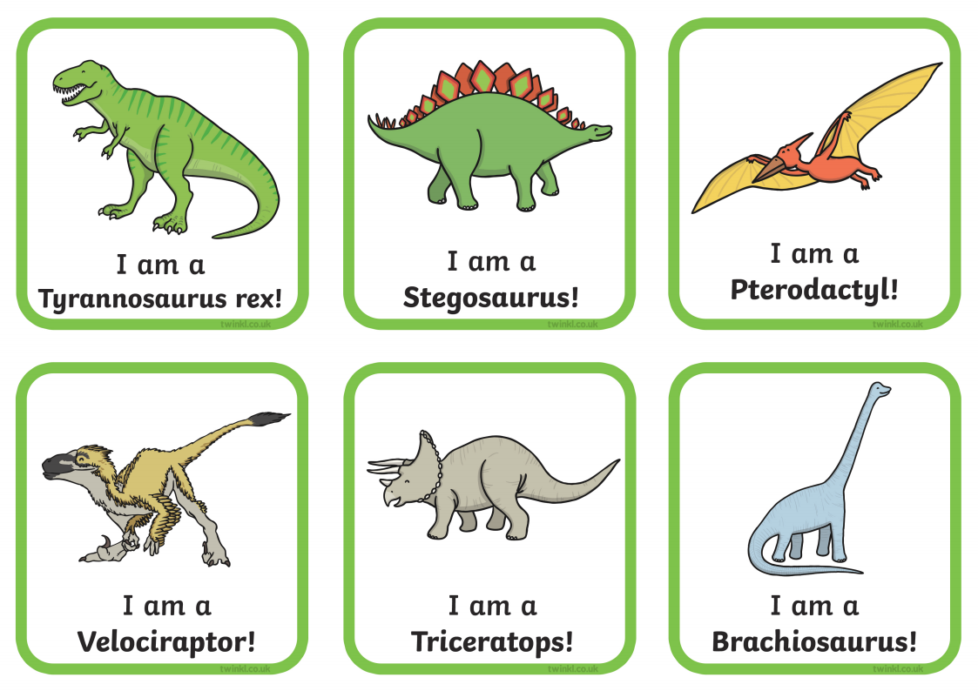

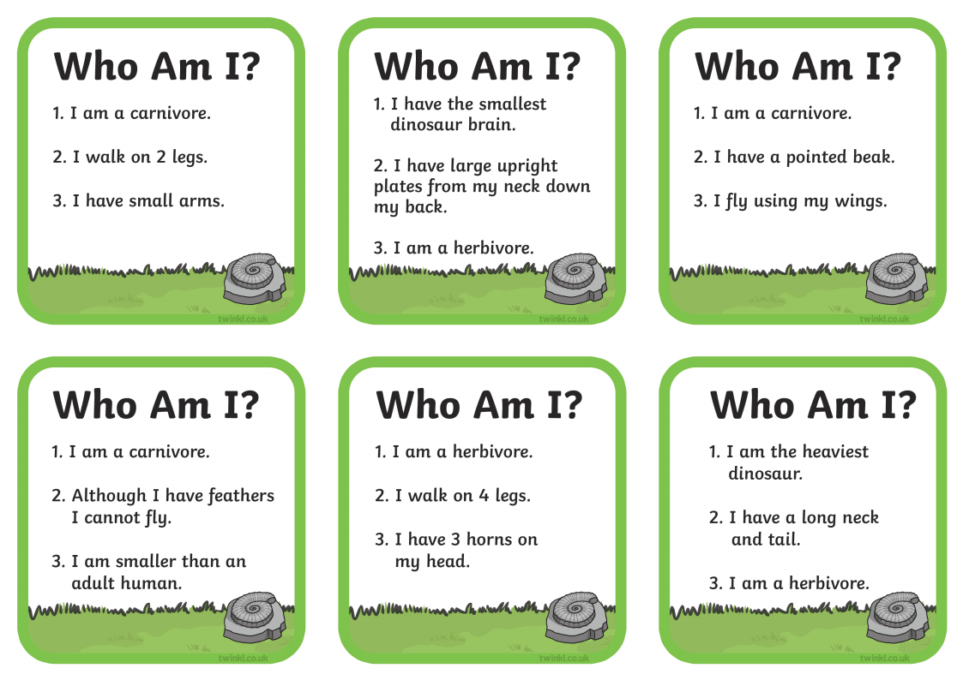
No need to print. These can be used on screen.

Why not set up a Dinosaur trail.
Adapt ‘We’re going on a Bear hunt’ (words available on You tube) to ‘We’re going on a Dinosaur Hunt’
You could make some Dinosaur footprints using chalk or paper (even add on some numbers or alphabet sounds)
At the end of the trail you could have some toy Dinosaurs or follow the recipe below to make some fossils or eggs. Or anything you can adapt.
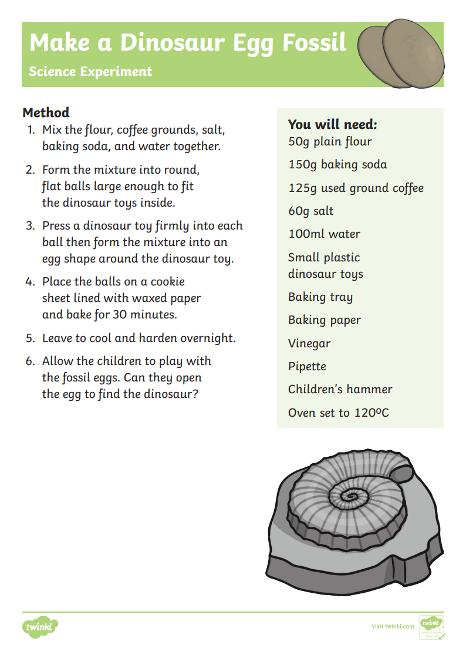

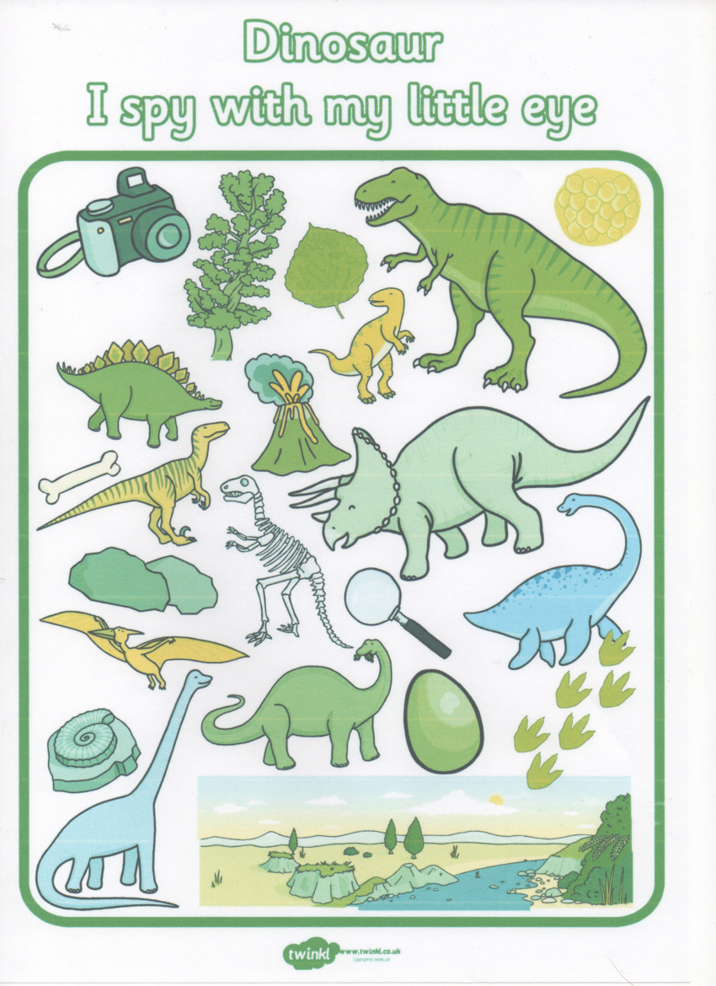
How about a game of eye spy?
No need to print this can be used on screen.

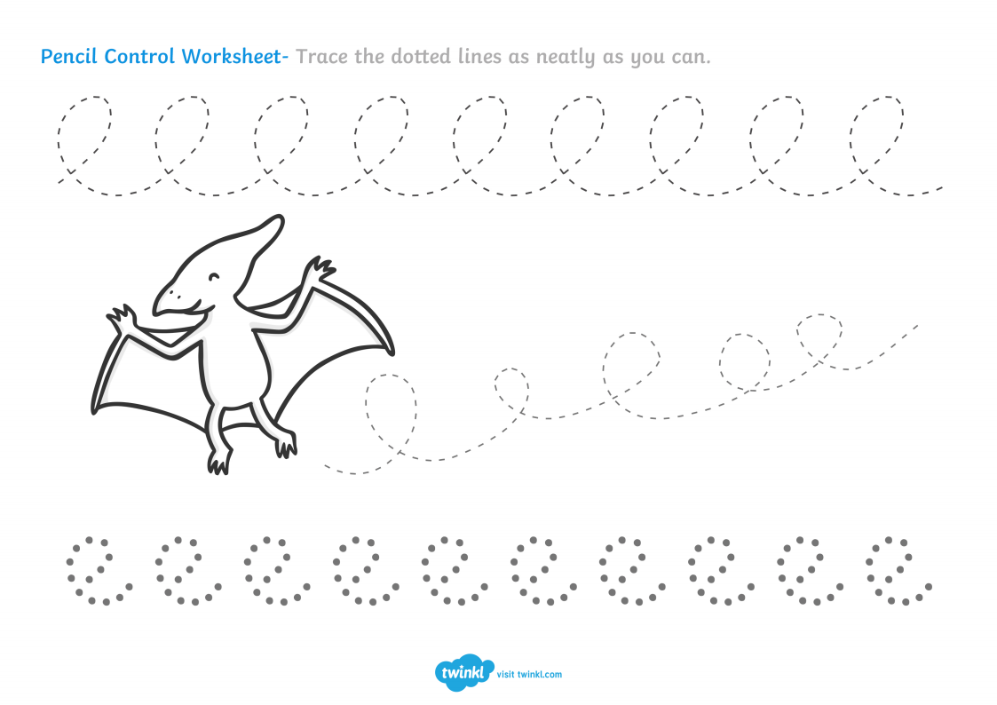
Below are some pencil tracks for your child to practice their pencil control. If you don’t have access to a printer you could make something similar yourself. You could also encourage your child to make these shapes with their fingers in shaving foam, sand, rice, flour. When outside they could use chalks, water pistols, or even paint brushes and water now that the weather has warmed up.

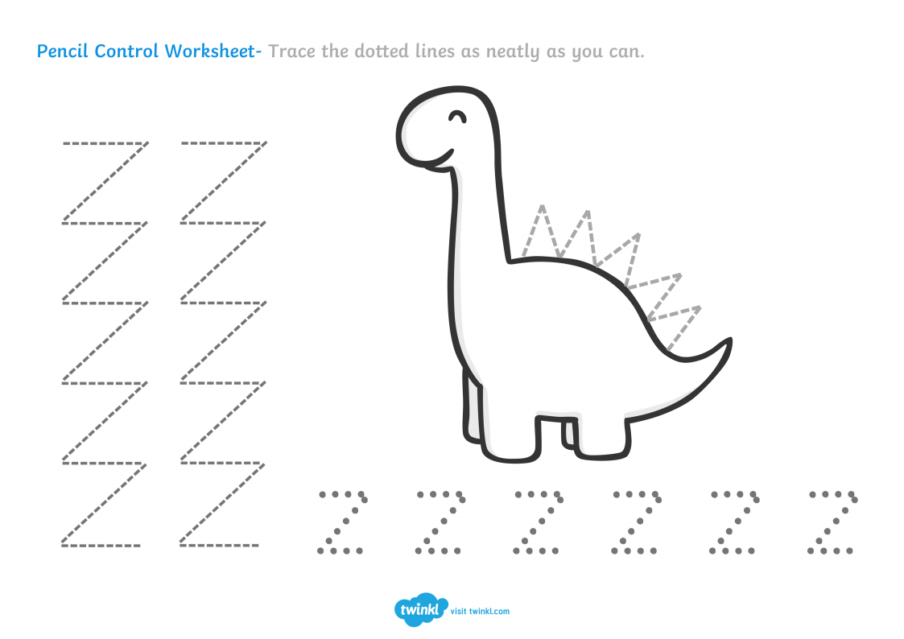
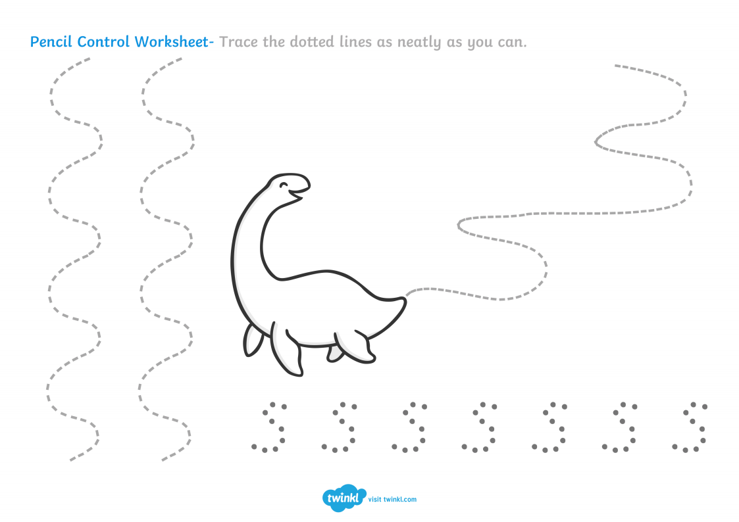

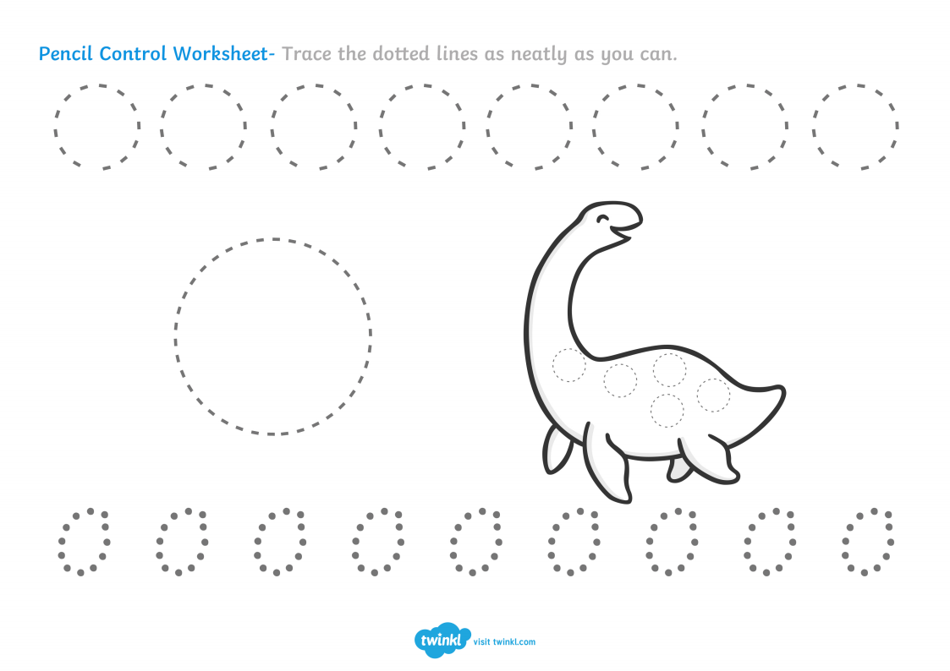
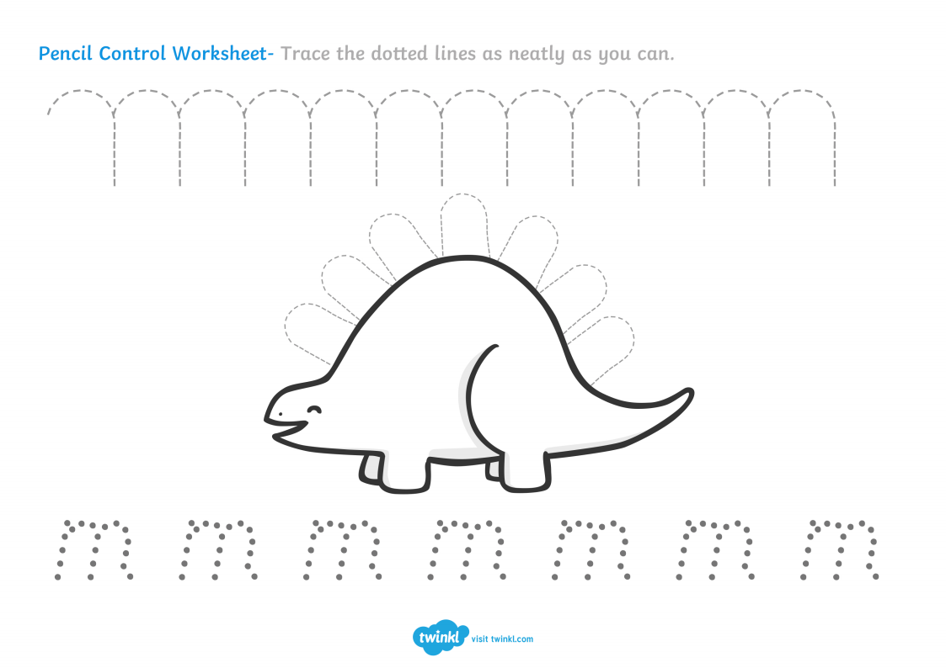

To help with number recognition you could either print these out and cut them into cards, then ask your child to use a clothes peg (you could write numbers on these)to match the right number to the dinosaur picture/s. Or if you haven’t got access to a printer just ask your child to point to the correct number. Encourage you child to touch and count the dinosaurs.
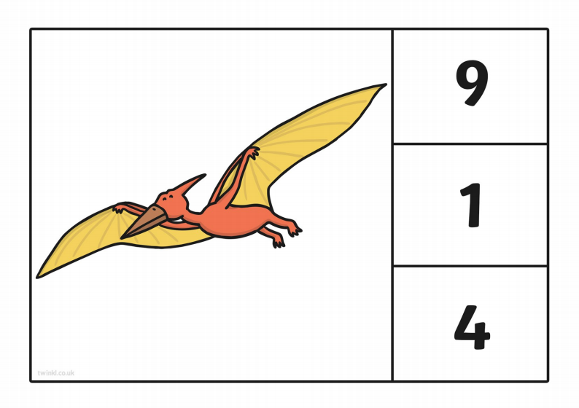
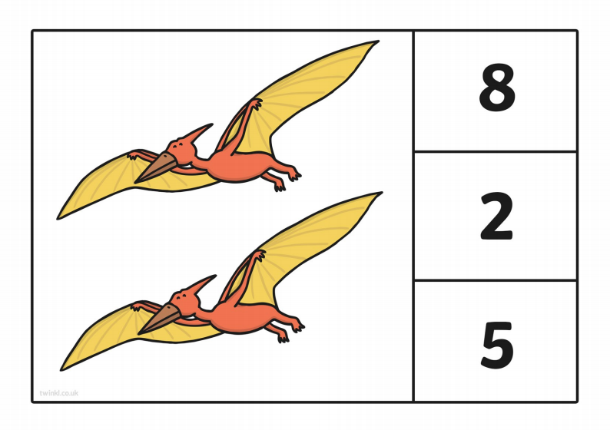

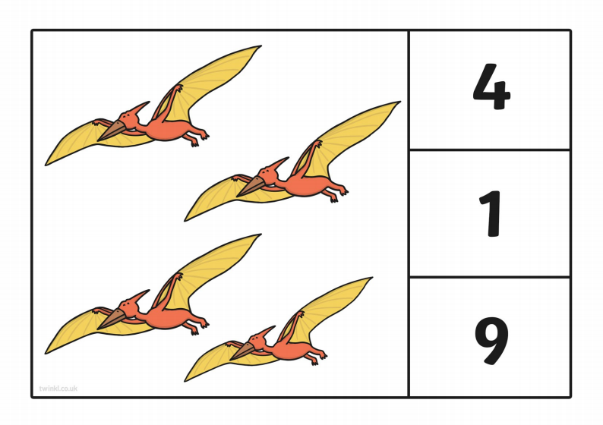
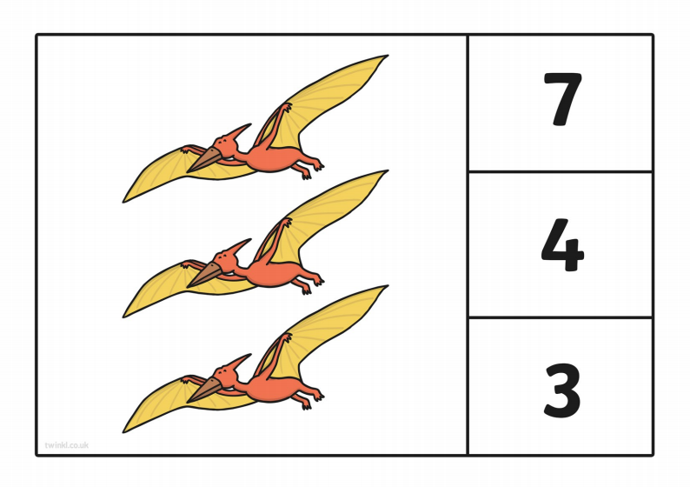

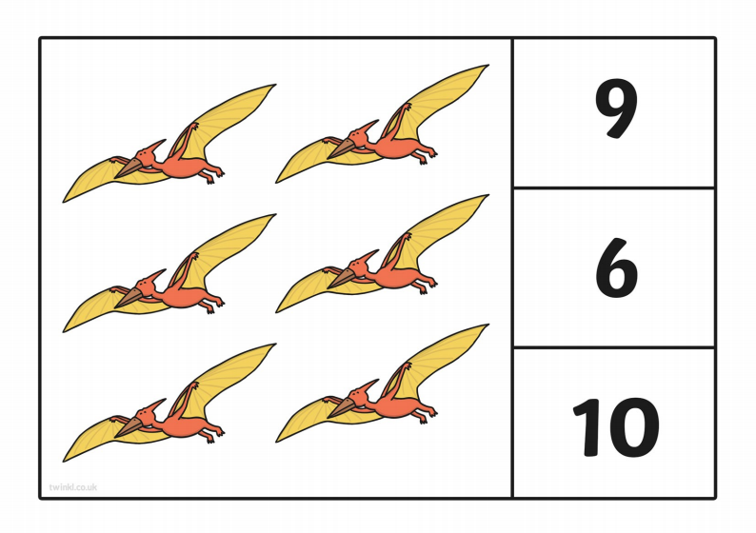
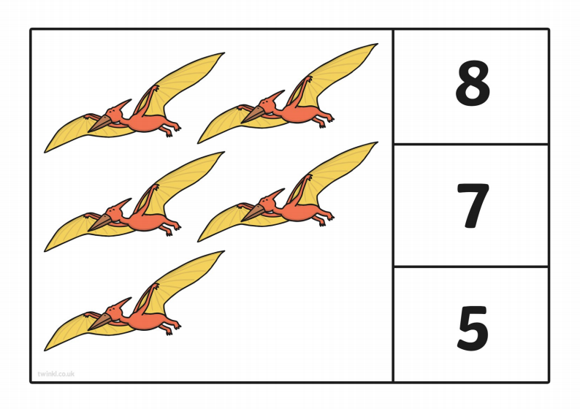

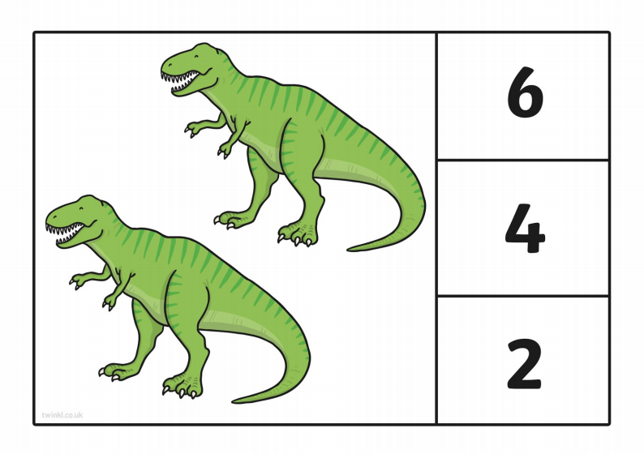
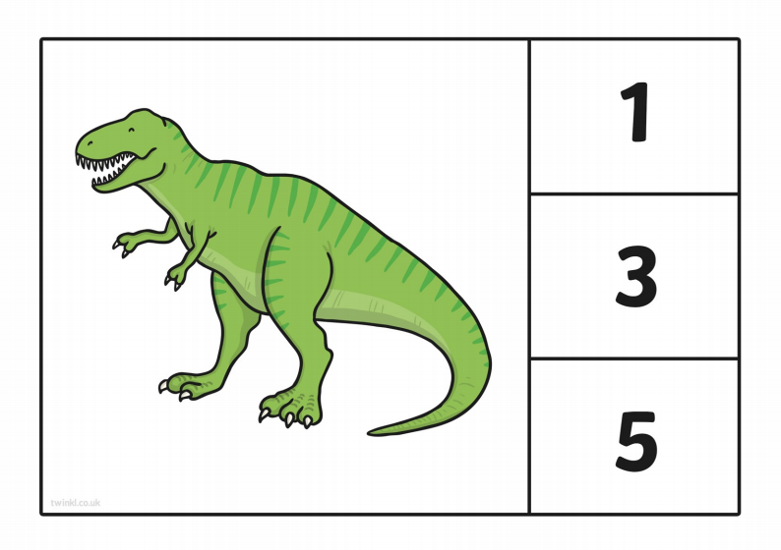

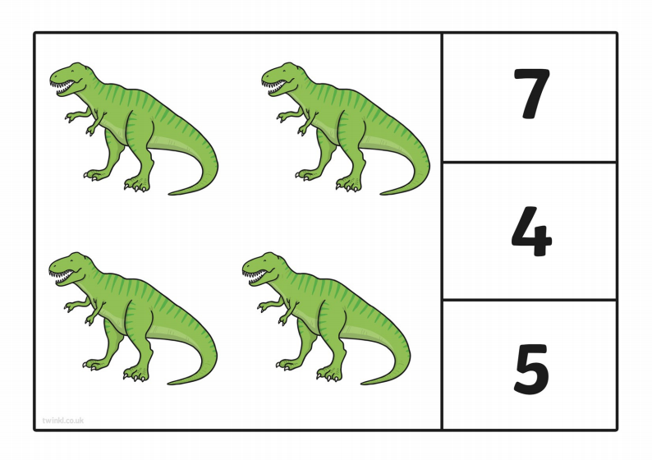
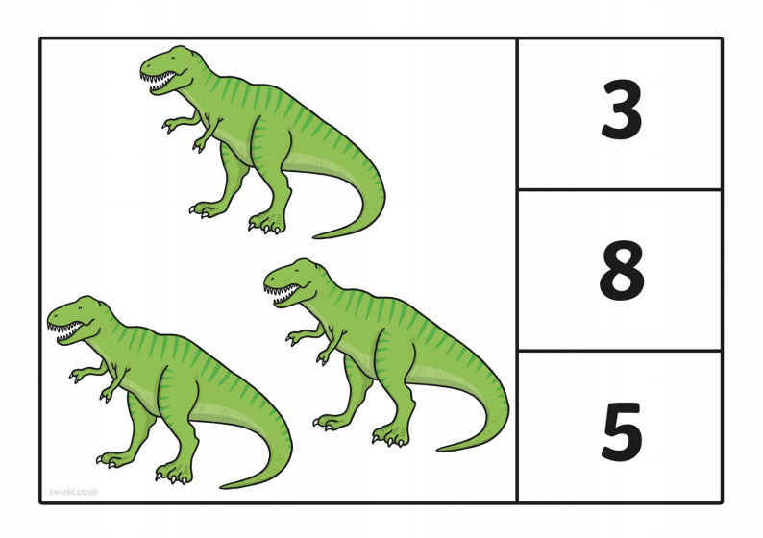
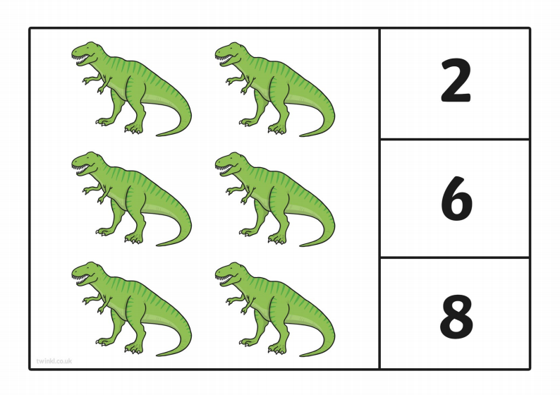
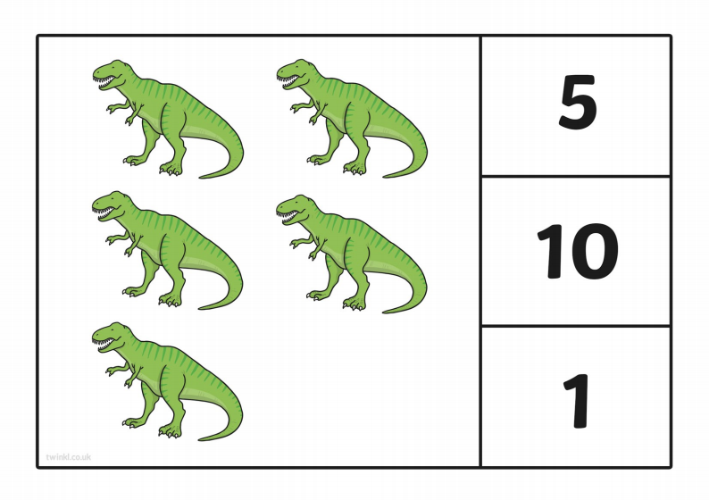

Why not take this opportunity to share some stories with your child.
Our focus book is ‘Dinosaur Roar’ by Paul and Henrietta Stickland. This book will continue to help your child to identify rhyming words as well as introducing them to the concept of opposites.
You can find videos of this story on You Tube. The book is also available to buy on ebay and amazon.
If you have any other good Dinosaur stories please could you share them on our School twitter site for your child’s friends to see. @Williamstownrec.

You could also use this opportunity to create some junk model Dinosaurs using your recyclable waste. Some fantastic ideas available on Pinterest.
It would be fantastic to see these shared on twitter.

If you are stuck for ideas to keep your child entertained You may find these links useful for information and online games
Dinosaur discovery game on bbc bitesize
https://www.bbc.co.uk/bitesize/topics/zdp4382/articles/znc3y9q

Feed the dinosaurs on scholastics website ctrl & Click the link below or copy and paste
https://d3ddkgxe55ca6c.cloudfront.net/assets/t1267519604/a/c2/48/feed-dinos-v1-523953.swf
https://www.twinkl.co.uk/.../early-years-dinosaurs-activities

For a fun and Physical activity why not teach your child this Dinosaur dance on You Tube
CBeebies: Boogie Beebies - Do The Dino!

Above all please have fun and stay safe. Hopefully we will see you soon
Mrs Edwards xx

