Please remember there is no need to print out any of these activities they can be completed in your child’s Busy Book or on paper.
Summer Term- Tymor yr Haf
Year 1- Mrs Thomas.
Home Learning – Week 1, Monday 20th April.
Theme – A Walk on the Wild Side.

As part of this theme we will focus on an animal or flower each week and trying to learn a little about it.
This week we will be looking at frogs. What do you know about frogs?
Suggested Book Bank
These books would be useful to enhance our learning this week. Look for them being read on Youtube or visit libraries.wales/my-digital library for an e copy of the title (link on Twitter).
Story Books (Fiction)
The Trouble with Tadpoles by Sam Godwin
The Teeny Weeny Tadpole by Sheridan Cain
Look out for the Big Bad Fish! By Seridain Cain
The princess and the frog (traditional)
Information Books (Non Fiction)
Growing Frogs by Vivian French
How Does a Frog Grow – RHS
Tadpoles and Frogs – Usborne.

Youtube –
Amphibians, educational video for kids
Tadpoles to frogs with Ethan Spencer
Lifecycle of a frog - Brittanyard1000

Poems of the Week
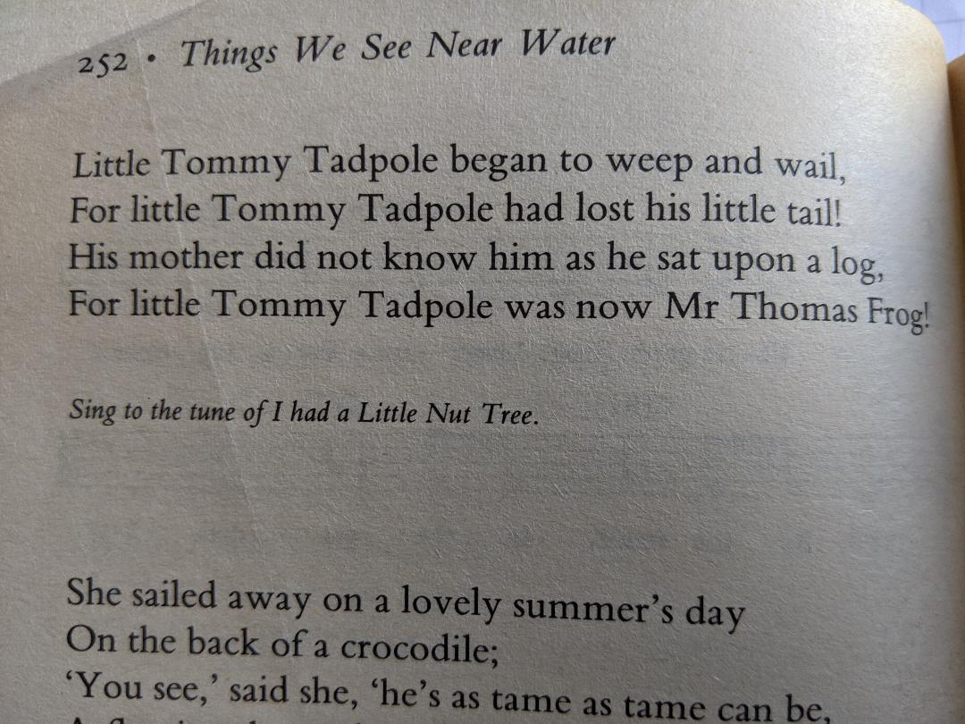
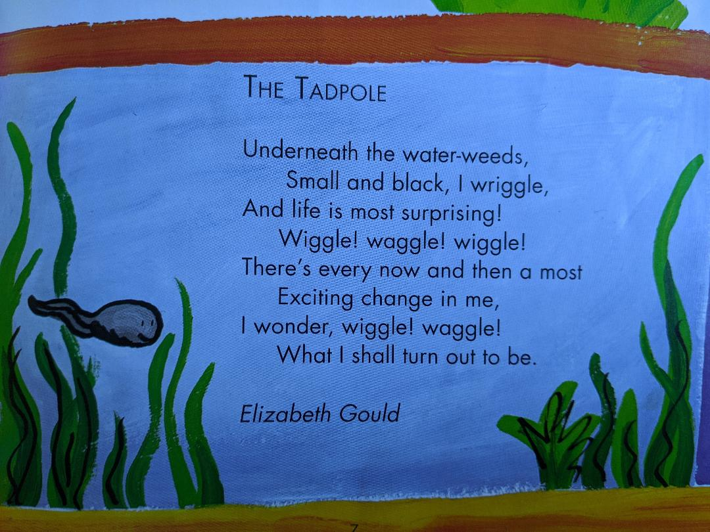

Physical activities to try at home – indoors and outdoors
Cosmic yoga kids adventure – Frank the frog (Youtube)
Try frog jumps across an imaginary pond on the Imaginary Lily pads. How many jumps
Ball work – bounce +catch (standing on the spot / walking ) Challenge can you bounce, clap and catch? What’s your score without missing a catch? Can you improve your score?

Creative
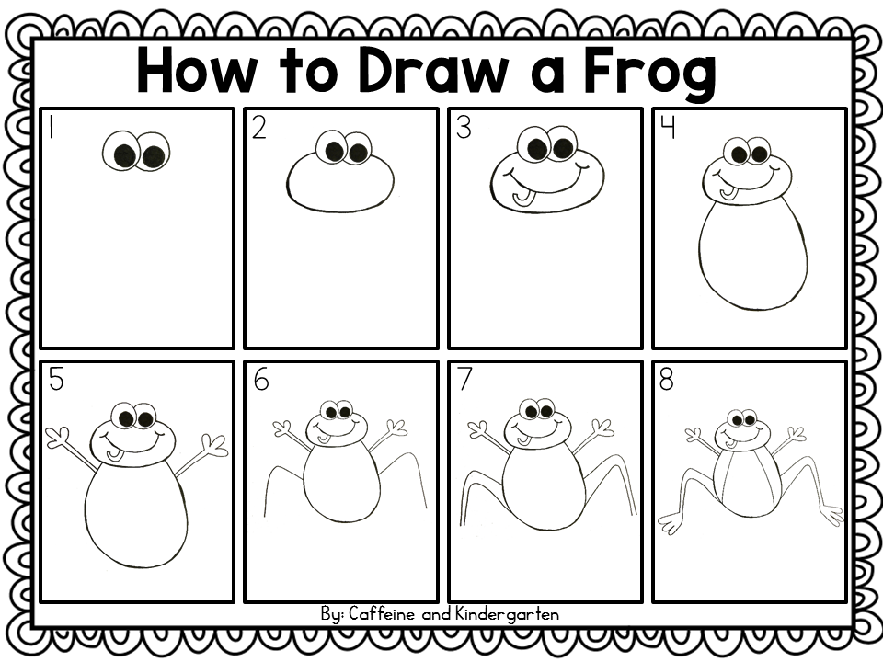
Can you draw a frog? Where does your frog live? Does he have any frog friends? What colour is / are your frogs? What are your frog’s names? Are all your frogs the same size?
Look at Youtube – How to draw a frog! Easy Drawings for kids - for more ideas and tips.
You could draw your frogs outside with chalk too!
Music – Listen (watch) Paul McCartney and the Frog chorus on Youtube. Can you keep the steady beat with the frogs? What instruments can you hear? Are they loud or quiet? Fast or slow? What did you think about the music? Why? (its ok not to like something, as long as you give a reason!)
Welsh
The welsh word for frog is Bili Broga –
Our focus questions are Wyt ti’n hoffi Bili Broga? Do you like frogs?
A – Ydw , dwi’n hoffi Bili Broga (yes, I like frogs) or Nag ydw, dydw i ddim yn hoffi Bili Broga!
You could use this question with lots of other animals too- here’s some we know
Pry copyn – spider cwdi hw – owl neidr – snake llygoden – mouse.
We know lots of other welsh animal words too for cat, dog, rabbit, pig, hedgehog, bird (plus many others too) I wonder how many they can remember?( www.learn-welsh.net pets)
Bili Broga story – listen to a story about Bili Broga on Facebook ‘Cymraeg I Blant Penfro’

1 2
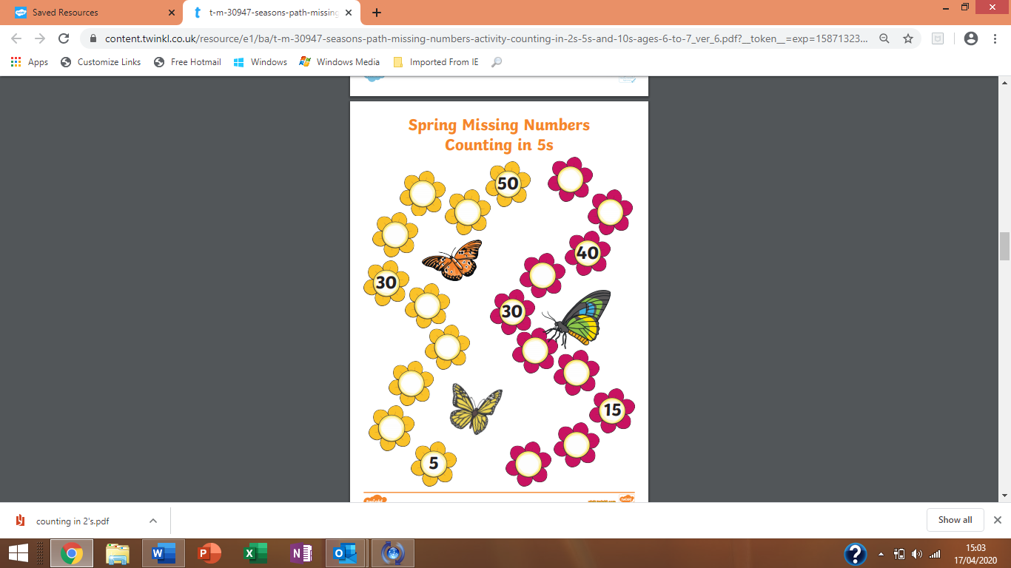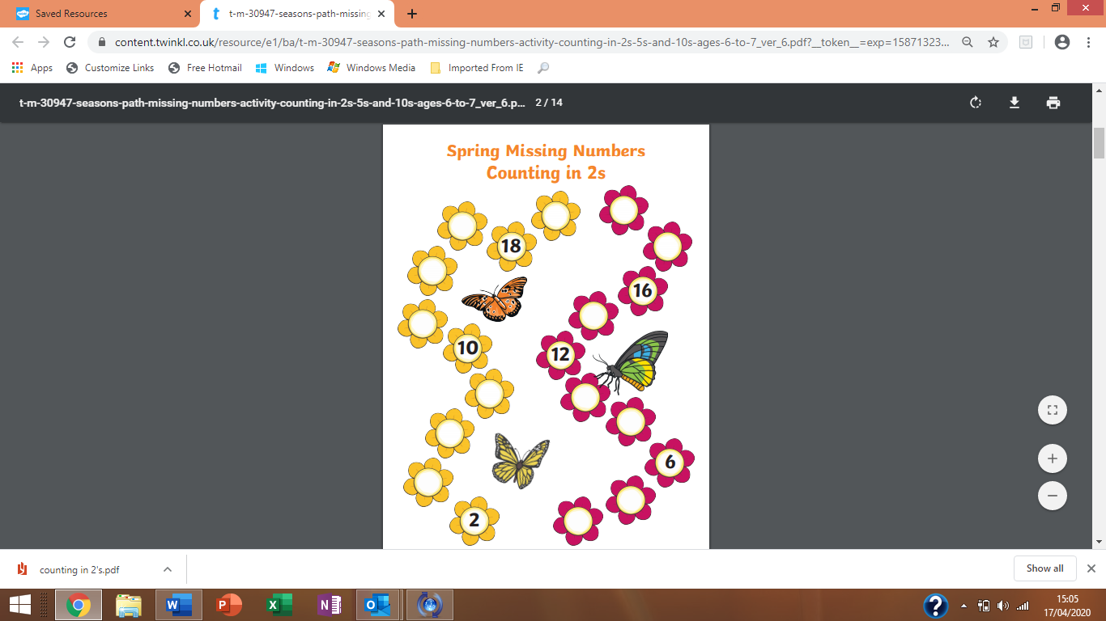
3 4
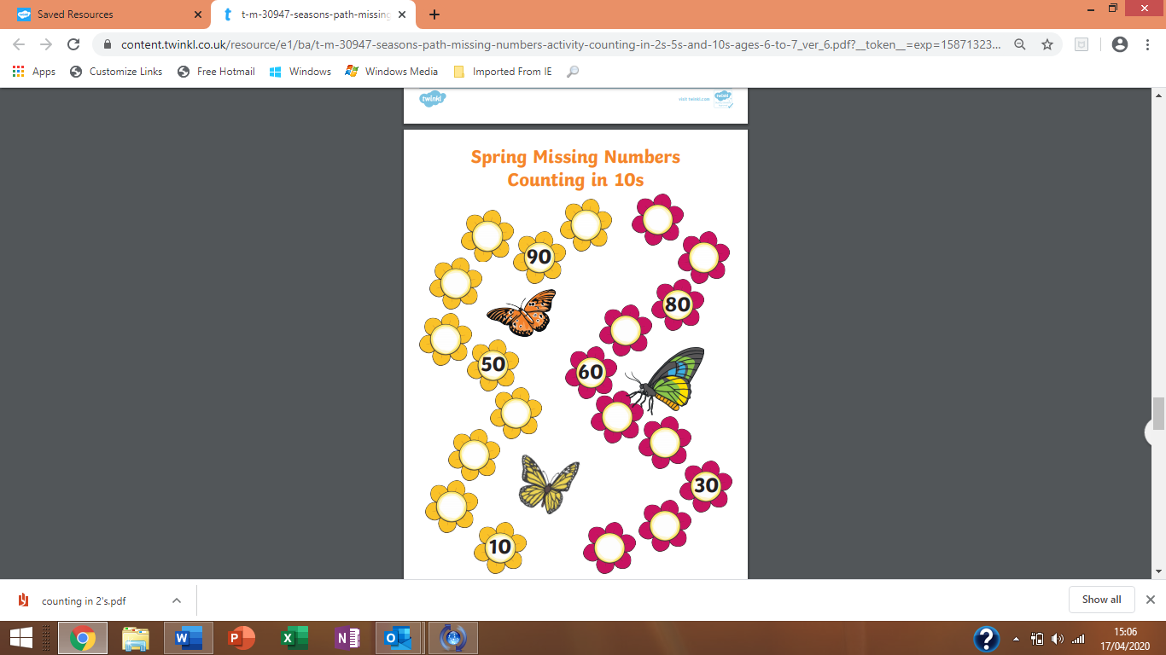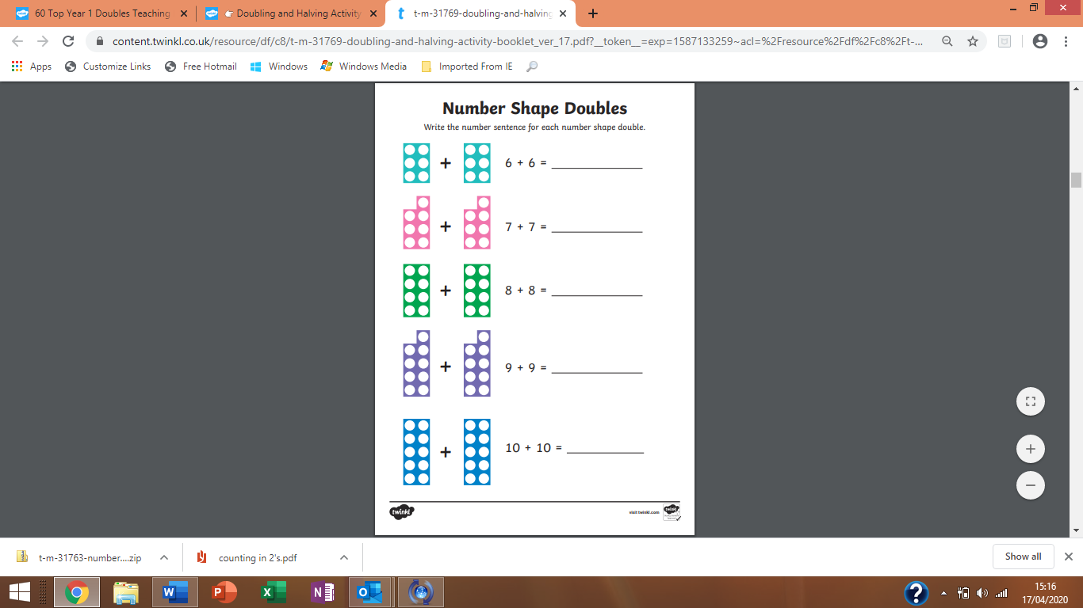
*** there is no need to print this work, simply write the answers in their busy book. You can always create your own challenges based on the above skills!
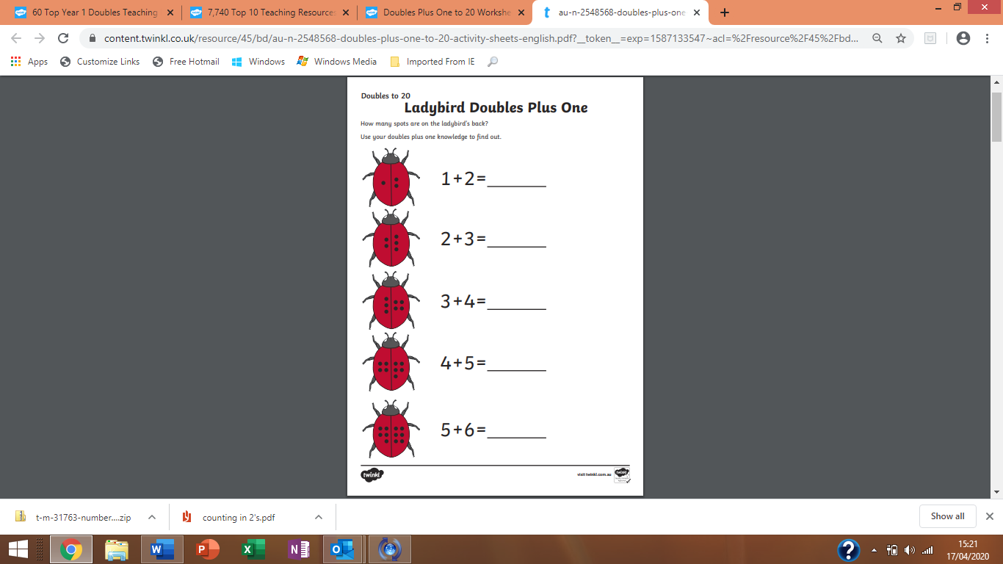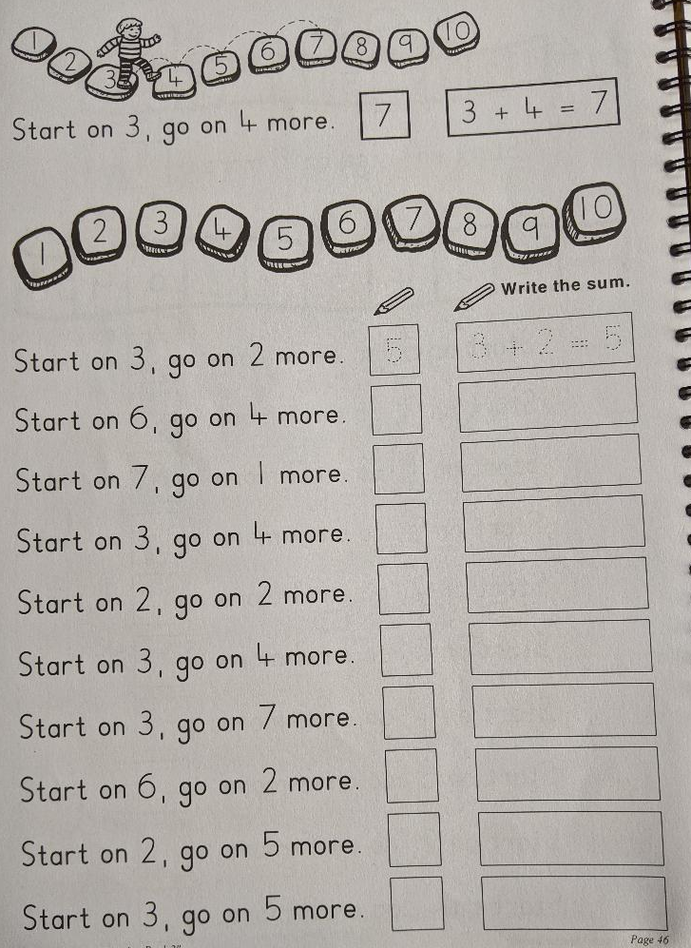
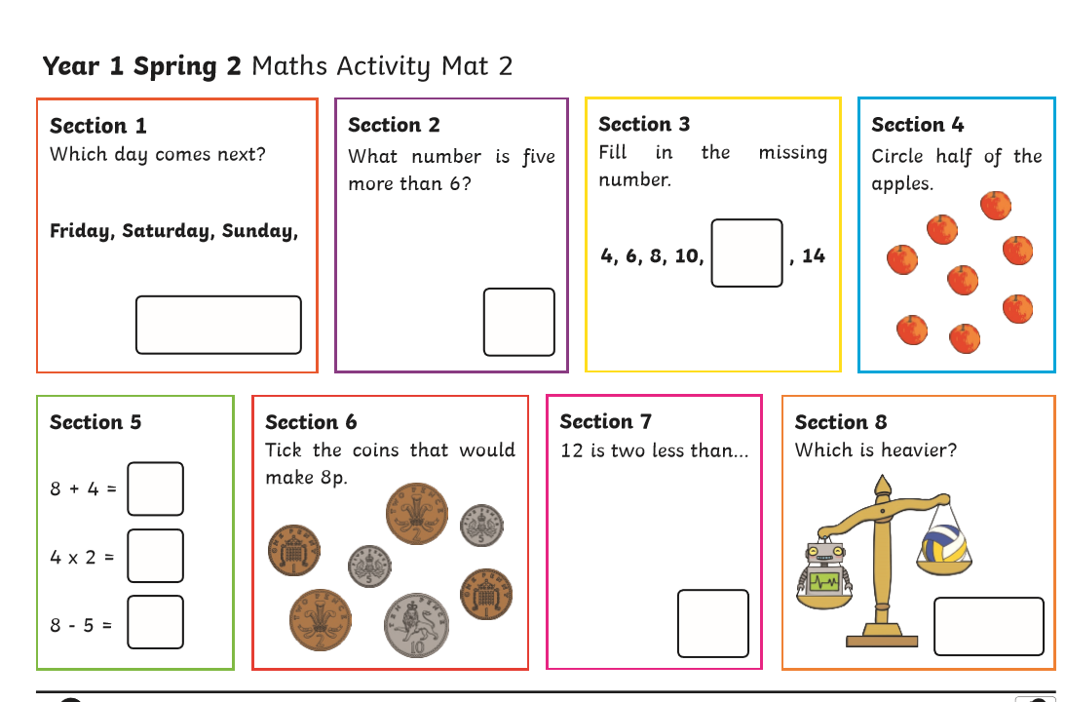
Parents please note - We have not yet introduced the symbol x (times / multiply) in section 5, we would simply say 4 lots of /towers of …

Language
1. Can you copy one of this week’s poems neatly into your book? Think about letter formations, spaces, capital letters, full stops, letters sitting on the line (tails swinging under). Remember to read back your work. (Note to parents – pupils can copy the poem or as a challenge you can read it and they can write it or the ultimate challenge can they write it from memory ?) don’t forget to read back through your work.
2 .Learn to read high frequency words ( in reading file) – How many can they read in a minute? Choose 5 words to learn how to spell.
3. Our sound of the week is the trigraph ‘igh’. How many words can you think of / find / read / spell with this trigraph in it?
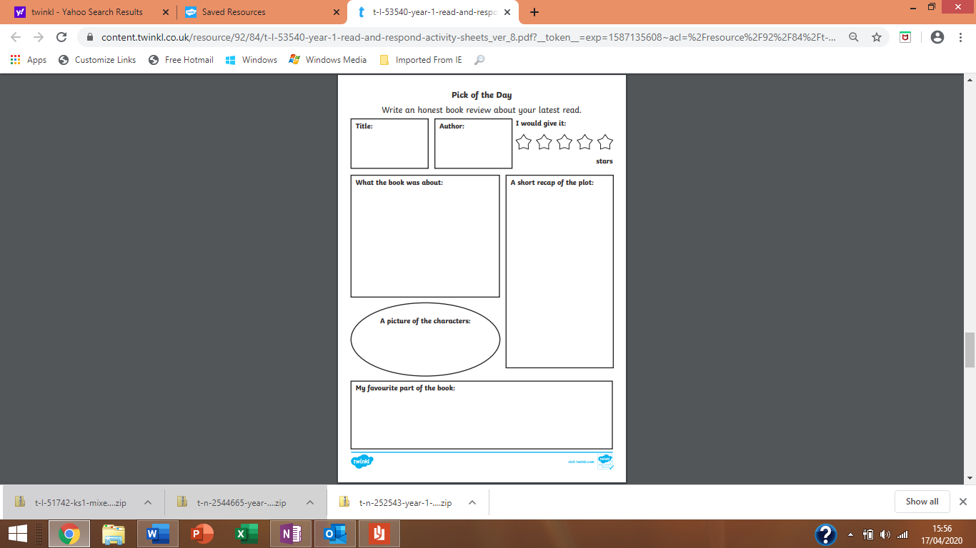
Every week, I’ll be asking pupils to complete a book review. You can create your own or use the format of the one above. Remember to encourage pupils to ask and respond to Who? What? Why? When? and Where? questions about the book that they are reading / sharing with an adult to develop a greater understanding, this will also help with comprehension tasks that will follow later in the term.
Finally, each week this half term you will be challenged to create a fact file about our chosen animal or plant. Therefore, this week our fact file will be about frogs!
A fact file requires information about the animal /plant you are studying. You can follow the format below, create your own style or how about simply folding an A4 sheet of paper in half and creating your own information book?

I’d like you to include –
A drawing - you could label this to extend your learning.
A title – the name in English and Welsh
Some interesting information about your focus of study-
Such as - How many legs does it have? Does it have fur/ scales / skin? Where does it live? What does it eat? How does it move? It’s life cycle. It’s colour. The sound it makes. What’s the most interesting fact you learnt?
Include new vocabulary – this week it could be that really, long word – metamorphosis (can you remember what this means?), froglet, frogspawn, herbivore, amphibian.

Don’t forget if you go out to study tadpoles in the wild you must not take them away from their natural habitat. Look, learn and let them live in their natural environment.
Remember, do a little every day, explorers do not complete their study in one day! Good luck! Keep safe and happy exploring. Love and miss you all,
Mrs Thomas @ teamThomas

Dear Mums and dads,
Don’t panic! I have included a lot of activities this week based on feedback I’ve received during my welfare calls. Please do not feel obligated to complete all the tasks (extra shinnies on our return if you do!) but try and provide your child with a range of experiences to help develop their skills, knowledge and understanding based on our area of research, which this week of course is frogs. Of course, if you find alternative tasks along a similar line please feel free to follow it, it’s the skills, knowledge and understanding that is important. Next week we will be looking at sunflowers – I’ve included a link on our class twitter feed that will provide you with free sunflower seeds if you wish to have a sunflower growing competition at home! Thank you all for your warm welcome when I’ve called. Keep safe. Take care , Mrs Thomas
Example of a fact file format you could use.


