Williamstown Primary

Home School Learning Pack Year 3 W-C 20/4/20

Literacy, Numeracy and Topic.
Please continue to record books that the children are reading at home in their reading records.

Useful Websites
TWINKL- free code 1 month = PARENTSTWINKLHELPS
BBC BITESIZE TOPMARKS- Hit the button
SCHOLASTIC HWB

Story Starter!
Can you complete this story starter using capital letters, full stops, wow words and adjectives.
The Adventure
The school holidays were here. Sophie and Jack were excited, they had lots of fun planned with their friends. However, this was not a normal holiday, it was an adventure. The biggest, greatest adventure they had ever been on. ‘’Come on, time for bed” said Mum. As the rest of the world drifted off to sleep, Sophie and Jack were wide awake, they were ready for the mission to start…

Book Review
Remember to continue reading books and recording them in your reading record whilst at home. As a challenge, write a book review on your favourite book! Remember to include:
Author Fiction or Non Fiction
Title What is the book about?
What was your favourite part? Is it a good book and why?
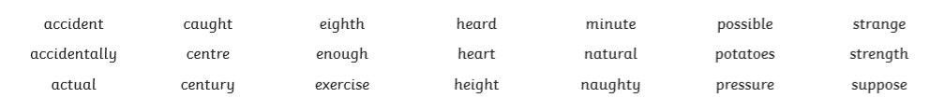
Continue to practise your spellings at home. Here are some new spellings to practise. You can also practise them with a friend! Use each spelling in a sentence when you have practised them all.

Season Mind Map

We are now in the Spring season. Can you research spring and make a mind map/ spider diagram of all the things you can find that relate to spring!

How is Spring different to other seasons that we have?
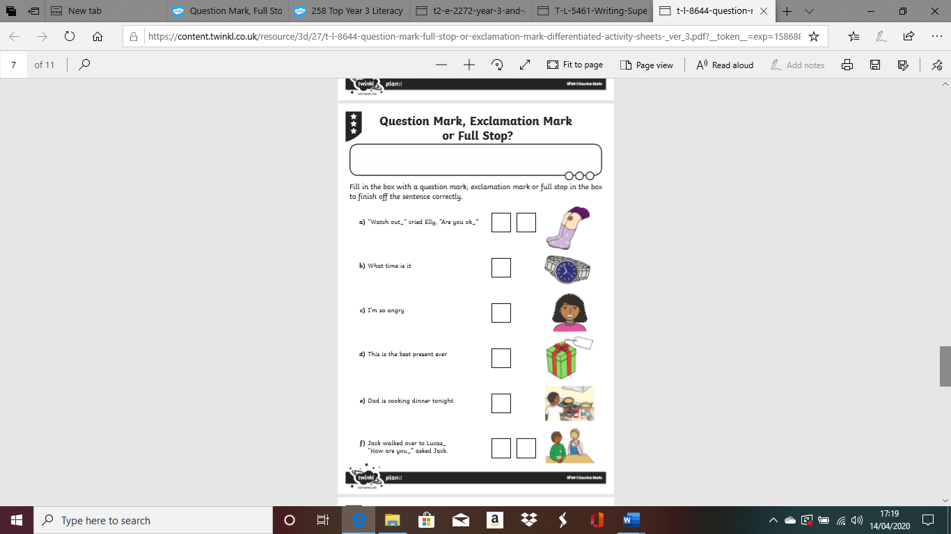
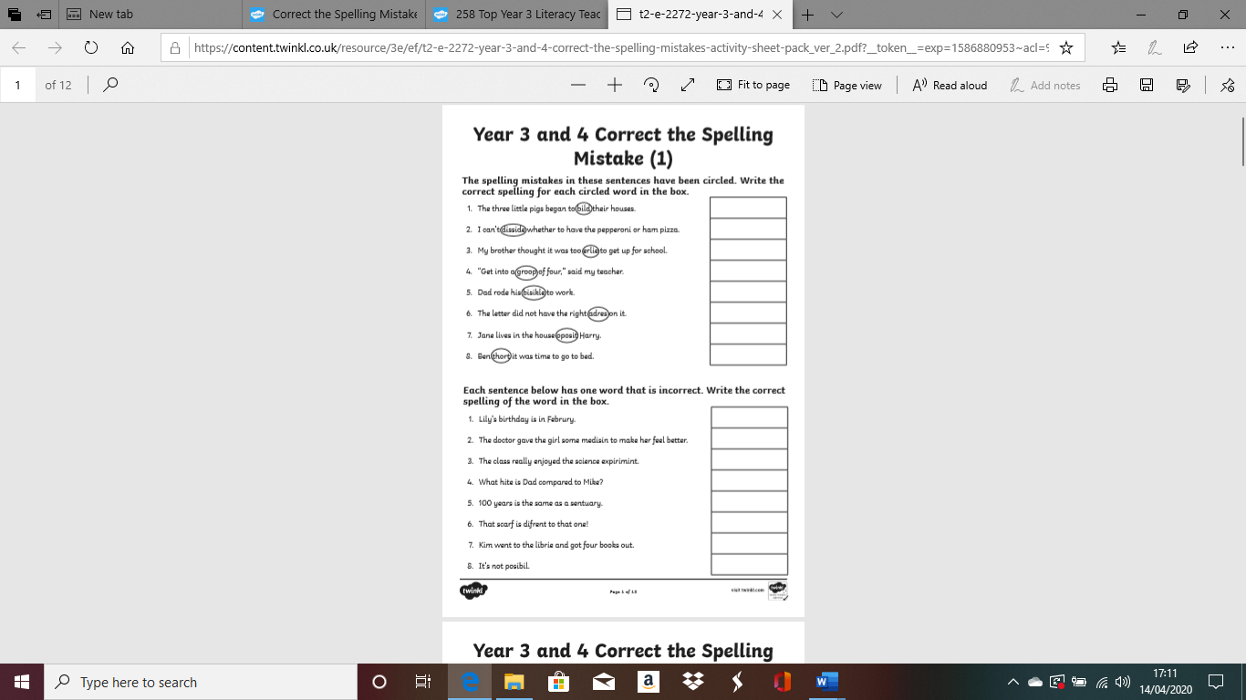
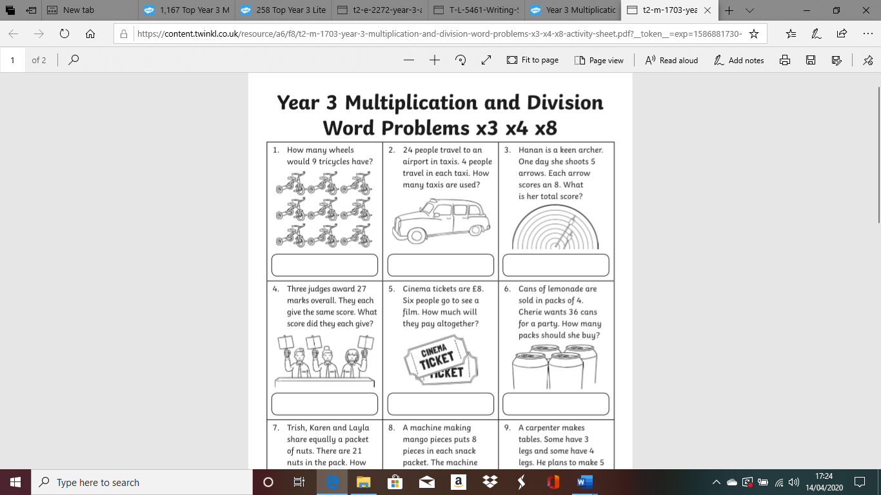
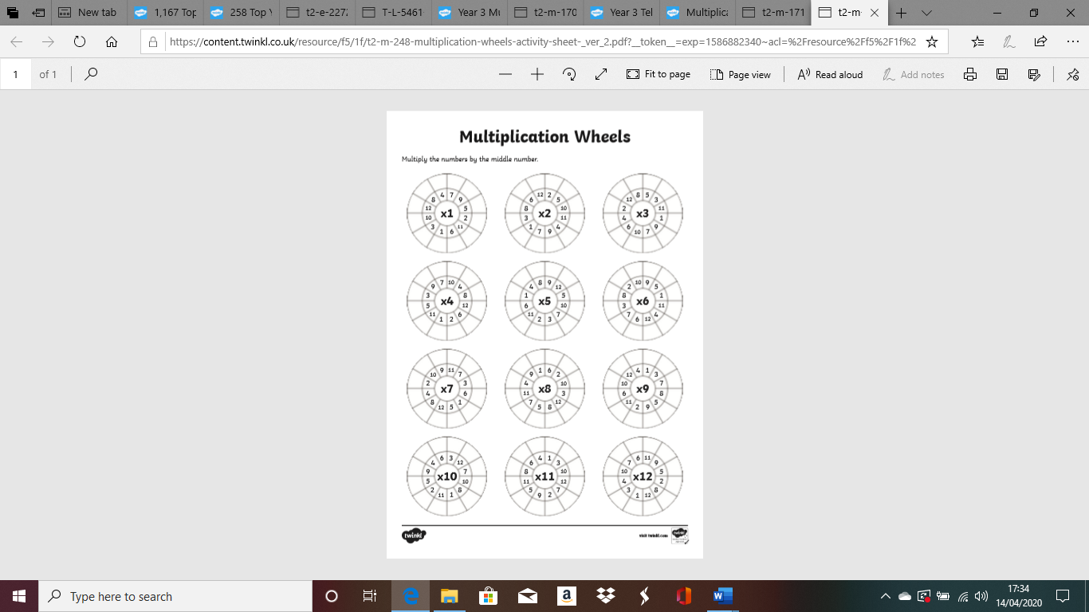
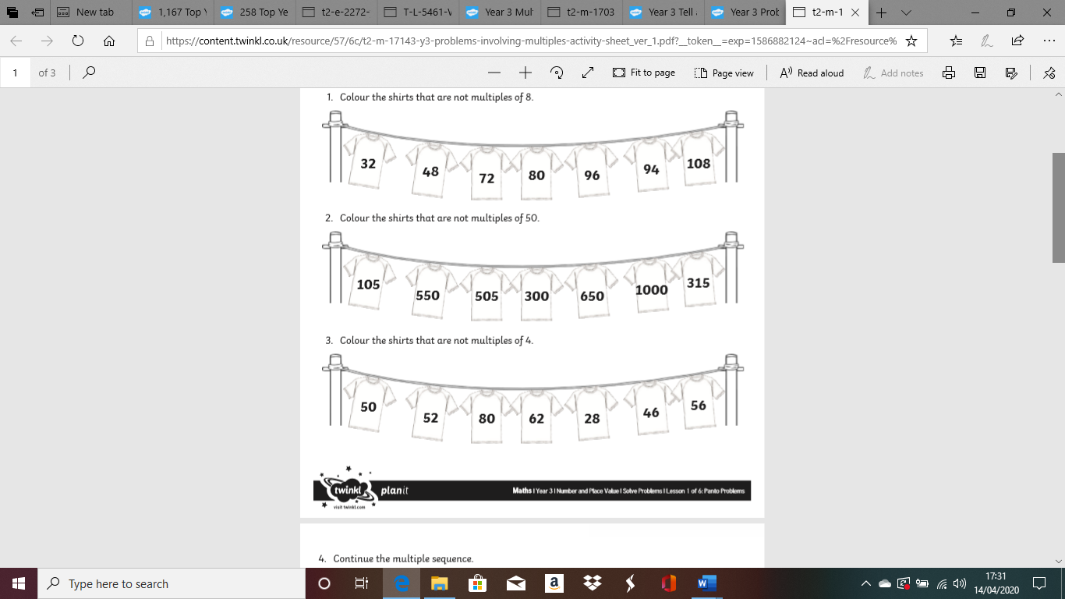
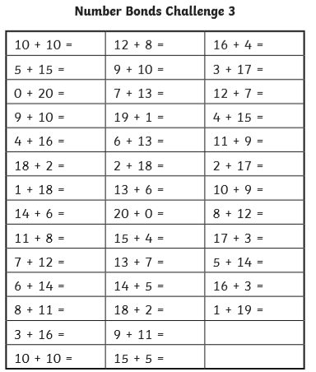
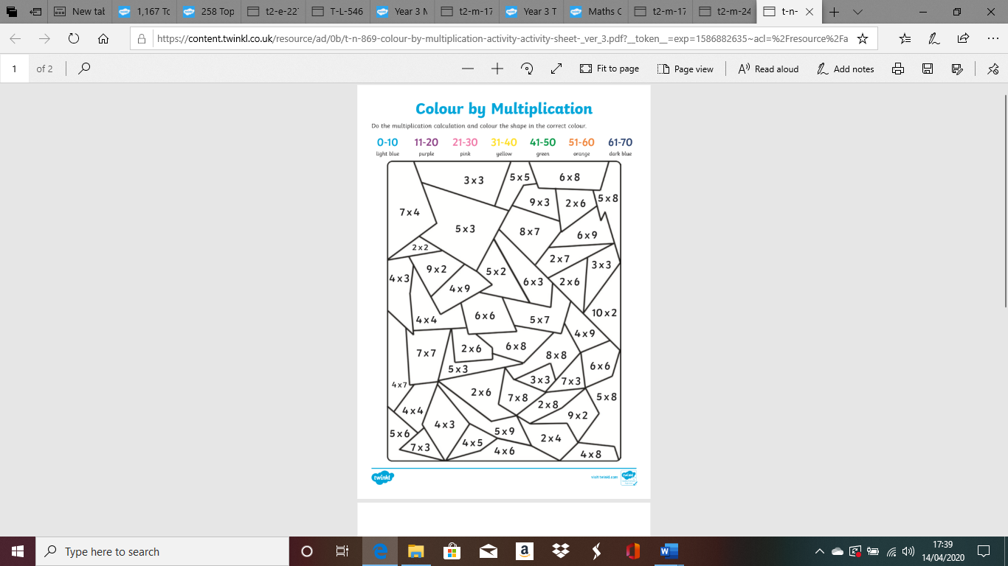
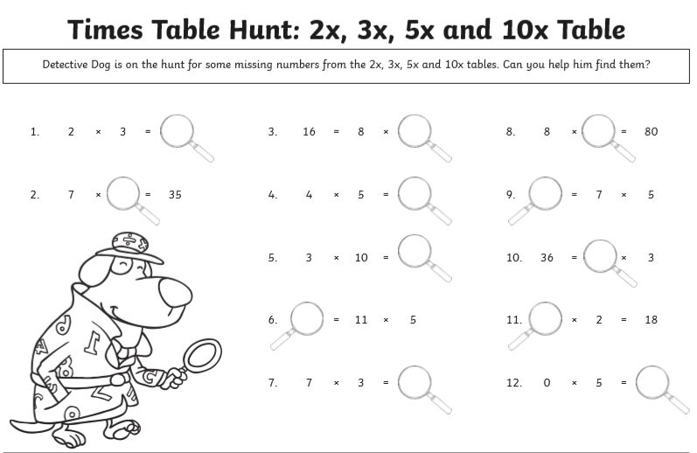
Staying Healthy!
It’s really important to stay healthy and look after ourselves, especially now whilst we are at home.

Can you research different ways how we can stay healthy and write your ideas down? You might want to write a list, record your ideas in a table or create a mind map or poster!

