School Closure Home Learning Pack Week three
Miss Kear & Miss Thomas’ Year 6
Hello everyone!
Hope you are all well and enjoying being at home. Are you doing your work in your P.J’s? Finished all your Easter eggs? I didn’t have any because as you all know I don’t like chocolate! Ha ha. Remember if you are in Miss Densley’s or Mr Stagg’s Maths class you can also complete the Maths work in their packs (on the website under year 5).
In this pack we have included-
Maths:
- Mental Math test
- Problem solving – you need to look for the pattern.
- Emoji Code breaking activity
- Multiplication board game
- Coordinates in four quadrants
Literacy:
- A comprehension on Ancient Egypt.
- Work on collective nouns
- Work on idioms
- Biography. Earlier in the year you all wrote your autobiography. Now its time to so some research on a famous person of your choice to write a biography for them. Use the sheet to help you. You can include photos, pictures, drawings etc. Think of someone you know a lot about or are interested in. (popstar, sportsperson, author, scientist etc)
- Please keep up your reading!
ICT:
Using formulas in Excel. There is a link to YouTube to help you and the spreadsheet for this work has been uploaded to the school website. If you haven’t got Excel on your computer, you can use it through HWB and Office 365.
Science:
I’ve noticed on twitter that some of you have been busy making rainbows for the NHS! This science experiment is called ‘Grow your own rainbow’. If you are unable to do this, don’t worry!
If you would like to tweet us, our twitter account is @williamstown5_6. Keep up the hard work.
Miss Thomas and Miss Kear
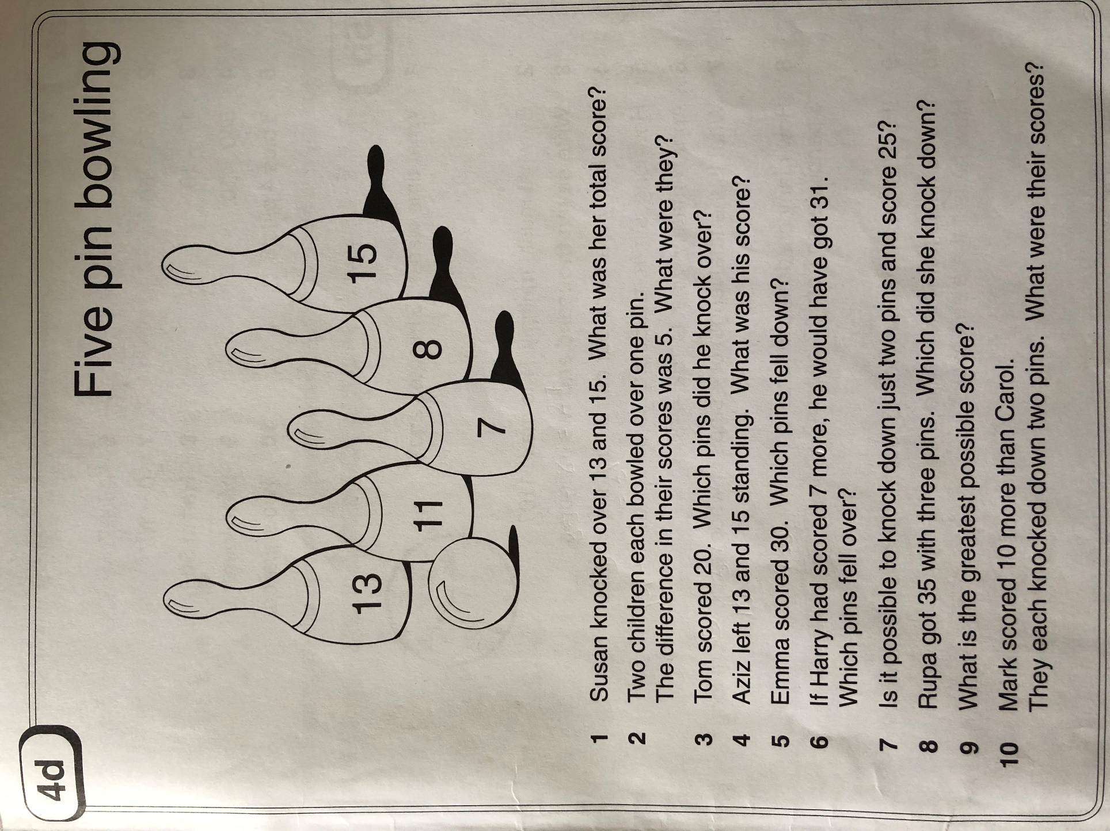
Mental Maths Test.

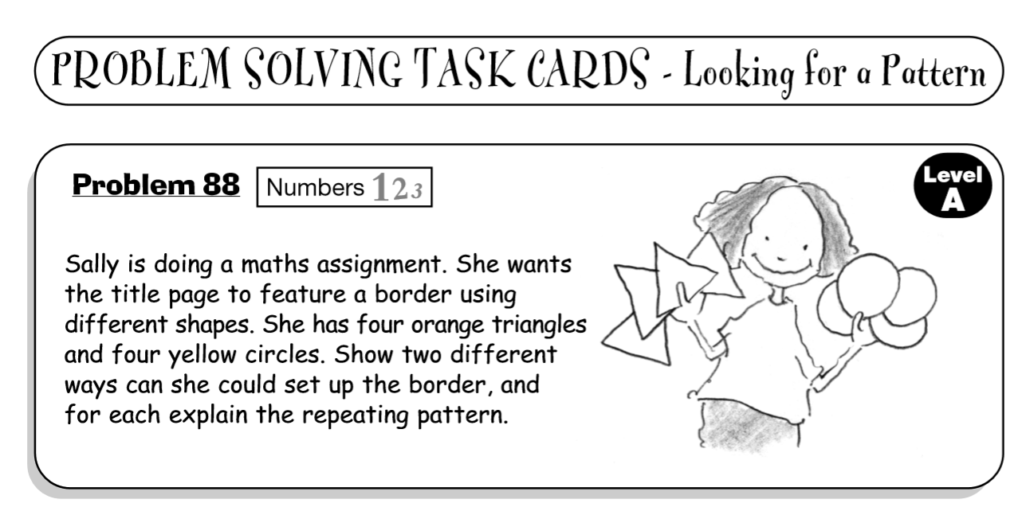

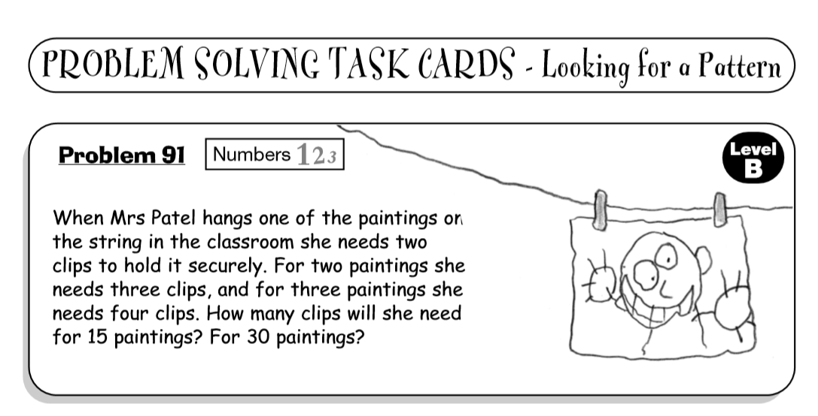

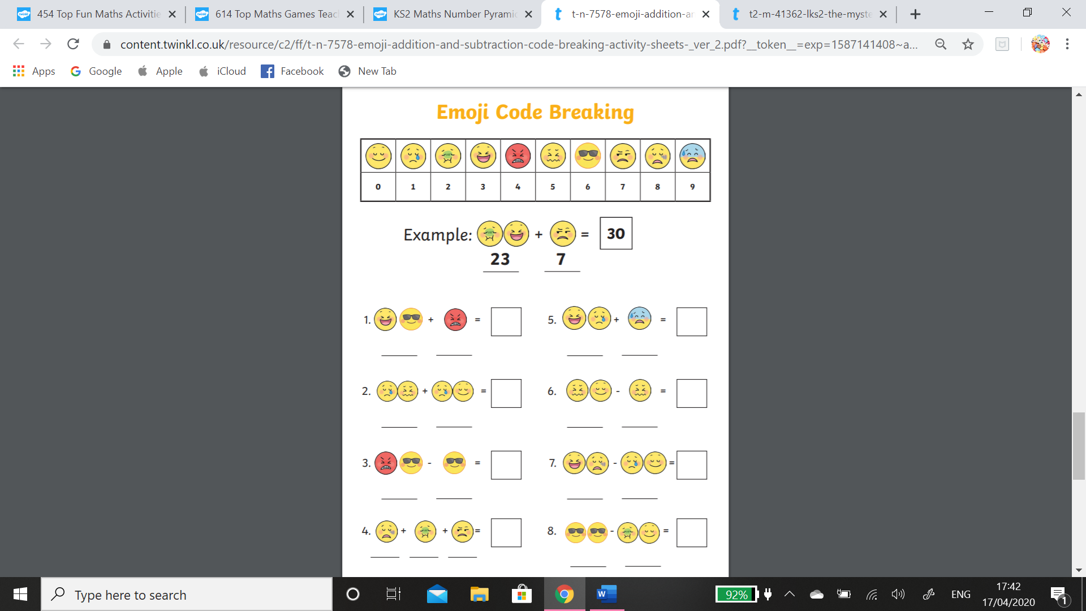

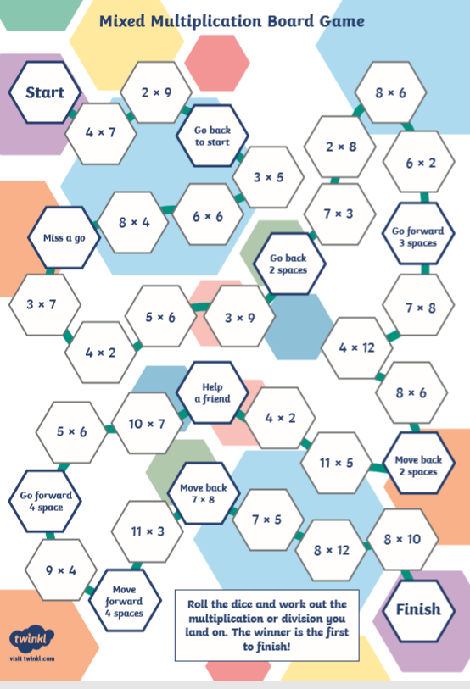
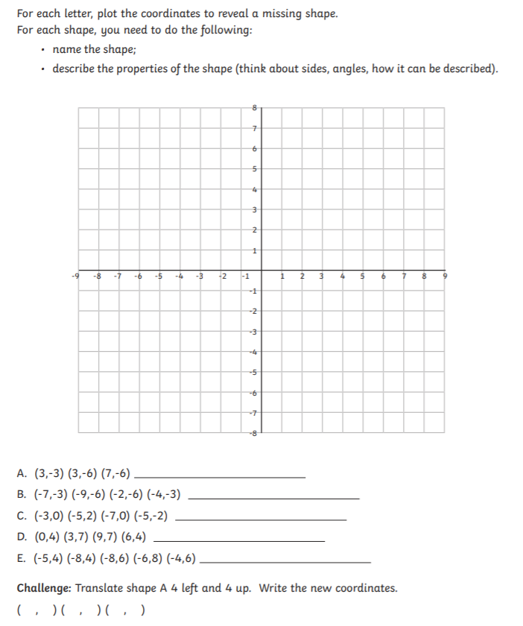
Remember the saying ‘Along the corridor and up the stairs’ when plotting the coordinates.
Ancient Egypt Comprehension task
The ancient Egyptian civilisation began more than 5000 years ago and lasted longer than any other in human history. Around the year 3100 BCE, King Narmer united the two kingdoms of Upper Egypt and Lower Egypt. In paintings from that time and thereafter, pharaohs were shown wearing a double crown, red for Upper Egypt and white for Lower Egypt.
Due to its closeness to the Mediterranean Sea, the lands around Lower Egypt (in the north) were rich and fertile. It was a great location for trade and for controlling the River Nile. On the other hand, Upper Egypt had only a narrow strip of land to cultivate and the rest of the country was a dry desert.
Upper Egypt bordered the land of Nubia to the south. Nubia was a source of rare wild animals, gold, animal skins and slaves. The kings of Egypt often traded with Nubia and sometimes fought wars with it too.
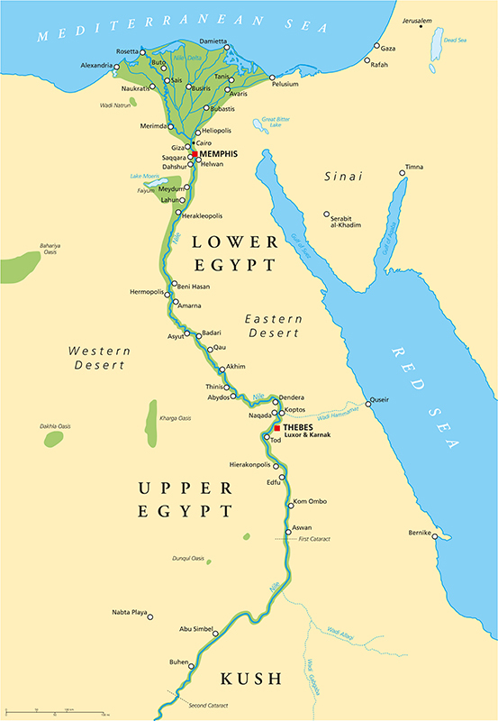
Map of Ancient Egypt
When the two kingdoms of Egypt were united, King Narmer and his successors ruled Egypt for 30 dynasties (or families) of kings and queens. These rulers were often called pharaohs. Pharaohs were the most powerful people in Egypt. Each pharaoh had two titles: ‘Lord of the Two Lands’ and ‘High Priest of Every Temple’. The pharaoh owned all the land, made the laws, collected taxes and defended Egypt against foreign invaders.
The pharaohs were almost all men, however, several women did rule Egypt. Hatshepsut was the fifth pharaoh of the eighteenth dynasty of Egypt; she came to the throne in 1478 BCE. She is thought (by Egyptologists) to have been one of the most successful pharaohs. Her reign lasted longer than that of any other woman of an ancient Egyptian dynasty.
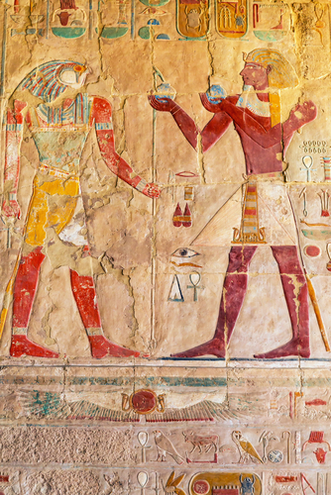
Relief on the wall of Queen Hatshepsut Temple in Egypt
Ancient Egypt was one of the most progressive civilisations in the world; women had more rights in Egypt than in other cultures of the time. Egyptian people believed that happiness and joy were goals in life. As part of that, they also believed that family and home were important. Women were equal to men in contributing to business and had equal rights to sign contracts, own property, act as witnesses in court or even start divorce proceedings.
The last pharaoh of Egypt was a woman named Cleopatra VII. She was the daughter of Ptolemy XII and came to power in 51 BCE when she was about 17 years old. Cleopatra VII ruled Egypt until 30 BCE and then the country fell to the Roman Empire and Egypt became a Roman province. Cleopatra committed suicide on August 12th, 30 BCE. According to tradition, she killed herself by letting an asp (Egyptian cobra) bite her.
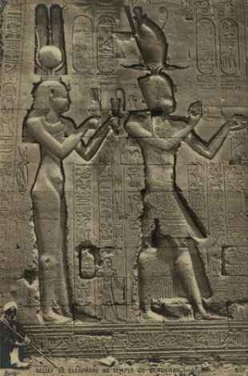
Relief sculpture of Cleopatra VII
Egypt has always been a dry, hot country. The ancient Egyptians depended on the waters of the River Nile, which flows north through the harsh and arid desert. Every year, rain and melting snow in the highlands of Ethiopia caused the Nile in Egypt to flood.
As the Nile delta flooded, the fields around the river were enriched with water carrying the fertile soil brought down from the mountainsides. This water was used to irrigate fields and crops. The River Nile was an important source of food from fishing. The Nile was also essential for travelling and transporting goods by boat. The Nile brought life and civilisation to ancient Egypt.
Many people lived beside the Nile and Egyptian houses were almost entirely built from mud bricks (although the pharaohs’ palaces were built from stone). This kept houses cool inside. Although, if the weather was very hot, people would often sleep outside on the houses’ flat roofs.
The Old Kingdom is the name given to ancient Egypt during the time between the 3rd and 6th dynasties. This is best known as the time in which the great pyramids were built. The pyramids were created as burial places for the Egyptian kings, including the huge pyramid at Giza.
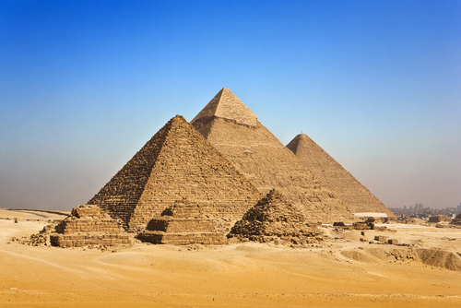
Pyramids at Giza
The Pyramid of Giza is the oldest and last remaining ‘wonder’ of the 'Seven Wonders of the Ancient World'. It was built as the tomb for the Egyptian pharaoh Khufu and took around 20 years to create. It was almost 147 meters tall, contained three burial chambers and was originally built circa 2550 BCE. (Circa is the Latin word for ‘about’ and is used when the exact date is not known.)
Archaeological excavations have found that the pyramids were not built by slaves, but by Egyptians who lived in the area. Entire communities were developed for the labourers and their families. They had shops, houses, butcher shops and even bakeries to make the thousands of loaves of bread that were needed to feed the workers.
Pyramid building was a complicated process and a lot of planning went into building each one. Millions of blocks of rock and limestone were needed (many weighing over two tonnes) and each one was fitted into place with accuracy and precision.
The Egyptians developed expertise in many areas, including architecture, surveying, mathematics and even astrology, to help them build the pyramids.
Rock was cut out from quarries and carried by boats on the River Nile; it was often transported quite far to reach the construction site. Accurate measurements were used to create perfectly rectangular fields. These were often aligned towards the pole star and were planned using plumb lines, sighting instruments called merchets, and gromas to make precise right-angles.
Egyptian scientists observed the movements of the stars across the sky. They kept very detailed records of these movements, year after year. From these, they were able to forecast when the Nile would flood each year. Everyday life revolved around the flooding of the Nile, and the planting and harvesting of crops. The ancient Egyptians developed their calendar based on the three cycles of the Nile River. Each season was four months and each month was thirty days.
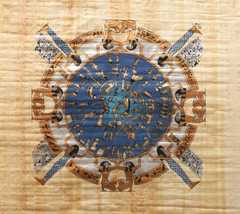
Ancient Egyptian Calendar
The Nile River meant life or death to the ancient Egyptians and this is why most of the pyramids and burial tombs are on the west side of the Nile. The ancient Egyptian people worshipped hundreds of gods and goddesses. Their primary deity Ra, the sun god, was born in the east, travelled through life and died in the west, ready to be reborn each day.
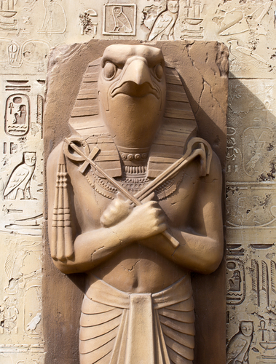

Remember:
What did the colours on the double crown symbolise?

Understand:
Why was Upper Egypt at a disadvantage?

Apply:
What facts would you select to show that ancient Egypt was a progressive civilisation?

Analyse:
Why did the ancient Egyptians pay close attention to the stars?

Evaluate:
Do you think it is better that the pyramids were not built by slaves?

Create:
Imagine you are an Egyptian labourer, involved in the building of a pyramid. Write an account of a day in your life.

Reading Test Questions
Make sure you have read Ancient Egyptians. When you have finished reading, begin answering the questions.
Read back through the book to help you. Then look back over the book to check your answers.
Do not guess: the answer should be based on what you have read.

Step 1

Multiple Choice
What were the goals of the ancient Egyptians? Select two.
to become rich
happiness
joy
to become a pharaoh

What brought life and civilisation to ancient Egypt? Select one.
the Nile
money
good fortune
the pharaohs

Find and copy one word that suggests that the ancient Egyptians pursued reform and change.
Ancient Egypt was one of the most progressive civilisations in the world; women had more rights in Egypt than in other cultures of the time. Egyptian people believed that happiness and joy were goals in life. As part of that, they also believed that family and home were important. Women were equal to men in contributing to business and had equal rights to sign contracts, own property, act as a witness in court or even start divorce proceedings.

Collective nouns
A collective noun is a word that refers to a group.
Select a collective noun from the list below to correctly describe these groups of animals.

- A ……flock………………of sheep.
- A ……………………………. of bees.
- A …………………………….. of fish.
- A ……………………………..of wolves.
- A ……………………………. of elephants.
- A ……………………………. of rabbits.
- A ……………………………..of lions.
- A ……………………………..of monkeys.
- A ……………………………. of ants.
- A ……………………………. of hyenas.

pack flock warren pride colony herd
barrel shoal swarm cackle

Please invent collective nouns for…

apes bats giraffes hippopotamuses
kangaroos tigers owls peacocks
crocodiles sharks jellyfish children
Match these 10 idioms with their meaning. Write them out on some paper. You may need to ask for help!
Idioms

Idioms
- to bury the hatchet
- to draw the short straw
- to mind one’s p’s and q’s
- to let the cat out of the bag
- to pull your socks up
- to hit below the belt
- to smell a rat
- to paddle one’s own canoe
- to blow one’s own trumpet
- to be a wet blanket

Meanings
  - to be suspicious
  - to improve
  - to be a spoilsport
  - to boast about yourself
  - to make an unlucky choice
  - to make peace
  - to give away a secret
  - to act unfairly
  - to be careful how you behave
  - to do things for yourself

Have you finished and checked your work?

Moving on
Can you think of any situations where we might use idioms for example in speech?

Features of Biography


Purpose:
To give an account of someone’s life

Structure:
- Opening statement introduces the subject, and explains why he/she is known
- Significant events are ordered chronologically
- Closing statement explains how this person will be remembered, and sometimes gives the writer’s opinion

Language Features:
- Refers to named individuals
- Contains dates linked to specific events
- Written in the past tense
- Can include direct and indirect speech and quotes from other sources
- Written in 3rd person
- Includes time connectives to link ideas
- Events are anecdotal in style (rather than lists of facts), and engage the reader

ICT
You may remember we’ve been looking at data during our ICT lessons.
The next lesson would have been to use formulas in Excel. You can use Excel on your HWB account if you haven’t got access to it already.
Don’t worry if you find it too tricky. Here is a YouTube clip that explains the different formulas and how to use them. I have also attached the spreadsheet that features in the video so you can have a go.
https://www.youtube.com/watch?v=dg_YozTOCkc&feature=youtu.be

Science
I’ve seen many of you have created your own rainbows for the NHS, why not grow your own?
Here’s a video to help you:
https://www.youtube.com/watch?v=af_oNMjG8SQ&feature=emb_title
Tip: Don’t use Sharpies or permanent markers as the colour doesn’t run as much.
Tweet us your results at @williamstown5_6.


