School Closure Home Learning Pack Week Four
Miss Kear & Miss Thomas’ Year 6

Hello everyone!
We have really enjoyed speaking to some of you when we do our weekly phone calls. We are hoping that you are all keeping well and happy. We are so glad to hear that you are keeping in touch with each other! In this pack you will find:
Maths:
- Emoji code breaking
- Problems solving questions
- Money questions
- Two mental maths test’s – ask someone to test you.

English:
- Spellings – I have uploaded phase 15 and phase 16 week 10. If you are on a different phase, you will find yours in Mr Staggs pack.
- A comprehension on Whales followed by a reading test comprehension.
- There is a task here about designing a poster or leaflet to inform people about Whales.
- If you don’t fancy that then you could invent a new character for David Walliams’ new book. The sillier the better. Write a paragraph to describe your character and a picture of them would be great!
- Two sheets on pronouns. Before you shout, I know I haven’t been able to use everybody’s name in the sentences. There’s always another time!

Welsh:
Some sentences that you might remember. Just give it a try!

Science:
Skittles experiment – if you are unable to do this, don’t worry!

Keep up the hard work, you’re all amazing!
Miss Thomas and Miss Kear
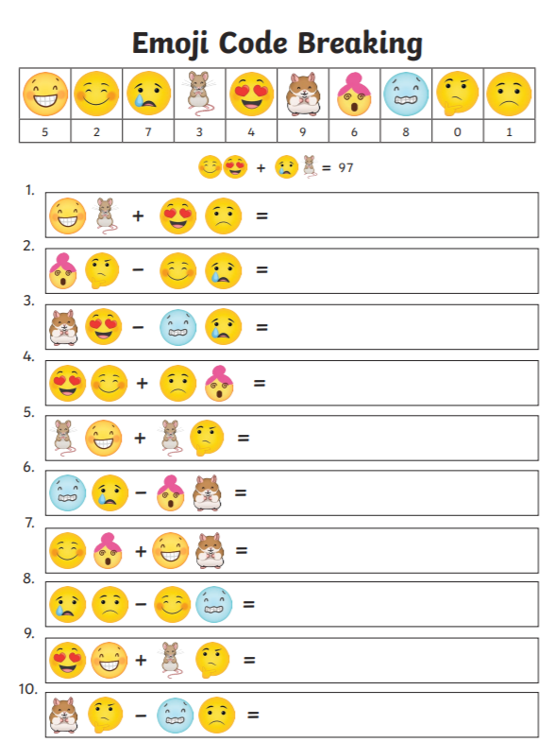

To help you solve these problems you can act them out.
Understand the problem:
- What do you know? – you can underline the important information in the problems.
- What do you need to find out?
- How are you doing to solve this problem? What are you going to try? What will you need to help you?
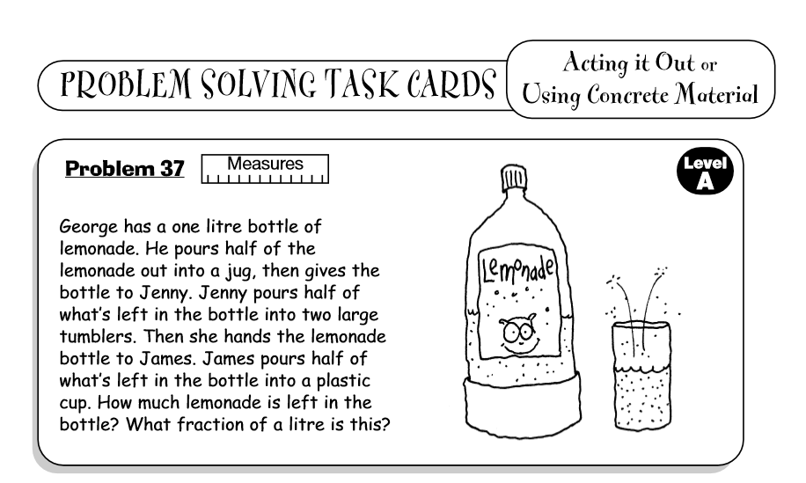
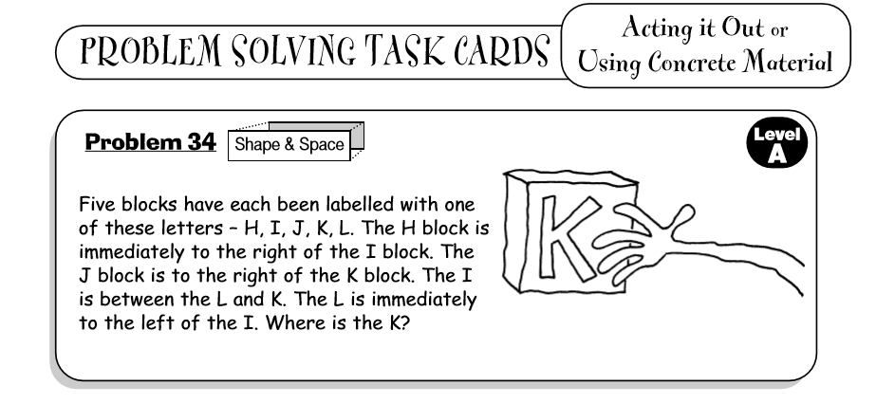

Money Questions. Chilli Challenge: I would like you to complete at least 6 questions. Remember you don’t have to start on mild. You have a choice of three mild questions, three medium questions and three hot questions.
Mild.
- I buy three bottles of water for 80p each. How much have I spent altogether?

- I buy a pack of pencils for £1.25 and a notebook for £1.50. How much have I spent altogether?

- Harry buys two ice-creams for 70p each and a packet of crisps for 50p. How much has he spent altogether?

Medium.

- I buy three cakes for £1.32 each. How much have I spent altogether?

- I bought a bike for £39.98 and a scooter for £9.78. How much have I spent altogether?

- Sam and three of his friends bought a drink each for £1.75. How much did they spent in total?

Hot.
- Annie bought 4 chocolate bars to give to her friends. Each one cost £1.43. How much change will she receive if she pays with a twenty pound note?

- Paul bought a book from a book shop. If it cost £6.23, how much change would Paul get back if he paid with a twenty pound note?

- Julie was given a £20 gift card for her birthday. She bought a dress that cost £13.27 and shoes that cost £5.50. How much money does she have left on the gift card?

Mental maths – ask someone to test you.
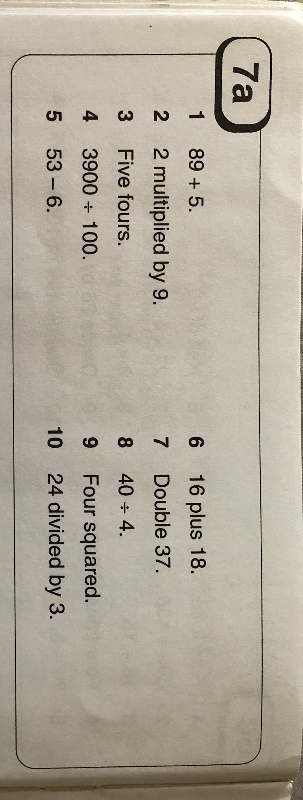

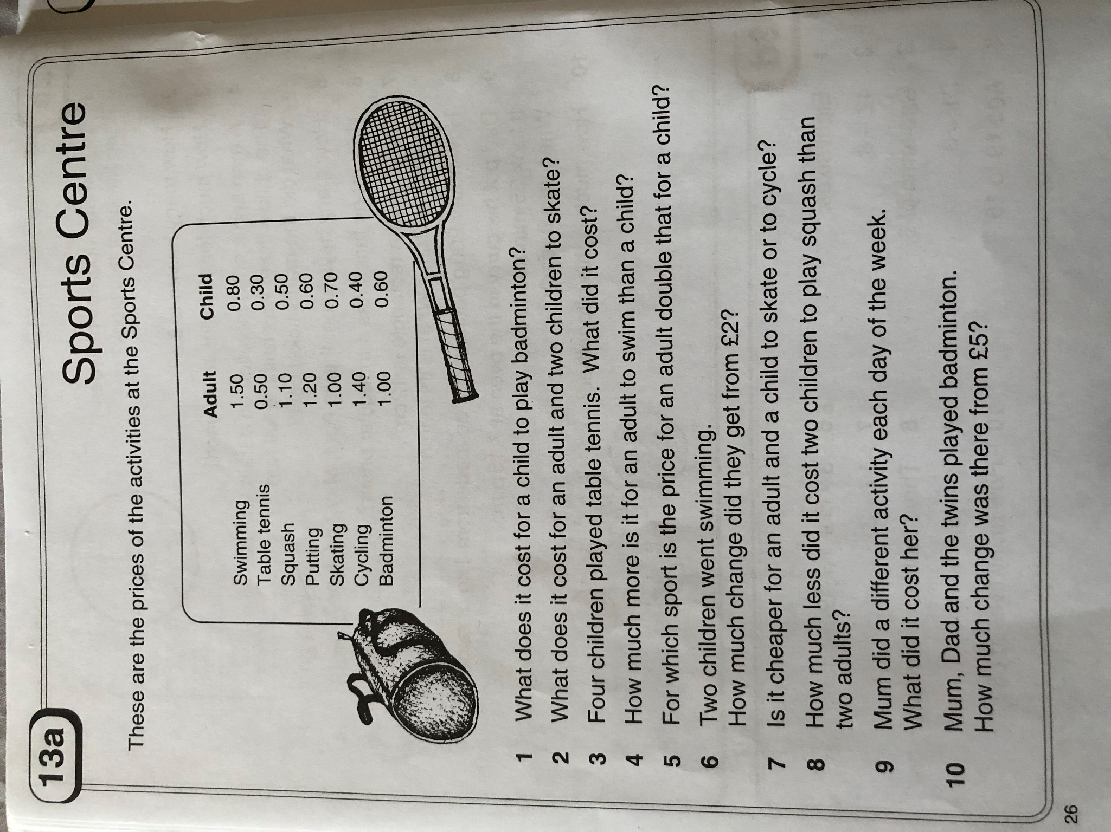
Mental Maths – ask someone to test you.
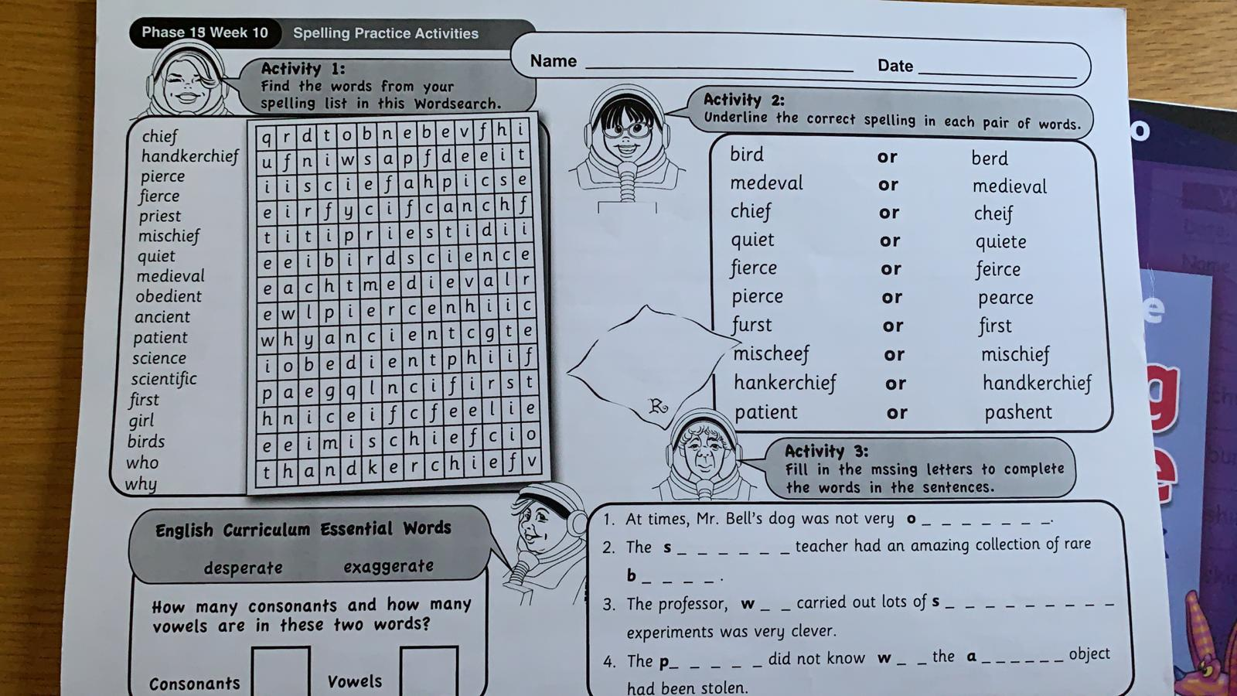
Phase 15 Week 10
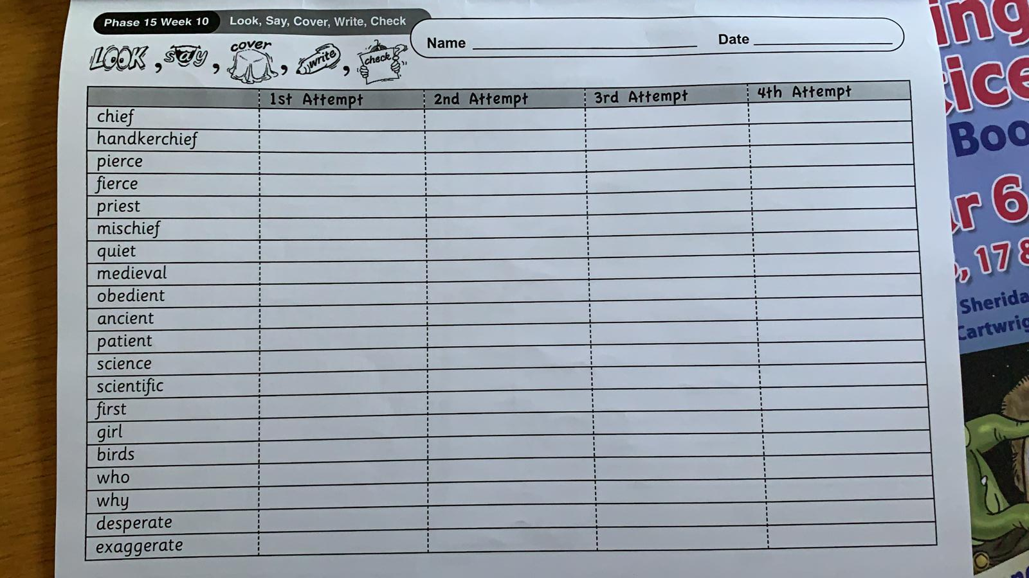
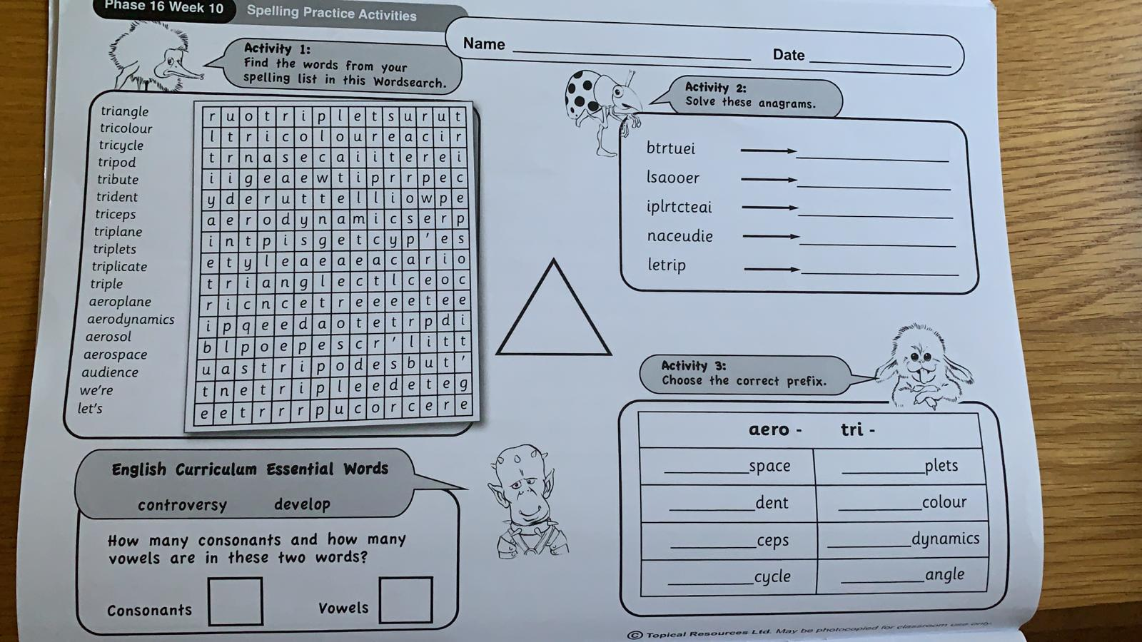
Phase 16 Week 10
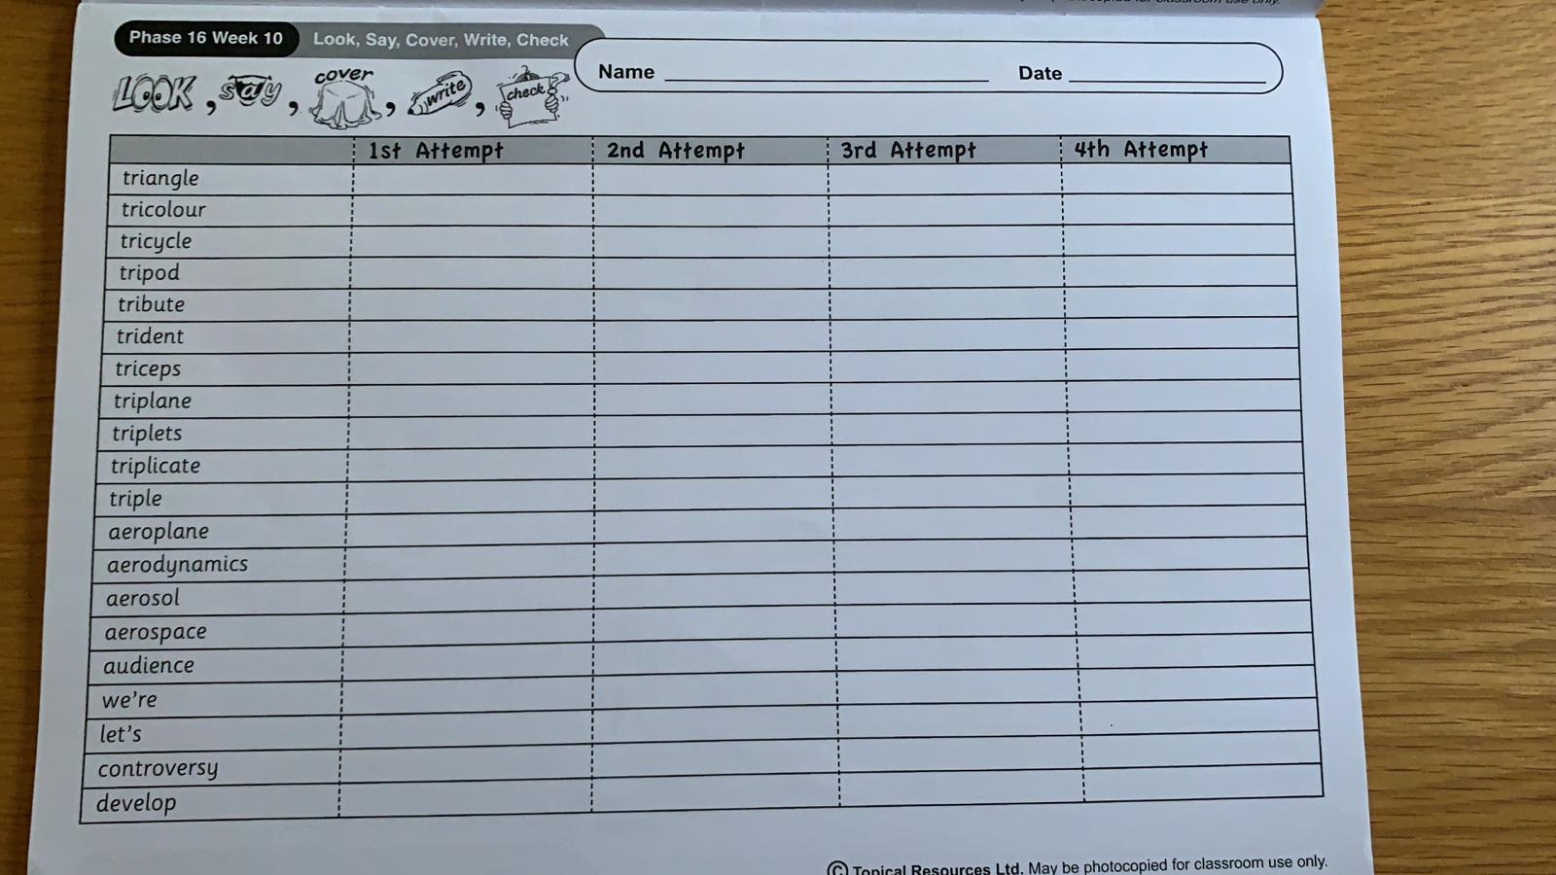
Comprehension:
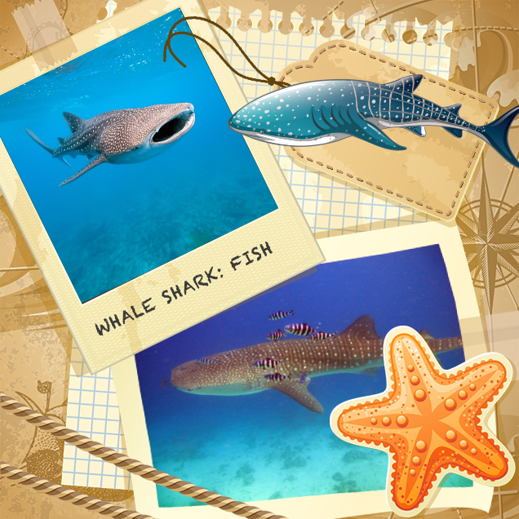
This is a book about the Whale Shark
Classification
Fish
Important characteristics
The whale shark is a slow-moving filter feeding shark and the largest known fish species. The largest whale shark ever observed had a length of 12.65 m (41.50 ft) and a weight of about 21.5 metric tons (47,000 lb). The whale shark holds many records for sheer size in the animal kingdom, and is by far the largest living nonmammalian vertebrate. The whale shark is the largest non-cetacean animal in the world.

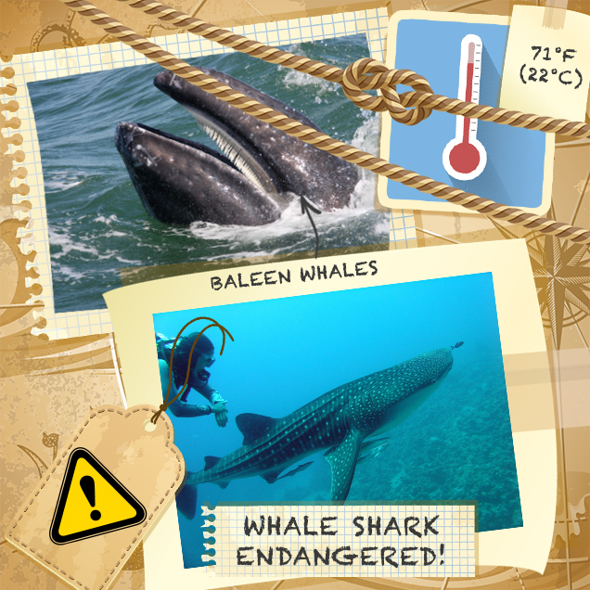
Skeleton
Vertebrate
Conservation status
Endangered
Where they live
The whale shark lives in open waters of the tropical oceans and is rarely found in water below 71°F (22°C).
Any other notes
The whale shark is not a type of whale – it is a fish, not a mammal. The name 'whale shark' comes from the fish's size, as it is as large as some species of whales. Also, whale sharks are filter feeders like baleen whales.

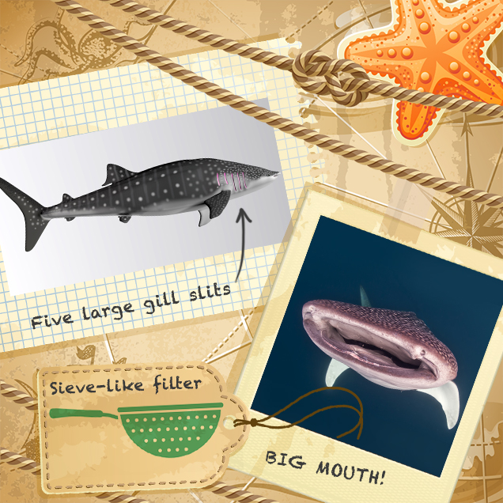
How whale sharks are adapted to their environment.
The whale shark is the biggest shark. Its mouth is at the front of its head. It has a wide, flat head, small eyes and five large gill slits. This enormous shark is a filter feeder and sieves enormous amounts of plankton to eat through its gills as it swims. The whale shark has an extremely efficient method for filtering that stops the filter pad surface from getting dirty.
The whale shark has lighter stripes and dots on its dark grey skin. Its skin is up to 10 cm thick.

What whale sharks eat
They feed mainly on plankton including copepods, krill, fish eggs, Christmas Island red crab larvae and small nektonic life, such as small squid or fish. They also feed on clouds of eggs during mass spawning of fish and corals.
Whale sharks are generally considered harmless to humans.

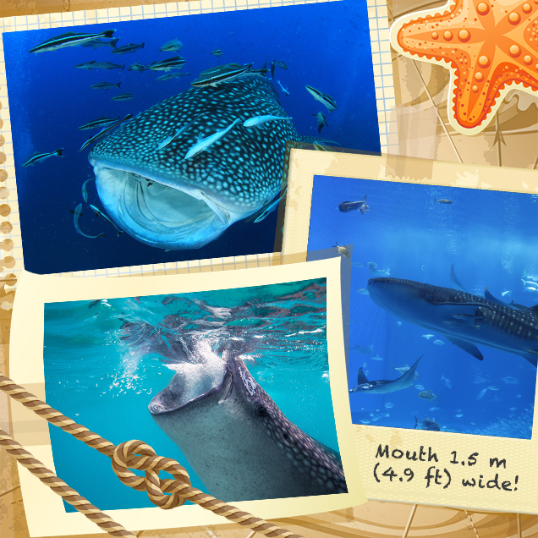

How whale sharks feed
Whale sharks have very large mouths and are filter feeders. Their mouths can be 1.5 m (4.9 ft) wide, with 300–350 rows of tiny teeth and 10 filter pads.
Whale sharks do not use their rows of teeth to feed. Instead, they either open their mouths and swim forwards, pushing water and food into the mouth, or they suck in water and then push it out through the gills. In both cases, the shark uses its filter pads as sieves to separate food from water.

Whale shark behaviour
Despite being large in size, the whale shark is generally not dangerous to humans. Whale sharks are docile fish and sometimes allow swimmers to catch a ride, although shark scientists and conservationists do not recommend this as it can disturb the sharks. Younger whale sharks are gentle and can play with divers.
Humans have never seen whale sharks mate or give birth.

Now try these comprehension questions.

Higher Order Thinking Skills

Remember:
What kind of water does the whale shark live in?

Understand:
Where does the whale shark get its name from?

Apply:
How would you explain the function of a whale shark’s filter pads?

Analyse:
Why do you think humans have never seen whale sharks mate or give birth?

Evaluate:
What evidence would you use to support the view that whale sharks are ‘extremely efficient’ feeders?

Create:
Design a poster or information leaflet to inform people about whale sharks.

Reading Test Questions
Make sure you have read the text. When you have finished reading, begin answering the questions.
Read back through the book to help you. Then look back over the book to check your answers.
Do not guess: the answer should be based on what you have read.

Step 1

Multiple Choice
How is a whale shark classified? Select one.

a reptile
a mammal
a fish
a whale

What words are used to describe the head of the whale shark? Select two.

wide
huge
flat
narrow

Find and copy the phrase (three words) that informs the reader that the whale shark is adept at filtering its food.
The whale shark is the biggest shark. Its mouth is at the front of its head. It has a wide, flat head, small eyes and five large gill slits. This enormous shark is a filter feeder and sieves enormous amounts of plankton to eat through its gills as it swims. The whale shark has an extremely efficient method for filtering that stops the filter pad surface from getting dirty.
Find and copy two words that suggest that whale sharks are passive creatures.
Despite being large in size, the whale shark is generally not dangerous to humans. Whale sharks are docile fish and sometimes allow swimmers to catch a ride, although shark scientists and conservationists do not recommend this as it can disturb the sharks. Younger whale sharks are gentle and can play with divers.

Put these sentences into the order they appear in the text.

The whale shark is the largest non-cetacean animal in the world.
They use their filter pads as sieves to separate food from water.
Whale sharks are filter feeders like baleen whales.
They feed mainly on plankton.
The largest whale shark ever observed had a length of 12.65 m.

Mark which statements are true and which are false.

The skin of a whale shark is dark grey.
Whale sharks are often found in water temperatures below 71°F (22°C).
Whale sharks have ten large gill slits.
Whale sharks have very large mouths.

Well done! Now go outside and play!

Use these personal pronouns to fill in the gaps.
she he his her
We she

Jenson smiled. He had done it and _______ couldn’t believe it. But he couldn’t have done it on _______ own.
“________ were great!” he said enthusiastically.

Janine’s mother ran down to the gate and called Janine, telling _______ what a silly girl ______ had been.
“What’s wrong?” _______ asked.
“You’ve got your shoes on the wrong feet!” shouted Janine’s mother.

Use these possessive pronouns to fill in the gaps.
yours
hers
ours
his

- These pens belong to us. They are ________.
- The apple belongs to you. It is _________.
- Sol owns the Frisbee. It is _________.
- This is Allyssia’s ruler. It is _________.
- The ball belongs to Bella. It is _________.

Pronouns
I | me | they | them | we
us | she | her | you | it
he | him | his | mine | yours
his | hers | ours | theirs

Task One
Copy out the sentences below and underline the pronouns.
- Harri sat sensibly on his chair.
- Daisy gave some sweets to her friend.
- Lola and Olivia went for a walk. They went to the shops.
- Teal went to look for Kailem. He found him outside.
- Amber picked up the pencil. She put it in her drawer.

Task Two
Copy out these sentences and fill the gaps with the correct pronouns.
- Keagan picked up the ball. He kicked ___ in the air.
- The team was happy when ____ won the cup.
- Charlotte went out in the rain. ____ got very wet.
- Eli went home. ____ had chips and beans for ___ tea.
- I bought some crisps. The shopkeeper gave them to ___.

Task Three
Copy out these sentences and replace the underlined word(s) with a suitable pronoun.
- The children were sad when the children were told off.
- The birds flew away when the cats chased the birds.
- When Bailey got home Bailey watched television.
- Chloe said that Chloe was bored.
- Jacob hung Jacob’s bag up.
- I like the biscuits. The biscuits are my favourite.
- Caleb ran after Harley. Caleb chased Harley all the way to school.
- Macey dropped the rubber. The rubber went under the table.
- Lily and Keana went to the library. Lily and Keana went to read some books.
- George played outside with George’s sister.

Welsh
Portrait in Words

Describe yourself using the vocabulary we have used in the past few weeks in Welsh!

Pwy wyt ti?

Ble wyt ti’n byw?

Oes brawd/chwaer ‘da ti?

Dwi’n hoffi gwisgo

Dwi’n hoffi bwyta

Dw i ddim yn hoffi bwyta

Mae’n gas ‘da fi (I hate)

Mae’n well ‘da fi (I prefer)

Dwi’n dwlu ar... (I’m crazy about...)

Skittles Candy Science Experiment
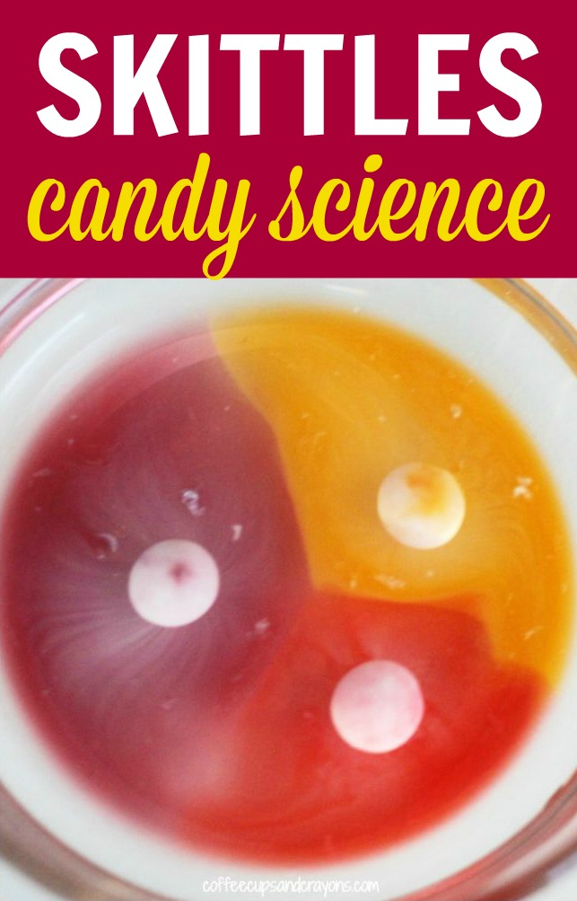
You will need:
- Skittles
- Water
- A jar or a bowl

Pour a little bit of water into a dish and add a couple of Skittles candies. Immediately you can start to see something happen.
Skittles are coated in food colouring and sugar. When you pour water over the skittles the coloured coating dissolves spreading through the water. The colour and sugar dissolve into the water and then diffuse through the water, making it the colour of the skittle.
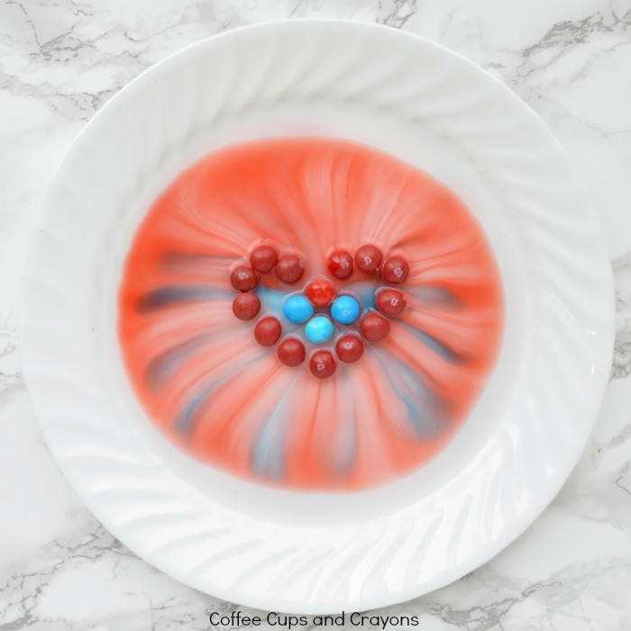
The Ss on the top start to dissolve and float to the top first, but it happens quickly so if you walk away you may miss it!

After you try it with a couple Skittles get creative and turn it into a shape like a heart to see how the results differ!
Can you make any other shapes?

