Williamstown Primary

Home School Learning Pack Year 3 W-C 27/4/20

Literacy, Numeracy and Topic.
Useful Websites
TWINKL- free code 1 month = PARENTSTWINKLHELPS
BBC BITESIZE TOPMARKS- Hit the button
SCHOLASTIC HWB

Hello everyone, I hope you are all safe and well. I am missing you all and can’t wait to see you all as soon as we are able to return to school. I hope you are enjoying your time off, working hard but also having as much fun as possible
Here is your new pack for this week including English work, spellings, maths challenges and topic work. Our new topic this term is ‘Keeping Healthy’!
Remember to keep reading, stay safe and keep in touch with your friends when you can
Miss Thomas x
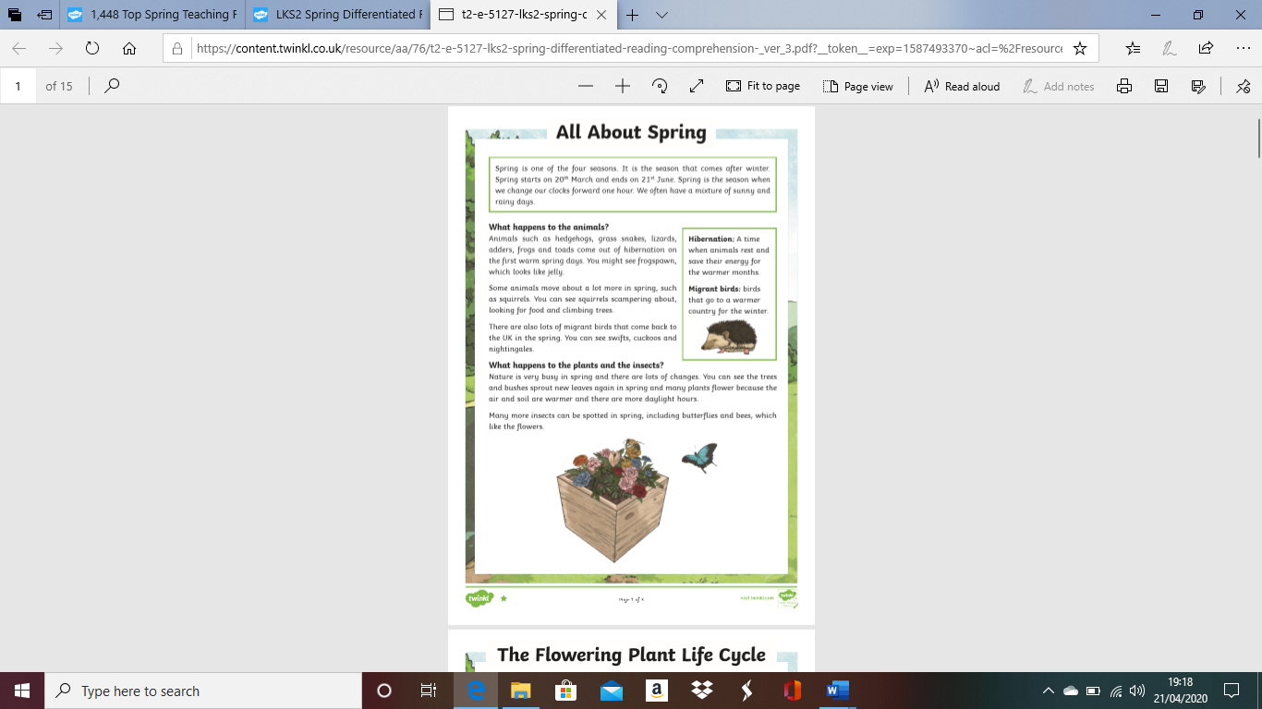
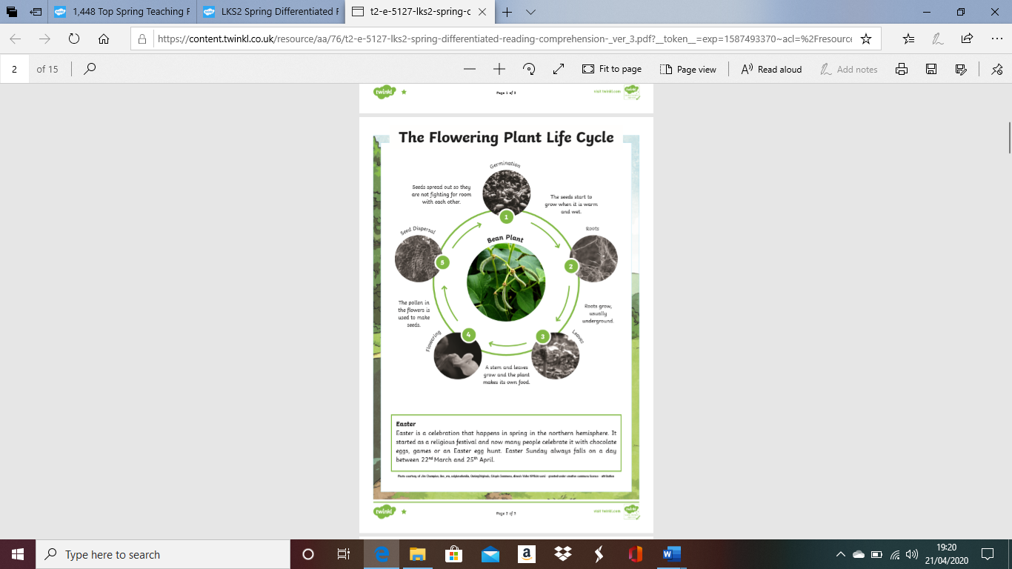
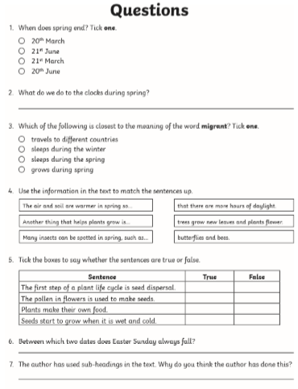
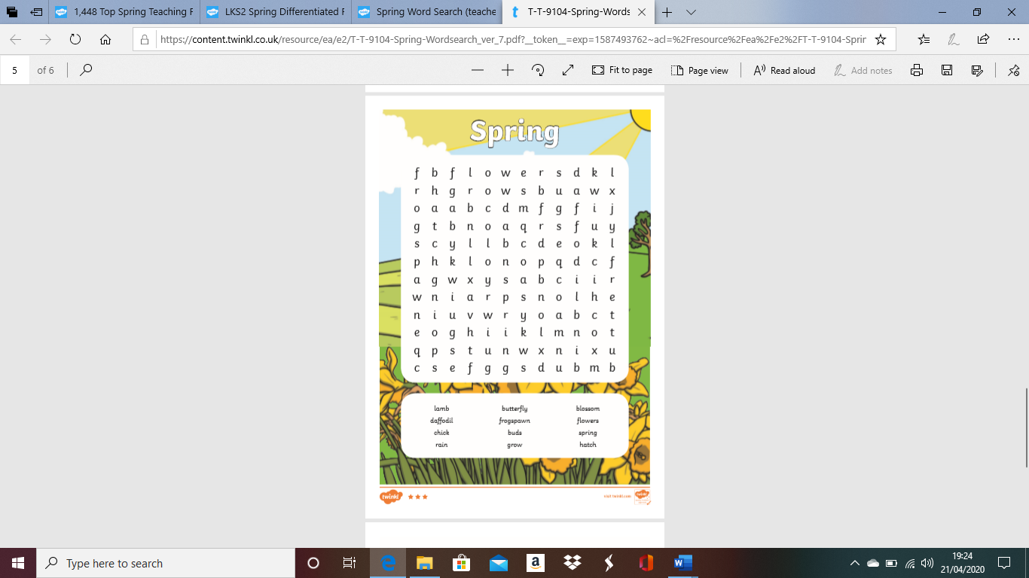
Continue to practise your spellings at home. Here are some new spellings to practise. You can also practise them with a friend!
Use each spelling in a sentence when you have practised them all.
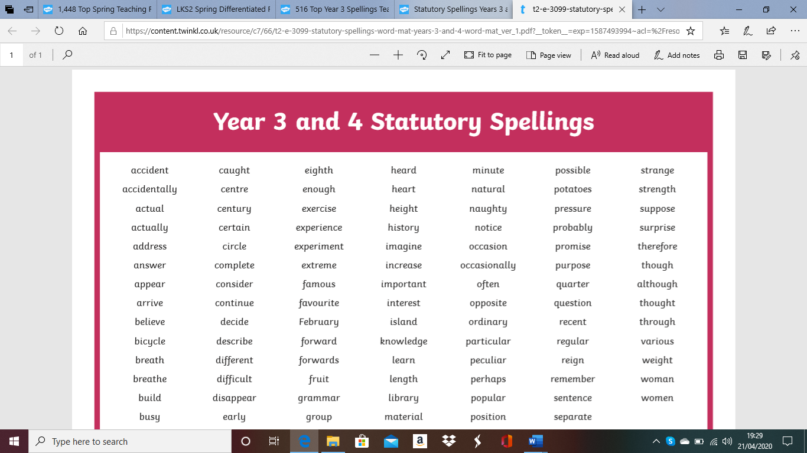

Complete the Acrostic Poem below.
You need to start each sentence with the correct letter. This poem is about Spring.

Copy out the second spring poem to practise your handwriting!
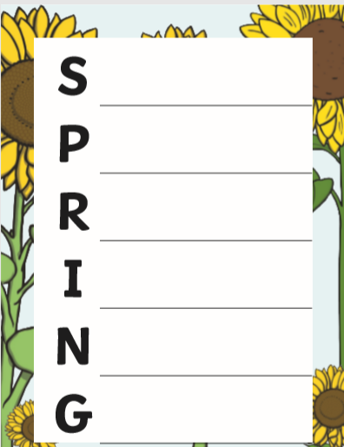
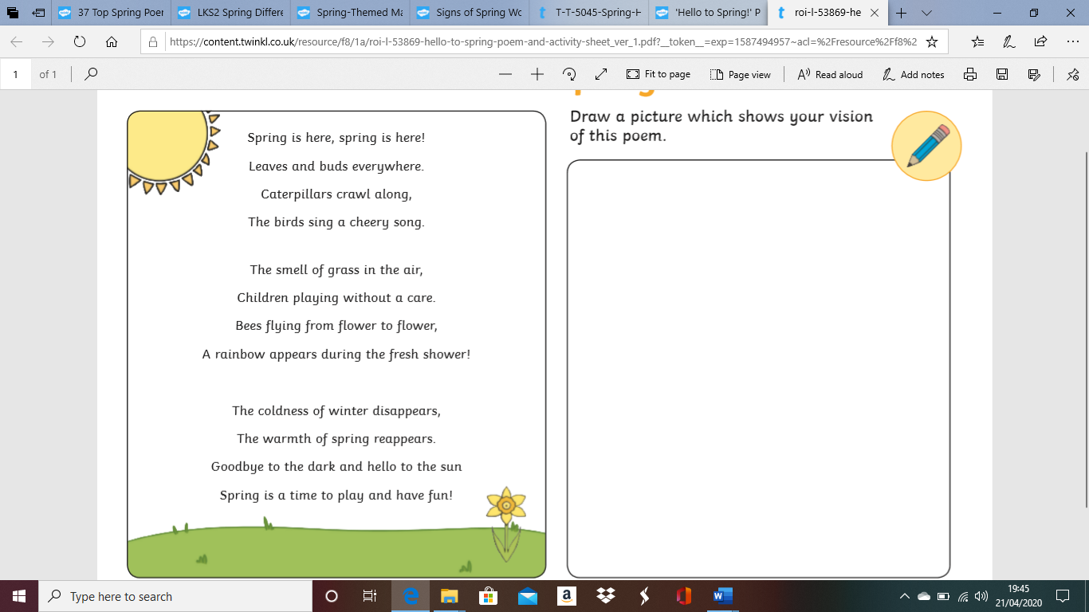
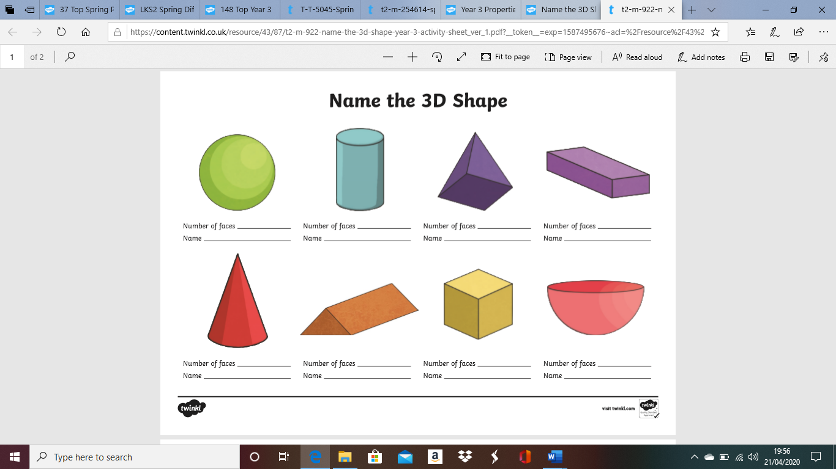
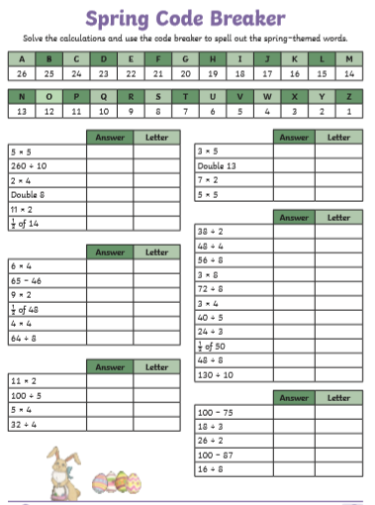
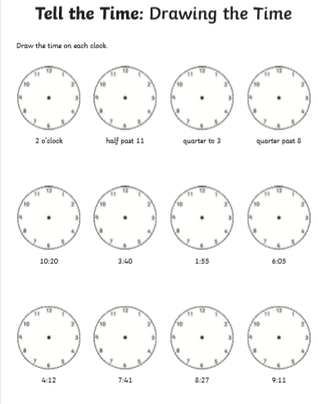
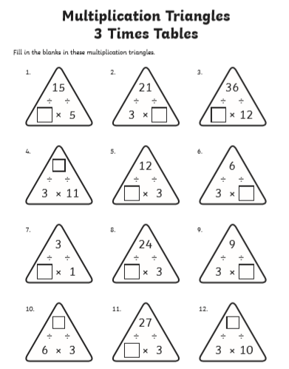
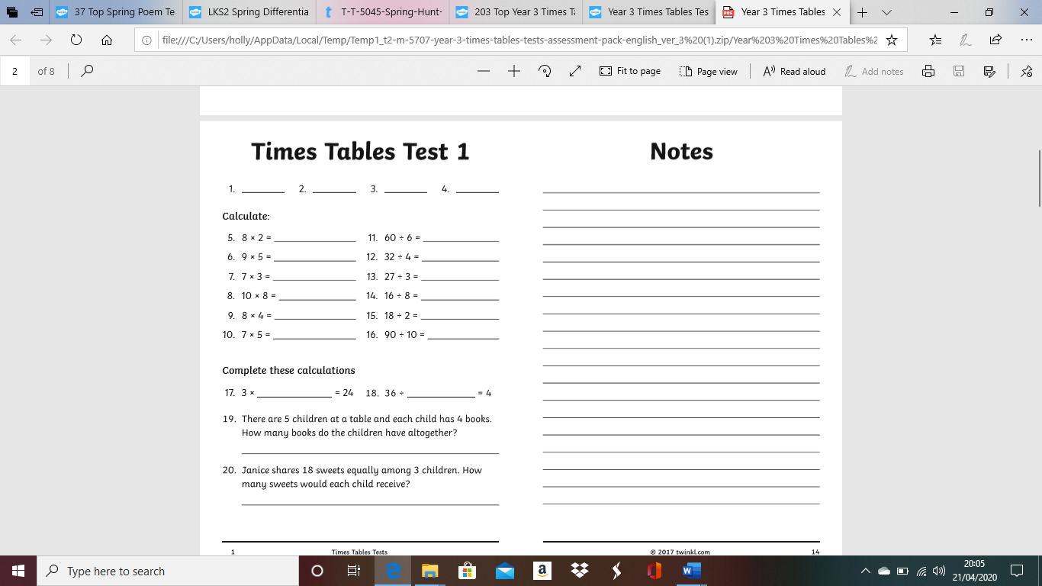
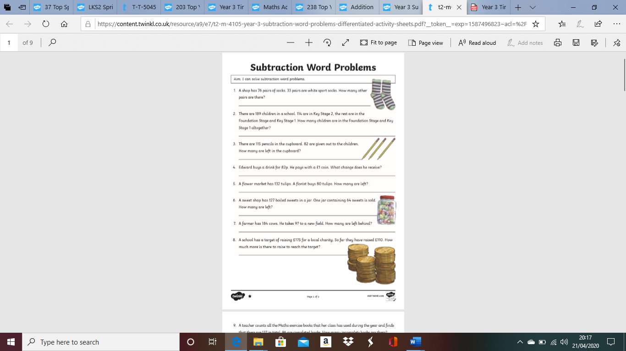
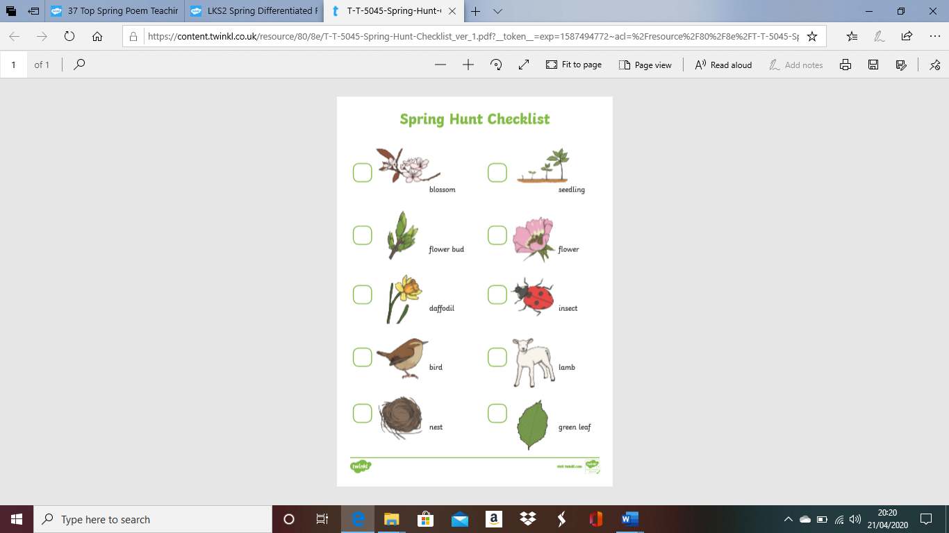
As part of our new topic we are looking at Staying Healthy!
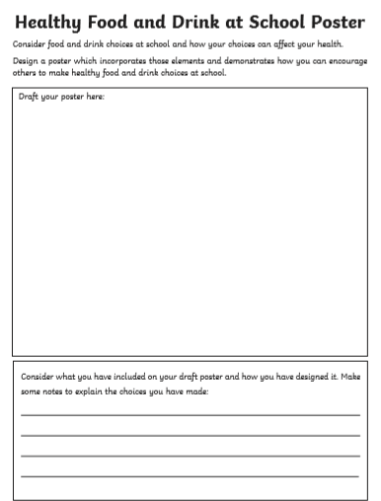
Drawing Challenge!

Can you draw your favourite healthy foods (mostly fruits and vegetables). Label each healthy food and write a full sentence to say why it is one of your favourites!

Table Challenge!

Ask everybody in your house what their favourite healthy foods are! (They can give you more than one answer)..
Record your results in a table to see which foods are the most popular!

