Hello everyone, Sut mae? Hope you are all keeping safe. Here are activities for this week. Again, I’ve put a lot of content here and don’t expect you to complete it all. Some parents have asked for a range of tasks to work through as part of home learning. Please remember there is no need to print out any of these activities they can be completed in your child’s Busy Book or on paper and read from screen. Activities are just a guide on the direction of the skill set we would be developing in school, if you find similar alternatives online, great use them. The important element is to keep your child safe, happy and engaged. Remember to read a little every day, keep practising your sounds and complete a math activity too, look back on the parent guide issued in week one for tips on games. There are so many website and ideas out there that look amazing, many of which are now free. Let us know via twitter(@williamstown1_2) if there are sites/ apps you recommend toshare! Next week we will be looking at Worms- if you’ve got ideas to share let us know via twitter! Keep safe. Take care. Love and miss you all, Mrs Thomas + Miss Galliford. x
Summer Term-Tymor yr Haf
Year 1- Mrs Thomas.
Home Learning – Summer Term Week 2, Monday 27th April.
Theme – A Walk on the Wild Side.
This week we will be looking at Sunflowers. What do you know about Sunflowers
Youtube –
Timelapse from seed to sunflower
Lifecycle of a sunflower – Shannon
Other links used in course of planning

Poems of the Week
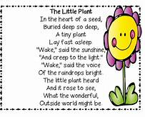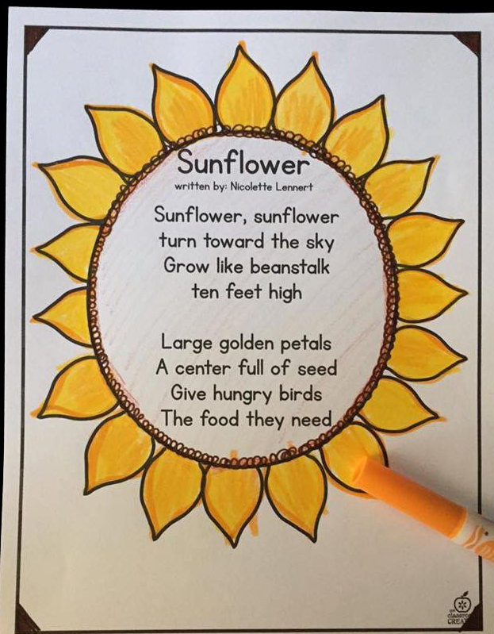

Suggested Book Bank
These books would be useful to enhance our learning this week. Look for them being read on *Youtube or visit libraries.wales/my-digital library for an e copy of the title (link on Twitter).
Story Books (Fiction)
*Sam plants a sunflower by Kate Petty
*Katie and the sunflowers by James Mayhew
*The sunflower parable By Liz Curtis Higgs
*The tiny seed by Eric Carle
*Sunflower House by Eve Bunting
*The Magnificent Sunflower by Lee Haydn Straight
Information Books (Non Fiction)
Seed to sunflower by QED
I’ve put a star* by all the stories I’ve found on Youtube!

Welsh
The welsh word for sunflower is Blodyn yr haul –
Our focus questions are pa liw ydy blodyn yr haul? What colour is the sunflower?
A –Mae’n melyn , brown a gwyrdd.
You could use this question with lots of other plants too- here’s some we know
Cenhinen Pedr – Daffodil Rhosyn – Rose * sunflowers (plural) in Welsh is Blodau yr haul
You can always use the English word eg Pa liw ydy Daisy? It’s the sentence pattern that is important – don’t forget you could also ask last week’s question – Wyt ti’n hoffi …? too, to make a simple conversation!
LLiwiau’s enfys song – sing along with this welsh classic by watching @FFa-la-la! On Youtube or Twitter or via the Hwiangerddi cymru website.
Welsh colours – Use the colour tweet on Twitter or visit www.learn-welsh.net for an audio version of colours
The children have learnt a rhyme about welsh colours previously, I wonder if they can recall it? They might recall the actions too.

Y lliwiau yn Gymraeg ( Tune – Baa Baa Black Sheep)
Gwyn fel yr eira White like the snow
Du fel y frân Black like the crow
Pinc fel y rhosyn Pink like the rose
Coch fel y tân Red like the fire
Llwyd fel y wiwer Grey like the squirrel
Melyn fel yr haul Yellow like the sun
Glas fel yr awyr Blue like the sky
Gwyrdd fel y dail. Green like the leaves
Dyna rai o'r lliwiau,
y lliwiau yn Gymraeg.
Anhysbys

The colours in Welsh
White like the snow
Black like the crow
Pink like the rose
Red like the fire
Grey like the squirell
Yellow like the sun
Blue like the sky
Green like the leaves

Physical activities to try at home – indoors and outdoors
Cosmic yoga kids adventure – Kids yoga for literacy (Youtube)
Try growing as slowly and as tall as a sunflower- How can you change your shape/ position? Can you wilt and wither too?
Ball work – Throw +catch (standing on the spot / walking ) Challenge can you throw, clap and catch? What’s your score without missing a catch? Can you improve your score?

Knowledge and understanding of the World
Draw a sunflower and label it – use the words- leaf, stem, roots, bud, petal, (you could include this in your fact file)
Plant a sunflower seed –What will you need to give it to drink? Where should you place it for it to grow successfully? What would happen if you forget to water it? Or give it too much water? Keep a photo diary every week to watch the changes, eventually make a picCollage.
Watch the Youtube video about the lifecycle of the sunflower.
Play - Sparky the alien on Topmarks website – Growing plants / growing plants 2
Creative
Watch – Van Gogh, art with Mati + Dada on Youtube to find out about this famous artist and his life.
Look at the famous picture of the sunflowers by Vincent Van Gogh- what do you like/Dislike? About the picture. How would you improve it?
Draw, paint, create your own picture of a sunflower or bunch of sunflowers – what materials will you use? Will it be 2d or 3d? what colours will you add? Will they all be the same shade of a colour? (opportunity to look at lightening/darkening of colours)
Music – Use sunflower seeds (bird food) to make sunflower shakers from recycled materials. What happens to the sound the more/ less seeds you add? Can you make and shake a sunflower dance? Check out KIDZ Bop Kids – sunflower (Dance along) on Youtube! Maybe those of you on Zoom could learn it together? or dance together via a Whats app chat with your class friend?
Language (I’ll try to keep these activities similar from week to week)
1. Can you copy one of this week’s poems neatly into your book? Think about letter formations, spaces, capital letters, full stops, letters sitting on the line (tails swinging under). Remember to read back your work. (Note to parents – pupils can copy the poem or as a challenge you can read it and they can write it or the ultimate challenge can they write it from memory ?) don’t forget to read back through your work.
2 .Learn to read high frequency words ( in reading file) – How many can they read in a minute? Choose 5 words to learn how to spell. How could you use these words in a sentence?
3. Our sound of the week is the trigraph ‘ure’. How many words can you think of / find / read / spell with this trigraph in it?
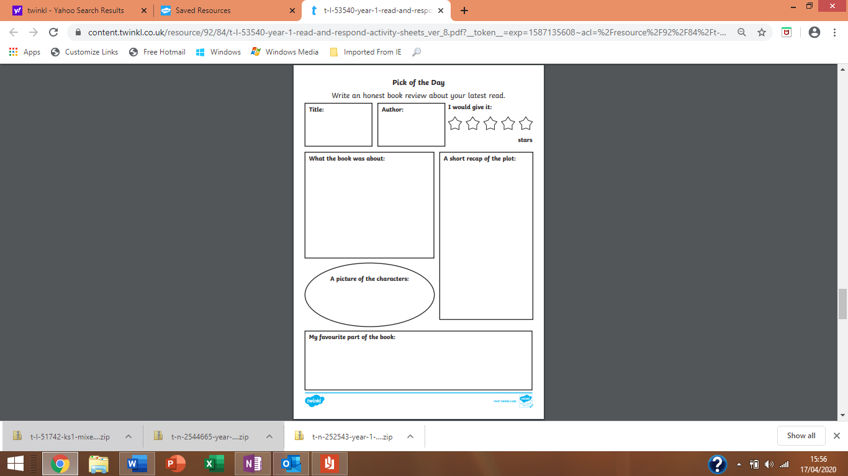
Book review- Which story will you choose to review this week? It can be one from my book list at the top of the page or it can be one of your own. You can create your own Book review form or use the format of the one above. Remember to encourage pupils to ask and respond to Who? What? Why? When? and Where? questions about the book that they are reading / sharing with an adult to develop a greater understanding, this will also help with comprehension tasks that will follow later in the term.

Create a factfile about Sunflowers. A fact file requires information. You can follow the format below, create your own style or how about simply folding an A4 sheet of paper in half and creating your own information book?

I’d like you to include –
A drawing - you could label this to extend your learning.
A title – the name in English and Welsh
Some interesting information about your focus of study-
Such as - How does it grow? What does it need to grow? It’s life cycle. It’s colour. What’s the most interesting fact you learnt?
Include new vocabulary – this week it could be, germinates, shoot, root, seedling, bud, stem, wilt, wither, rotate, petals, tall, height.

Remember to keep all your fact files safe for future learning – they don’t always need to look the same
You could create a time capsule of your home learning- what else would you put in your time capsule? Keep adding to it until we return to class. I’d love to look through your Time capsule with you when we return to school - if you decide to make one and are willing to share!

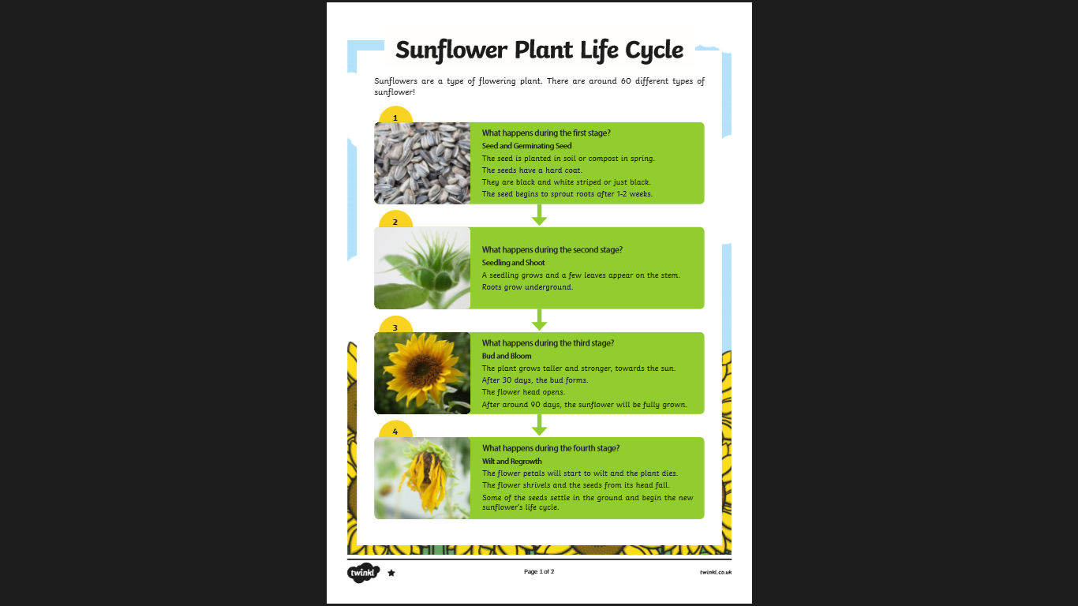
Please read this with your child there are many high frequency words they should be able to read independently – you know your child and their reading ability, we’re all at different stages.
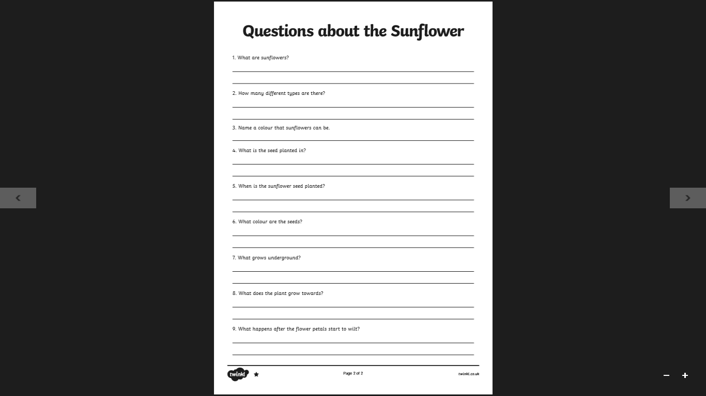
This is a comprehension task to help develop your child’s understanding. At a basic level , questions can be answered orally or for a challenge write answers down using words from the text to help.
Maths
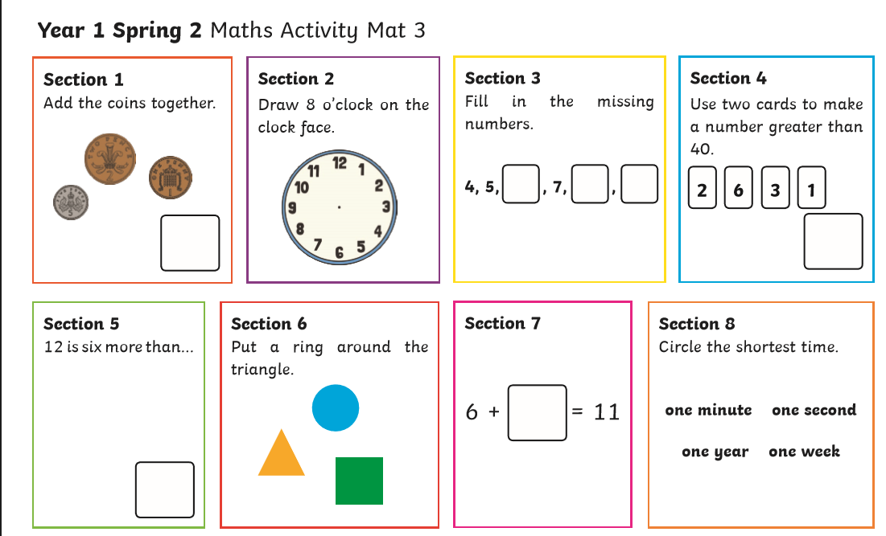
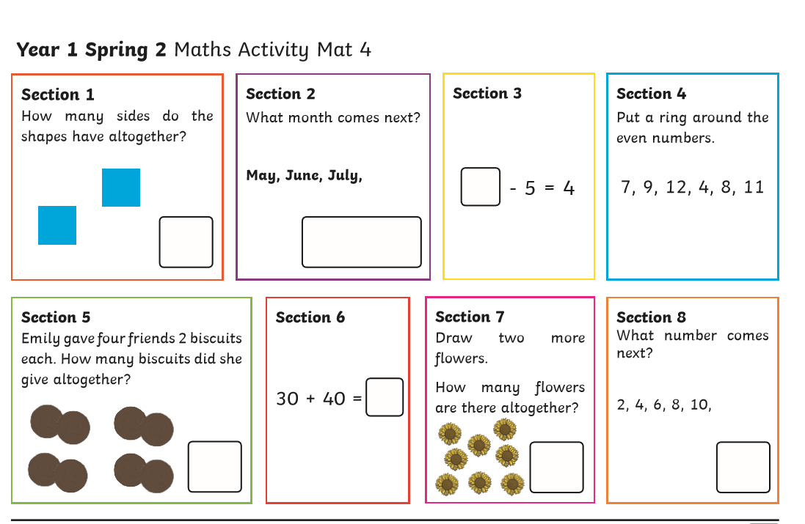

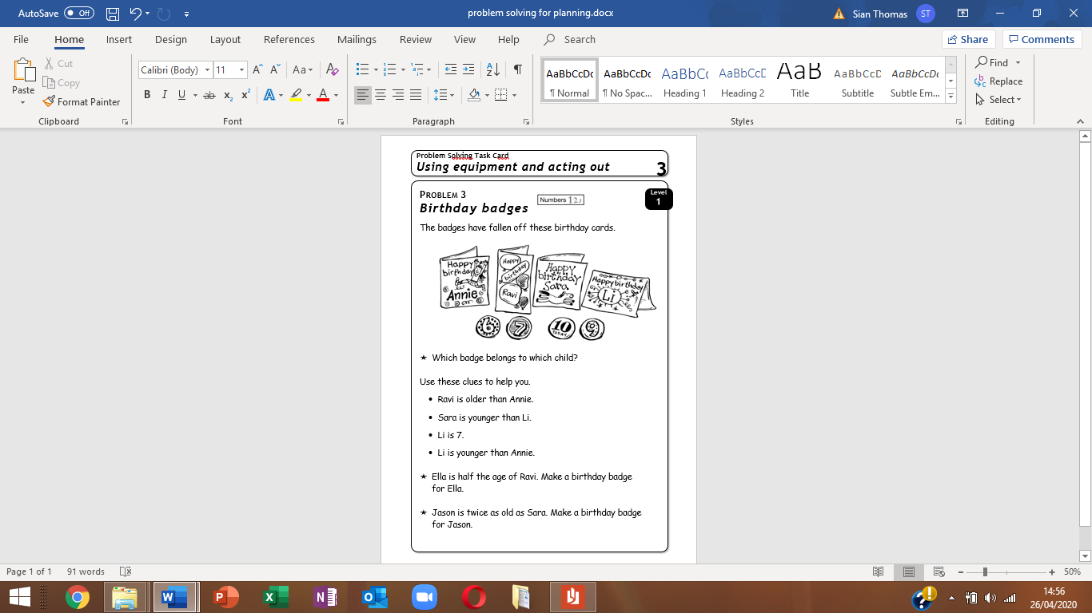

P.s (I’ve included the Top Tips for the problem solving task on the next page!)
.
Top Tips To complete this activity,
Look at the picture together.
I would first encourage the children to make birthday badges and name cards (for the children in the maths problem). Use either cut up cardboard packaging / post it notes etc
Then, I would also make a number line to 15 /20 (either write it, use number magnets/ cards/ chalk)
Next, I would play with the number ‘badges’ helping the children make the connection between older and younger and larger and smaller numbers.
Then I would read the 4 clues with the children. Encouraging the children to listen carefully for precise information to find our starting point. (Li is 7, clue 3)
Next I would put the name card and 7, badge on the number 7 on the number line.
From this point your child should be able to work out clue 2
That will leave them with clue 1 and 4 – encourage children to read each clue and think about the concept ‘older’ being a higher number. From talking through this they should be able to work out the answers.
The last 2 questions are simply halving and doubling.
Challenge: The total of the ages of two children is 10. Make birthday badges for the children.

N.B - This is a ‘problem solving ‘activity, it is meant to challenge your child’s thinking. All pupils have the skills required to complete it, It’s simply encouraging them to make the connections. We have completed several, similar Problem Solving activities together in class.

