Hello everybody. I hope you are all safe and well?

I know we haven’t spoken to everybody during these unusual times, please be reassured that we are thinking of you and missing you all. In Nursery we are phoning the children who don’t have older siblings, and the teacher of the older sibling’s phone those parents. However, I do hope to contact each of you shortly just for a check in, sometime in the next week.
I’ve put together some more ideas to help with your child’s home schooling. I have tried to put ideas on here that do not need printing off. If you don’t have some of the resources required for certain tasks please feel free to improvise. It is the outcome of the task that is important.

Week 4 Home Tasks
Language and Literacy
- Please can you continue to read or listen to the story ‘Dinosaur Roar’ (available on you tube).
Ask your child questions about the story
eg. Which Dinosaur roared?
How did the other Dinosaur feel?
What did the strong Dinosaur lift?
What colour was the long Dinosaur?
What did the Dinosaurs eat?
Where would the Dinosaurs have slept?
- Please continue to share on twitter any other Dinosaur stories that your child enjoys listening to and joining in with.

- Challenge!................Can your child retell the story to you? You could even share a video of them telling the story on twitter?
- Can your child recognise differences in the Dinosaurs in the stories?

Here are a couple of fun ideas to help with recognising differences:
If you have some plastic toy dinosaurs why not take them out side with some paper and pencils. Let the sun cast shadows for your child to trace.
(Learning about different sizes, shapes and shadows)

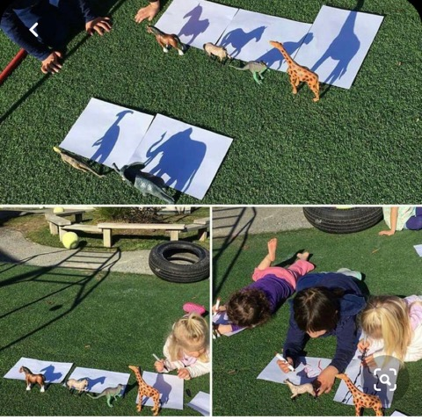

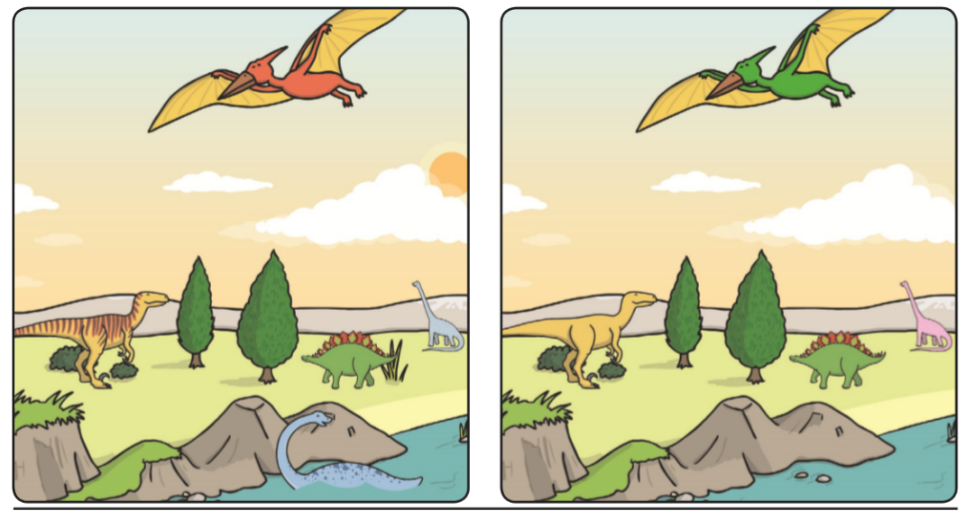
Can you spot 5 differences in the pictures below?

Can you spot 5 differences in the pictures below?
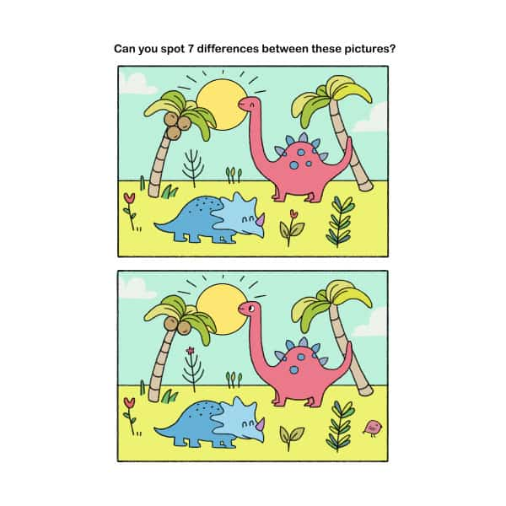


- Can your child draw some dinosaur pictures/make dinosaur junk models and make up some funny rhyming dinosaur names for them? Maybe they could try to write the names down. Even if it’s just one or two sounds that’s fine. If not, could you write them? It will help them realise that the spoken word can be written down.
Again, it would be fantastic to see these creations shared on twitter.


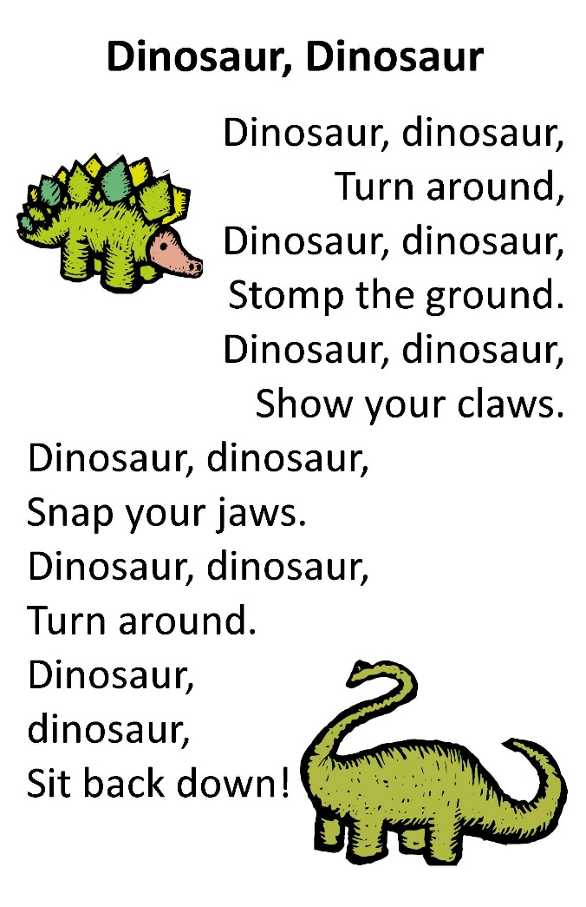
- Here’s a nice easy rhyme for you to learn this week. Just like the ‘Teddy Bear Teddy Bear’ rhyme. Ask your child to think of actions to go with the rhyme.

- A number of Parents have mentioned that they have been encouraging their child to write their names. This is Fantastic!
If you feel you would like to help your child with this, below is a copy of the rhymes we use in school with the children to help them form the letter sounds correctly.
You can use these when your child is writing with a pencil or even if you give them some foam/sand/rice/paint/water and encourage them to make the letter shapes using their fingers/paintbrushes/sticks etc.

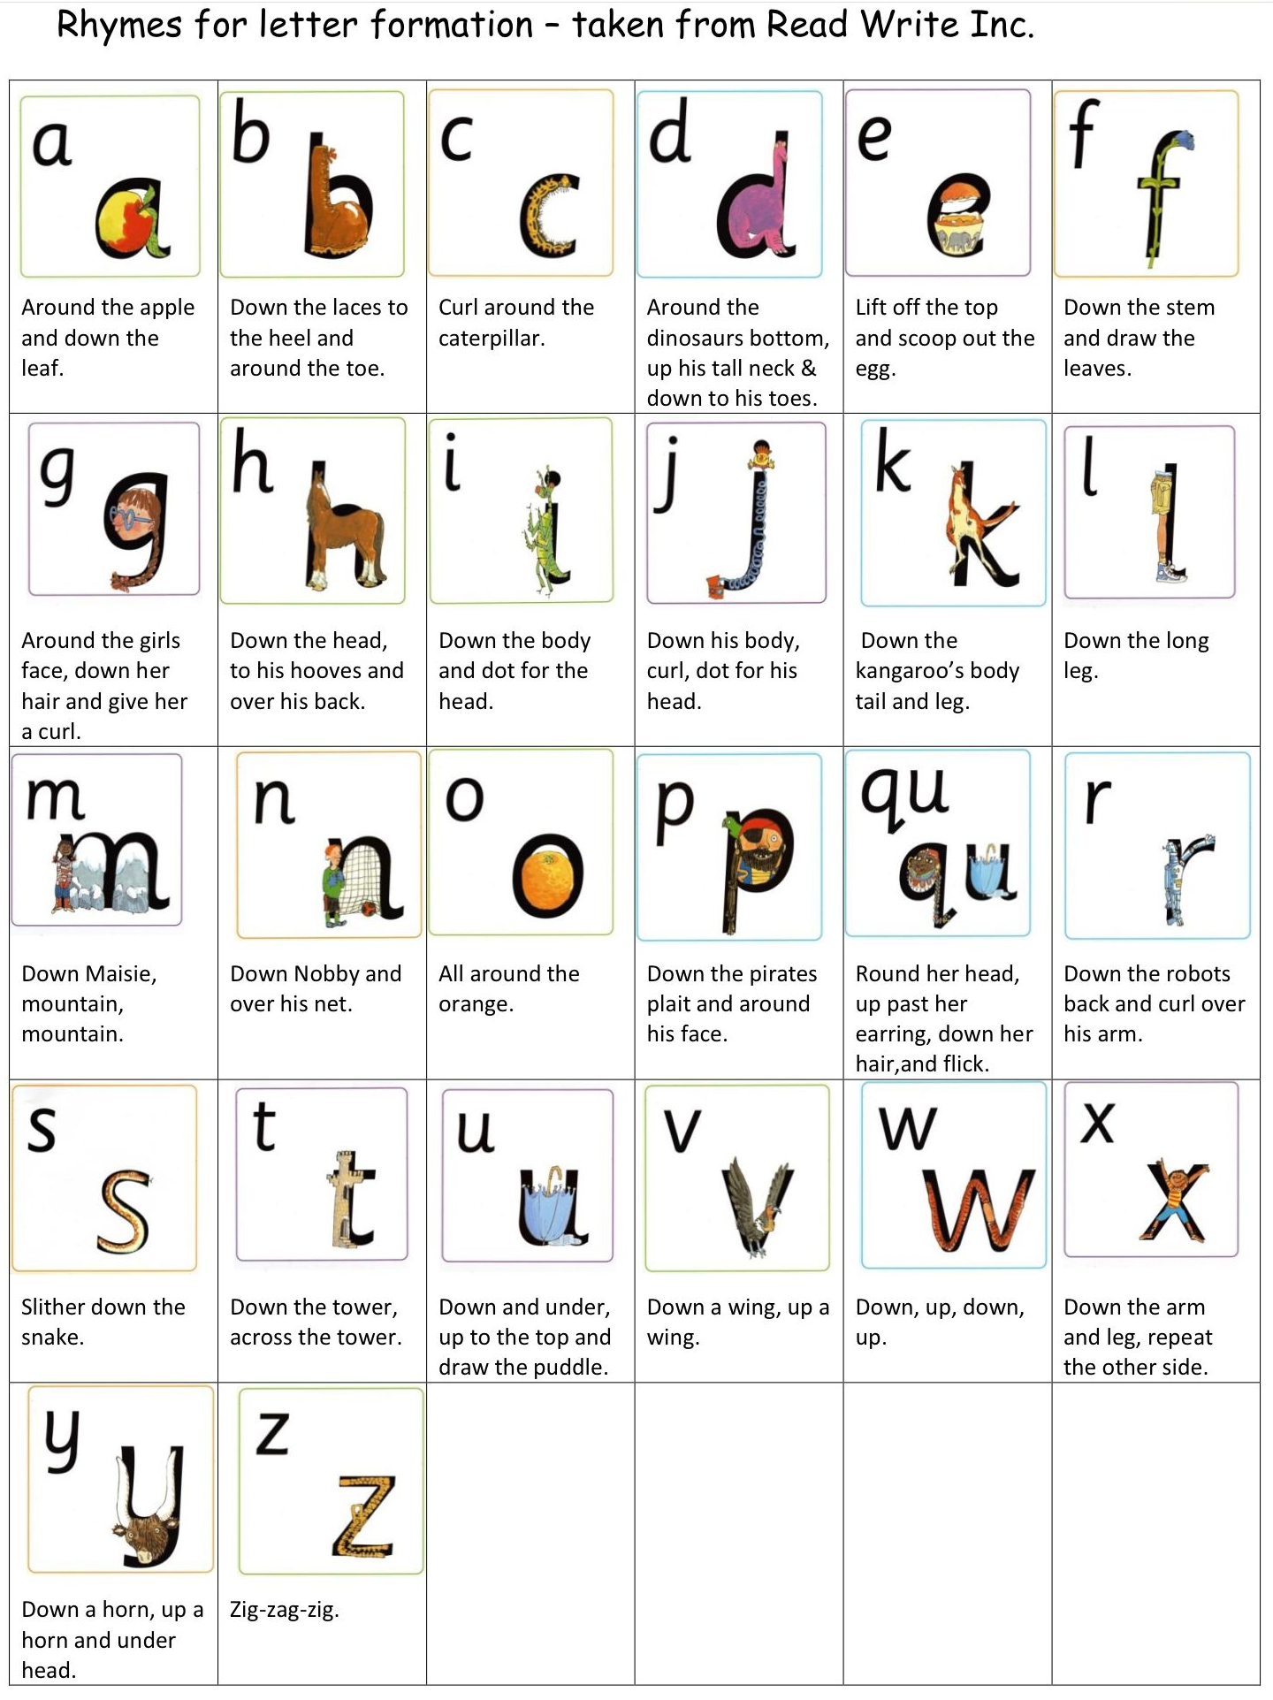

Mathematical Development.

- In nursery we need the children to realise that anything can be counted not just numbers. Eg. Claps, jumps, steps. You could set up a dinosaur theme course/trail and challenge your child to Clap/Jump/Hop a certain number of times when they reach a specific dinosaur. Similar to the one that one of our Mam’s shared on twitter.

- There is an app available on android called ‘Dino Games’ which has lots of matching games on it. These games enable your child to develop an understanding of one to one correspondence, by matching pairs of objects or pictures. You could adapt this concept as you like, eg: Finding matching toy dinosaurs if you have some or drawing/printing sets of matching dinosaurs. Or try inventing a new matching game to share with us on twitter.

- Here’s a fun activity for size comparison. Ask your child to build a tower as TALL as the dinosaur. If you haven’t got toy dinosaurs your child could create some from your recycling and measure those. You could use Lego, Duplo, Stickle bricks. Whatever you have to hand.
Discuss with your child which is the TALLEST/SHORTEST? Dinosaur/tower. You could have a competition!
You can also investigate the towers using the terms MORE or LESS bricks. Asking your child which one used MORE/LESS?

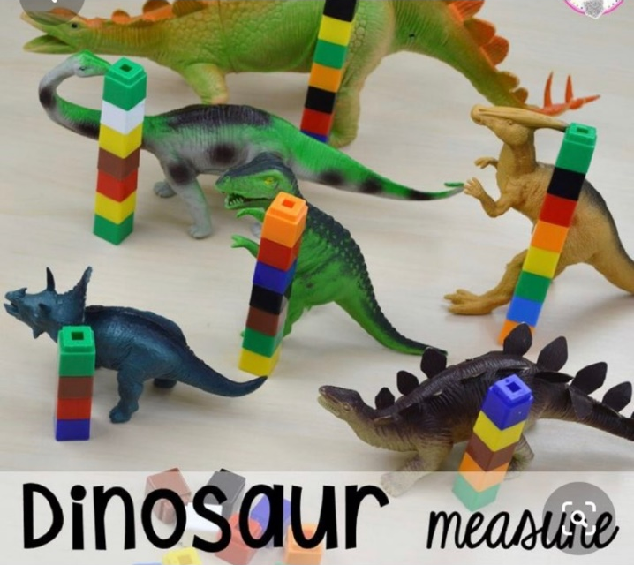

- Here’s a lovely counting and discovering story Called ‘Hide a Saurus’

https://www.youtube.com/watch?v=w9QpjTFD9VA&t=484s

- Daily in nursery we teach the children to count to 10 forwards and backwards using songs and rhymes. I have found this song on ‘you tube’ which will help your child with this. As well as a fun way for you both to learn the names of different dinosaurs.
ctrl & click the link below: https://www.bing.com/videos/search?q=10+little+dinosaurs+song+youtube&docid=608015086418855071&mid=AA123CC977F02A2F8595AA123CC977F02A2F8595&view=detail&FORM=VIRE

- Why not design a simple race track, either on paper/card or using a car/train mat or track.
- Allow your child to race some dinosaurs. You could use a dice to determine how many spaces each dinosaur moves. (This will help with number recognition and relating a number to its respective quantity). When the race is finished discuss with your child which dinosaur came 1st, 2nd,3rd or last. This is another concept your child needs to know by the time they leave nursery.
3
9
10
11
12
8
7
6
5
4
2
1
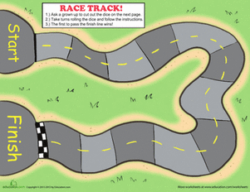

You could try something completely different and take a virtual tour of the Natural History Museum in London to see the Dinosaurs. Ctrl & click link
https://artsandculture.google.com/streetview/the-natural-history-museum/JQF3coVswSVUVw?sv_lng=-0.1762903879874216&sv_lat=51.49616592945689&sv_h=-109.70700419101597&sv_p=43.072121722341336&sv_pid=DEltO_m4LHeilnRUjvXiaQ&sv_z=1

Physical Development
Gross motor Development
Why not try
cosmic yoga kids adventure ‘Tiny T-rex’
and cosmic yoga ‘Dinosaurs and Dodos’ on ‘You Tube’

Fine Motor Development
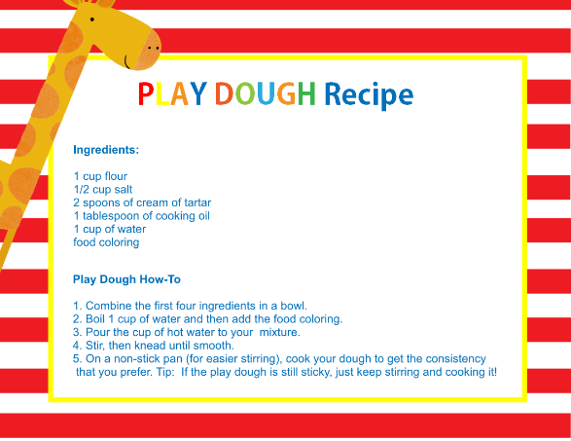
You could make your own playdough and transform it into dinosaur fossils.
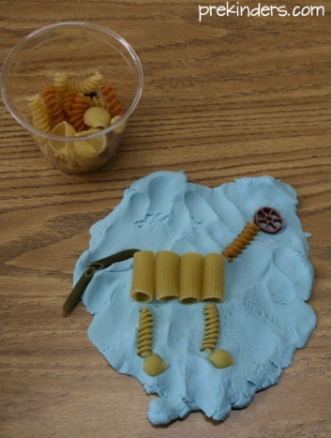

Have lots of fun. Be as inventive and creative as you like.
Please! Don’t forget to share.
Huge Hugs to the little ones.
Mrs Edwards and the Nursery Team xxx

