
School Closure Home Learning Pack
Mrs Jones’ Class, Year 3/4
Hello Y3 and Y4,
I hope you are all well. Here are this week’s activities.
In Maths we are going to continue learning about how numbers are made up (Place Value). We will also recap counting in twos, fives and tens.
In Literacy, I have listed the next three sets of words to learn. Do not move up a set unless you can spell at least 7 of the words in the previous set. Following last week’s work on capital letters, we will look at using question marks or full stops.
While we are all at home, it is important that we make sure that we look after our teeth. This week I would like you to map your teeth and dance along to the tooth brushing song.
Take care of yourselves and your families,
Mrs Jones x

Numeracy 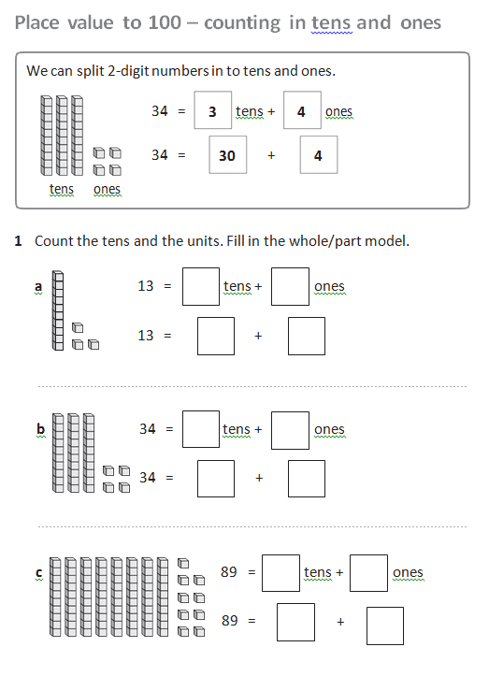
YEAR 3
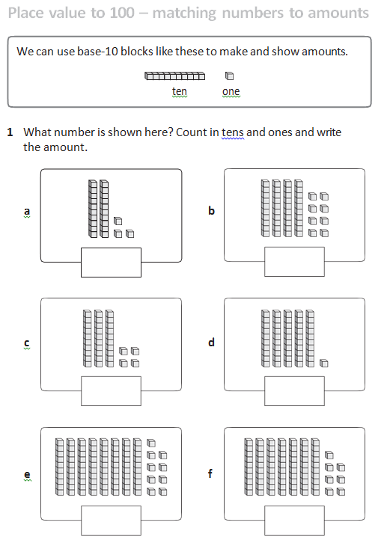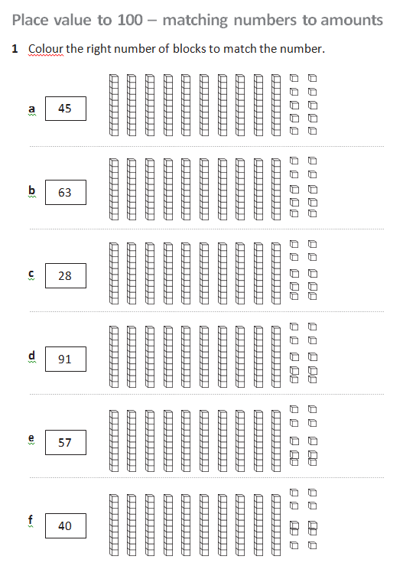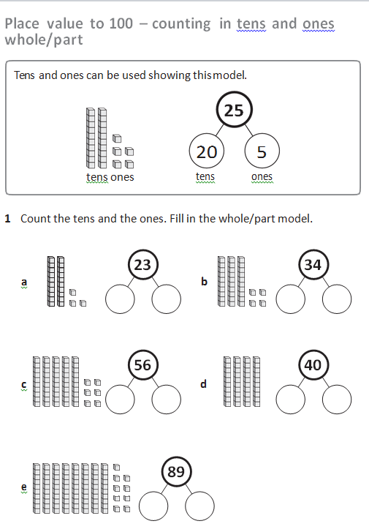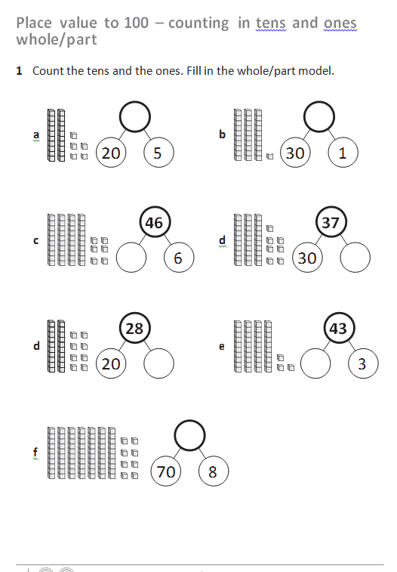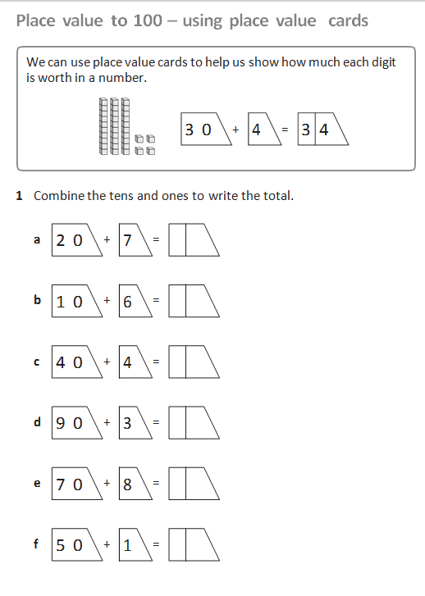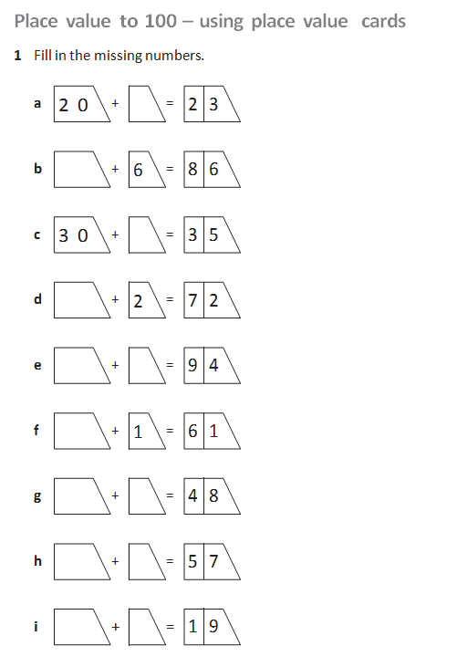
Year 3
Year 3
Year 3
Year 3
Year 3
Year 3
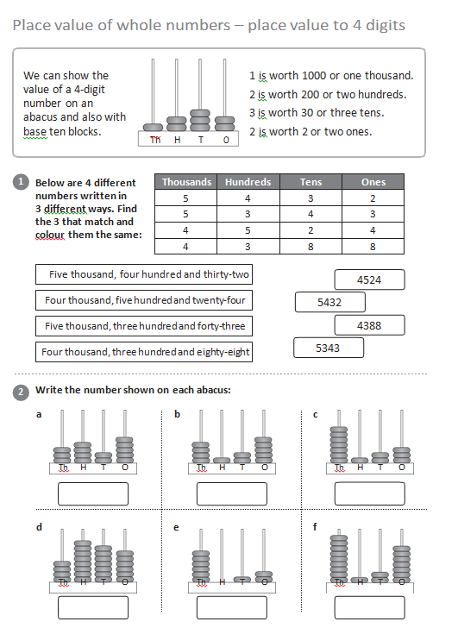
Year 4

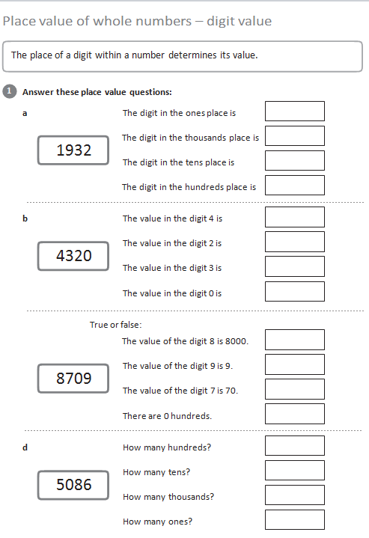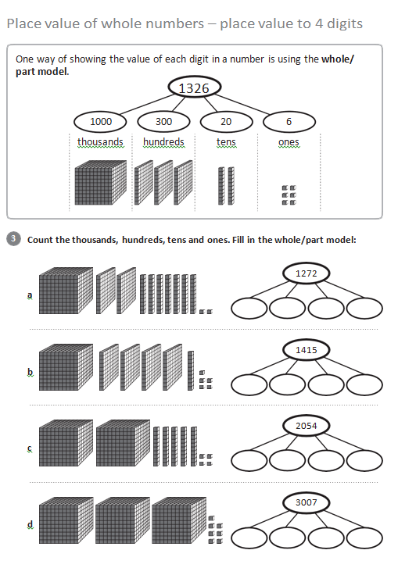
Year 4
Year 4
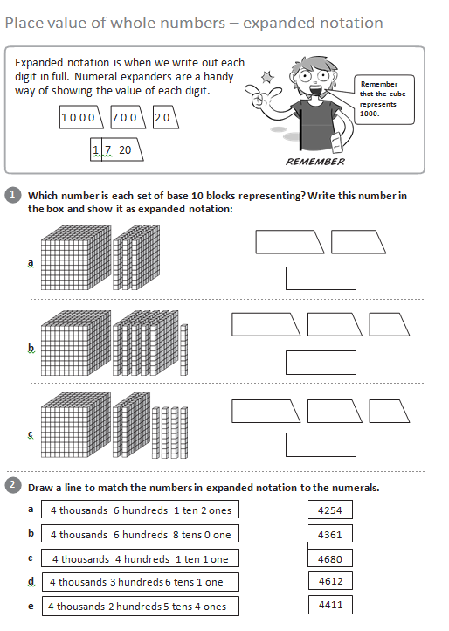
Year 4

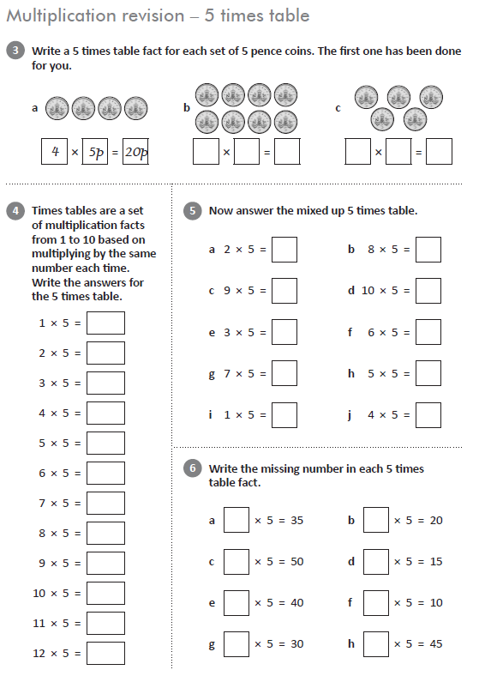
Year 3 and 4 Recap
Year 3 and 4 Recap
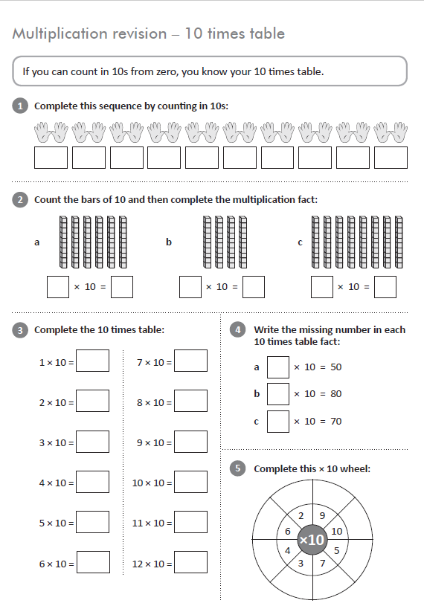

Year 3 and 4. See if you can do these without any help. If you can, write out your 4x table on a sheet of paper. Remember, the 4x table is double the 2x table.
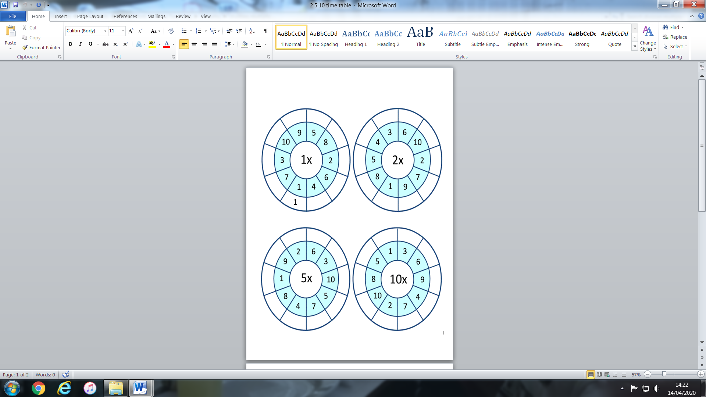

Problem Solving task cards for Year 3 and 4.
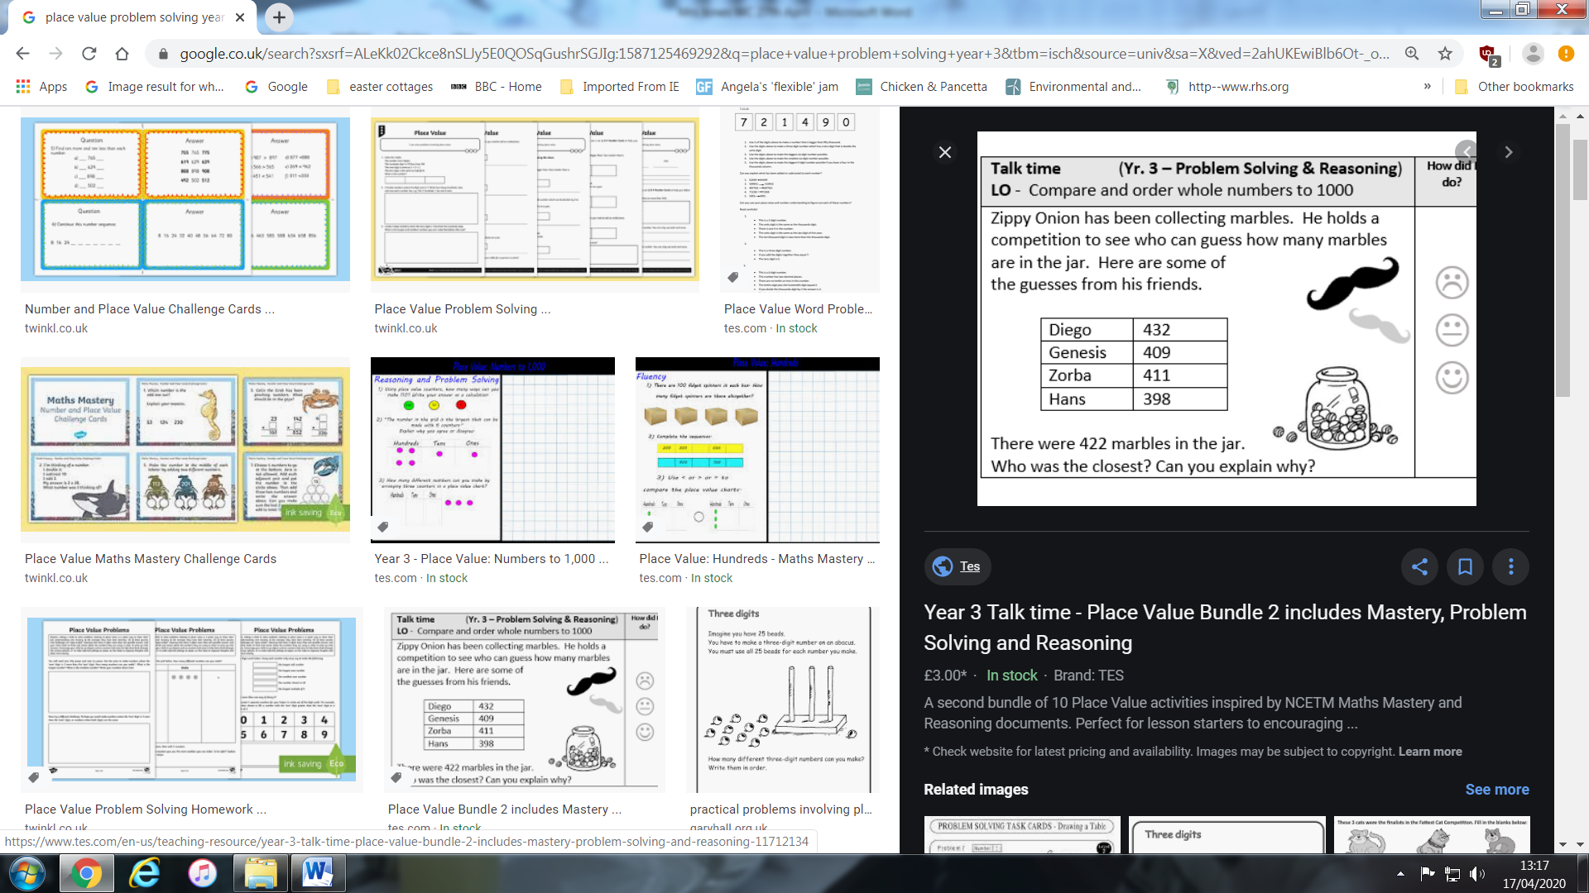

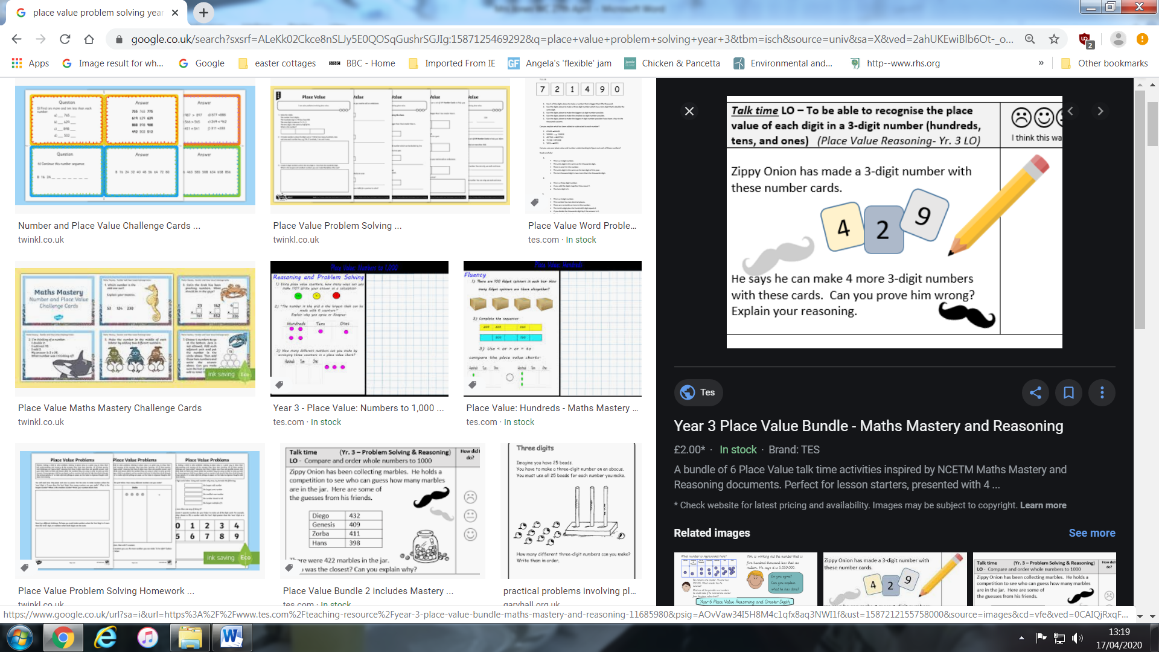

Literacy
Reading.
Read a little bit every day. On Friday try answering the questions.
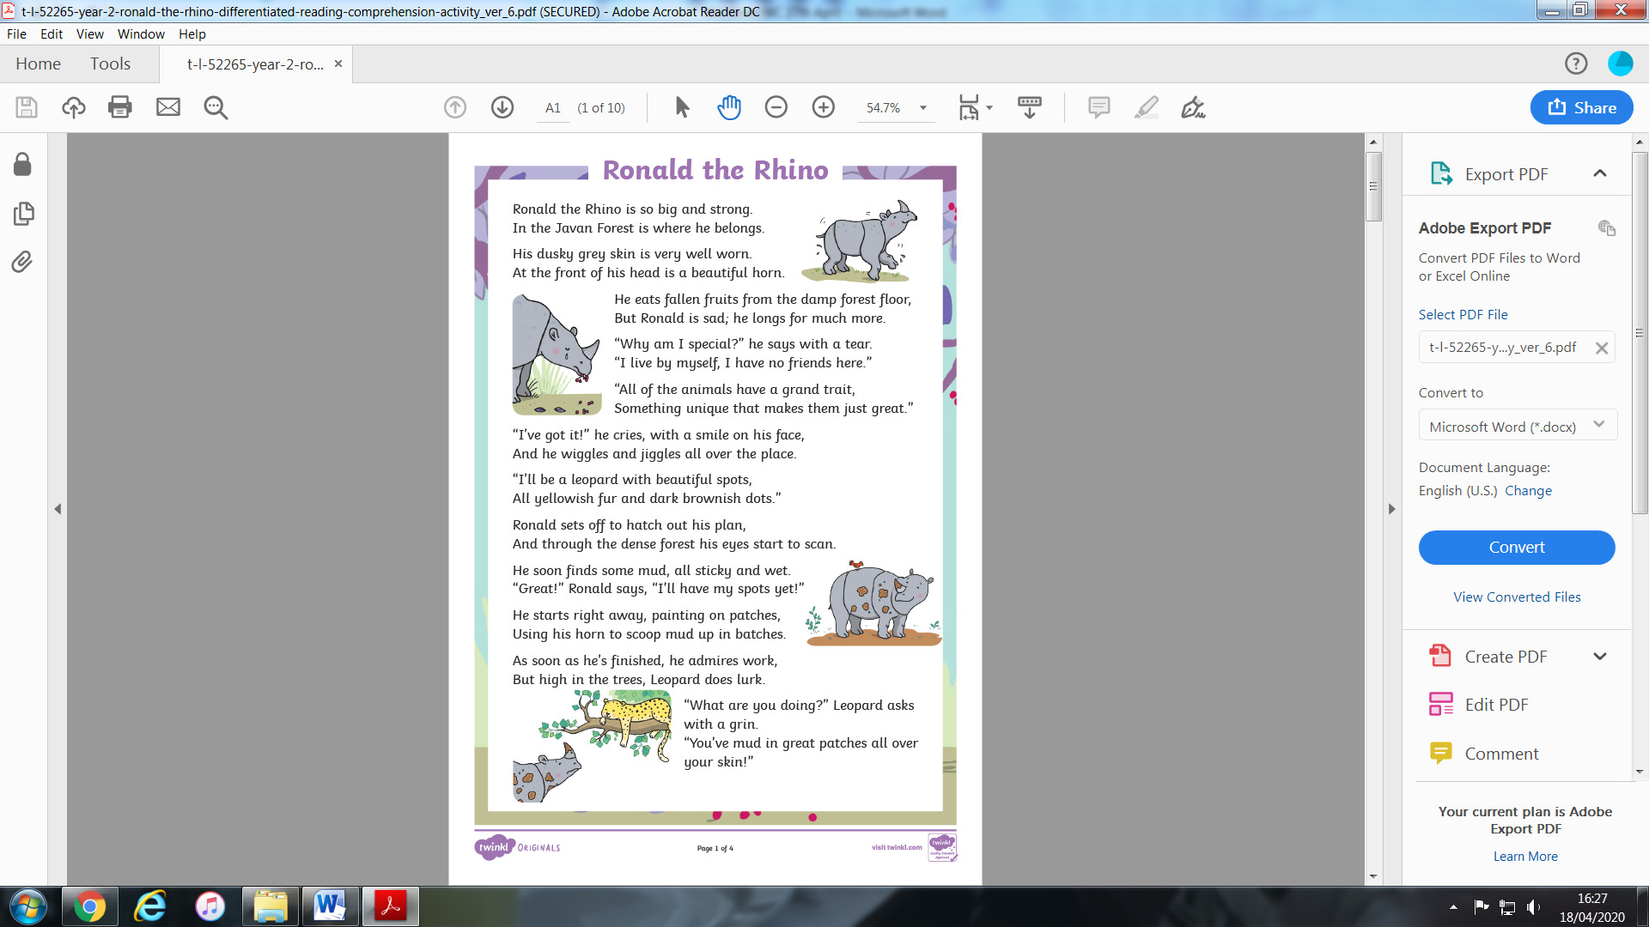
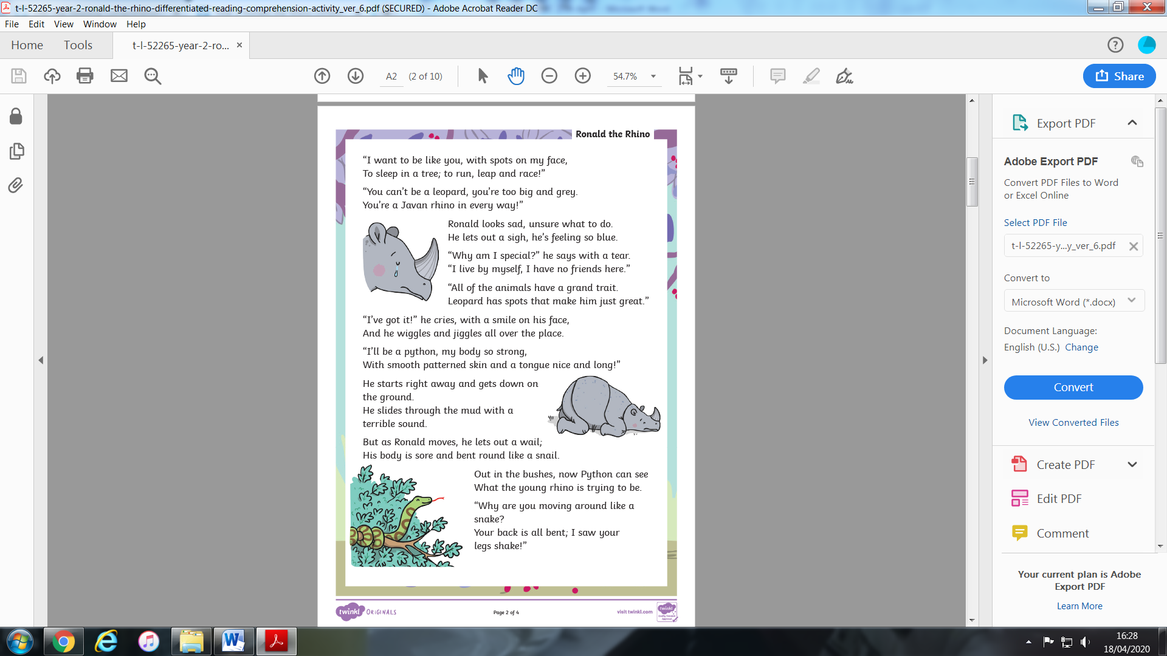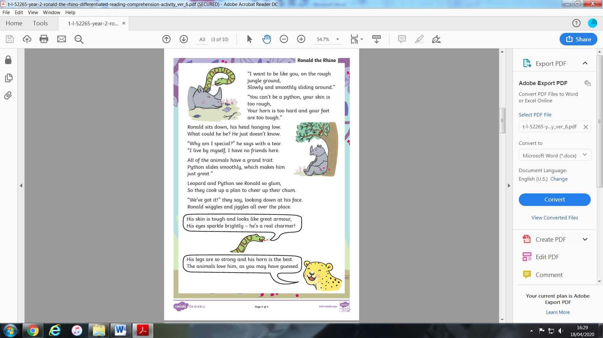
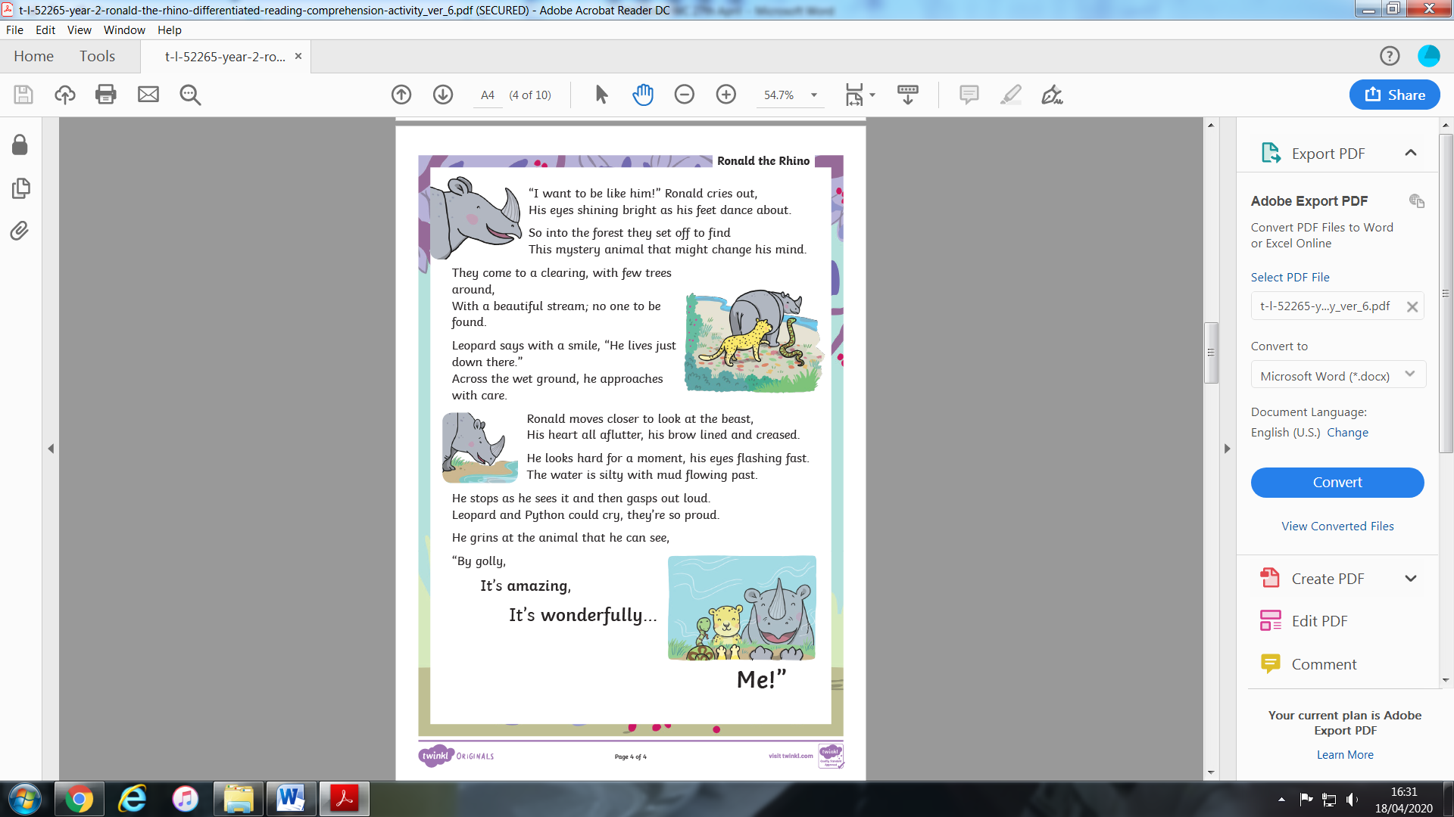
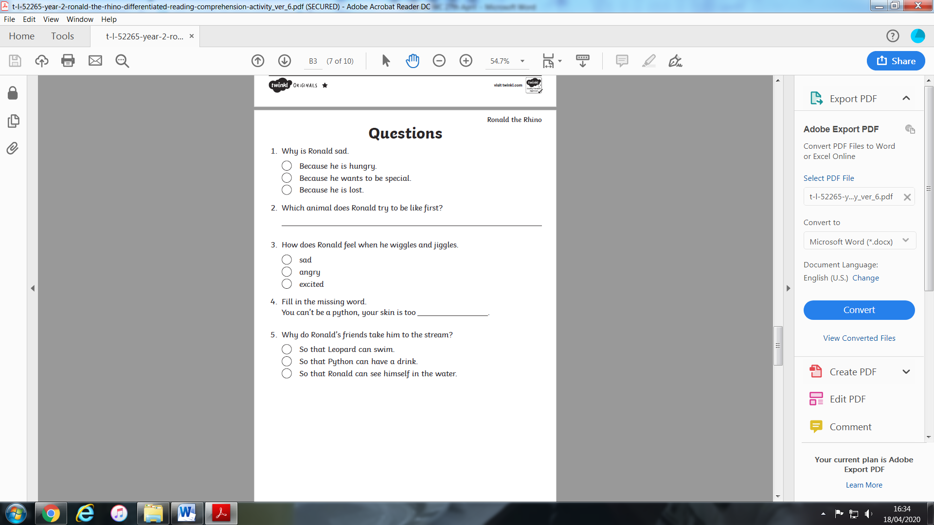
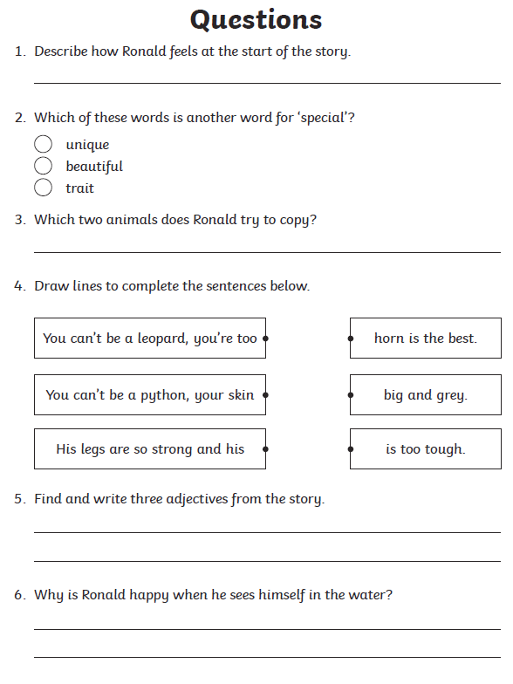
HFW Spellings
Here are the next three sets of words to learn. Each child in class is on a different set. Please do not move onto the next set until you have at least 7 correct in the previous set. When your child has learnt the word, ask him/her to write a sentence using that word.
SET 6
little
there
but
play
first
school
these
door
took
what

SET 5
make
made
came
as
into
now
when
so
them
then

SET 4
see
will
her
was
on
his
come
look
from
some

Punctuation – Question Marks and Full stops.
Look at the poster about question words. You all know that sentences end with a full stop. Sorry! some sentences end with a question mark. Did you already know this?
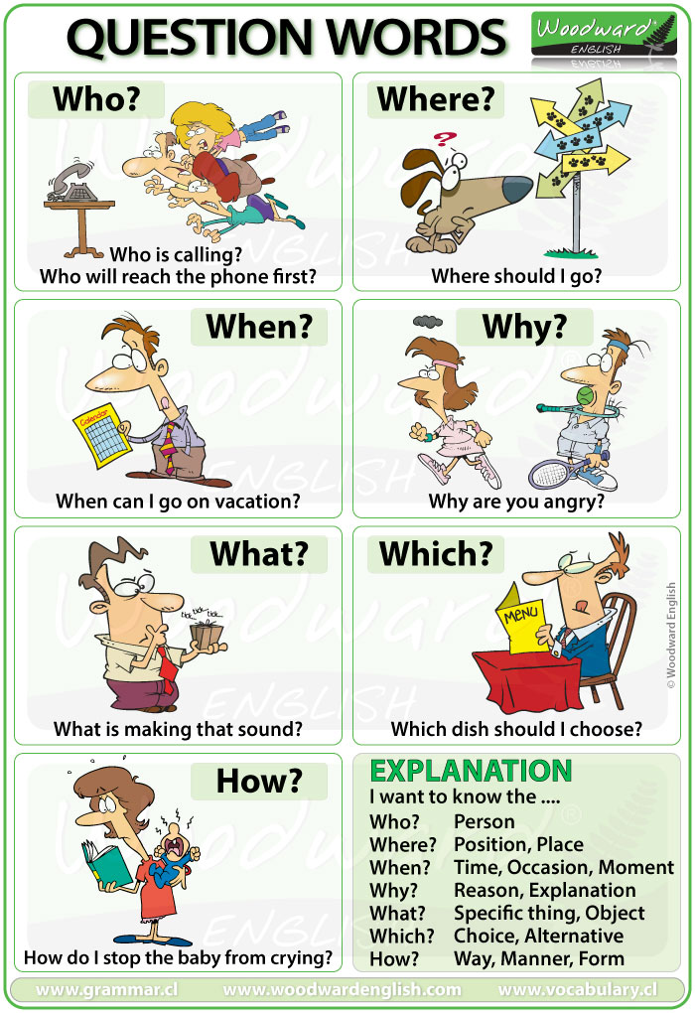

What is a question?
A question is a type of sentence that we ask or write to gain further information from a person or people responding.
Written questions are punctuated with a question mark to show that the sentence has been completed.

Watch the video clip at the following link
https://www.bbc.co.uk/bitesize/topics/z8x6cj6/articles/zcm3qhv
As you can see the question mark goes after the last word in the questioning sentence.
Year 3
Have a go at re-writing the sentences and putting in all the punctuation, (Capital letters, full stops or question marks).
I went to the football match on Sunday
When will the party begin
Which of these are your favourite
Sam and Tom visited their friend on Saturday
The bench has green cushions
Why are you crying
Where are the tickets
Copy the question mark ten times.
? ? ?____________________________________________
Write two sentences and two questions of your own.
__________________________________________________________________________________________________________________________________________________________________________________________________________________________________________________________________________________________________________________________________________________________________________________________________________________________________________________________________

Year 4
This is a bit harder. You have to read and understand each sentence to decide if information is being asked for, or if a statement is being made. Don’t forget your capital letters!!

- blowing fiercely, the wind gusted through the frost-covered valley
- what time does the film start
- what I wanted was out of stock
- this is the best present ever
- the ornate, mahogany wardrobe was covered with dust
- sit down now
- how do spiders spin their webs
- hidden beneath the autumnal leaves, the fox watched a rabbit slowly approach
- how dare you speak to me like that
- can I borrow a rubber
- why is your P.E. kit on the floor
- you made me jump

Phonics – Spelling
Have a go at the following online games.
https://www.phonicsbloom.com/uk/game/fishy-phonics?phase=2
https://www.phonicsbloom.com/uk/game/alien-escape?phase=3

Topic
Health and Wellbeing – Teeth
While we are all at home it is really important that we look after our teeth, especially because Dentists are not open at the moment.
Did you know:

Your teeth are uniquely yours.

Your teeth are like your fingerprint: They’re uniquely yours. This is why dental records are sometimes used to identify human remains. Even identical twins don’t have identical teeth. Bonus fact: Your tongue also has a unique “tongue print.”

Your mouth is home to 300 types of bacteria.

Plaque contains millions of bacteria, made up of 200 to 300 species. The main culprit for poor tooth health is Streptococcus mutans, which converts sugar and other carbohydrates into the acids which eat away at your teeth.

They’re a bit like icebergs.
About a third of each tooth is underneath your gums. This is why keeping your gums healthy is as important as making sure your teeth are well cared for. Your gums should always be pink in colour, and firm.

But it isn’t invincible.
Even though it’s there to protect your teeth, the enamel can still chip or crack, and it isn’t safe from decay. Sugars and acids, like those found in soft drinks, interact with bacteria in your mouth and attack your enamel, which marks the start of tooth decay. Soft drinks are particularly damaging when you drink them often, or slowly throughout the day.

You make 10,000 gallons of spit.
Your body produces about a quart of saliva every day, which comes out to about 10,000 gallons over a lifetime. Saliva plays many important roles in your overall health. For example, it makes food easier to swallow and contains enzymes to jumpstart digestion. When it comes to your teeth, saliva washes away lingering food particles, and contains calcium and phosphate, which can neutralize the acids in plaque that cause damage and decay.

Make sure you brush your teeth at least twice a day. Listen to the Buzzin & Brushing song on You Tube.
https://www.youtube.com/watch?v=q-gvPOgvovc
I use this at home to help me time my two minutes of brushing.
See what other facts you can find out and make a colourful poster about the importance of brushing your teeth.
Science
Watch the video clip about teeth: https://www.funkidslive.com/learn/hallux/dentist/what-are-all-the-different-types-of-teeth-and-why-do-we-lose-our-baby-teeth/
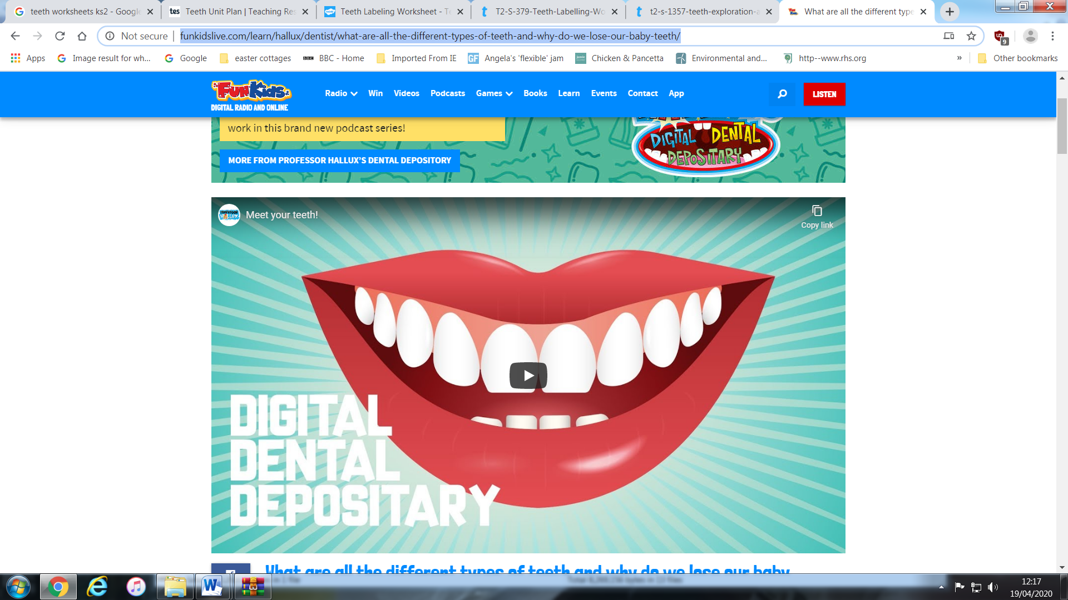

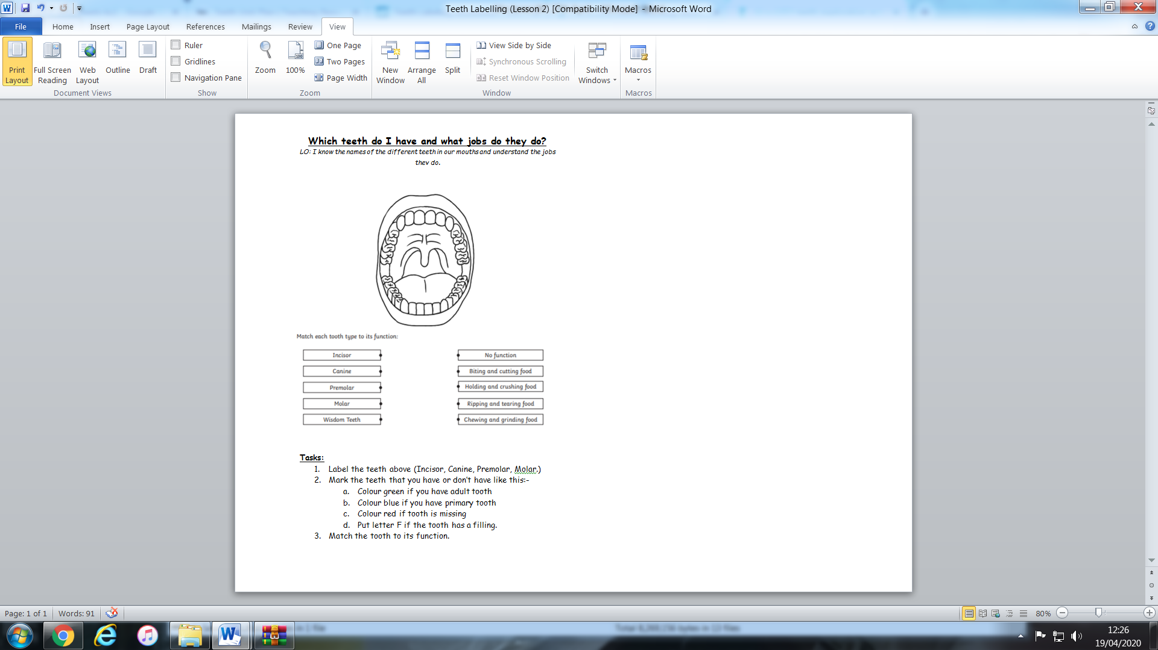
Humanities – History
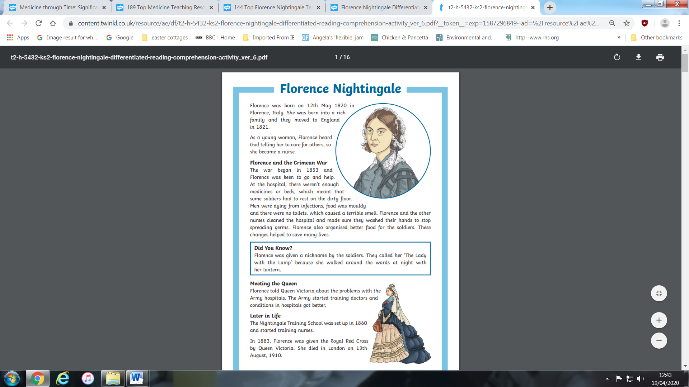
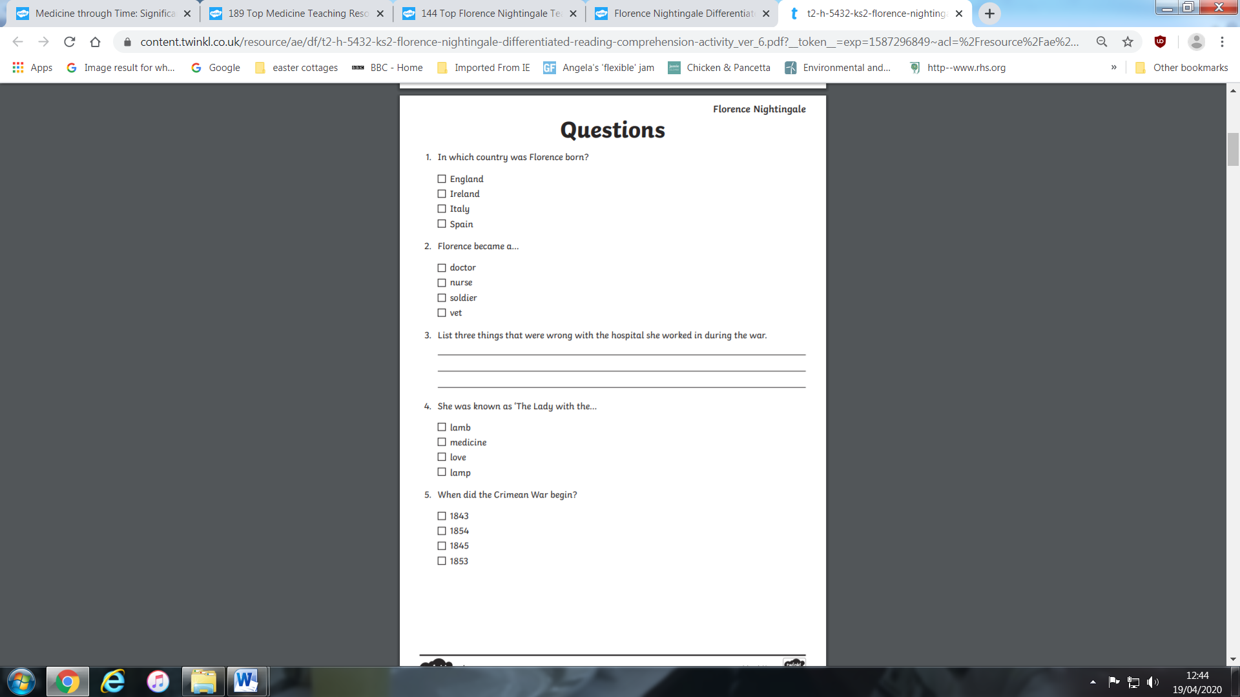
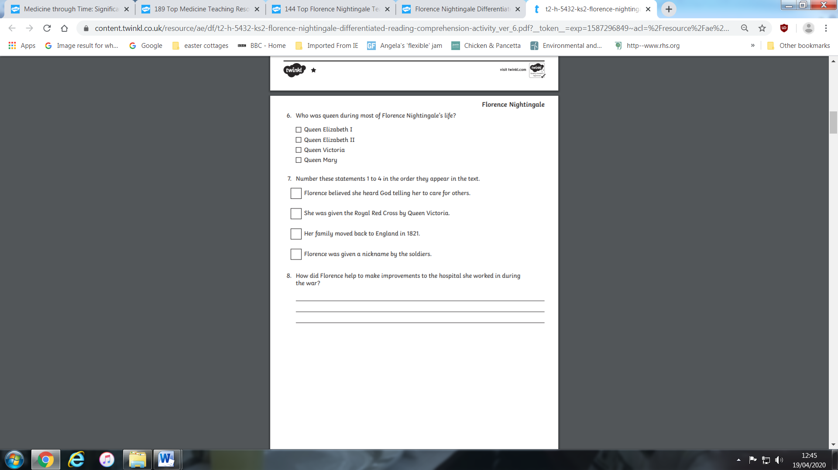

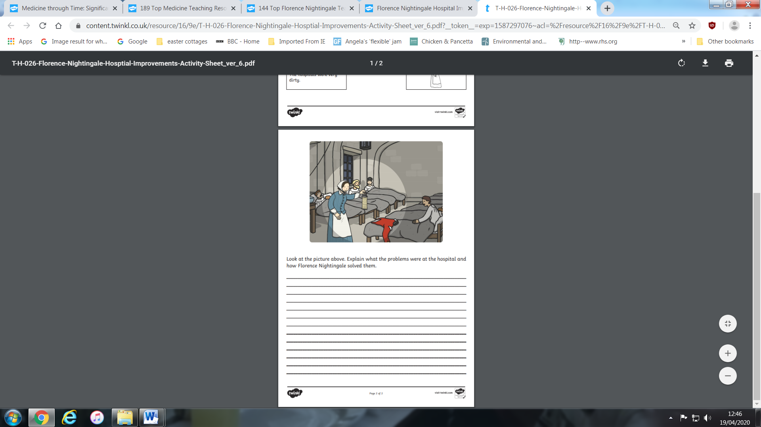

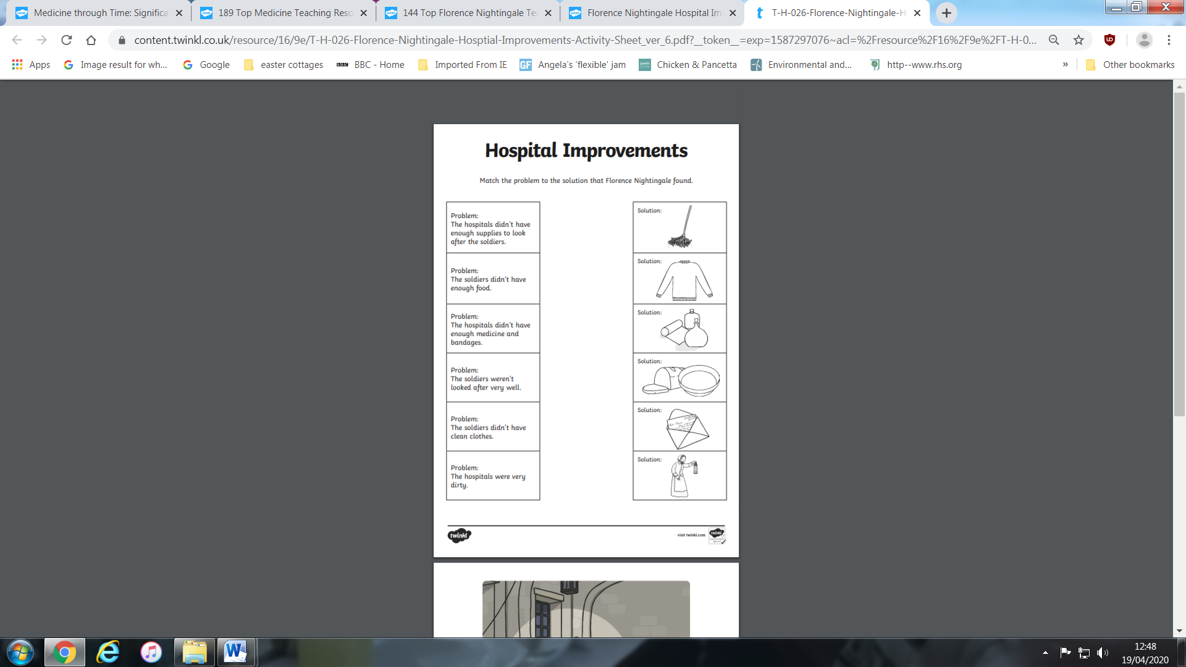

Expressive Art
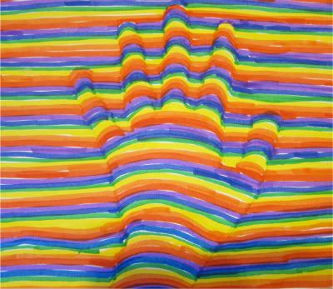
https://www.youtube.com/watch?v=YNEXzvnD7mI
Have look at the video above and have a go.
- Draw around your hand.
- Use a ruler and mark 1cm along the side of the page on both sides.
- Join each side but do not go over the hand.
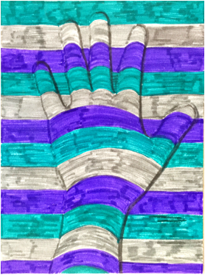
- Draw curved lines over the hand.
- Colour in the hand.



