Week 4- Reception

Summer Term: The Seaside

Hi all,
I hope this finds everyone well and healthy. It has lovely to speak to many of you and Mrs Chapman and Mrs Lane has enjoyed their chats too.
This week there are a range of things you can be doing to help your child keep their focus and education going in the right direction.
Literacy:
Oracy (Speaking and Listening)

I have attached a hyperlink to CBBC ‘Tig goes to the Seaside’ for you and. Your child/ children to watch. Below are some points of discussion:

https://www.bbc.co.uk/cbeebies/radio/woolly-and-tig-the-seaside

- What does Tiggy think is great about going to the seaside?
- What kind of activities does Tiggy do at beach? What kind of activities do you do at the beach?
- What are your favourite things about going to the seaside?
- Are there any thing you don’t like about the seaside? (I love the seaside but I don’t like the seaweed or when the sand gets in my food).

Reading
On Sunday myself and my husband went for our daily exercise and went for a walk around by the knap lakes and Jackson’s Bay which is close to where we live. When I was there, I took some pictures of the seaside to remind you of some of its features. Obviously, there were very few people there and the shops and cafes were closed but it made me realise how peaceful the beach can be and how busy and noisy the beach can be in the summer. So, on that note I have chosen a book for you to read and explore about a very busy part of the beach,( which I’m sure is still busy even when we are in lockdown)- Under the Sea.

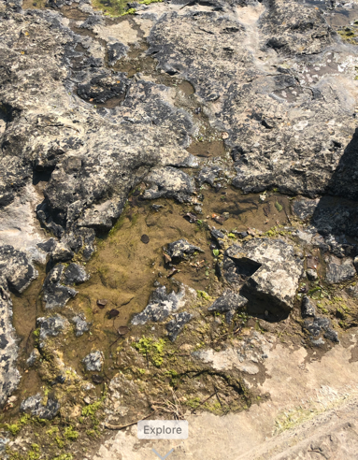
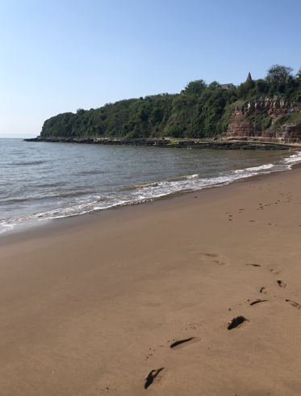
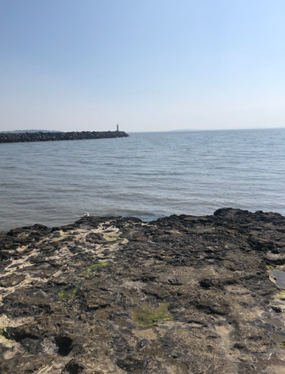

The book is called Starry Eyed Stan

Please read the book- it is the file labelled Starry- Eyed Stan and is in PowerPoint view so you can enjoy the pictures and explore them and the words together.

Activity:

There are so many under the sea creatures in the text, how many can you remember? Say a list and get an adult to write them down for you? Can you draw any of them?

Rhyming activity:

There is a lot of rhyming in the book. Listen to the story being read to you can you shout ‘snap’ when you hear a word that rhymes with another (this is a great activity to help listening skills).

Phonics:

Sh- sound can you read and practise the ‘sh’ sound- Below is a list of words with the ‘sh’ sound in which are linked to the seaside- can you try and work with an adult to break them down and work out what they say?

Can you think of any other words they do not have to be seaside related maybe you have a ‘sh’ sound in your name.

Sh ar k
F i sh
Sh e ll
Sh ore
Sh in g le
Beach sh o p
Sh i p
Beach sh a ck
Sh a ll ow water
Sh e ll f i sh

Writing
Please, please keep practising those formations and their names it is so important for the children to be confident and solid in their formations before they go to year 1. The biggest favour you can do for your child is read to them and keep practising their pencil grip and letter formations. Things will be so much easier for them as they develop through the year groups.

Find the ‘sh’ sounds in the sentences:

I love going to the fish restaurant to order shellfish.
I like to swim in shallow water it is not such a shock if you go under.
I am going to have a rest in the beach shack.
My family love going to the beach shop and buy shells and souvenirs.

Numeracy:
Size and comparisons:
When we talk about size in the early years, we use the following vocabulary – We try to use the different variations of the words so your child has a good understanding and a good choice of descriptive words.

Large, larger, largest, big, bigger, biggest, huge and massive.
Small, smaller, smallest, little, tiny.

Challenge 1: Can you draw 4 fish getting bigger?

Challenge 2: Can you draw 4 crabs start with the biggest and then get smaller?

Activity: Interactive game:

Use the link to play the size game. When you get onto the welcome page choose ‘At the Beach’

https://www.topmarks.co.uk/early-years/lets-compare

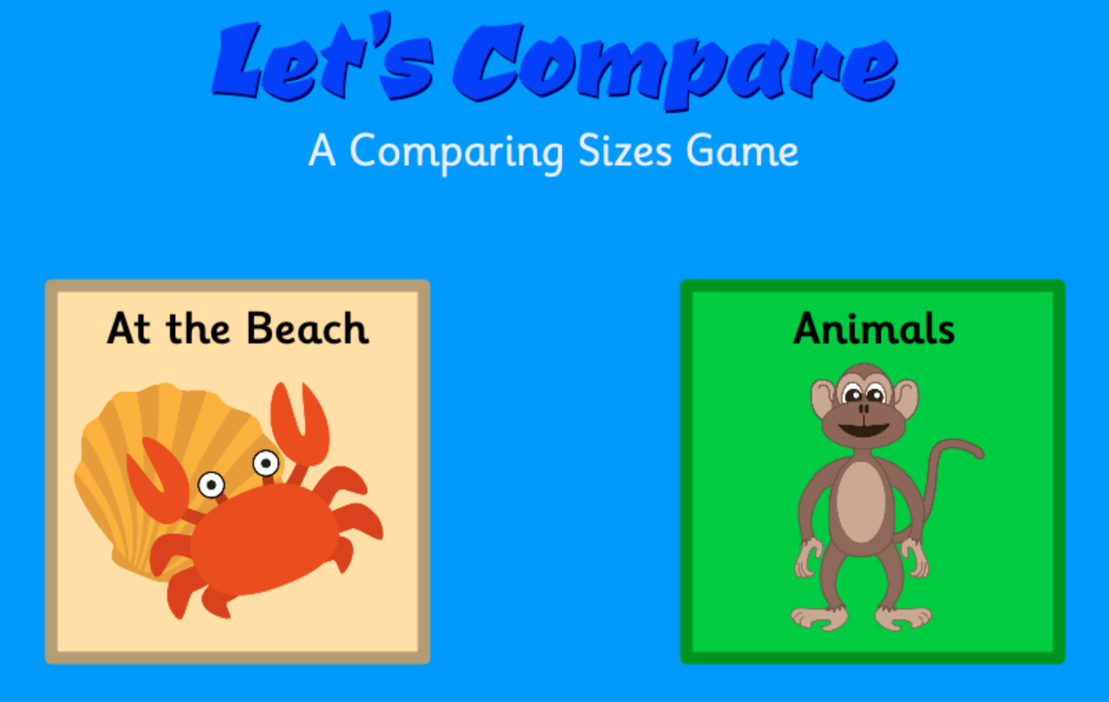

Anything you wish to share with us pop on twitter so we can see it.
Lots of love and speak soon, Mrs Brown xx

