Hello again everyone.
I hope you are all still staying safe and keeping fit and well.

Thank you to those of you that have been able to share their child’s activities with us on twitter.
It has been lovely to see you all embracing and enjoying your home learning.
I am trying hard to accommodate all of you with the activities I am setting. However, I am also aware that not all of you have access to certain resources.
Please don’t panic if you haven’t got certain resources. All we ask is that you try your best and adapt the activity to anything you have at home. After all it is the learning outcome of the activity that is important, along with it being something that your child enjoys. As this will ensure that your child is engaged in the activity.
Week 5 Week Beginning 04.05.20
Language and Literacy Activities.
- Please continue to read stories to your child. (Dinosaur stories preferably), asking questions after the story is finished. Please Don’t worry if you haven’t got any dinosaur books as any story will be fine.

Please can you help your child learn this poem this week. It would be lovely to see them reciting it and putting some actions to it on twitter.
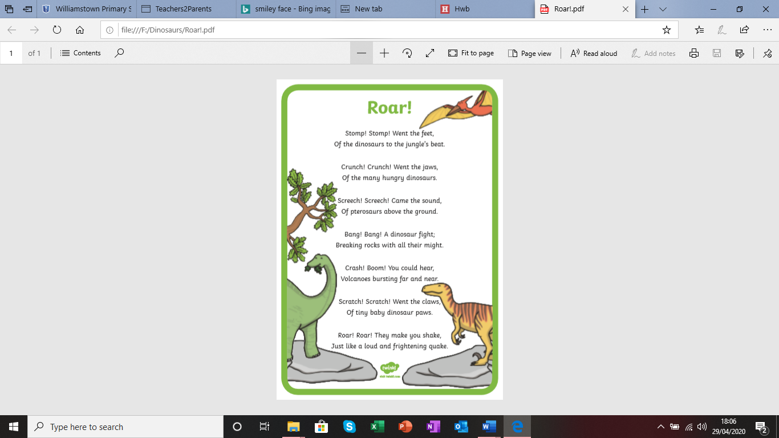

- It would be beneficial to your child to know as many of the alphabet sounds as possible by the time, they go to reception class.

- An easy way to help with this would be to access the ‘Jolly Phonic Songs’ on You Tube at ctrl & Click this link https://youtu.be/J1ZludcLyi8
- The children also enjoy watching alphablocks on You Tube ctrl & click the link https://youtu.be/s7LjGDcXqcs

- You could play a dinosaur sound matching game. Here is an example
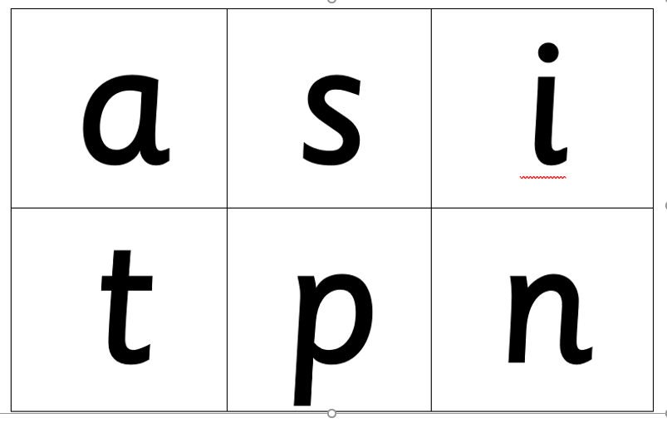
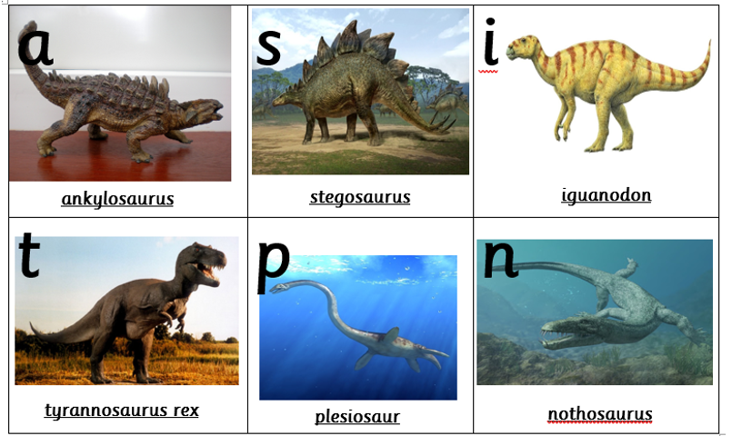

The original is available in the printable section on the website.
(Keep the pictures on a page to act as a board. Cut out the letters and ask your child which sounds they are? Can they find they matching sound on the board?)

- Another idea would be to play alphabet snap or pairs. You could use any alphabet cards for this. You could even make your own by writing lower case letters on paper and cutting them out to make cards. Or if you have access to a printer there are some dinosaur alphabet cards in the printable section on the school website :

- Another lovely matching game would be to put some alphabet labels on your child’s toy dinosaurs and match them to alphabet cards laid out on the floor or table.

- Or you could go on a Dinosaur alphabet hunt. Hide some Dinosaurs with the alphabet labels on them. Give your child an alphabet card and ask them to hunt for the dinosaur with the matching label.
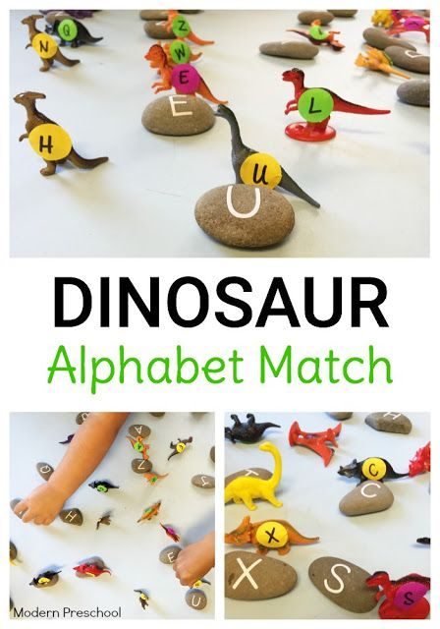
- Lots More activities can be found on Pinterest
- https://in.pinterest.com/pin/Ae_hoplejnCHJidcHLOxKElqL59nIQXZ7lFrzWvPbiXNXZJNtNR-x5c/

- It is also always a good idea to revisit previous activities to ensure your child retains any information they have learned.
- Please continue to help your child recognise their name, and if they feel confident and happy enough, they can try writing it. Remember it doesn’t have to be on paper, they can write in sand, rice, paint, flour, shaving foam, conditioner. Usually the messier the better.



Mathematical Development:
This week I would like to concentrate on shape and number recognition.
At the end of their nursery year, the children would be expected to recognise and name a circle, square and triangle. Can they tell you how many sides/corners the shapes have?
If possible, I would also like them to recognise and name a rectangle.
If your child is consistent in the knowledge of these shapes you could begin to talk to them about the 3D shapes cube, cuboid and sphere.
The children would also be expected to be able to recognise, compare and order numbers 1-5 at the end of their nursery year.
If your child is already confident with numbers 1-5 you can move on to recognising numbers to 10.
If they are confident and consistent with this, they could try counting in 2’s to 10
With this in mind I have set the following activities to help:
Can your child build a shape dinosaur? They could use stickle bricks or blocks they have at home. Or hunt around the house for any shape items that could be used. Alternatively, you could draw shapes on a piece of paper or card or print out the shape sheets available in the printable section on the website..

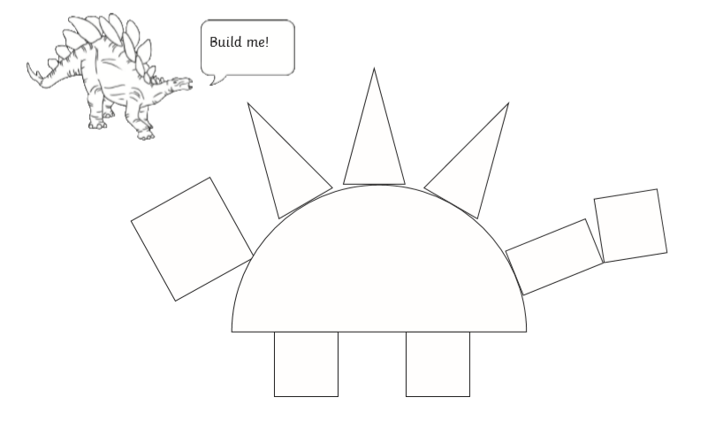
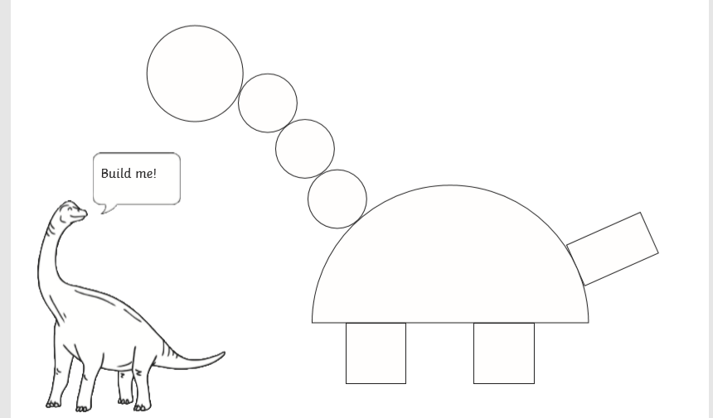

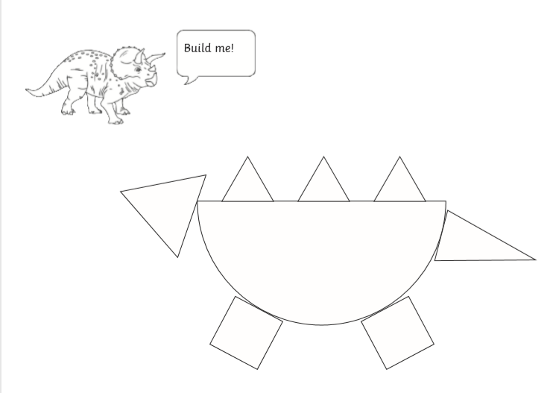

- As for number recognition you could adapt the dinosaur hunt and matching games that I mentioned in the Language and Literacy section and replace the alphabet with numbers.
If you do want some cards to print, I found some relating to the ‘Hide a Saurus’ story that I mentioned last week, they are available in the printable section on our website.
Please ignore the number word cards. Your child is not expected to know these. It was the way they card’s downloaded. Sorry.

- If you have any magnetic/foam/plastic numbers at home. An activity that the children love in school is to put the numbers in jelly. When the jelly is set, challenge your child to find specific number and match it to a number card. This can also be done in sand, water, foam, gloop (cornflour and water mixed).

- A number of parents have told me that their children love to do worksheets. Please don’t feel any pressure but I have included some for those of you who wish to use them. These can also be found in the printable section.

- Also please continue to read/look at/listen to ‘Dinosaur Roar’ and discuss with your child the opposites that can be found in the story. Can they think of any other opposites? Eg: in-out, hot-cold, up-down etc. https://www.youtube.com/watch?v=5MMiiXlFNZA

Other useful links:

Follow this link for some fun weekly dinosaur ideas and printables:
https://www.theherdtheatre.co.uk/dinosaur
Follow this link to a child friendly animated song to help teach the name of the dinosaurs:
https://www.youtube.com/watch?v=P10p7ALXkcU&t=124s
Follow this link for a lively dino dance:
https://youtu.be/Imhi98dHa5w
Follow this link for lots of resources and ideas:
https://www.twinkl.co.uk/
Hope you have lots of fun. Enjoy!

Stay safe. Huge Hugs!
Mrs Edwards and the Nursery Team

