Summer term 1
Week beg: 04/05/20

Reception planning and ideas for learning
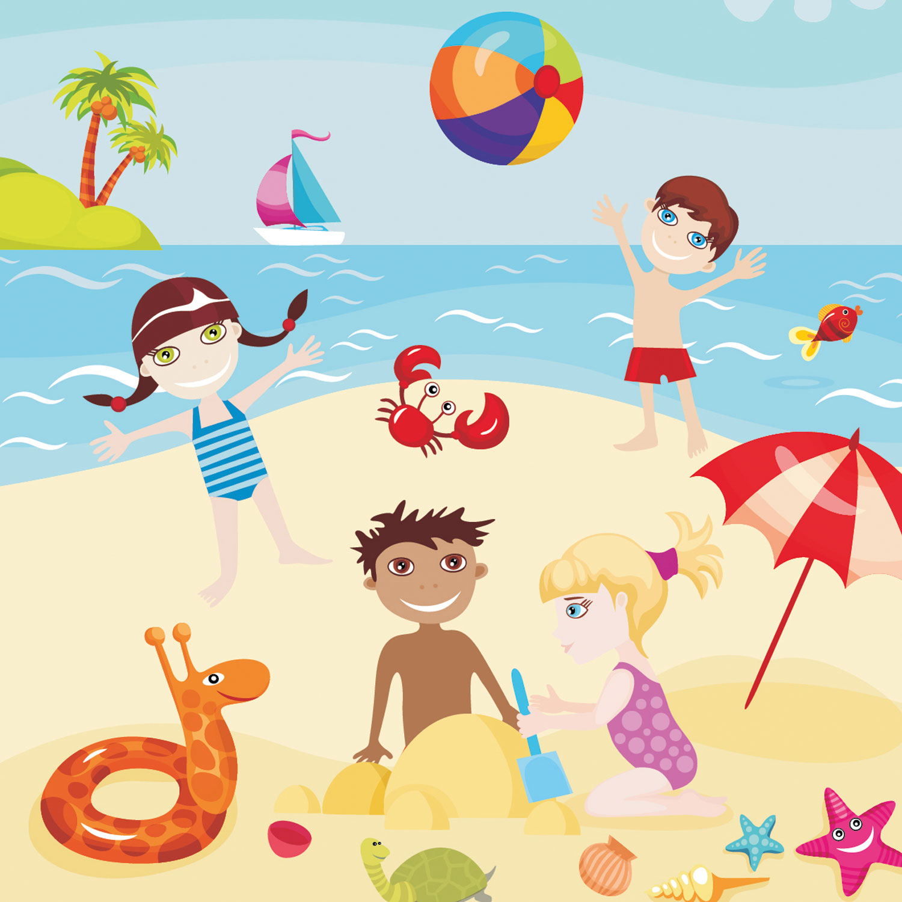
(Topic- The seaside)

Hi all,

Anyone else feel the they are now finding the situation difficult, well you’re not alone. Many parents are feeling the same. As time goes on it is probably getting more tricky to get your child to sit down and concentrate own learning. This is normal as we have been out of routine and school for longer and longer as time goes on. But remember what I keep saying, do not despair do what you can and try not to worry about it.
Have a look at this weeks’ activities and ideas.
Sending you loads of love and hugs and best wishes. Remember this is not forever and the main thing is we all come out of this the other side well and healthy.
Lots of love, Mrs Brown, Mrs Chapman and Mrs Lane xxx

Literacy : Continue to practise:

- Sounds (there is a copy of the letter formations and rhymes on the reception home learning page).
- Practise forming these by recording short cvc words such as sat, cat, mat, dog, him etc (a consonant, vowel, consonant).
- Name writing- begin practising surname too.
- Reading – bedtime reading. Of books, or you reading to your child. Make a list of simple words and hide them around the house, if they find them, they can keep them only if they can read them. If not. You keep it and see who wins by having the most at the end.

This weeks’ text ‘Lucy and Tom at the seaside’ by Shirley Hughes

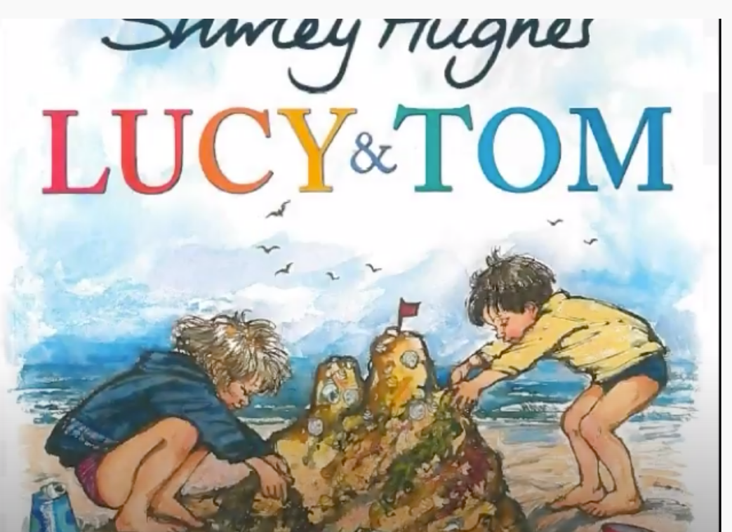

Please use the link to read the story with your child. Someone is reading it so they can actually explore the text alone if they wish. Please can you discuss the DIFFERENT ACITVITES AND THINGS YOU TAKE WHEN VISITING THE SEASIDE.

Here is the link to the website to read it: https://www.youtube.com/watch?v=ww5FPkawJdg

Writing

What would you pack in your case for the Seaside?
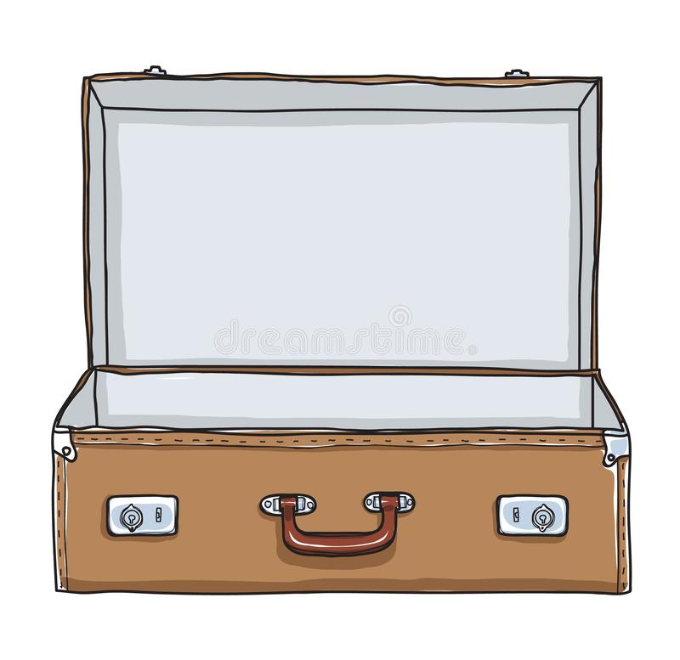

Can you help your child to make a list? They can suggest the items you may have to write the trickier words for them.

Here is an example


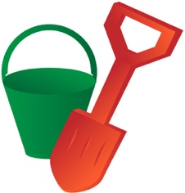




If you child would rather draw the outline of a suitcase (or you can) or you can print this one. They can then draw what they would pack. An example if above. The purpose of this activity is speaking and listening and to talk about the kind of items that would be suitable to pack and those that would not be for example: a bucket and spade would be a good idea, but you are unlikely to pack your skiing clothes.

If you write a list with them can they then read the list with your help and identify the right words?

Numeracy

Counting and recording numbers

When your child is completing this sheet please ensure they are forming their numbers the correct way and correct any reversals or mistakes. Practising number formations 0-9 is a great idea anyway.

Can your child accurately count the amounts and record the number of each seaside creature?
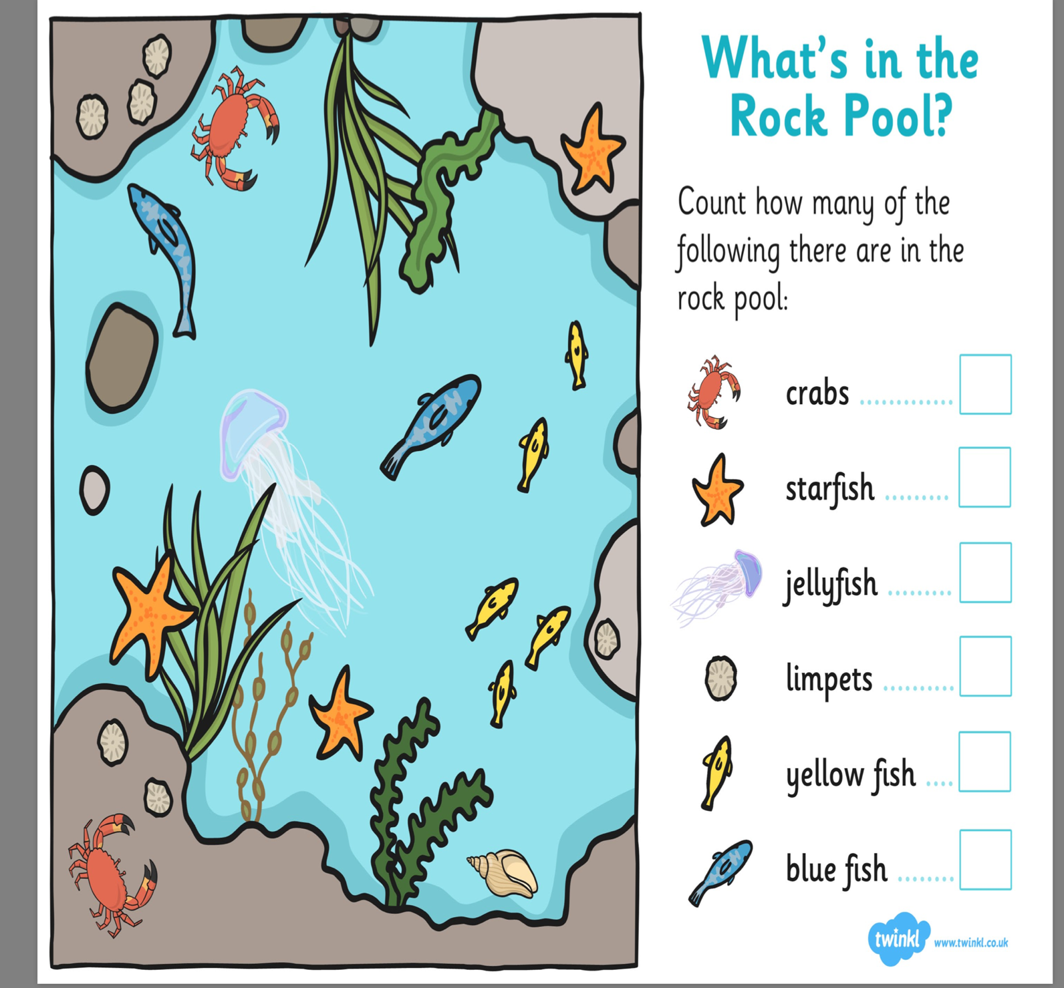

Weight and weighing

Have a discussion with your child about things that weigh heavy and light.

Can they find things around the house or in the garden that are light and heavy?
Can they split a piece of paper in half and draw pictures of what they find for example: they may spot outside the garden table which is heavy and then a leaf on the floor which is light.

Discuss a range of vocabulary we use when we are discussing weight eg: heavier, heaviest, heavy, light, lightest, lighter, weighing, the same and balance.

Another fantastic way to explore weighing and weight is any cooking or baking you can do which involves weighing out ingredients.
I undertook my first ever baking attempt during this lockdown period, there is a picture below -my husband said it was delicious but I think he had to say that after the effort I went to!
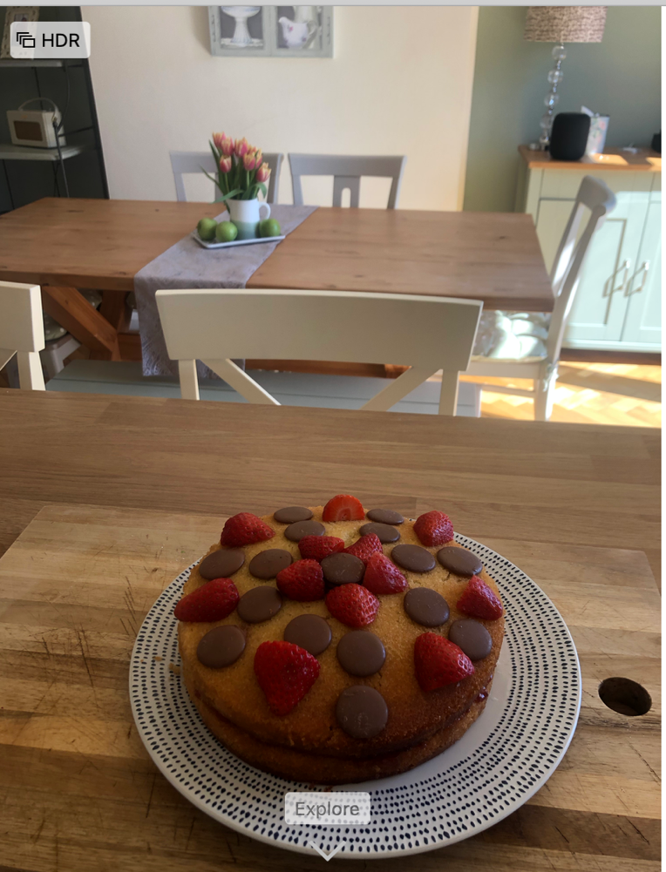

Strawberry and chocolate button Victoria Sandwich- well even Mary Berry had to start somewhere.

Heavy and light – another activity

Briefly explain to your child that some weights are measured in ‘grams’ and some weighs may have ‘g’ written after it so that it shows how many grams it weighs.

These next three questions get gradually more difficult. It is asking the children to out the suitcases in weight order from lightest to heaviest. Ask the child in each question who’s suitcase (Mine, Mrs Chapmans’ or Mrs Lanes’) is the LIGHTEST and which is the HEAVIEST?

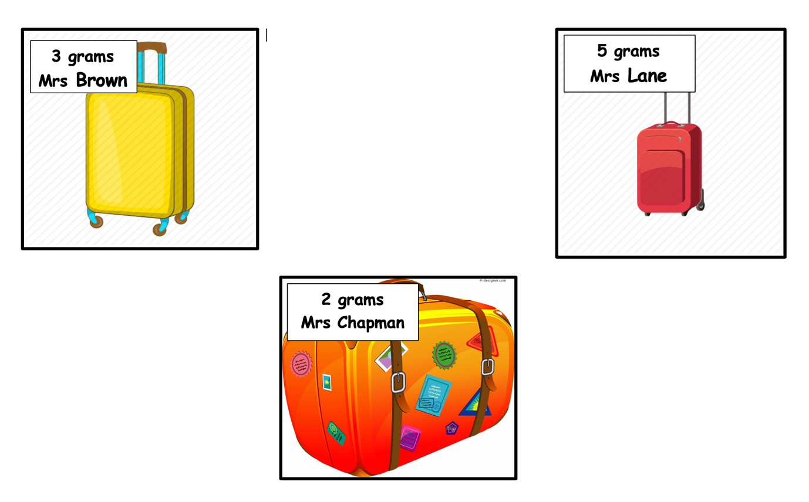
QUESTION 1

QUESTION 2
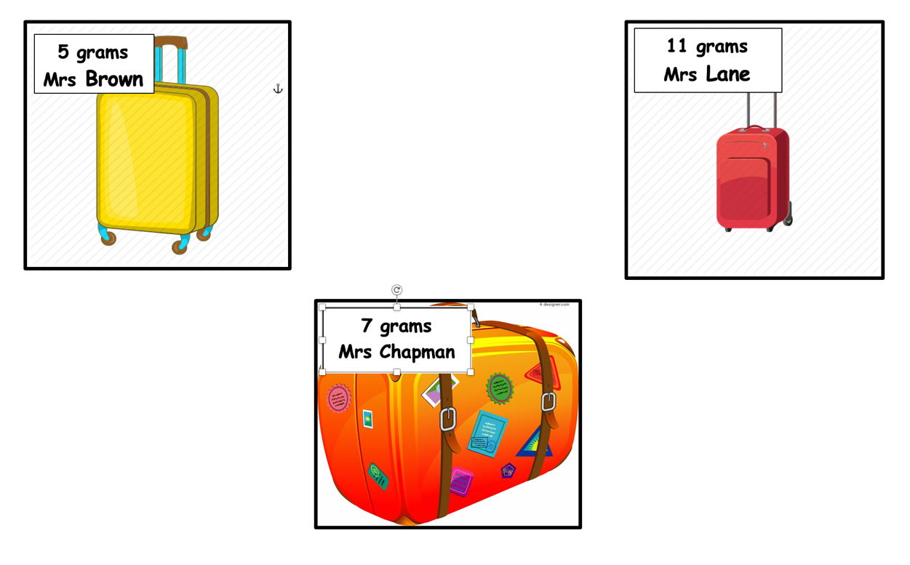

QUESTION 3

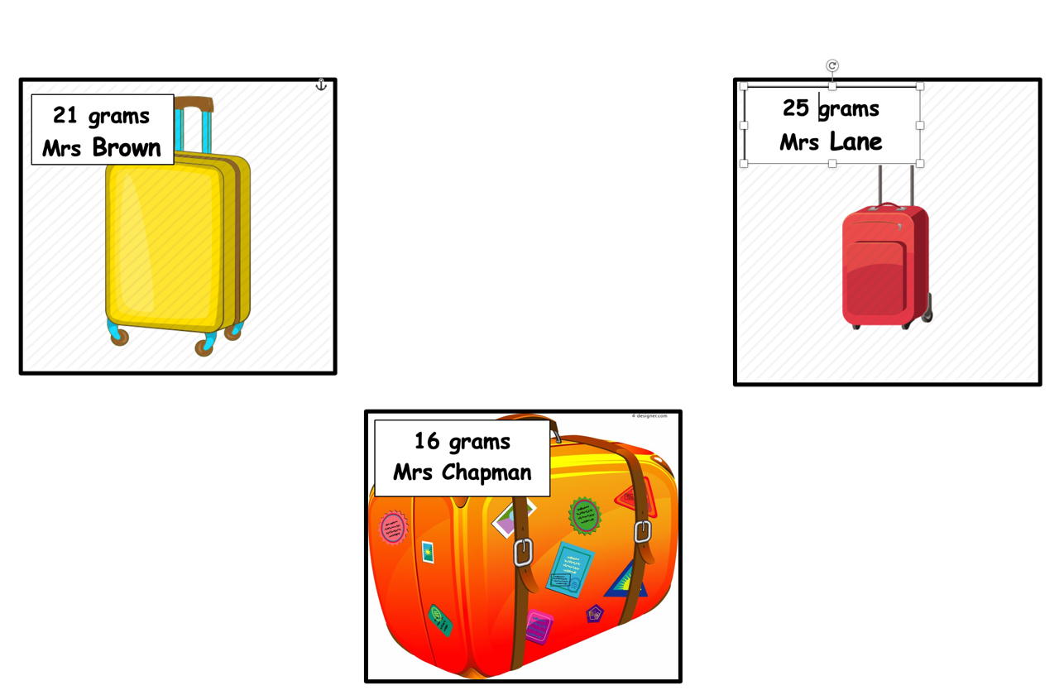

Welsh Second Language

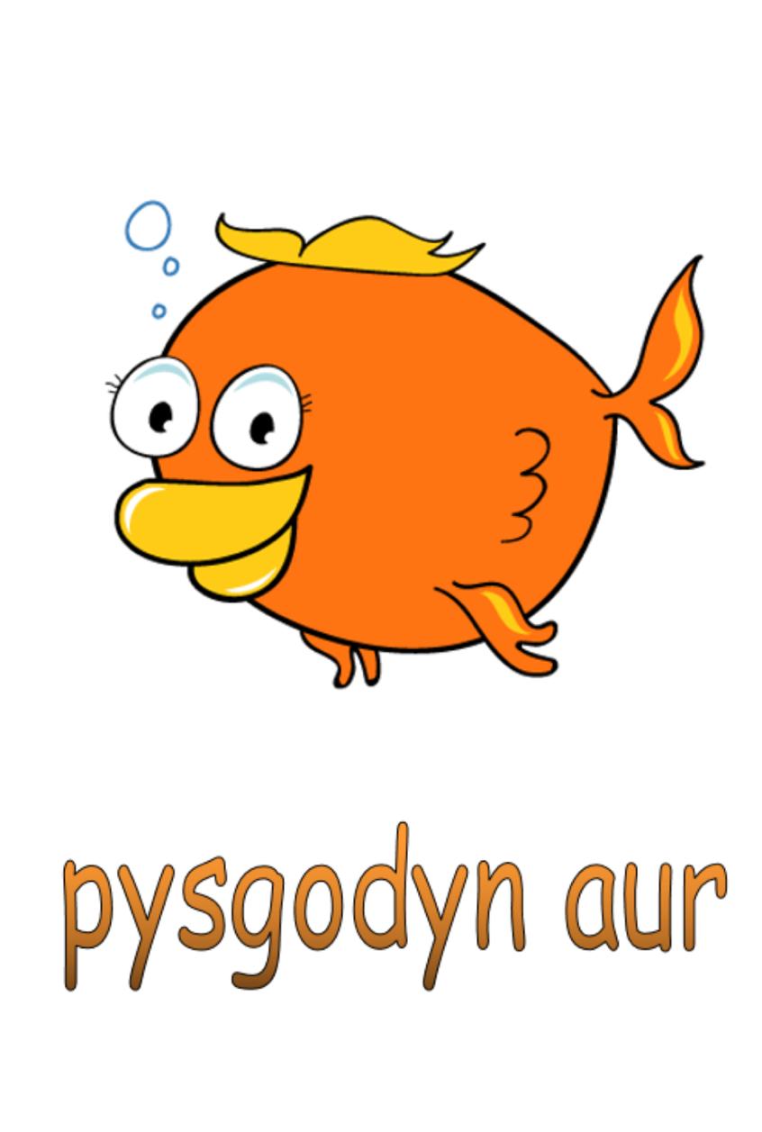
On the reception home learning main page there is a powerpoint named
The Seaside Welsh Vocabulary- please explore this.

Get your child to draw the pictures and label them buy copying the welsh words underneath. Try your best with the pronunciation. It doesn’t matter if it’s not perfect.

Just for fun- (but also observation and listening skills)

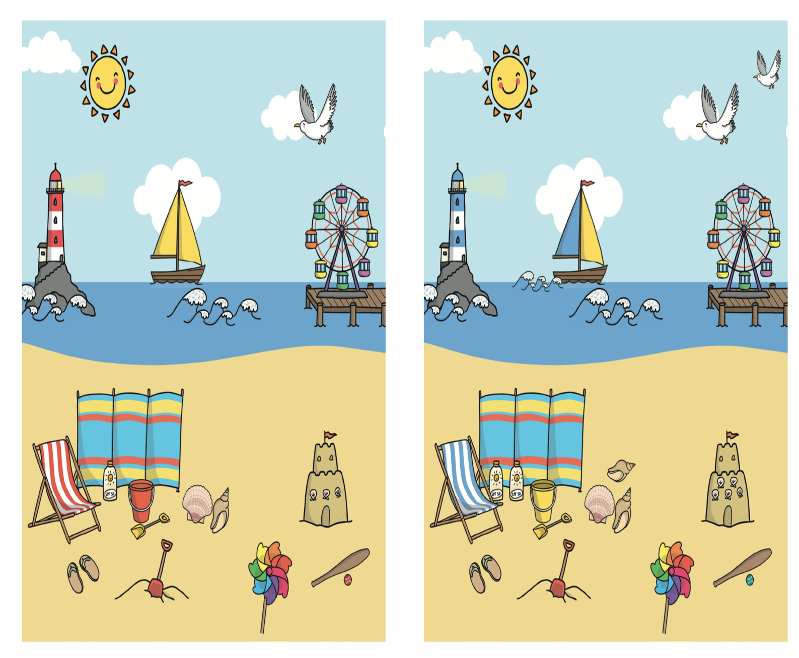
Can you spot the 10 differences?

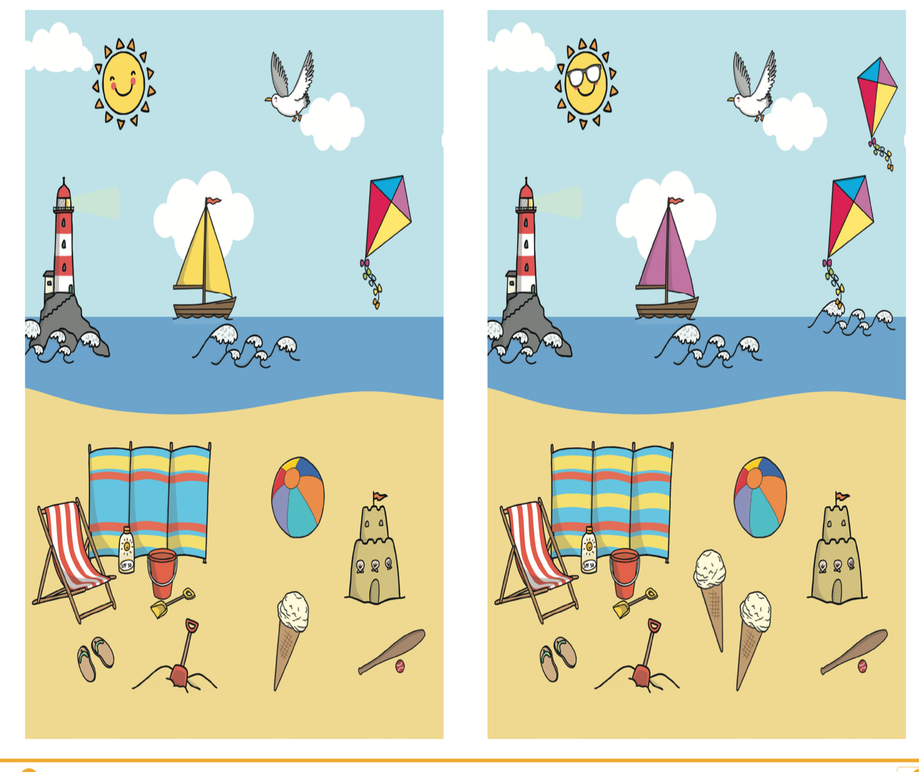
Can you spot the 10 differences?

NEXT WEEK WE WILL BE LOOING AT DIFFERENT SEASIDE CREATURE.
Before then can you make a list of some creature you might spot on the beach or under the sea? Best of luck and see you all soon xx

