Helo pawb, Sut mae? Hope you are all keeping safe. Here are our activities for this week. Again, I’ve put a lot of content here and don’t expect you to complete it all. Some parents have asked for a range of tasks to work through as part of home learning. Please remember there is no need to print out any of these activities, they can be completed in your child’s Busy Book or on paper and read from screen. Activities are just a guide on the direction of the skill set we would be developing in school, if you find similar alternatives online, great use them. The important element is to keep your child safe, happy and engaged. Remember to read a little every day, keep practising your sounds and complete a math activity too, look back on the parent guide issued in week one for tips on games. There are so many website and ideas out there that look amazing, many of which are now free. Let us know via twitter(@williamstown1_2) if there are sites/ apps you recommend to share! Next week we will be looking at dandelions- if you’ve got ideas to share let us know via twitter! Keep safe. Take care. Love and miss you all, Mrs Thomas + Miss Galliford. x
Summer Term-Tymor yr Haf
Year 1- Mrs Thomas.
Home Learning – Summer Term Week 3, Monday 4th May
Theme – A Walk on the Wild Side.
This week we will be looking at Earth Worms. What do you know about Earth Worms?
PSWBCD
This week I’d like you to think of something you could do to make someone who doesn’t live with you, happy – send someone a card / picture. Paint a pebble and give it to someone, bake a cake for someone …What will your act of kindness be?
Suggested Book Bank
These books would be useful to enhance our learning this week. Look for them being read on *Youtube or visit libraries.wales/my-digital library for an e copy of the title (link on Twitter).
Story Books (Fiction)
*Superworm by Julia Donaldson
*Yucky worms by Vivian French
*Wonderful worms by Linda Glaner

Information Books (Non Fiction)
Nature facts by Dorling Kindersley
I’ve put a star* by all the stories I’ve found on Youtube!

Poems of the Week
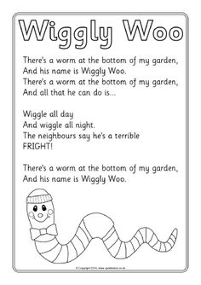
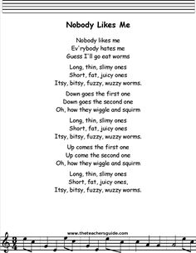
Creative
Worms make different patterns in the soil as they travel underground, it’s quite amazing to see, if you make a wormery (see below) you’ll be able to see these first hand. Here are patterns that have been made on the ground by some creative humans using natural resources. What pattern can you make outdoors using natural resources and indoors with manmade resources. Take a picture of your creations and use it as part of a picCollage of home learning craft or send it to us via Twitter. This can be done with your grown up helper!
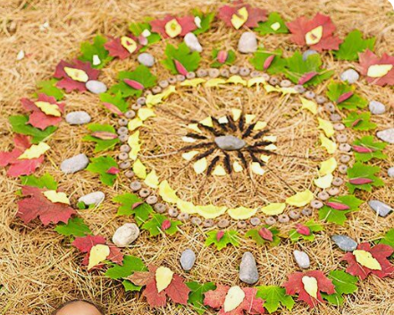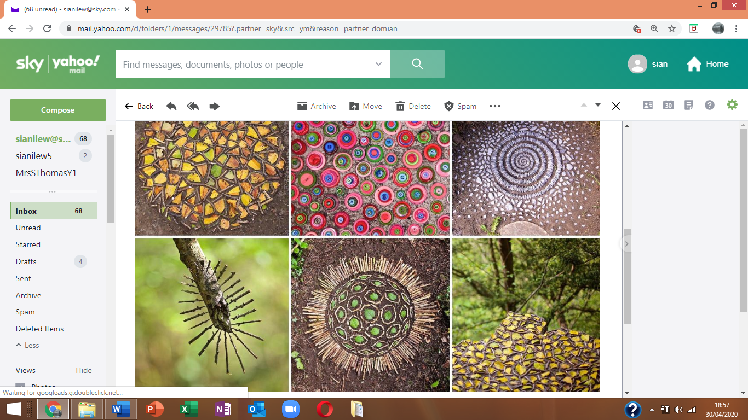
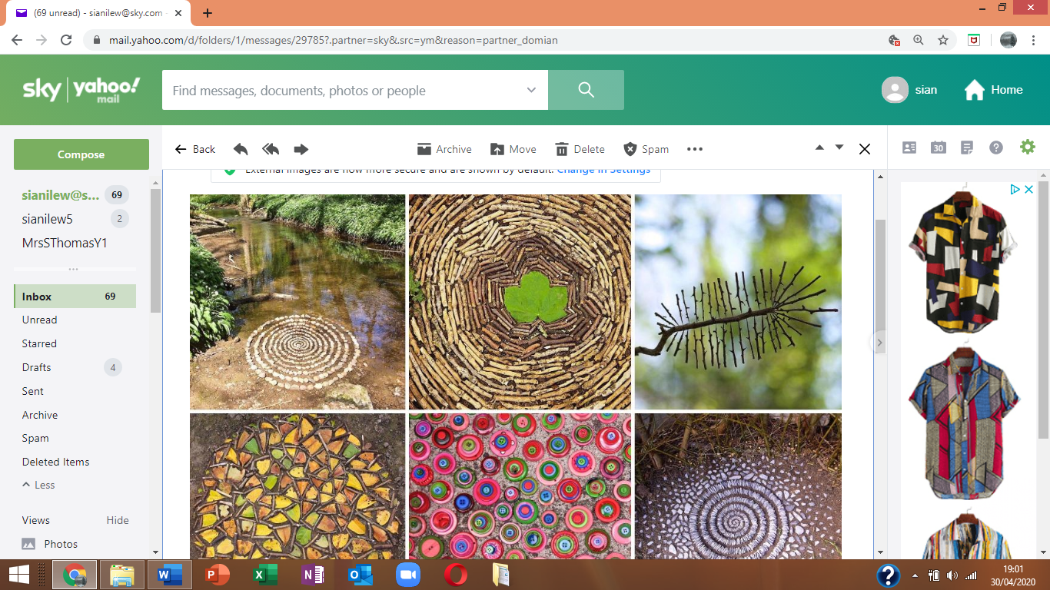

Welsh
The welsh word for worm is abwydyn .
Our focus question is Oes abwydyn gyda ti? Have you got a worm?
A –Oes , mae abydyn gyda fi (yes I’ve got a worm) Nag oes, does dim abwydyn gyda fi (no I haven’t got a worm)
You could use this question with lots of other animals and plants too. (Not sure how to pronounce a word? Ask Alexa or Google! Or ask me when I phone during a welfare call.)

Physical activities to try at home – indoors and outdoors
Cosmic yoga kids adventure – Kids yoga @The Twits’ (Youtube)
Can you wriggle and slither like a worm? Can you make yourself into a short worm? A long worm?
Ball work – Throw +catch (standing on the spot). Challenge- Can you throw the ball against a wall and catch on your own? to a partner? Increase your distance to extend the challenge? Bounce down against a wall and catch the rebounding ball. Vary the size of the ball for skill development.
Make playdough and roll worms of various lengths – the length of a spoon, or book, shoe or toy car etc

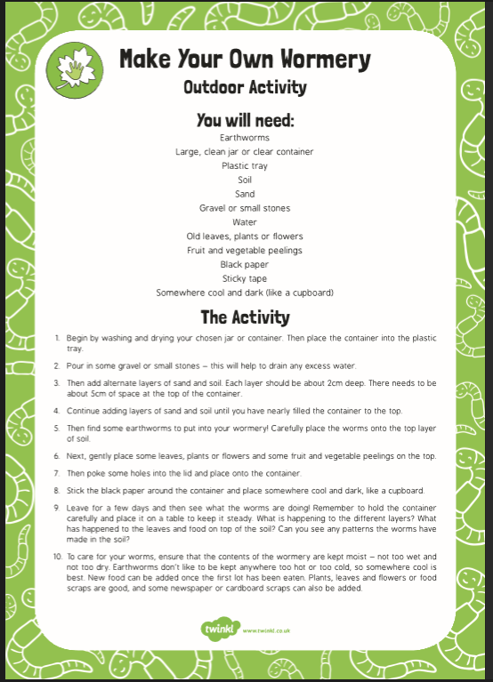
Knowledge and Understanding of the World -When you’re out on your daily hourly exercise look carefully at the environment, what can you see that is natural? What can you see that is man-made?

Language (I’ll try to keep these activities similar from week to week)
1. Can you copy one of this week’s poems neatly into your book? Think about letter formations, spaces, capital letters, full stops, letters sitting on the line (tails swinging under). Remember to read back your work. (Note to parents – pupils can copy the poem or as a challenge you can read it and they can write it or the ultimate challenge, can they write it from memory?) don’t forget to read back through your work.
2 . Learn to read high frequency words ( in reading file) – How many can they read in a minute? Choose 5 words to learn how to spell. How could you use these words in a sentence?
3. Our sound of the week is the trigraph ‘ear’. How many words can you think of / find / read / spell with this trigraph in it?
Remember
You can use the online games on
Phonicsbloom.com
Letters and sounds .com
Phonicsplay
To reinforce your sound recognition. They are all free at present.
Work on phase 3 / 4 .
Which games are your favourites? Let us know so we can play them in class too when you all return.
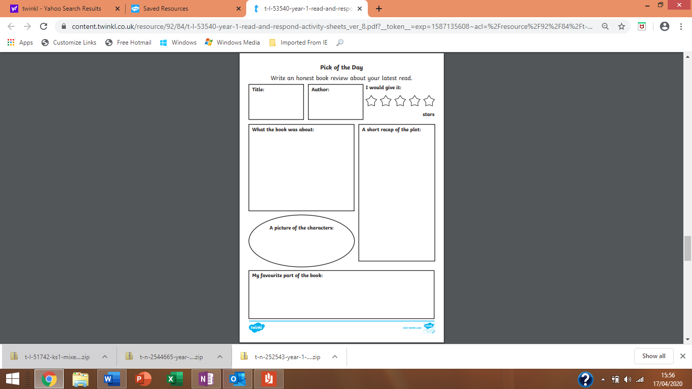
Book review- This week I’d like you all to review the book ‘Superworm’ by Julia Donaldson. You can create your own Book review form or use the above format. Remember to encourage pupils to ask and respond to Who? What? Why? When? and Where? questions about the book that they are reading / sharing with an adult to develop a greater understanding, this will also help with comprehension tasks that will follow later in the term.

Create a factfile about Worms. A fact file requires information. You can follow the format below, create your own style or how about simply folding an A4 sheet of paper in half and creating your own information book?
I’d like you to include –
A drawing - you could label this to extend your learning.
A title – the name in English and Welsh
Some interesting information about your focus of study-
Such as - How does it move? What does it eat? Where does it live? It’s life cycle. It’s colour. What’s the most interesting fact you learnt?
In class we’ve looked at compound words – when 2 or more words are joined together to make a new word eg, sun + flower = sunflower. Can your child work out what these compound words are? Can they write them down in a list?
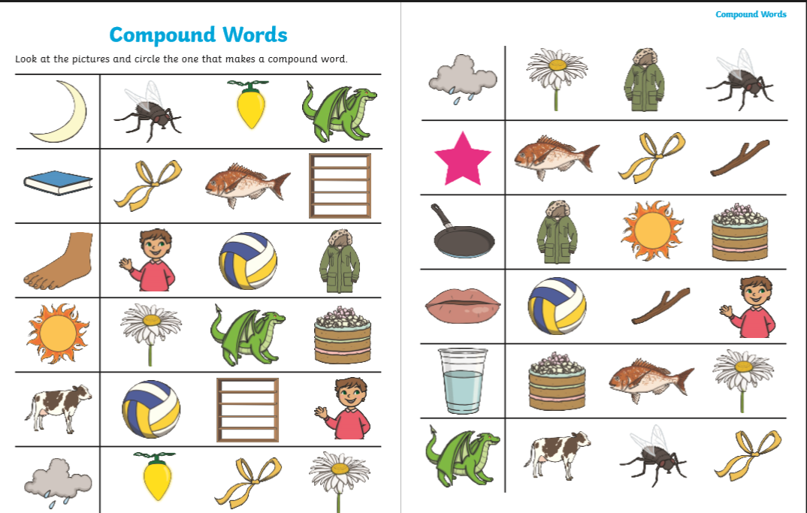
Maths
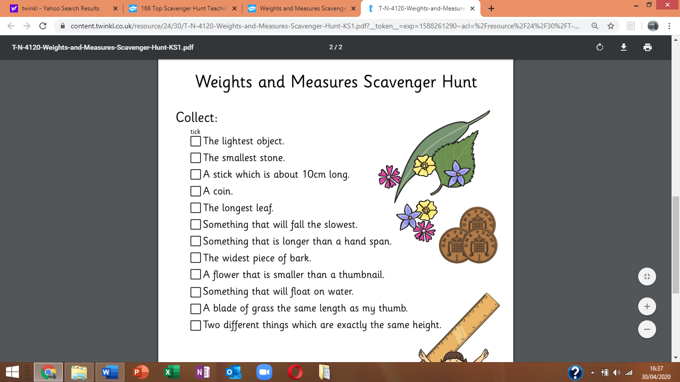
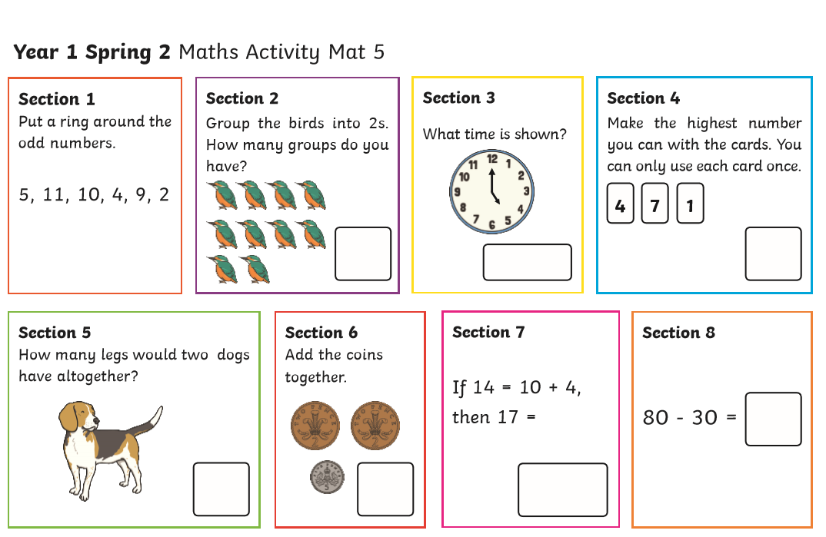

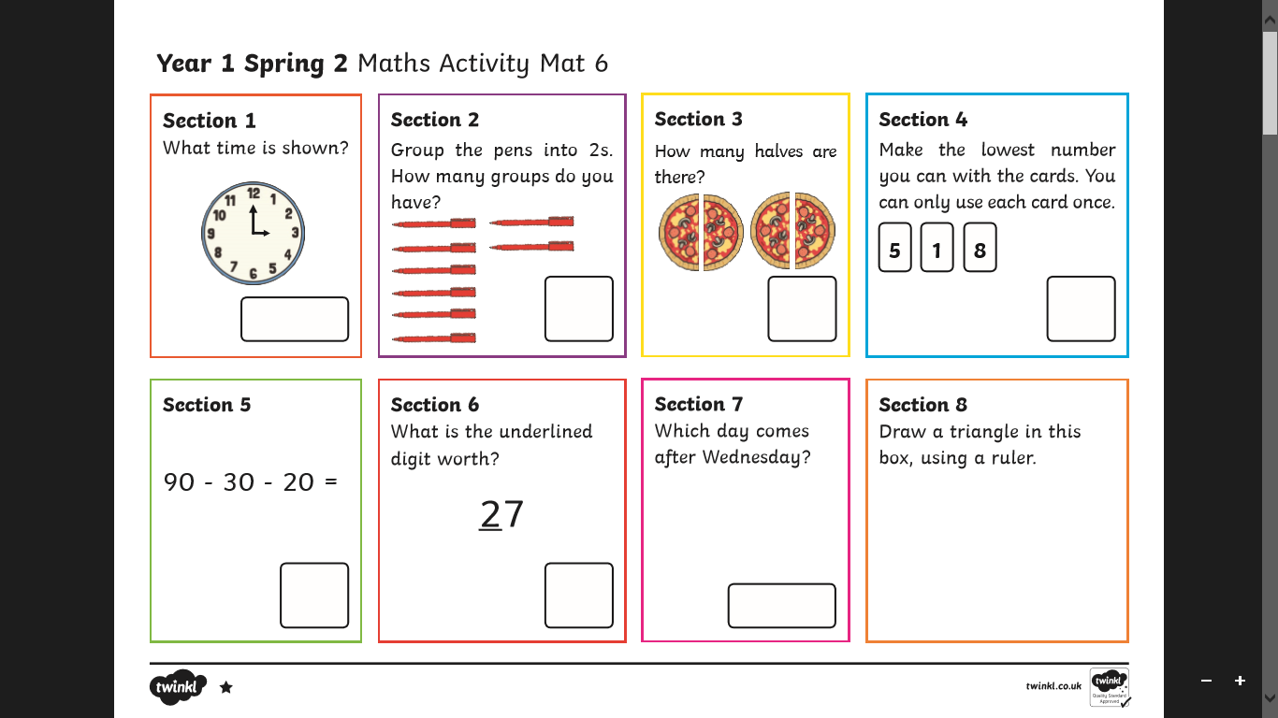
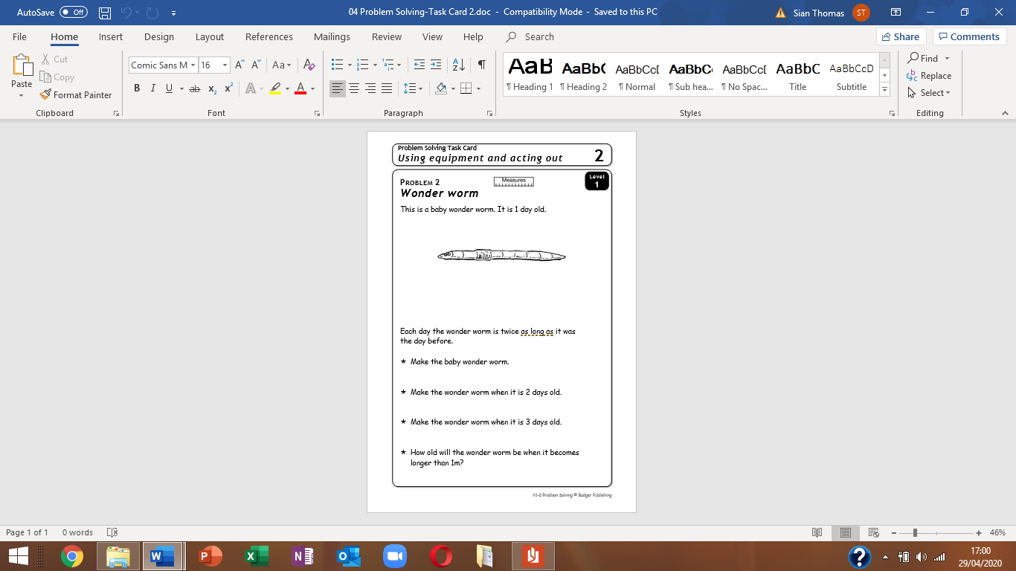
Problem 2 Wonder worm
Children will need Plasticine and metre sticks for this activity. They each make a worm the same length as the worm on the page (10cm). Discuss how they can work out how long the worm is when it is
2 days old, and then ask them to try out their ideas. For the worm on Day 2 they make the worm twice as long (20cm), and then twice as long again for Day 3 (40cm).

Ask children to explain how they can find out how many days it will take the worm to grow to more than 1m. They might choose to put worms together to make the length of the worm after each new day. They should compare their worms with the metre stick. The worm will be 5 days old when it is longer than 1m. The worm will be 160cm, but children do not need to know the exact length – they only need to compare lengths with.

Haven’t got a metre stick? Use a measuring tape or simply cut a metre length of string/ wool/ ribbon or make a metre stick from card, or draw it with chalk on the patio / pavement.
Haven’t got plasticine? Use playdough/ clay or make traditional dough or you could use fondant icing- or foil?

N.B - This is a ‘problem solving ‘activity, it is meant to challenge your child’s thinking. All pupils have the skills required to complete it. It’s simply encouraging them to make the connections. We have completed several, similar Problem Solving activities together in class.
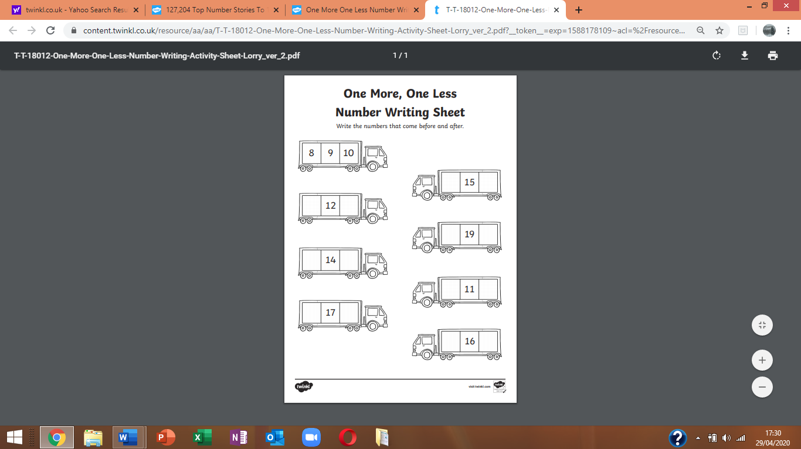
Practice
1+1 is 2 half of 2 is 1
2+ 2 is 4 half of 4 is 2
3+3 is 6, half of 6 is 3
4+4 is 8, half of 8 is 4
5+5 is 10, half of 10 is 5
6+6 is 12, half of 12 is 6
7+7 is 14 , half of 14 is 7
8+8 is 16 , half of 16 is 8
9+9 is 18 , half of 18 is 9
10+10 is 20, half of 20 is 10
To complete this task, I suggest you ask you child to first write a number line from 0-20 with the correct number formations. Then use this as a resource to help them complete the task.
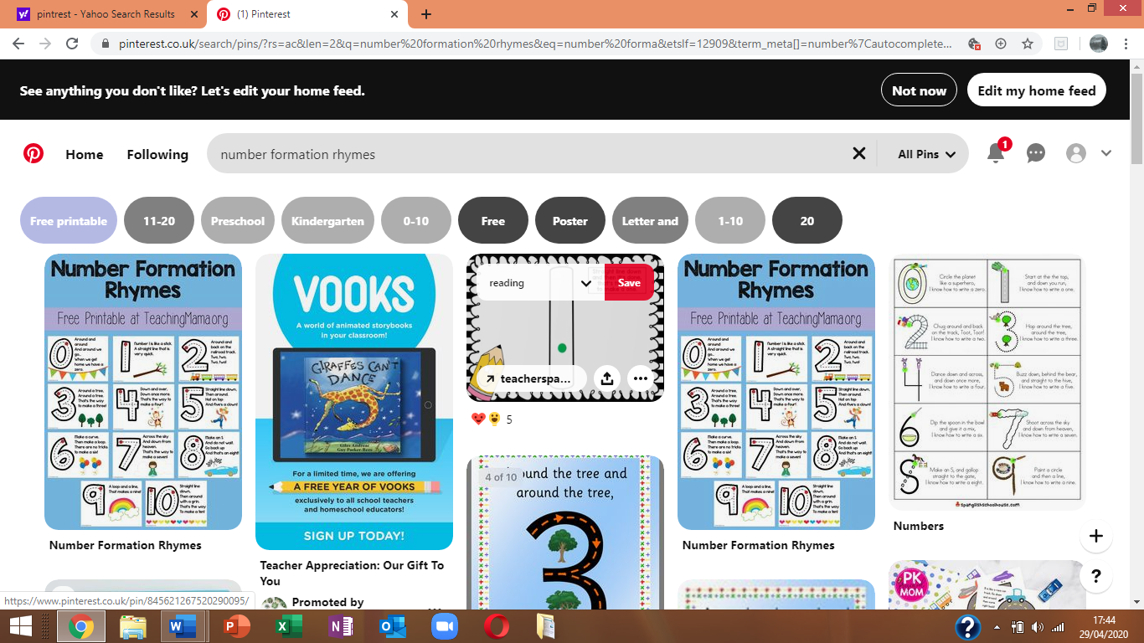
Below is a quick reminder of how we form our numbers.
Please look online for a clearer image of the number rhymes if required, we use these rhymes ( from Pinterest) in the whole of Foundation Phase. I ‘ve included it to illustrate the straight backs on some numbers and starting positions highlighted by the red dot.
(I included a hard copy in your home learning packs back in October!)

A final activity I ‘d like you to revise this week, is the use of the prepositions – on top of, in front , behind, under, over, above, below, through ,to the side of , in between you could extend this by revising the concepts of left and right too. It would be great if you could use this vocabulary when playing with your child, encouraging them to use the vocabulary in context too. Thank you for your support, I’m sure you’re doing great! Remember every little helps! Enjoy your week x Mrs Thomas x

