

School Closure Home Learning Pack
Mrs Jones’ Class, Year 3/4
Hello Y3 and Y4,
How are you all? I hope you and your families are well and that you have managed to do some of the work so far.
I know some of the children have been finding some work either too challenging or difficult to do without a printer. Please don’t worry; your child will not fall behind. Ask them to do what they can and if your child learns better by playing games on the computer, this should be encouraged as well. I have included a list of possible websites you could visit.
In Maths this week I would like you to look at ‘Position’ The sheets get harder as you go through them because of the range of abilities in our classroom. In school we would do this as a practical activity so you could draw a compass in chalk in the garden. Make a map of your kitchen. Maybe you could blind fold someone in your family and give them instructions for a homemade obstacle course! If you have any toy cars, you could practise making half and quarter turns, clockwise and anti-clockwise.
I have put the next two sets of spellings for you to practise. Only do them if you have learnt the sets before. I have also set up a class login to the Oxford Reading website so that you can read books which are part of our reading scheme. Don’t forget to make a note of the books you read.
This week’s writing focus is about writing instructions. Have a look at the peanut butter sandwich video link and have a go!
Keep up the hard work!
Mrs Jones

W/c 4th May 20
Numeracy
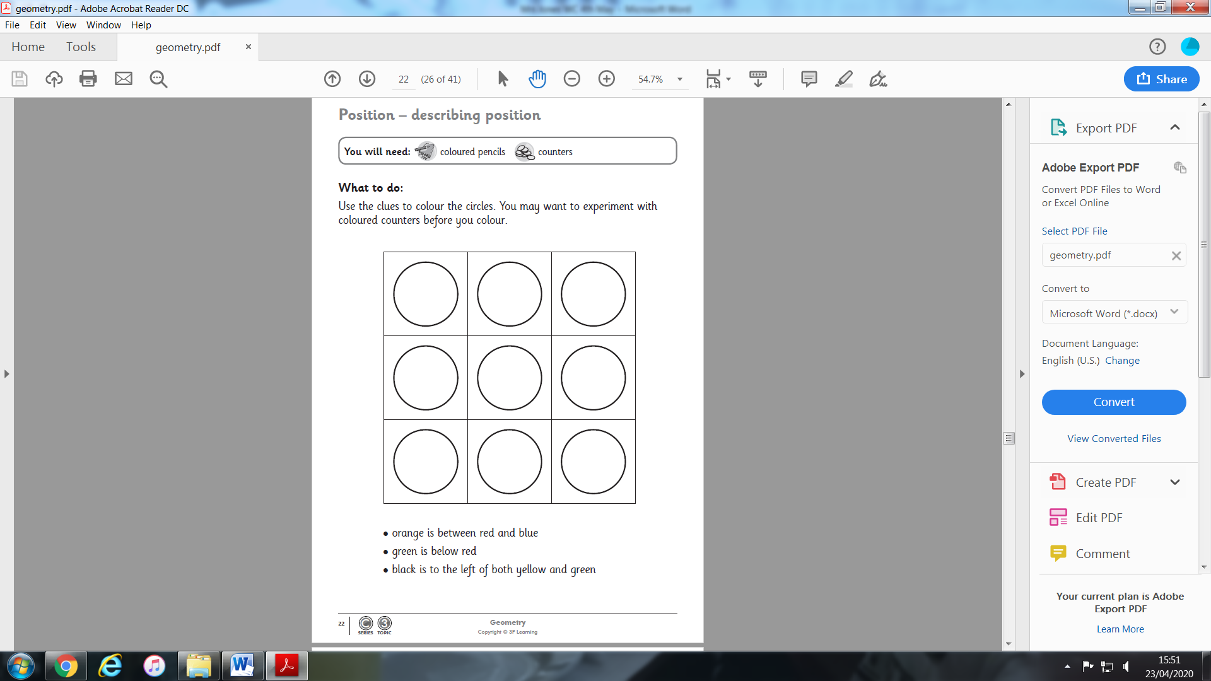
N.B. Not all the circles will be coloured in. Only the first two rows when Mrs Jones tried it!
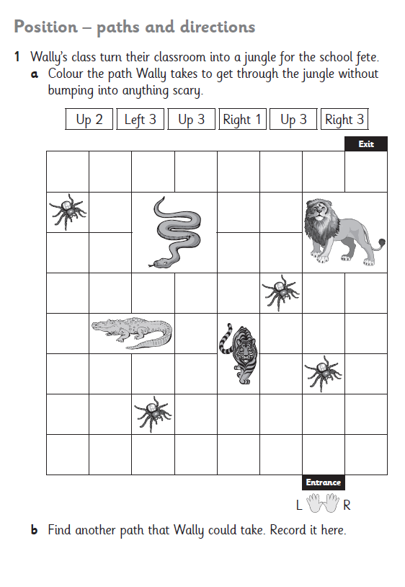
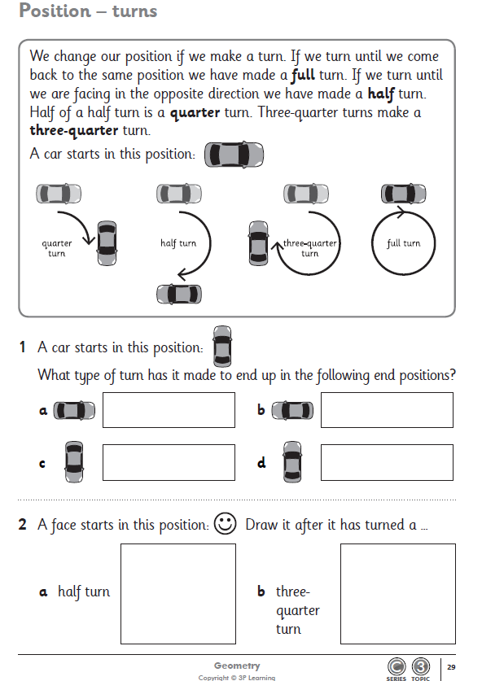
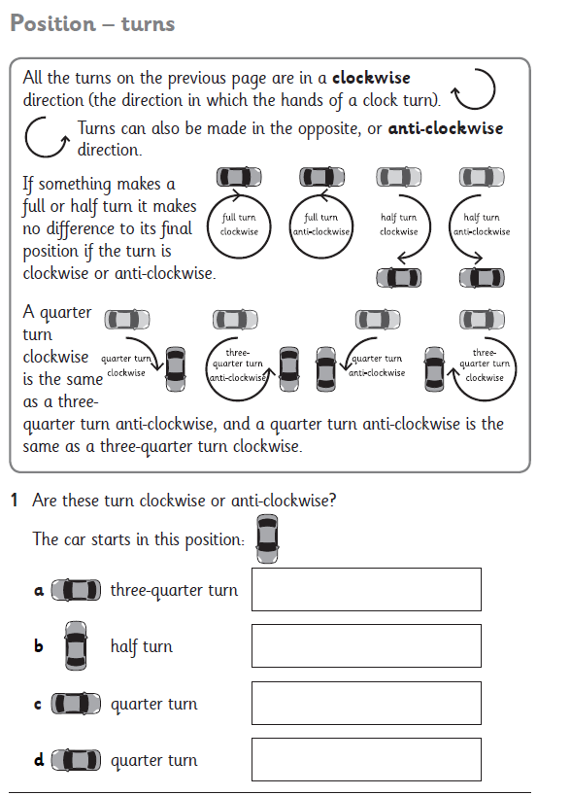
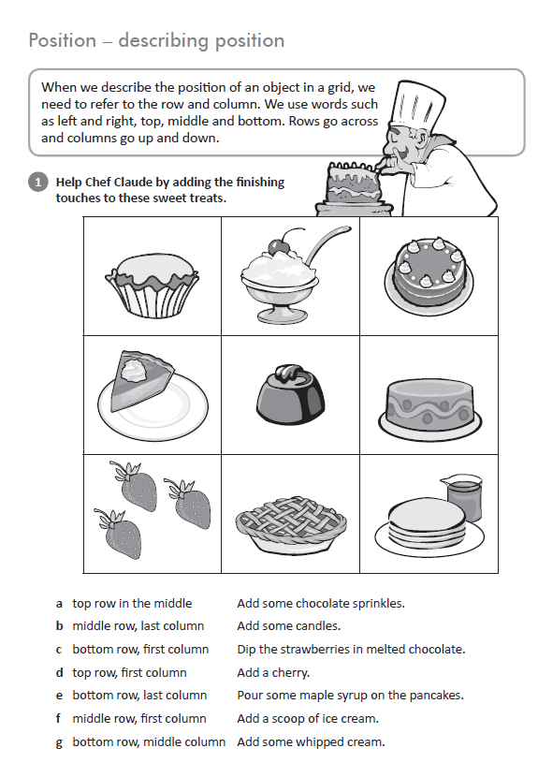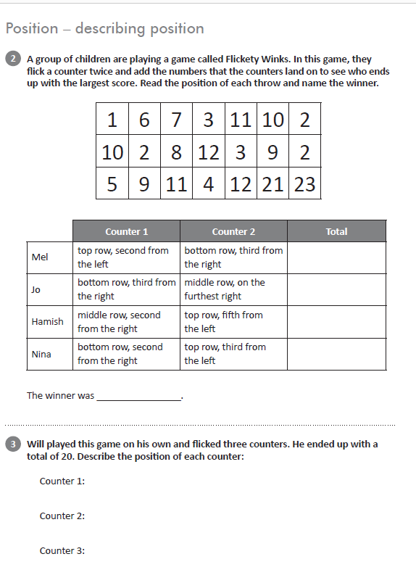
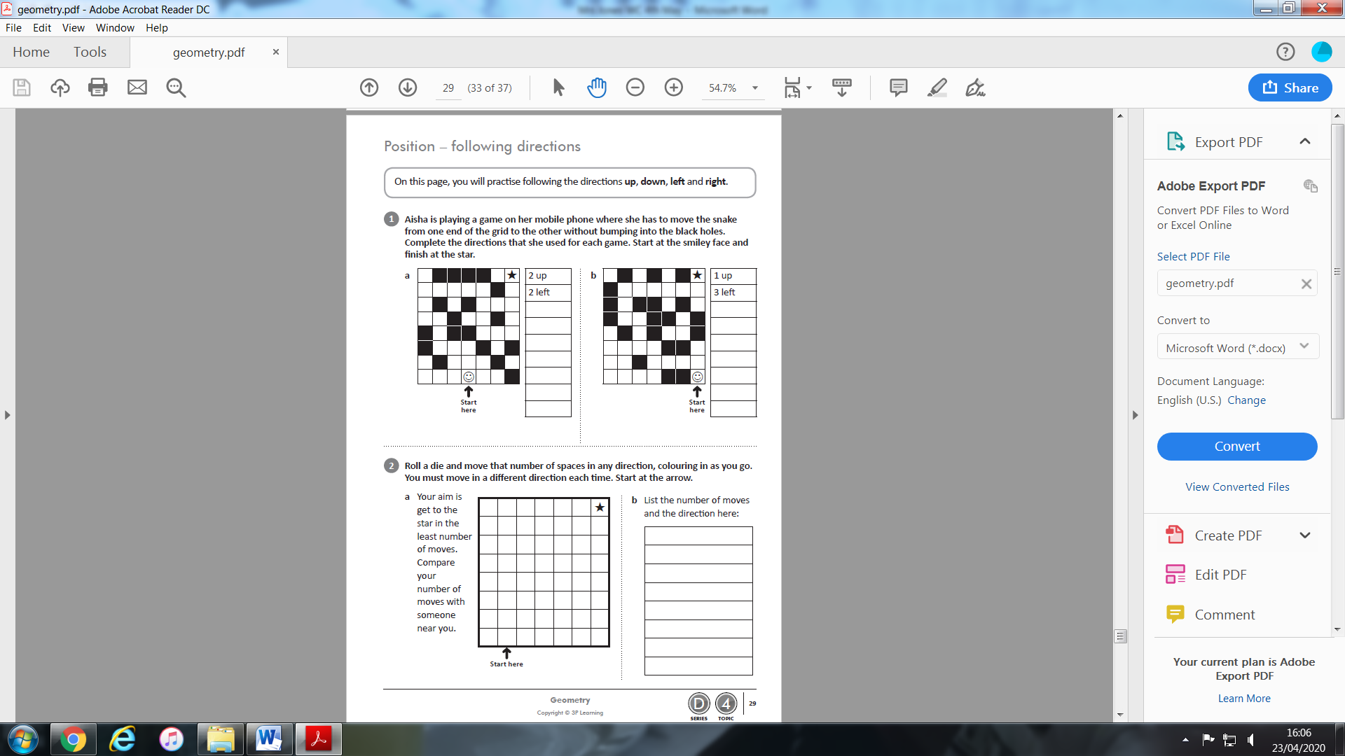
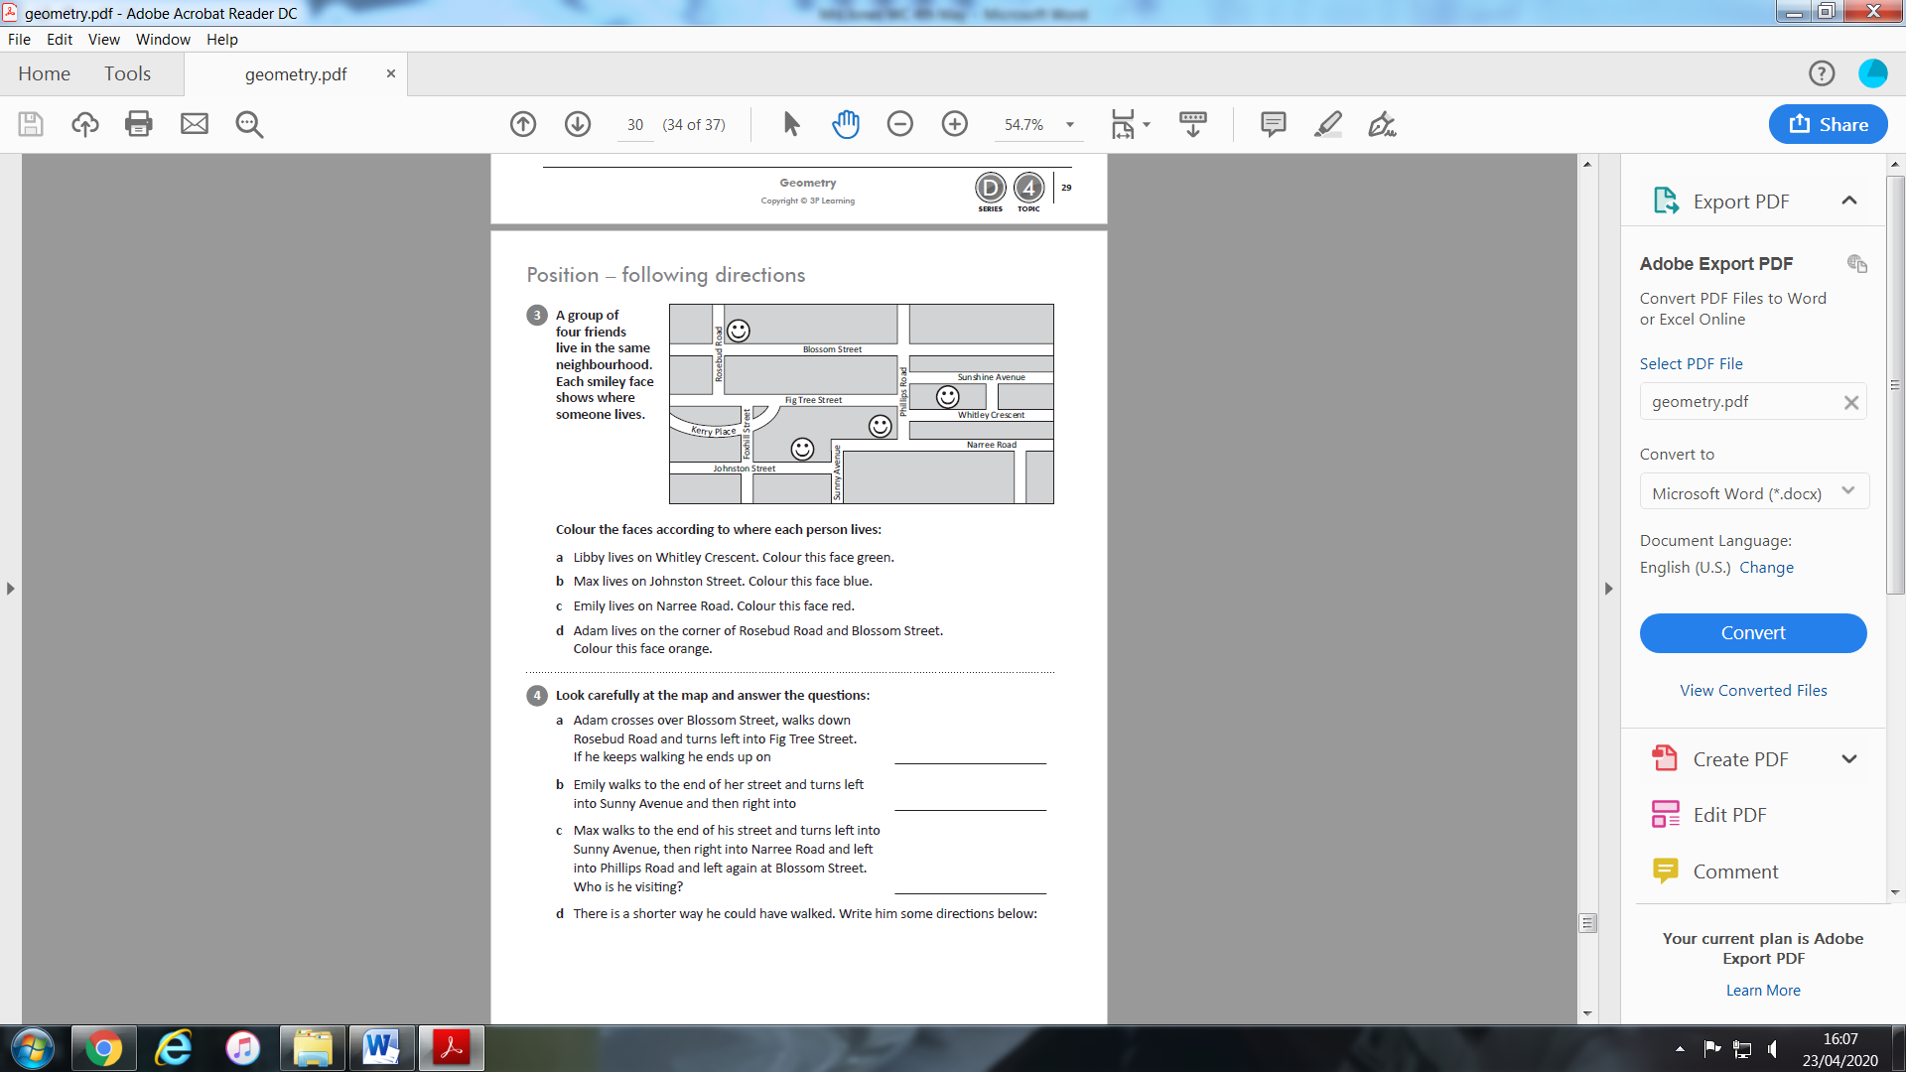
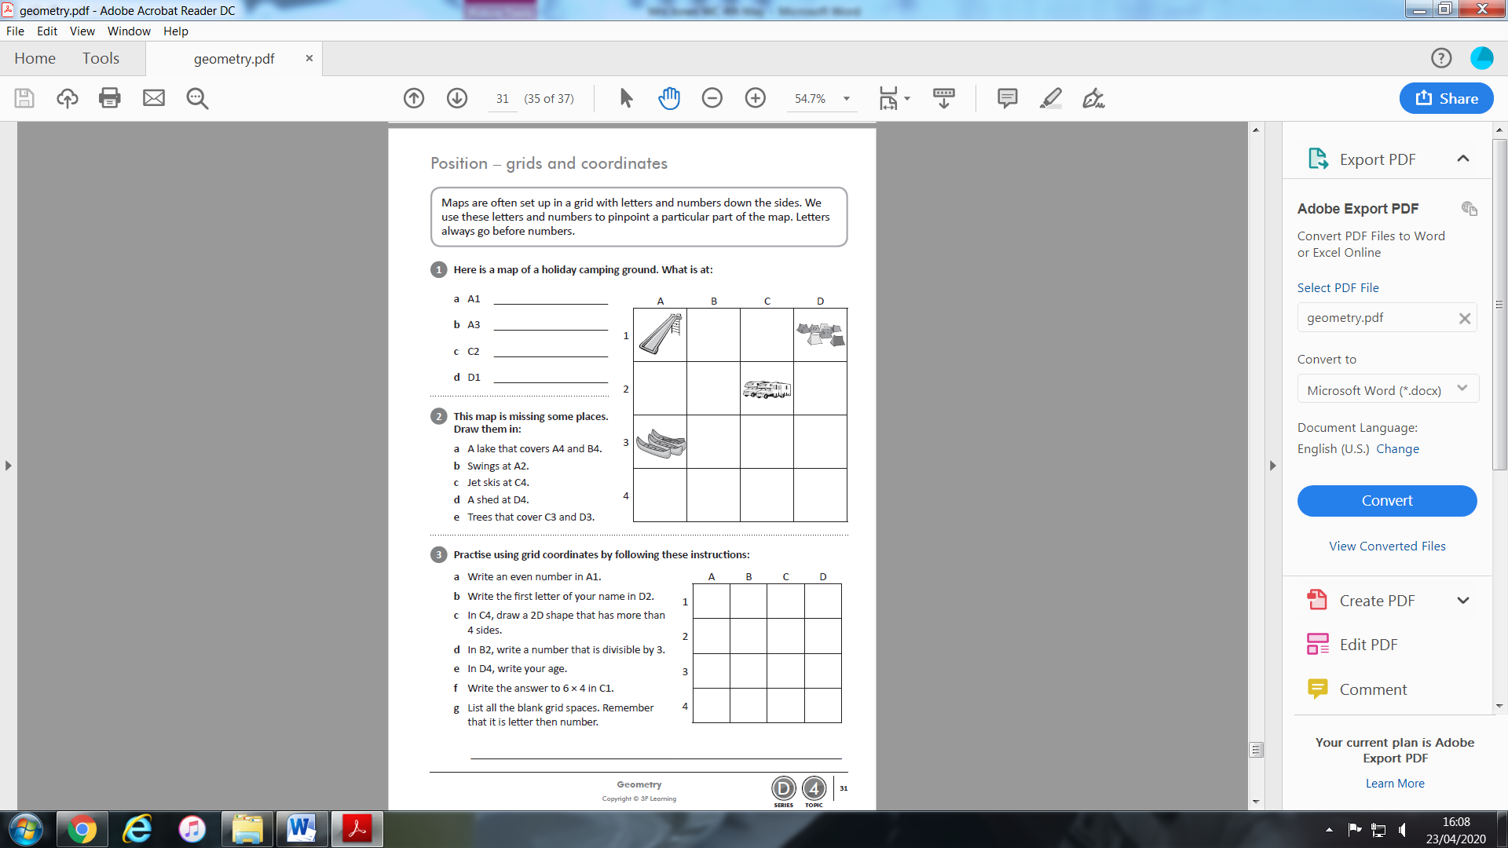
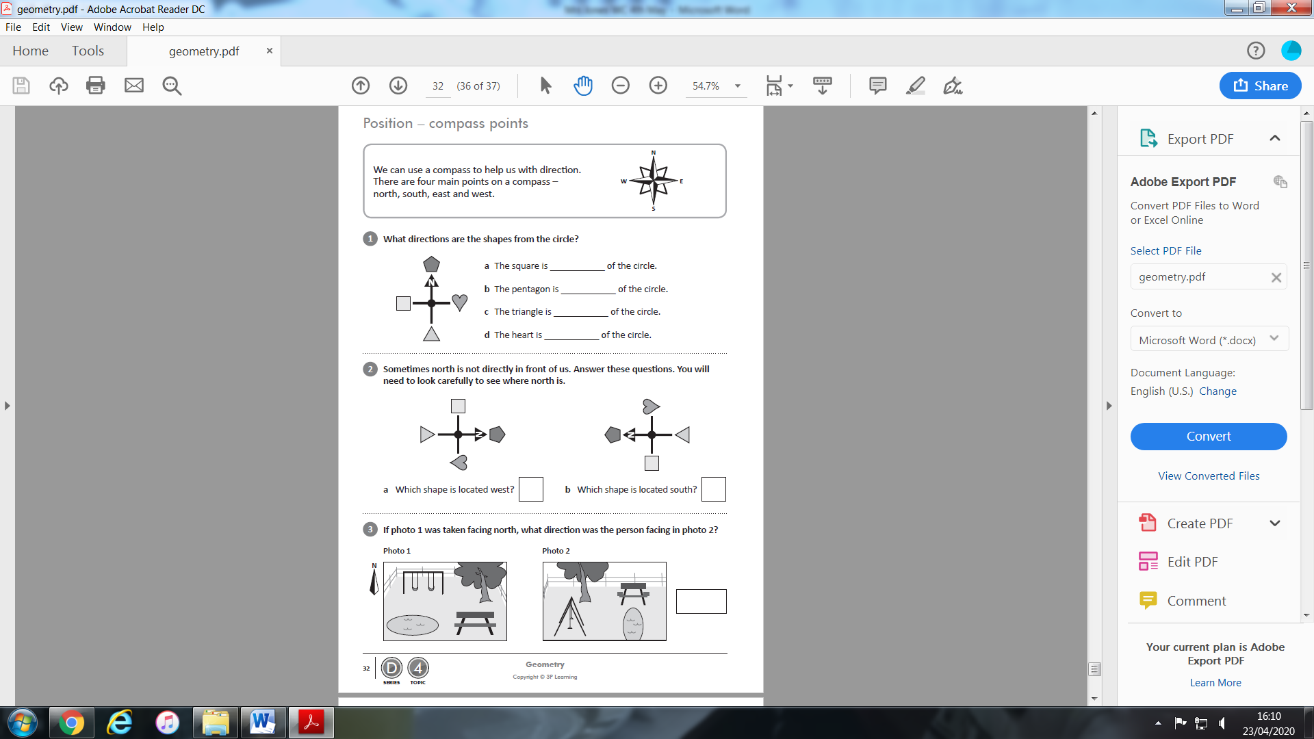
Year 4 work on position.
Have a go!
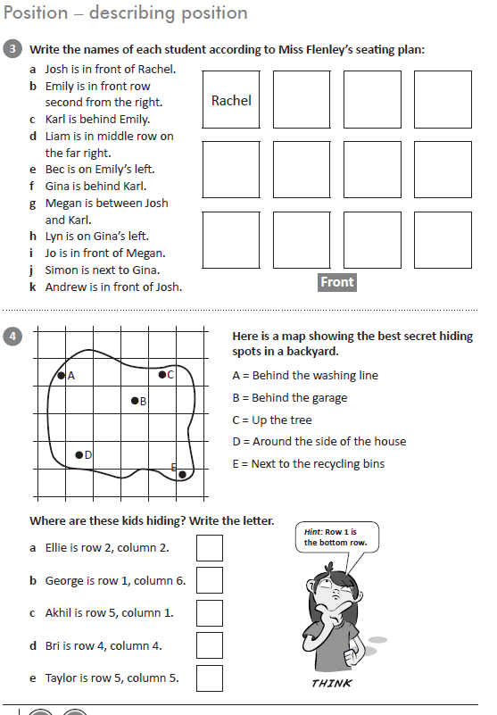
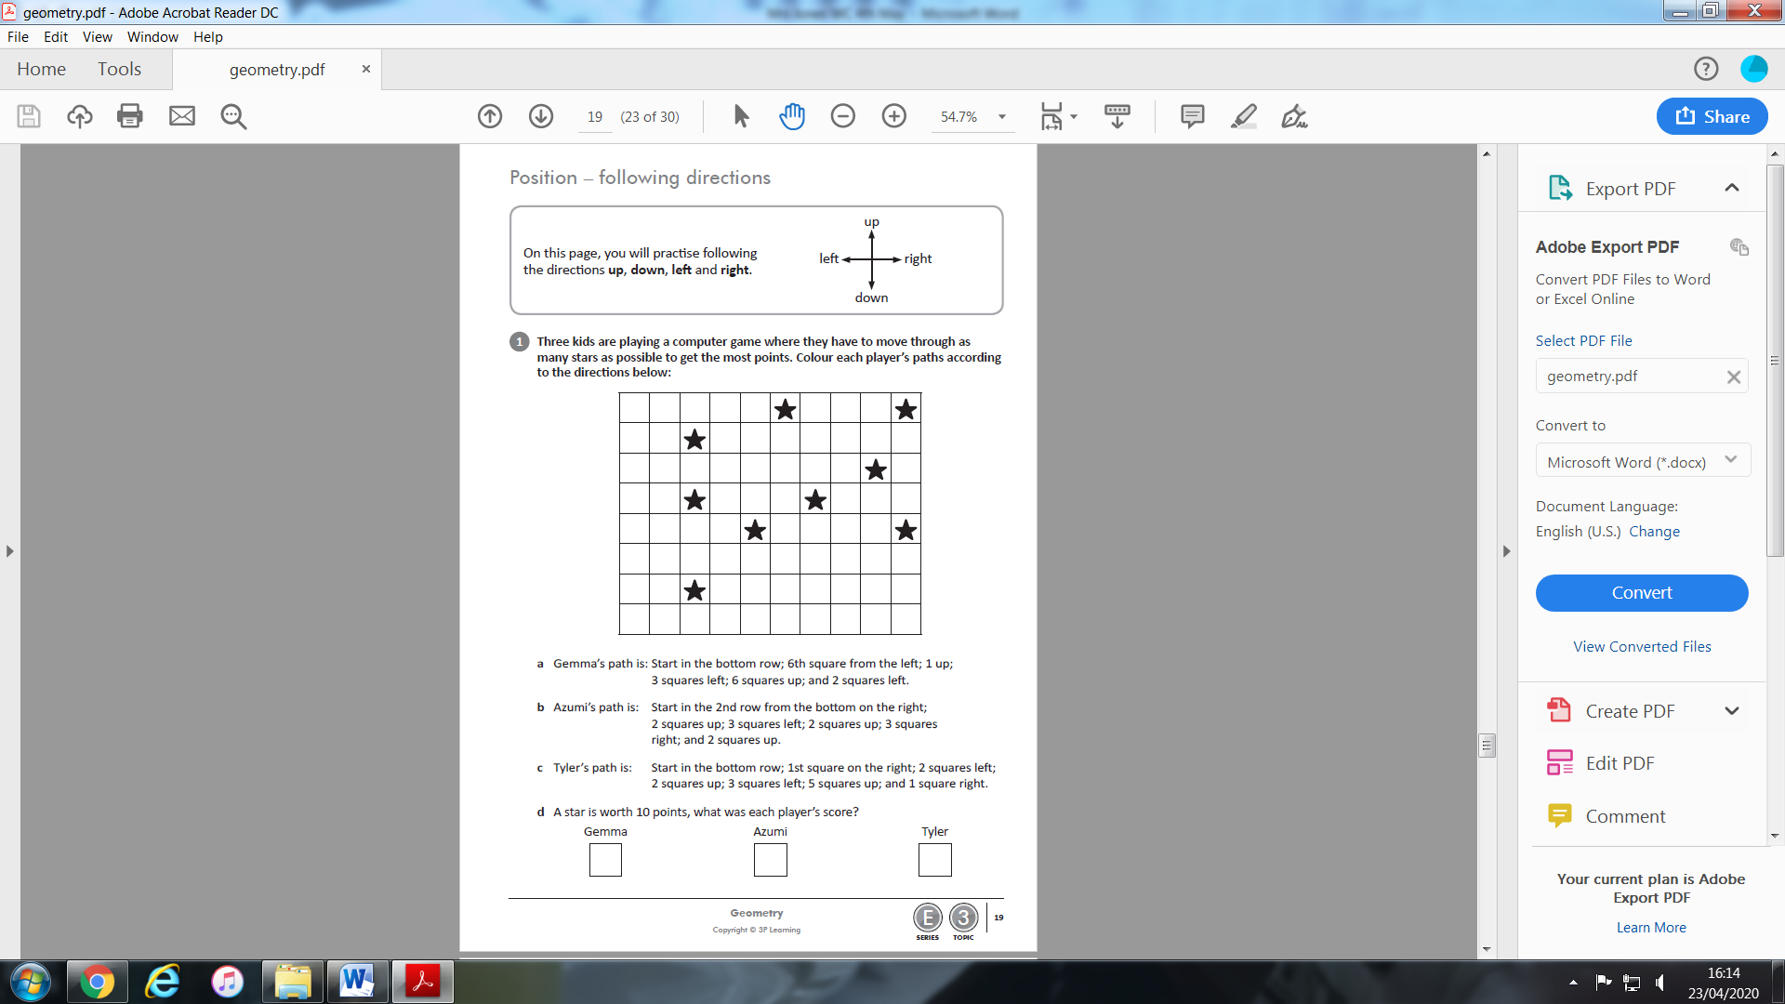
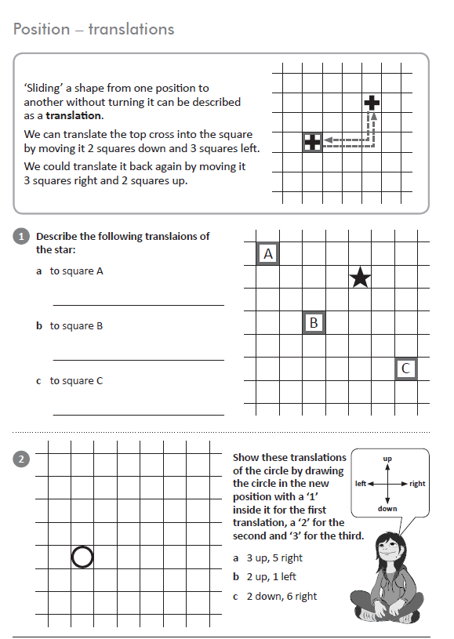
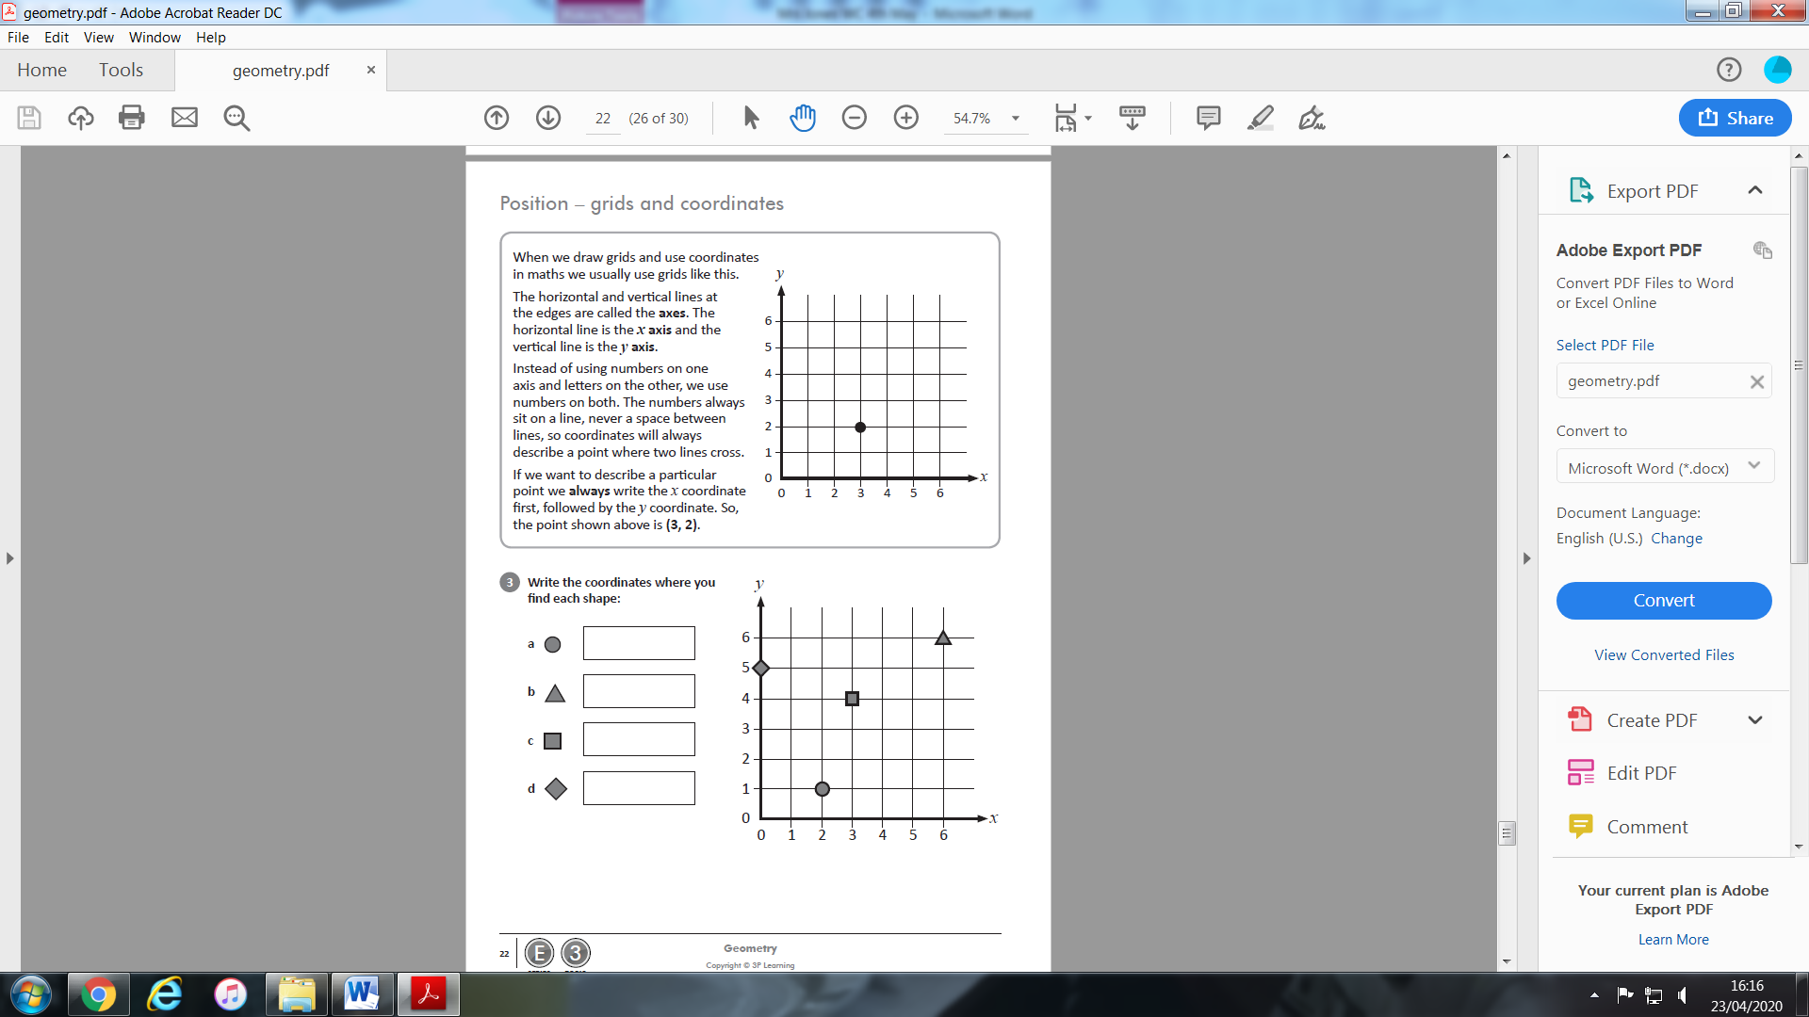
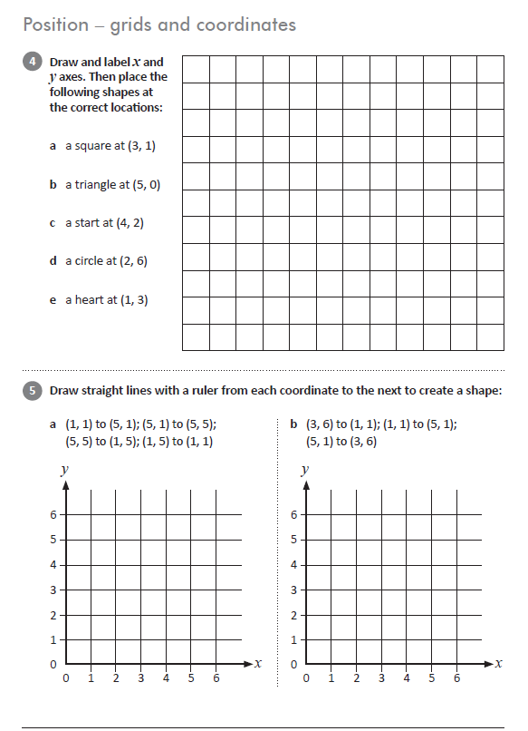
Literacy
Spelling –
2 weeks ago I asked you to play some games for the sounds ‘ai’ and ‘ay’. Have a go at this worksheet to see what you can remember.
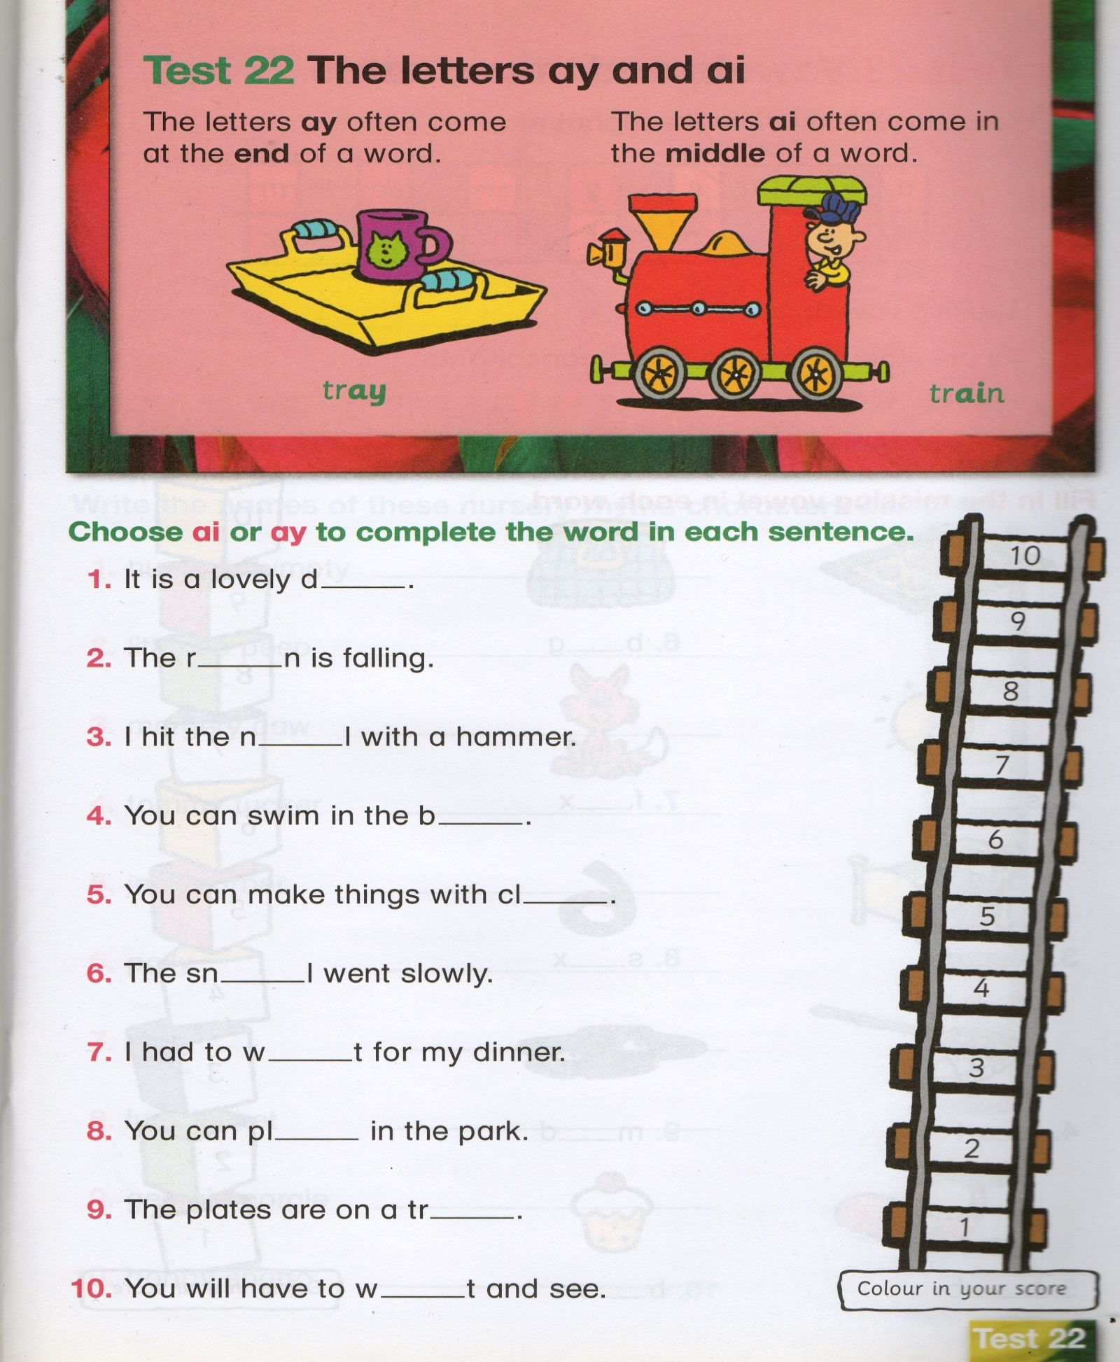

HFW Spellings
Here are the next two sets of words to learn. Each child in class is on a different set. Please do not move onto the next set until you have at least 7 correct in the previous set. When your child has learnt the word, ask him/her to write a sentence using that word. From next week I will only put one set up at a time. Everyone needs to work at their own pace!
Reading
Log on to Oxford Owl using the link below.
Click on the Pink Button at the top of the screen that says ‘My Class Login’. The class name is ‘mrs jones class 34’ and the password is ‘Reading2020’
Click on My bookshelf. Here you can choose a book to read. Make sure you write the book you choose in your yellow reading record.
https://www.oxfordowl.co.uk/?selLanguage=en&mode=hub
SET 8
who
new
two
over
than
that
out
too
with
why

SET 7
at
yes
where
pull
put
must
much
again
all
how

Genre – Writing instructions.
This term our literacy focus is writing instructions. Watch the following video clip.0:20 / 5:28

THIS "EXACT INSTRUCTIONS CHALLENGE" IS SO HILARIOUS
https://www.youtube.com/watch?v=Ct-lOOUqmyY
Your Challenge is to write instructions on how to… Brush your teeth.
- Don’t forget to number the steps.
Have fun!!
- Think about what equipment you will need.
- Remember to give exact measurements.
- Get a grown up to try and follow your instructions.
- Could you video it so we can watch it when we are back in school?

Welsh language Development.
Learn parts of the body.
Play the following online games.
https://wordwall.net/resource/42573/welsh/welsh-parts-body
Have a go at all of the games – Find the Match, Match up, Balloon pop and Crossword.
Next week I will put a worksheet online to see how much you can remember!

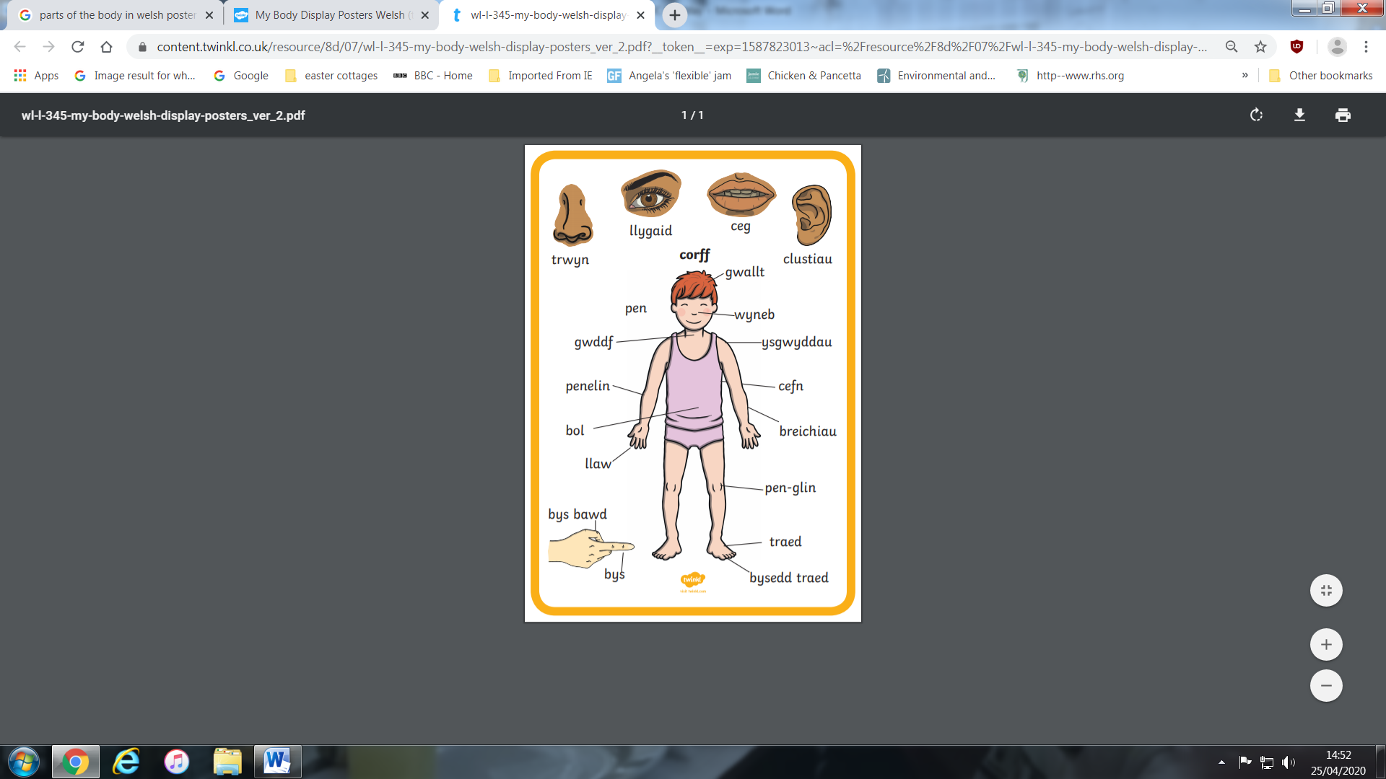
Topic
Global Citizenship - Needs and wants.
Hopefully you have already made a mind map of what humans and animals need to stay alive and healthy. Have a look at the following pictures. Can you sort them into two groups. The first group should contain things you NEED. The second group are things you WANT. Talk about what is important to you. Can you live without it? Does everyone in the world have these things?
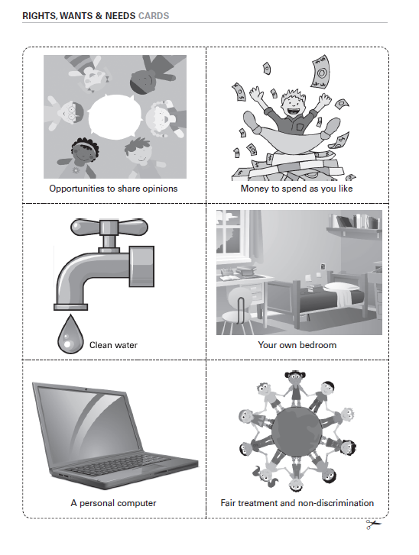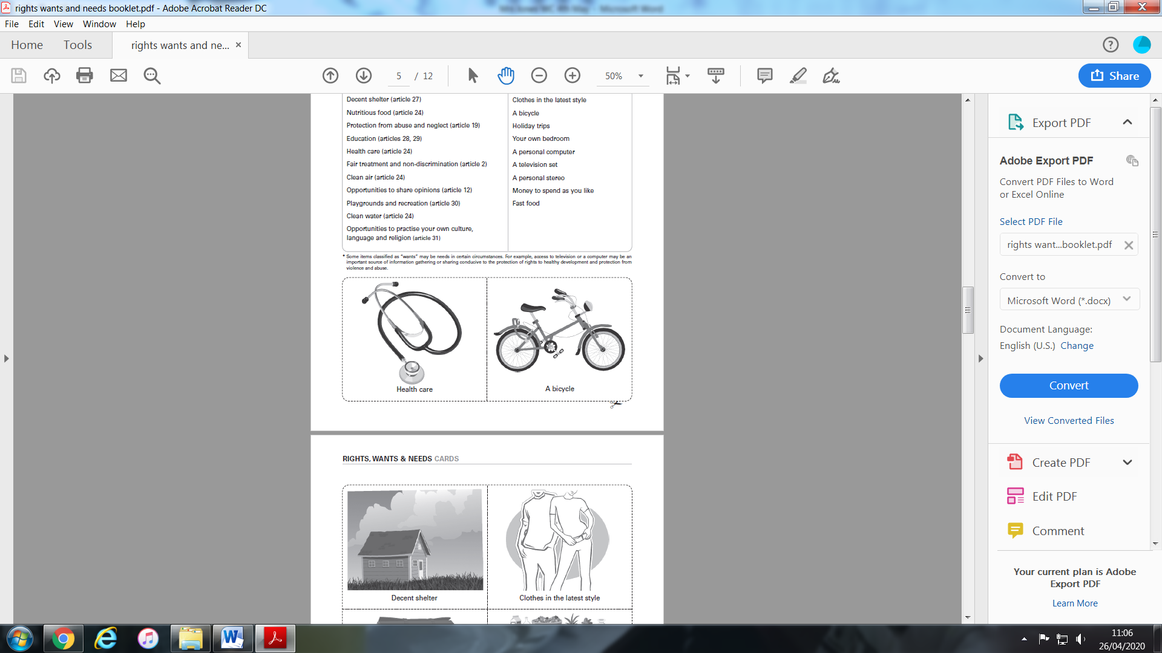
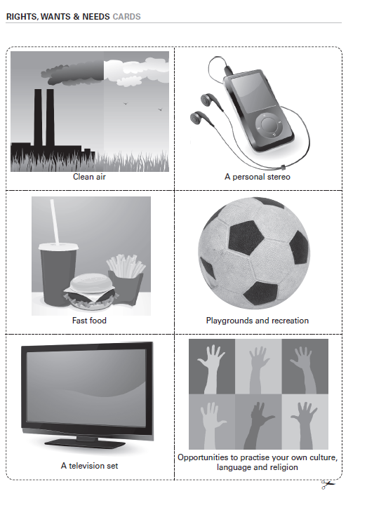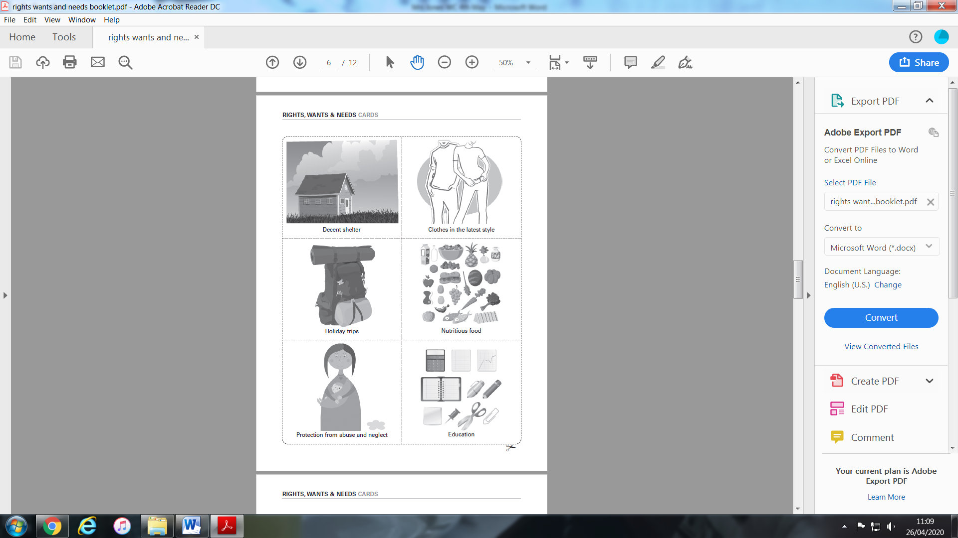
Make a poster of what Humans need to stay healthy.
Over the next few weeks we will look at each of these items separately.
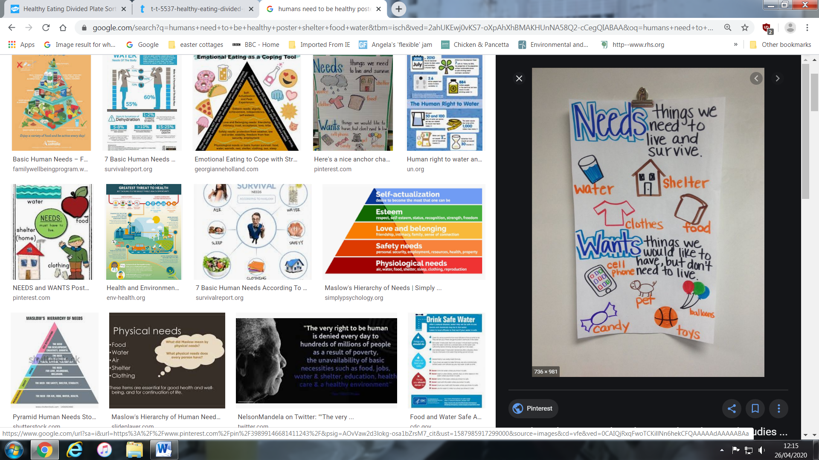

Thinking Skills – Ask your parents for help!!
Answers next week!
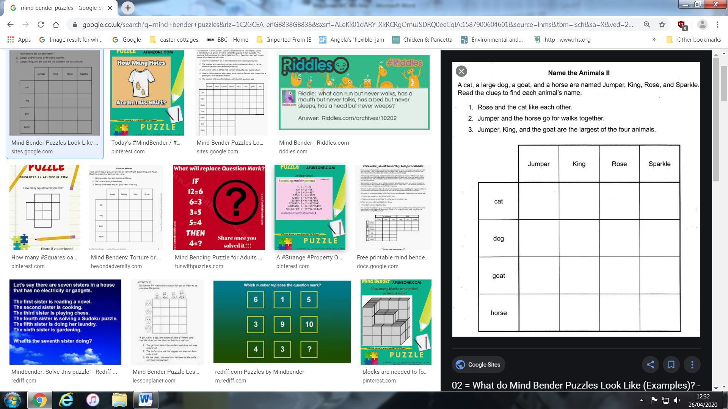

Expressive Art /Science
Fill in the sheet to show what you already know about parts of a plant.
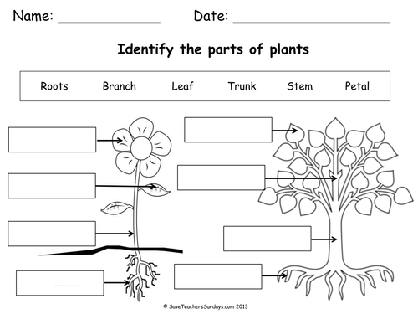
Think about the skills you needed to draw a leaf. You have to look at each part of the plant very carefully. You may have measured parts of it. You also needed to use your measuring skills if you drew a 3D hand last week. Bring these skills together and have a go at drawing a flower to scale (the size it really is).


It could be a huge Hibiscus or a delicate Daisy!

Personal, Social and Emotional Health.
L.O. To recognise and reflect on the emotions felt in one day.
Have a look at the following list of scenarios.
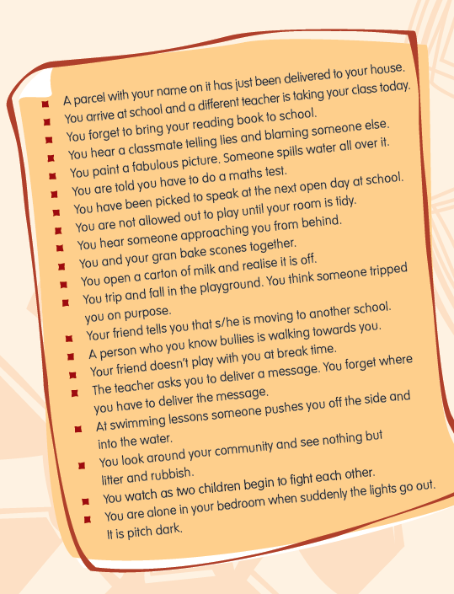
Can you plot the emotion felt for each scenario on the graph?
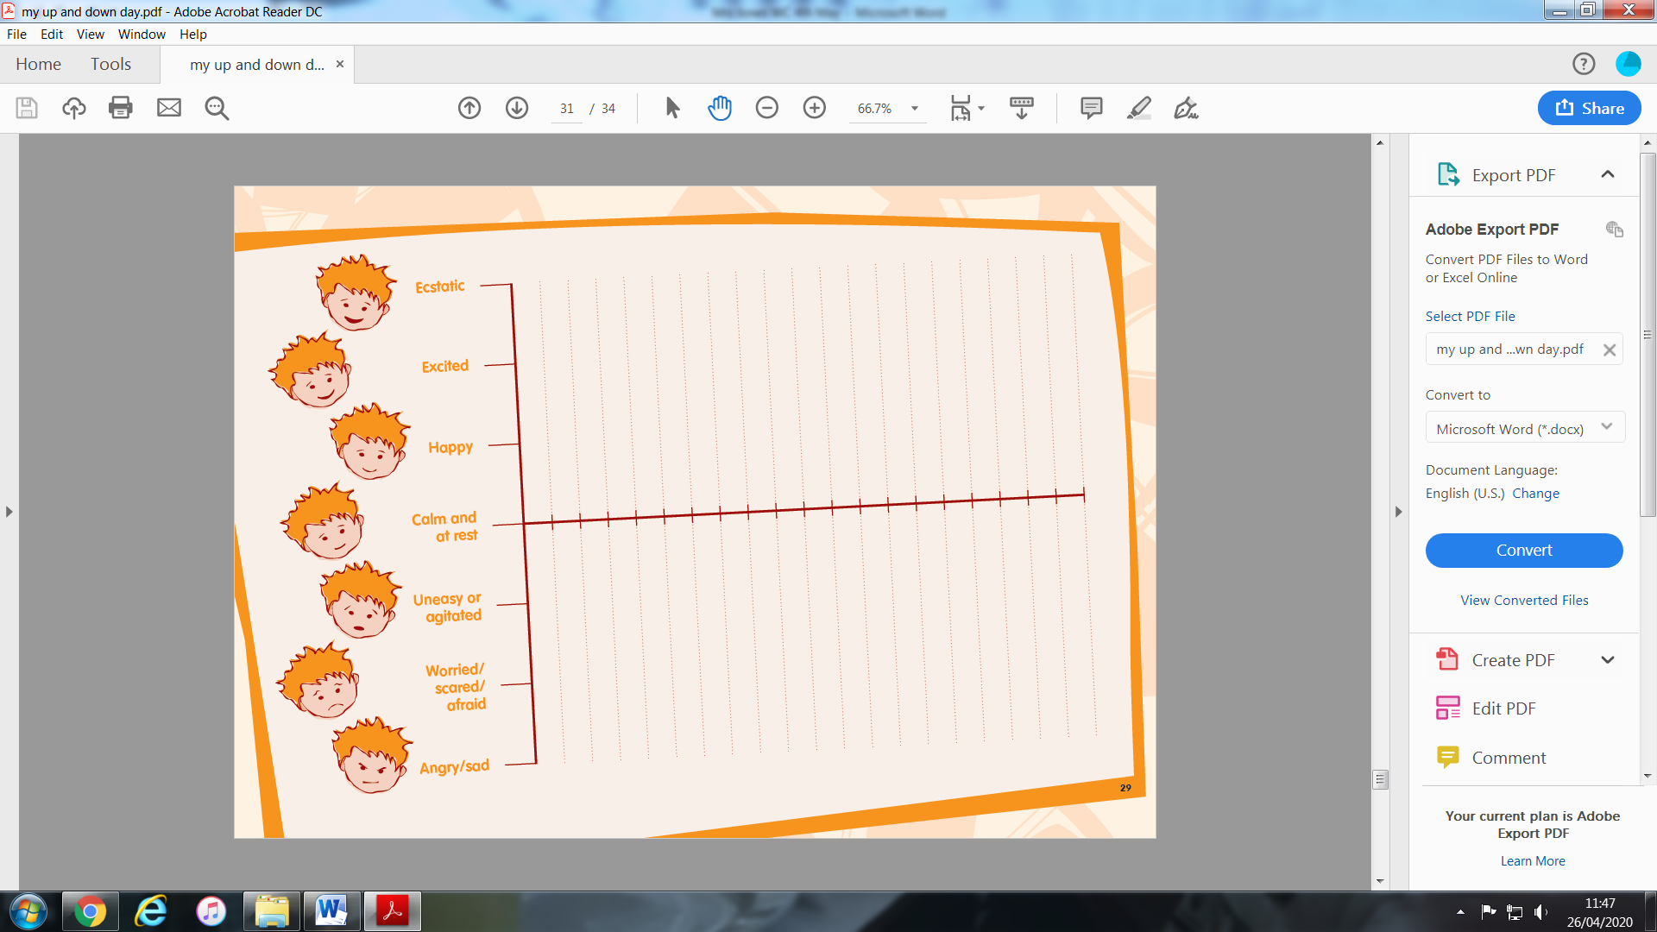
Remember to join all the points on the graph.
Everyone has different feelings at different times of the day (ups and downs). By looking at how we are feeling and what makes us feel in a certain way, we can learn to express our emotions and begin to understand how to control them. While we are all stuck at home, the way we feel and how we react to that also changes the feelings of the people we are living with.
See if you and your family can plot your own feelings graph for a day in the week.

WEBSITES
Literacy
- ixl
- Letters and Sounds website/ app
- Oxford Owl
- Phonics Play
- Phonics Bloom
- Topmarks literacy
- Book Trust

Maths

- ixl
- Top Marks
- CBBC Numeracy games
- Maths is fun
- Maths Zone

Extras
- Scratch Jr app - Great for online programming.
- https://mommypoppins.com/family/weework-craft-projects-kids-easy-indoor-activities - lots of science experiments to try at home.
- Funology.com – Crafts, Science, Magic tricks to beat boredom.

