School Closure Home School Pack
Miss Densley’s Class
Week beginning 4.5.20
I’ve added some more ideas for another week of home learning. I’ve left the ongoing spelling/reading/times tables on there.
Literacy
- Practice the reading/spelling of high frequency words – you can do this in creative ways using different materials (e.g. paint, magnetic letters) and try timing yourself
- Carry on with your reading books – make sure someone asks you lots of questions about them and if you are reading Dockside practice those cover words
- I have included a sheet of general literacy activities and some paper to complete them on
- Here is a link for Oxford Owl’s free ebook library (you will have to create a login but it should all be free): https://www.oxfordowl.co.uk/for-home/find-a-book/library-page/?view=image&query=&type=book&age_group=Age+9-11&level=&level_select=&book_type=&series=#

- Please see below for the next activities from the ‘King of the Fishes’ workbook. You can find the story in last week’s work pack.

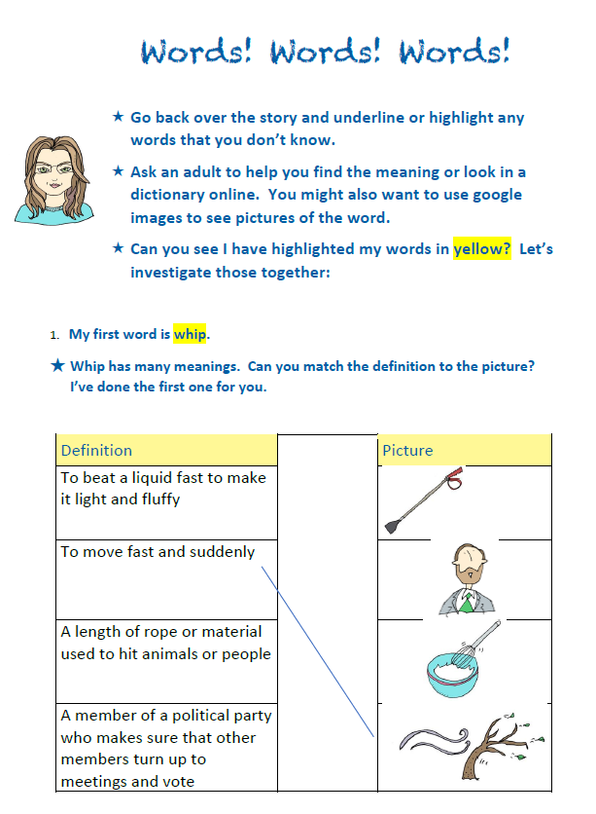
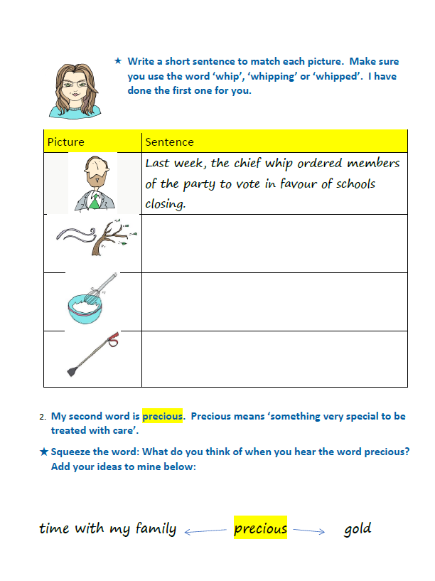
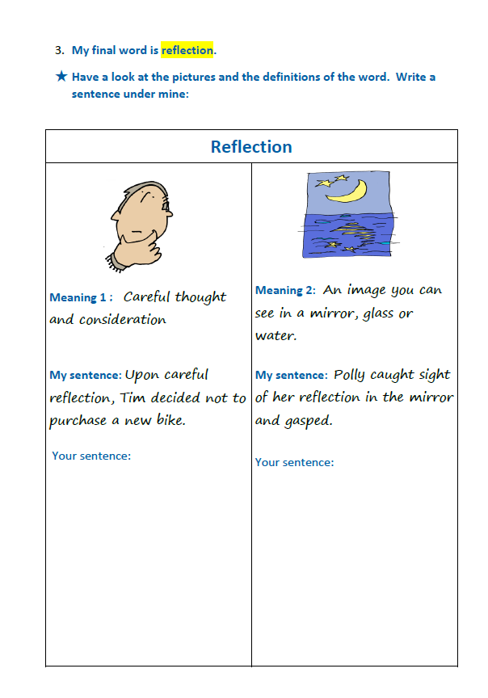
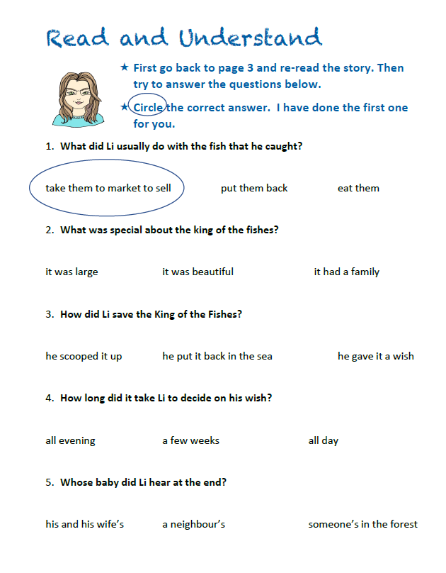
Maths
- Practice your times tables (in class we have practised the 2, 5, 10, 3, 4, 6, 8 and 9). A great tool for this is J2Blast on Hwb (I can see some of you have already had a go at this!)
- Practice telling the time on analogue (clock faces) and digital clocks
- Topmarks is a fantastic website to help with both of these

- This week’s topic is to use doubling and halving strategies when working with simple proportions (might be worth having a practice of doubling and halving using Topmarks first). To share objects in a given ratio e.g. red blocks and blue blocks in a ratio of 1:2. There is a sheet below for you to have a go at and here is a link explaining how to do it: https://www.youtube.com/watch?v=cflZnf9H5l4

Don’t forget all the different strategies we have learned for dividing (sharing blocks, using our times tables – we know that 60 ÷ 5 = 12 because we know 5 x 12 = 60 and the bus stop method which is used on the video).

You don’t have to do all the sheet you can choose to be Driver A or B (Driver B is slightly trickier).

Good websites to help with any of the above include Letters and Sounds for phonic practice, Topmarks, Crickweb for problem solving practice, Twinkl, Espresso, Hwb, BBC Bitesize and Primary Resources.

Rally Coach: Ratio - Driver A | Rally Coach: Ratio - Driver B
1. Divide £8 in the ratio 1:1 | 2. Divide £100 in the ratio 4:1
3. Divide £6 in the ratio 1:2 | 4. Divide £100 in the ratio 1:3
5. Divide £12 in the ratio 1:3 | 6. Divide £24 in the ratio 5:1
7. Divide £24 in the ratio 1:7 | 8. Divide £10 in the ratio 3:2
9. Divide £20 in the ratio 4:1 | 10. Divide £14 in the ratio 5:2
11. Divide £24 in the ratio 3:1 | 12. Divide £18 in the ratio 5:1
13. Divide £28 in the ratio 4:3 | 14. Divide £99 in the ratio 7:2
15. £72 in the ratio 5:4 | 16. Divide £200 in the ratio 3:7
17. Divide £12 in the ratio 3:2:1 | 18. Divide £50 in the ratio 5:4:1
19. Divide £30 in the ratio 2:2:1 | 20. Divide £84 in the ratio 5:4:3

History
I have uploaded another Powerpoint from Twinkl about the Ancient Greek Olympics for you to have a look through. I have included some pictures of Greek vases below: see if you can guess what event each vase shows (see slide 7). I have also included a Venn diagram for you to complete (see slide 8) – see if you can think of any extra events to include in your Venn diagram. You may need to do a bit of research on the modern Olympics to complete this. This website may help with this: https://www.olympic.org/

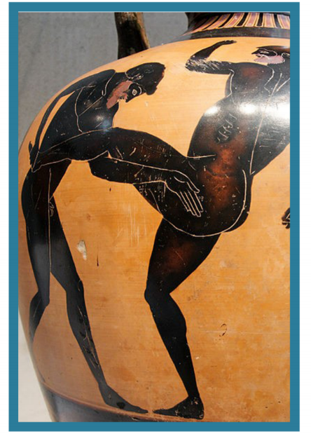

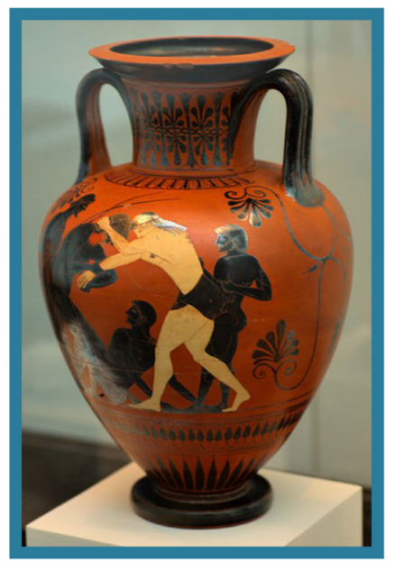

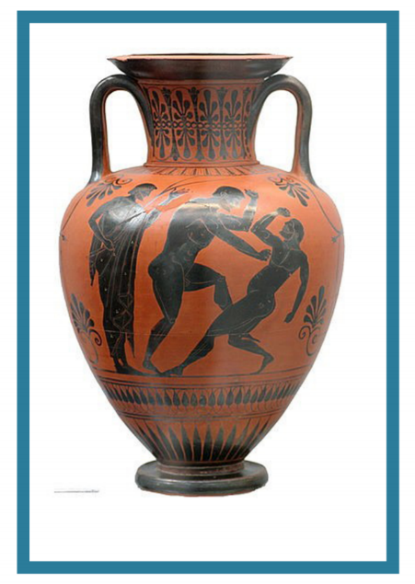

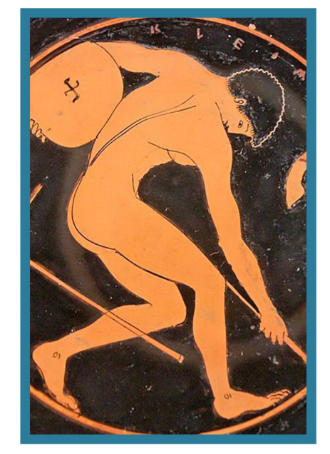

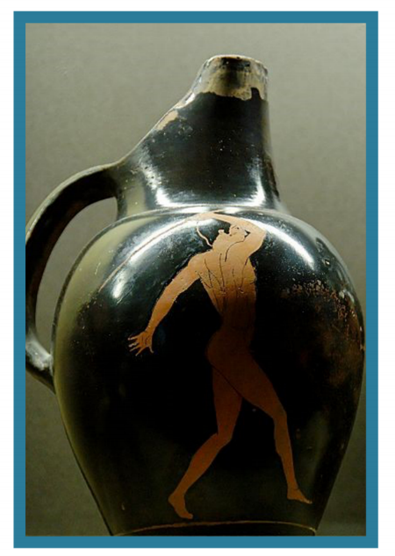

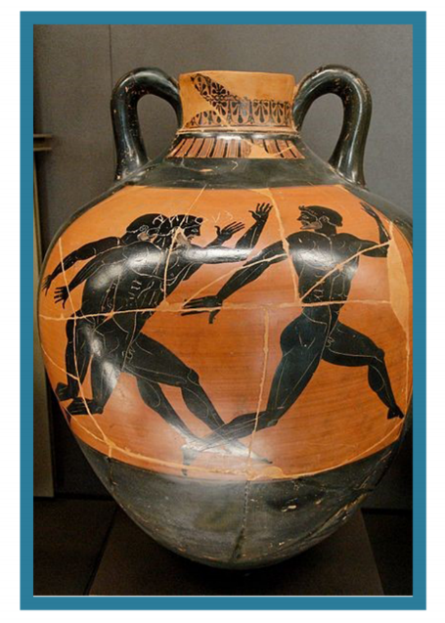
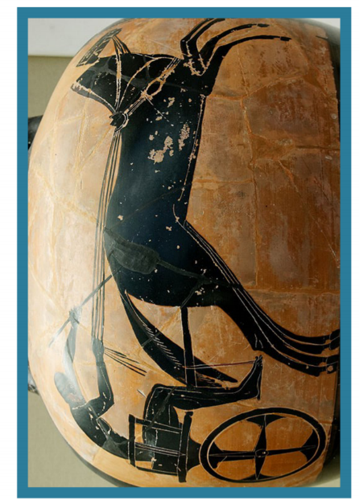

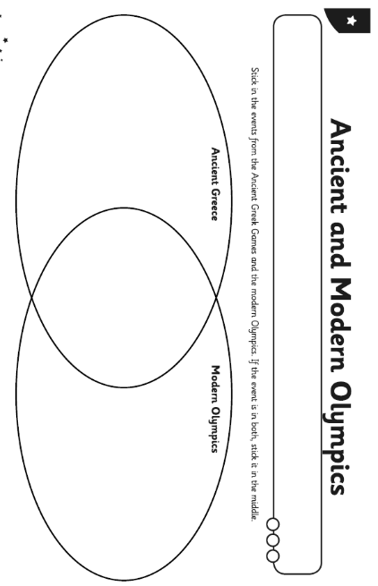
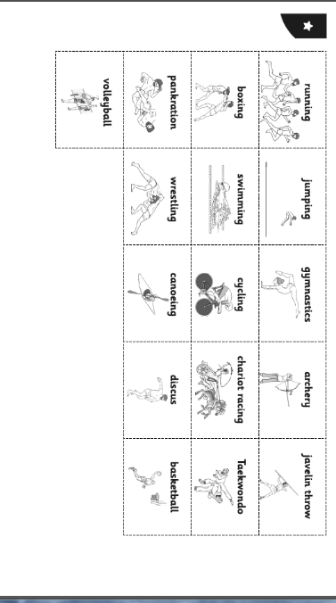
Welsh
Have a read through of the poem I have included below (the translation is underneath) and have a go at performing it. See if you can connect the couplets together (see sheet below) either by drawing a line or colouring in matching colours. Finally, try underlining the rhyming words in the poem (e.g. dre – hwrê). Notice that the words don’t rhyme in English.
Also here’s the link for the Cyw website where there are lots of activities for you to explore: https://cyw.cymru/en/

Mynd i’r Dre.
Mynd i’r syrcas yn y dre
Gweld y clown,hip,hip,hwrê!

Mynd i’r ffair sy yn y dre,
Taflu peli hyd y lle.

Mynd i’r caffi yn y dre,
Prynu hufen iâ i de.

Mynd i’r parc sy yn y dre,
Cicio pêl i’r chwith, i’r dde.

Mynd i’r pwll sy yn y dre,
Nofio’n chwim o le i le.

Wel,dyna hwyl sy yn y dre!

Mair Elwyn

Cysylltwch y cwpledi (connect the couplets).

Nofio’n chwim o le i le.

Mynd i’r parc sy yn y dre,
Gweld y clown,hip,hip,hwrê!

Prynu hufen iâ i de.

Taflu peli hyd y lle.
Cicio pêl i’r chwith, i’r dde.
Mynd i’r pwll sy yn y dre,

Mynd i’r caffi yn y dre,

Mynd i’r ffair sy yn y dre,

Mynd i’r syrcas yn y dre

Going to Town
Going to the circus in the town
See the clown, hip hip hooray!

Going to the fair which is in the town,
Throwing balls all over the place.

Going to the café in the town,
Buying an ice cream for tea.

Going to the park which is in the town,
Kicking a ball to the left, to the right.

Going to the pool which is in the town,
Swimming quickly from place to place.

Well, there’s the fun that’s in the town!

Mair Elwyn

ICT
This week’s activity is about improving your stop-frame animation from last week. I would like you to insert pauses into it to improve the quality. Here is a link to help you with this: https://www.youtube.com/watch?v=uIDRWsHkc8c&feature=youtu.be
Try planning out a simple narrative for your object. You could perhaps draw it out first: first this happens, then this, and finally this.
Insert ‘pauses’ into your animation to improve the final animation. This stops it ‘rushing’ to the end which some of you may have found in the previous activity. To make a pause take several frames where nothing moves. If the animation is running at 12 frames per second, how many frames would equal half a second? Add 12 frames at the beginning of your animation and 12 frames at the end.
Evaluate your final animation. Was your animation an improvement on the previous one? What could you do next time to make it better?

Try to include a bit of physical activity every day. Joe Wicks has proved really popular on his YouTube channel – you can have a look here: https://www.youtube.com/channel/UCAxW1XT0iEJo0TYlRfn6rYQ

Happy home learning! Hope you are all keeping safe and well,

Miss Densley

