Home Learning Pack Year 6 Week 5
Miss Kear & Miss Thomas’ class

Hello everyone!
Hope you are all well and happy! Here’s this week’s work. Please don’t try and do it all in one go! This is meant to be done a little bit each day as we would in school. In this work pack you will find:
Maths:
Emoji code breaking activity
Mental maths test – ask someone to test you
Writing numbers to 10,000,000 in words
Mean – the mean is the average of the numbers. Remember, to find the mean you add up all the numbers and then divide by how many numbers are there.
Problem solving – working backwards
English:
A short comprehension about blurbs.
Writing a blurb for a book.
A missing word sheet
Phrases and clauses
Brainteasers (Maths and English mixed)
Boost your brainpower - quick activities. (Answers included so you can get the idea!)
Art
Making paper stars to brighten up your bedroom or colour in rainbow colours and put in your window to support the NHS.
Welsh
Welsh weekly challenge
Keep up the hard work!
Miss Thomas and Miss Kear

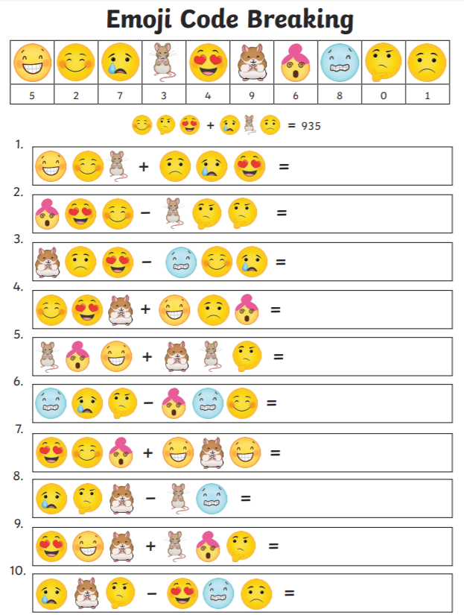

Mental maths test – ask someone to test you

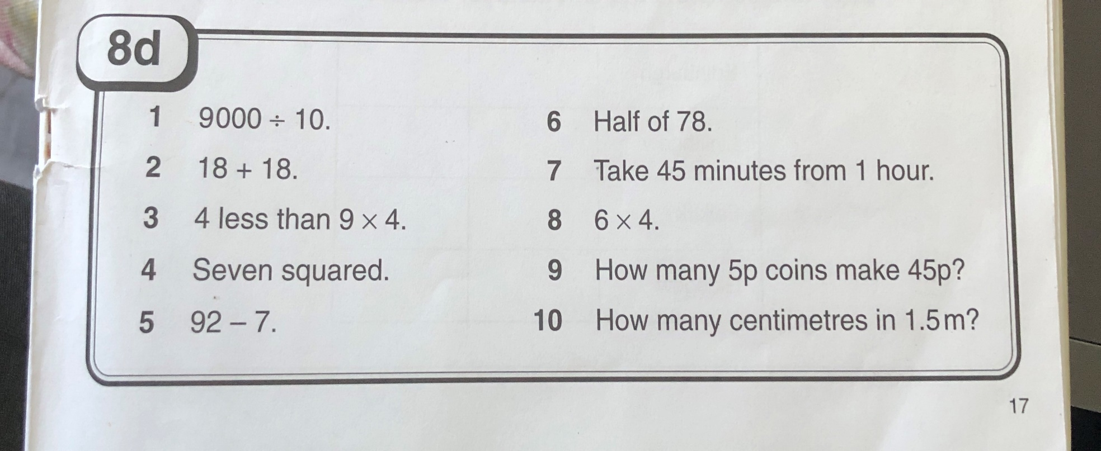

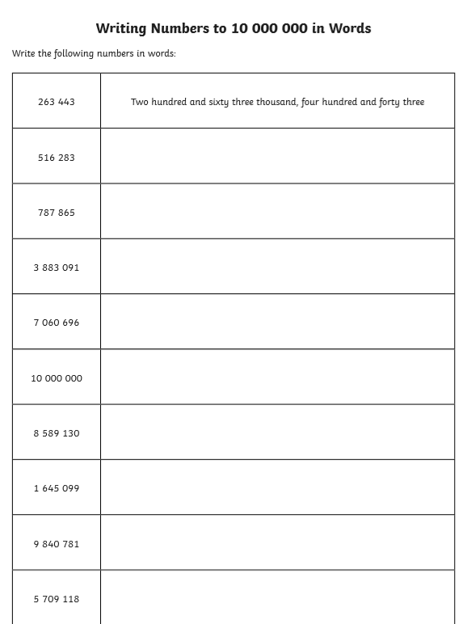
Challenge: Can you add 2 of these numbers together? How would you set out the calculation?

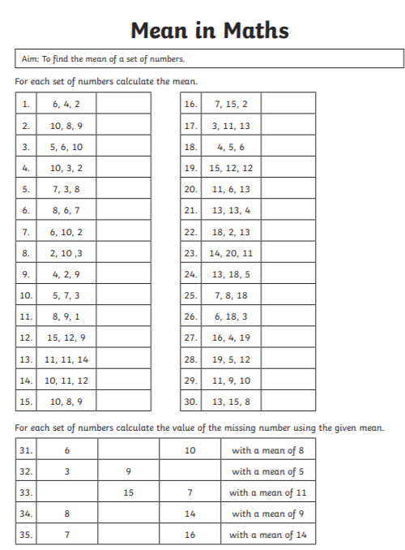
Remember, to find the mean you add up all the numbers and then divide by how many numbers are there.
Problem solving – working backwards
Understand the problem:
- What do you know? – you can underline the important information in the problems.
- What do you need to find out?
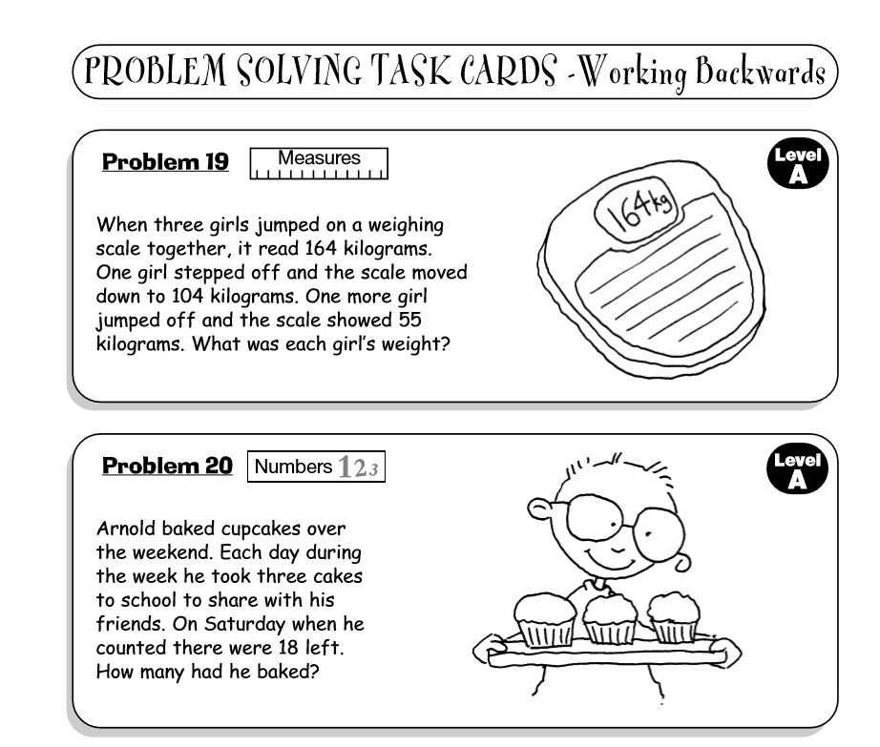
- How are you doing to solve this problem? What are you going to try? What will you need to help you?

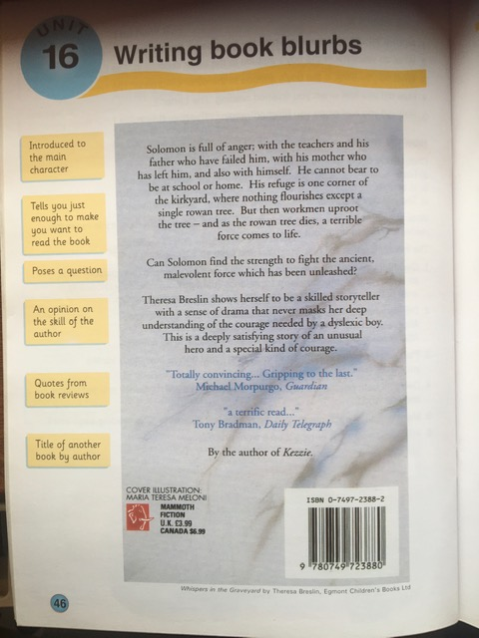

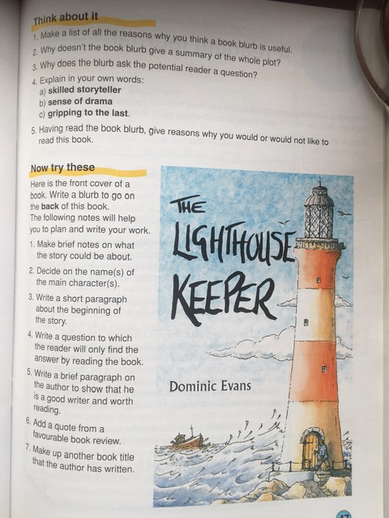

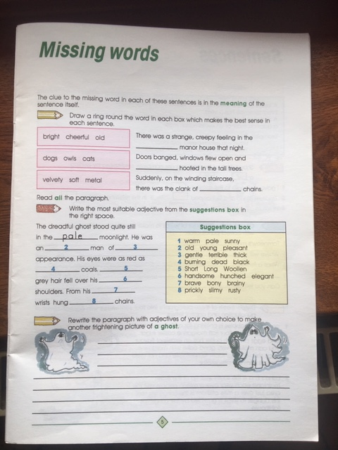

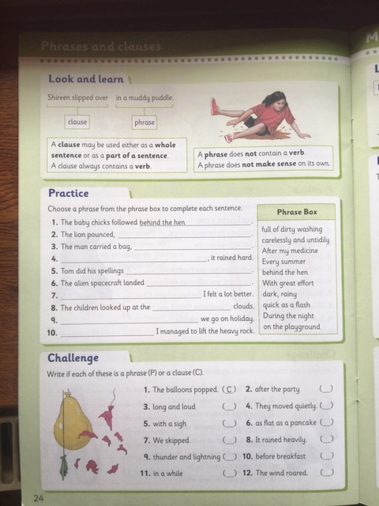

Brainteaser: 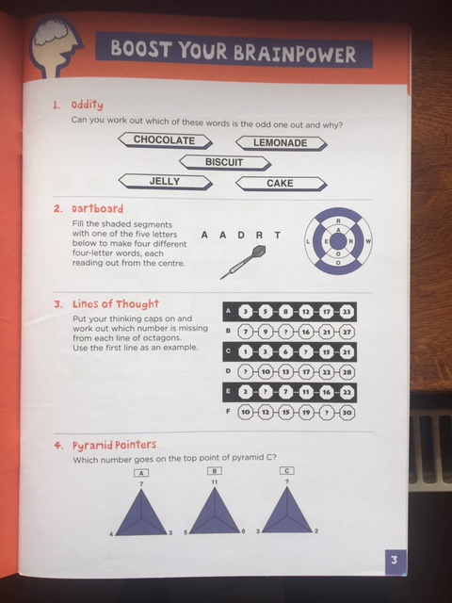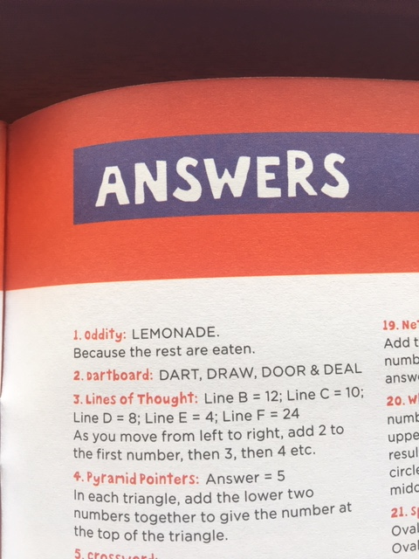

Art:
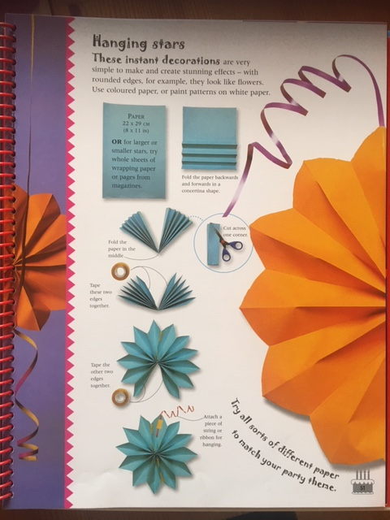

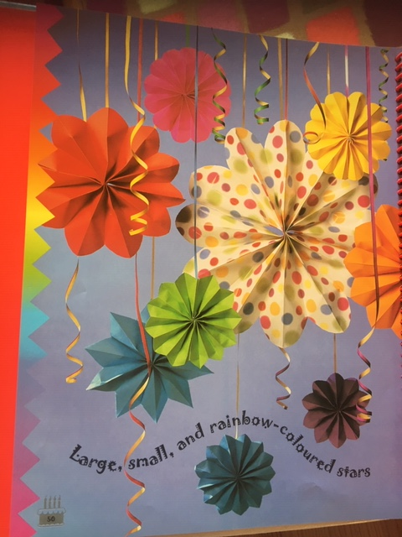

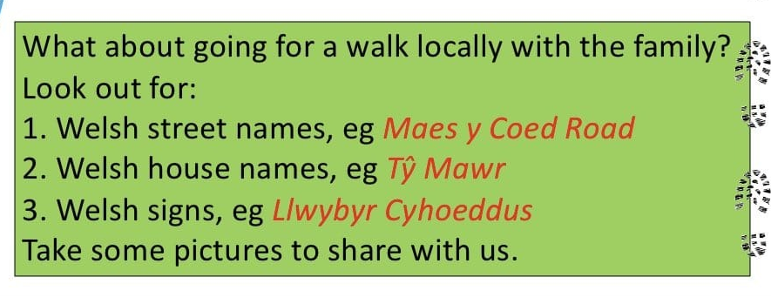
Welsh Weekly Challenge

