Williamstown Primary

Home School Learning Pack Year 3 W-C 4/5/2020

Useful Websites
TWINKL- free code 1 month = PARENTSTWINKLHELPS
BBC BITESIZE TOPMARKS- Hit the button
SCHOLASTIC HWB
Hello everyone, I hope you are all safe and well, still working hard but also having as much fun as possible
Here is your new pack for this week including English work, spellings, maths challenges and topic work focusing on ‘Keeping Healthy’.
Keeping Healthy includes focusing on our body and mind, our wellbeing, healthy eating, fitness, nature and the environment and positive relationships i.e friendships.
Remember to keep reading, stay safe and keep in touch with your friends when you can
Miss Thomas x
Letter Writing
This is a very strange time for us all as we have been off school for a while now and I’m sure lots of you are missing your friends! This week you have a challenge to write a letter to your best friend. You may want to include:

- Any tips to help with school work.
- A book you read that you enjoyed.
- A good film that you have watched.
- Something fun you have done.
- Any walks you have gone on/ exercise you have done.
- Something new you have found out.
- A skill you have learned throughout your time off school.
- How much you miss them

Film Review Challenge

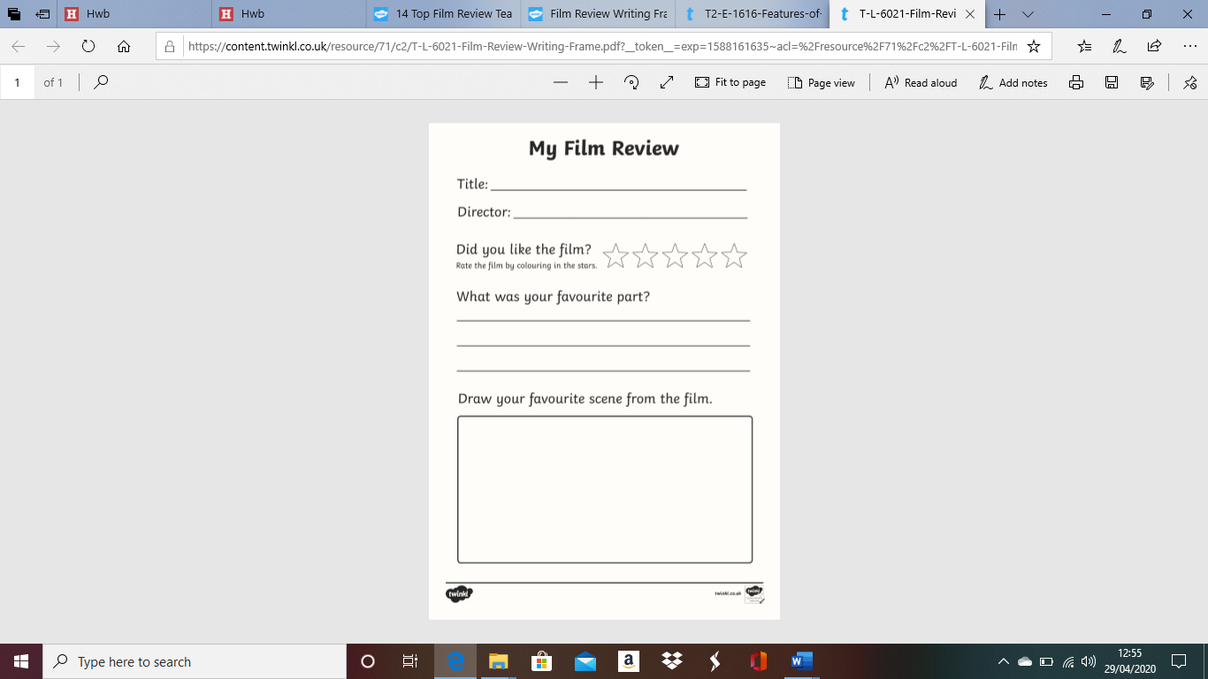
This week I would like you to write a film review on a film you have watched during your time off. Use the template below to help you. You could also include the best part of the film, the worst part, why you enjoyed the film and who would you recommend the film to?
Here are your spellings for this week. Remember to practise them by writing them out and then using them in a sentence.
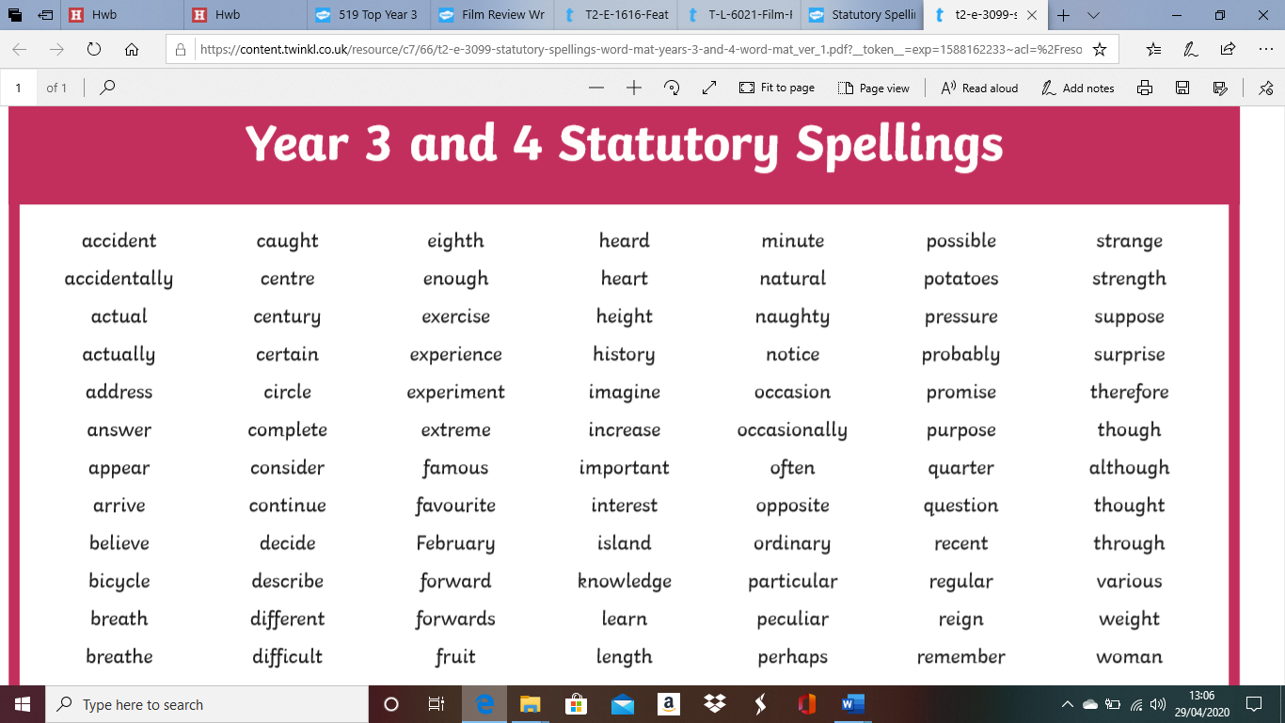
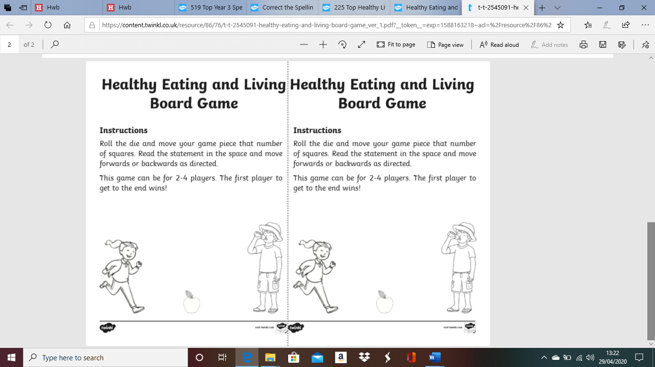
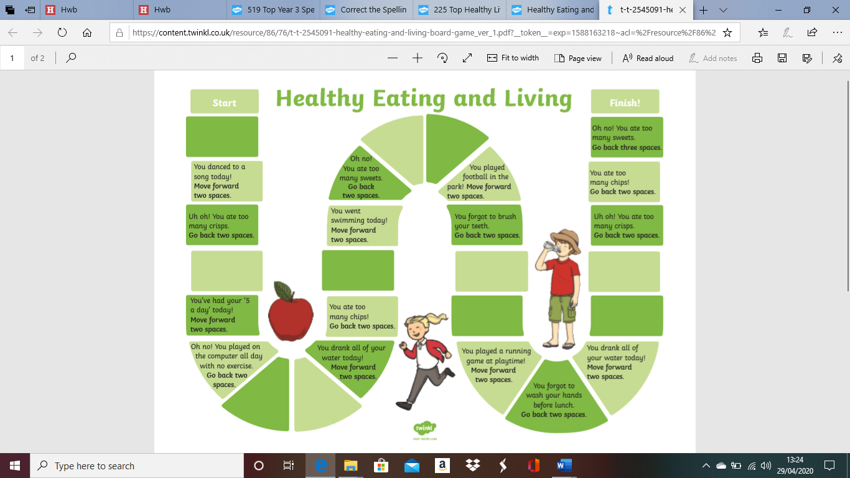
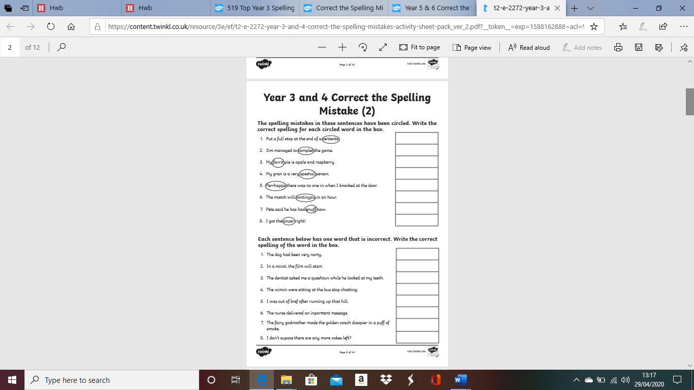
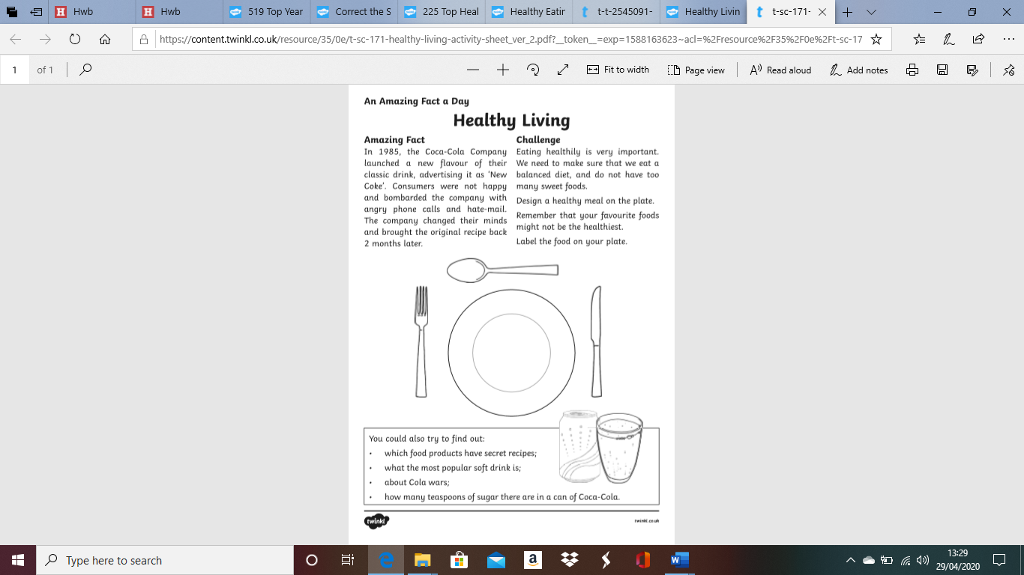

Maths Magic!
Its super important to practise our times tables and have confidence in ourselves. Your challenge is to learn your 2, 5 and 10 times tables off by heart. You can learn these by listening to songs (there are some great ones on youtube) writing them down and covering them is also a good way to remember.

After you have learned these, you can move on to your 3 and 4 times tables and in time learn the rest .

Complete the multiplication triangle focusing on 2s 5s and 10s below.

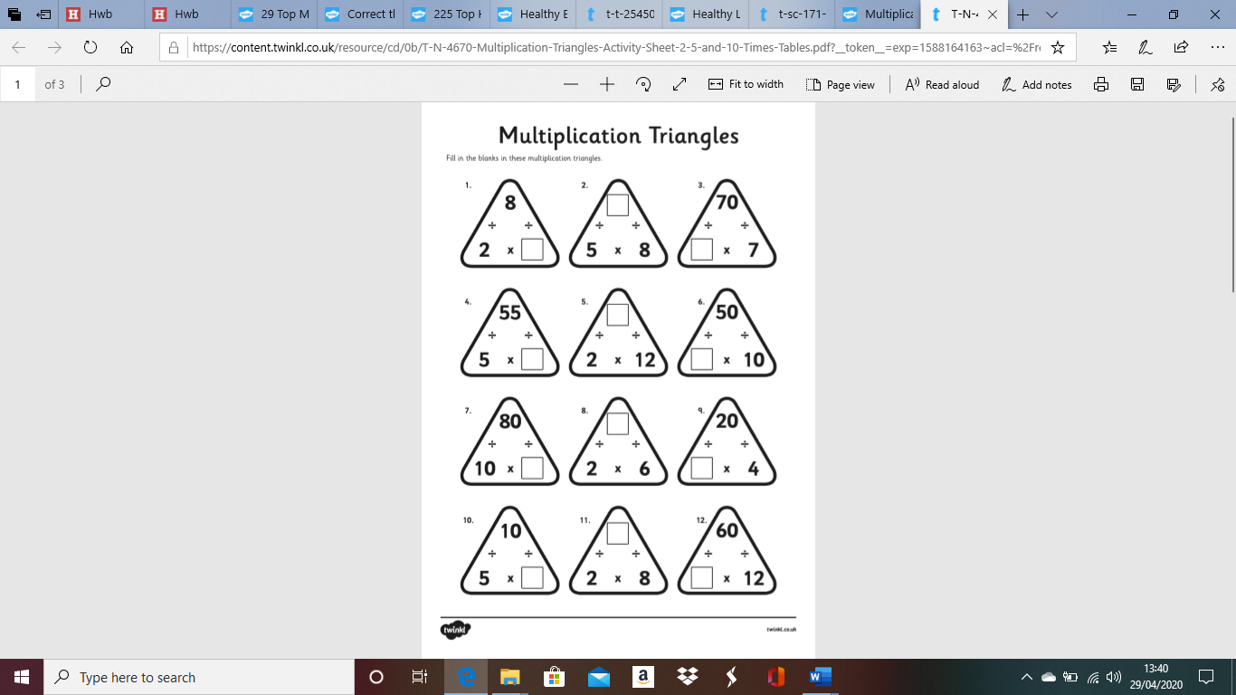
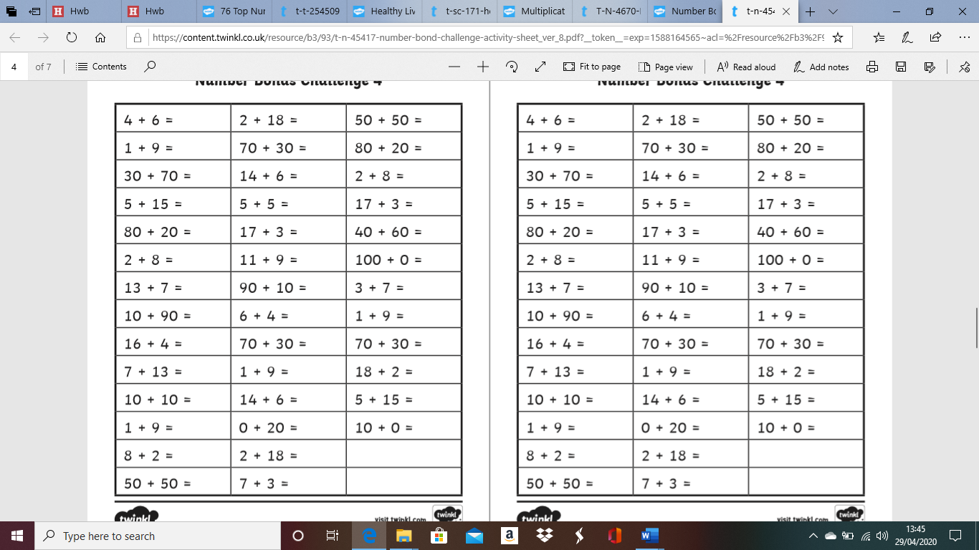
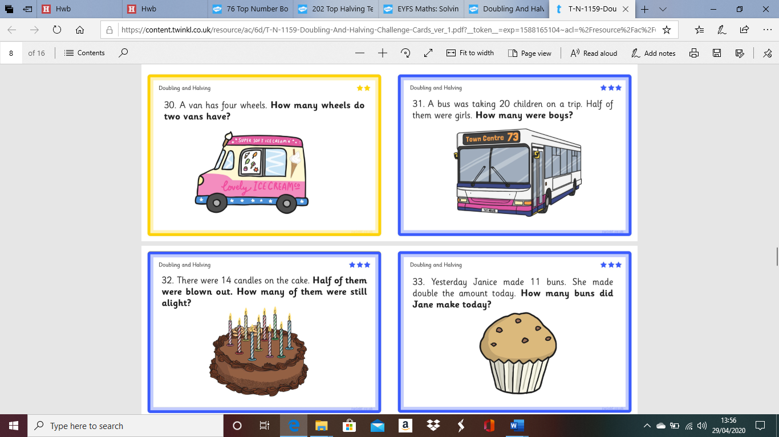
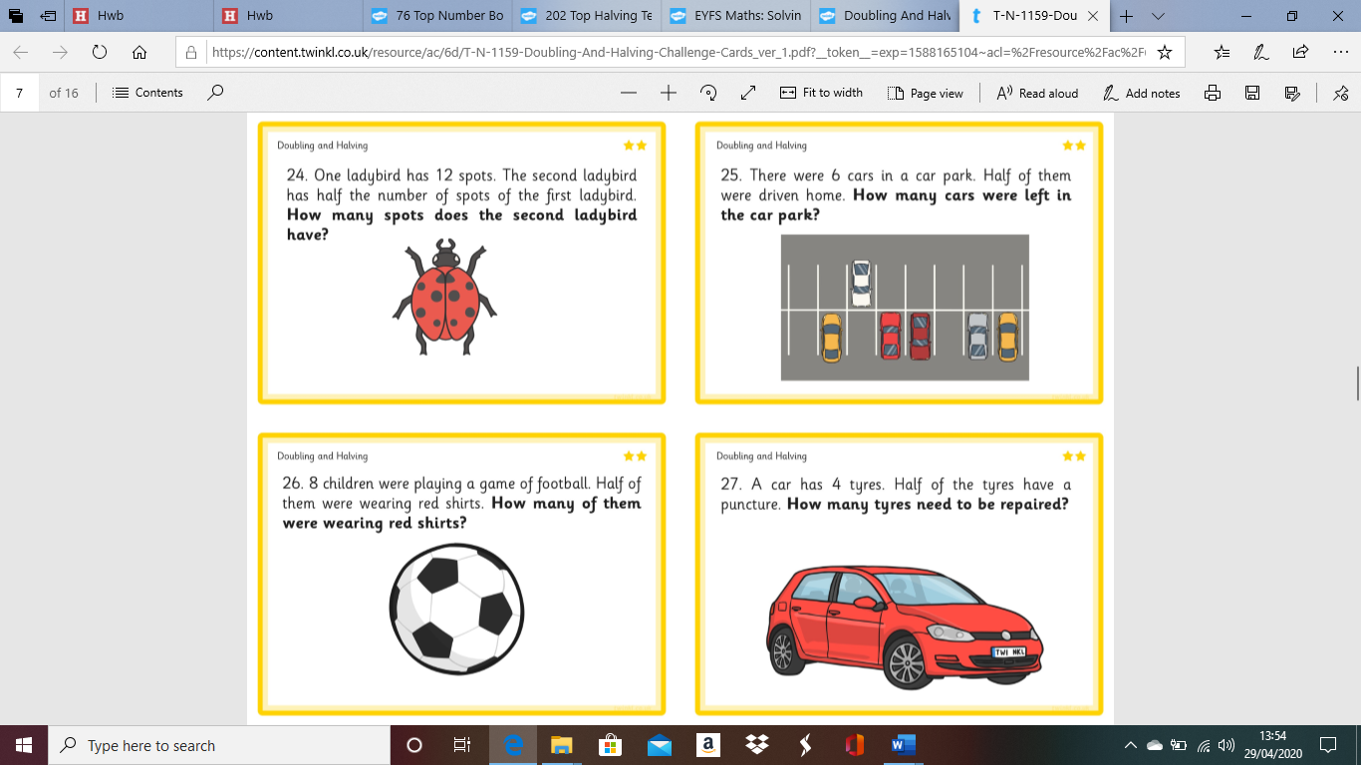
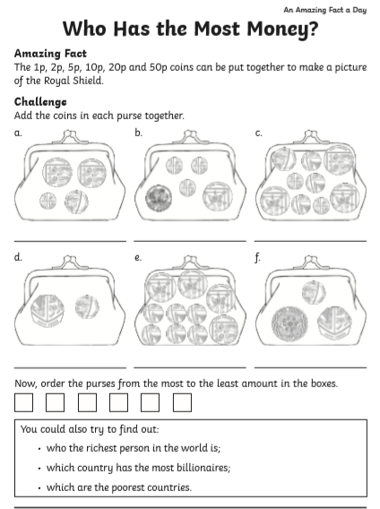
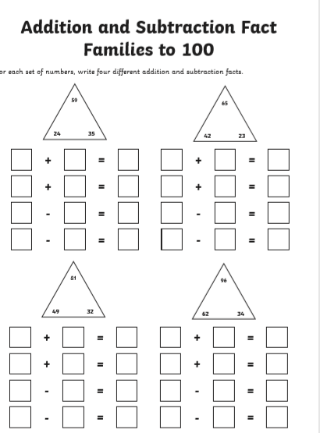
This 100 square can help you with lots of your maths challenges
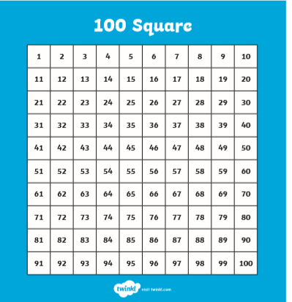
BBC Bitesize is a great resource for home learning. Here are some links to some great online learning you can try at home! (Copy and paste each one into your search bar)

https://www.bbc.co.uk/bitesize/articles/zfxx6v4
(Maths Adding and Subtracting Word Problems)

https://www.bbc.co.uk/bitesize/articles/zbn492p
(English- Using Adverbs)

https://www.bbc.co.uk/bitesize/articles/z773bdm
(Wellbeing Activity on Teamwork)

