Week 6
Week Beginning 11-05-20
Hello again everybody.
We hope you are all still staying safe.
We have completed the first three weeks of this term, and hopefully learned lots about Dinosaurs? Moving on from the past we thought a good link would be to look at Jungle/Safari animals, as some of these animals actually lived alongside dinosaurs towards the end. eg: crocodiles, snakes, frogs, anteaters.

Language and Literacy
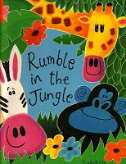
- Our focus book is ‘Rumble in the Jungle’ by Giles Andreae.
We appreciate that you might not have a copy of this book
at home, but you and your child can still share the story if
you Ctrl & click the link below:
https://www.bing.com/videos/search?q=rumble+in+the+jungle+kids&qs=n&sp=-1&pq=rumble+in+the+jungle+kids&sc=2-
- You will notice this is a rhyming book. Please help your child identify any rhyming words they can hear in the story.
- When sharing any story at home with your child, please can you encourage them to hold the book correctly and turn the pages one at a time, from the bottom left hand corner. This may seem trivia but it is an important part of their progress and development.
- Can your child remember details from the story? Ask who? What? Where? When? How? questions to find out.
- Can your child recognise the difference between print and pictures in stories? (Ask the question you may be surprised)
- Please continue to help your child to recognise their name. If your child wants to practise writing their name there is a copy of the letter formation rhymes in last week’s home learning pack.
- How many logos can they recognise around the house or in the environment? eg: apple, Tesco, Asda to name but a few. Maybe they could find some and take a photo to share on twitter.
- The cbeebies web site (link below) have some excellent shows and games for your child to play. To help them learn about different Jungle/Safari animals
- Play the ‘What am I?’ game on the week 6 powerpoint section

- https://www.bbc.co.uk/iplayer/group/p05ws693
- https://www.bbc.co.uk/cbeebies/shows/andys-safari-adventures

Mathematical development

- Discuss with your child the different patterns the animals have.
- How many different patterns can they see around the house or in the environment when you are out exercising?
If you have access to a printer, there is an animal pattern matching game in this week’s printable section. Alternatively, you could make your own matching game with cut up patterned material or paper.
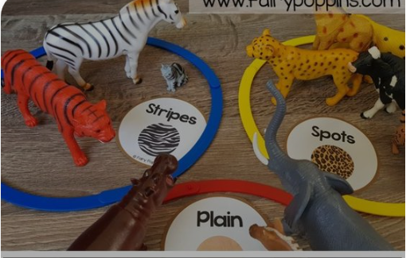

- Talk to your child about the names of the animal’s babies. Eg:
A calf is a baby Elephant, Giraffe, hippo, rhino
A foal is a baby Zebra
A cub is a baby tiger, Lion, hyena
A hatchling is a baby crocodile
An infant is a baby chimpanzee, gorilla
You could play a matching game to help with this. There are some animal cards in this week’s printable section. Alternatively here are some links for some online matching memory games https://www.memozor.com/memory-games/for-kids/wild-animals
https://youtu.be/Y9Eyr8yCoX4 https://www.bbc.co.uk/cbeebies/shows/andys-safari-adventures

- If your child has some Jungle/Safari animal toys at home. Why not set up a race track. See which animal comes 1st 2nd 3rd and last.
If you don’t have Jungle animals You could make some animal masks and race each other? Or use whatever you have to hand. It is the use of 1st 2nd 3rd and last that is the important factor.

- Please continue to help your child to count to 10 forwards and backwards.
- If you feel they are now confident in doing so, you can increase up to 20 forwards and backwards.

- Can your child put the numbers 0-5 or 0-10 in the correct order to form a number line? You can use numbers written on squares of paper to see if they can do it. Share their success on twitter for all of us to see.

Creative Development
- Let’s help protect the environment for these amazing animals we are learning about, and use some of our recycling to make some jungle craft.
- How about these Binoculars? Or Giraffe?
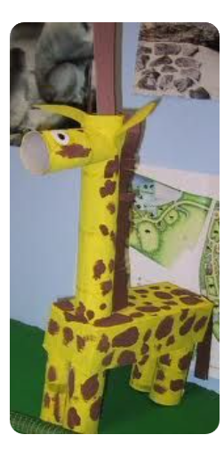
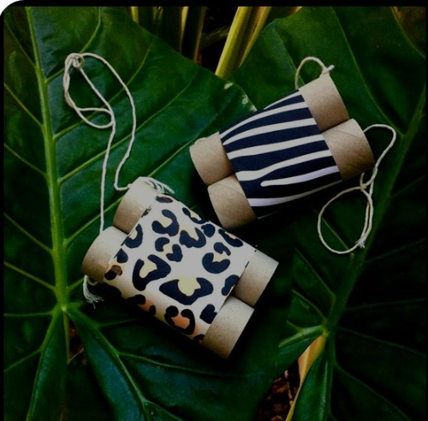

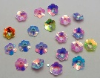
Celebrate your creativity on Twitter. Let’s see who can get a virtual shinny?

Other ideas
- Why not take a virtual tour of Longleat safari Park. This is full of very interesting information, to help your child learn about the different animals and what they eat, how they sleep etc
https://www.youtube.com/watch?v=pUmHClrRPxc

- If you have an AR enabled device you can view life size animals from your device in your room. It’s absolutely fascinating check out this link to see how
https://www.bbc.co.uk/newsround/48489309

https://www.google.com/search?q=Giant+panda&hl=en-GB

Have fun!
Stay safe!

More Huge Hugs!
From Mrs Edwards and the Nursery team x

