Helo eto, Sut mae? Hope you all found a unique way of marking VE day at home. Please remember there is no need to print out any of these activities, they can be completed in your child’s Busy Book or on paper and read from screen. Activities are just a guide on the direction of the skill set we would be developing in school, if you find similar alternatives online, great use them. The important element is to keep your child safe, happy and engaged. Remember to read a little every day, keep practising your sounds and complete a math activity too, look back on the parent guide issued in week one for tips on games. There are so many website and ideas out there that look amazing, many of which are now free. Let us know via twitter(@williamstown1_2) if there are sites/ apps you recommend! Next week we will be looking at a subject of pupil choice relating to our theme, let me know during our weekly welfare calls your child’s choice and I’ll select the most popular idea. Ideas could include – weather, birds, wild flowers, wildlife, insects, ponds, rivers, forests etc! Keep safe. Take care. It’s been lovely seeing some of you on Twitter this week, you’ve grown so much already! Love to you all, Mrs Thomas + Miss Galliford. x
Summer Term-Tymor yr Haf
Year 1- Mrs Thomas.
Home Learning – Summer Term Week 4, Monday 11th May
Theme – A Walk on the Wild Side.
This week we are learning about Dandelions. What do you know about dandelions?
Physical activities to try at home – indoors and outdoors
Ball work – Throw the ball upwards let it bounce +catch it (standing on the spot). Then try walking whilst repeating this action. Challenge- Can you bounce the ball against a wall and catch it? Try working with a partner instead of using a wall? Increase your distance to extend the Challenge- Vary the size of the ball for skill development.
Creative Movement – Watch dandelion fluff float on the breeze – Can you float and twirl, rise and fall like the dandelion fluff? Does your shape change? Does your direction change? Where will your journey end?
Cosmic Yoga – Fairy Floss
PSWBCD
This week s activity has been suggested by one of our parents. It encourages children to think of the future. Think of 5 things you’d like to do when lockdown lifts. Keep the list safe and tick them off when they’ve been realised. It will give the children time to plan and reflect. You could extend this task by making a list of 5 local things they’d like to do and 5 things they’d like to do a little further afield too. It’s a task the whole family could get involved in and offers a great opportunity to discuss importance / relevance. A slant on this might be to keep a Jar of Future Joy. When the activity is realised, how did it make them feel? Don’t forget, the children are able to write the lists themselves with a little encouragement.

Suggested Book Bank
These books would be useful to enhance our learning this week. Look for them being read on *Youtube or visit libraries.wales/my-digital library for an e copy of the title (link on Twitter).
Story Books (Fiction)
*Freddie and the fairy by Julia Donaldson
*The dandelion seed by Joseph Anthony

Information Books
Wildflowers by Usborne

I’ve put a star* by all the stories I’ve found on Youtube!

Poems of the Week

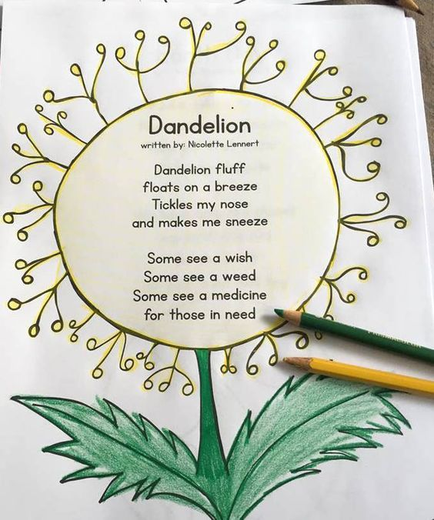
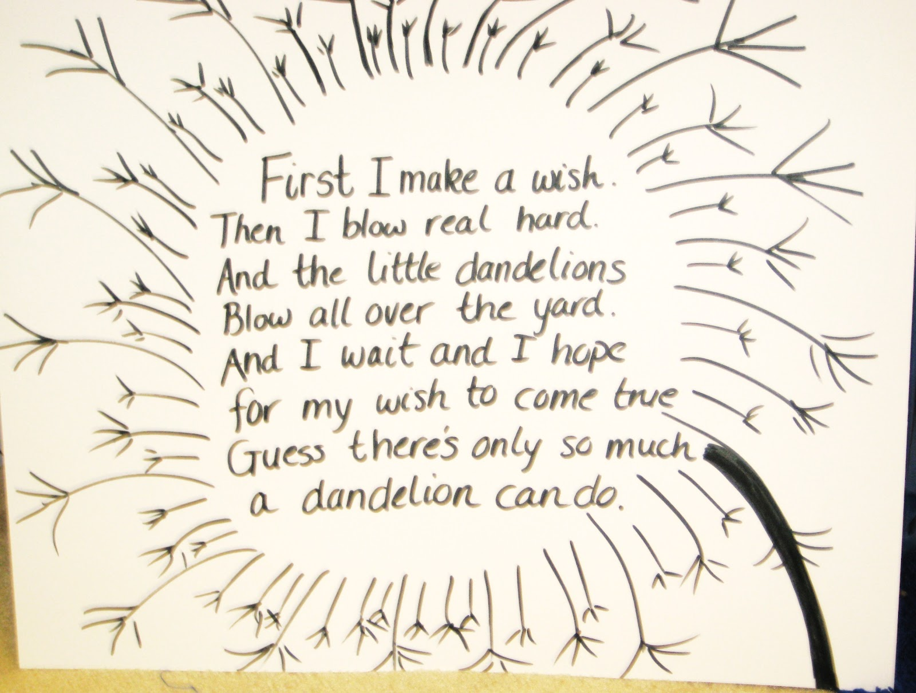
Music
Watch and listen to the ‘Official Dandelion Music video – Just Micci’. How does this music make you feel? Can you remember any of the lyrics? Sometimes words were not used just a simple sound – what sound was it? I’ll give you a clue it was a vowel! Can you recall the rhythm that was used with this ‘o’ sound? What instrument can you hear? How many voices can you hear? Was the music fast or slow? Loud or quiet? Which instruments can you play? Which instrument would you like to play (if any) in the future.

Ict -
Download ‘Beebot ‘ app . This game helps your child to learn to develop their coding skills , as well as spatial awareness and offers opportunities to discuss directions and give instructions– predict a route, plot the route and discuss outcomes . How could you improve your instructions?
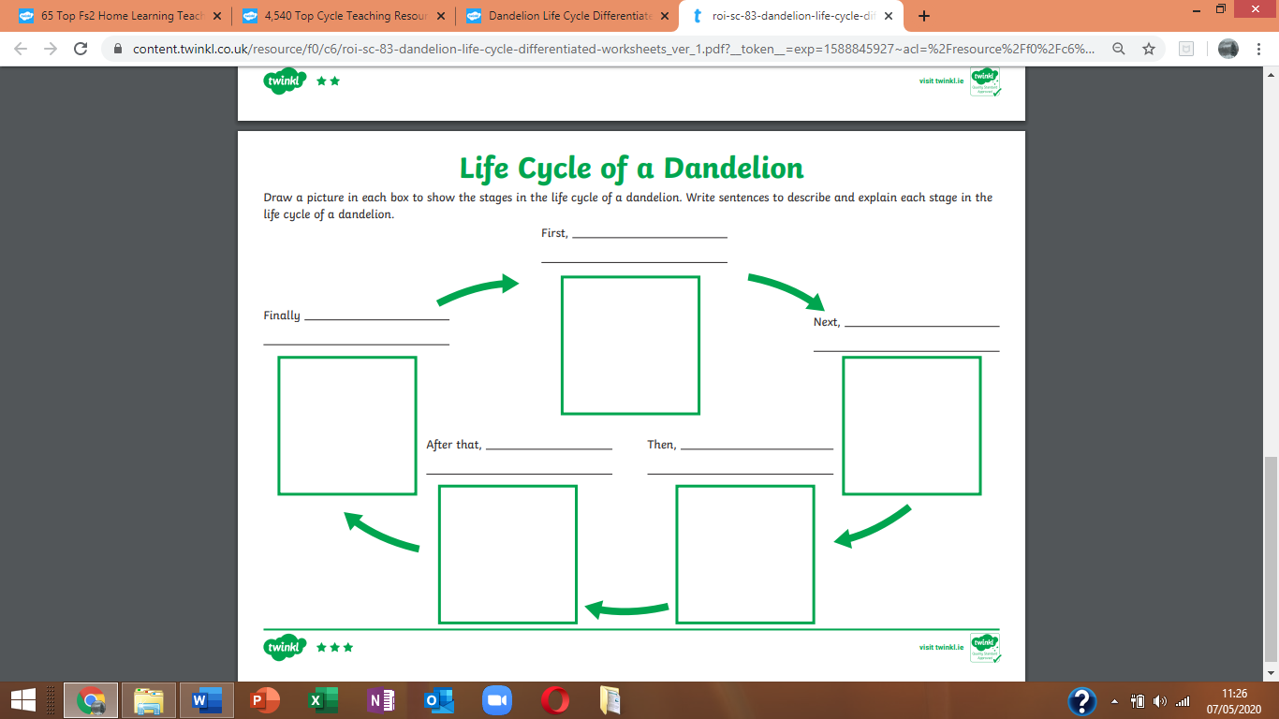
Knowledge and Understanding of the World –
Watch ‘Dandelion lifecycle animation’ on youtube and talk about the changes in the dandelion’.
Watch BBC bitesize ‘The lifecycle of a dandelion’. This will help answer the task below. What new vocabulary have you learnt? Can you include some of your new vocabulary when completing the task below. Remember to use your phoneme fingers and sound mats (in your reading file) to help you with your spelling.

Watch BBC Bitesize ‘What a materials are different objects made from?’ and discuss the different material names.
Draw 2 SETS (as opposite) Can they write a label for each set? Can they find / draw 6 examples of each item?
Challenge – Write a label for each item in the set.
This could be completed indoors and outdoors, comparing the results.
Discussions about materials can be used as part of your daily routine. This will help strengthen your child’s understanding.
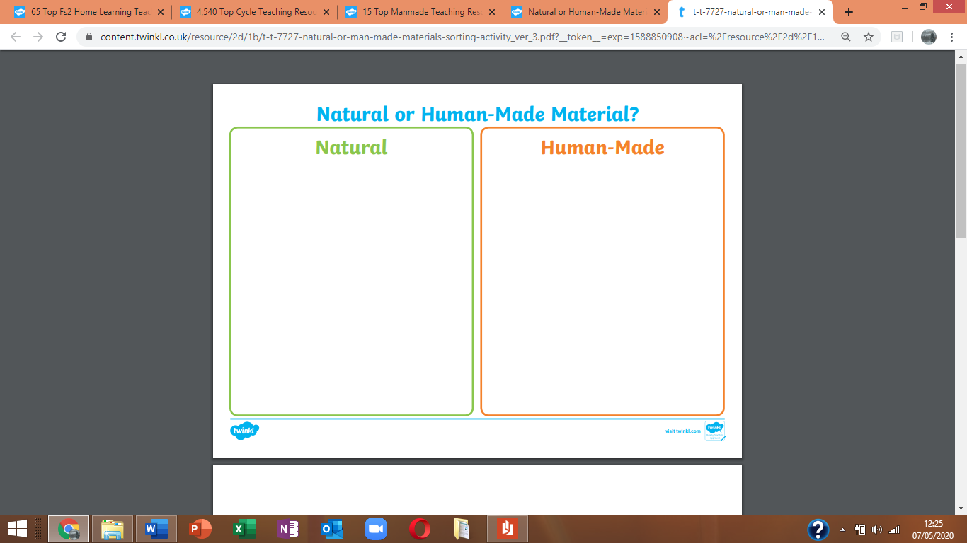
Creative
Create a dandelion fairy picture – Remember there are girl and boy fairies in the Fairy Kingdom. Do they all look the same? Are they all the same size? What colours/ materials can you use? You could include some actual dandelion heads in your designs.
Outside – Use dandelions to dress your shadow ! Can you dress someone else’s shadow? Can you take a picture of your designs? Use PicCollage app to store your designs. (pupils used this app regularly to record their work in class)
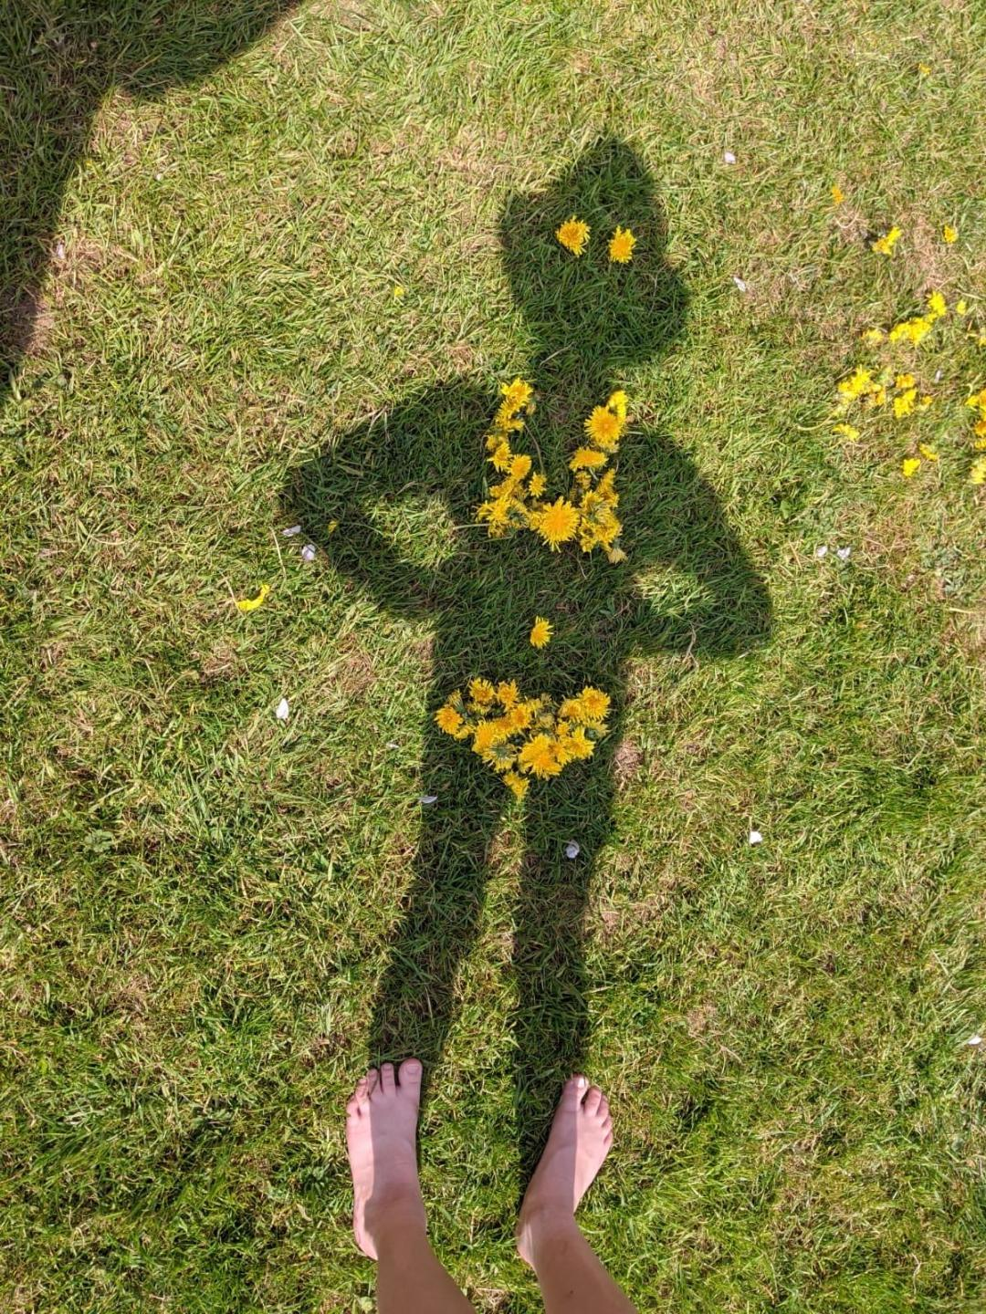

Welsh
Q – Sut wyt ti heddiw ? (How are you today?)
Dwi’n……… (I’m……..) you could add …’diolch’ to finish.
Dydw i ddim yn ………. (I’m not…..)

Hapus…..happy gyffrous………excited iawn ……ok
Trist ….sad wedi blino ……….tired ofnadwy ….miserable
Bendigedig ……wonderful grac – angry
** use Alexa or google translate to help with pronunciation if you aren’t sure.

Language (I’ll try to keep these activities similar from week to week)
1. Can you copy one of this week’s poems neatly into your book? Think about letter formations, spaces, capital letters, full stops, letters sitting on the line (tails swinging under). Remember to read back your work. (Note to parents – pupils can copy the poem or as a challenge you can read it and they can write it or the ultimate challenge, can they write it from memory?) don’t forget to read back through your work.
2 . Learn to read high frequency words ( in reading file) – How many can they read in a minute? Choose 5 words to learn how to spell. How could you use these words in a sentence? Think back to all the words you ve learnt to spell previously as part of your high frequency challenge. How many can you remember how to spell correctly?
3. Our sound of the week is the trigraph ‘air’. How many words can you think of / find / read / spell with this trigraph in it?
Remember
You can use the online games on
Phonicsbloom.com
Letters and sounds .com
Phonicsplay
To reinforce your sound recognition. They are all free at present.
Work on phase 3 / 4 .
Which games are your favourites? Let us know so we can play them in class too when you all return.
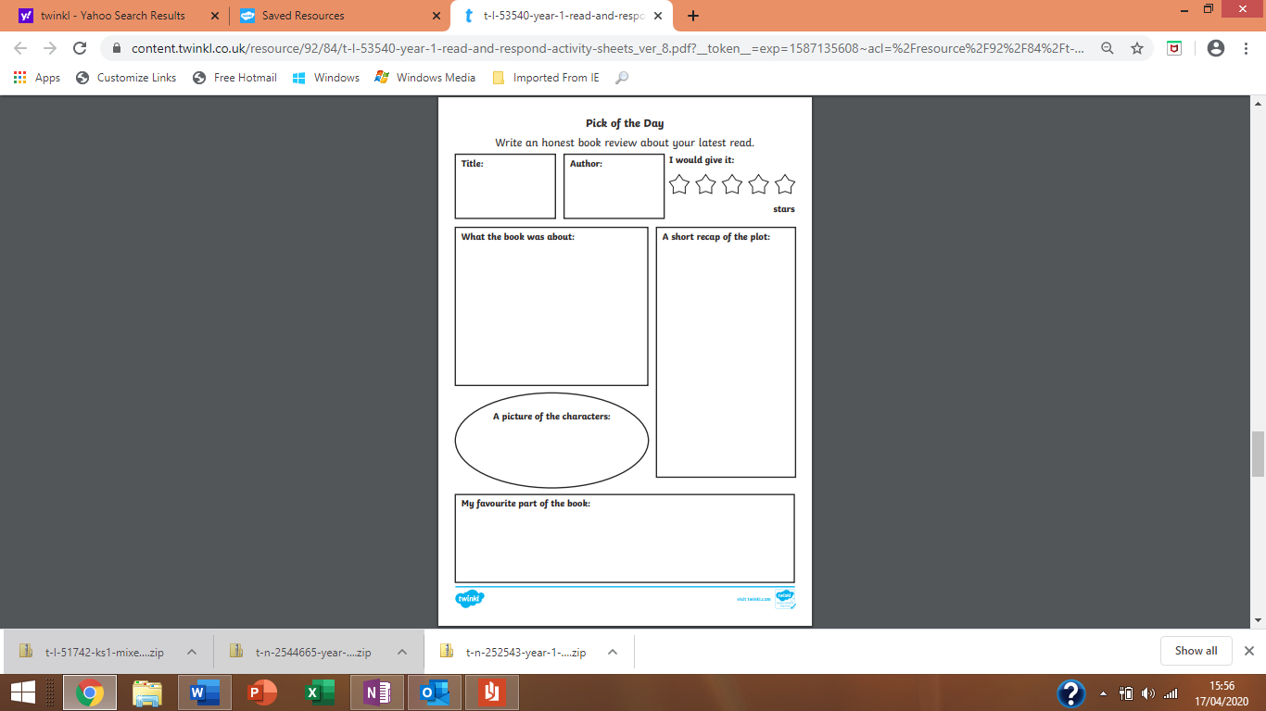
Book review- This week I’d like you all to review your favourite bedtime/daytime story once again. You can create your own Book review form or use the above format. Remember to encourage pupils to ask and respond to Who? What? Why? When? and Where? questions about the book that they are reading / sharing with an adult to develop a greater understanding, this will also help with comprehension tasks that will follow later in the term.

Create a factfile about dandelions. A fact file requires information. You can follow the format below, create your own style or how about simply folding an A4 sheet of paper in half and creating your own information book?
I’d like you to include –
A drawing - you could label this to extend your learning.
A title – the name in English and Welsh
Some interesting information about your focus of study-
Such as - How does it move? What does it look like? Where does it live? It’s life cycle. It’s colour. What’s the most interesting fact you learnt?
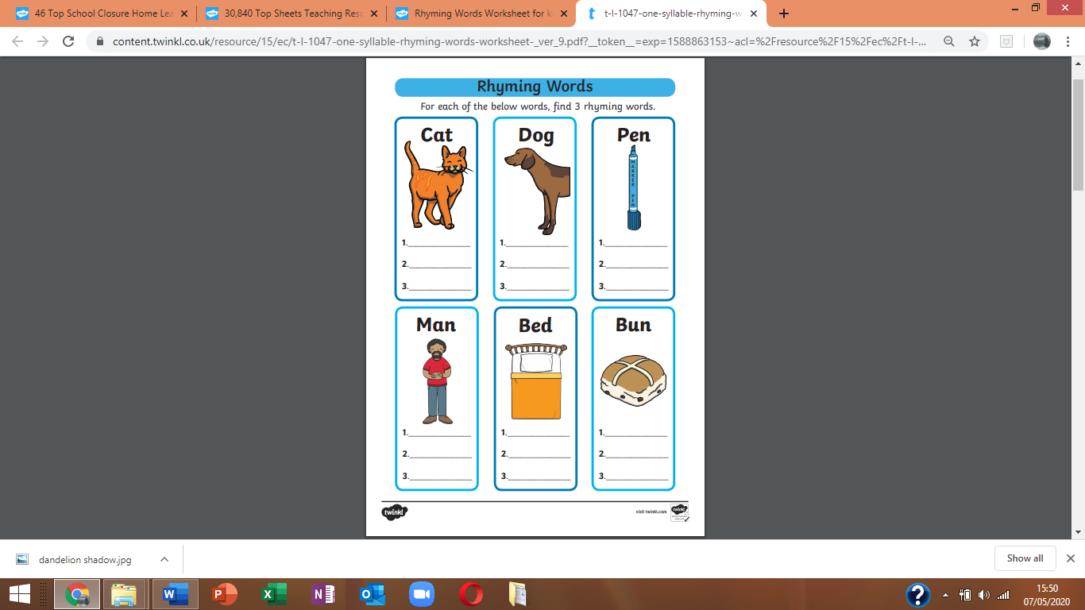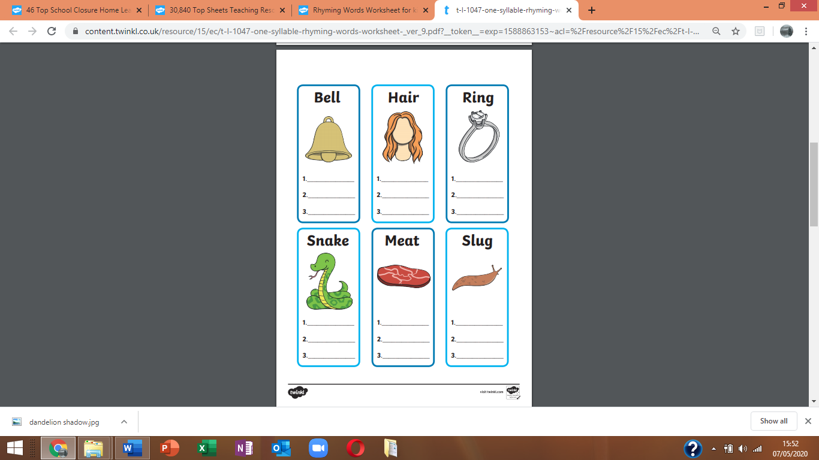
Maths
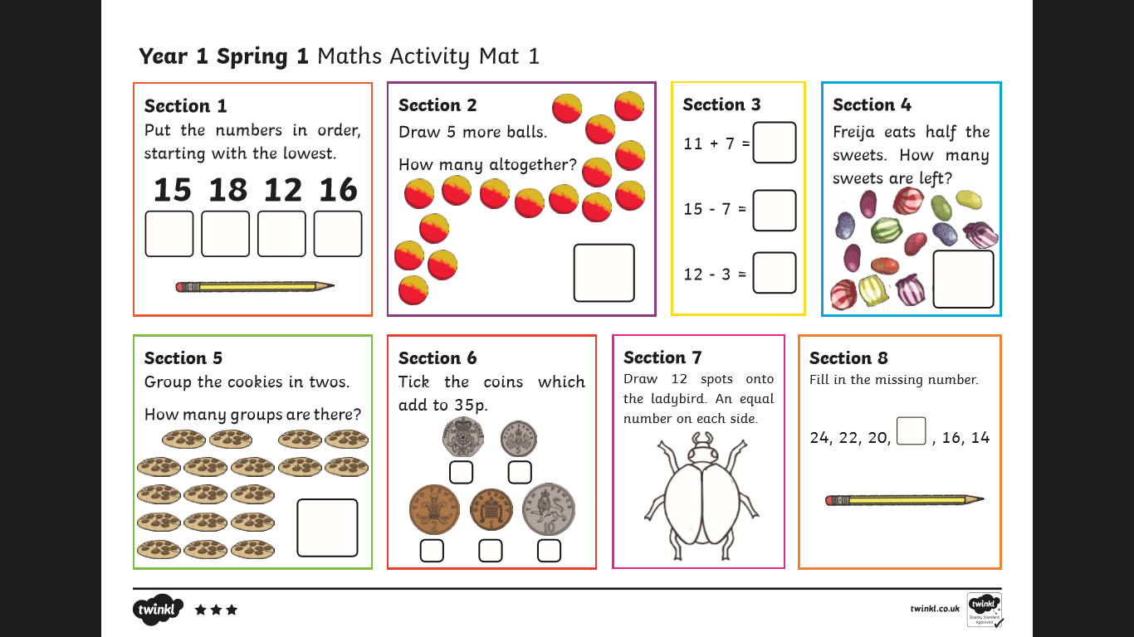

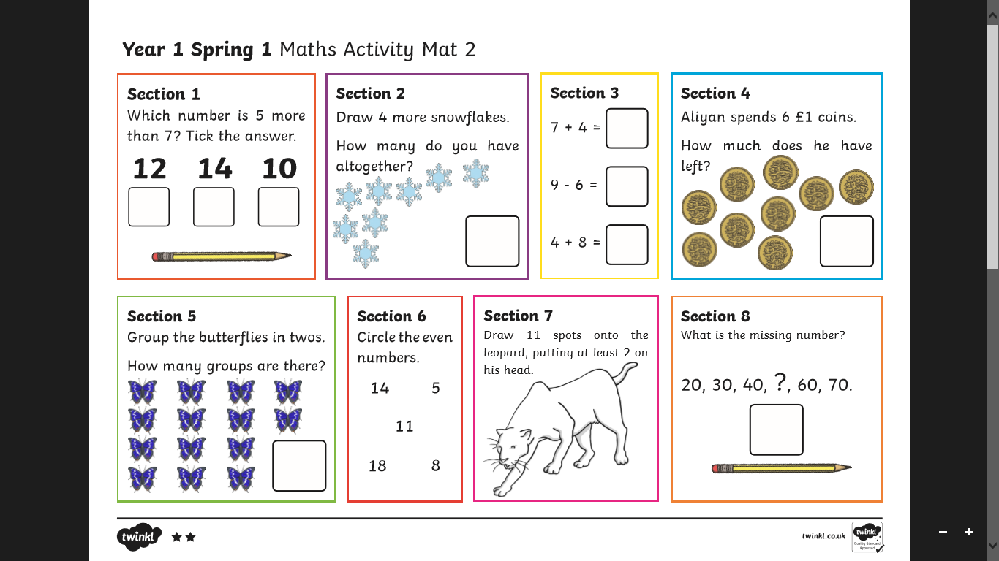

Keep revising prepositions – on top of, in front , behind, under, over, above, inside ,below, through ,to the side of , in between you could extend this by revising the concepts of left and right too.
Encourage free, natural use of language. Continue to develop understanding through practical tasks. Perhaps you could use describe the route you took on your daily exercise, or the position of toys when playing or tableware whilst sitting at the table or even where food is on their plate – learning is everywhere!
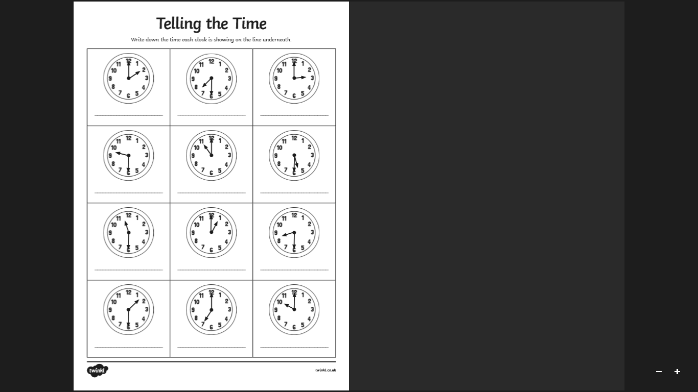
Practice- Story of 6
There are 7 different ways of making the number 6 using 2 numbers (within 10)
0+6 =6 6-6=0
1+ 5=6 6-5=1
2+4=6 6-4=2
3+3=6 6-3=3
4+2=6 6-2=4
5+1=6 6-1=5
6+0=6 6-0= 6
Can you remember the story of number 5, 4, 3,2,and 1? Using the same pattern as above.
We sometimes use practical apparatus to help us visualize our learning.
Challenge – How many number stories can you write?
Dandelion counting.
Draw a chart and write the days of the week.
(Children have previously drawn charts by copying an example in class, this challenges their ability to use a ruler to draw straight lines and take ownership of their work).
Many pupils can write the days of the week independently if not they can copy from paper/ tablet / phone.
Each day write the number of dandelions you spot in your garden or whilst out walking.
You could extend the challenge by writing the number word.
And/or include a tally chart.
Ask / answer questions- Which day did you spot the most/least number of dandelions? Which days did you spot the same number of dandelions?

