Williamstown Primary

Home School Learning Pack Year 3 W-C 11/5/2020

Useful Websites
TWINKL- free code 1 month = PARENTSTWINKLHELPS
BBC BITESIZE TOPMARKS- Hit the button
SCHOLASTIC HWB
Hello everyone, I hope you are all safe and well, still working hard but also having as much fun as possible
Here is your new pack for this week including English work, spellings, maths challenges and topic work focusing on ‘Keeping Healthy’.
Keeping Healthy includes focusing on our body and mind, our wellbeing, healthy eating, fitness, nature and the environment and positive relationships i.e friendships.
Remember to keep reading, stay safe and keep in touch with your friends when you can
Miss Thomas x

Poems
This week I’d like you to have a look at some poetry. Here two poems for you to look at. Read them carefully. Are there any words you are unsure of? What do you like/dislike about the poems? How are they similar and why? How are they different and why?

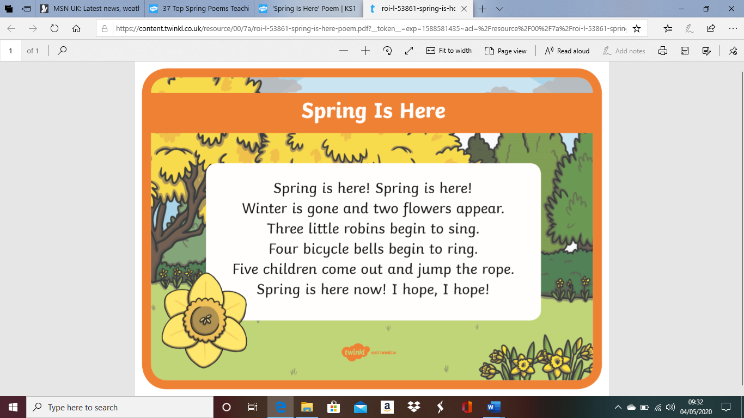

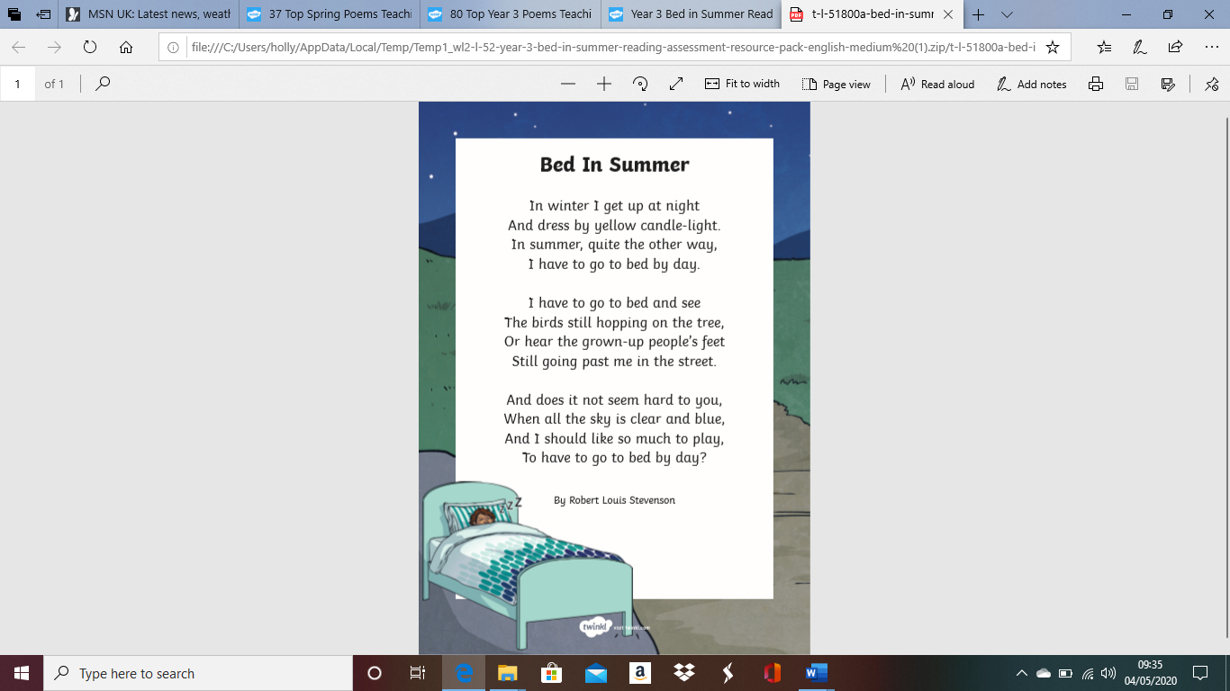
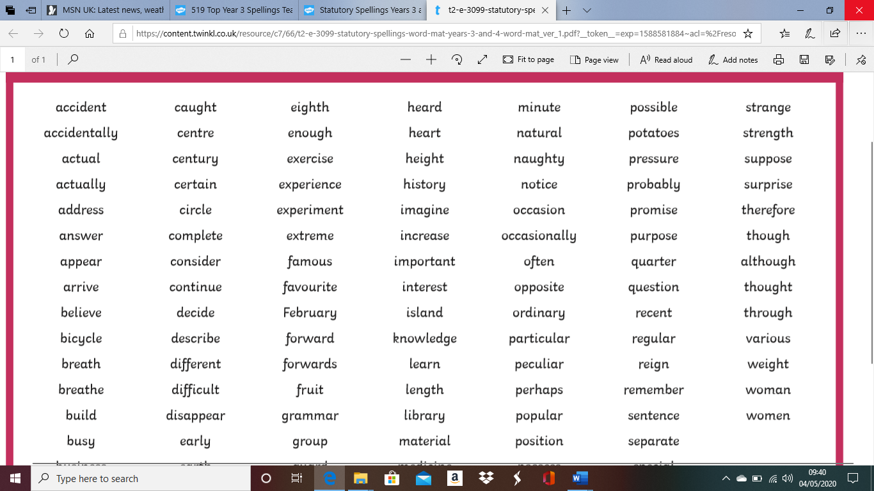
Here are your spellings for this week. Remember to practise them by writing them out and then using them in a sentence.

BBC Bitesize English Activity
Copy and paste the links below into your search browser to access these great online learning activities!:)

https://www.bbc.co.uk/bitesize/articles/zjk9kmn
(Reading Activity)

https://www.bbc.co.uk/bitesize/articles/z7s6t39
(Using Commas)

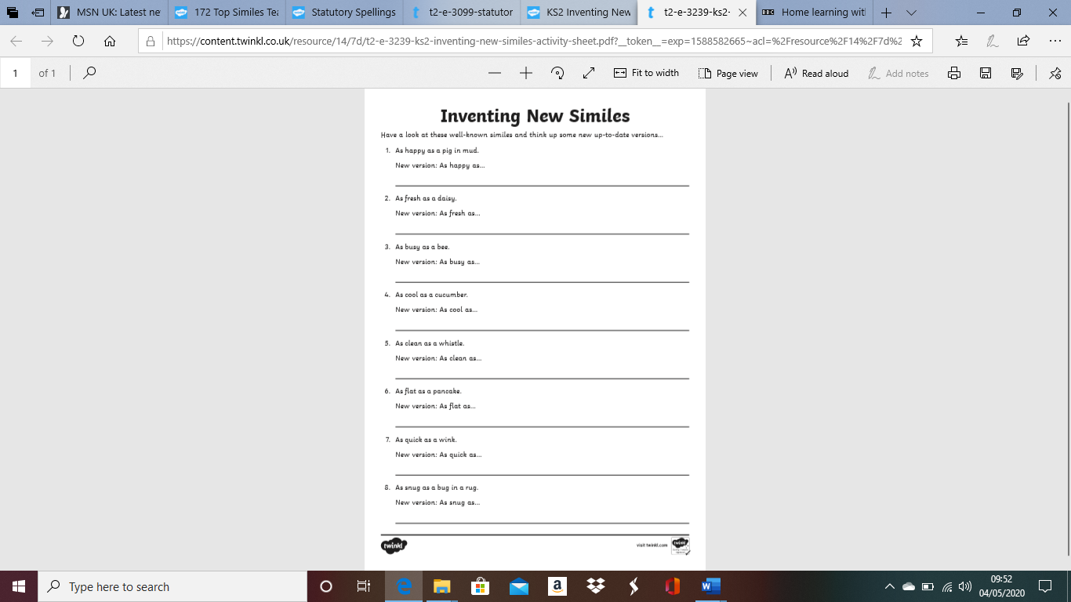
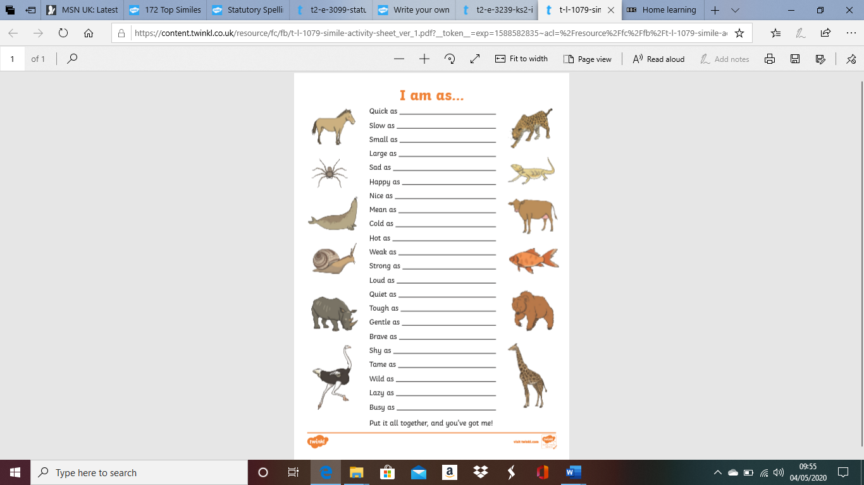
Maths Magic!

This week I would like you to have a go at finding a ¼ of numbers. A ¼ is a ½ of a ½.

So for example if we were finding a ¼ of 12, first we would find the ½ of 12 which is 6 and then half it again to find the quarter. ¼ of 12 = 3

Have a little go at these questions and remember practise makes perfect!
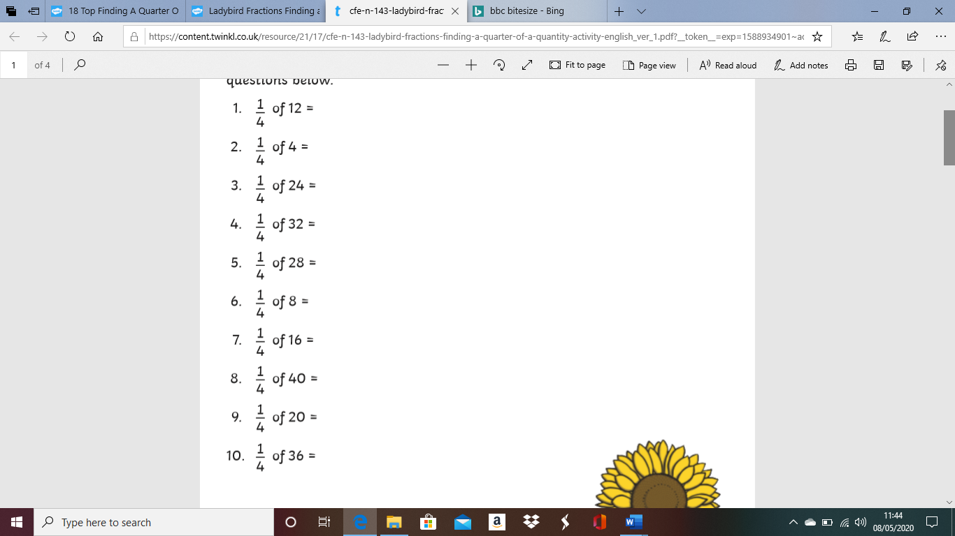

BBC Bitesize Maths
Copy and paste the links into your search engine for some great online maths learning activities.
https://www.bbc.co.uk/bitesize/articles/zbkvbdm
(Multiplying and Dividing by 3)

https://www.bbc.co.uk/bitesize/articles/zkwfvk7
(Adding Money)

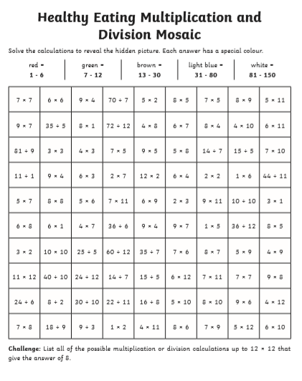
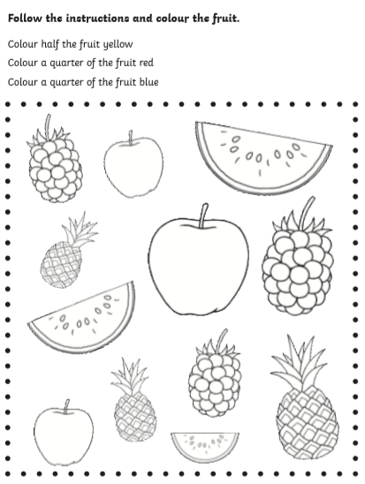
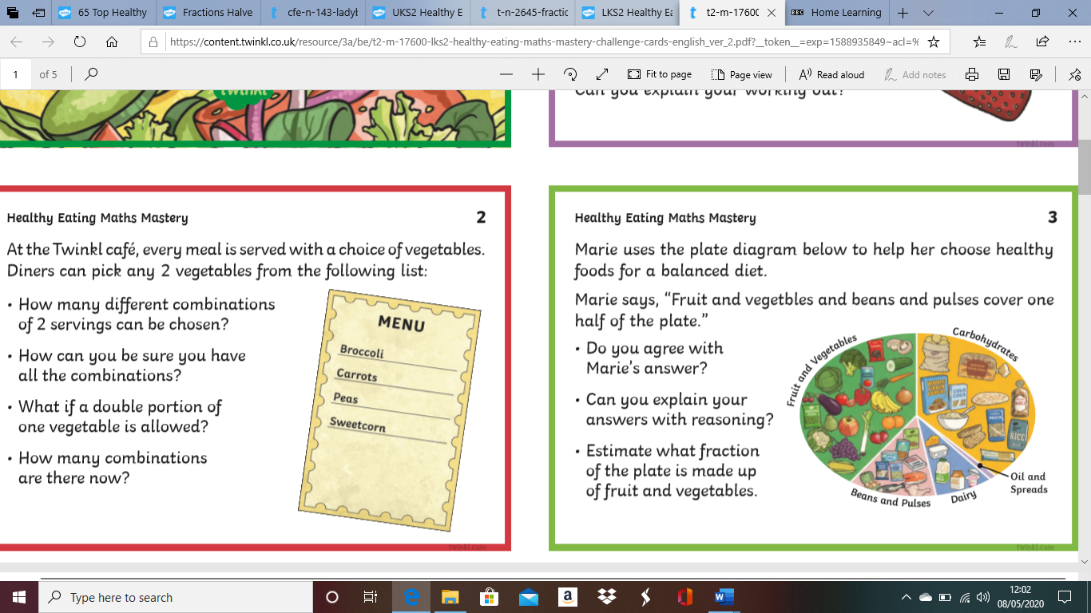
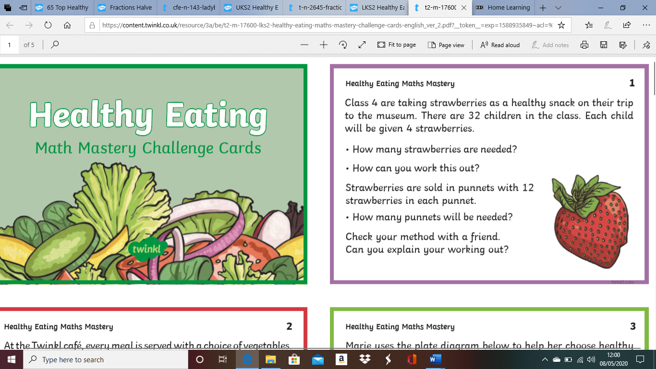
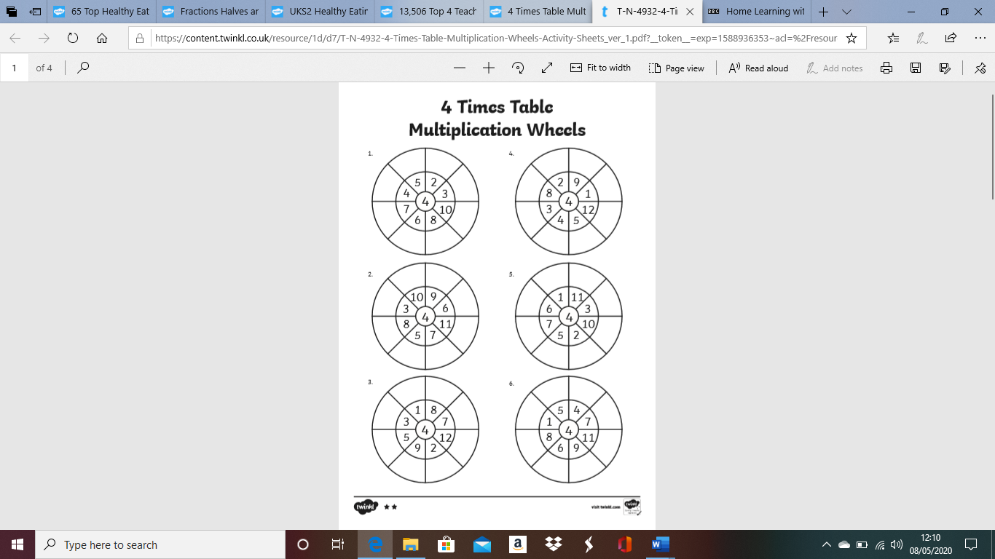
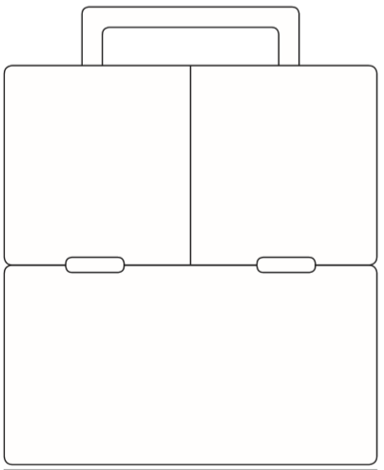
Design your own healthy lunch box!
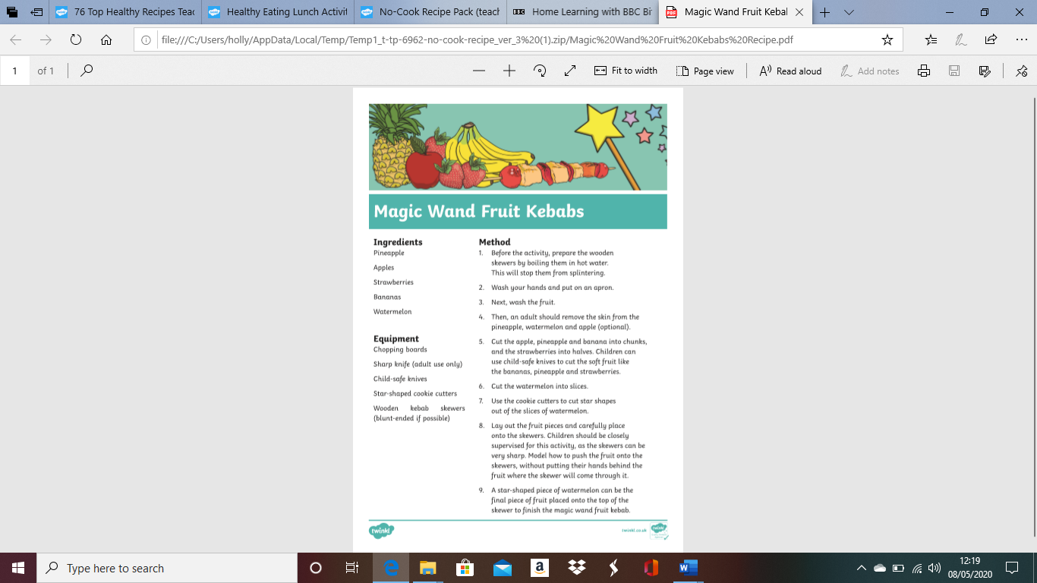
Maybe you could have a go at making a healthy snack this week! Here is a recipe for fruit kebabs, you could use the fruit in the recipe or choose your own You could also upload your finished kebabs to our twitter page!

BBC Bitesize Activities!

Learn all about what plants need to live with this great online activity! (Science)
https://www.bbc.co.uk/bitesize/articles/znm4kmn

Learn all about light and dark with this link! (Science)
https://www.bbc.co.uk/bitesize/articles/zjjx6v4

