

School Closure Home Learning Pack
Mrs Jones’ Class, Year 3/4
Hello Y3 and Y4,
This week there are some sheets looking at money. Many of you can recognise the coins but it would be useful to show your families what you already know. Again the sheets get harder as you go along and I have put the chilli challenge at the top of each section of Maths work. This week focus on adding money and next week we will look at giving change.
Topmarks Games for money: https://www.topmarks.co.uk/maths-games/5-7-years/money
This week have a look at the poem by Kit Wright. It sounds like the type of accidents which happen to me! What funny things have happened in your family?
Last week, I hope you found time to play the Welsh Language games. See what you can remember by labelling parts of the body.
There are a range of ideas for topic work, please do what you can. We will be looking at all of these in more depth when we are back in school so do not worry if you cannot complete all the work.
Stay safe, Stay happy!!

Mrs Jones.

W/c 11th May 20
Numeracy
Mild Chilli Challenge
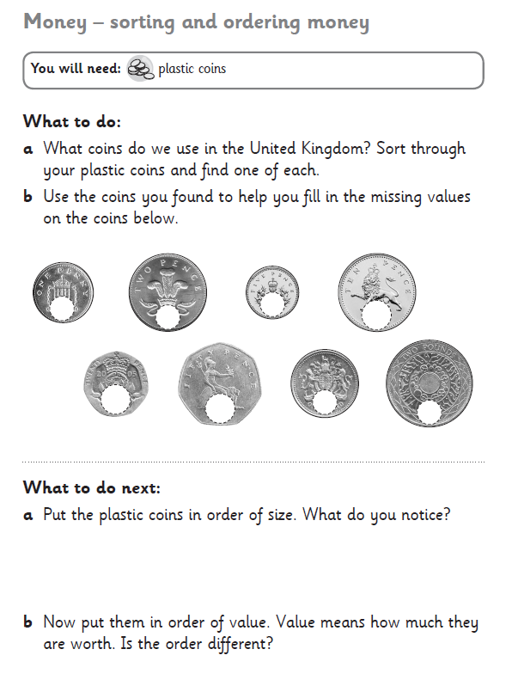
You can use plastic coins or real money.

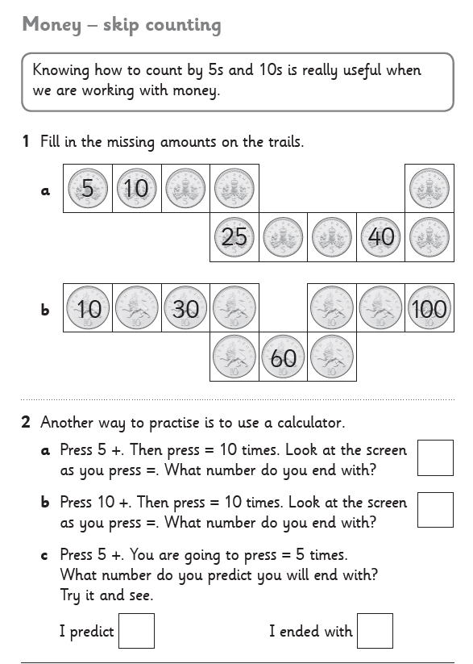

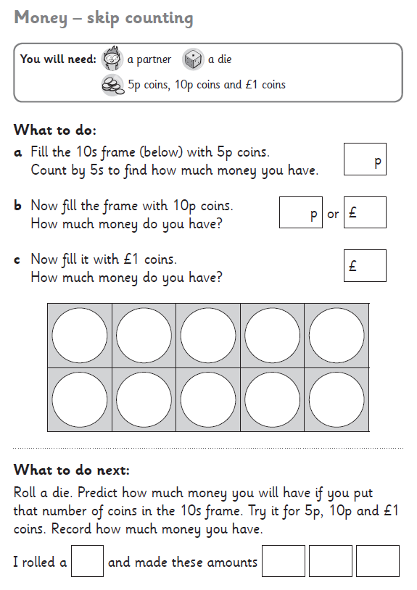
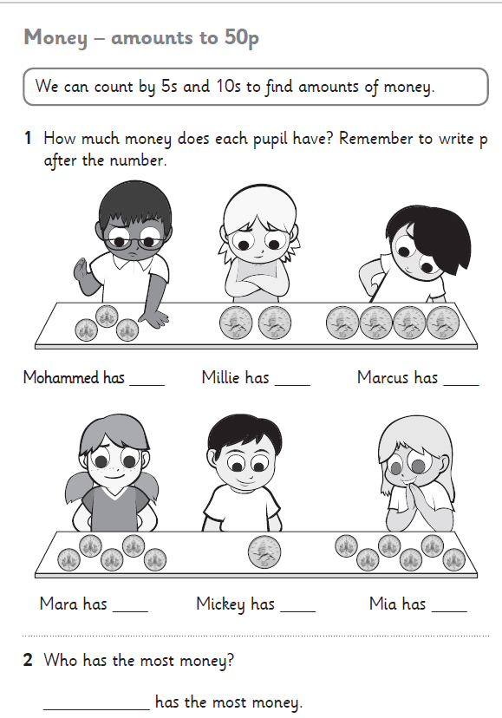
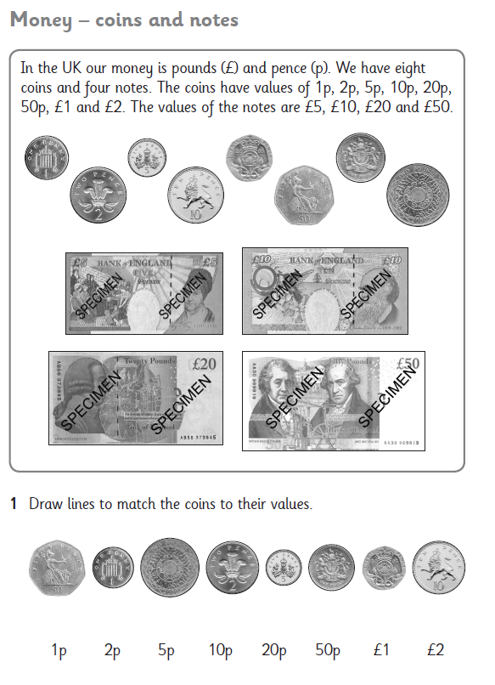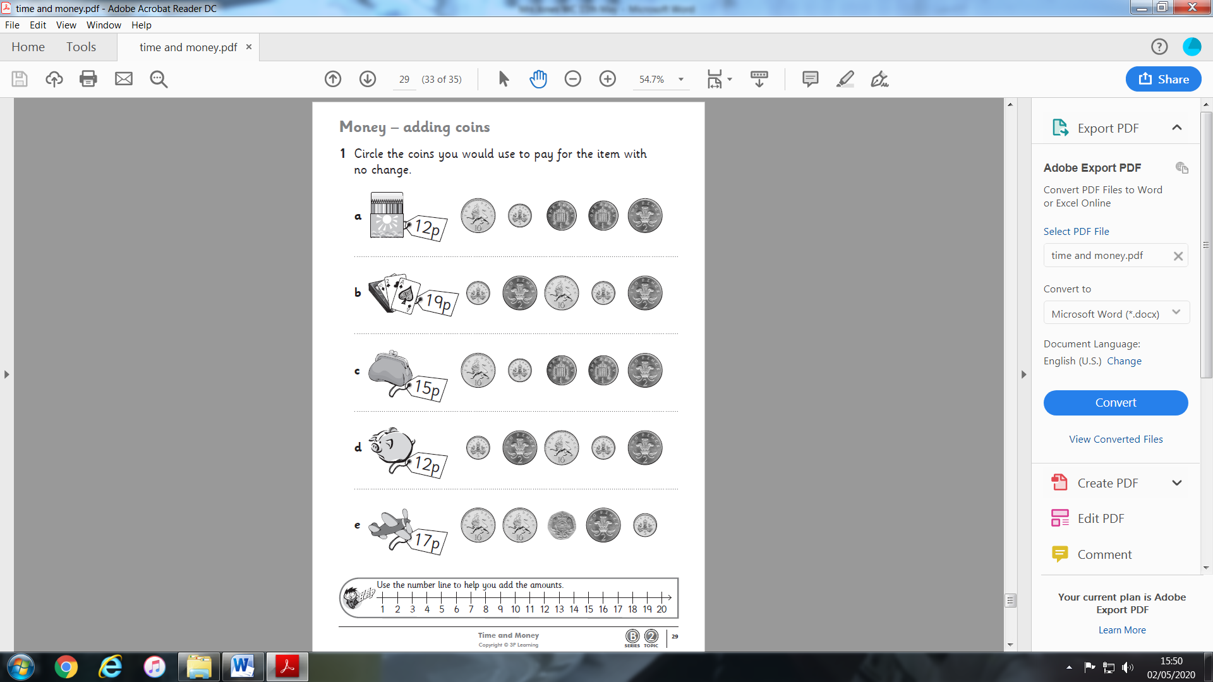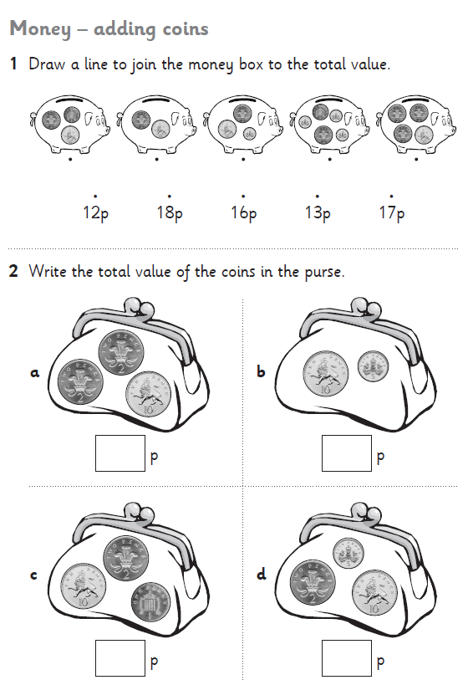
Medium Chilli Challenge
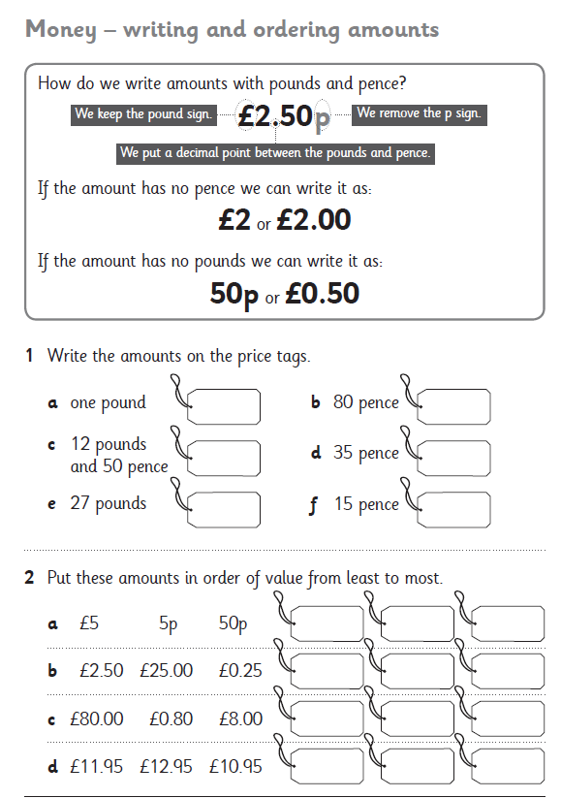
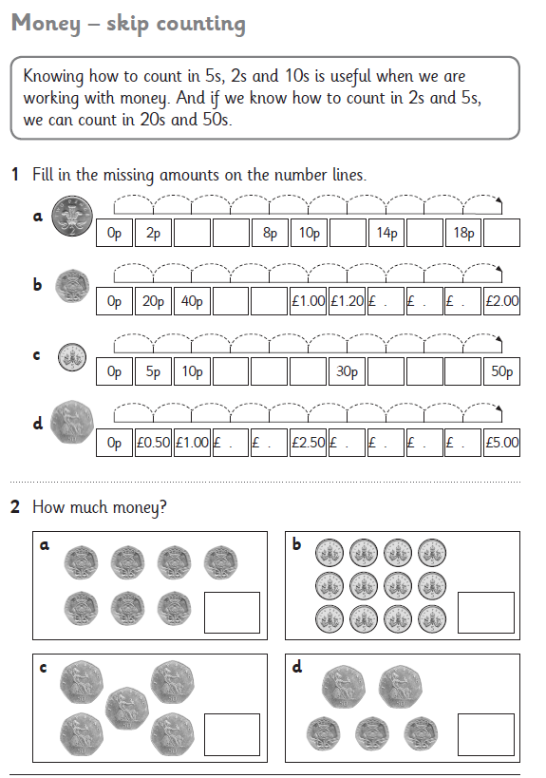
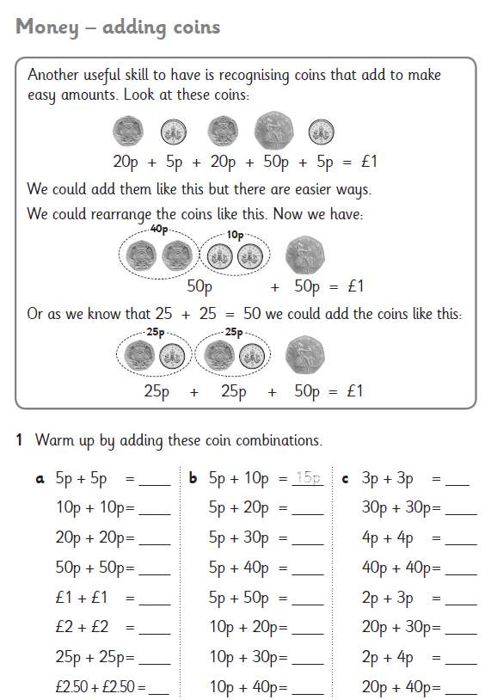
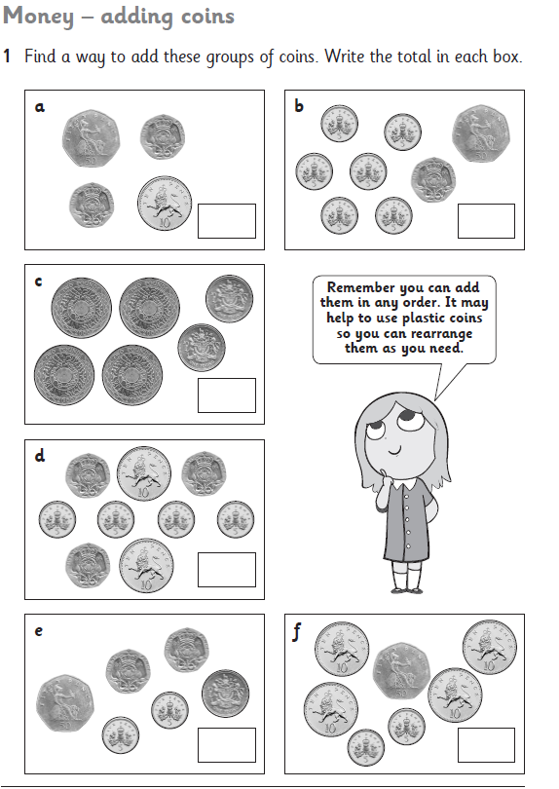
Hot Chilli Challenge
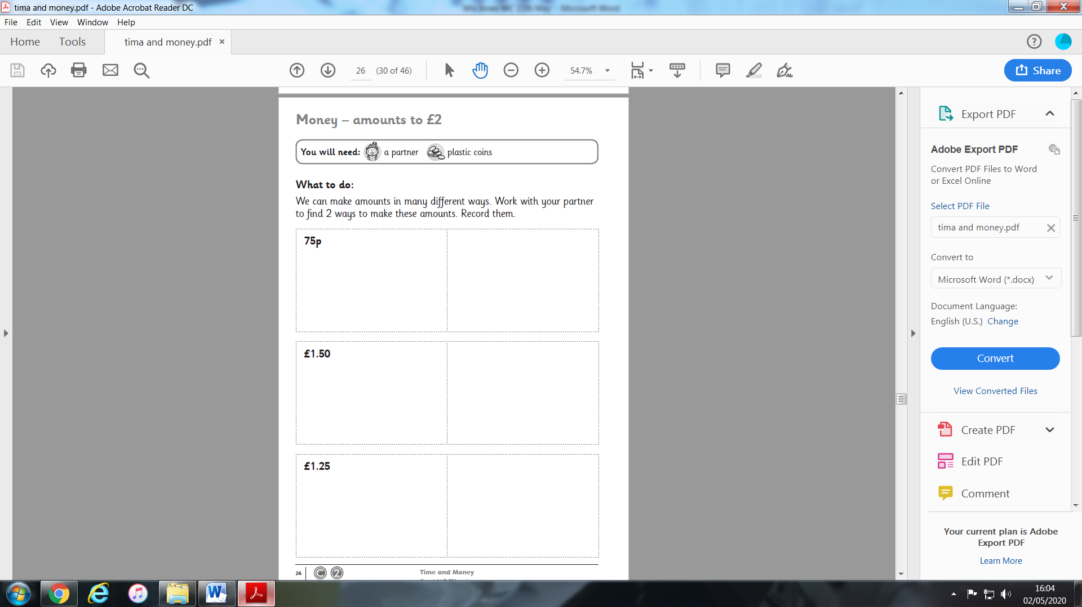

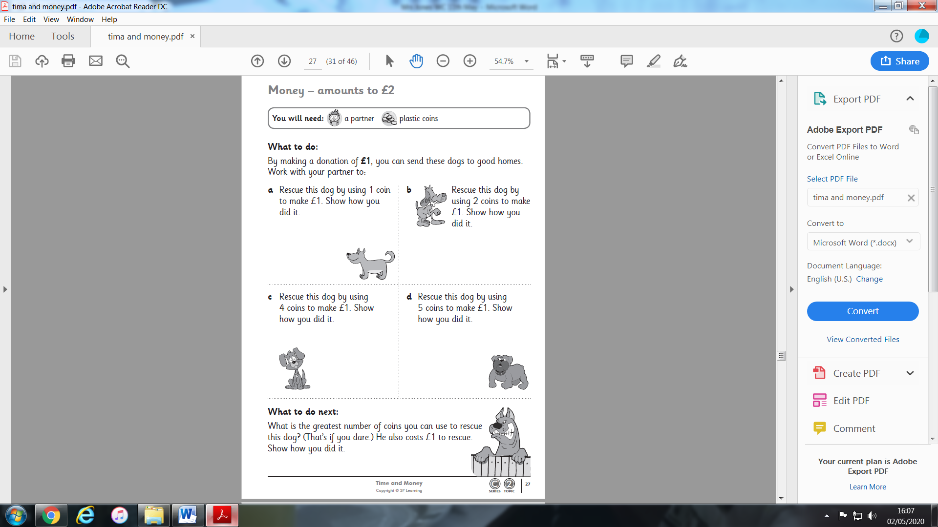
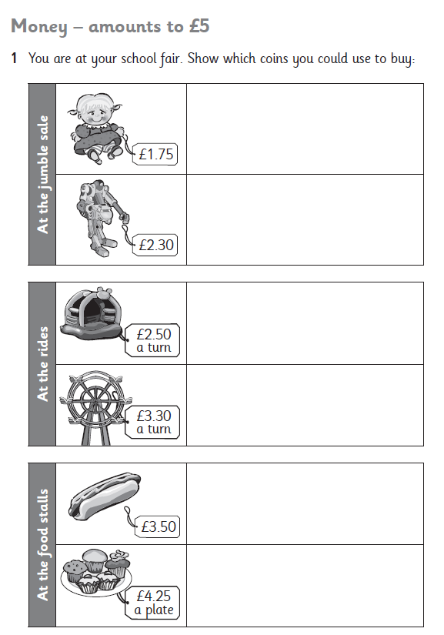
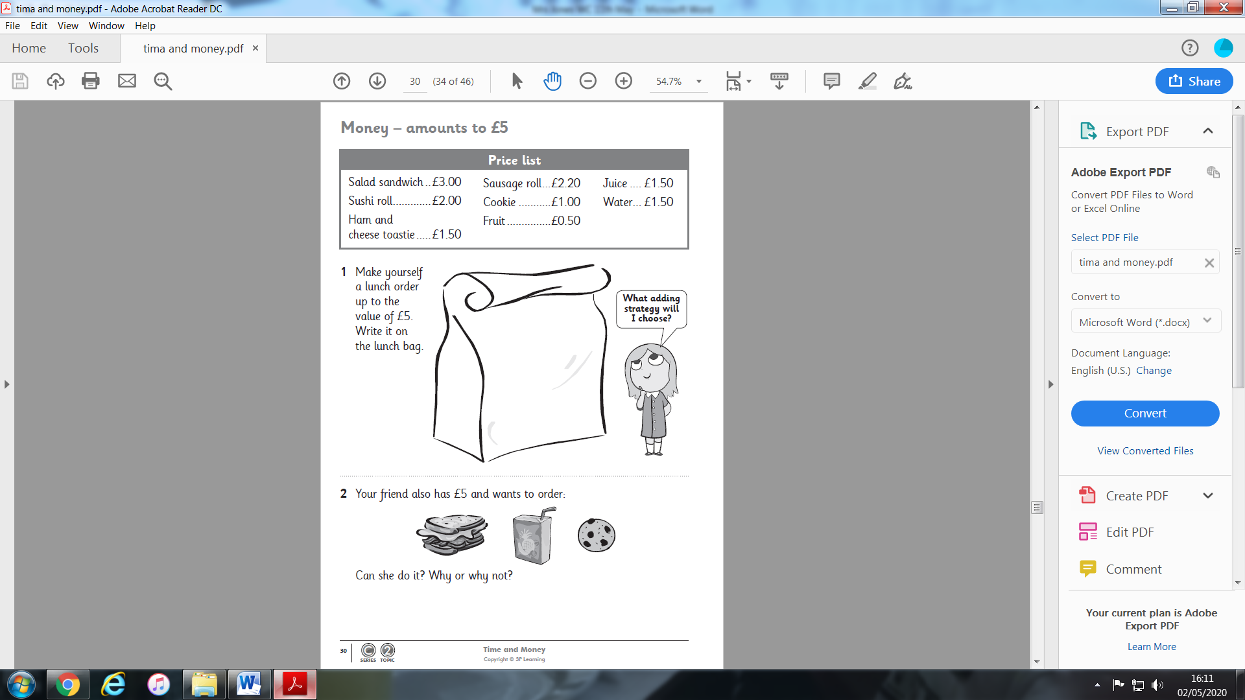

Money Bags Challenge

Problem Solving skills
Ram divided 15 pennies among four small bags.
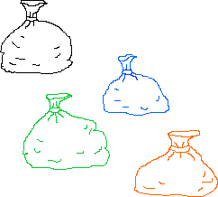
He labelled each bag with the number of pennies inside it.
He could then pay any sum of money from 1p to 15p without opening any bag.
How many pennies did Ram put in each bag?

Getting Started:
How would you make 1p?
What do you need to do now to be able to make 2p?
Does this help to make 3p?
Could you use 1p and 2p bags to make 4p? If not will you need to make another bag?

This is a very tricky problem, answers next week!

Good Luck!

Literacy
HFW Spellings
Here are the next two sets of words to learn. Each child in class is on a different set. Please do not move onto the next set until you have at least 7 correct in the previous set. When your child has learnt the word, ask him/her to write a sentence using that word.
SET 9
him
oh
your
old
time | Reading  Log on to Oxford Owl using the link below.  Click on the Pink Button at the top of the screen that says ‘My Class Login’. The class name is ‘mrs jones class 34’ and the password is ‘Reading2020’  Click on My bookshelf. Here you can choose a book to read. Make sure you write the book you choose in your yellow reading record.  https://www.oxfordowl.co.uk/?selLanguage=en&mode=hub  There is still a list of websites you can play games on, this is attached at the end.
help
saw
one
were
here

Reading time
Read the poem Dad and the Cat and the Tree by Kit Wright.

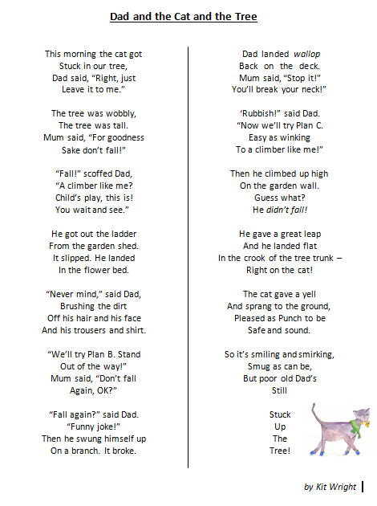

Sequence events in the poem – Draw a comic strip of what happened in the poem. Look through the poem again and decide what picture you could draw to show what happens.

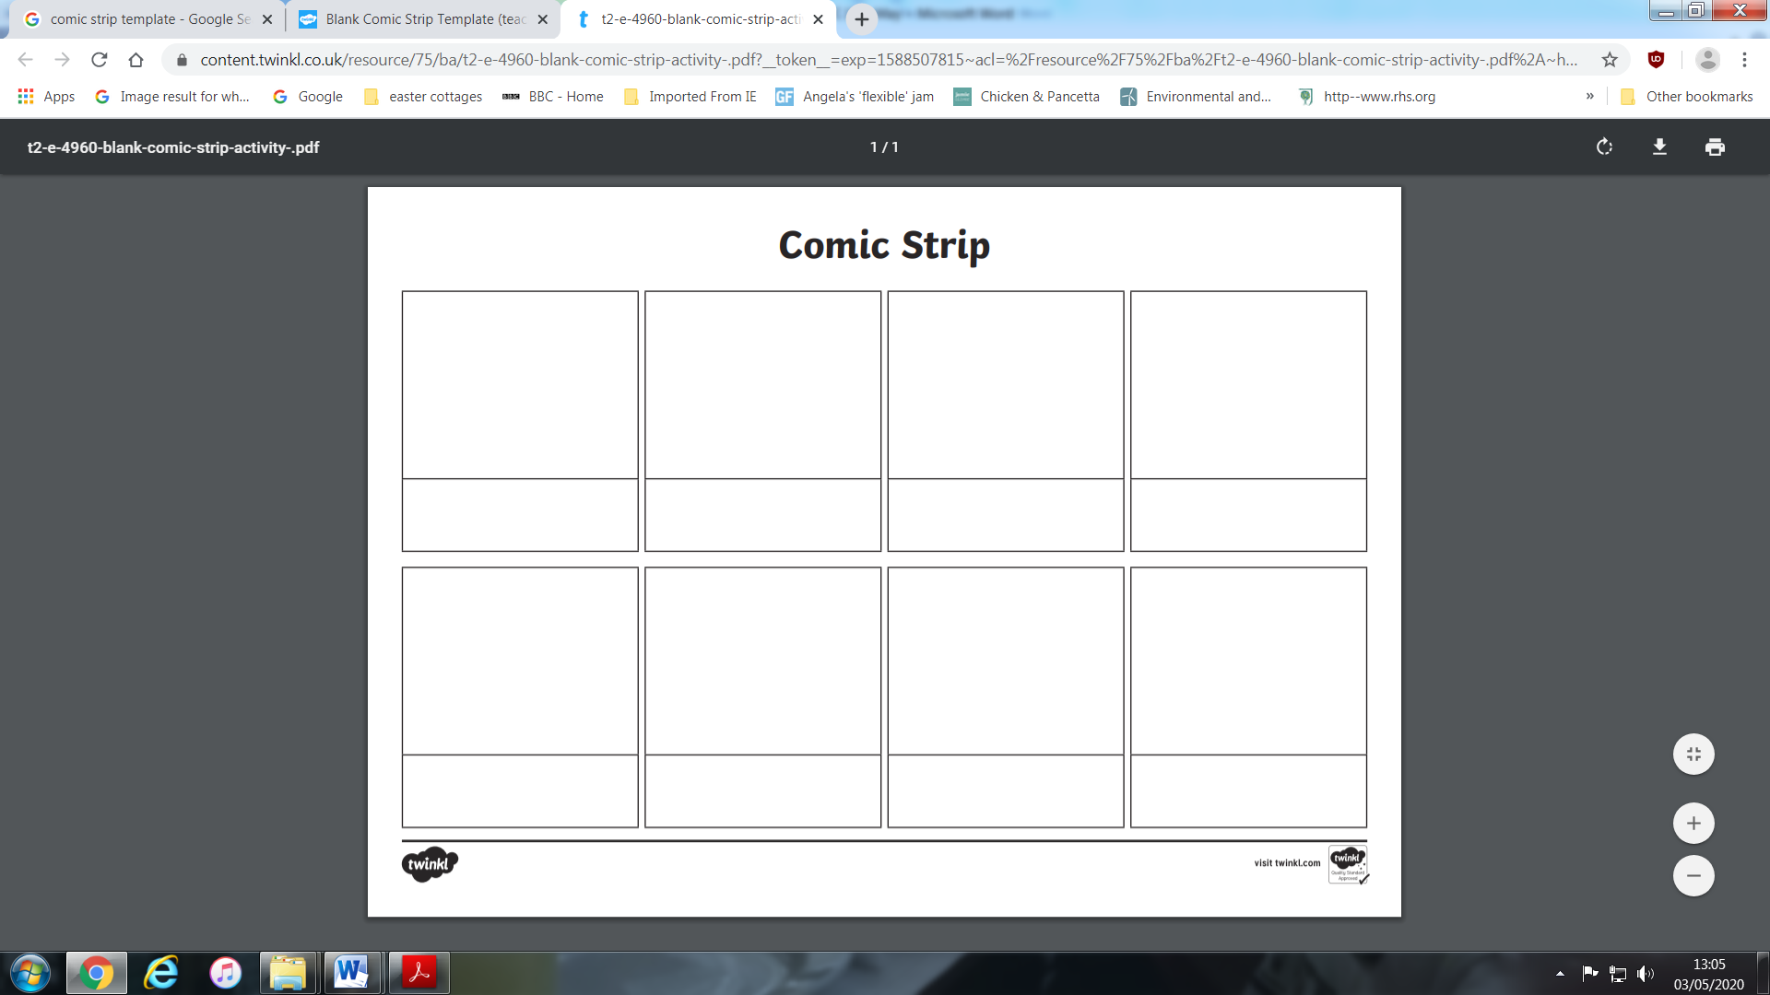

Writing time
What might happen next? How will Dad get out of the tree? Will someone have to go up to rescue him?
Draw what you think will happen now that the Dad is stuck in the tree. Write some sentences under your picture. Remember to use capital letters to start your sentences and full stops to finish them.

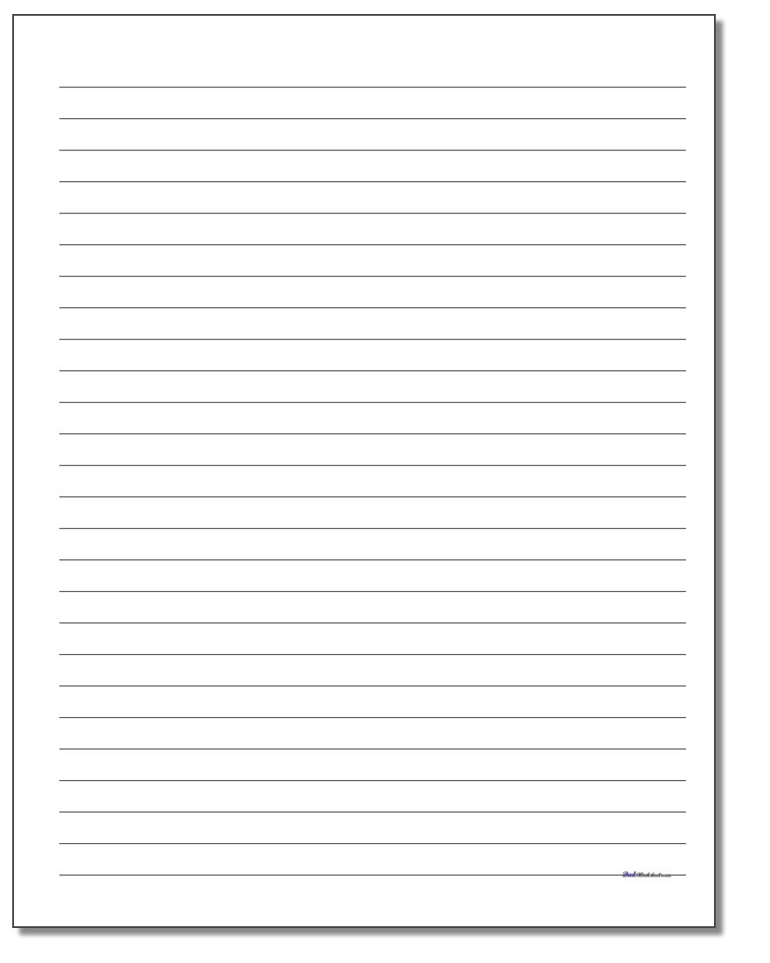
Now try these extras
- Write down things at home that have made you laugh on Funny things that have happened in my family. Draw a picture of one of these.
- Explain to someone to say how you would get a cat out of a tree. Can you draw a picture of you saving the cat?
Funny things that have happened in my family

Welsh language Development. – Can you label the parts of the body?

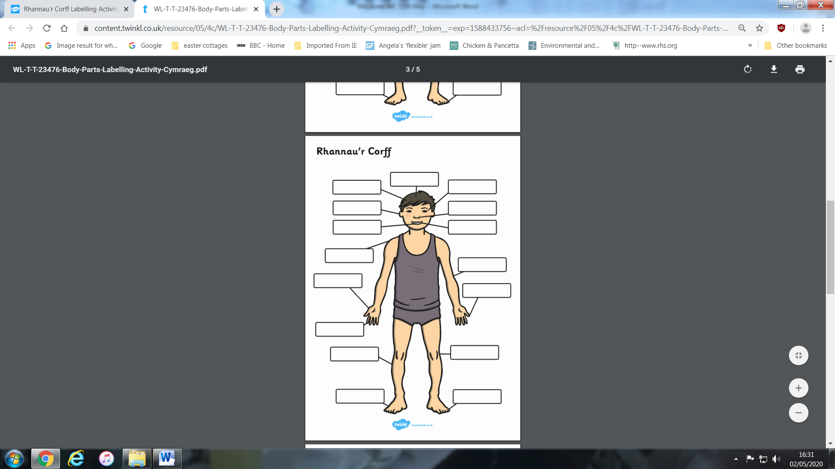

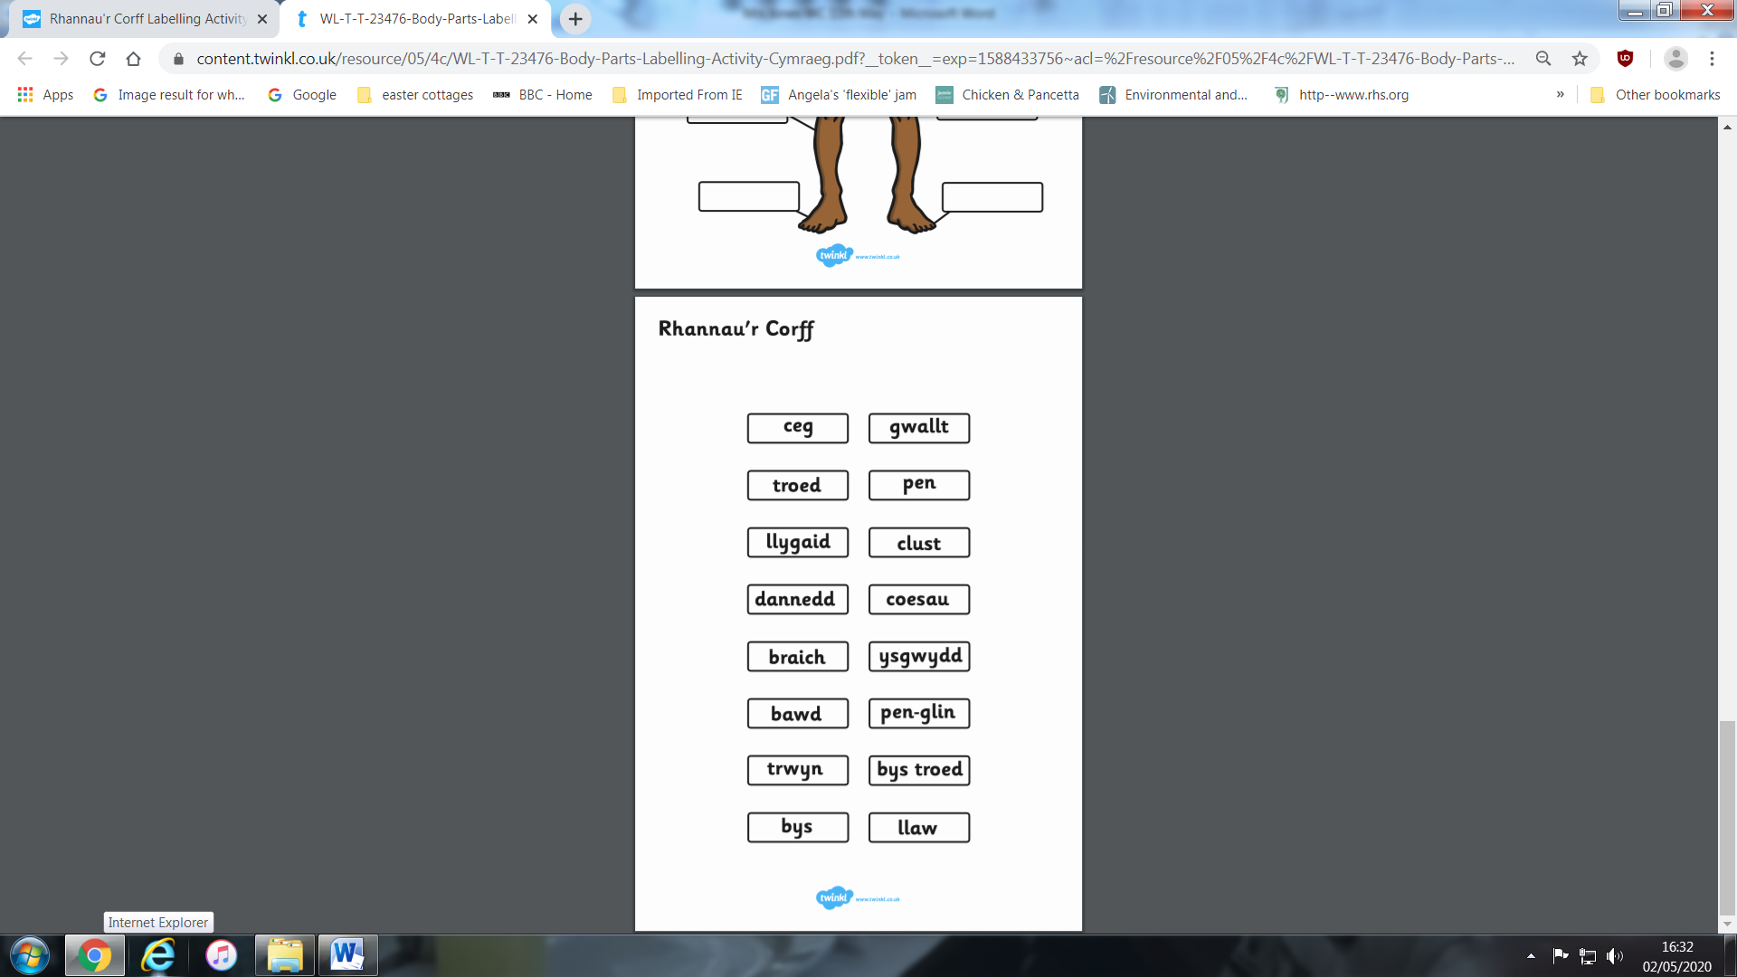

Topic
Thinking Skills – Ask your parents for help!!
Answer from last week!
Cat is called Sparkle, Dog is called Jumper, Goat is called Rose and Horse is called King.
Well done if you got it right!

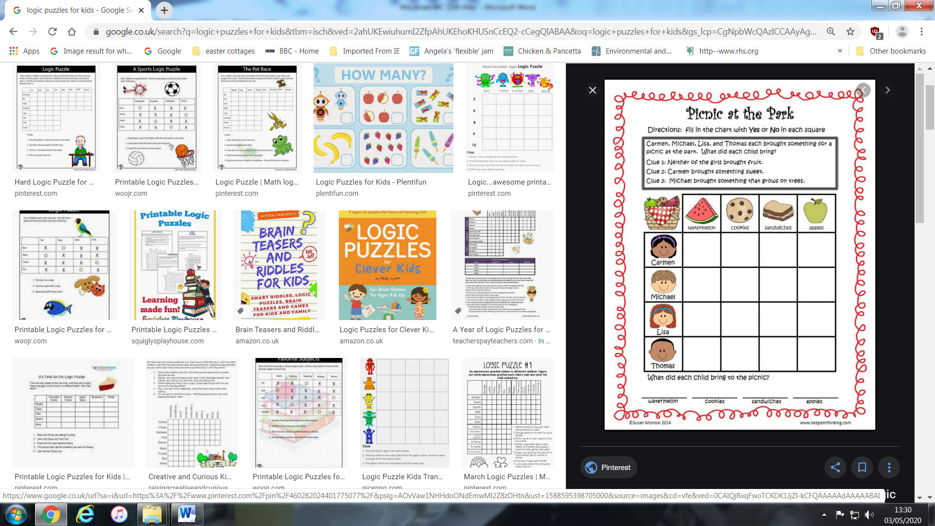
Health and Wellbeing
Keep a diary of what you eat this week before you do the healthy plate activity.
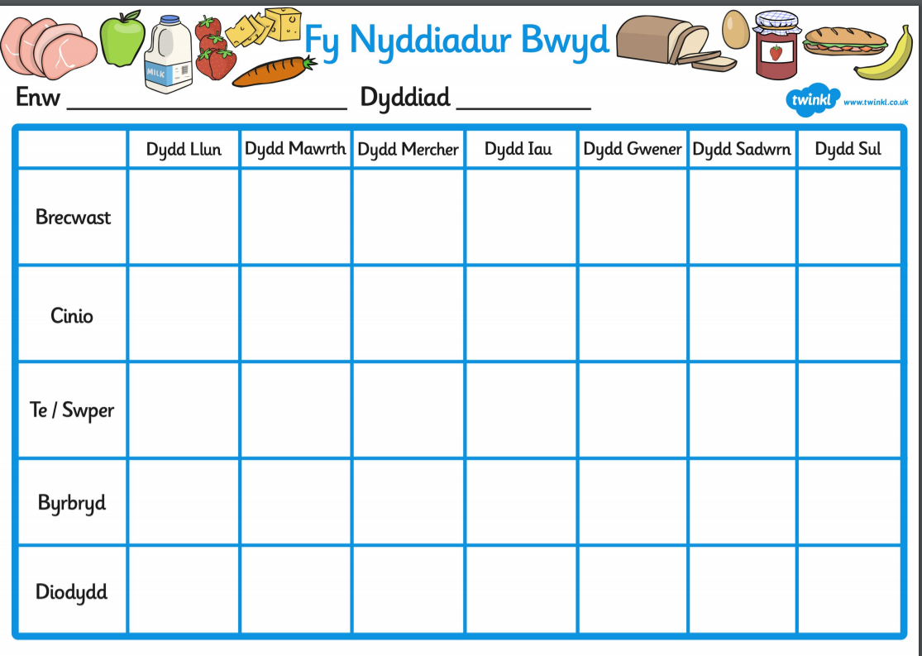
Drinks
Snack
Have a look at the following poster of Food Groups. Humans and animals need food to survive and stay healthy.
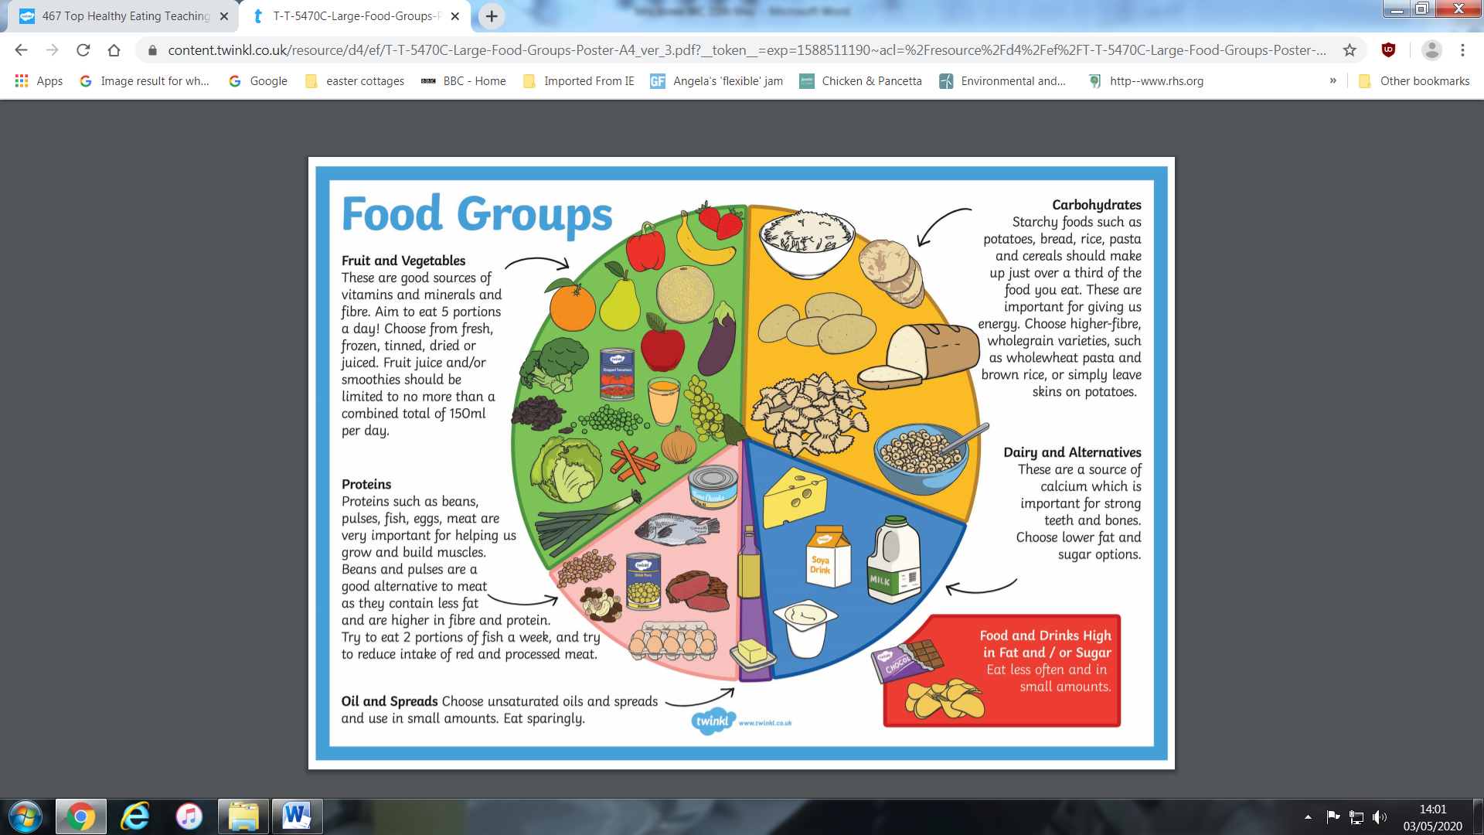
Think about what you ate yesterday and try and put the foods you have eaten in the correct section of the plate. If you do not have a printer, maybe you could use a paper plate to draw your foods on.
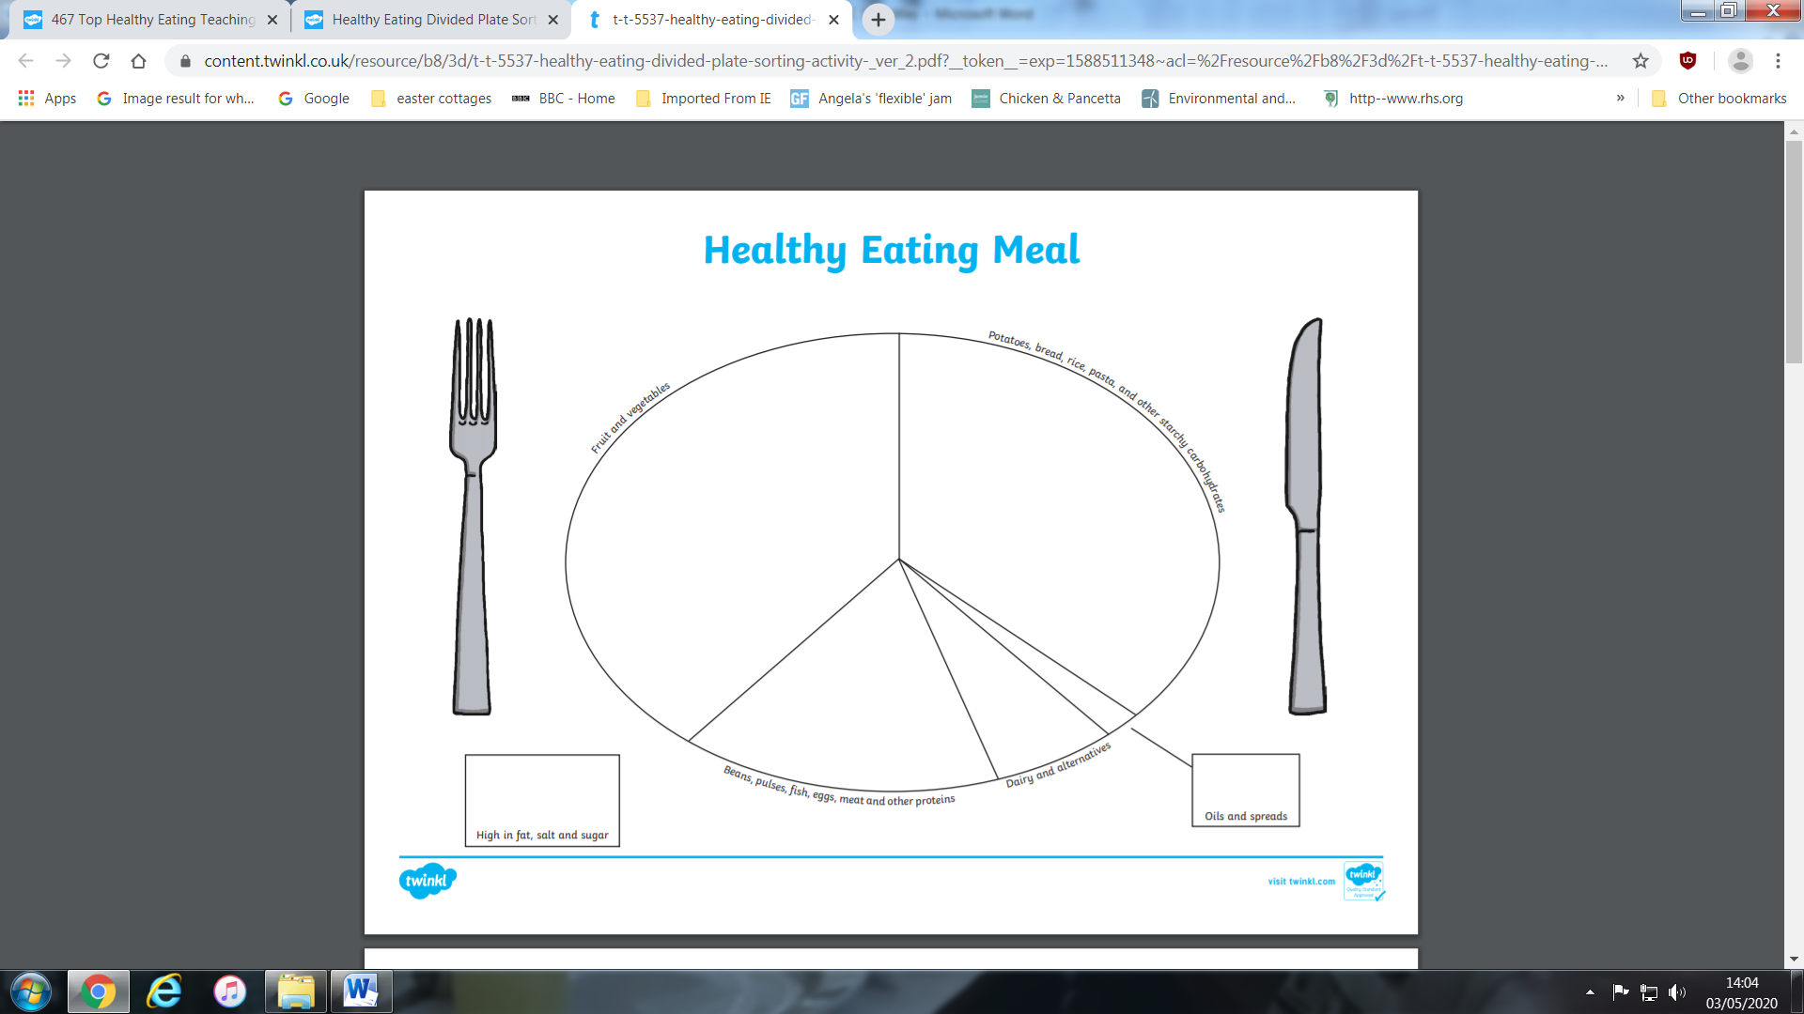
Science
Since we are learning about food, here is a science experiment you could try at home.
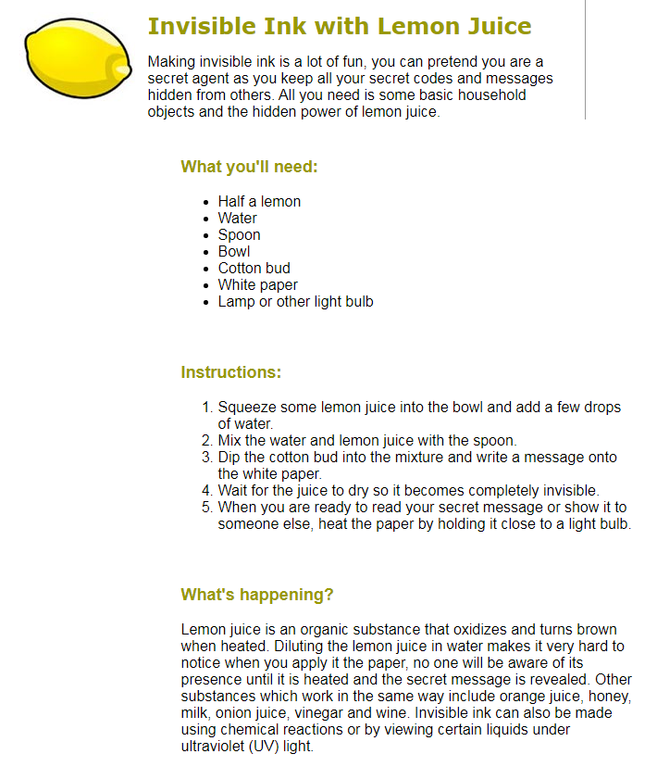
You could write a secret message to someone in your family.

Humanities
Habitats – We have already looked at some habitats for mini-beasts. This week could you please do some research on the internet about some of the animals which live in the following habitats. You could either present it as a mind map or a table. Try and find 3 animals for each habitat. Which habitats do humans live in?
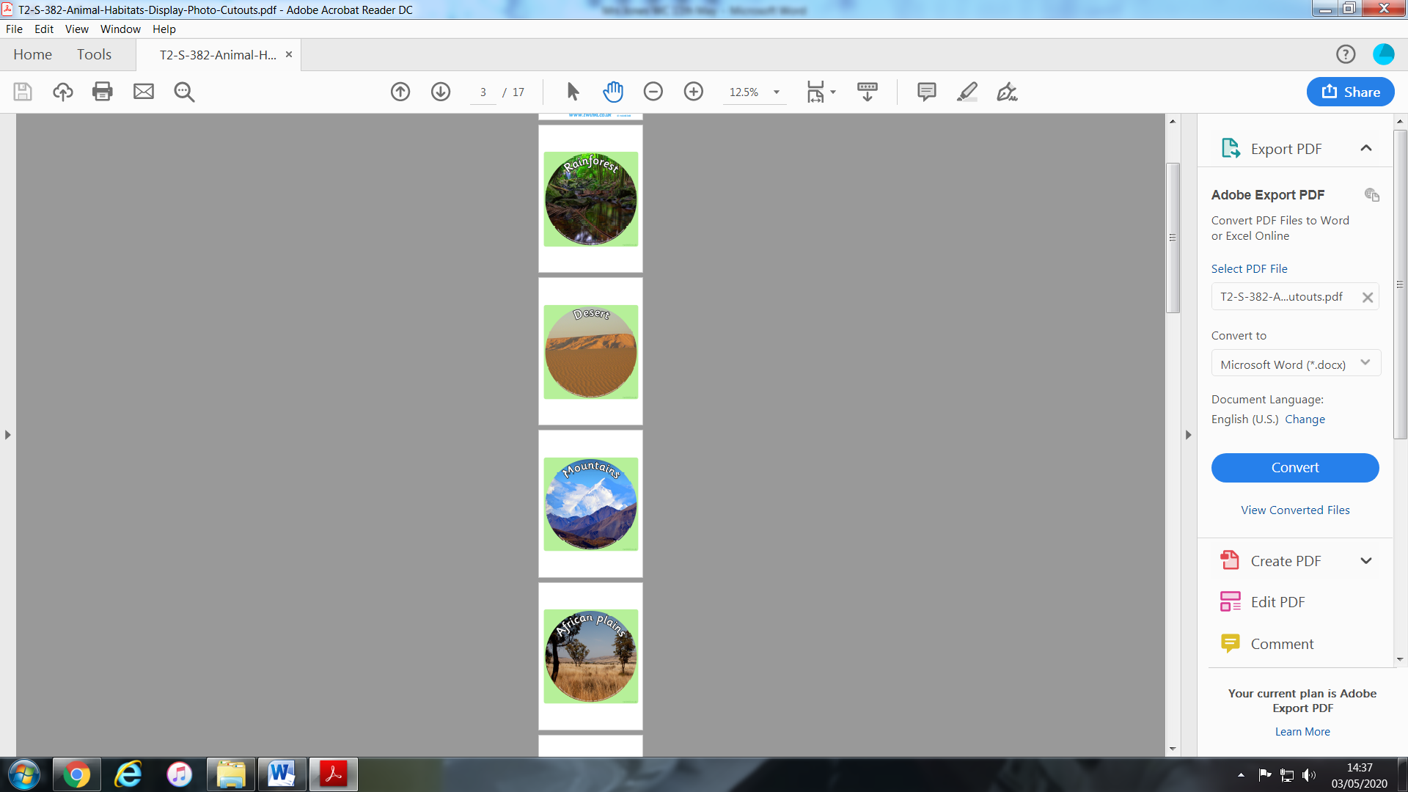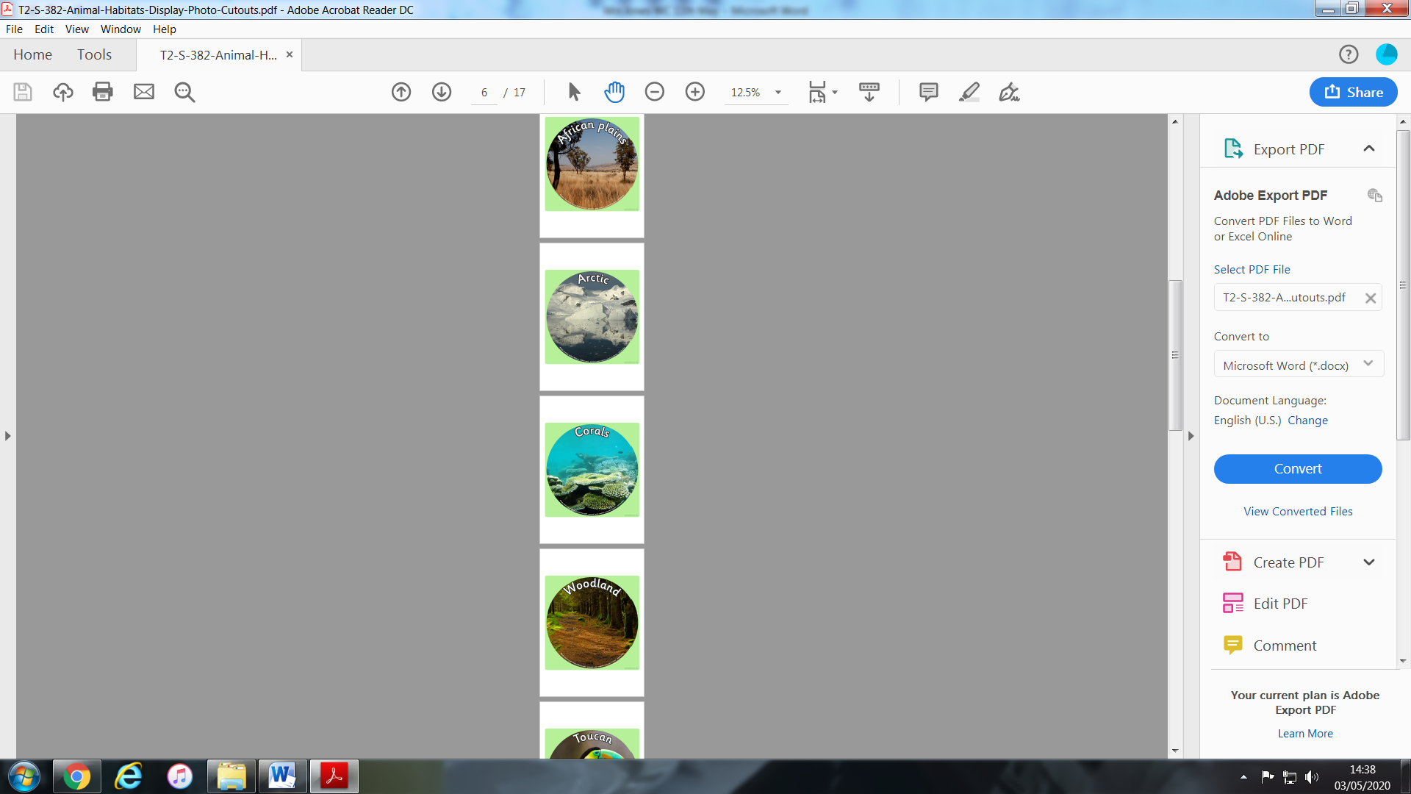

WEBSITES
Literacy
- ixl
- Letters and Sounds website/ app
- Oxford Owl
- Phonics Play
- Phonics Bloom
- Topmarks literacy
- Book Trust

Maths

- ixl
- Top Marks
- CBBC Numeracy games
- Maths is fun
- Maths Zone

Extras
- Scratch Jr app - Great for online programming.
- https://mommypoppins.com/family/weework-craft-projects-kids-easy-indoor-activities - lots of science experiments to try at home.
- Funology.com – Crafts, Science, Magic tricks to beat boredom.

