School Closure Home School Pack
Miss Densley’s Class
Week beginning 11.5.20
I’ve added some more ideas for another week of home learning. I’ve left the ongoing spelling/reading/times tables on there.
Literacy
- Practice the reading/spelling of high frequency words – you can do this in creative ways using different materials (e.g. paint, magnetic letters) and try timing yourself
- Carry on with your reading books – make sure someone asks you lots of questions about them and if you are reading Dockside practice those cover words
- I have included a sheet of general literacy activities and some paper to complete them on
- Here is a link for Oxford Owl’s free ebook library (you will have to create a login but it should all be free): https://www.oxfordowl.co.uk/for-home/find-a-book/library-page/?view=image&query=&type=book&age_group=Age+9-11&level=&level_select=&book_type=&series=#
- I’ve found a lovely free book to download about coming to terms with school shutdown: https://parsleymimblewood.wordpress.com/

- Please see below for the next activities from the ‘King of the Fishes’ workbook. You can find the story in week 4’s work pack.

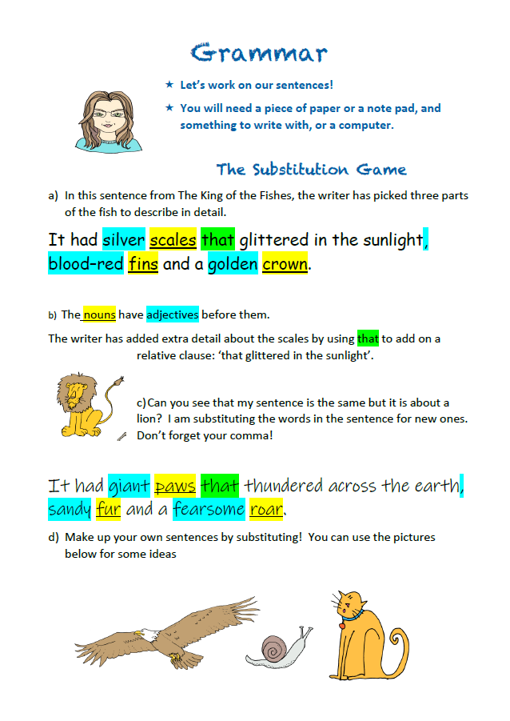

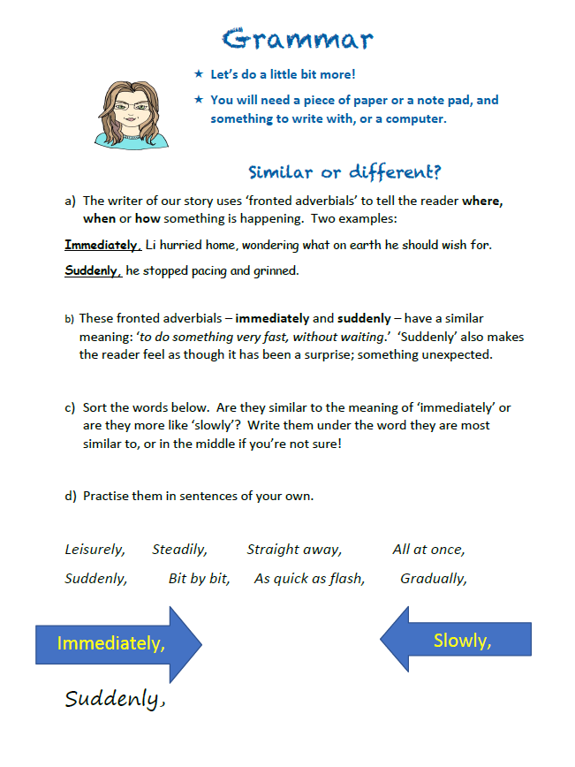

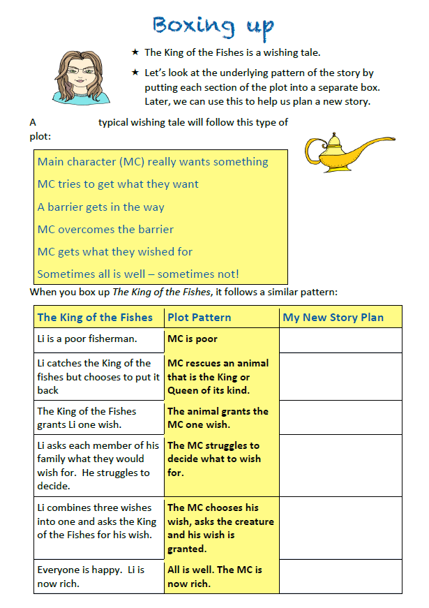

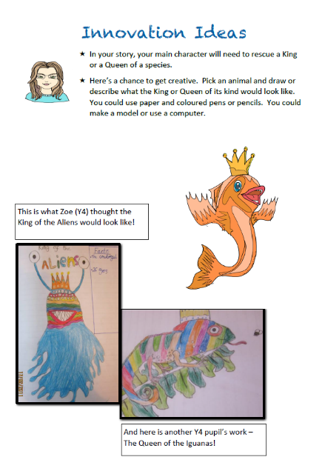

Maths
- Practice your times tables (in class we have practised the 2, 5, 10, 3, 4, 6, 8 and 9). A great tool for this is J2Blast on Hwb (I can see some of you have already had a go at this!)
- Practice telling the time on analogue (clock faces) and digital clocks
- Topmarks is a fantastic website to help with both of these

- This week’s topic is fractions. The aim is to recognise connections between fractions e.g. one-tenth is half of one-fifth (if this is too tricky just look at recognising a quarter as half of a half), add and subtract fractions with the same denominator and add fractions with the same denominator to make a whole.

Here is a good link to build your own fraction wall to understand the connections between fractions (I had to use internet explorer because of flash): https://www.topmarks.co.uk/Flash.aspx?f=Fractionsv7
I quite often use a bar of dairy milk chocolate to help with this topic as well.

Have a go at the sheet below. To add/subtract two fractions with the same denominator you just need to add/subtract the number on top e.g. 2/5 + 1/5 = 3/5 or 3/8 + 5/8 = 8/8 or 1 whole. I have also included a practice sheet below with some slides from a Powerpoint to make it more visual.

Good websites to help with any of the above include Letters and Sounds for phonic practice, Topmarks, Crickweb for problem solving practice, Twinkl, Espresso, Hwb, BBC Bitesize and Primary Resources.

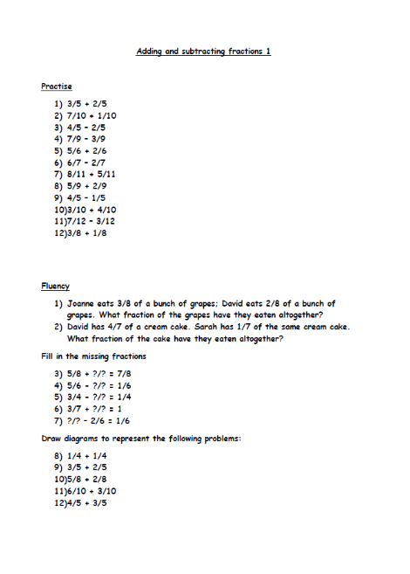
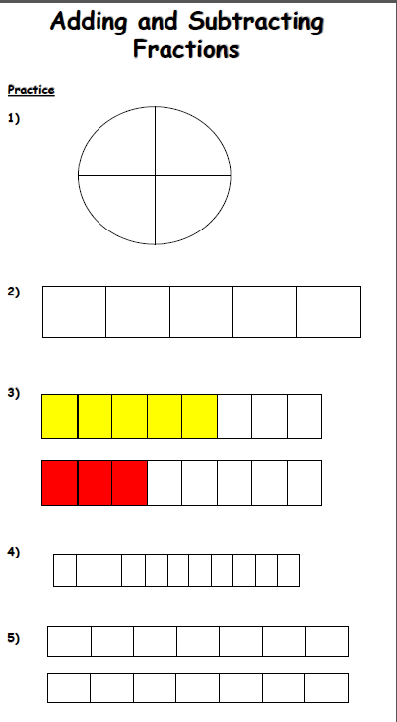
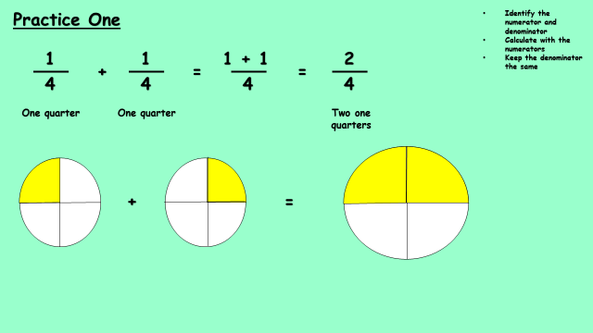

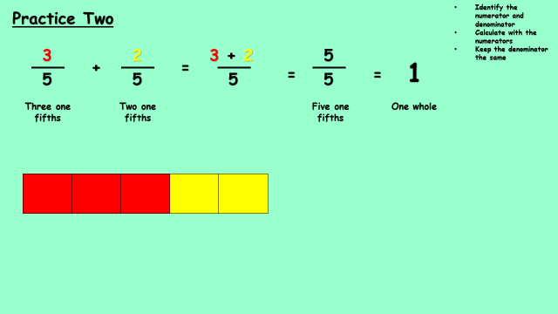

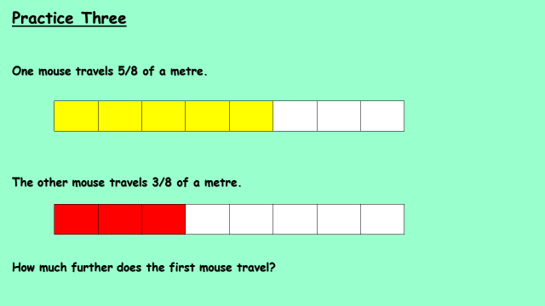

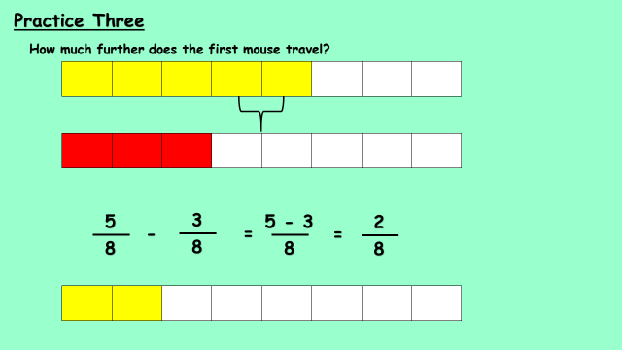

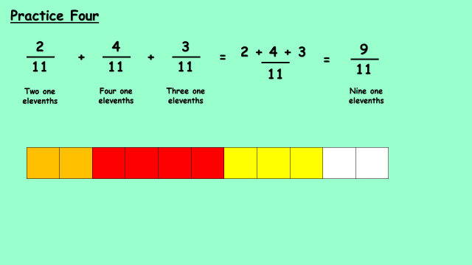

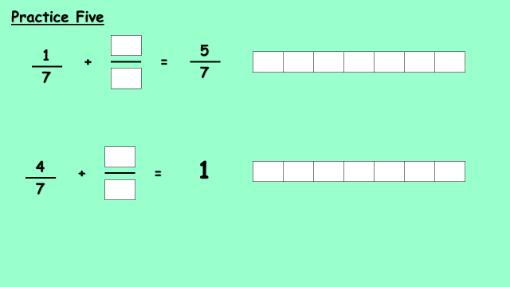

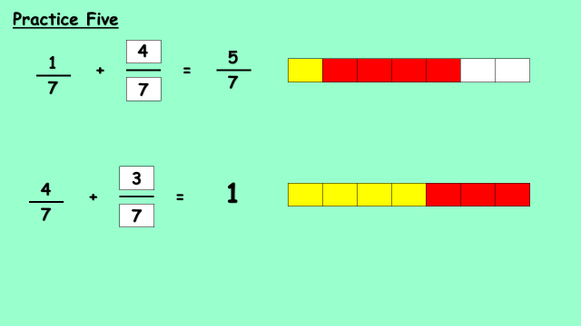

History
I have uploaded another Powerpoint from Twinkl about the Battle of Marathon for you to have a look through. I have included two worksheets below for you to complete. The Powerpoint will help you with these.

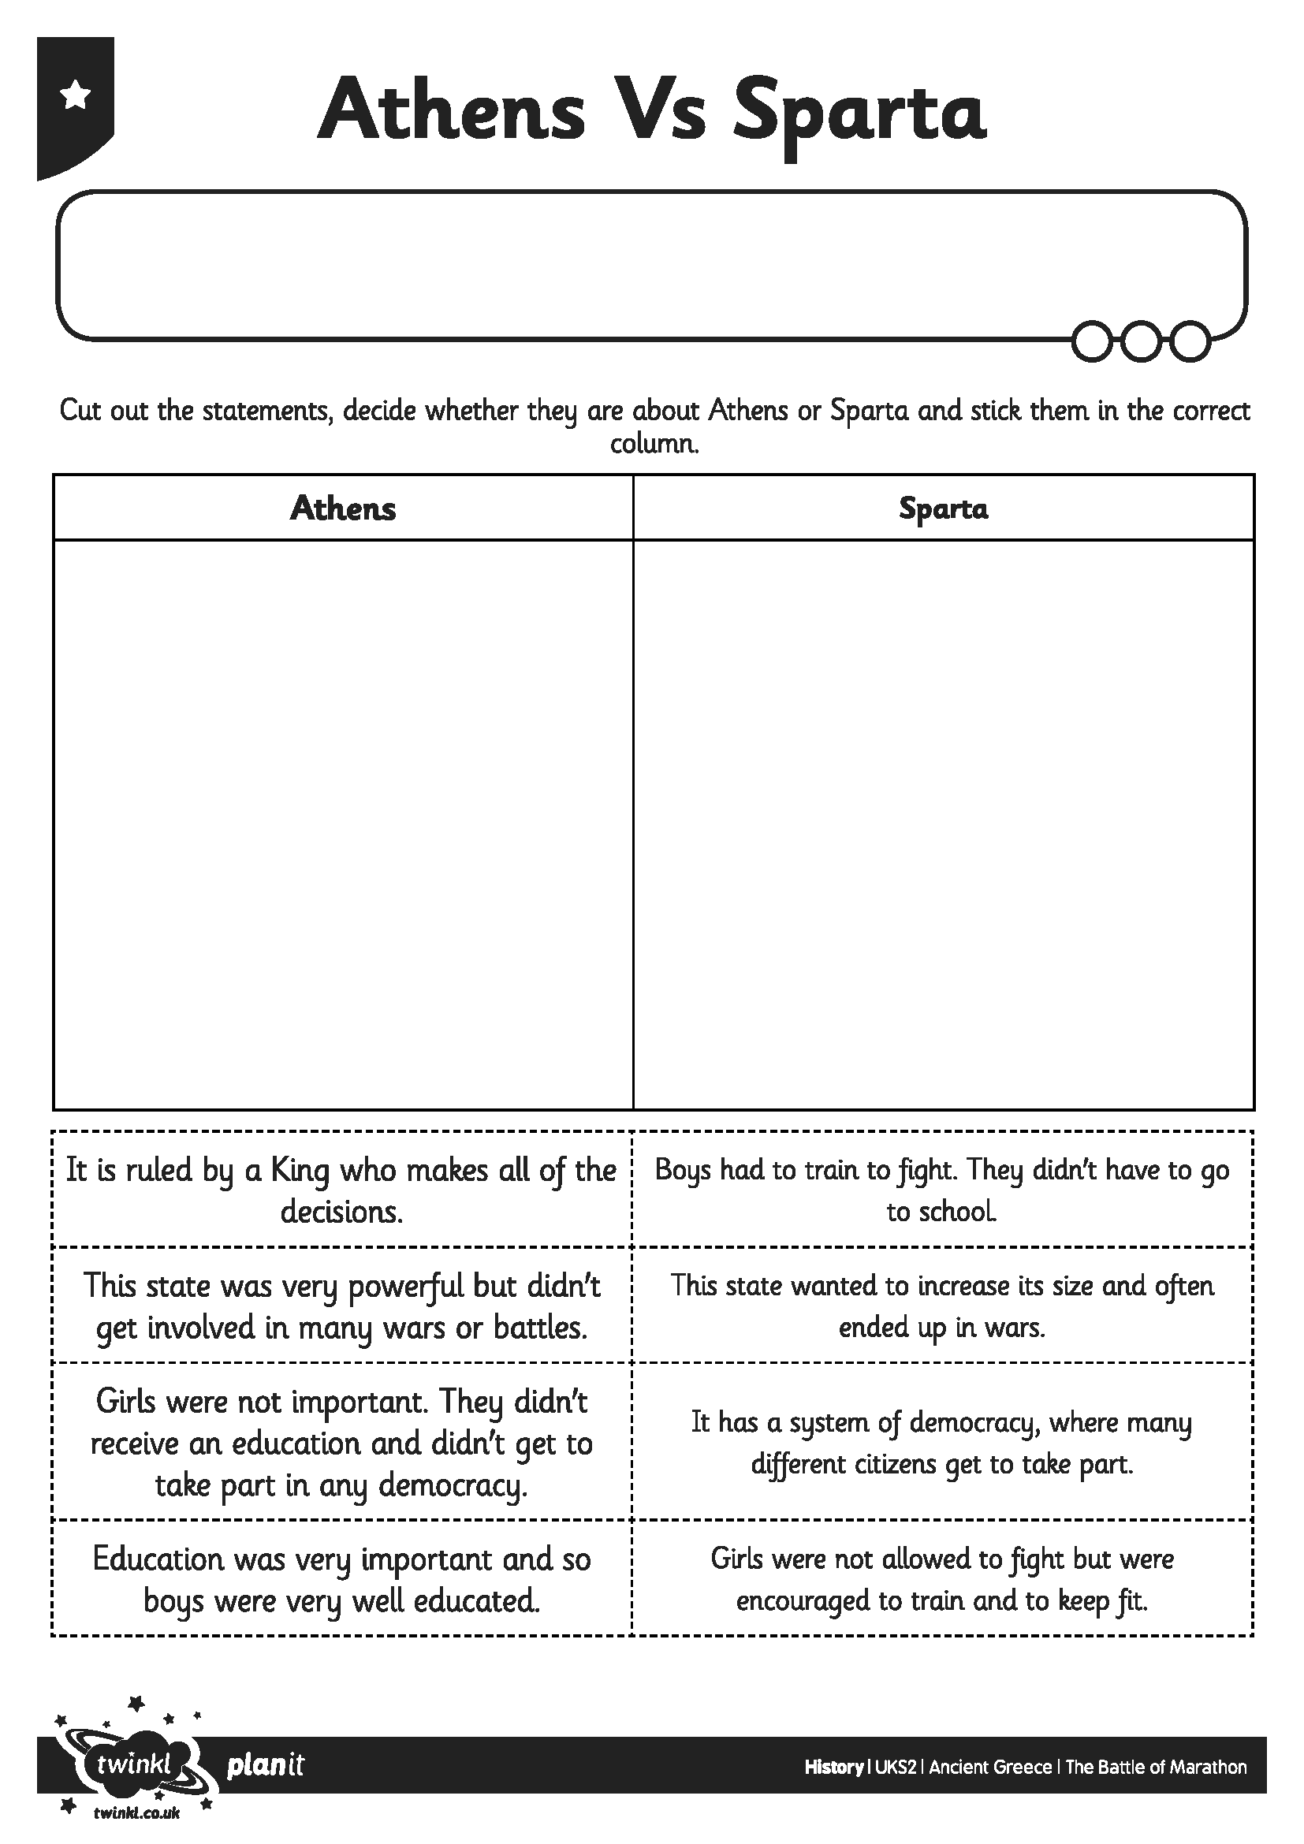

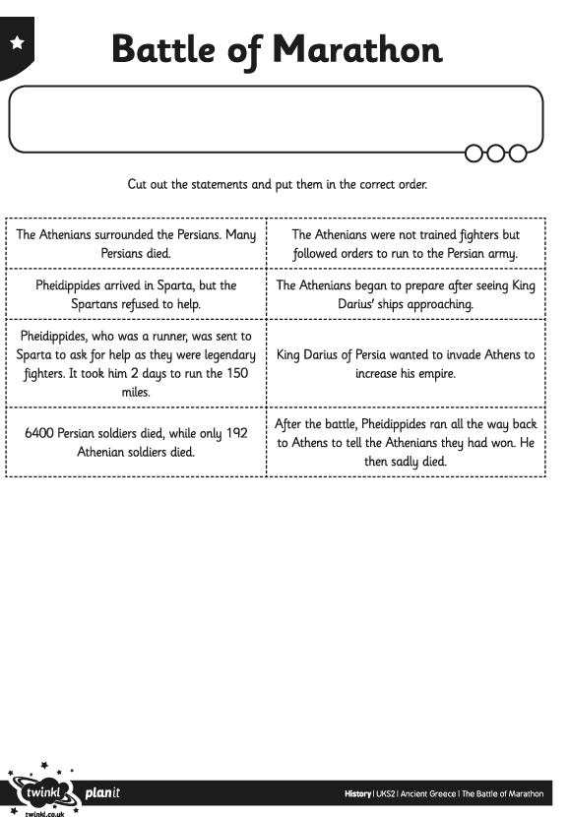

Welsh
Have a go at writing your own postcard (see sheets below). There are sentence starters on the sheets to help but see if you can use some of the vocabulary you have learnt from ‘Y Dref’ in previous work packs.
Also here’s the link for the Cyw website where there are lots of activities for you to explore: https://cyw.cymru/en/

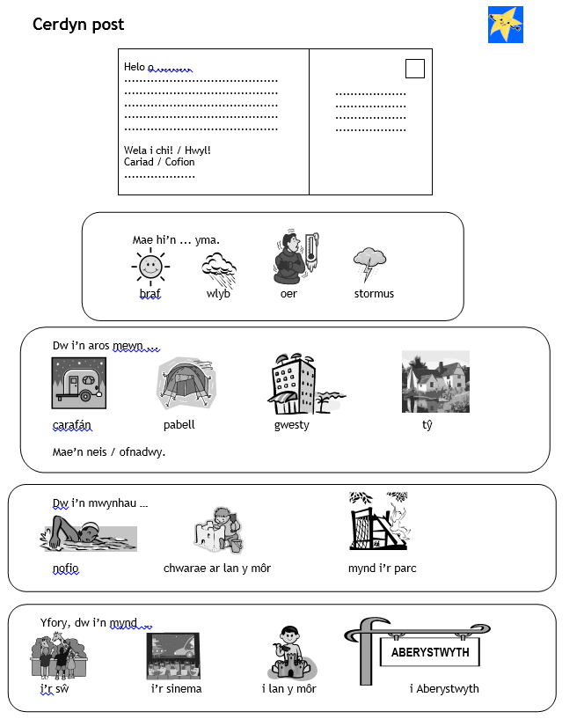

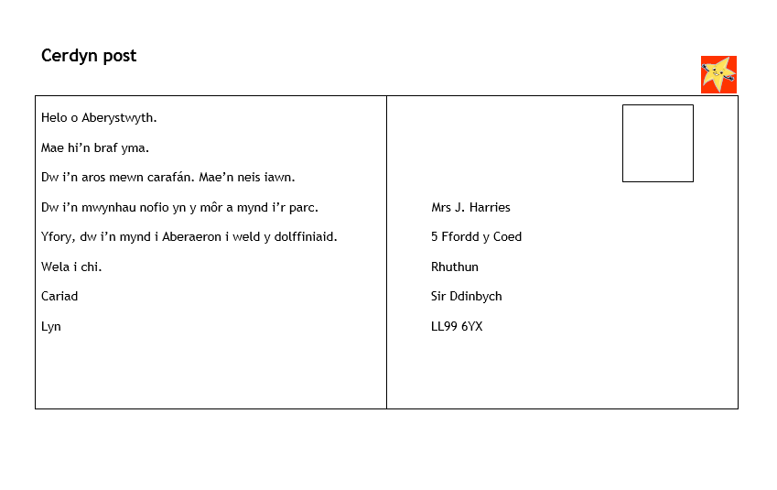
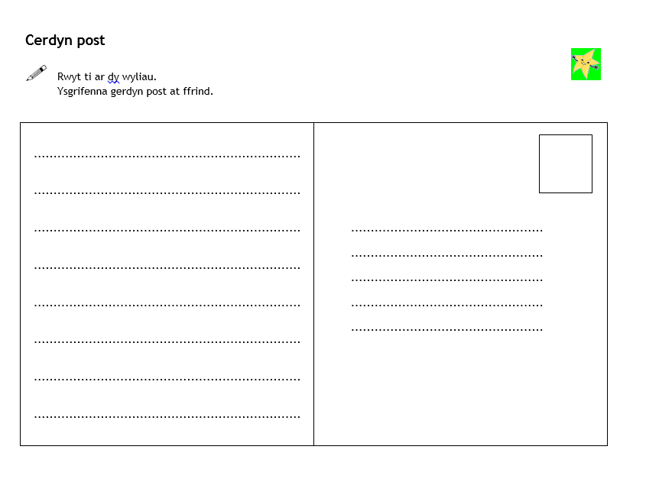

ICT
This week’s activity is to plan, create and export a stop-frame animation. I would like you to plan out a new short narrative or base it on the previous animation. Create a simple storyboard template of the shots you will need. You could experiment with different camera shots: long shot, extreme close up and point of view (of your character/object). You could build a simple set using half a cardboard box which is decorated appropriately.
Here is a link showing you how to export your finished film to the camera roll and an opportunity to import the finished animation into your video editing application e.g. iMovie and add titles, music and sound effects: https://www.youtube.com/watch?v=xpo80hlJkOI&feature=youtu.be
I have also included a storyboard template below to plan out your animation.
Here is a useful link about online safety on Hwb – lots of relevant information for parents/carers and activities to complete: https://hwb.gov.wales/zones/online-safety/news/articles/42ae160b-7ab4-4510-8792-c70ef861c6d5

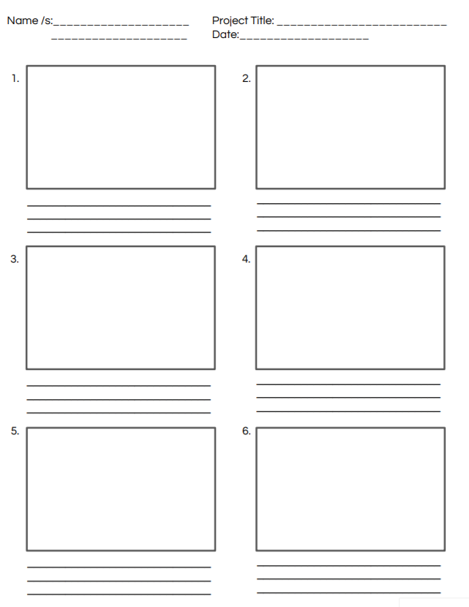

Try to include a bit of physical activity every day. Joe Wicks has proved really popular on his YouTube channel – you can have a look here: https://www.youtube.com/channel/UCAxW1XT0iEJo0TYlRfn6rYQ

Happy home learning! Hope you are all keeping safe and well,

Miss Densley

