Home Learning Pack Week 6 Year 6
Miss Kear & Miss Thomas’ class

Hello Year 6.
How are you all? We hope you are all well and happy. Don’t forget to keep reading as we can’t have Guided Reading at the moment. We don’t mind what you are reading as long as you keep it up.
In this pack you will find:
Maths:
Area Chilli Challenge – You have a mild, medium and hot challenge. We would like you to try at least 2 of the worksheets. If you’re feeling confident give them all a go!
Mental maths test – ask someone to test you.
Multiplication and Division Mosaic
Problem solving – Guessing and checking
English.
Comprehension. There are more questions this week so no writing task.
Using Dictionaries: You can always look up a definition online if you don’t have a dictionary in the house.
Where do our words come from? We’ve talked a little bit about this before when we’ve discovered words that don’t seem to fit any spelling pattern. It’s often because they come from another language.
Three short challenges (English and Maths) No answers this week!
Baking Rainbow cakes. When you can find flour and eggs give these a try. Lots of ideas of how to decorate.
Keep up the hard work!
Miss Thomas and Miss Kear

Chilli Challenge: Below you will find three worksheets on area. They are mild, medium and hot. We would like you to complete at least two of these worksheets, if you’re feeling confident give them all a go! Area – To quickly work out the area of a square/rectangle, you multiply the height by the width. Make sure you include the units of measurement in your answer and don’t forget the ² after the units when you write your answer.
Mild: For this worksheet you can either count the squares or multiply the numbers. 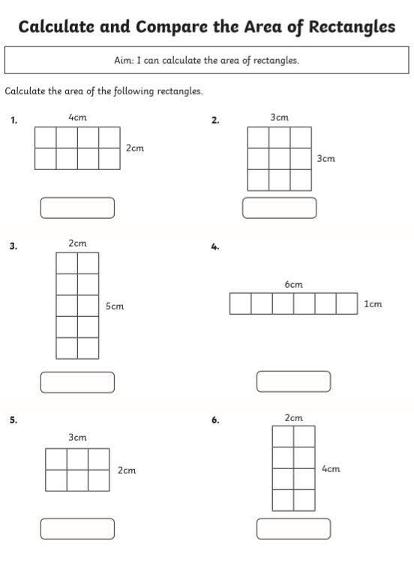
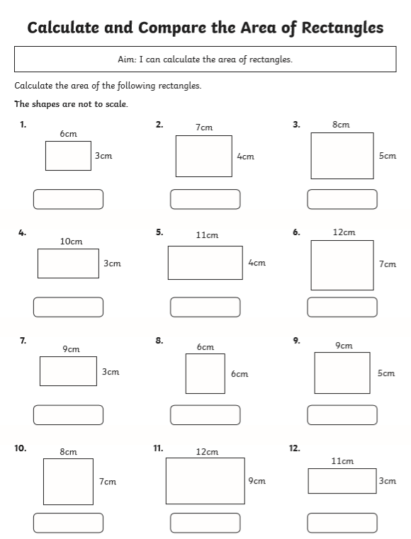
Medium:
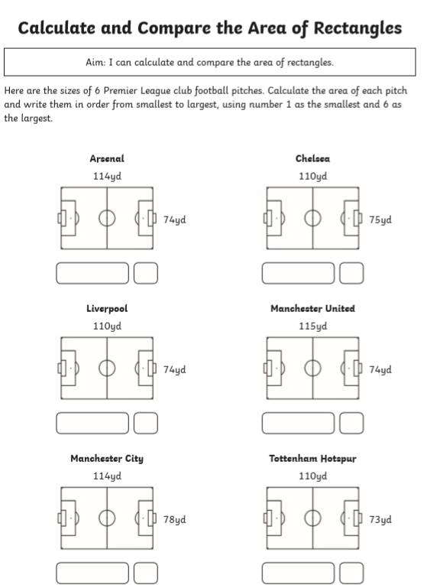
Hot:
Mental maths – ask someone to test you.
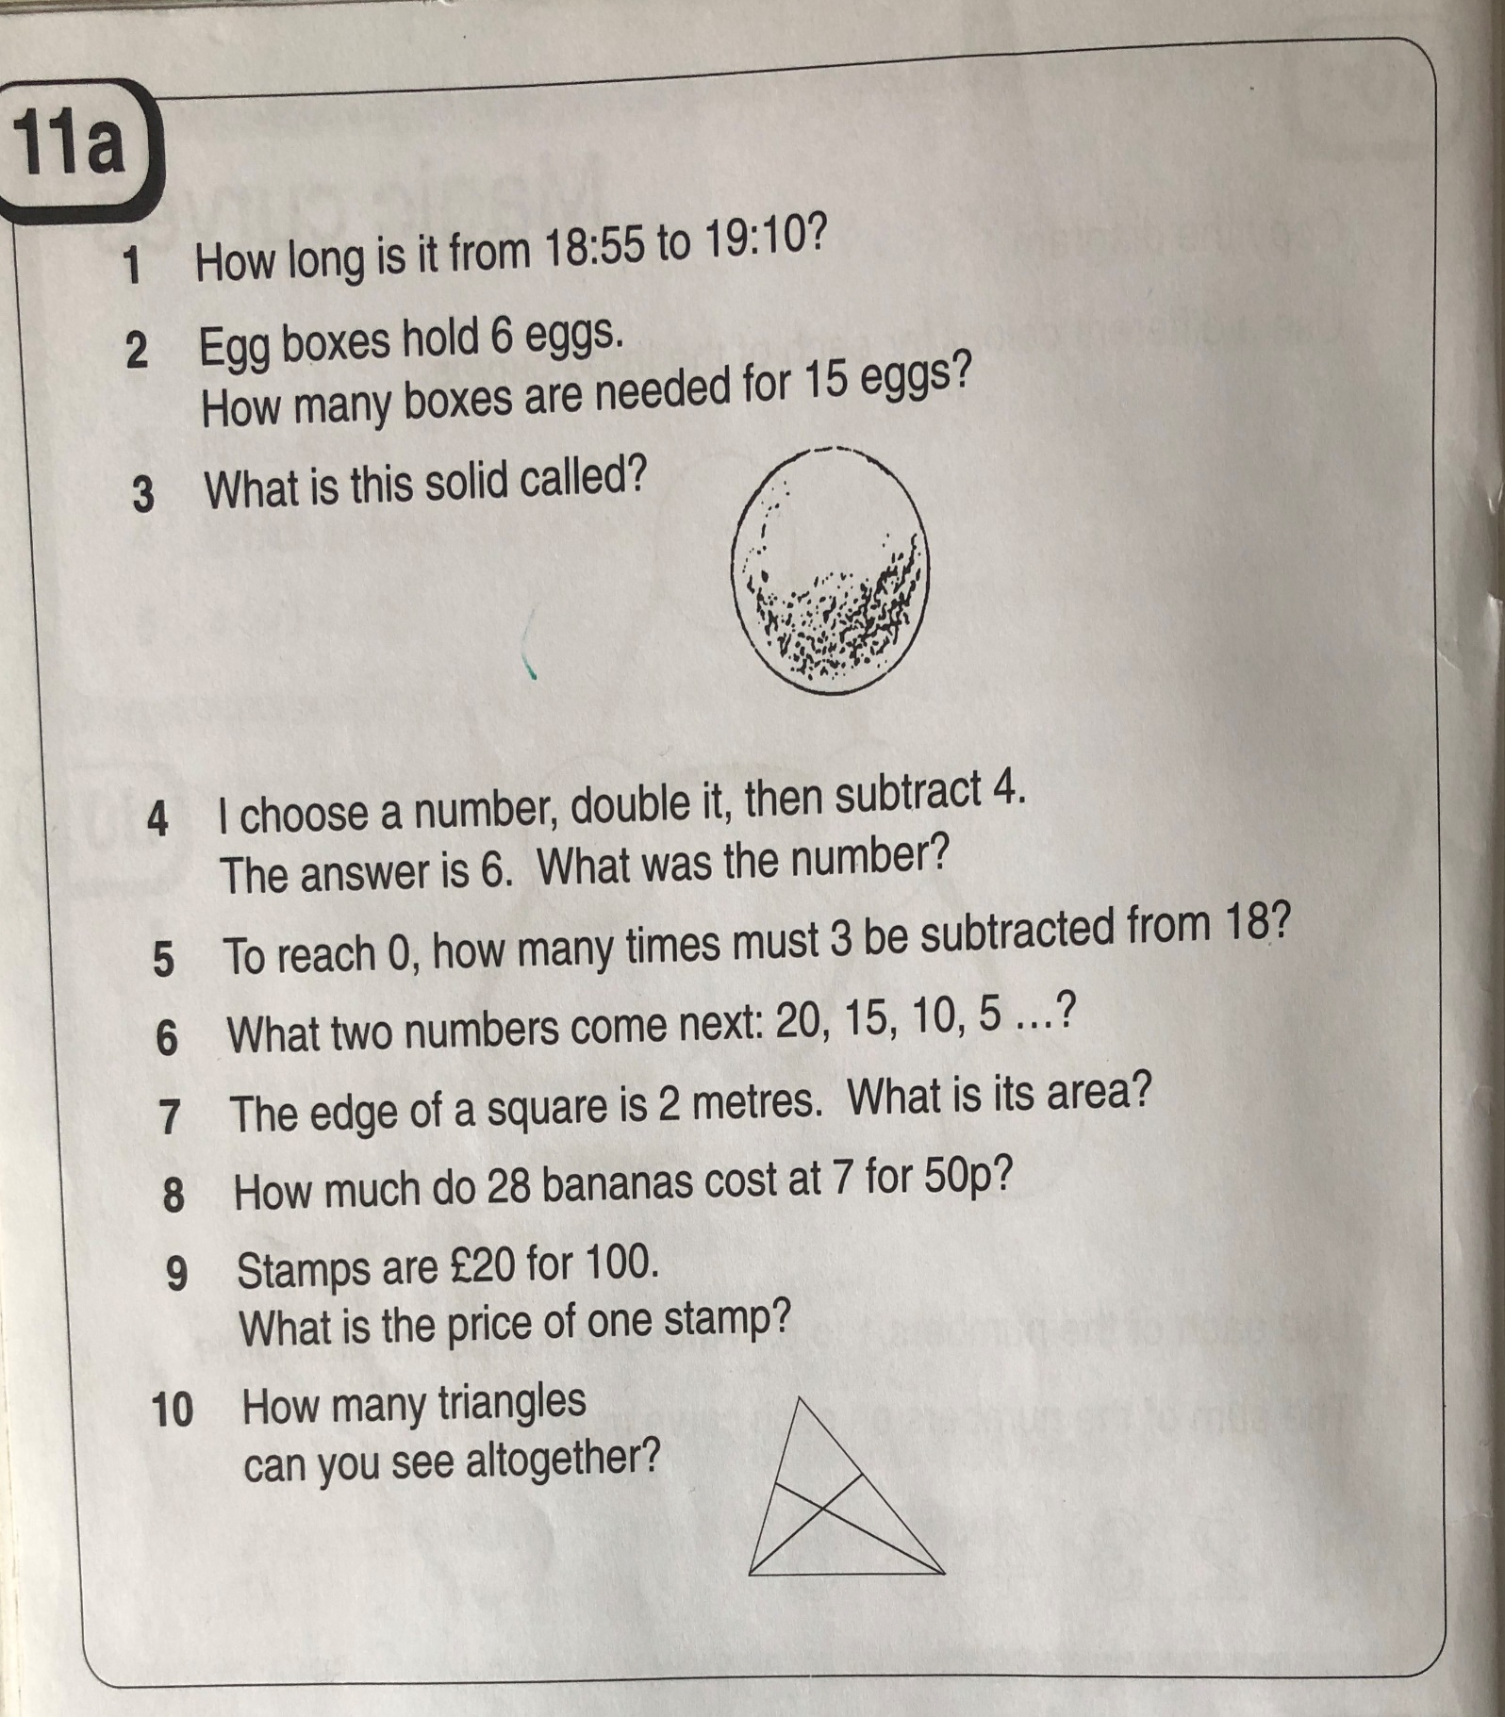

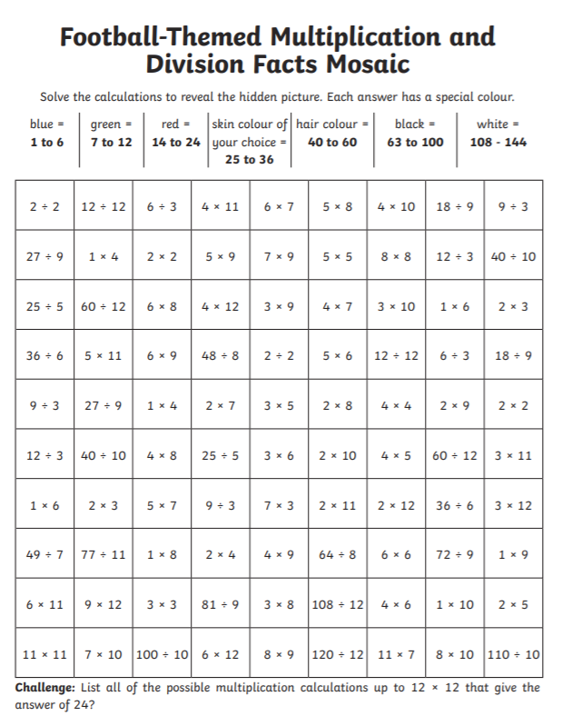
Problem solving – Guessing and checking.
Understand the problem:
- What do you know? – you can underline the important information in the problems.
- What do you need to find out?
- How are you doing to solve this problem? What are you going to try? What will you need to help you?


