HOME LEARNING
RECEPTION – WEEK 6
SUMMER TERM TOPIC- AT THE SEASIDE

Hi,

All- we hope everyone is keeping well and keeping their brains active.
If some of you are feeling fed up with the situation and a bit anxious then that’s normal and we too have days when we feel this way- you are certainly not alone.

This week I have decided we will look at a specific area of the seaside and focus our learning around that.
Let’s look at- UNDER THE SEA!

We will be exploring creatures in particular creatures that live under the sea. There is an amazing world happening under our oceans and I have included some fascinating video clips to watch of different sea creatures and their lives in the ocean.

LITERACY:

Speaking and listening:
Watch the Baboo sea creatures- the video which lasts for around 7 minutes.
Here is the you tube link:

https://www.youtube.com/watch?v=tSzqojYlAyI

In this video it shows many pictures of different sea creatures, do you know their names?

Get an adult to write down the names of any sea creatures you recognise eg: jelly fish. Have a chat and see if you can discuss the following ideas:

- What creatures do you recognise?
- Have you ever seen any of these sea creatures in real life?
- Which creatures do you like the most?
- Are there any sea creature you would be frightened of?

Watch the BBC ‘Animals that’s live under the sea’.

https://www.bbc.co.uk/bitesize/clips/zmxqxnb

Activity: Share your learning- become the teacher:

You will hopefully learn some new things. Can you watch the video by yourself and then tell someone in your house 3 new things you NOW KNOW that you didn’t know before?

You are like the teacher passing on your information. Maybe someone in your family is in work during the day and when they get home you can share your new found knowledge.

READING:

This week we are going to read and explore the book ‘COMMOTION IN THE OCEAN’ written by Giles Andreae.

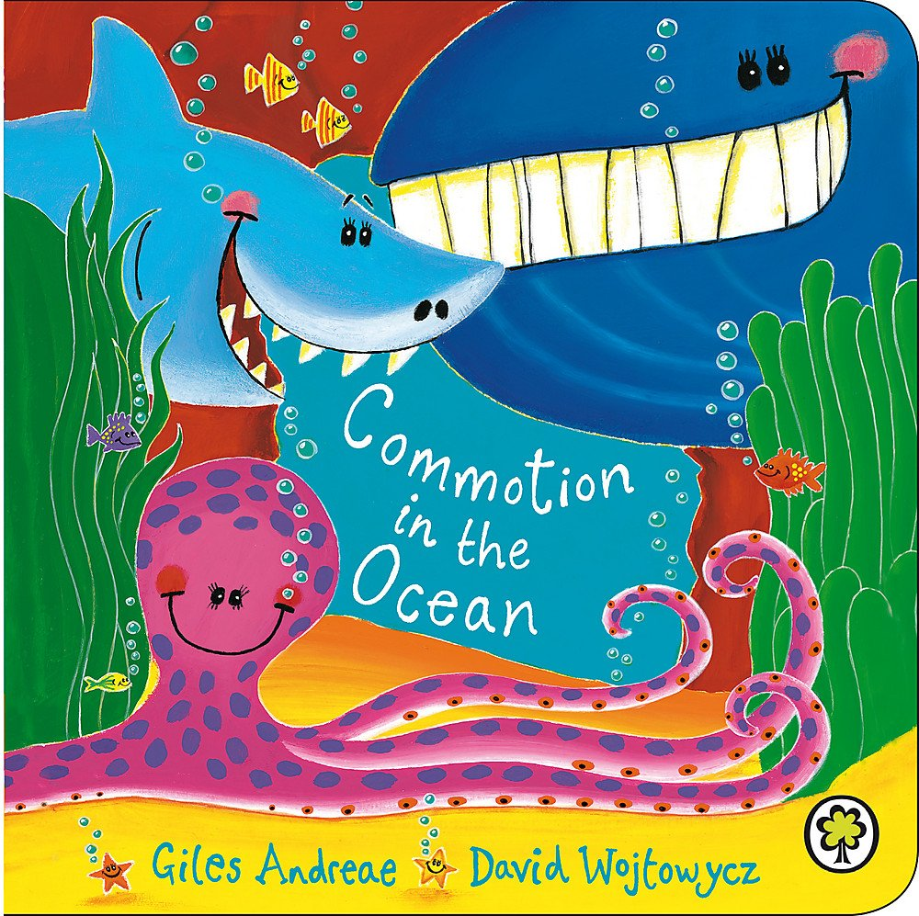

This book is full of great poems about sea creatures and the antics that go on during the ocean.
Explore the book by watching it being read on this you tube link:

https://www.bbc.co.uk/bitesize/clips/zmxqxnb

Many of the poems have rhyming words:

Eg: CRAB - land and sand
Dolphins - squeak and speak.

Can you listen to the book again and spot any rhyming words by shouting snap when you hear the second word that rhymes?

Recognising rhyming words is a very important aspect of reading when in reception.

NUMERACY:

Counting- sheet attached on website labelled Sea Life Counting – count the amounts of each sea creature and make sure your numbers are formed correctly and facing the right way.

Adding- Complete sheet attached on website labelled Sea Life Adding.

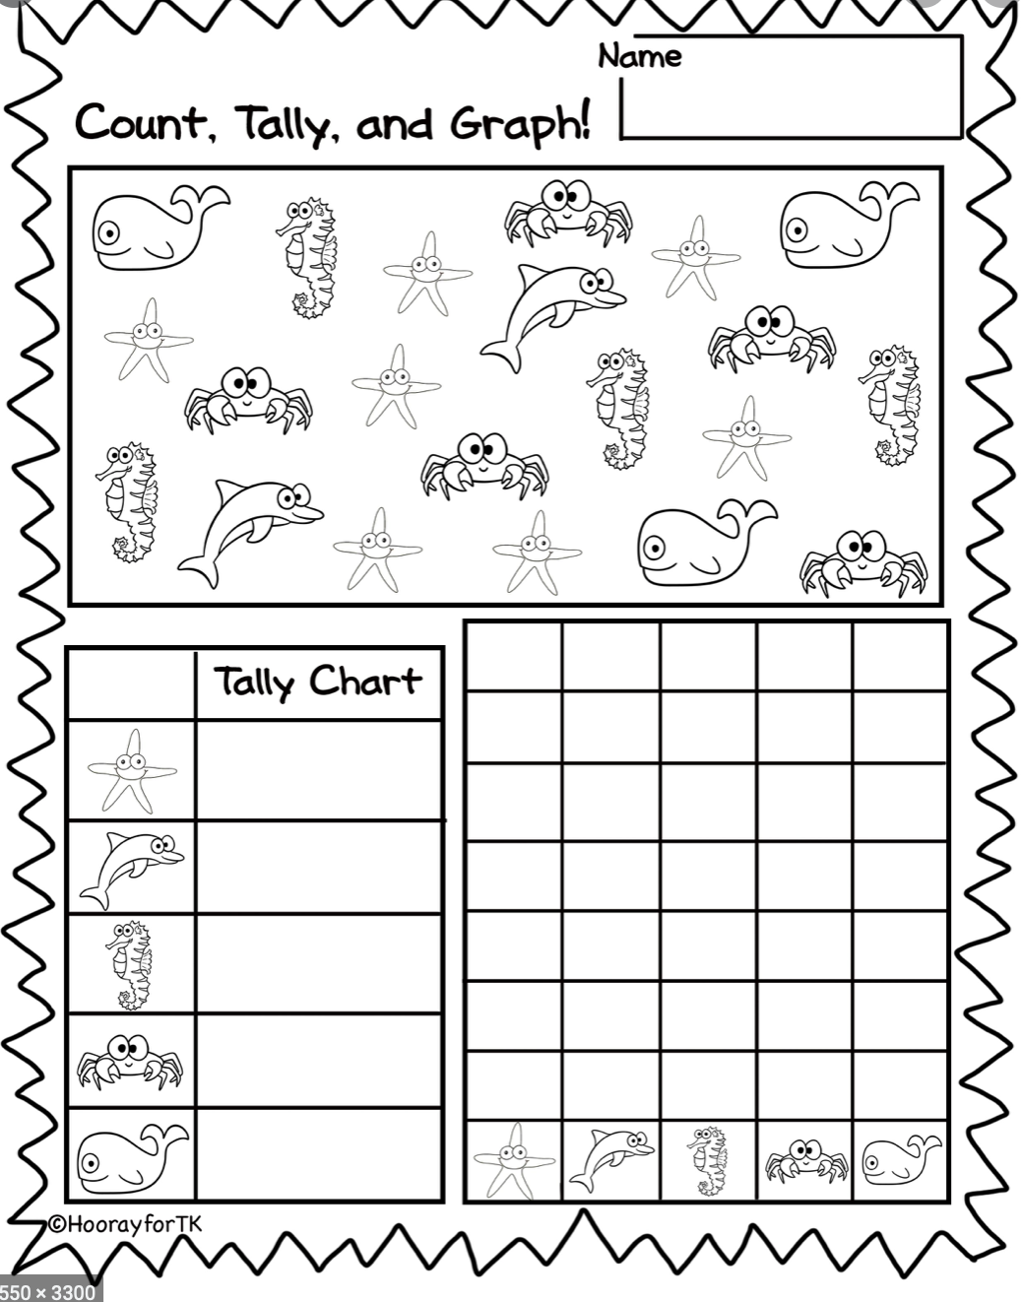
After completing the sheet above:

Can you make your own graph of favourite sea creatures ask your family; you could facetime your grandparents to ask them?

Think about the sea creatures you would like to give as your options eg:
Sharks
Dolphins
Octopus
Jelly fish

Creative Development

Create your own patterned sea fish:
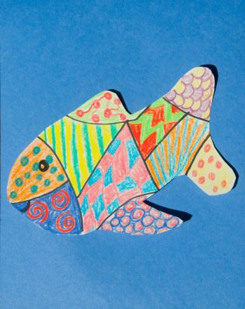
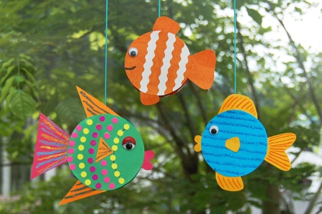

Fish can be made using paint, crayons, collage or using clothes and materials on the floor.

Take a picture and add to Twitter we would love to see them. @williamstownrec

We have spoken to a lot of you over the last few weeks and you are all doing fab things at home. We are super proud at how our pupils are coping and miss you all millions.

Speak to you soon,

Best wishes
Mrs Brown, Mrs Chapman and Mrs Lane xx

