Week 7 Week Beginning 18-05-20

Hello everyone!
We hope you are all safe and well?
We really do appreciate how difficult these times are. If you have any concerns or queries please don’t hesitate to mention them when a staff member contacts you. Or in an emergency use the number that has been forwarded to you.
Although these are difficult times, PLEASE don’t underestimate the benefits of your child spending this quality time with you. Your children are amazing and are a credit to you! Keep up the brilliant work!
We will be continuing to learn about Jungle animals this week.

Language and Literacy.
- Below are some animal mats, please could you and your child discuss the animals you can see. Ask your child open ended questions eg:
- What would the animal eat?
- How would he get his food?
- Where does the animal live/sleep?
- Who lives in a tree?
- Who lives under the ground? etc.
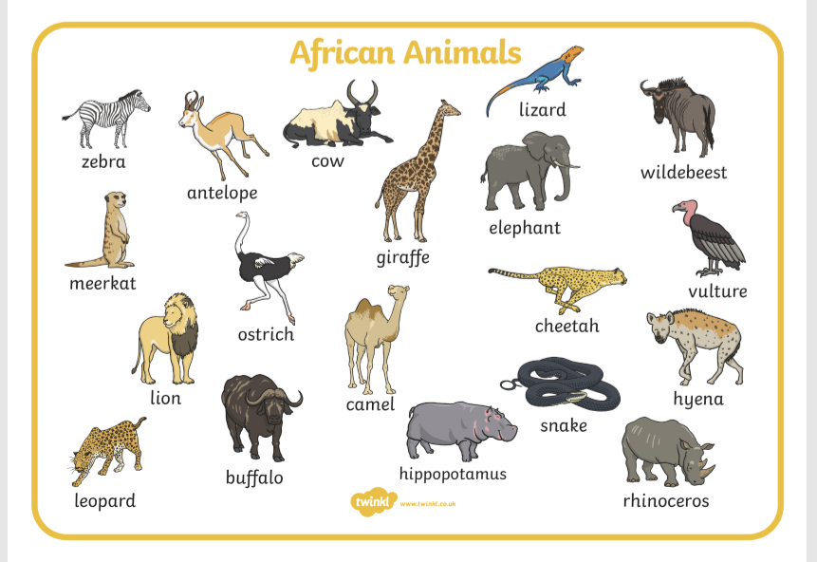

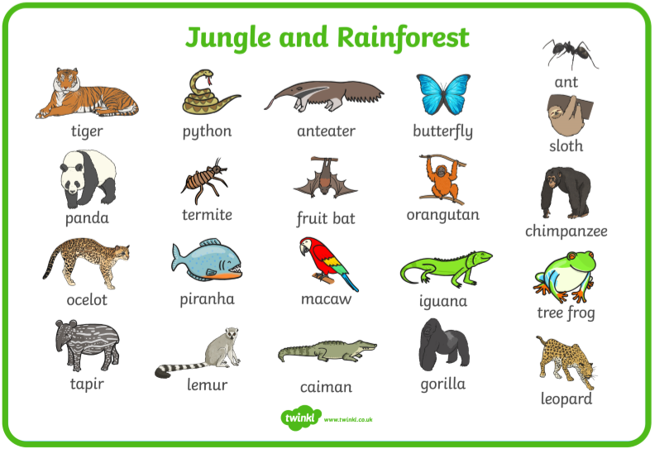

- Using the boards above, can your child identify the initial sounds of any of the animals? Either visually or aurally when you say the name of the animal. eg: What is the first sound you can hear when I say “snake”? etc.
Following the above activity you could
Play a game called ‘Kims Game’
- Write down on small individual pieces of paper the letters they recognise.
Set out 3 or 4 of them on a table or the floor. Ask your child to have a good look at them. Then tell them to close their eyes while you remove one. Can they tell you which one is missing? You can increase/decrease the number of letters according to how easy/difficult they find it.
This game can be played with anything if they found the letters a little tricky.
You could use toy animals, pictures of animal’s, household items. The purpose of the game is to develop their memory skills. In time when they start to learn to read, this will help them remember words they are being taught.

- Listen to the story of ‘Walking through the Jungle’ by Julie Lacome.

Ctrl & click or copy and paste the link below into your search engine.
https://youtu.be/Mi1QZu1_ZYE
- Ask you child questions about the story. eg:
- Which animal did the little boy see 1st, 2nd, 3rd and last
- What noises did they make?
- What would the animal like to eat?
- How do they think the little boy felt when he heard the noises?
- How do they think THEY would feel if they heard the animal noises?
- Where would they sleep?

- Ask your child to act out the story, by walking, creeping, running, leaping, swinging.
- Can the move like the animals?
- Can they make the animal sounds?

Make the story fun by bringing it to life!
It would be lovely to see them acting it out.

- Please continue to practise the jolly phonic sounds with your child. Helping them with the action and forming the sound correctly.

Ctrl & click the link below or copy and paste it into your search engine
https://youtu.be/1Qpn2839Kro

Our sound of the week is ‘d’

- How many items can your child find around the house/garden/environment beginning with ‘d’. Remember we use the phonetic sound rather than the name eg. D for dog
- Can your child use pebbles, sticks, blocks, leaves etc to form the
letter d? Take a photo to record your child’s progress.

- Please continue to sing Nursery rhymes with your child, helping them to recognise the words that rhyme in each song.

Mathematical Development
- Can your child make a jungle animal out of their building blocks?
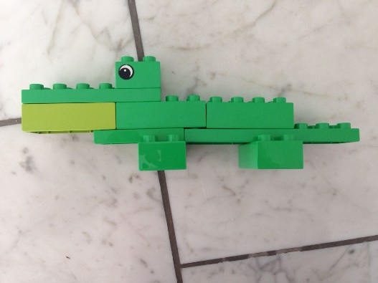
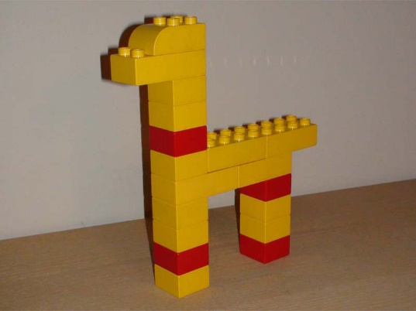
Ask your child to ‘add one more’ block or ‘take one block away’ to make one more or one less on their creation.

- Using your child’s toy animals, or pictures of animals ask your child to count how many of each animal there are. Then ask them to write the number on a piece of paper. If they find this tricky can they indicate the number using lines eg if there are 3 tigers they can symbolise this by writing 3 lines l l l.

You could make a simple chart for them
Animal | How Many
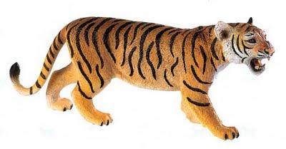
tiger
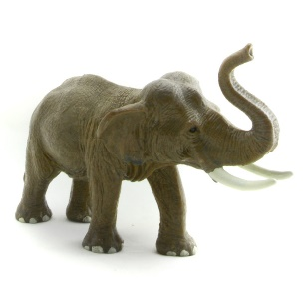
elephant
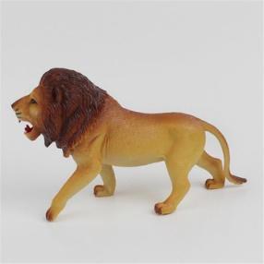
lion
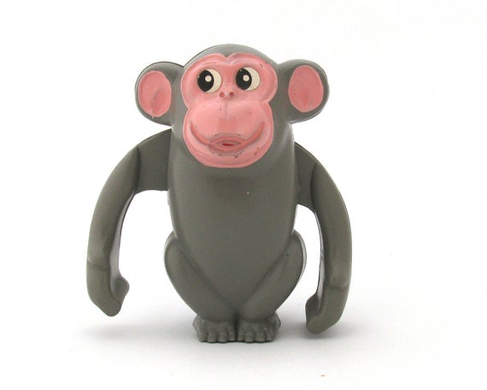
monkey
This format could be used for anything. If you don’t have toy/picture animals. Why not use household items eg: how many tins of beans, boxes of cereal etc.

- When looking at different Jungle animals, whether it is toys, pictures or even on the internet. Ask your child to count how many legs, ears, horns, tails etc the animal has. Then ask how many would they have,
if they had 1 more or 1 less?

Creative Development

- Using two different coloured paper strips can your child make a repeating pattern paper chain snake
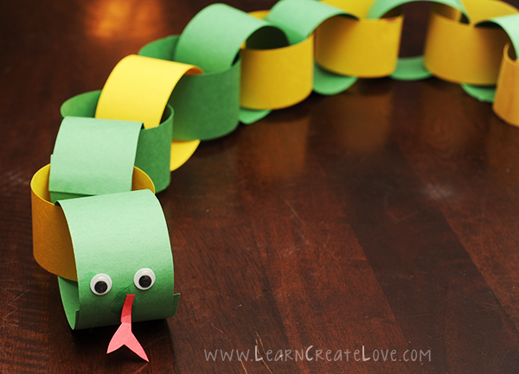
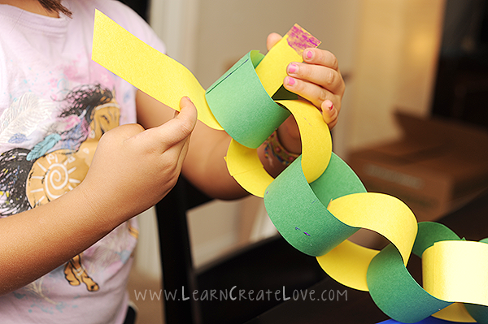
Don’t worry if you haven’t got coloured paper. Cut the paper into strips and ask your child to colour them.
Don’t forget to take a photograph to record your child’s work.

- Ask your child if they can remember the song, we sing in Nursery about monkeys swinging in a tree. Can they teach it to you?
This link will give you an idea of the words. It is a rhyme that helps develop your child’s ability to count backwards, also incorporating the use of ‘one less’ as each monkey is snapped up. The tune is different, and we say “along came a crocodile as bold as can be” instead of “as quiet as can be” https://youtu.be/Qq1YVoKrPMI I hope your child remembers it. It was one of their favourites.

Physical Development

Try some cosmic yoga.
Here are some of the many benefits of teaching yoga to children: Yoga helps your child to: Develop body awareness. Learn how to use their bodies in a healthy way. Manage stress through breathing, awareness, meditation and healthy movement. Build concentration. Increase their confidence and positive self-image
Here’s a link to a fun yoga jungle adventure:
Either ctrl & click or copy and paste the link:
https://youtu.be/C4CaR0syf1g
another favourite with the children is ‘Tumble Tots
https://youtu.be/1ac-xMobPyw
this link will take you to a dance about elephants having wrinkles along with a variety of the children’s other favourites. An easy way to exercise. They LOVE it! We hope you will too.

Stay safe!

Huge hugs
Mrs Edwards and the Nursery Team x

