Summer 1 week 7
Beg: 18/05/20
Topic- The seaside

Hi everyone,

Hoping that everyone is well and is coping as best as they can.
It’s half term next week so you will have a break from all this work, hopefully the sunshine will stay so you can get out on your bike or Scooter when you are going for your exercise.

This week we will be looking at how the seaside has changed over time.
Lots of our work this week will be focussed around the KNOWLEDGE AND UNDERSTANDING OF THE WORLD aspect of the. curriculum. After the maths and literacy section you will see learning about how the seaside has changed from what it was like in the past, for example, the activities we do at the seaside, the swimwear we wear and even how we get to the beach 🏖

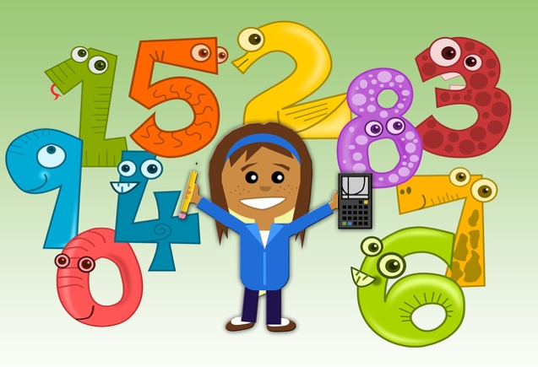
Numeracy:

Don’t forget how important it is to keep practising those number formations 0-9.

This week see if we can start writing some double -digit numbers.

Activity 1:- Can you write the numbers: 11 up to 20?
Sometimes when someone says a number eg: 17 it is tricky to know what numbers you need to write- have a go.

Make sure you follow the formation rhymes we know for example number 4 ‘down and across and down some more, that’s the way we make a 4’.

Activity 2: Look at the next few beach pictures which show different things you may spot at the beach. Can you spot all the different 2d shapes in the pictures?

Think about the shapes we have learnt in school square, triangle, rectangle and circle. We have also talked about semicircles. When you spot a shape can you tell a grown up how many sides and corners that shape has?

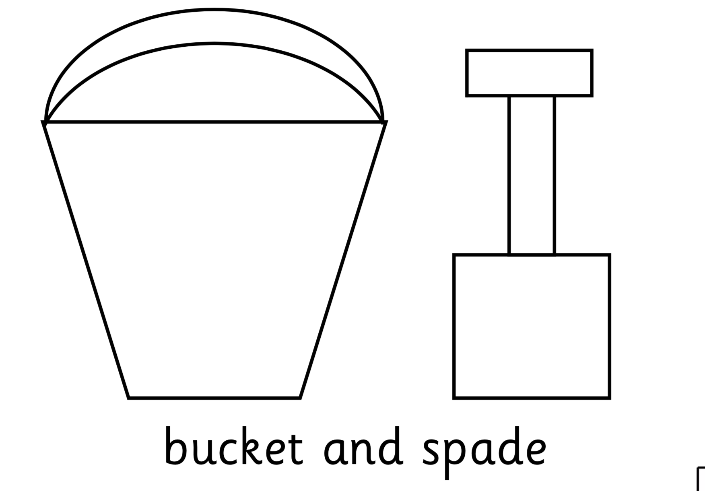

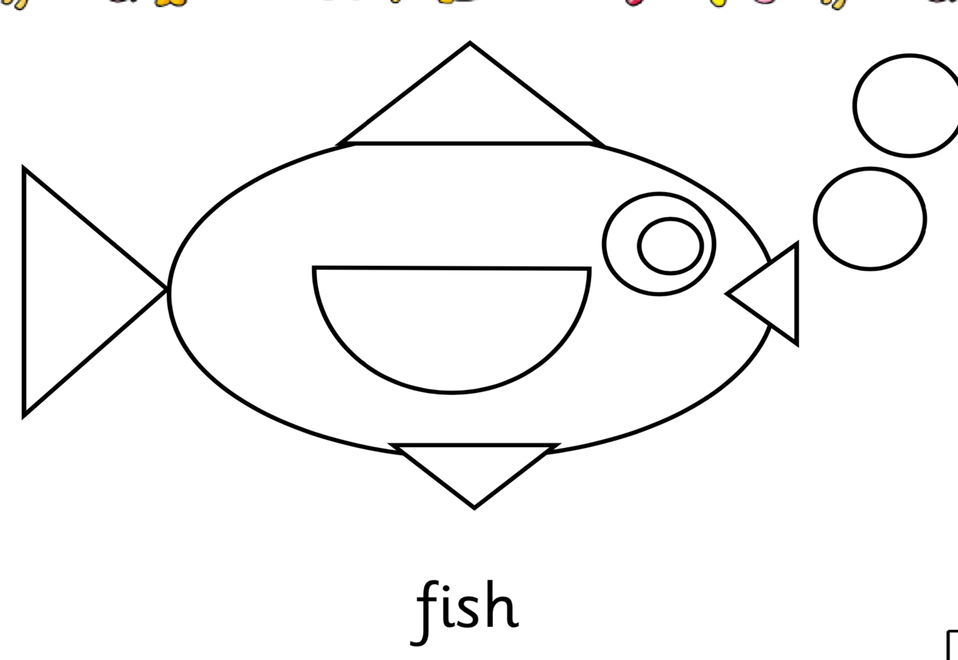
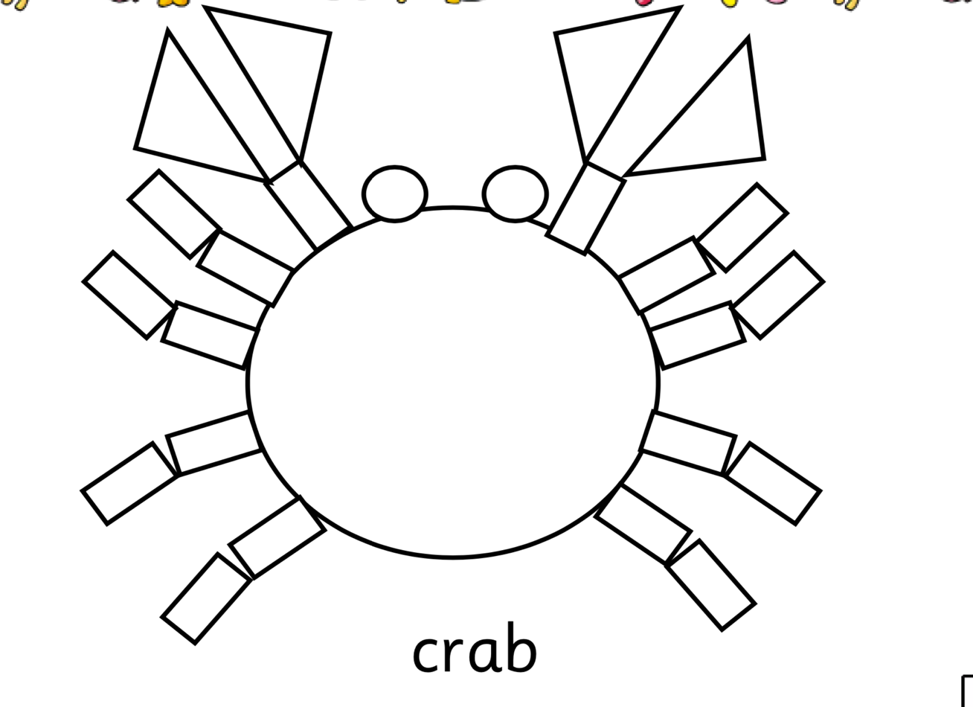
Activity 3- Careful counting- Seaside I spy.

Can you count the different seaside items and write the total amount?
You can use the screen shot (on the next page) and then just record the numbers on a piece of paper for each. Just draw a little picture of each item and then write how many.

Which item did you spot the most?

Which item did you spot the least?
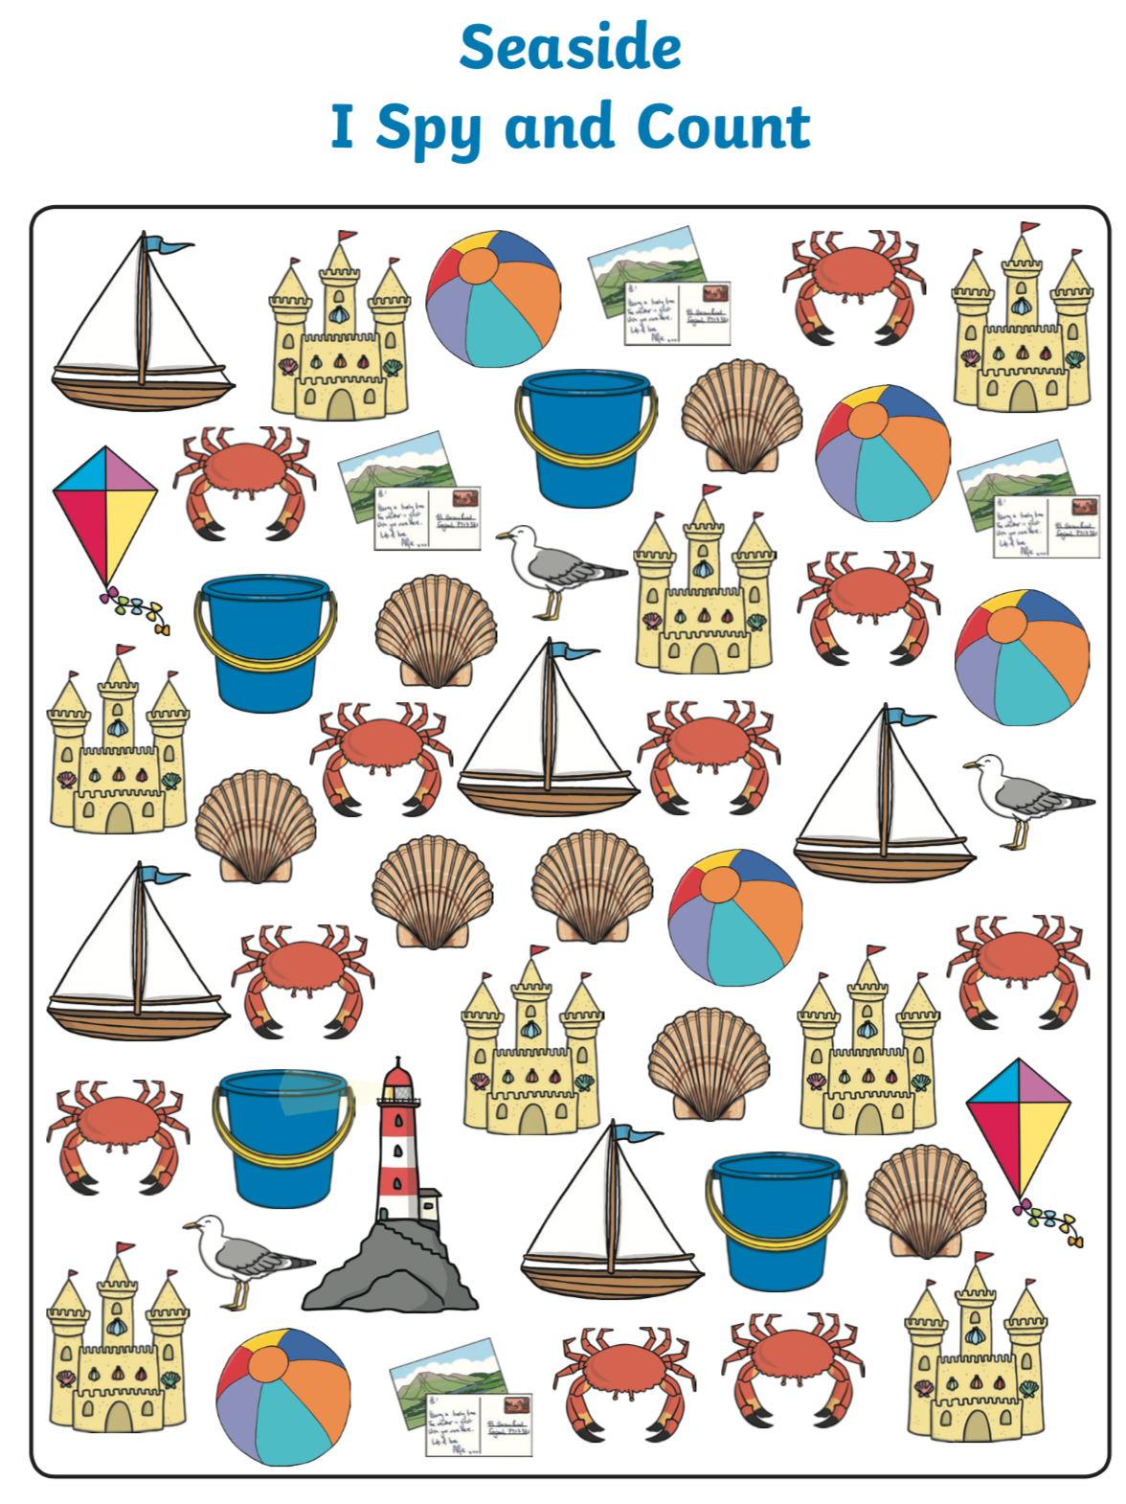
LITERACY:

Activity 1: There are lots of create rhymes and songs about the seaside. I have screen shot and added a few here.
Get an adult to read them with you, you may be able to read some of the smaller words by yourself. Can you learn any of these songs and rhymes?
Maybe you could make up actions for them and then perform them for someone- maybe even over FaceTime!!
If you do a recording of the rhyme with actions, we would love to see it!! Add it to our twitter page.
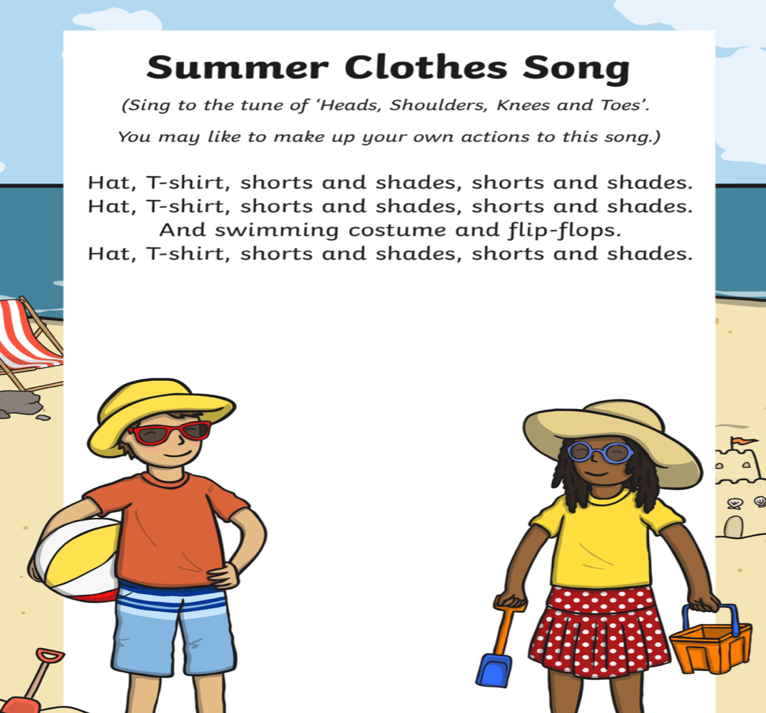

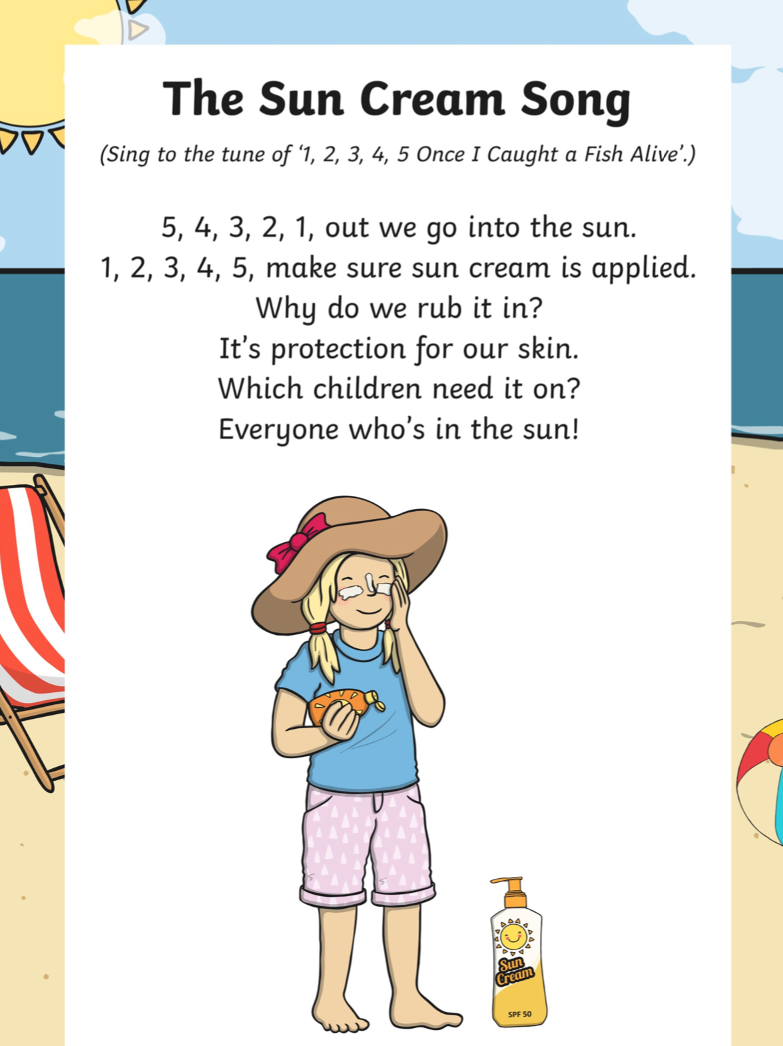
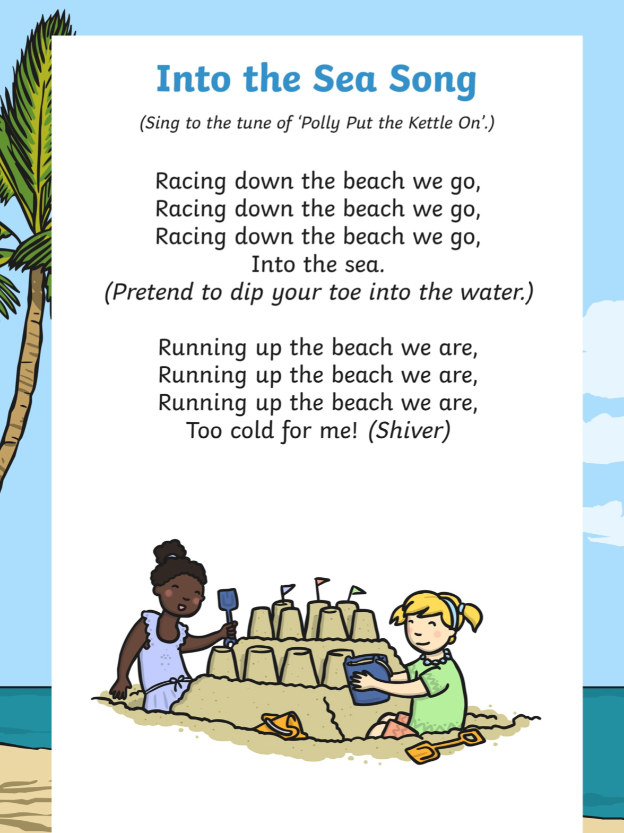
Activity 2: which is your favourite seaside song/ rhyme?

Mine is ‘ oh I do like to be beside the seaside’ it makes me feel jolly and happy.

Have a think which one you like the most and think about why. Ask whoever lives in your house which what their favourite? Do they know any others?

Activity 3: Use your handwriting book to write these seaside words, you may want an adult to write one of each first so you can copy- remember we are always trying to keep practising those letter formations and ensure they are formed correctly.

- Sea
- Sand
- Beach
- Sun
- Spade

When we write spade we need to remember that the p goes down as it is a ‘descender letter’ and the d goes up high as it is an ‘ascender’ letter.

Activity 4: ORACY- Odd One Out

Look at the pictures of the animals. Can you decide on each row which animal is the odd one out and give a reason why?
For example, in the first line a crab is the odd one out as it doesn’t live in the sea and isn’t a type of fish.
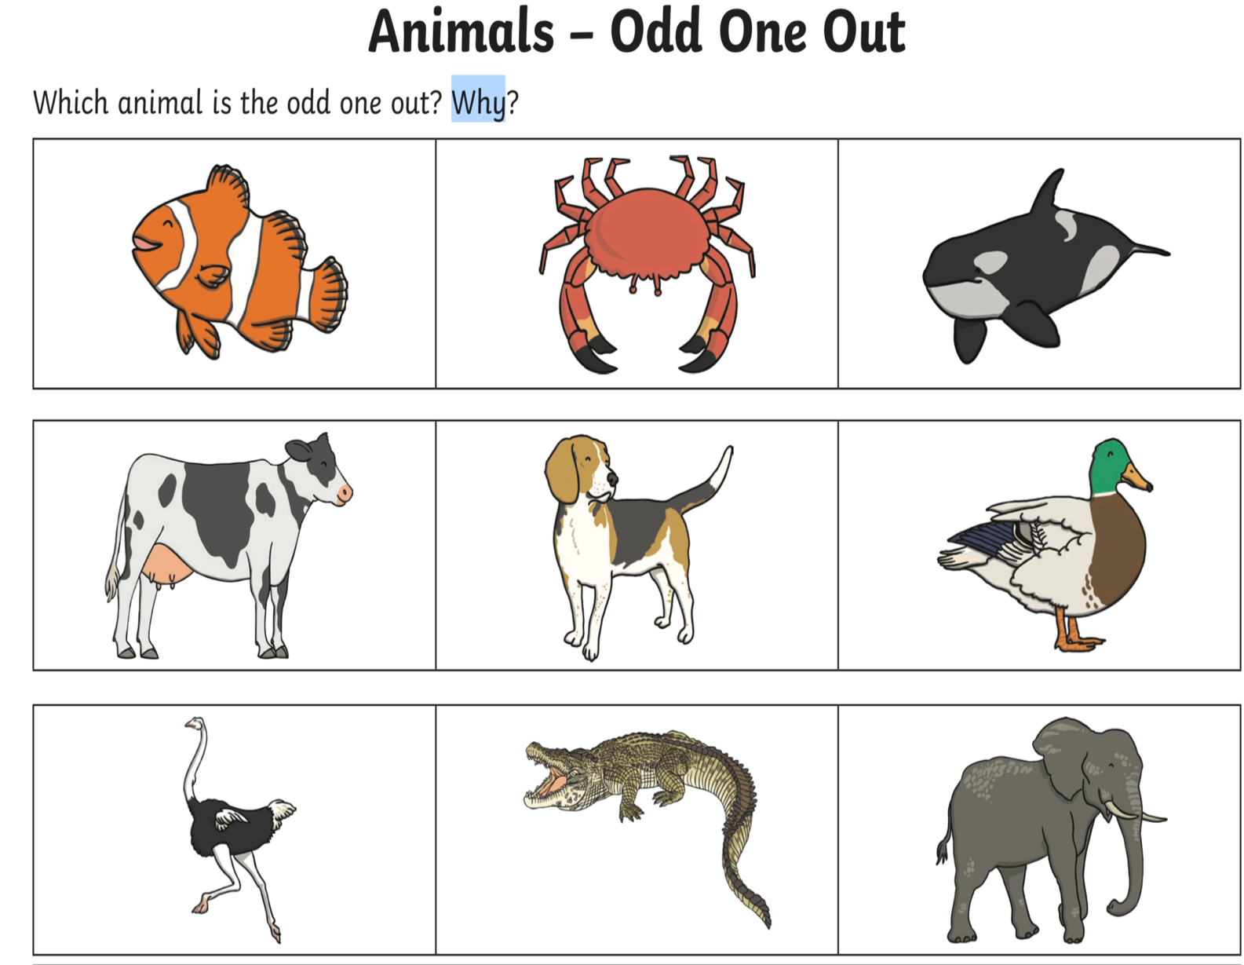
Knowledge and understanding (mainly history based this week)

So, visiting the seaside a long time ago would have been very different to visiting the seaside today.

View the PowerPoint all about the seaside Now and Then. You are going to need a grown up or a big brother or sister to read it with you. But that’s great as it’s going to be important to chat about it as you explore it.
This PowerPoint is saved on the reception Home-Learning page called Seaside PowerPoint Wk 7.

We will be exploring the difference a lot more after the half term break, but for now can you start by making a little list (again with some help) if anything that is similar to the seaside today and anything that is different.
It is best to do this on a piece of paper which is split down the middle into two sections with SIMILAR and DIFFERENT as the two titles.

Just for fun!!- there are a few activities to complete to keep that brain working and have fun!
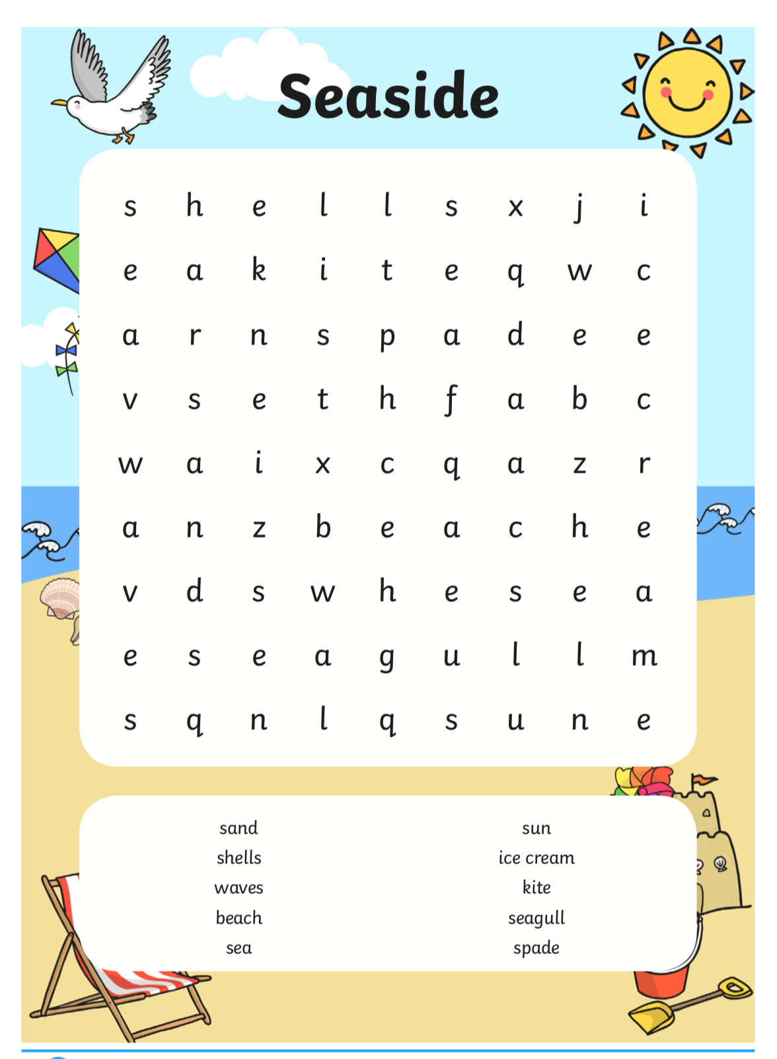
Seaside Jumble- can you. Find all of the seaside words?

Spot the difference:
You need to carefully look at the two pictures to see if you can spot the 6 differences. Good luck!
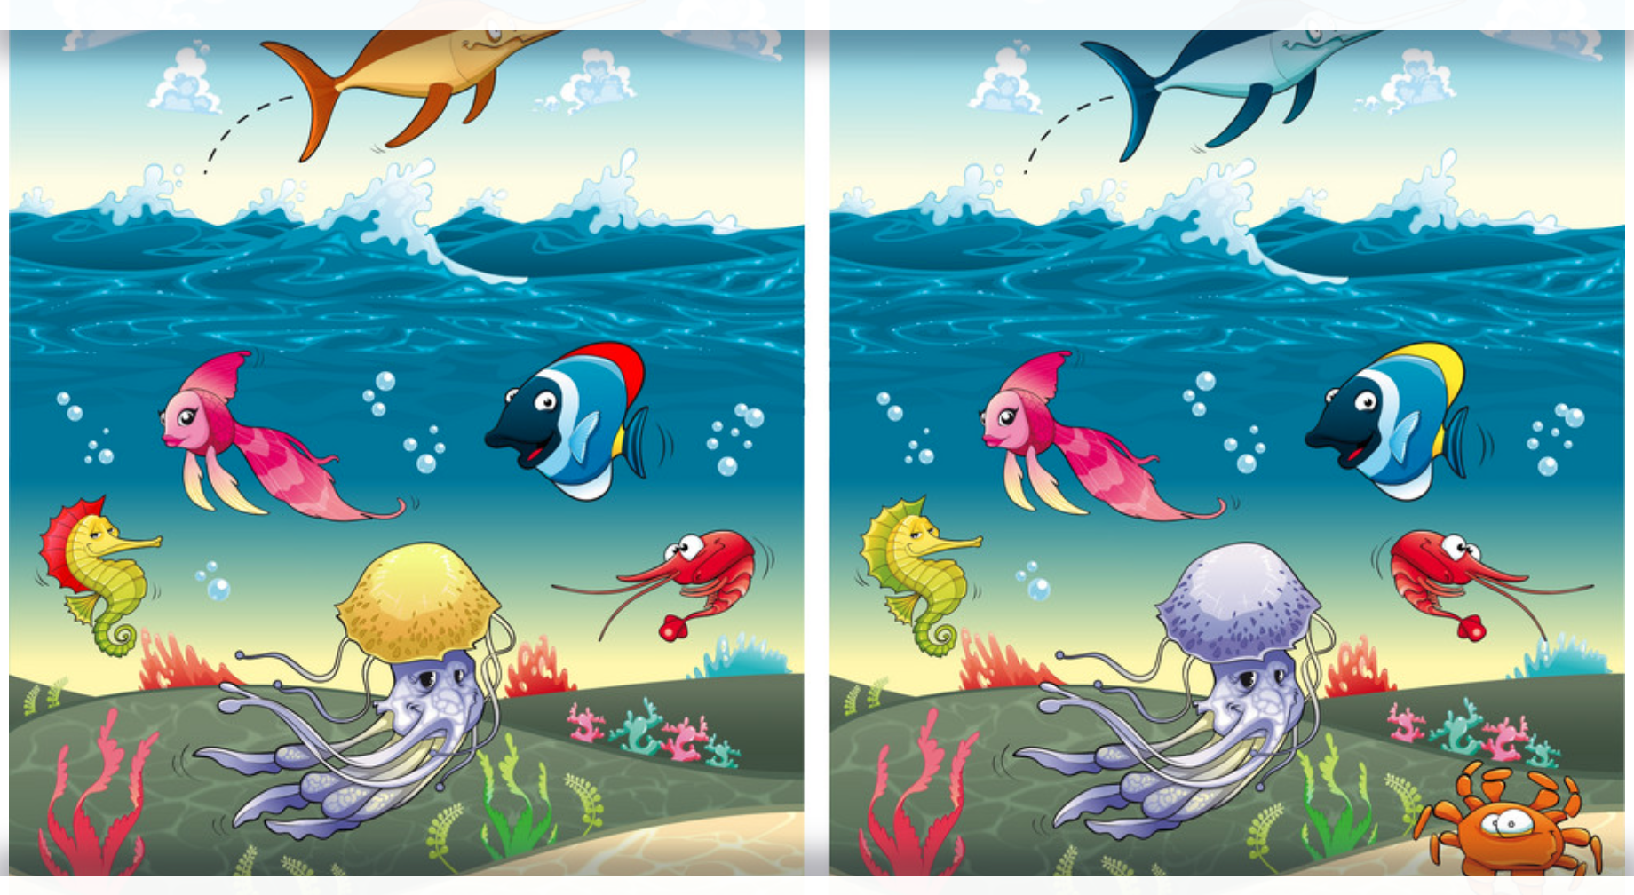

Best of luck with all this weeks, learning and hopefully we can soon all spend a day at the seaside when all this is over.

Don’t forget we are ringing off a ‘no caller ID’ as some families we haven’t been able to get hold of for a few weeks.
Also, we are here if you need us you can contact us using the emergency phone line which I keep with me.
So if you ring or text it will only be me and anything discussed is always private and confidential.

Reminder of that number: 07940433991

Best wishes to all of you and we are really hoping of news soon to when things can become a little more normal. Myself Mrs Lane and Mrs Chapman are all working down the HUB and were talking the other day about how much we miss seeing all your little faces. Take care everyone and speak soon and don’t forget do what you can with the work, don’t get stressed at this age everything is learning!

Lots of love and hugs,

Mrs Brown, Mrs Lane and Mrs Chapman
Xx

