Helo eto, Sut mae? It’s been lovely speaking with you all this week and hope that you’ve all managed to have a quick look at ‘Google Classroom’ . Please remember there is no need to print out any of these activities, they can be completed in your child’s Busy Book! Some pupils have filled their busy books and created learning files or scrap books for their learning – fantastic ideas!
Love to you all, Mrs Thomas + Miss Galliford. x
Summer Term-Tymor yr Haf
Year 1- Mrs Thomas.
Home Learning – Summer Term Week 5, Monday 18th May
Theme – A Walk on the Wild Side.
This week we are learning about Butterflies. What do you know about Butterflies?
PSWBCD
This week I‘d like you to think about what makes a good friend? I want you to think of 2 friends, one from class and the other can be from class or elsewhere. Make a list of 5 things you like about each of your friends. Are they the same qualities? What makes each friend special? What are you going to say to your friend next time you see them?
Read/Listen to ‘Little Beaver and the Echo’ by Amy MacDonald (Youtube)
Q-Who lived on the other side of the pond?
What could the Little beaver hear? Have you ever heard an echo?
Why did the Beaver feel sad? Have you ever felt like this?
Where did the Beaver live? Can you describe it
When did he realise he had friends? Who were they?
How did the animals travel to the other side of the pond? Have you ever travelled in a boat or on water?
Physical activities to try at home – indoors and outdoors
Ball work – Hold the ball in front of you. Pass the ball across your stomach, around your back until it’s in front of you again. How many times can you pass it around in a minute? Whilst your favourite song is playing? Try reversing the movement, is it easier or trickier? Can you beat your score? Challenge-Pass the ball like a figure of 8 around/ between your legs. Vary the size of ball? Which size ball do you prefer working with?
Creative Movement – Can you wriggle like a caterpillar? Roll into a cocoon, lie still. Rise slowly, stretch your wings and flutter like a beautiful, graceful butterfly? Remember to think about the height of your movement, change directions and move the trunk of your body from side to side. Landing elegantly.
Cosmic Yoga – Coco the Butterfly and friends.

Poems of the Week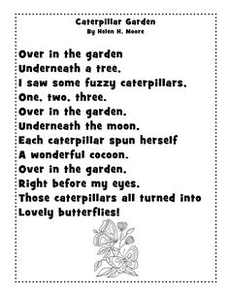
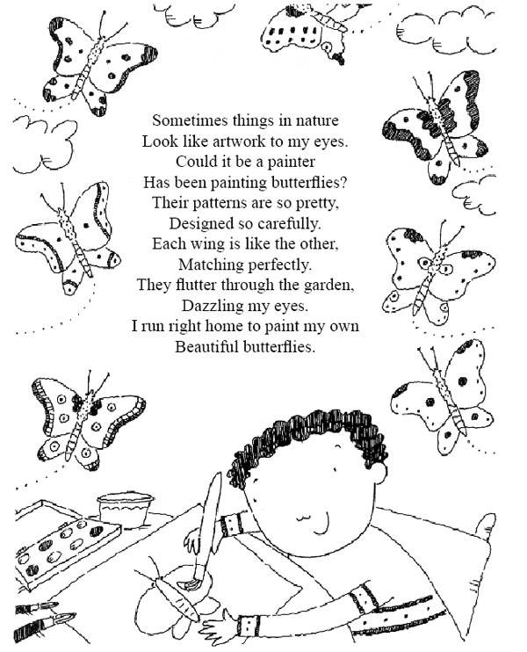
Suggested Book Bank
These books would be useful to enhance our learning this week. Look for them being read on *Youtube or visit libraries.wales/my-digital library for an e copy of the title (link on Twitter).
Story Books (Fiction)
*The Hungry Caterpillar by Eric Carle
*The Butterfly by Anna Milborne and Cathy Shimmen
*The Crunching Munching Caterpillar by Sheridan Cain
*The very impatient caterpillar by Ross Burach
Information Books
Caterpillar butterfly by Vivian French
Caterpillar to butterfly by QED
*The life of a butterfly by Robin Bernard

I’ve put a star* by all the stories I’ve found on Youtube!

Lego challenge
Can you build a butterfly using Lego?
Win list
Both wings need to use the same number of bricks
Both wings need the same colour bricks
Both wings need to look exactly the same.
Ict -
Use JIT5 program on android / tablets/pc to design a butterfly garden using the ‘Paint’ option. Remember to explore different colours and vary the size of your tools. How delicate can you make your designs/ how many different colours can you use? Challenge – Can you use ‘animate’ in JIT5 to make your butterfly move?
Scratch Jr is also an app, we’ve introduced in class. This would allow your child to select a butterfly avatar and create simple code to make it move, I wonder if you child could remember how to use it? The children picked this up surprisingly quickly in class, there are several Youtube videos for parents on how to use this program if you are unsure how to use this program and you want to help your child develop their coding skills at home . https://www.bbc.co.uk/bitesize/articles/zmp98xs, watch this clip and try some coding activities.

Knowledge and Understanding of the World –
Watch https://www.bbc.co.uk/teach/class-clips-video/how-caterpillars-change-into-butterflies-no-narration/zn4rkmn and answer the questions that accompany the clip.
Complete the activity describing the lifecycle of the butterfly below using the words – First, Next, Then and Finally as sentence starters .
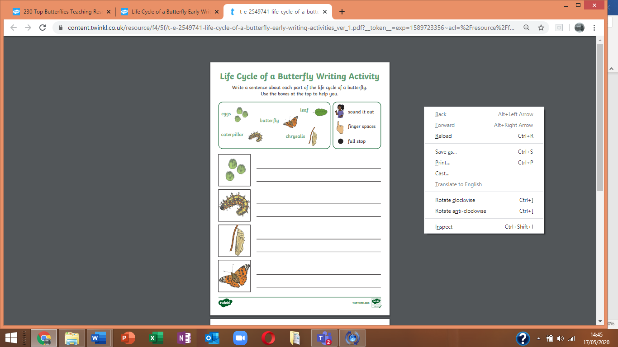

Try making butterflies from leaves, petals and stones – I found some lovely natural art left on my local walk for all walkers to enjoy – perhaps you too could make and leave your art work on your daily exercise route! #naturalartwork
Creative
This week I’d like you to look at colour mixing with your child, mixing primary colours (red, yellow , blue) to make secondary colour (green, orange , purple) . In class we would use food colouring, paint, playdough and fondant icing to help teach this. There are so many ideas on Pinterest and Google to help teach this, be creative and explore, share your ideas via Twitter. By the end of the week, hopefully your child will have developed an understanding and knowledge base that
Yellow and red make orange, blue and yellow make green, red and blue make purple – happy mixing.
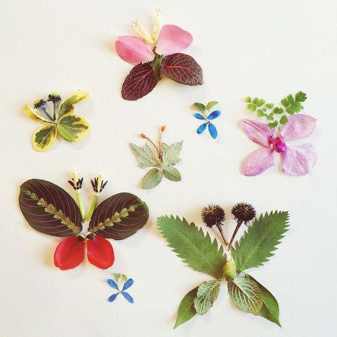

Welsh Welsh word for Butterfly is Pili Pala, caterpillar is SianiBlewog or lindysyn
Q – Beth wyt ti’ n gwisgo ? – What are you wearing?

A- Dwi’n gwisgo ………, ………….., ac …………..
Extend by adding a colour e.g crys t glas , (blue t-shirt) challenge – How many items can you list?
Learn- welsh.net have some games and activities that can be used to remind us of some of the clothes we’ve learnt. Or you could use the word mat below.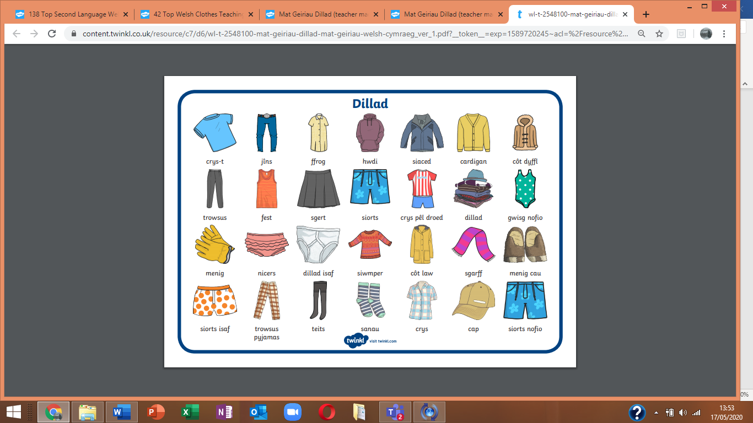

Language (I’ll try to keep these activities similar from week to week
1. Can you copy one of this week’s poems neatly into your book? Think about letter formations, spaces, capital letters, full stops, letters sitting on the line (tails swinging under). Remember to read back your work. (Note to parents – pupils can copy the poem or as a challenge you can read it and they can write it or the ultimate challenge, can they write it from memory?) don’t forget to read back through your work.
2 . Learn to read high frequency words ( in reading file) – How many can they read in a minute? Choose 5 words to learn how to spell. How could you use these words in a sentence? Think back to all the words you ve learnt to spell previously as part of your high frequency challenge. How many can you remember how to spell correctly?
3. Our sound of the week is the digraph ‘er’. How many words can you think of / find / read / spell with this trigraph in it?
Remember
You can use the online games on
Phonicsbloom.com
Letters and sounds .com
Phonicsplay
To reinforce your sound recognition. They are all free at present.
Work on phase 3 / 4 .
Which games are your favourites? Let us know so we can play them in class too when you all return.** See new game link below for‘Small townSsuperheroes’language ganes
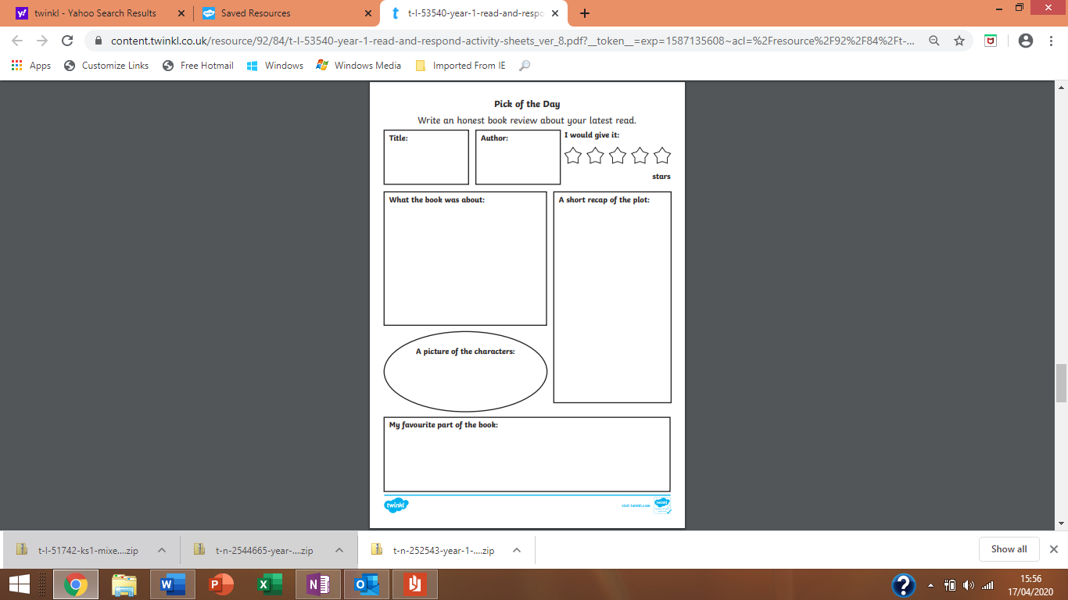
Book review- This week I’d like you all to review your favourite bedtime/daytime story once again. You can create your own Book review form or use the above format. Remember to encourage pupils to ask and respond to Who? What? Why? When? and Where? questions about the book that they are reading / sharing with an adult to develop a greater understanding, this will also help with comprehension tasks that will follow later in the term.

Create a factfile about butterflies. A fact file requires information. You can follow the format below, create your own style or how about simply folding an A4 sheet of paper in half and creating your own information book?
I’d like you to include –
A drawing - you could label this to extend your learning.
A title – the name in English and Welsh
Some interesting information about your focus of study-
Such as - How does it move? What does it look like? Where does it live? It’s life cycle. It’s colour. What’s the most interesting fact you learnt?

Language skills
Develop your language skills playing with Small Town Superheroes (link below) . The games with Annie (sound it out + spelling tricky words,) Ursula ( reading and understanding + signs, headings and captions ), Sally+Percy (simple sounds), Ernie (sentences + punctuation ) are particulary good and relate to out practise in class.
https://www.bbc.co.uk/games/embed/small-town-superheroes?exitGameUrl=http%3A%2F%2Fbbc.co.uk%2Fbitesize%2Farticles%2Fzncgvk7
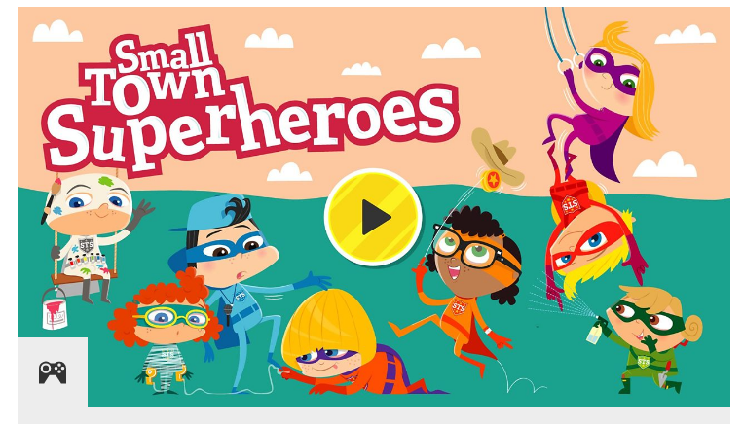
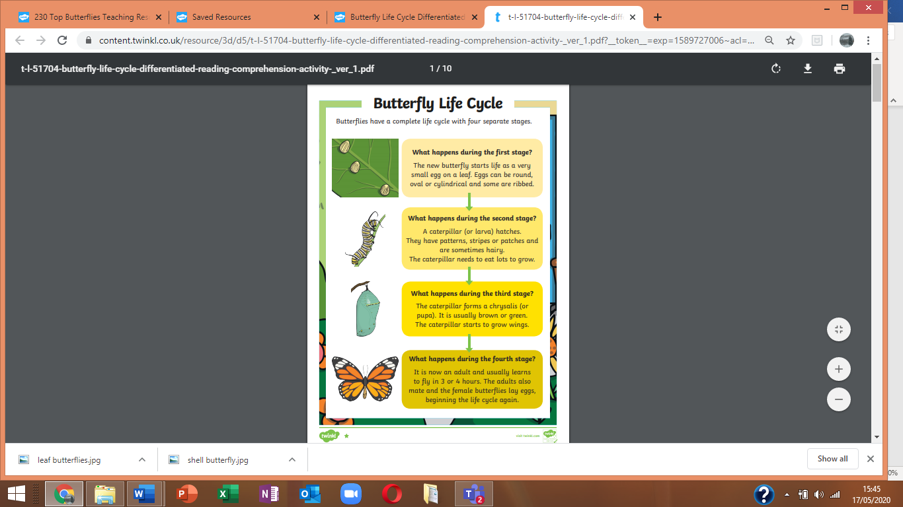

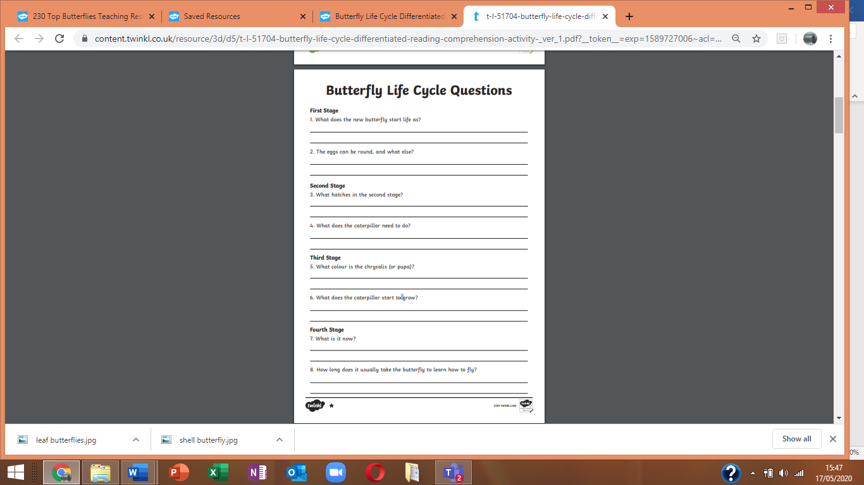
Maths
Keep revising prepositions – on top of, in front , behind, under, over, above, inside ,below, through ,to the side of , in between you could extend this by revising the concepts of left and right too.
Encourage free, natural use of language. Continue to develop understanding through practical tasks. Perhaps you could use describe the route you took on your daily exercise, or the position of toys when playing or tableware whilst sitting at the table or even where food is on their plate – learning is everywhere!

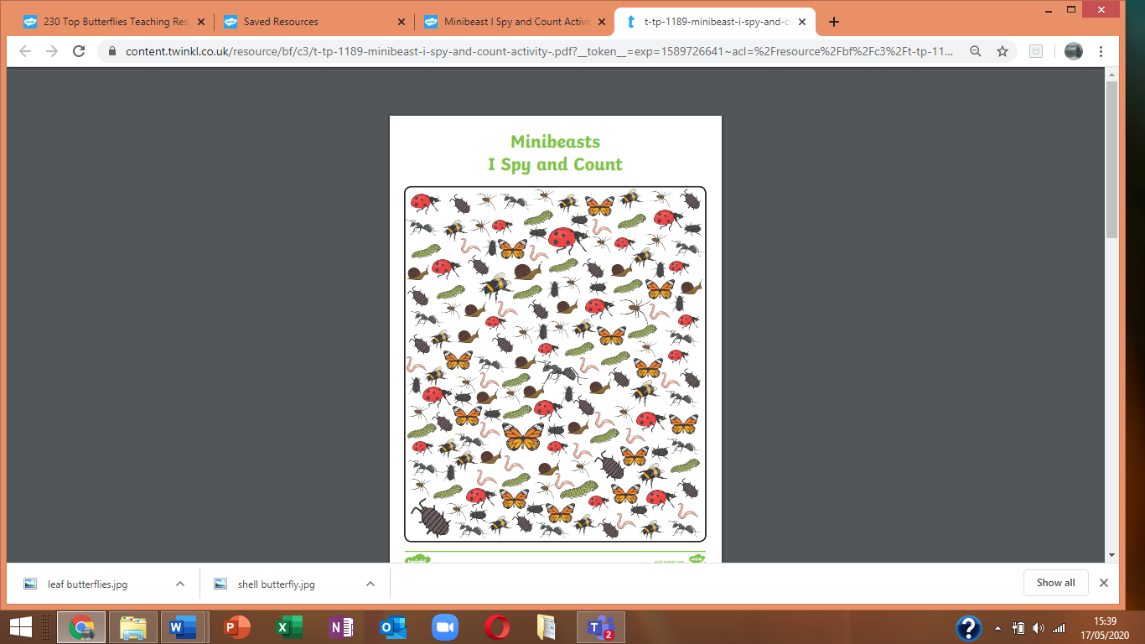
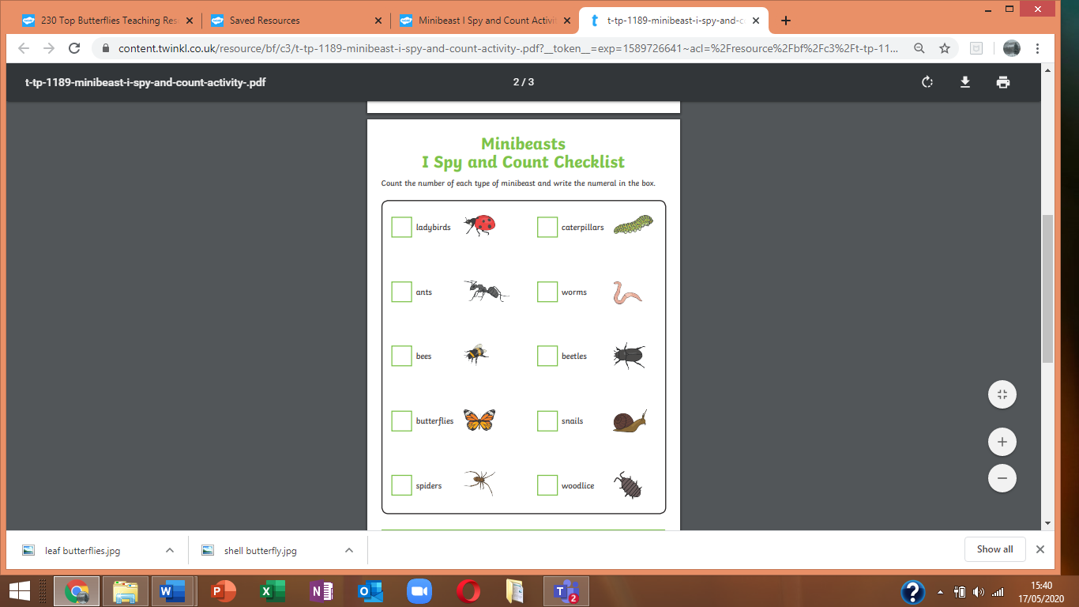
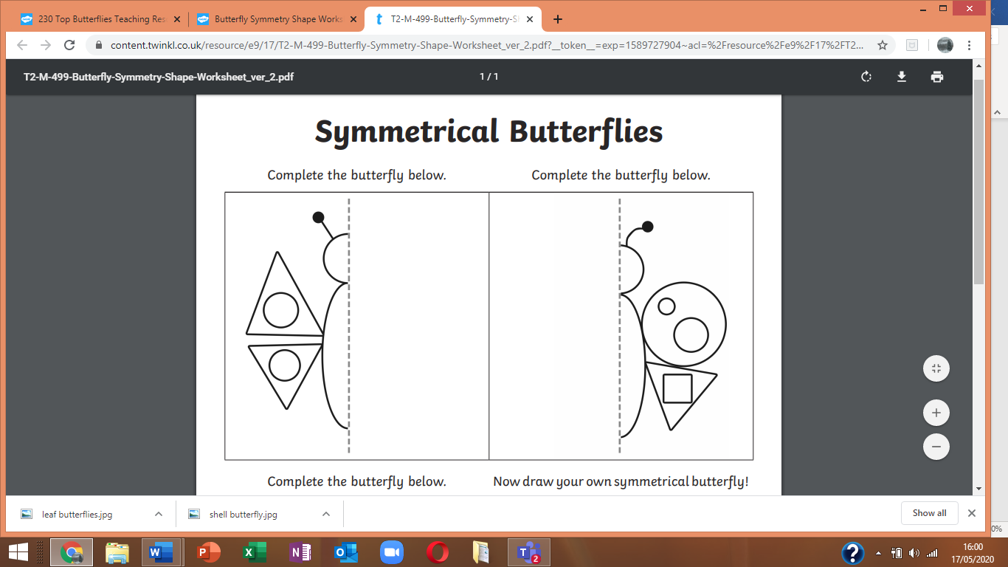

In class we have explored symmetry using mirrors and shapes in class, It is quite tricky. The above activity is simply an illustration of the type of activity we would do at this point using shapes and ask your child to complete it. As a challenge I would set simple symmetrical drawings such as the ones above for children to complete with the aid of a mirror.
Practice- Story of 7
There are 8 different ways of making the number 7 adding 2 numbers (within 10)
0+7 =7 7-7=0
1+ 6=7 7-6=1
2+5=7 7-5=2
3+4=7 7-4=3
4+3=7 7-3=4
5+2=7 7-2=5
6+1=7 7-1= 6
7+0=7 7-0=7
Can you remember the story of number6, 5, 4, 3,2,and 1? Using the same pattern as above.
We sometimes use practical apparatus to help us visualize our learning.
Challenge – How many number stories can you write?
Doubles
Double 4 Double 2
Double 5 Double 7
Double 9 double 3
Double 6 Double 8

Double 8
How many
Cylinders pyramids
Cuboids spheres
Cubes
Can you find around your house?



