

School Closure Home Learning Pack
Mrs Jones’ Class, Year 3/4
Hello Y3 and Y4,
How are you all? We hope you are all well and happy.
This week in maths, I would like you to have a look at giving change. This is quite difficult and we did not have time to do this in school. Please have a go and if you want to practise online, here are 2 games you could play
https://www.mathsisfun.com/money/money-master.html
https://www.funbrain.com/games/change-maker
Don’t forget to keep reading, it doesn’t matter what you are reading as long as you keep it up. Remember our class login and password is
mrs jones class 34
Reading2020
Topic work this week focuses on animals and their adaptations. Also there is a link for you to have a bit of musical fun with!
Next week is half term, if you have time it would be really useful if you could have a go at learning the 3x table and 4x table.
Here is a really good website to help you
https://www.timestables.co.uk/
Enjoy!!

Mrs Jones.

W/c 18th May 20
Numeracy
Mild Chilli Challenge
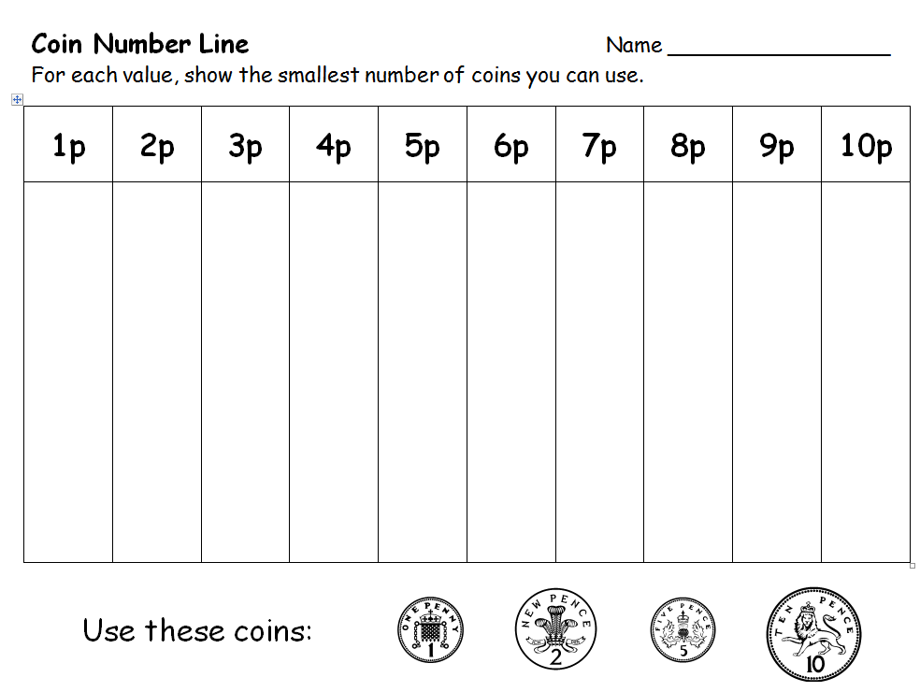
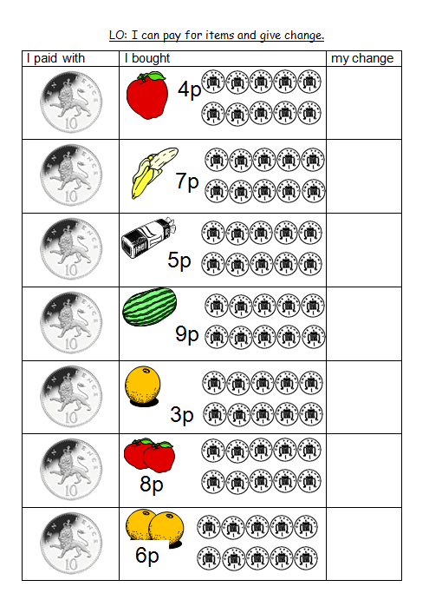
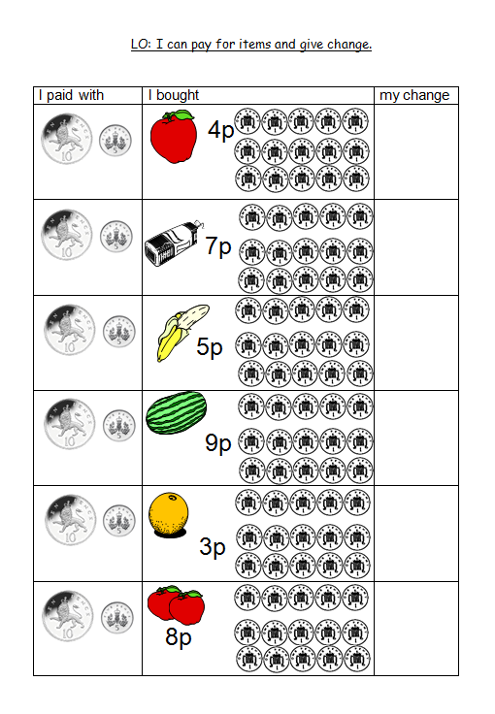
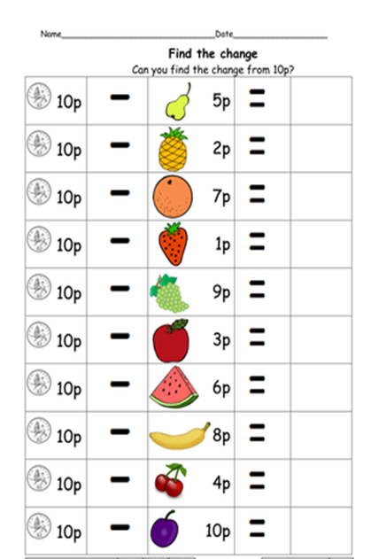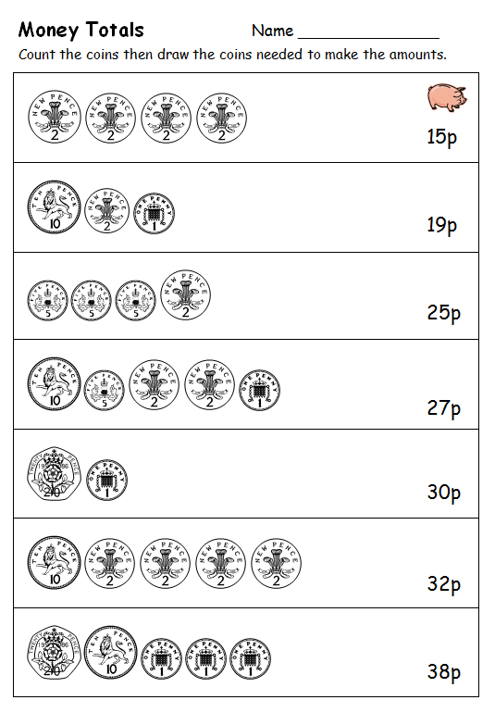
Medium Chilli Challenge

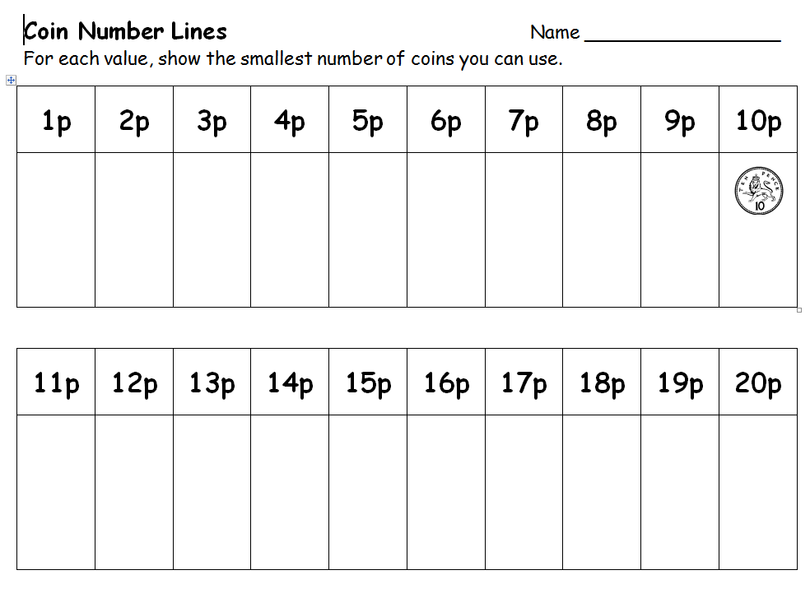
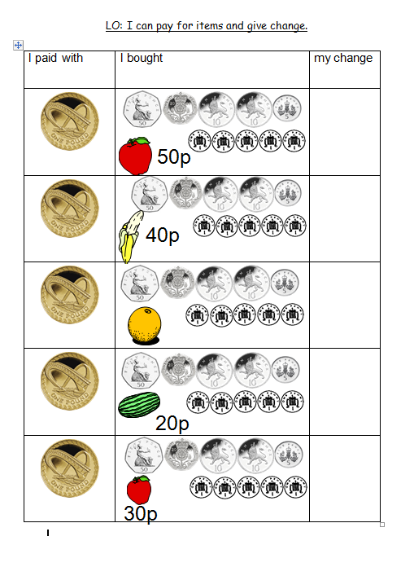

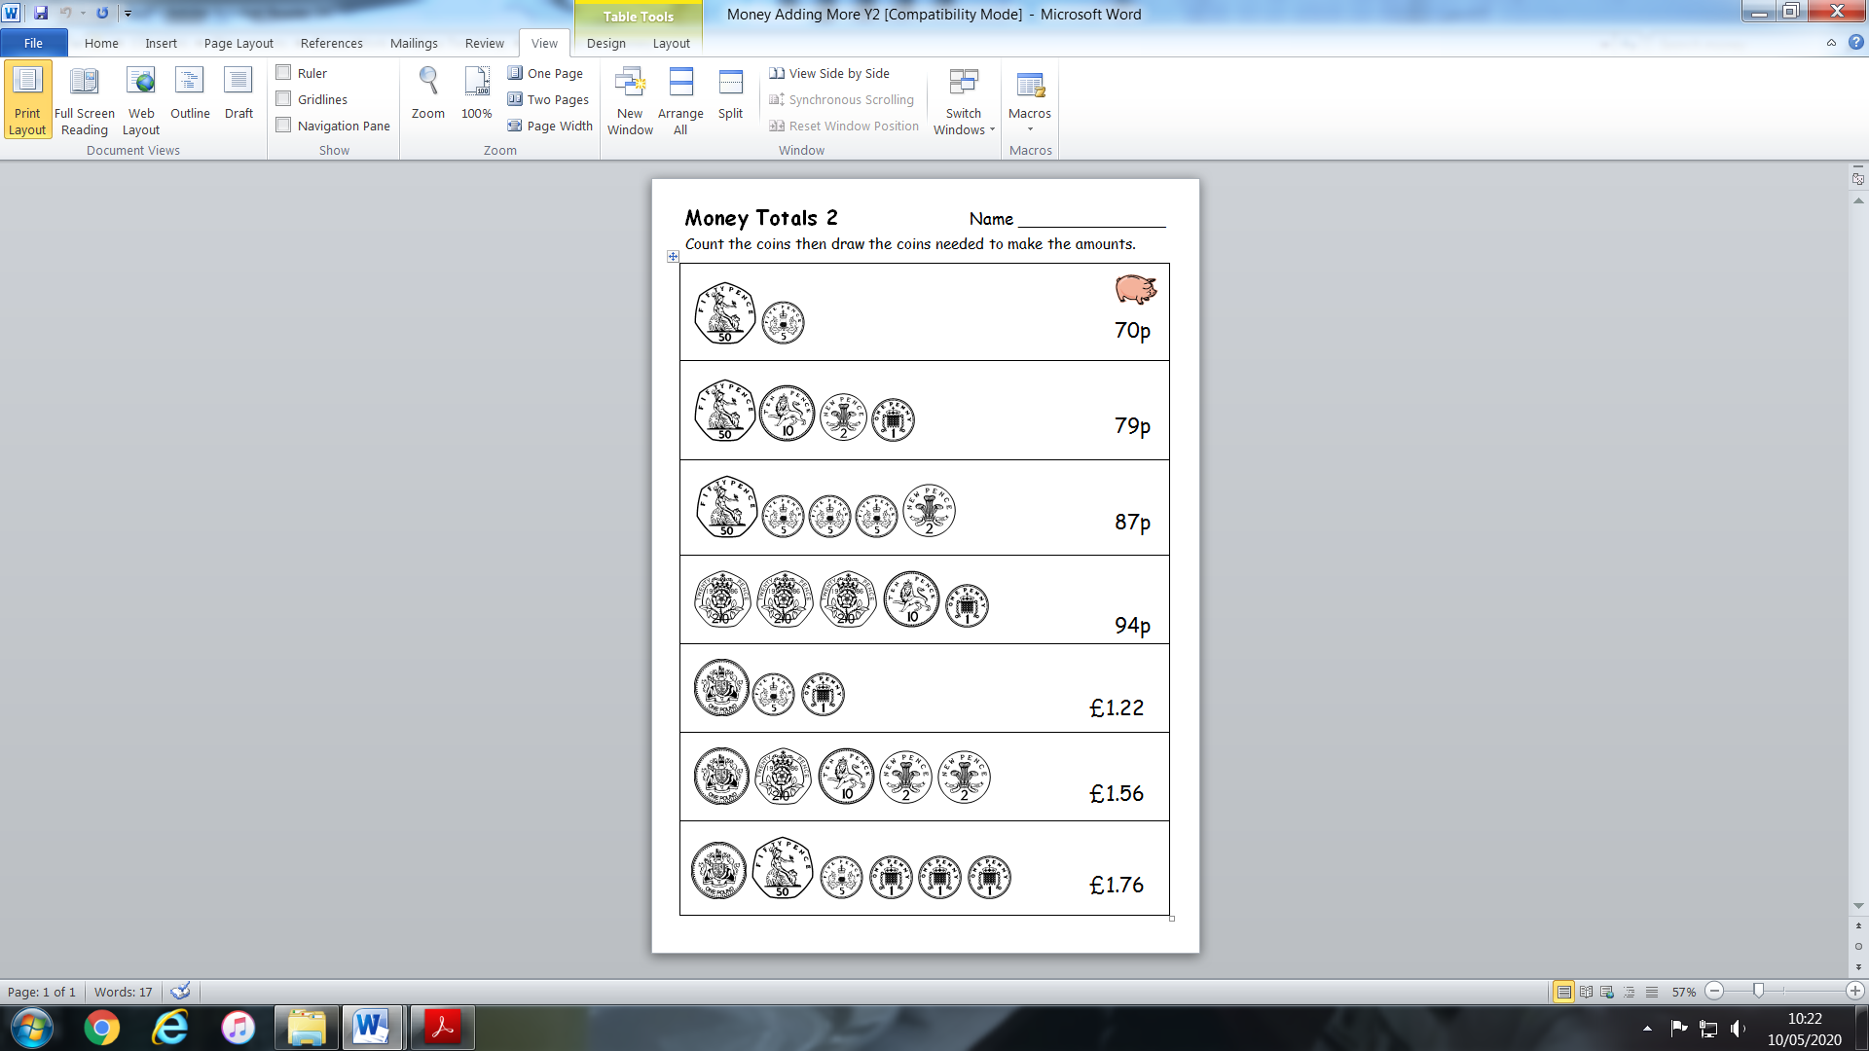
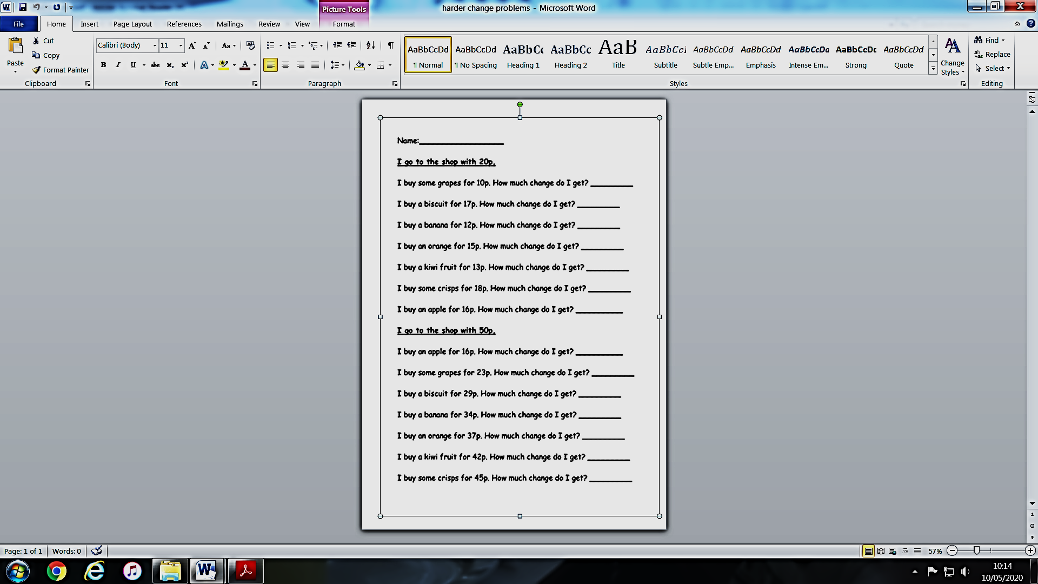
Hot Chilli Challenge

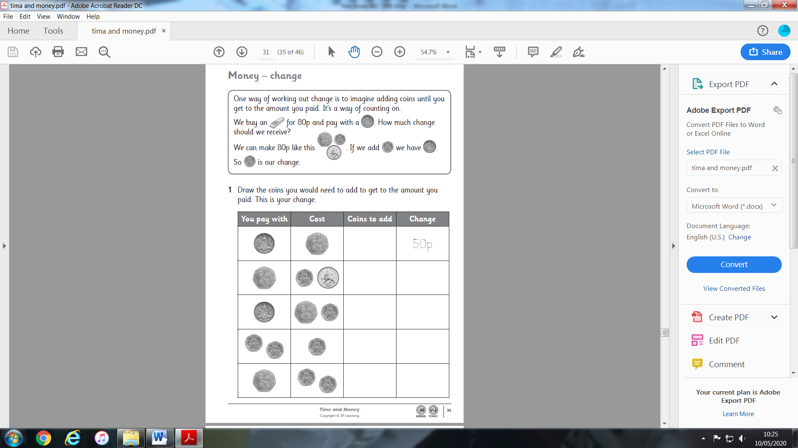
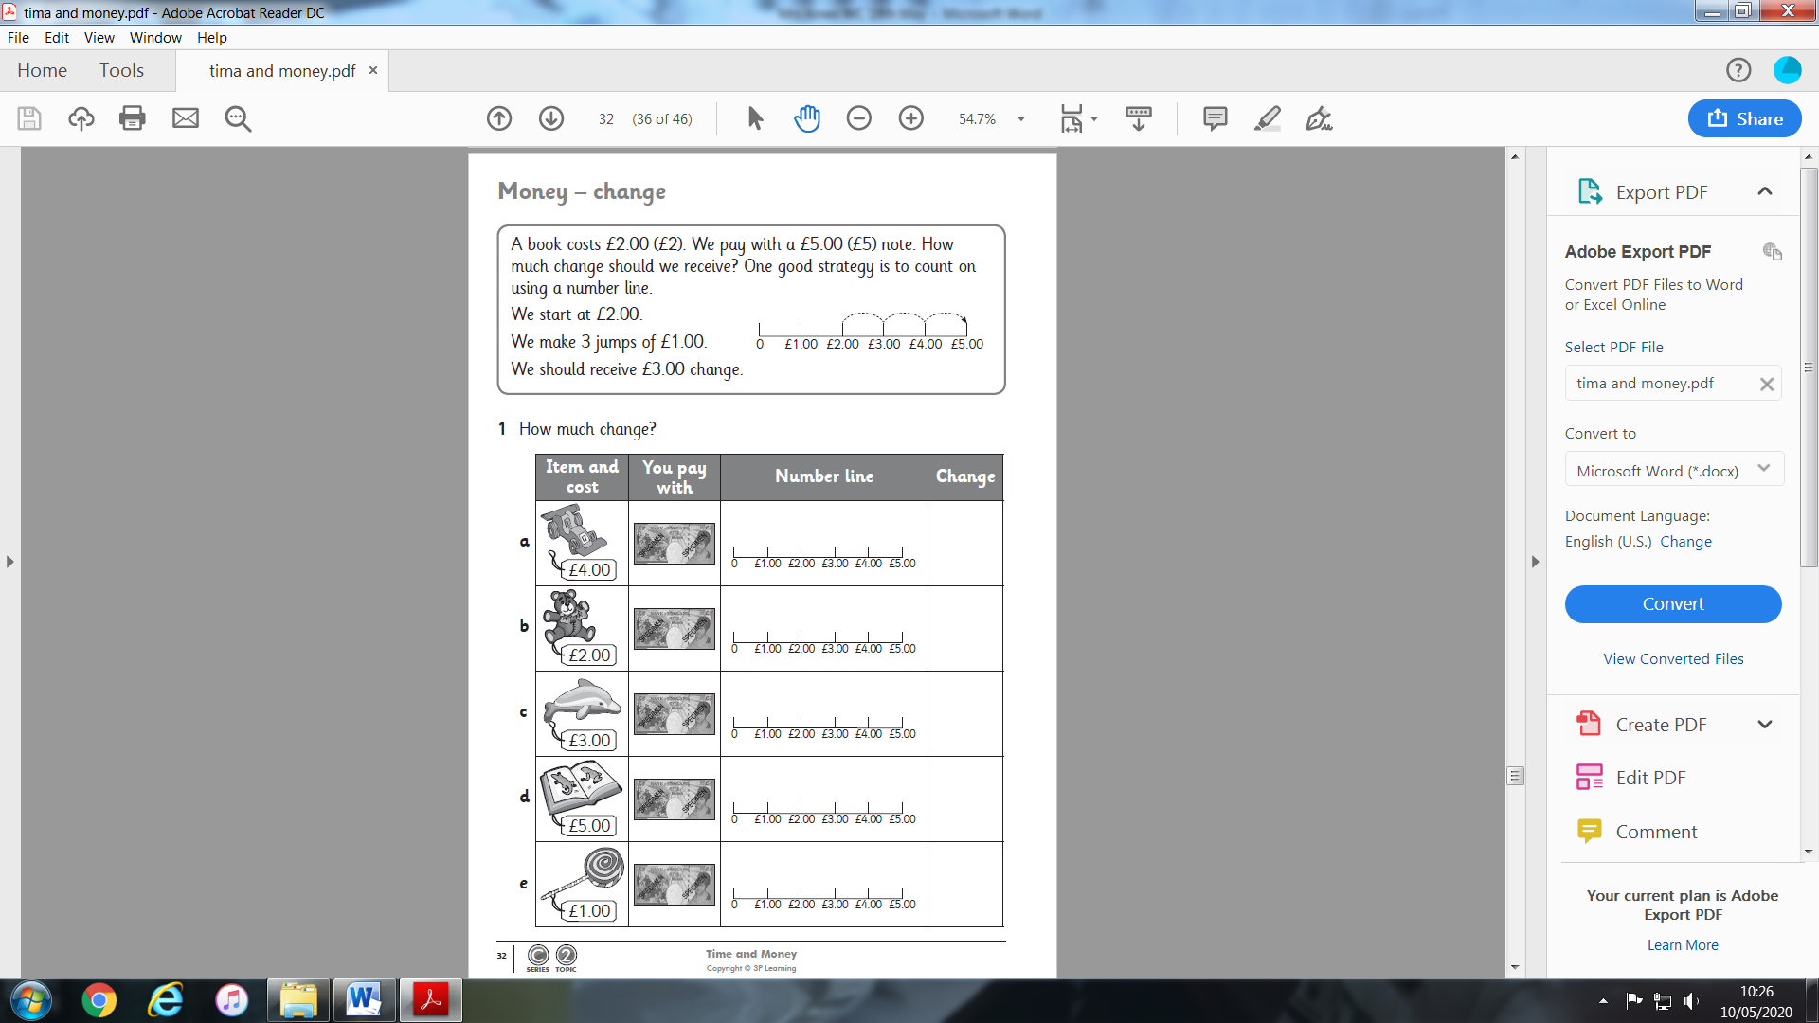
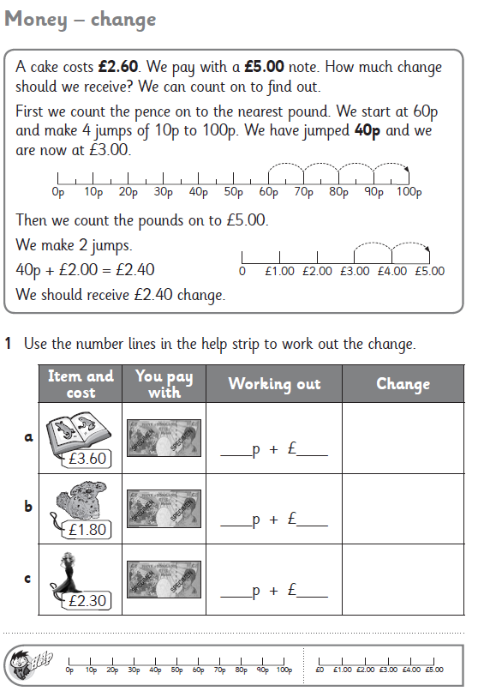
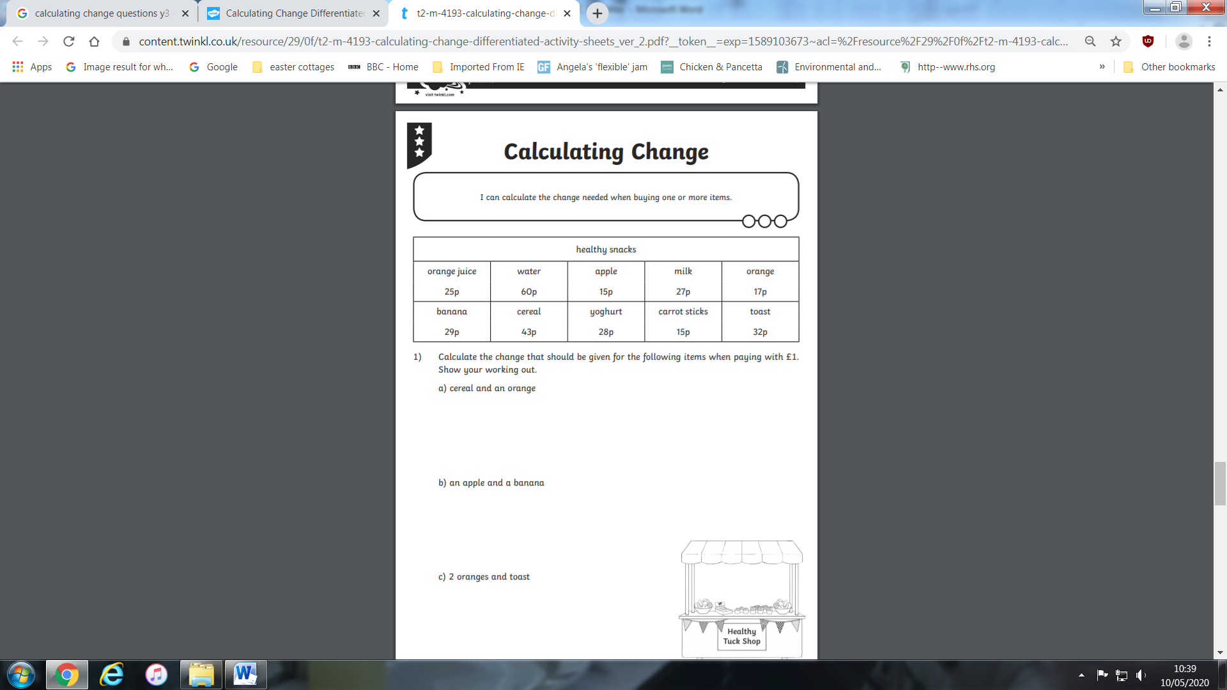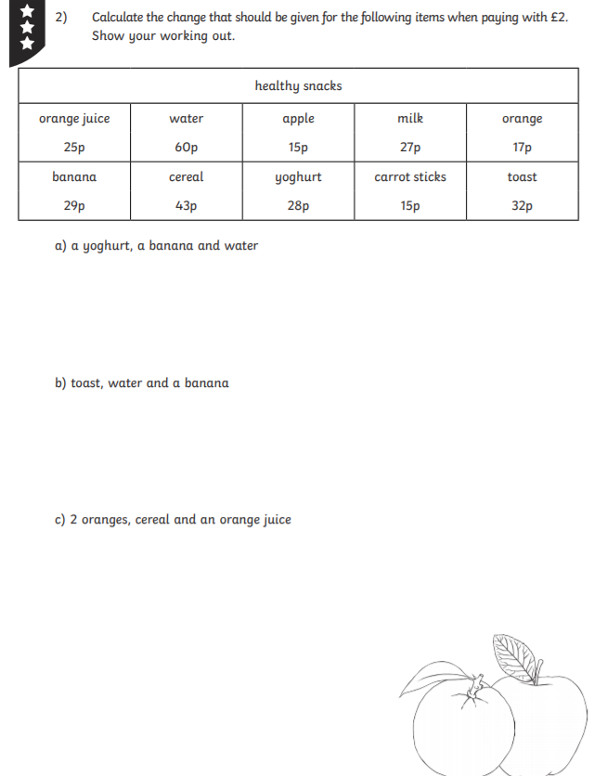

Money Bags Problem from last week.
Answer: You need to have the following amounts – 1p, 2p, 4p and 8p.
1p 2p 3p = 1+2 4p 5p = 4+1 6p= 4+2 7p= 4+2+1
8p 9p= 8+1 10p= 8+2 11p= 8+2+1 12p = 8+4 13p= 8+4+1 14p= 8+4+2
15p = 8+4+2+1

The Money Maze

Problem Solving

Go through the maze, collecting and losing your money as you go. You may not go through any cell more than once, and can only go into a cell through a gap, for example, you may not go from 5 to 6, or from 7 to 3.

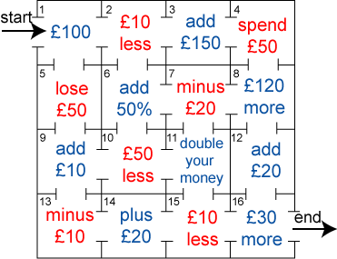
£40

Which route gives you the highest return? How much is it?
Which route gives you the lowest return? How much is it?

Literacy
HFW Spellings
Here is the next set of words to learn. Each child in class is on a different set. Please do not move onto the next set until you have at least 7 correct in the previous set. When your child has learnt the word, ask him/her to write a sentence using that word. The words are getting trickier, please don’t worry.
SET 10
which | One way to remember ‘should, could, would’  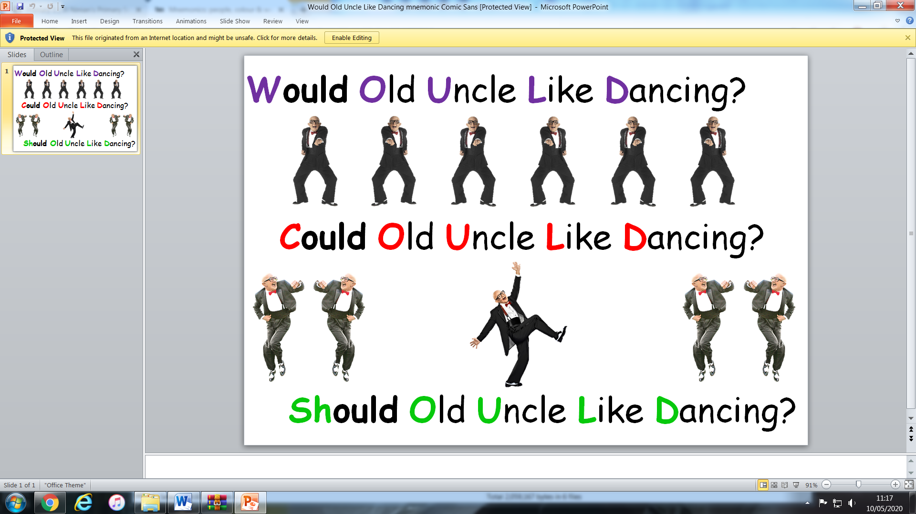
looked
back
Mr
Mrs
about
could
would
should
day

Music
Please have a look at the following link.
https://learningmusic.ableton.com/index.html
It’s brilliant, everyone in my house has had a play on it and it has been lots of fun being the DJ.
I hope you enjoy it.

Reading time
Read the two poems, If You Should Meet a Crocodile and The Vulture
  - What things do the poems have in common?
  - Which do you like the best? Why is that?
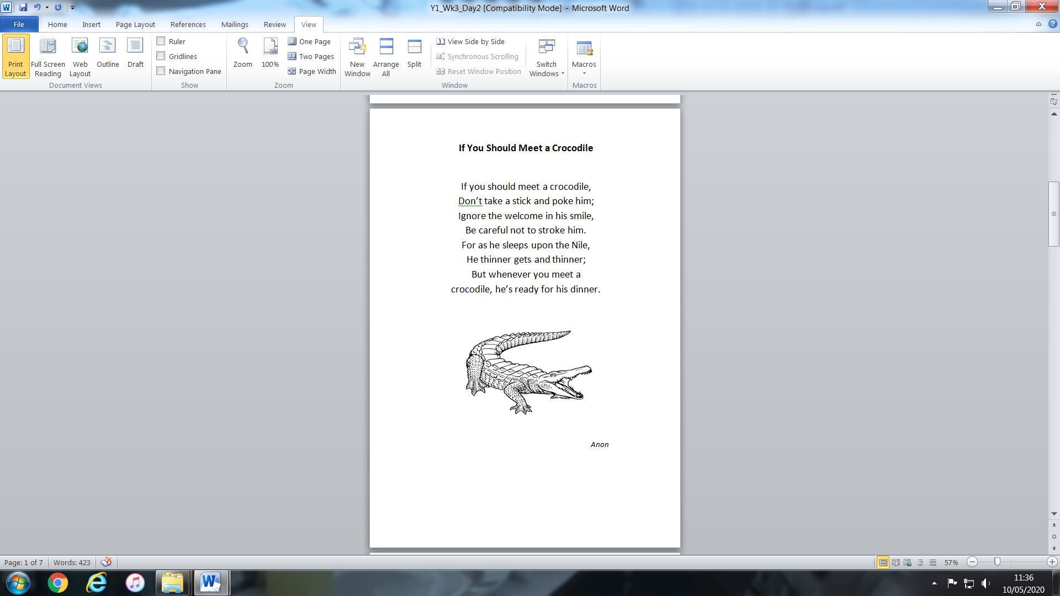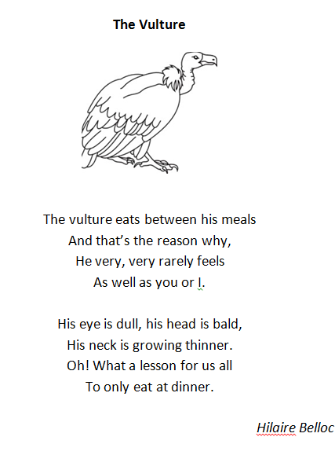

Rhymes in poems
Use a coloured pen to highlight the pairs of rhyming words in The Vulture.
  - Are you sure that you have all pairs listed on Rhymes in The Vulture?
  - Read the other words in the box below the table. Copy each into the correct rhyme section. Think of other rhyming words….

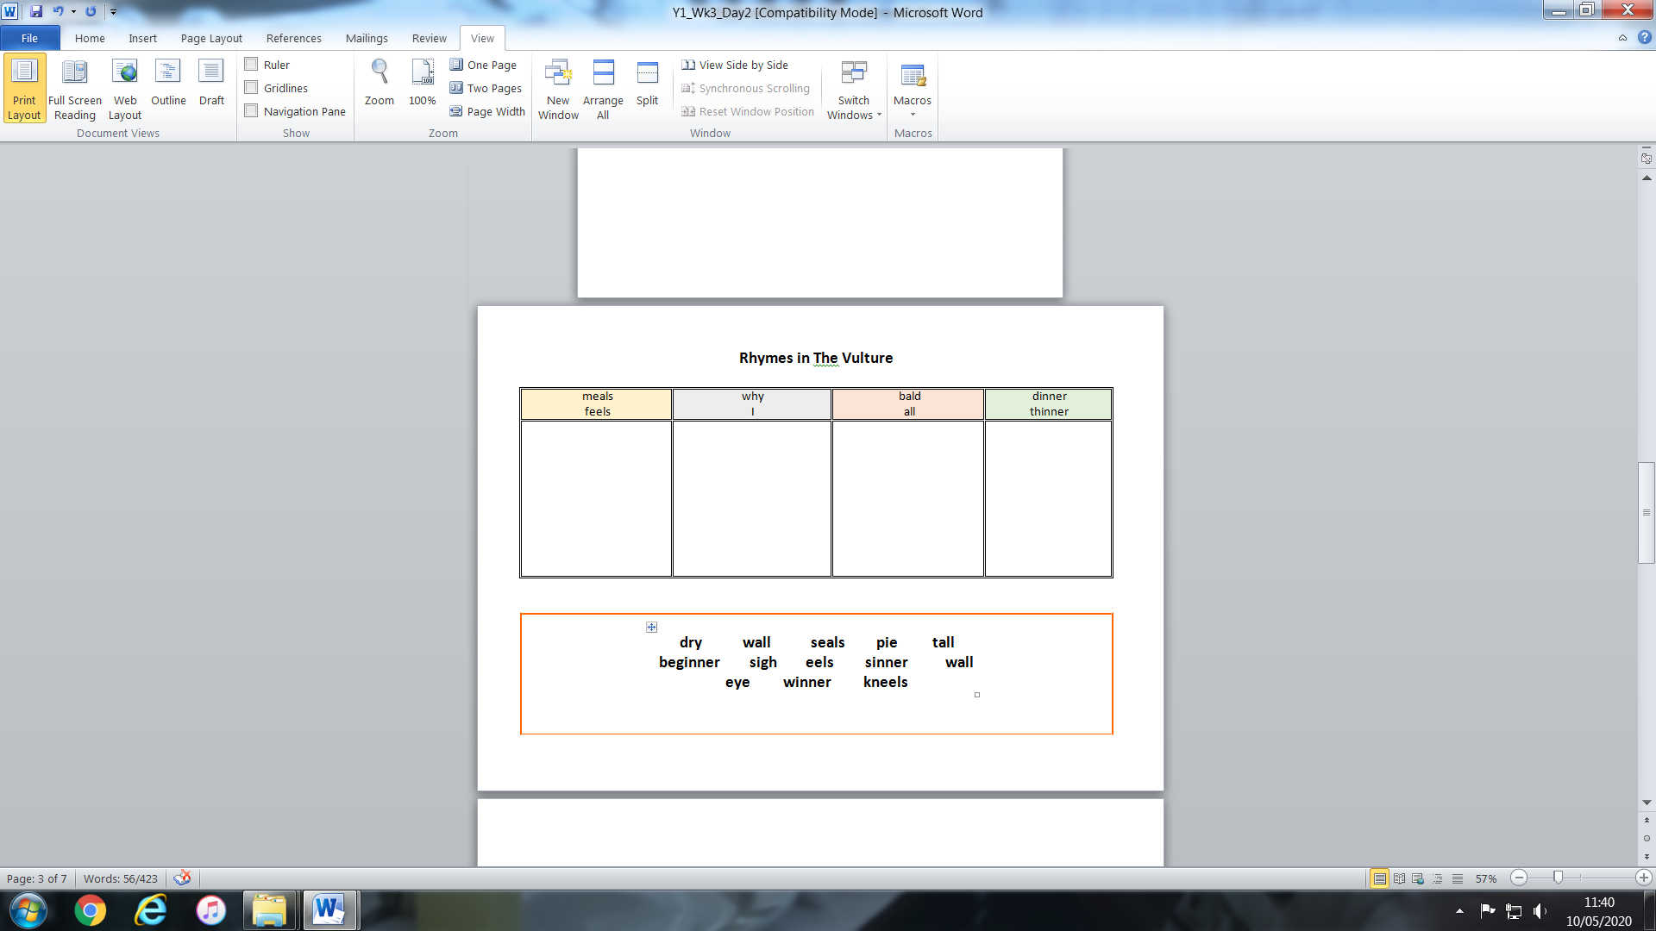

Writing about animals and their food
Use either the Picture of the Vulture or the Picture of the Crocodile.
  - Stick your picture in the middle of a large piece of paper.
  - Name your animal, e.g. A Vulture.
  - Label the different parts of your animal with words and short phrases. Try and use adjectives to describe parts of the animal (e.g. sharp beak, handsome feathers, big bald head, very sharp claws for holding things etc.)

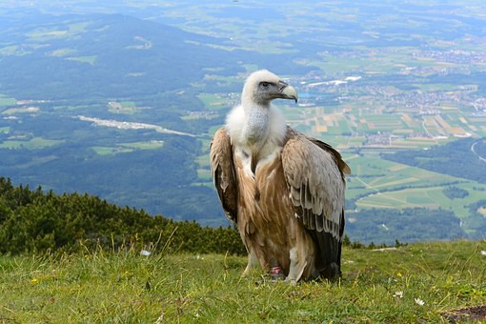

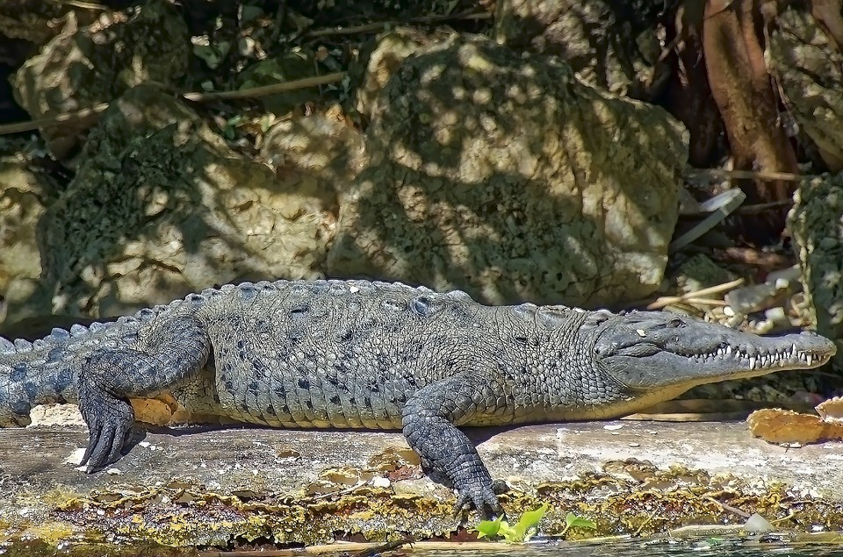

Now try these Fun-Time Extras
- Stick a paper plate onto a large piece of paper or draw round a big plate on a piece of paper so that you have a plate shape.
- On your plate, draw what horrible things you think a crocodile or a vulture’s dinner might contain! Write some sentences next to the plate to explain what gruesome objects they are eating.
- On My Favourite Three Animals draw pictures of these creatures and write a sentence for each one saying what they like to eat.

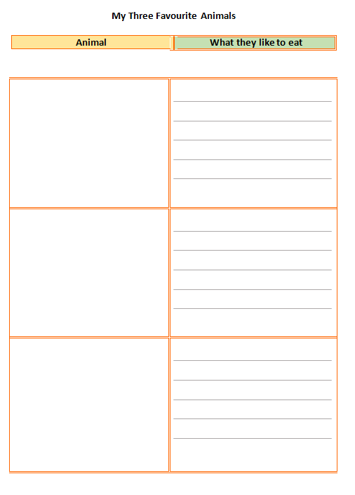

Topic

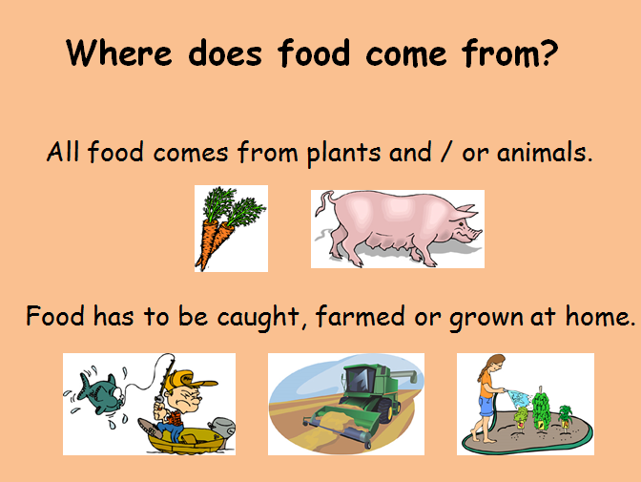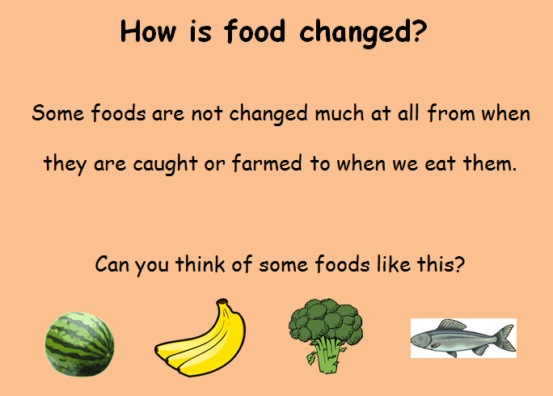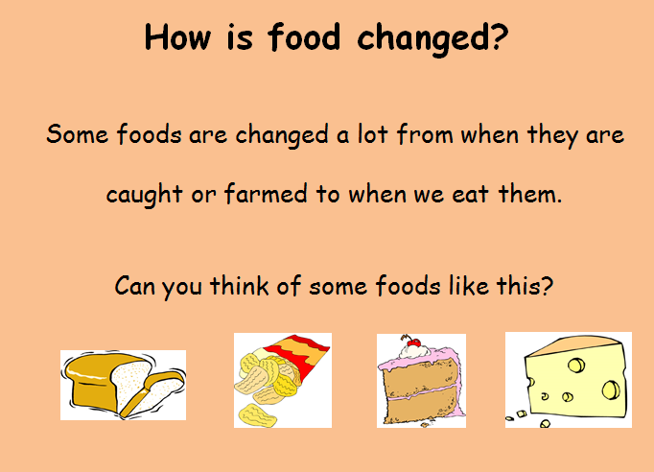
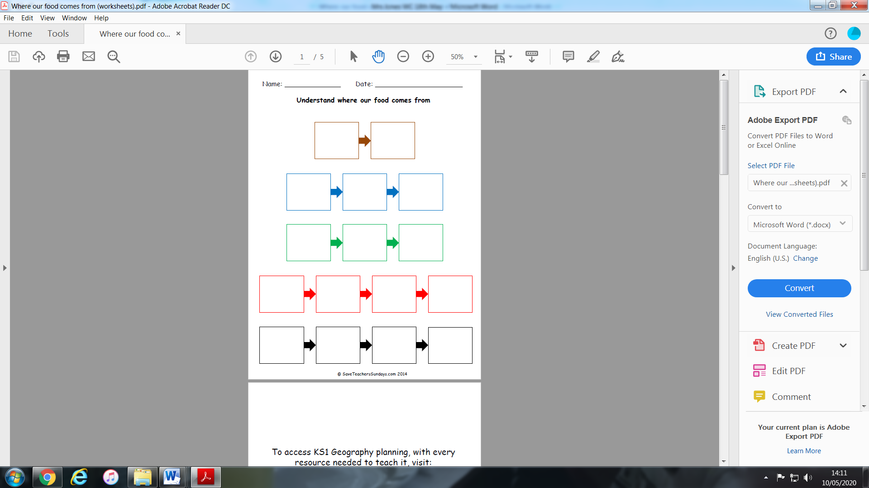

Cut out the pictures and put them in the correct boxes above. Each box is a different colour to help you. If you do not have a printer, draw a flow diagram.
Apples are picked
Apples are grown in orchards

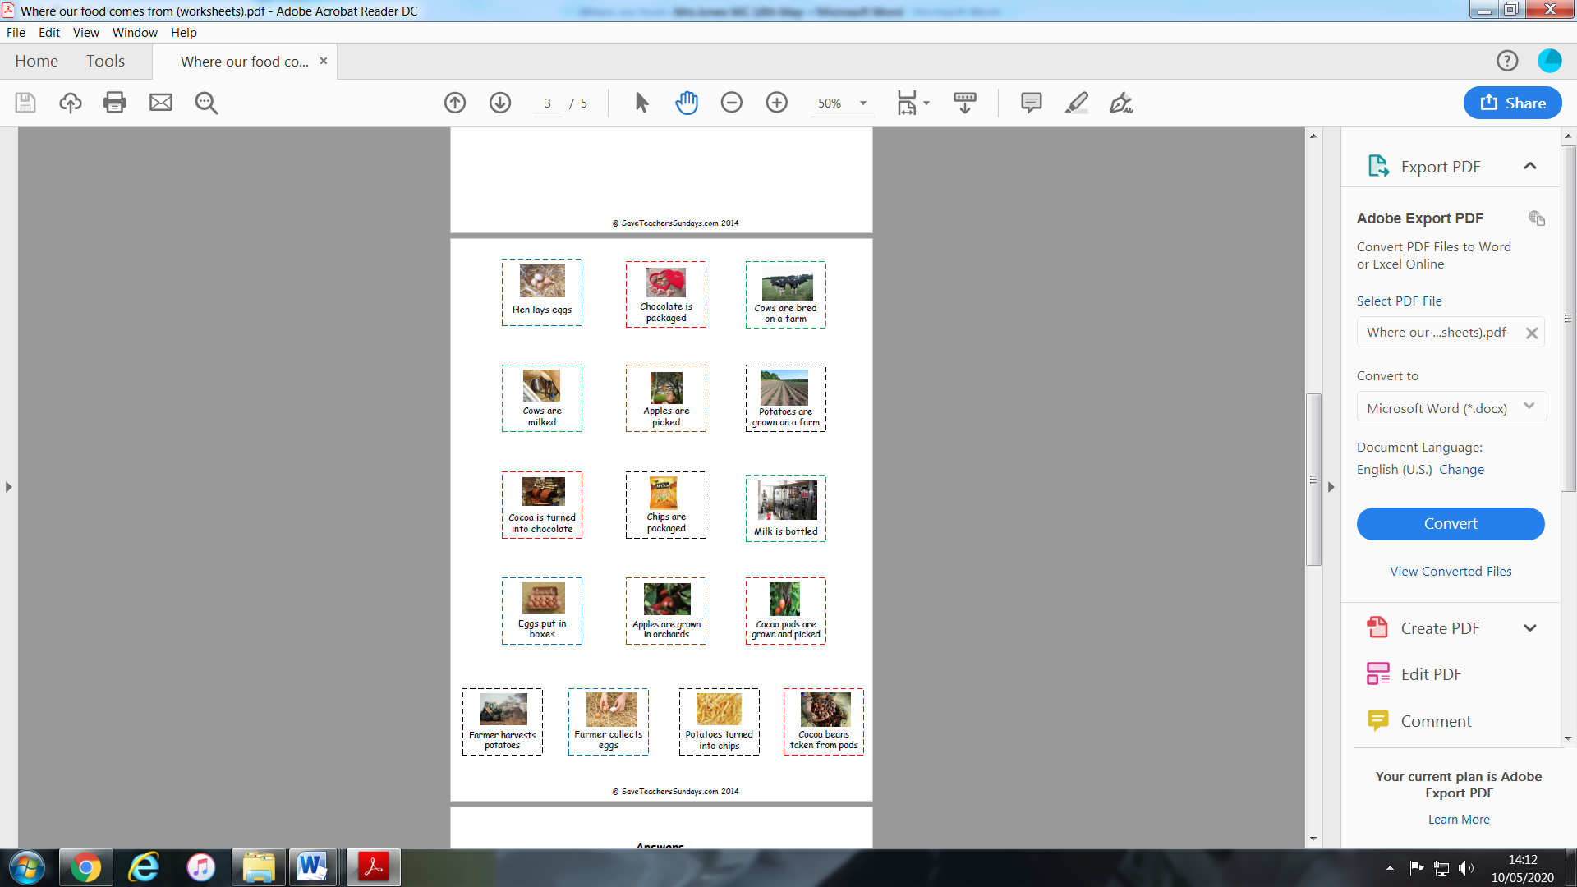
Watch one of the following videos and draw your own flow diagram to show how it is made.
Orange Juice – https://www.youtube.com/watch?v=kvWrLXwJzck
Cornflakes - https://www.bbc.co.uk/bitesize/clips/zctkjxs
Ice-Cream - https://www.youtube.com/watch?v=8WEMZ86Eho8

Thinking Skills
Answer from last week!
Carmen – Cookie, Michael – Apple, Lisa- Sandwiches, Thomas - Watermelon

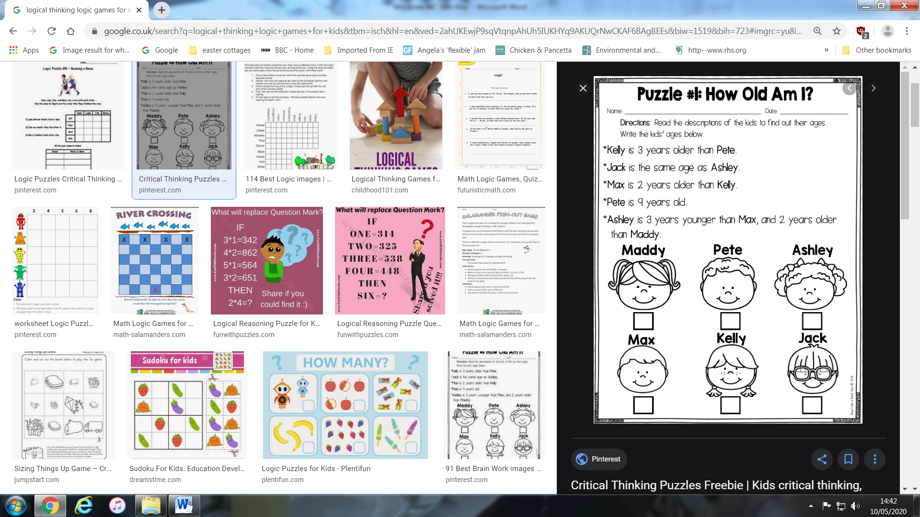
Animal Adaptations.
Last week, I hope you managed to find some animals that live in the different habitats. Animals all have special features to allow them to live in their habitat.
Have a look at the following video https://www.youtube.com/watch?v=anRp7FQ9CKY
Use the one of the animals you researched last week to fill in the table below. I have given you an example for a garden.
Habitat | Animal | Adaptation
Garden  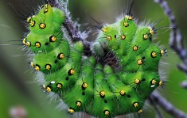 | Emperor Moth Caterpillar | Green colour for camouflage.  Long spiky hairs to scare predators. These can be very itchy and release poisons if broken. Yellow spots to scare predators by looking like lots of eyes.
Rainforest
Desert
Mountains
Artic
Coral Reef
Woodland

Science Experiment.
As we have been looking at healthy eating and teeth, I thought it would be interesting to see how acids which are found in fizzy drinks and orange juice can wear away the enamel on your teeth. Did you know that egg shells are made of Calcium Carbonate – a hard mineral that is similar to Calcium Phosphate, the substance our teeth are made of?

Bouncing Eggs!
Aim - Make an uncooked egg bounce.
Experiment with different liquids to see what effect they have on eggs.
Learn how the acid in household liquids dissolves eggshells leaving the inside if the egg intact.

Watch the following video and then have a go!

https://www.rigb.org/families/experimental/series-2/eggsperiments


