School Closure Home School Pack
Miss Densley’s Class
Week beginning 18.5.20
I’ve added some more ideas for another week of home learning. I’ve left the ongoing spelling/reading/times tables on there.
Literacy
- Practice the reading/spelling of high frequency words – you can do this in creative ways using different materials (e.g. paint, magnetic letters) and try timing yourself
- Carry on with your reading books – make sure someone asks you lots of questions about them and if you are reading Dockside practice those cover words
- I have included a sheet of general literacy activities and some paper to complete them on
- Here is a link for Oxford Owl’s free ebook library (you will have to create a login but it should all be free): https://www.oxfordowl.co.uk/for-home/find-a-book/library-page/?view=image&query=&type=book&age_group=Age+9-11&level=&level_select=&book_type=&series=#
- I’ve found a lovely free book to download about coming to terms with school shutdown: https://parsleymimblewood.wordpress.com/

- Please see below for the final activities from the ‘King of the Fishes’ workbook. You can find the story in week 4’s work pack. There is a lot to work through and if you find this daunting why not just write one section of the story. You will also have half term to continue with this. At the end of the workbook is an opportunity to create a book – this is optional. Also, you could always type your story if you prefer using one of the word processing programmes on Hwb.

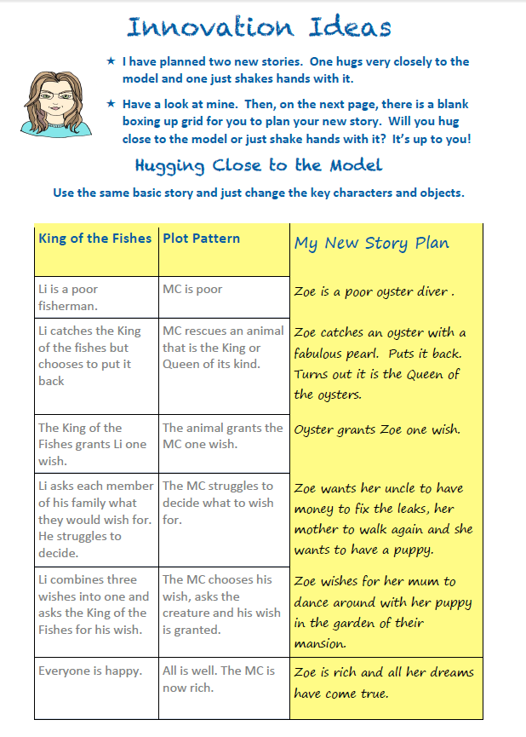
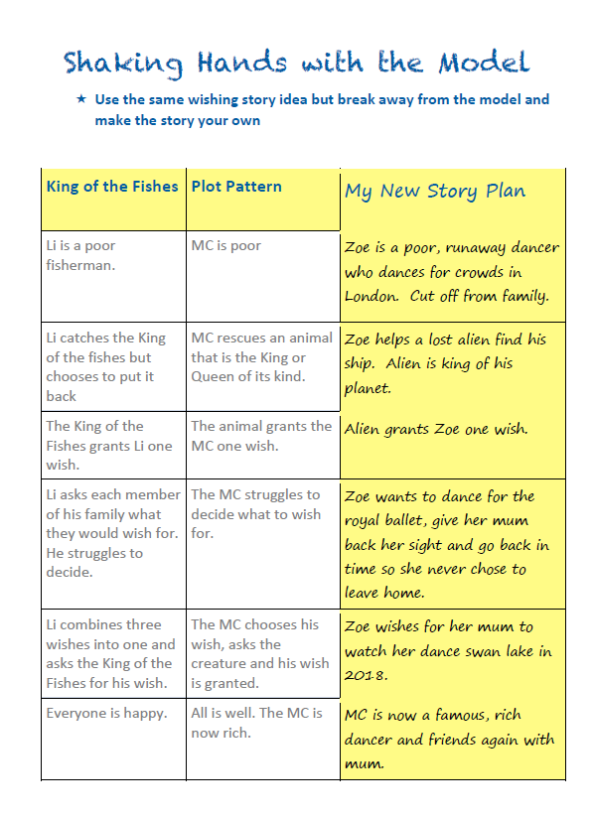
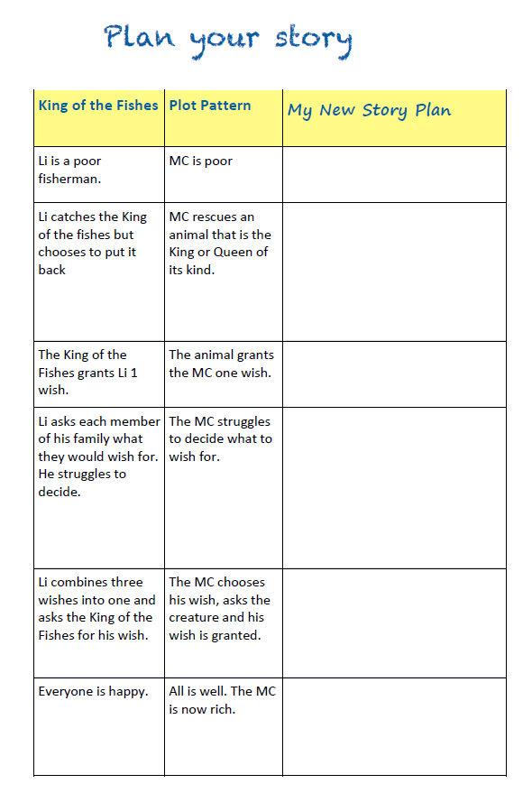
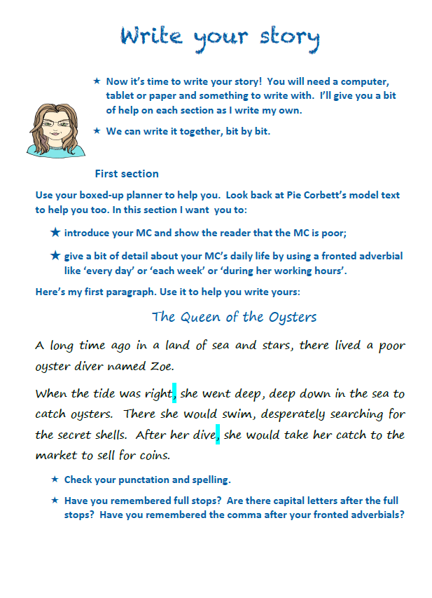
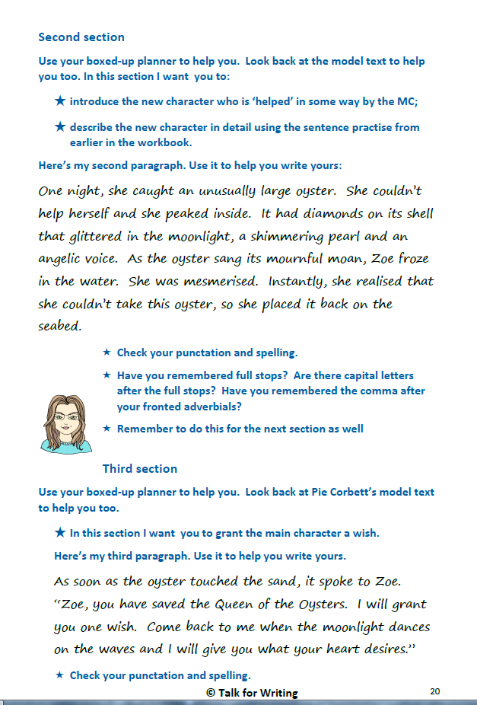
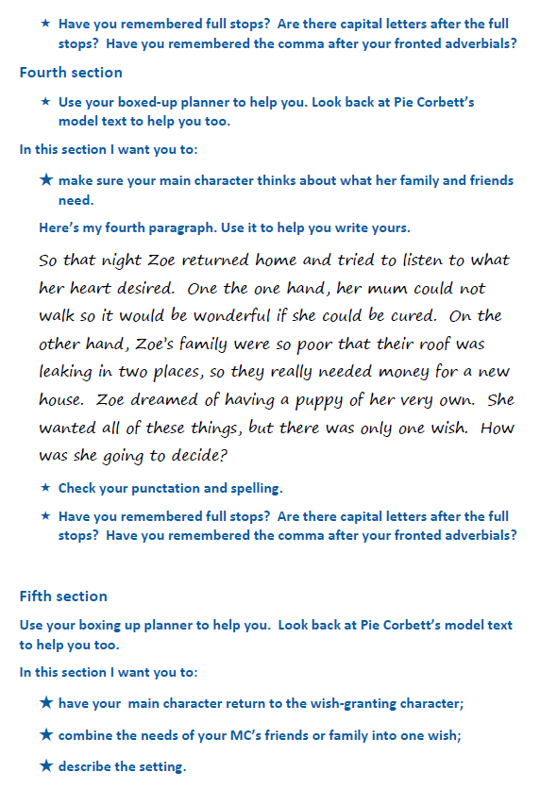
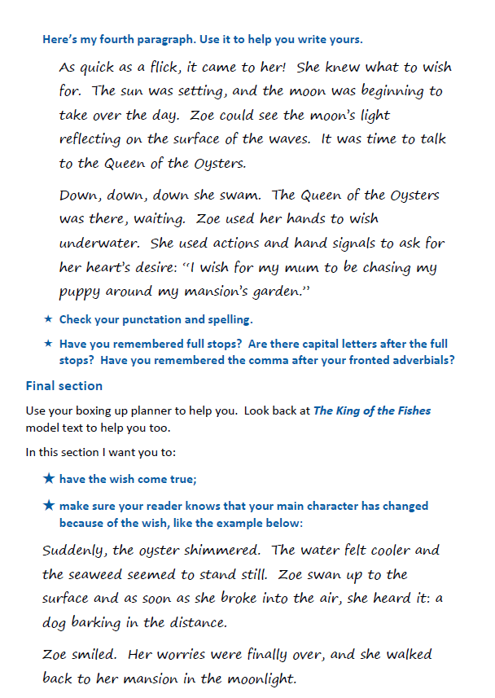
fifth
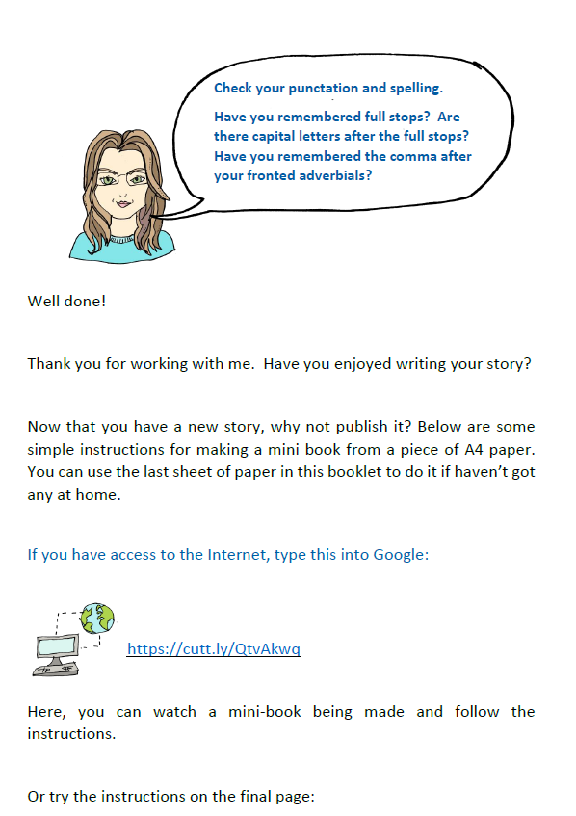
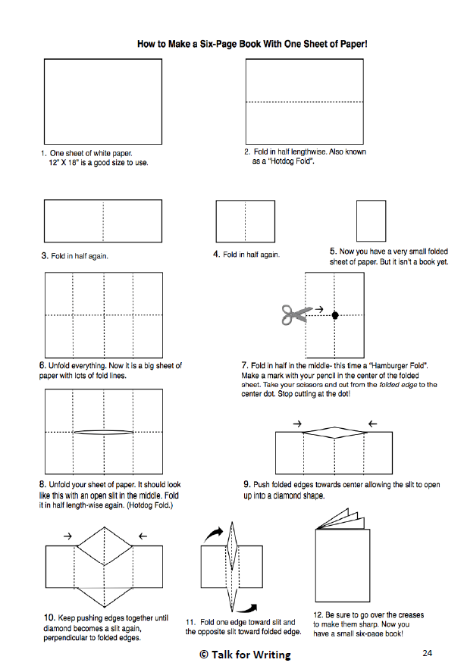
Maths
- Practice your times tables (in class we have practised the 2, 5, 10, 3, 4, 6, 8 and 9). A great tool for this is J2Blast on Hwb (I can see some of you have already had a go at this!)
- Practice telling the time on analogue (clock faces) and digital clocks
- Topmarks is a fantastic website to help with both of these

- This week’s topic is using coordinates to specify location. It might be worth recapping the compass points with this activity: http://resources.hwb.wales.gov.uk/VTC/compass_bearings/eng/Onlineactivity/default.htm (needs Flash so may need to use Internet Explorer)

I have included 3 levels of an activity below – you can choose which one you want to have a go at (the first is the easiest, the last the hardest).

Here is a useful link to explain how to complete the sheets: https://www.youtube.com/watch?v=6eX4PZJjofI
The first half of the video is the relevant part but you are welcome to continue your learning about the four quadrants if you like.

Good websites to help with any of the above include Letters and Sounds for phonic practice, Topmarks, Crickweb for problem solving practice, Twinkl, Espresso, Hwb, BBC Bitesize and Primary Resources.

Here is another great link I’ve found for home learning: https://www.tes.com/teaching-resources/teacher-essentials/home-learning

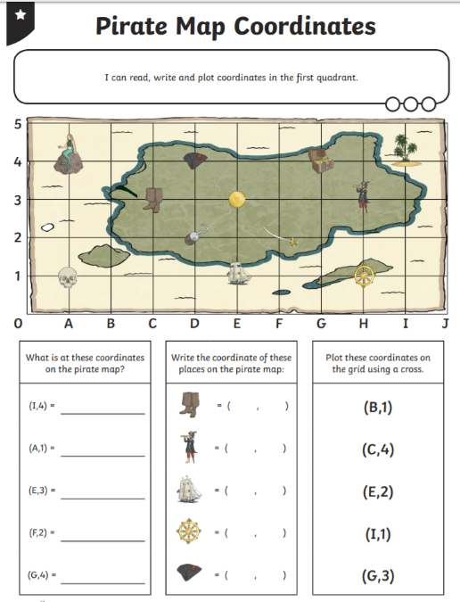
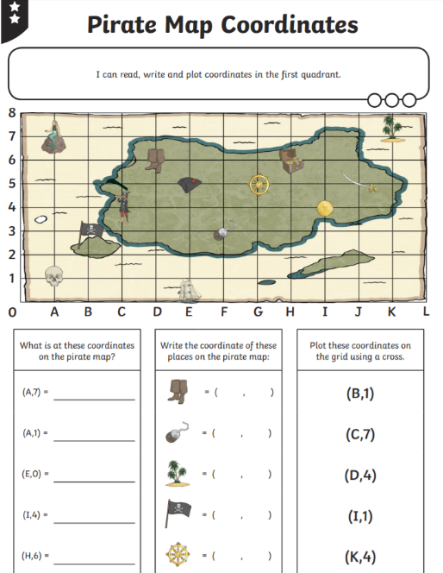
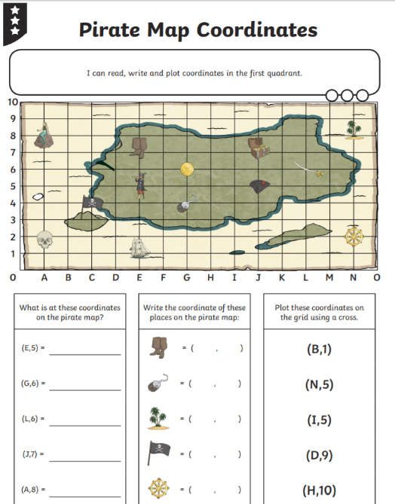
History
I have uploaded another Powerpoint from Twinkl about the Greek Gods and Goddesses for you to have a look through. Choose two of them and complete the fact files below to show what you have learned about them.
Try to pick out the key points from the Powerpoint e.g. Hades was the God of……, Ancient Greeks were afraid of him because….., he was also the God of……, because……
We will use the same Powerpoint for our next History task and have a go at planning our own Greek myth.

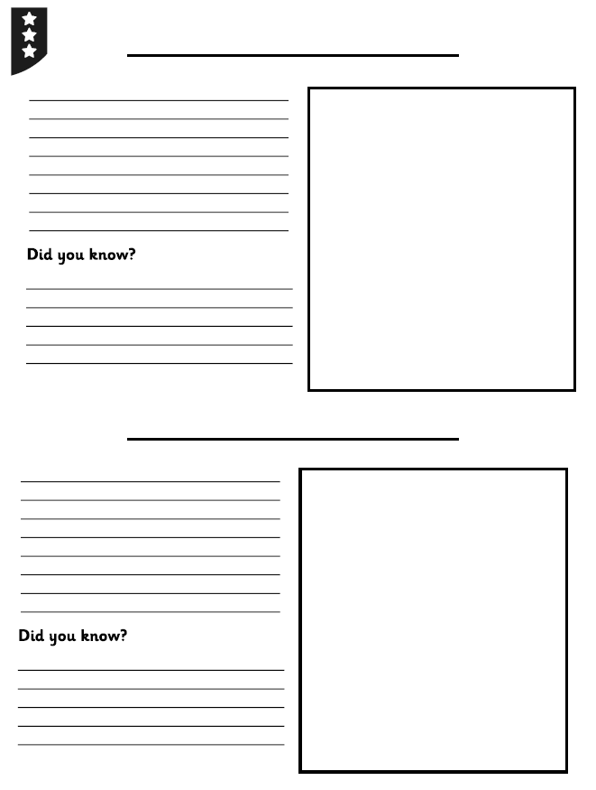
Welsh
See if you can design a pamphlet/leaflet to attract visitors to a town or place of interest. I have included some templates below but feel free to create your own. An idea for the title is “Dewch i’r Dref” (“Come to the Town”) and you can show off the vocabulary you have learned in previous work packs. Another idea might be to include a quote from a resident of the town such as “Dwi’n mwynhau mynd i’r sinema!” (“I enjoy going to the cinema!”).
Also here’s the link for the Cyw website where there are lots of activities for you to explore: https://cyw.cymru/en/

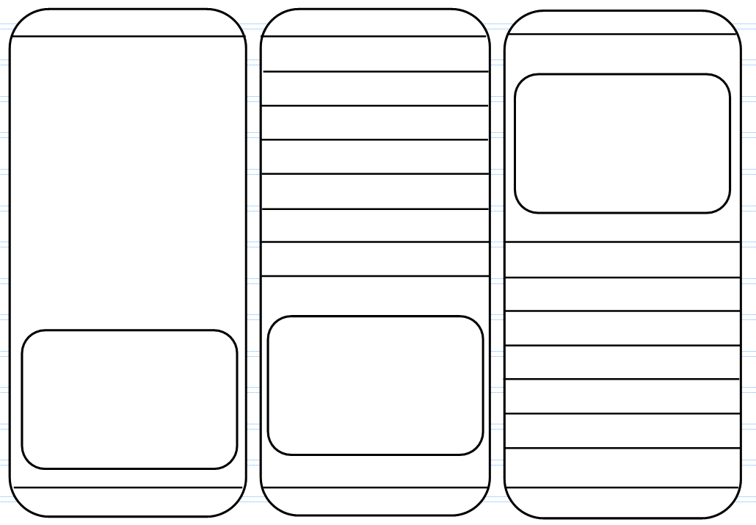
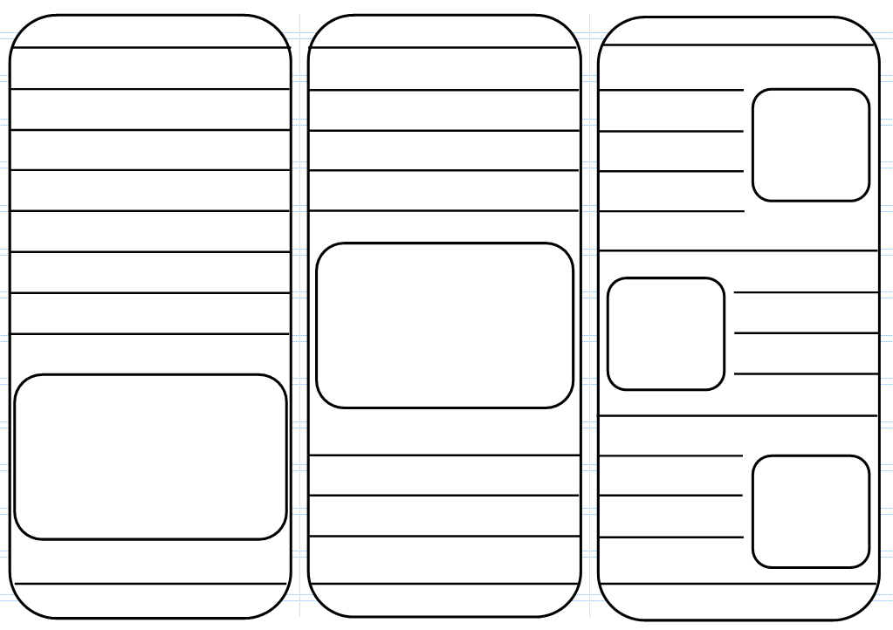
ICT
This week you will be importing media and performing simple video editing using iMovie. It may be helpful if you already have some pictures or videos on your iPad that you can use but you can also capture some during the editing process if not.
Using this link to help you: https://www.youtube.com/watch?v=xbBhrxArIls&feature=youtu.be I would like you to create a new project. Import photos and video clips into your project and have a go at trimming a clip to shorten or possibly lengthen. Look at the Ken Burns effect (how the picture moves) and change the start and end points. Try adding a title, a caption, change transitions, music and narration. All these things are explained in the video. Happy video editing!
Here is a useful link about online safety on Hwb – lots of relevant information for parents/carers and activities to complete: https://hwb.gov.wales/zones/online-safety/news/articles/42ae160b-7ab4-4510-8792-c70ef861c6d5

Try to include a bit of physical activity every day. Joe Wicks has proved really popular on his YouTube channel – you can have a look here: https://www.youtube.com/channel/UCAxW1XT0iEJo0TYlRfn6rYQ

Happy home learning! Hope you are all keeping safe and well,

Miss Densley

