Home Learning Pack Week 7 Year 6
Miss Kear & Miss Thomas’ class
Hello everyone! Here we go again for another week! We are missing all your smiley faces and hoping you are all keeping well and happy.
This week Tabitha came striding into my kitchen carrying a dead baby rat!! I was not very happy at all. (Hope you are not too upset Miss Thomas!) I’m sure she thought it would be a nice present. Anyway, I was thinking about which comprehension to set for you this week and saw these articles in FirstNews so it was an easy choice!
This week the pack contains:
Maths:
Problem solving – drawing a table
Chilli challenge – Perimeter
Emoji code breaking activity
Mental Maths test – ask someone to test you

English:
A comprehension and writing task based on the newspaper articles “Killer Kitties” and “Pig Poo Fire.”
Verbs and Adverbs

Quick Challenges (maths)

Art
Making a door sign for your bedroom. You only need card from an old cereal box and some pens or paint.

Keep up all the hard work
Miss Thomas and Miss Kear
Problem solving – drawing a table
Understand the problem:
- What do you know? – you can underline the important information in the problems.
- What do you need to find out?
- How are you doing to solve this problem? What are you going to try? What will you need to help you?
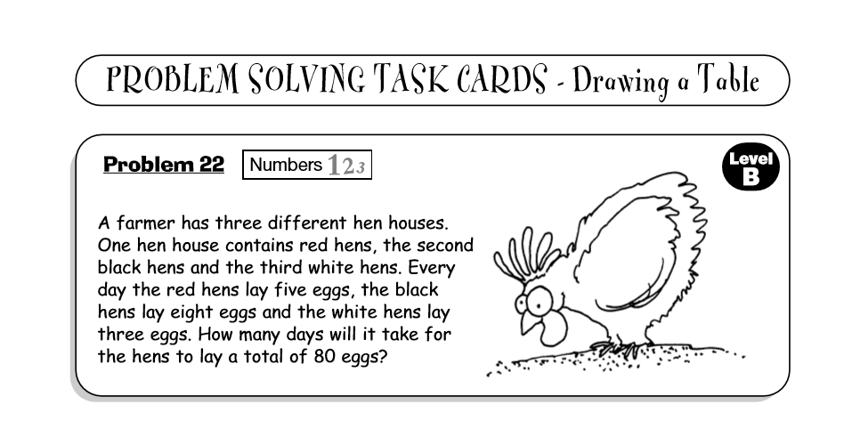
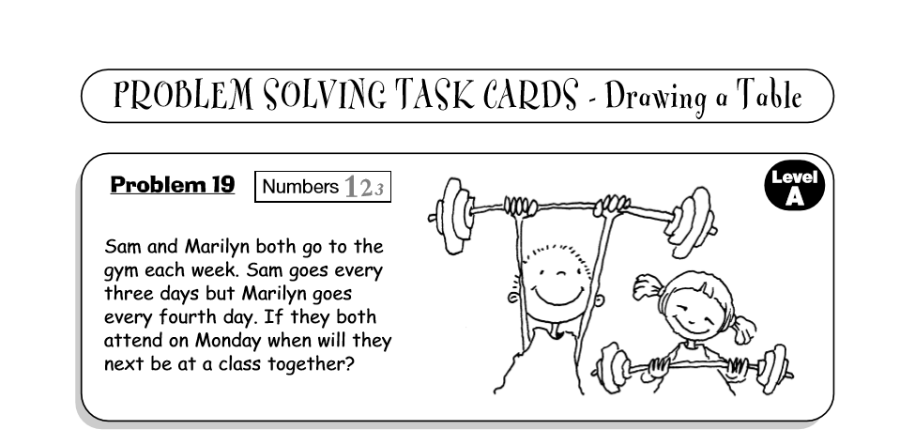

Chilli Challenge: Below you will find three worksheets on Perimeter. They are mild, medium and hot. We would like you to complete at least two of these worksheets, if you’re feeling confident give them all a go! Perimeter – the perimeter is the length of the outline of a shape. To find the perimeter you have to add the lengths of all sides.
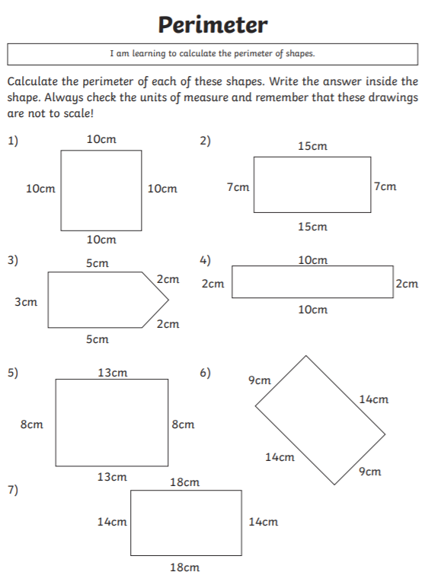
Mild:
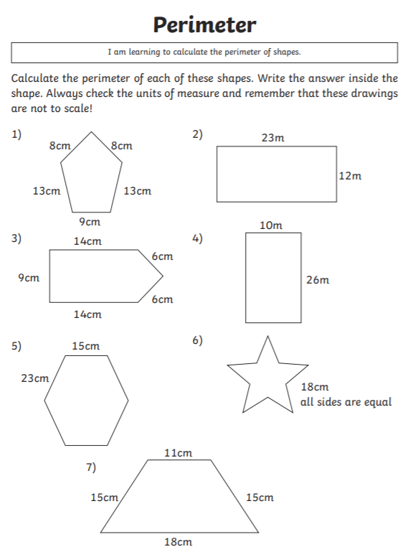
Medium

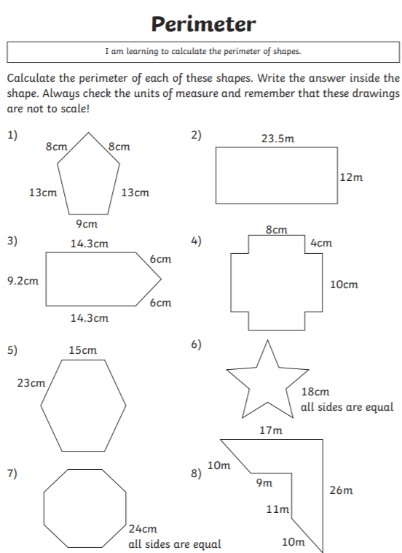
Hot:
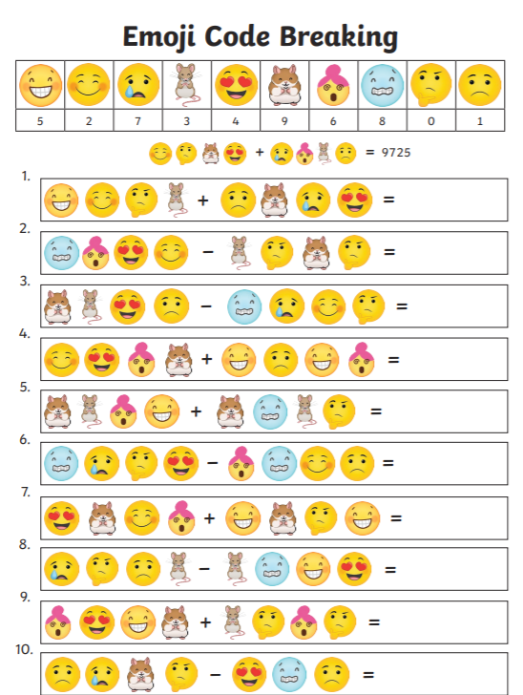

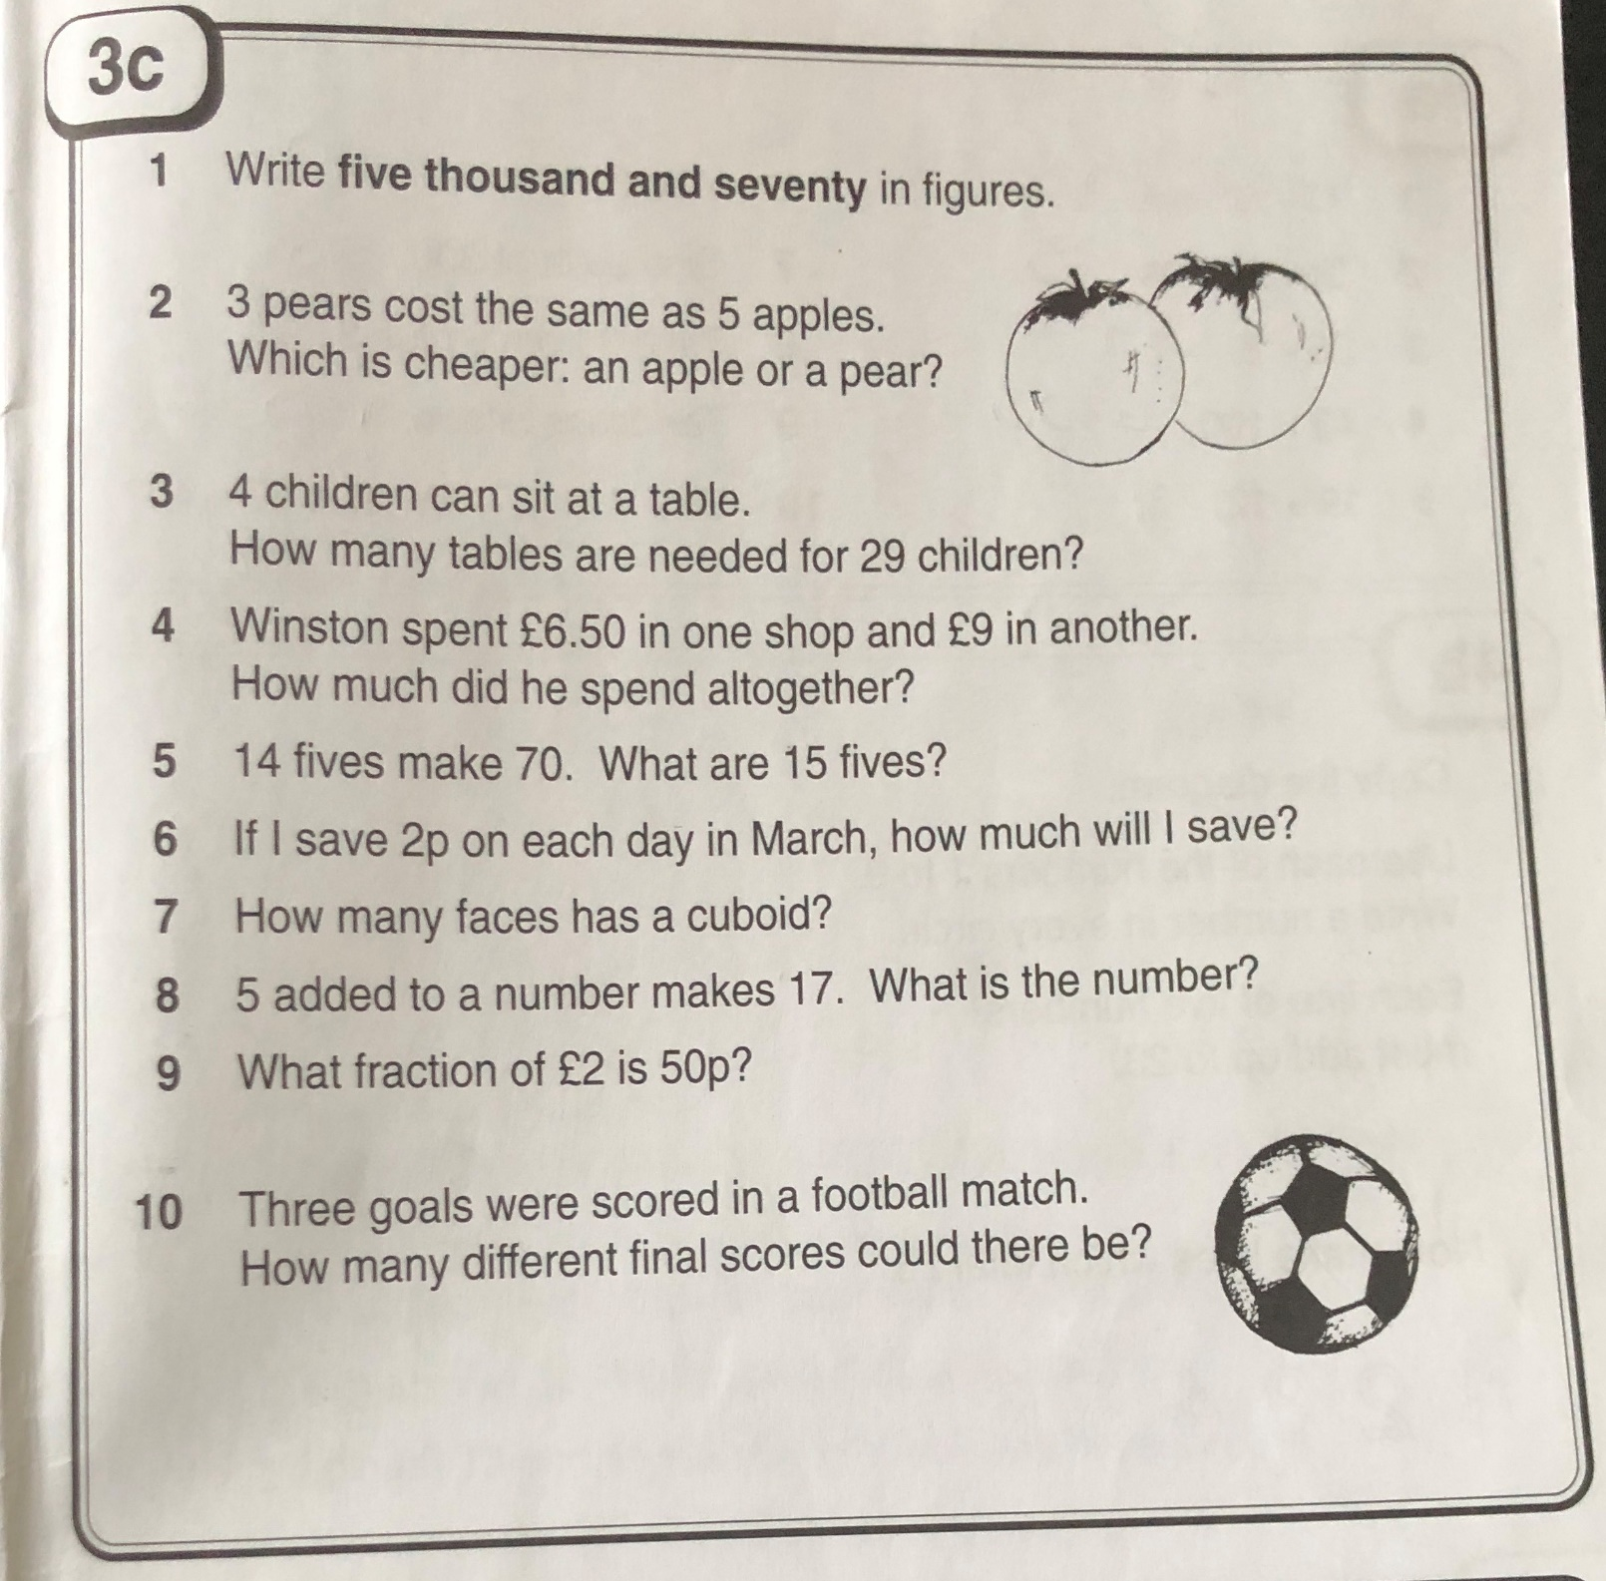
Mental maths - Ask someone to test you
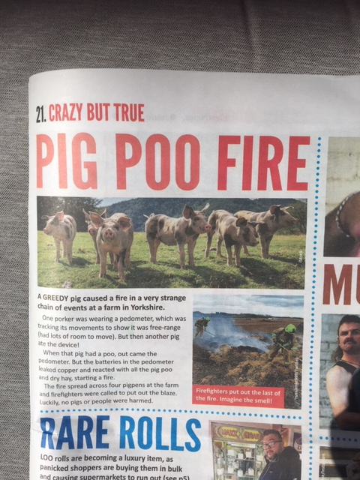

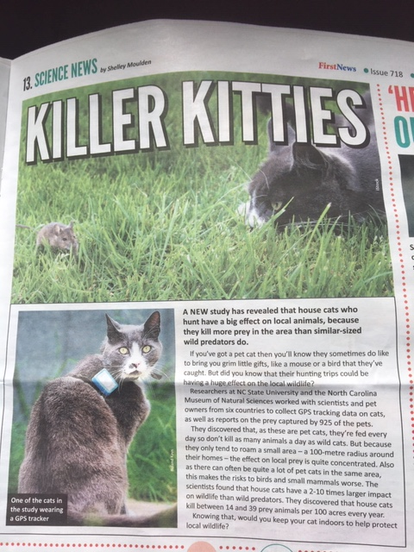

Comprehension Questions For Killer Kitties and Pig Poo Fire.

- Why do house cats have a big effect on local animals?
- If you or any of your family have a cat, what sort of creatures has it caught?
- Who carried out this research?
- Pet owners from how many countries took part?
- What makes the risk to birds and small mammals worse?
- Why don’t pet cats kill as many animals a day as wild cats?
- What is a pedometer?
- Which language does the word ‘pedometer’ come from?
- What caused the fire?
- How far did the fire spread and who stopped it?

The last sentence of the Killer Kitties article asks: ‘Would you keep your cat indoors to help protect local wildlife?
Even if you haven’t got a cat, imagine what you would do.
Write your opinion using the article to help you to give your answer. Give three reasons for each side of the argument (remember we did this in school about packed lunches?)
Make one paragraph the points for keeping your pet indoors and another to show the points against keeping your cat indoors.
At the end give your final opinion. You are more than welcome to illustrate it with pictures of your pet!



