Home Learning – Reception
Week 1 summer 2

Hi All,

You would have received a text message with your child’s hwb login and password.
This is because from Monday 15th we are transferring our home school learning to google classroom. There are a few reasons for this:

- It is easier for you to view resources
- THE MOST IMPORTANT REASON- we can start providing your child with feedback regarding their work and achievements.

All resources will still be available to download on the school website home learning section for the next three weeks as we are including a transitional period.

To access Google classroom simple search Hwb Login online and sigh in using the texted details. Remember it is case sensitive so you need to be careful entering your child’s details.
Once logged in it will take you straight to LB and all the Leaning materials.
Above some of the resources for our class it may say L Miller as the class code don’t panic you’re not on wrong page it’s simply my maiden name from when I was originally given a Hwb Login.

Please don’t panic just have a play this week see what you can discover.
Next week I will provide more detailed instructions for you, the target this week is to try logging in and seeing if you can open the resources (which are exactly the same as the ones on website for next three weeks- ones I put on these documents).

DAILY/ Weekly practise:

There are additional resources available which will help you to know the things you need to practise weekly. These are on the additional resources section of google classroom.

Maths / numeracy

Shape:

Shapes at the seaside

Can you fold, or split your paper into three sections.
Can you label them with the headings;

Circle
Square
Rectangle

Then you need to draw the beach items in the correct section, the items that are a circle under the circle heading and so on!

See if you can describe the shapes first to someone in your house eg: a square has 4 sides which are all the same in length. It has 4 corners.

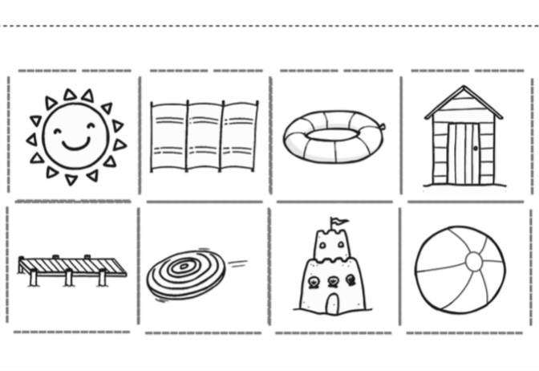
Addition

Under the sea addition

Can you add together the sea creatures?
Little tip count the first lot and write that number down and then ‘count on’ using your fingers to add them up!
You could write the answers next to them if you print sheet/ or if you can’t print no problem at all. Just write answers on paper.

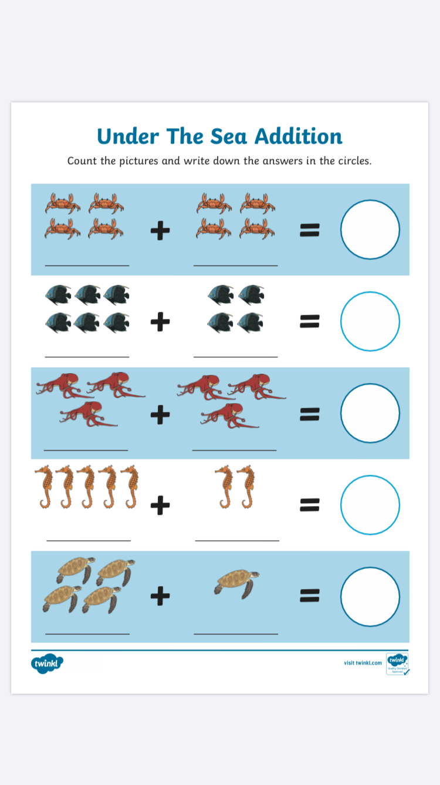

LANGUAGE/ Literacy

Play the Video attached (on the link) look carefully at each picture and which sound it is asking you to find. You need to find different objects at the seaside beginning with that sound.
You may need to say the item out loud to check you have the right sound. The video will then show you some items in the picture which do begin with that sound, you can check whether you were right or see if you missed anything out!
Best of luck.....

https://www.twinkl.co.uk/resource/t-t-2547195-what-can-you-see-seaside-powerpoint-game

Labelling at the seaside.

Can you carefully label the parts of the seaside correctly, even if an adult reads them out and you point? Can you copy any of the words onto the sheet or a piece of paper to practise your letter formations?
You can take a picture and upload this to show us.
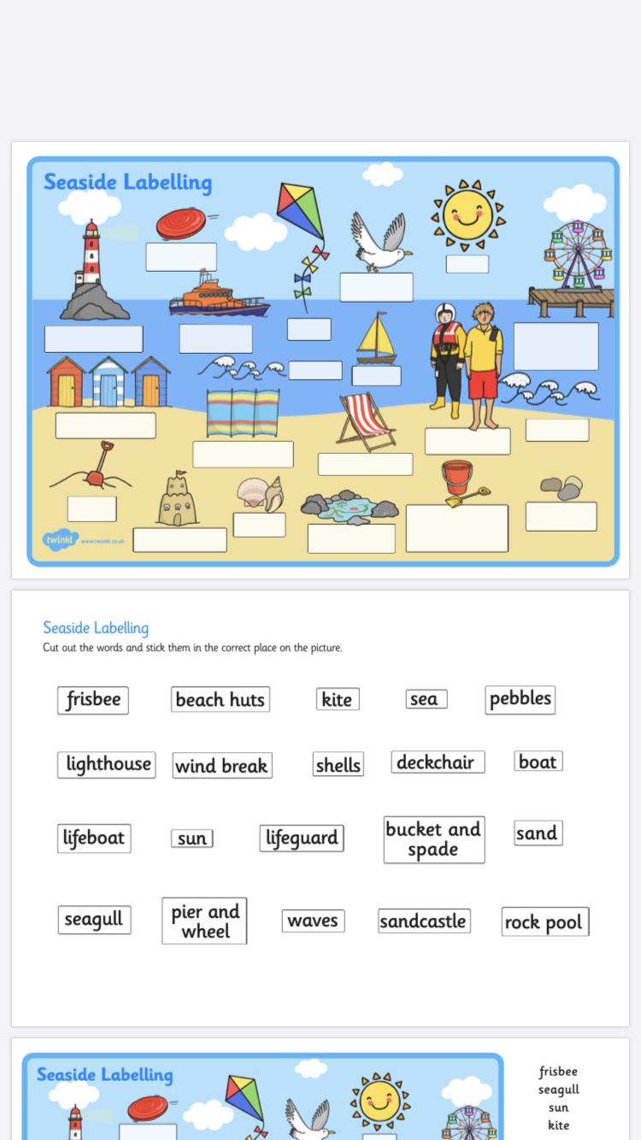
You could even copy them and draw your own little seaside illustrations.
Topic/ Theme work

I was out on one of my walks the other day and took some pictures of a beach near where I live in Barry. Can you spot anything in the pictures that you see at lots of beaches, eg: sand and sea.
You can just talk about these to someone in your house Or make a list if you want to.
It is very quiet at the beach in my pictures as it’s during lockdown.

It’s really important to keep practising that language when we are off school so see if you can use the topic related words and talk about not only what can you see but:
What you might hear?
What you might smell?
What your think the weather is like?
What is missing off the beach and seaside as it is lockdown?
What would you do on the beach if you were there?

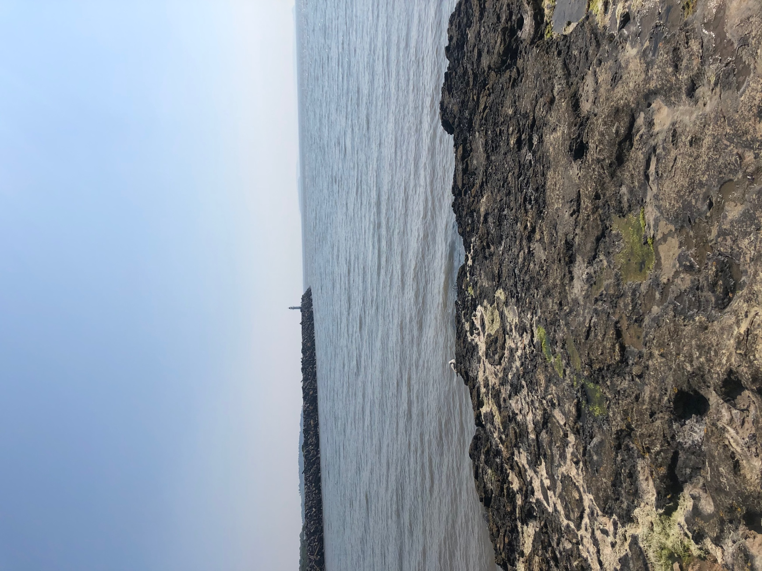
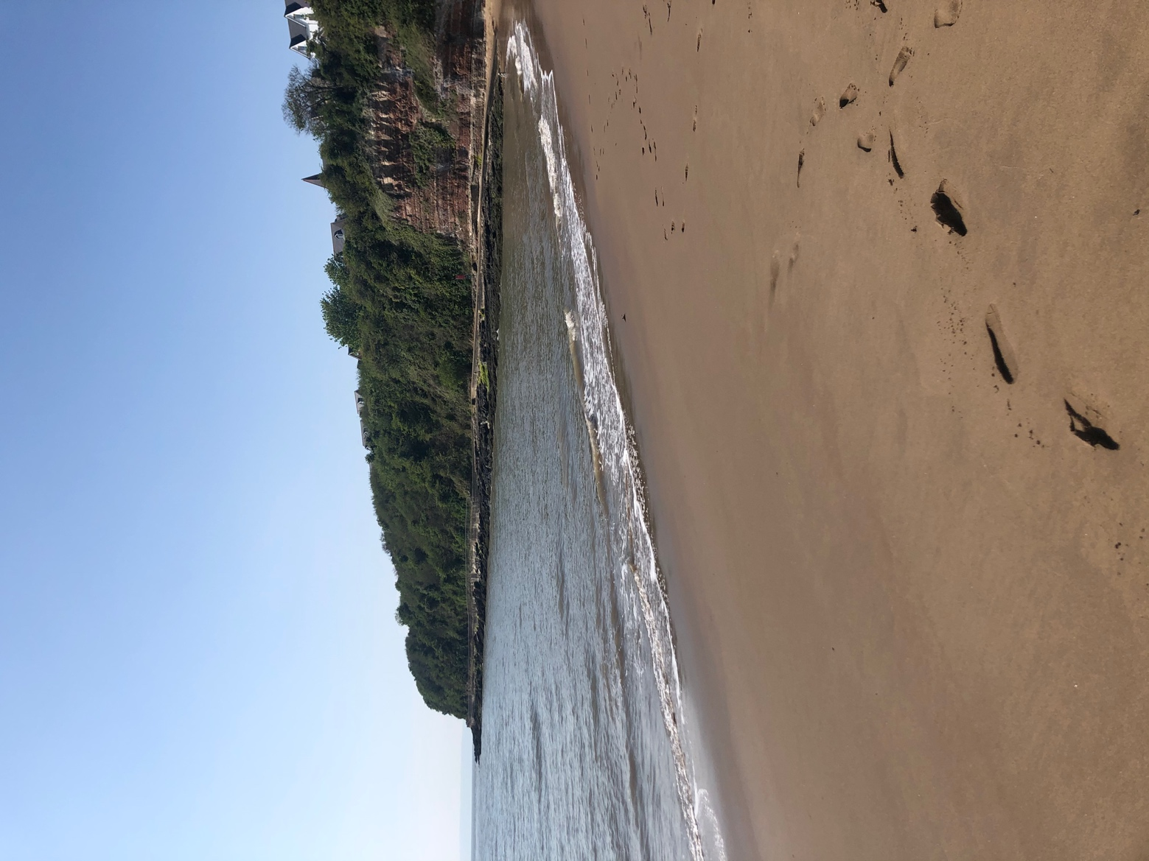
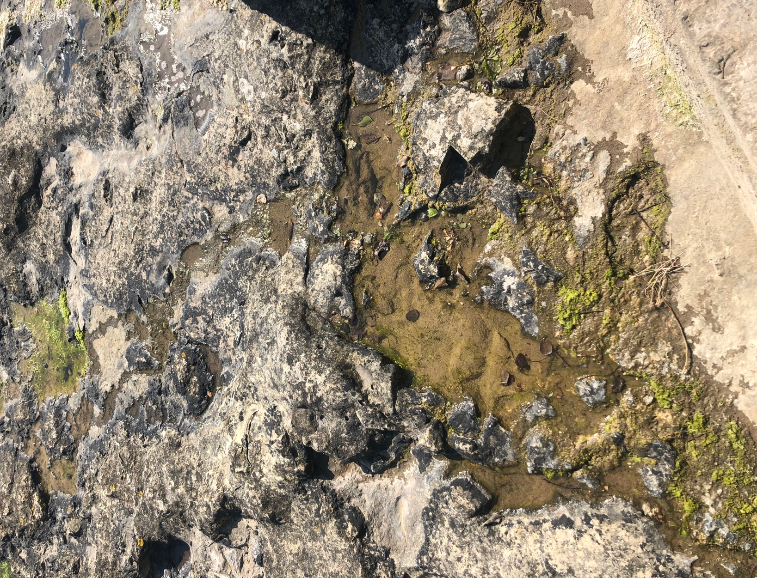
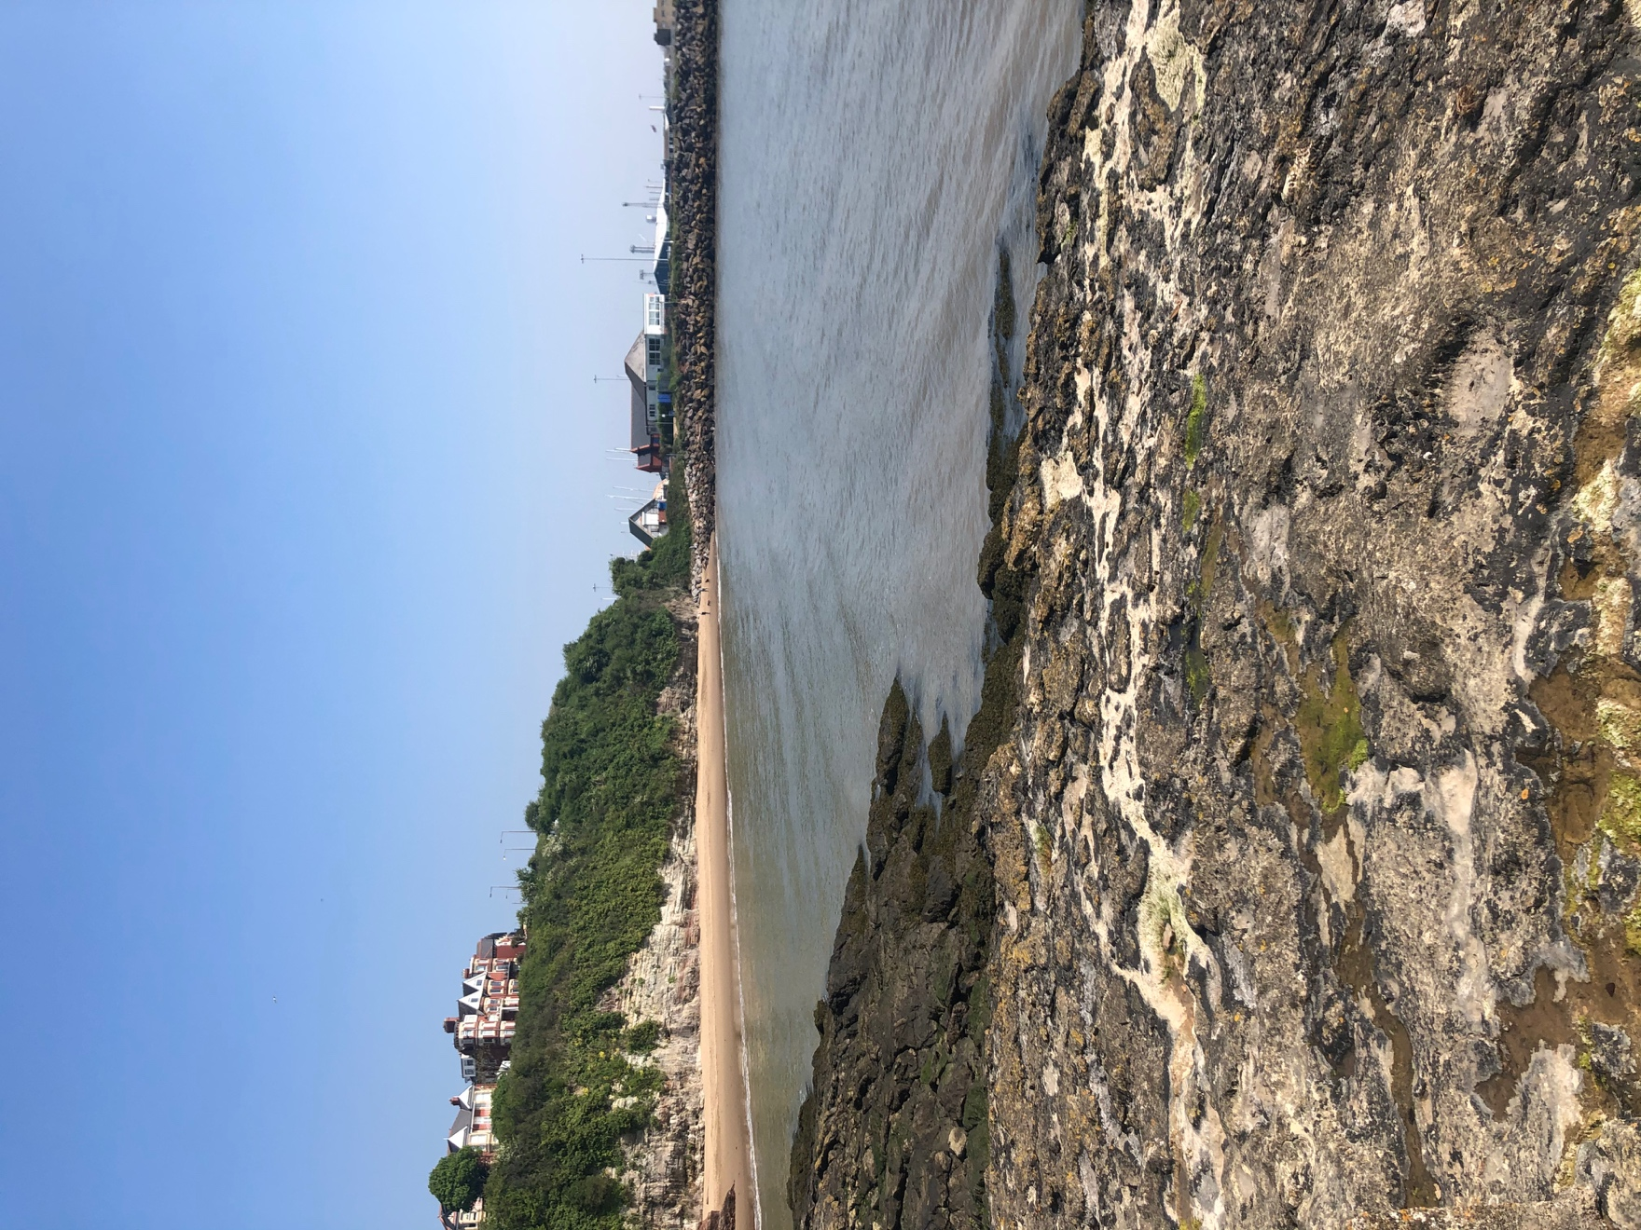
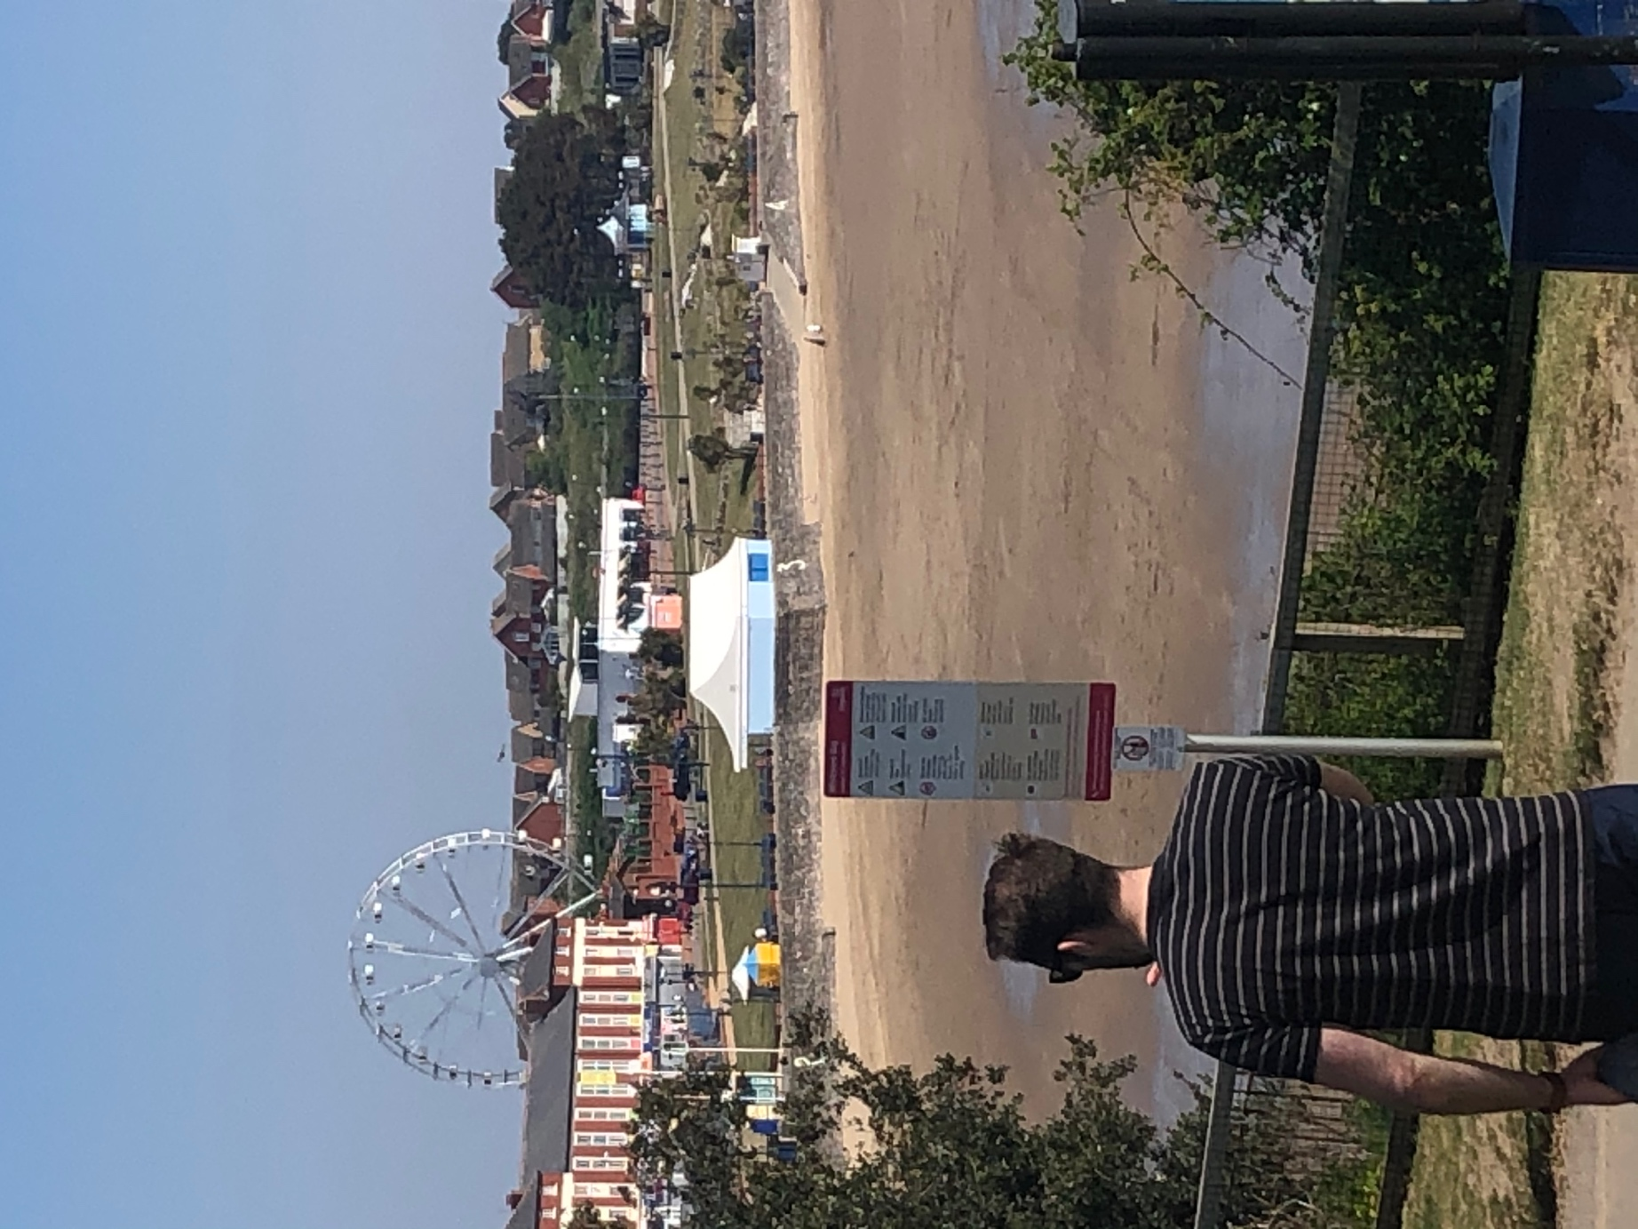

Oh I do like to be beside the seaside

Can you listen to and learn the traditional seaside song, ‘oh I do like to be beside the seaside’? Can you spot any rhyming words.
Maybe when you learn the song you could come up with some actions- even get someone to video you and add it to our Twitter page to show us or google classroom!

Here is a link to listen to it.

https://youtu.be/kcHyyuGjuk0

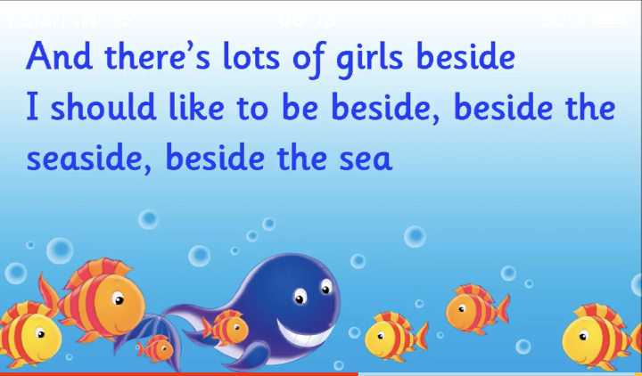

As I mentioned have a go at accessing google classroom as this allows you to upload pictures of what you have done so you can get some feedback. However it’s all a learning process so if you are finding it tricky don’t panic stick to the usual way you have been accessing resources on the website and it can be discussed on the weekly phone call.

Best wishes everyone and we really hope to have some news soon regarding school and what is happening.
We miss everyone million.

Lots of love, Mrs Brown, Mrs Lane and Mrs Chapman xx

