Home Learning Pack Week 8 Year 6
Miss Kear & Miss Thomas’ class
Hello Year 6!
It’s been lovely to speak to a few more of you this week when we have made our phone calls and great to hear that you are all well and enjoying this lovely weather.
All of you will have had a call or a message left for you by now to tell you about Google Classroom. We are going to be introducing it over the next few weeks and are emailing you 10 at a time. Well done to those of you who have managed to reply to us so far! Please don’t worry if you are stuck, this is new to all of us (teachers too) and we will all help each other through it. We don’t want anyone to get worried about it and will still be speaking to you on our weekly calls if there’s something you want to discuss. You will need to your hwb log ins and email addresses to find your email from us. If you need these or the class code, then please let us know and we can give that over the phone.
We will continue to produce a work pack until we tell you otherwise. This week we have:
Maths
Mental maths
Problem solving – creating an organised list.
Time – there isn’t a chilli challenge this week.
Emoji Multiplication Mosaic
English.
Reading comprehension.
Connectives
Writing Task: This weeks’ comprehension is about Cornwall. We would like you to write about the Rhondda as if it were a leaflet or web page for someone visiting the area- when it’s safe again! (This will be very similar to the work you did on St Lucia in the Autumn Term.)
Challenges
English and Maths
Art
Flower printing garden art.

Keep up all the hard work!
Miss Thomas and Miss Kear

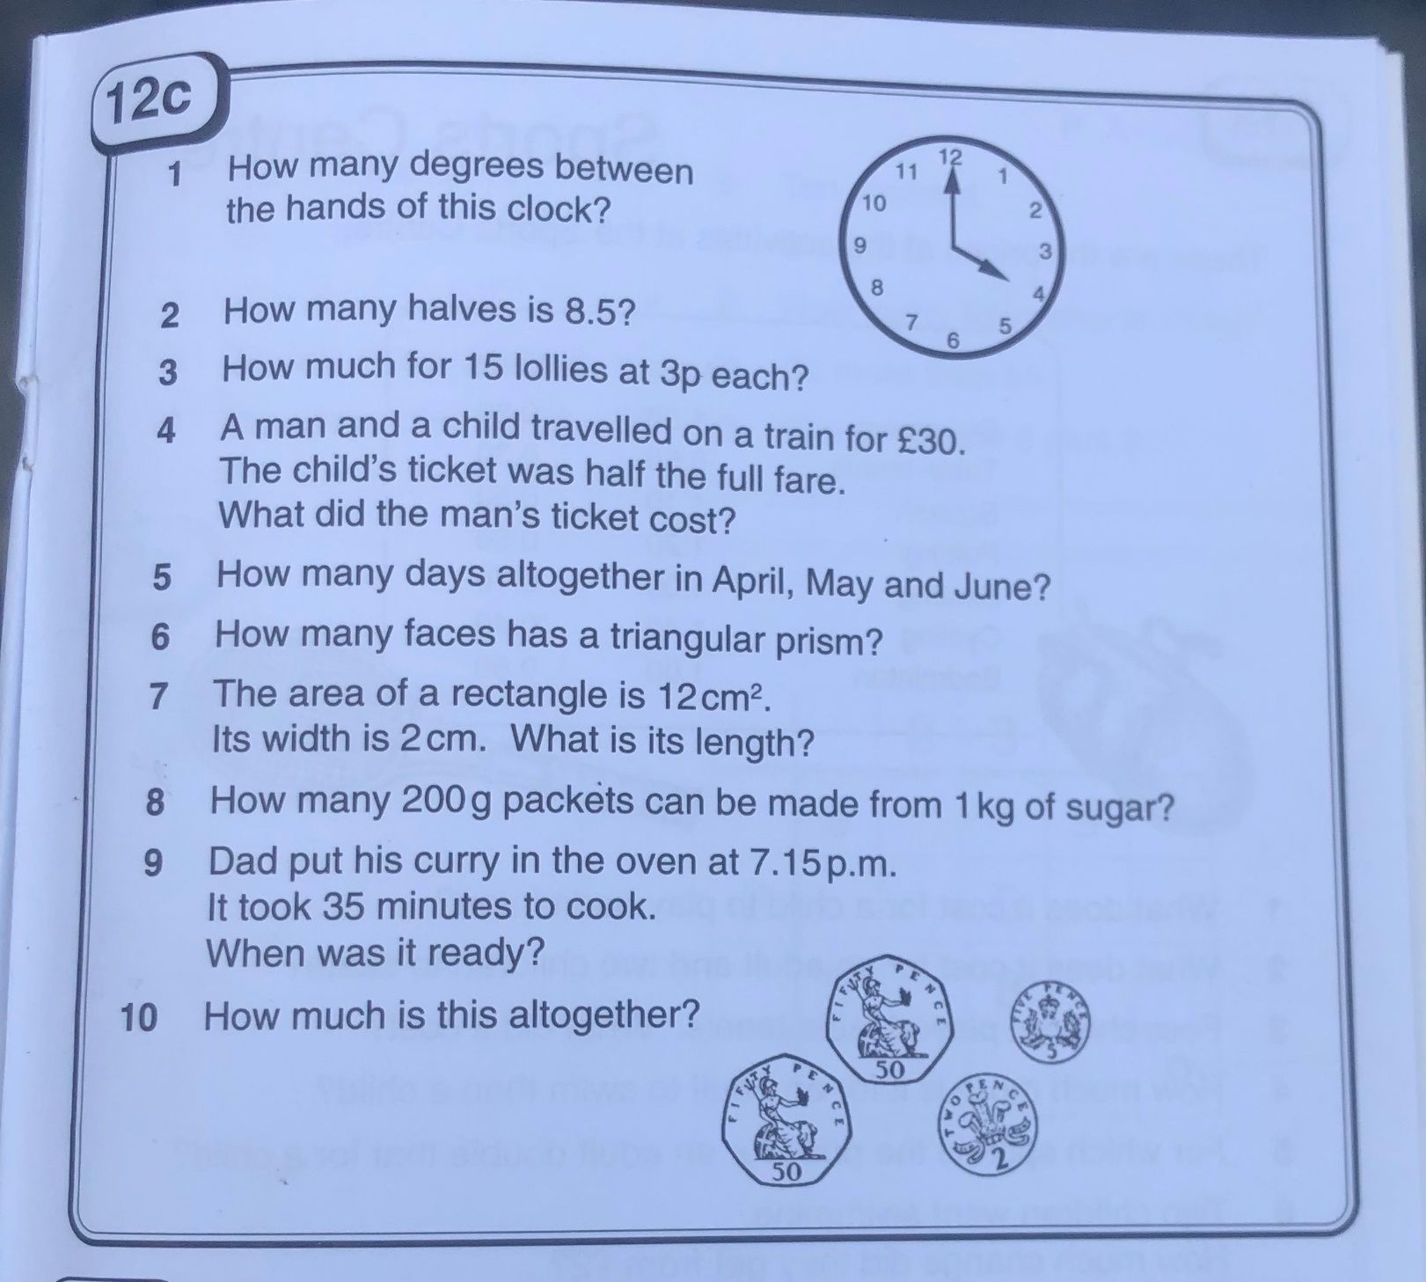
Mental Maths
Problem solving – Creating an organised list.
To complete these problems, you will need to create an organised list, using the information you’re given.
Understand the problem:
- What do you know? – you can underline the important information in the problems.
- What do you need to find out?
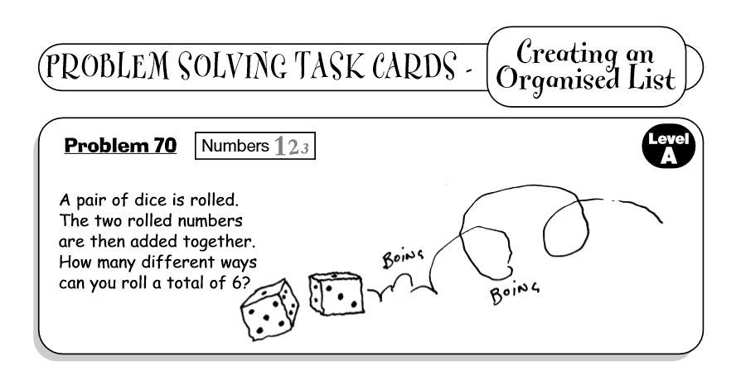
- How are you doing to solve this problem? What are you going to try? What will you need to help you?
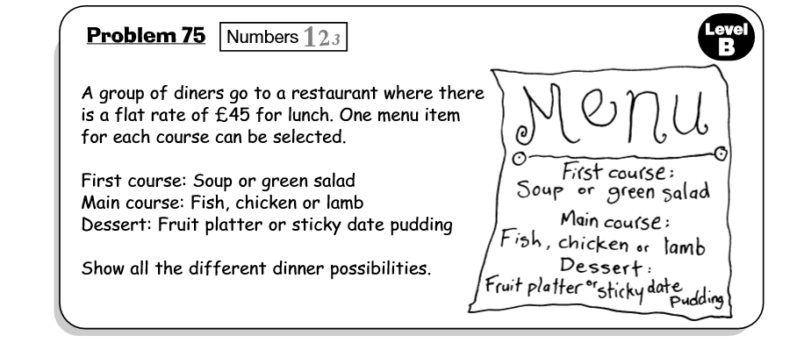
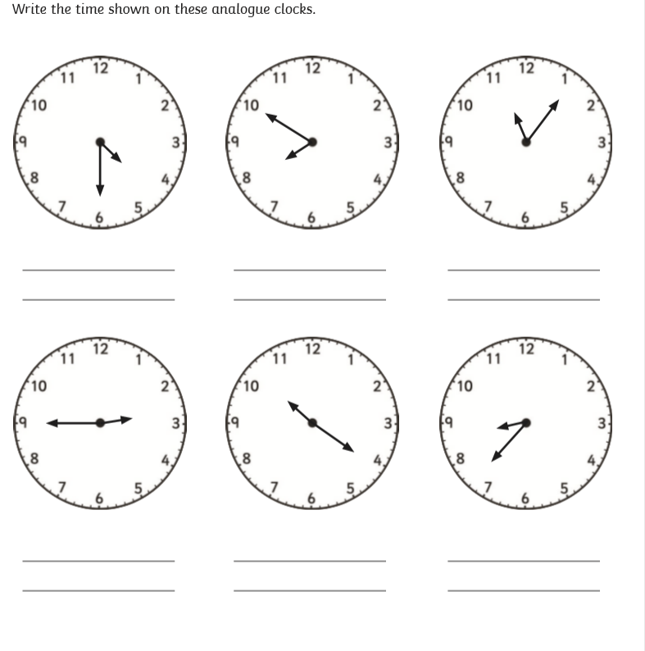
Time.

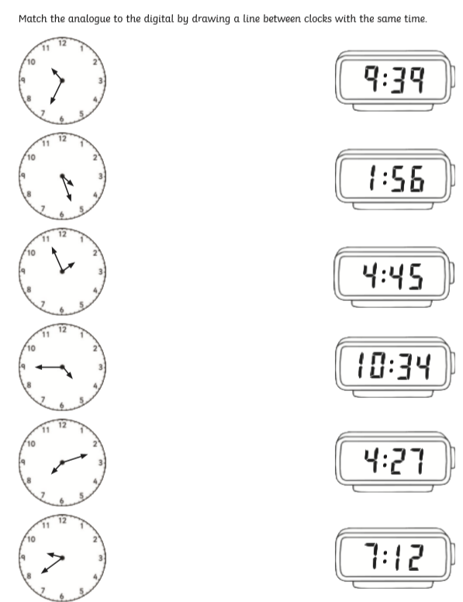
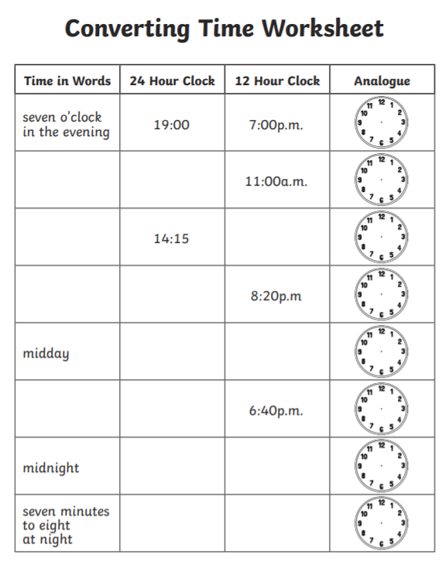
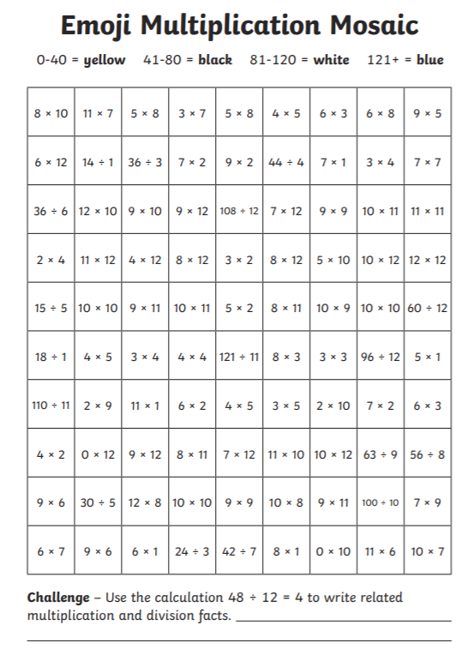
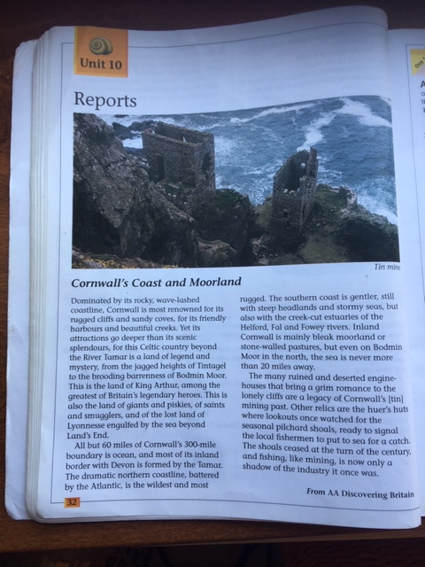
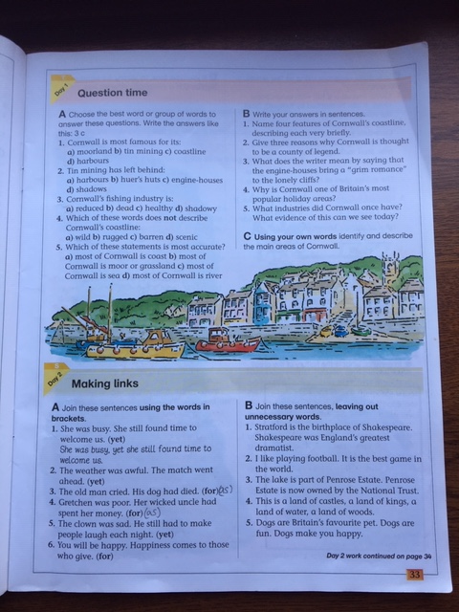

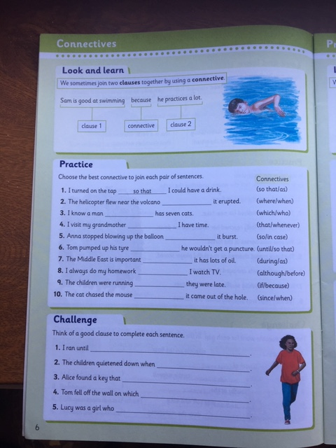
Writing Task: This weeks’ comprehension is about Cornwall. We would like you to write about the Rhondda as if it were a leaflet or web page for someone visiting the area- when it’s safe again! (This will be very similar to the work you did on St Lucia in the Autumn Term.)
Remember the success criteria?
- Make it look attractive with bold and colourful headings.
- Add pictures or photographs.
- List places of interest to visit.
- Give examples of places to eat. (Its ok if these are a short distance outside the Rhondda)
- Write a paragraph on the History of the area maybe explaining why most of the houses are terraced.
- Perhaps you could take photographs of any birds or creatures you find in your garden or when you are out for a walk.
- Explain what the weather can be like throughout the year.
- Include what plants/flowers are linked with Wales.

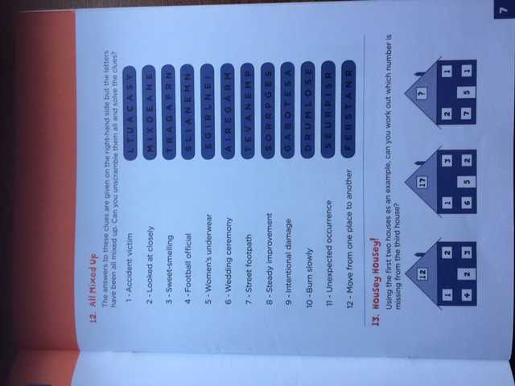
Art – Flower printing garden art.
Take a walk around your garden/local area to find some plants, flowers and leaves of all sorts of shapes, sizes and textures.
Dip them into different coloured paints and see what prints and patterns you can make on paper.
When your art has dried, take a photo and show us on Twitter!


