School Closure Home School Pack
Miss Densley’s Class
Week beginning 1.6.20
I’ve added some more ideas for another week of home learning. I’ve left the ongoing spelling/reading/times tables on there.
Literacy
- Practice the reading/spelling of high frequency words – you can do this in creative ways using different materials (e.g. paint, magnetic letters) and try timing yourself
- Carry on with your reading books – make sure someone asks you lots of questions about them and if you are reading Dockside practice those cover words
- I have included a sheet of general literacy activities and some paper to complete them on
- Here is a link for Oxford Owl’s free ebook library (you will have to create a login but it should all be free): https://www.oxfordowl.co.uk/for-home/find-a-book/library-page/?view=image&query=&type=book&age_group=Age+9-11&level=&level_select=&book_type=&series=#
- I’ve found a lovely free book to download about coming to terms with school shutdown: https://parsleymimblewood.wordpress.com/

- This half term I am going to give you some work on information texts from another Talk for Writing booklet called ‘Amazing Aliens’. I hope you enjoy – you will be working towards creating your own alien and describing it.

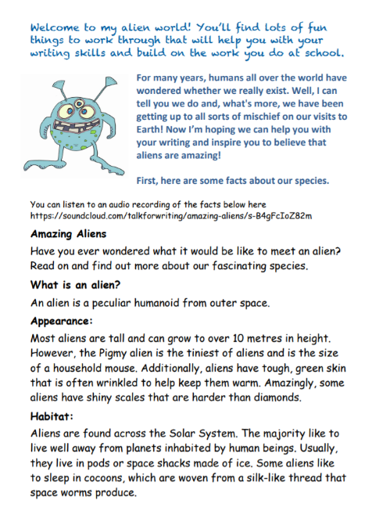
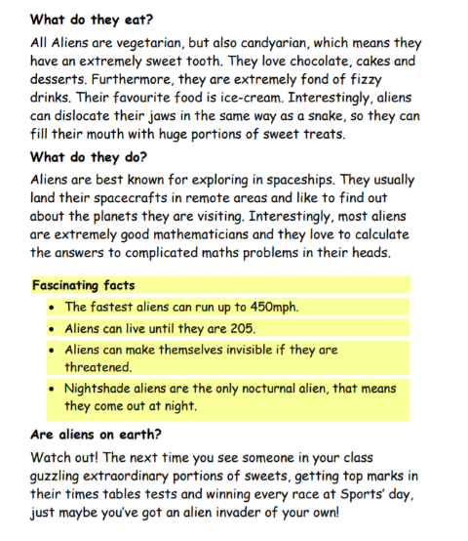

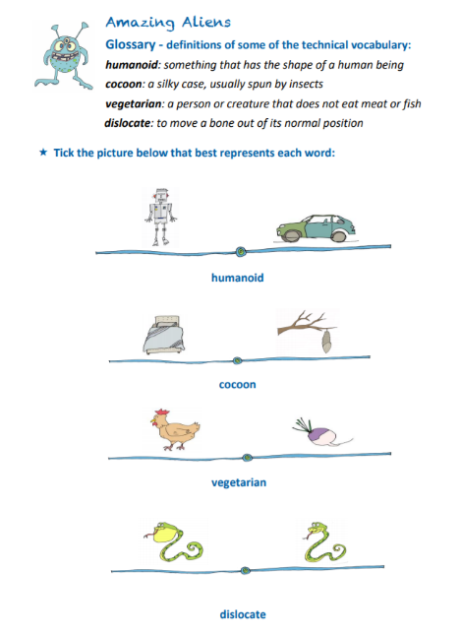

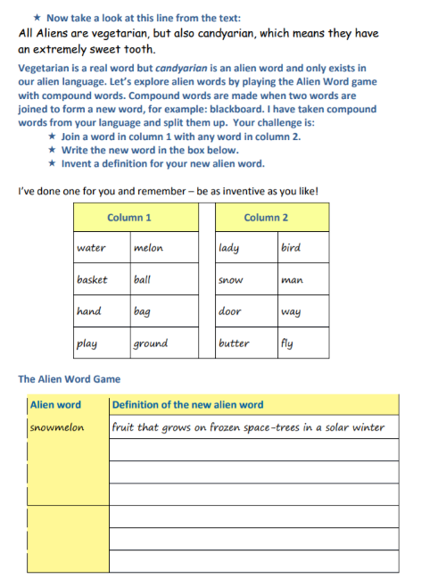
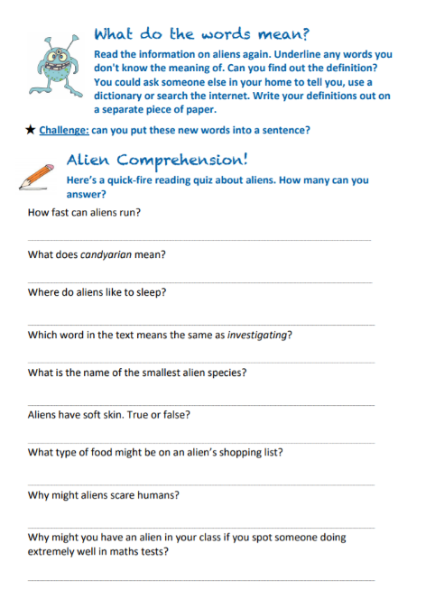

Maths
- Practice your times tables (in class we have practised the 2, 5, 10, 3, 4, 6, 8 and 9). A great tool for this is J2Blast on Hwb (I can see some of you have already had a go at this!)
- Practice telling the time on analogue (clock faces) and digital clocks
- Topmarks is a fantastic website to help with both of these

- This week’s topic is to manage money, compare costs from different retailers and determine what can be bought within a given budget.

Below are some blank shopping lists for you to fill in using the price list below it. You have a budget of £100 and have to decide what pet you can afford. Try checking your totals with a calculator after you have had a go at adding them up in your head or with column addition.

Good websites to help with any of the above include Letters and Sounds for phonic practice, Topmarks, Crickweb for problem solving practice, Twinkl, Espresso, Hwb, BBC Bitesize and Primary Resources.

Here are some more great links I’ve found for home learning: https://www.tes.com/teaching-resources/teacher-essentials/home-learning
www.collins.co.uk/learnathome

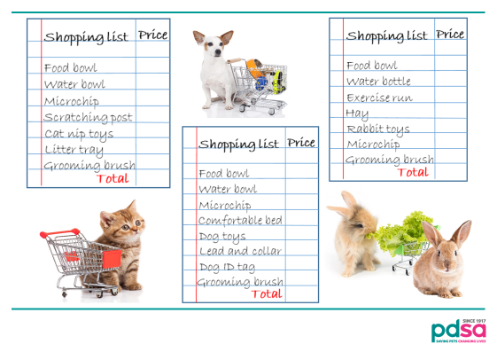



History
Using the same Powerpoint from last time about Greek Gods and Goddesses I would like you to come up with some ideas for your own Greek myth. Have a look through the Powerpoint from Slide 18 and see if you can answer the questions on slide 20 using the storyboard template below.
Below that I have included the story of Orpheus and Eurydice which your parent/carer may like to read to you to give you some more ideas. Below that is a set of story dice which you can either make or just refer to for some ideas for your own story. Happy story planning!

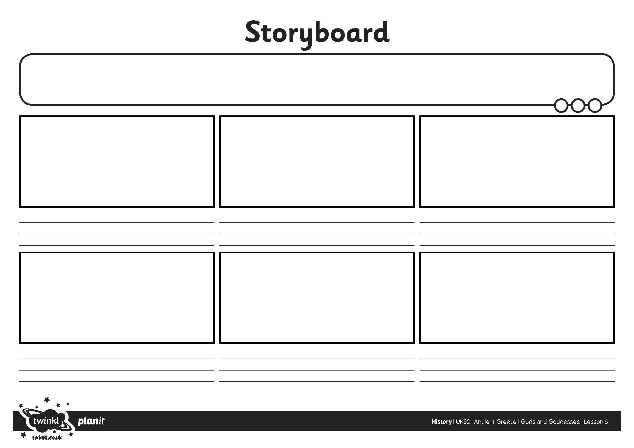

Orpheus and Eurydice
There once lived a skilled musician named Orpheus, who could play his lyre so beautifully that his music would enchant all who heard it. It was so powerful that it could turn bad men good and tame even the most wild of beasts.
One day Orpheus met the most beautiful woman he had ever seen. Her name was Eurydice and Orpheus was so captivated by her charm and beauty that he immediately fell in love with her. When Eurydice saw Orpheus playing his lyre her heart melted at once and she too fell in love. The couple were married within a few days and were blissfully happy together.
Eurydice was enjoying a stroll through the woods one day when she came across a shepherd tending to his flock. The shepherd, whose name was Aristaeus, was in awe of Eurydice and he longed to talk to her and find out who she was, but Eurydice was frightened by the man and she began to run from him. Aristaeus, not understanding why she was so scared, pursued Eurydice. He chased her through the woods calling out to her to stop and speak to him. Eurydice ran on in a panic, eventually tripping over a log and landing with a thud on the ground. Unseen by Eurydice a vicious snake crawled out from beneath the log and bit her. Its venom was so potent she died at once.
When Orpheus heard what had happened he was distraught. His wonderful wife had been taken from him so soon and he was inconsolable in his grief. Orpheus played his lyre to help ease his pain and the music that emanated from the instrument was so haunting that it moved the men, gods and even the plants and trees to tears.
Orpheus decided that he must try to bring Eurydice back to him. He set out on a daring quest to beg Hades – god of the underworld - to allow his wife to return to the human world. Hades was deeply saddened by Orpheus’ plight and so moved by the poignant music Orpheus played for him, that he agreed to give him the opportunity to get Eurydice back. He presented a challenge to the eager musician.
“I will allow Eurydice to follow you out of the underworld on one condition. Whatever obstacles you may encounter along your journey you must not look back at your wife. If you do then she will remain here with me eternally”
Orpheus did not hesitate in accepting the challenge. He was prepared to take on anything to get back his beloved wife and if all he had to do was not look at Eurydice as she followed him back out of the underworld that would be easy!
Orpheus set off on his journey with hope in his heart and his beautiful Eurydice close behind him, but soon he came to a huge wooden door which was chained shut. Lifting his lyre Orpheus’ quick fingers began to play a magical tune. The chains burst off the door which swung gently open, allowing Orpheus to slip inside and continue on his way. The young man longed to turn around to check that Eurydice was still there but he managed to resist and he continued on.
Beyond the wooden door Orpheus found himself inside a dank, dark room. The air was thick and stagnant and Orpheus’ eyes watered involuntarily in the putrid atmosphere. As the light was so low Orpheus pressed his hands against the moist, slimy walls and felt his way along through the room, moving as quickly as he dared. After a few minutes he became aware of the sound of heavy breathing and a deep rumbling growl began to resonate off the walls suddenly bursting into a thunderous roar. Orpheus’ heart pounded in his chest and his ears rang painfully. He could just make out the shape of a humongous three headed dog looming down on him menacingly. Orpheus recognised the beast at once as Cerberus - Hades’ grotesque hound. Thinking quickly Orpheus snatched up his lyre and began to play a soothing melody. Saliva rolled off the creature’s three tongues splashing onto a terrified Orpheus whose whole body trembled as he played. However, almost at once, the beastly dog began to calm down. It cocked its three heads sideways to listen to the soothing music, then it dropped to the ground pacified by Orpheus' captivating tune. Orpheus crept on through the room, treading nervously over the dog’s monstrous paws while continuing to play his instrument. Finally he reached the end of the room and was able to slip away unnoticed. He took a deep breath and slumped against the wall, mopping his wet brow with the back of his hand.
In his terror Orpheus had forgotten about Eurydice following him and he began to panic about whether she had made it through the room behind him or whether she was trapped with Cerberus. Orpheus remembered Hades’ words – he had promised that Eurydice would follow unharmed as long as he did not look back at her and he managed to calm down. Ahead of him in the distance he could see the inky black waters of the river Styx and he knew that once he had sailed across the river he would be able to pass safely back into the mortal world and be with his dear wife once more.

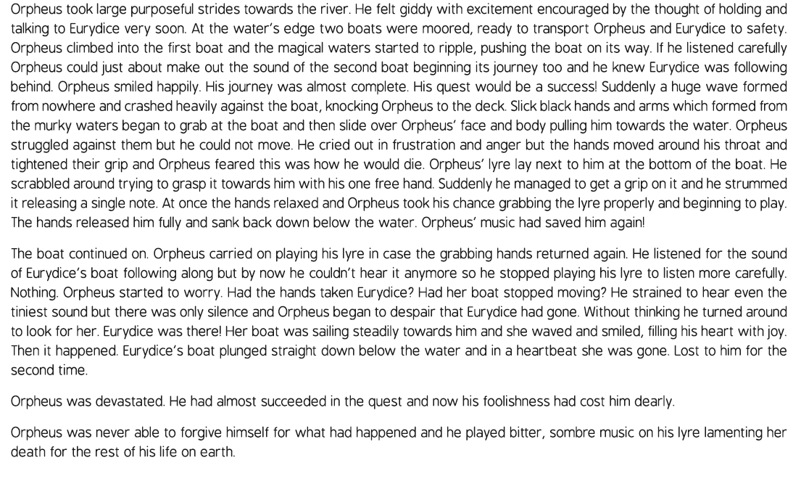

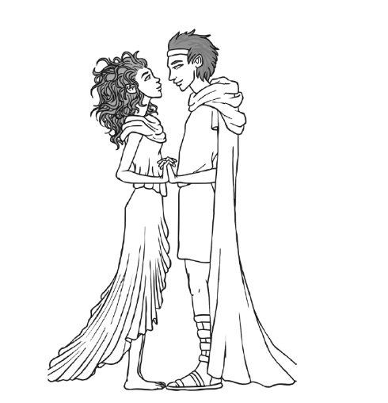

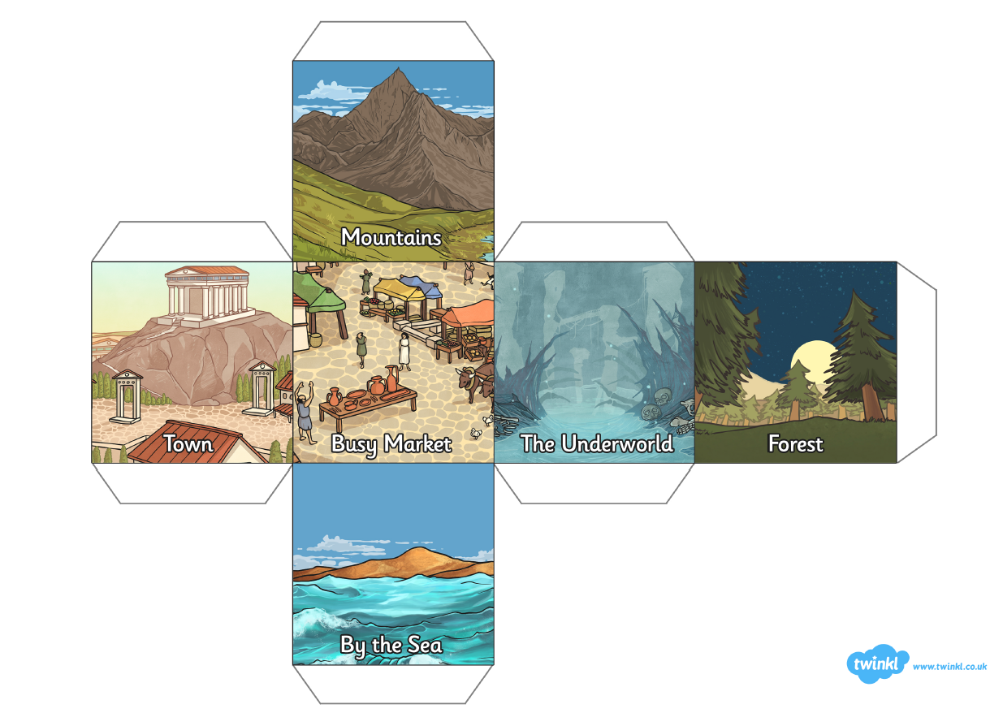

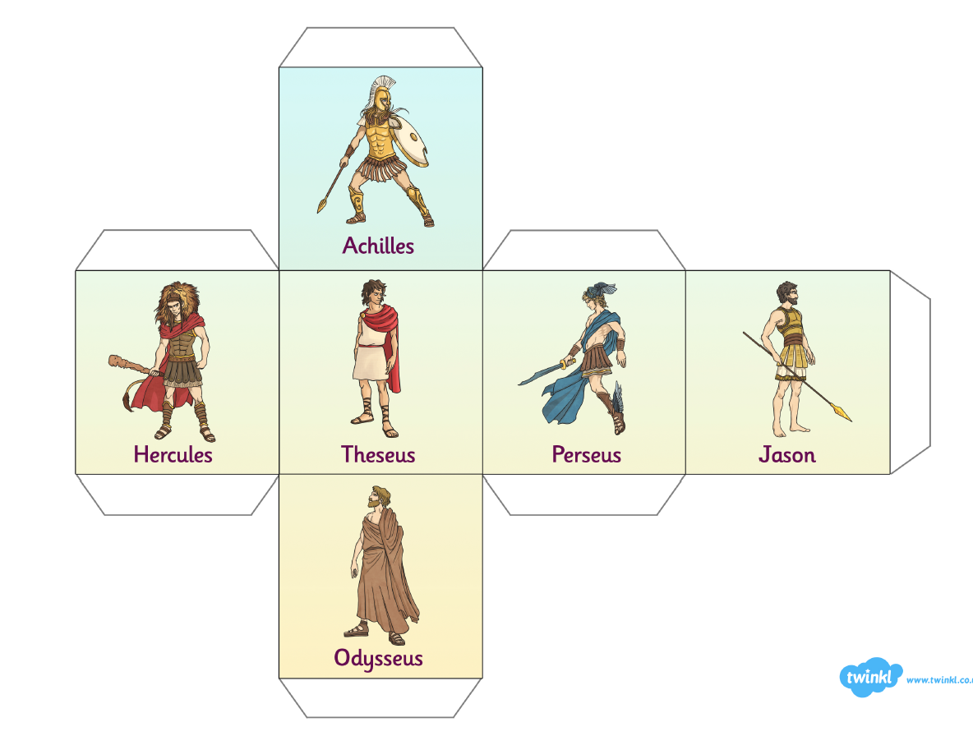

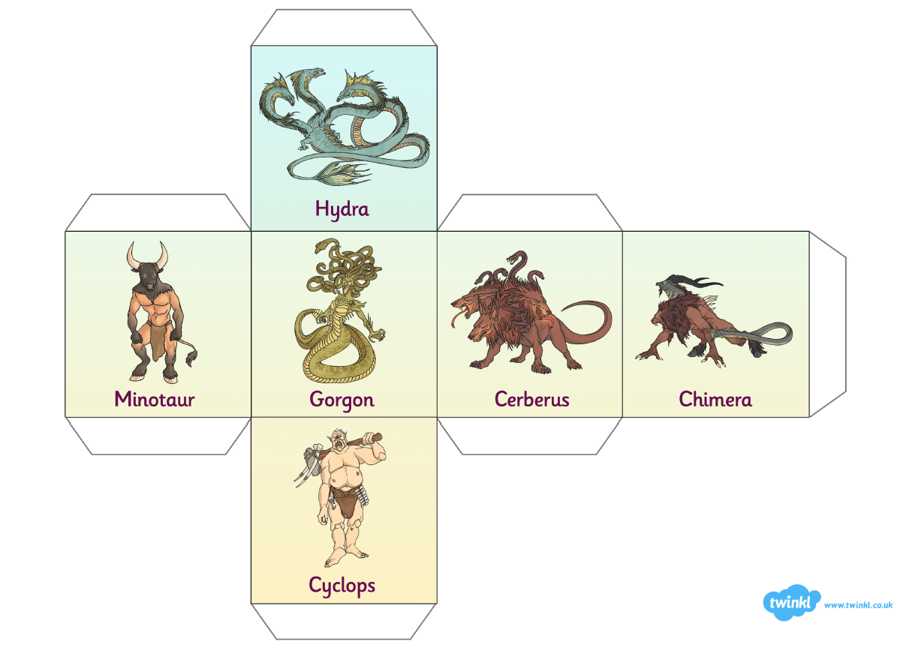

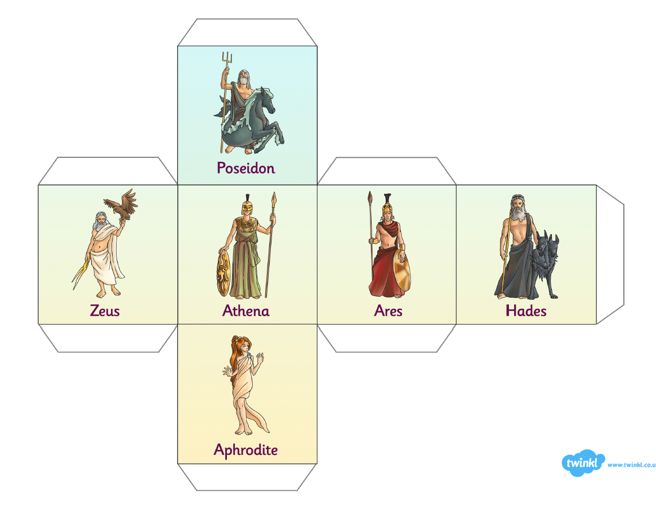

Welsh
The topic for this half term will be on “Amser” (“Time”). I have included some slides from a Powerpoint below for you to practice the “o’clocks” (1 through to 12 o’clock). Have a go at filling in the sheet below it – make sure you write the Welsh not just the numbers.
Also here’s the link for the Cyw website where there are lots of activities for you to explore: https://cyw.cymru/en/

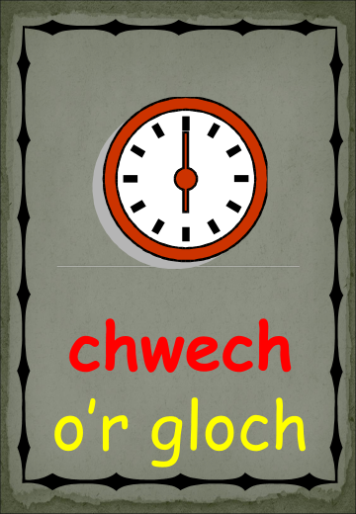
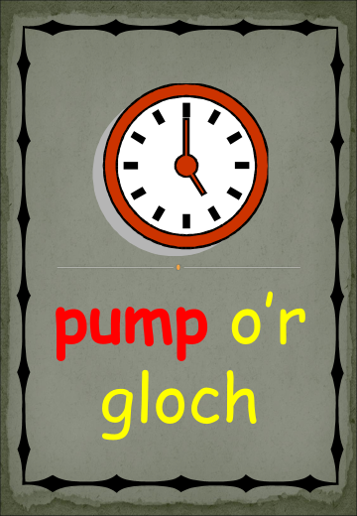
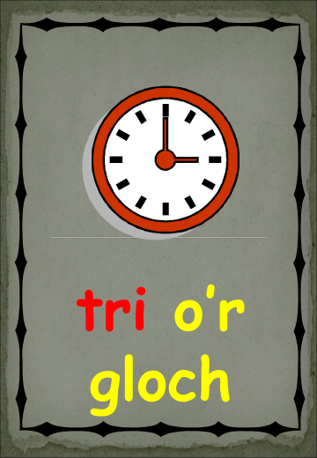
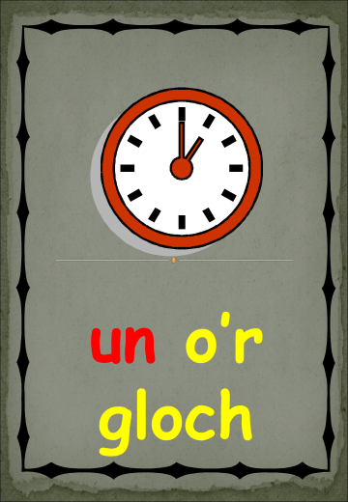
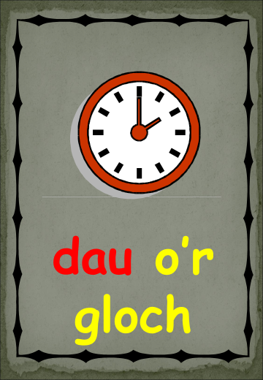
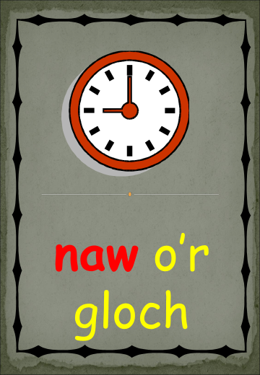
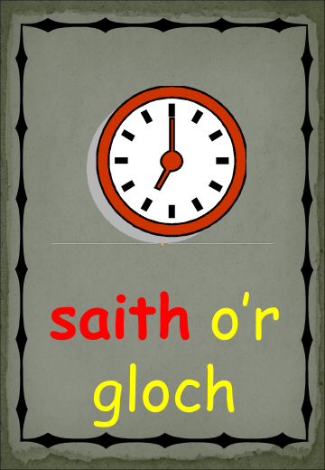
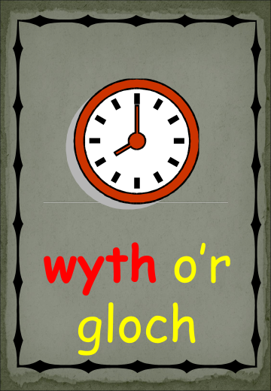
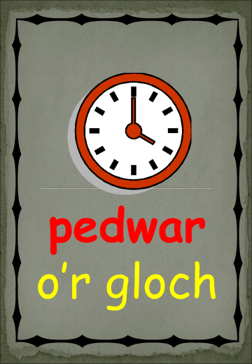

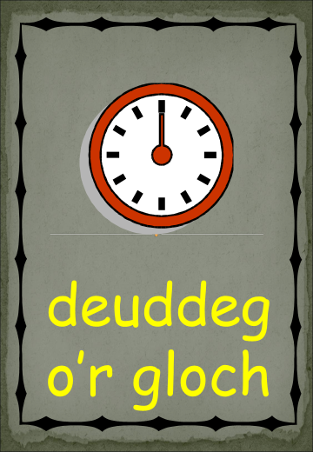
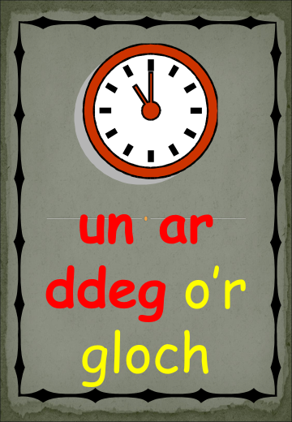
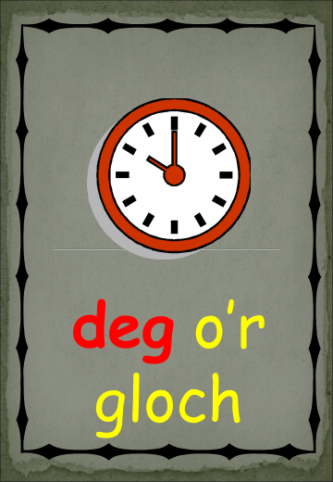

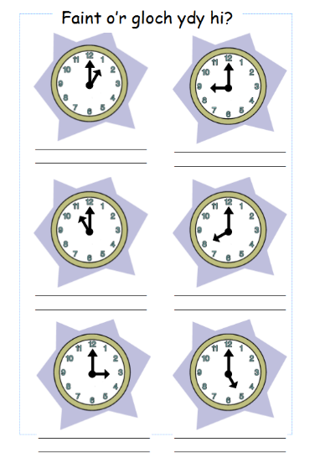
ICT
This week’s activity is to create a “digital story” using all the skills you learned from last week’s activity in iMovie. A digital story is a multimedia movie that often combines photographs, sound, music, text and a narrative voice to tell a personal story. Here is an example of one (apologies for the American accent): https://www.youtube.com/watch?v=LUdeRYK_9SU&feature=youtu.be
I would like you to plan your story using the storyboard we used in Week 6’s work pack then create the video. Try to write the story from a personal perspective: something that has happened to you. If you struggle with this you could always use the story you created based on King of the Fishes or your Greek myth. You will need to narrate the story over appropriate still images that highlight your story. Your video doesn’t need to be any longer than 2 minutes long.
Your WIN list (What I Need to make it successful):
Clear speaking voice
Photos at the appropriate point in the narration
Titles
Suitable music in the background

After you have created your video remember to evaluate it against your WIN list – have you included all the points? You could even have a go at uploading it to Google classroom for me to see!

Here is a useful webpage from BBC Bitesize telling you more about it: https://www.bbc.co.uk/bitesize/topics/zf2f9j6/articles/zyb72hv

This link shows you how to export the movie when it is finished (try sending it to Google classroom rather than J2Launch): https://www.youtube.com/watch?v=FsOEH_oEtdQ&feature=youtu.be

Here is a useful link about online safety on Hwb – lots of relevant information for parents/carers and activities to complete: https://hwb.gov.wales/zones/online-safety/news/articles/42ae160b-7ab4-4510-8792-c70ef861c6d5

Try to include a bit of physical activity every day. Joe Wicks has proved really popular on his YouTube channel – you can have a look here: https://www.youtube.com/channel/UCAxW1XT0iEJo0TYlRfn6rYQ
Here is another useful link with ideas for keeping fit: https://www.twinkl.co.uk/resources/twinkl-move?utm_source=newsletter&utm_medium=email&utm_campaign=newsletter_2020-05-17_GB-WLS_KeyStage2&utm_content=custom9

Happy home learning! Hope you are all keeping safe and well,

Miss Densley

