Hello , I hope you had a relaxing half term! Most of you by now have logged on to ‘Google Classroom’. Please head over there for pupil assigned tasks. This work is for those few who have yet to log on. Please try your best to log in via the google classroom app or via the Hwb website. if you’ve lost your passwords I’ll re issue them during this week’s welfare calls. Please remember there is no need to print out any of these activities, they can be completed in your child’s Busy Book!
Love to you all, Mrs Thomas + Miss Galliford. x
Summer Term-Tymor yr Haf
Year 1- Mrs Thomas.
Home Learning – Summer Term Week 6, Monday 1st
Theme – A Walk on the Wild Side.
This week we are learning about Rainbows. What do you know about rainbows?

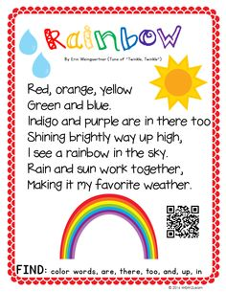
Welsh Welsh word for rainbow is enfys
Can you remember you welsh colours?
Try singing along with @ffalala Can yr enfys.

Suggested Book Bank
These books would be useful to enhance our learning this week. Look for them being read on *Youtube
Story Books (Fiction)
Rainbow fish.
Hare and the tortoise
How the crayons saved the rainbow

Try making butterflies from leaves, petals and stones – I found some lovely natural art left on my local walk for all walkers to enjoy – perhaps you too could make and leave your art work on your daily exercise route! #naturalartwork
Creative
Make a 3d rainbow using lego, socks, scarves, food etc or a simply draw/ colour paint a rainbow using all the 7 colours. What will you like to find at the end of your rainbow?

Language
1. Can you copy this week’s poems neatly into your book? Think about letter formations, spaces, capital letters, full stops, letters sitting on the line (tails swinging under). Remember to read back your work. (Note to parents – pupils can copy the poem or as a challenge you can read it and they can write it or the ultimate challenge, can they write it from memory?) don’t forget to read back through your work.
2 . Learn to read high frequency words ( in reading file) – How many can they read in a minute? Choose 5 words to learn how to spell. How could you use these words in a sentence? Think back to all the words you’ve learnt to spell previously as part of your high frequency challenge. How many can you remember how to spell correctly?
3. Our sound of the week is the digraph ‘ai’. How many words can you think of / find / read / spell with this digraph in it?
Remember
You can use the online games on
Phonicsbloom.com
Letters and sounds .com
Phonicsplay
To reinforce your sound recognition. They are all free at present.
Work on phase 3 / 4 .
Which games are your favourites? Let us know so we can play them in class too when you all return.** See new game link below for‘Small townSsuperheroes’language ganes
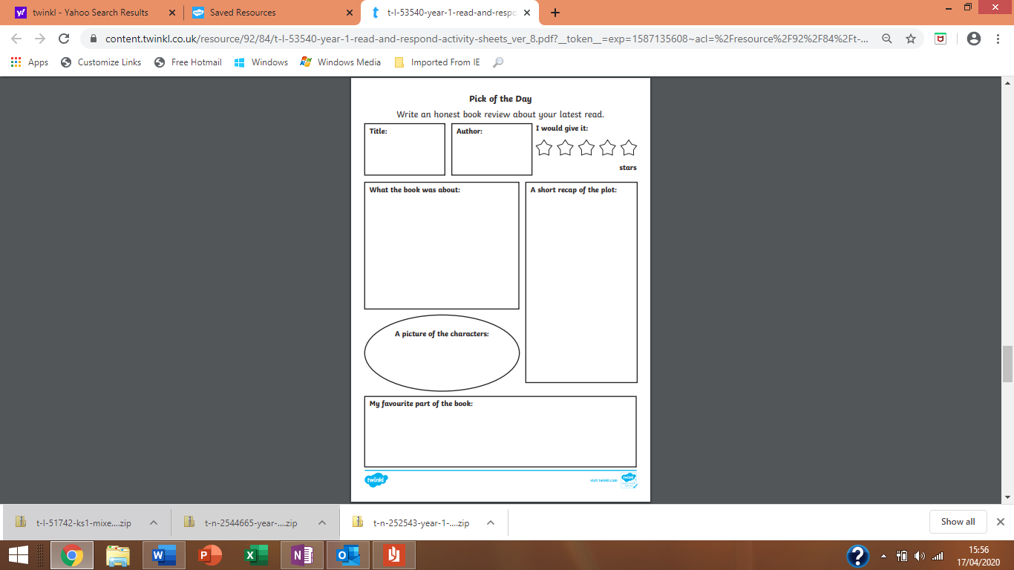
Book review- This week I’d like you all to review your favourite bedtime/daytime story once again. You can create your own Book review form or use the above format. Remember to encourage pupils to ask and respond to Who? What? Why? When? and Where? questions about the book that they are reading / sharing with an adult to develop a greater understanding, this will also help with comprehension tasks that will follow later in the term.

Create a factfile about rainbows. A fact file requires information. use this youtube clip to help you learn about rainbows https://youtu.be/nCPPLhPTAIk You can follow the format below, create your own style or how about simply folding an A4 sheet of paper in half and creating your own information book?
I’d like you to include –
A drawing - you could label this to extend your learning.
A title – the name in English and Welsh
Some interesting information about your focus of study-
Such as – What shape is it? What does it look like? When does it appear?. It’s colours. What’s the most interesting fact you learnt?

Language skills
Develop your language skills playing with Small Town Superheroes (link below) . The games with Annie (sound it out + spelling tricky words,) Ursula ( reading and understanding + signs, headings and captions ), Sally+Percy (simple sounds), Ernie (sentences + punctuation ) are particulary good and relate to out practise in class.
https://www.bbc.co.uk/games/embed/small-town-superheroes?exitGameUrl=http%3A%2F%2Fbbc.co.uk%2Fbitesize%2Farticles%2Fzncgvk7
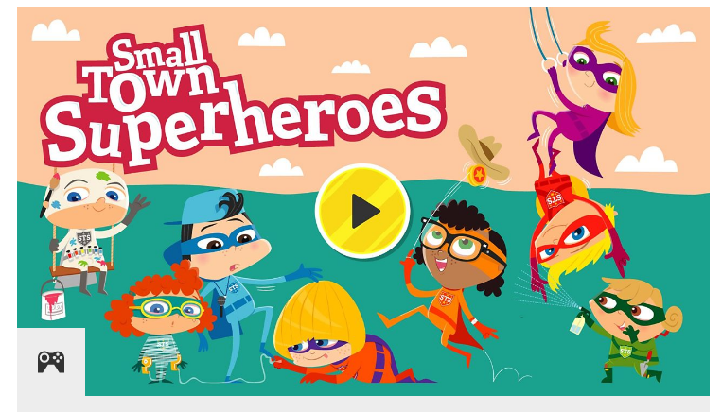

Rainbow song
https://www.youtube.com/watch?v=nkN6MPJSzAs
Listen carefully to the song . Listen again,, this time sing along with it .Think carefully, how many colours were mentioned in the song, listen again , were you correct ? Next can you write a list of all the colours that were mentioned in the song that are in the rainbow. Remember - when we've written lists in class we have written numbers at the start of each line to guide us. Can you think of 3 things in the world around us that are each colour.

Maths
Keep revising prepositions – on top of, in front , behind, under, over, above, inside ,below, through ,to the side of , in between you could extend this by revising the concepts of left and right too.
Encourage free, natural use of language. Continue to develop understanding through practical tasks. Perhaps you could use describe the route you took on your daily exercise, or the position of toys when playing or tableware whilst sitting at the table or even where food is on their plate – learning is everywhere!
How many 2d shapes can you recognise? Can you remember how many straight sides its got? Has it got curve sides? How many corners has it got?
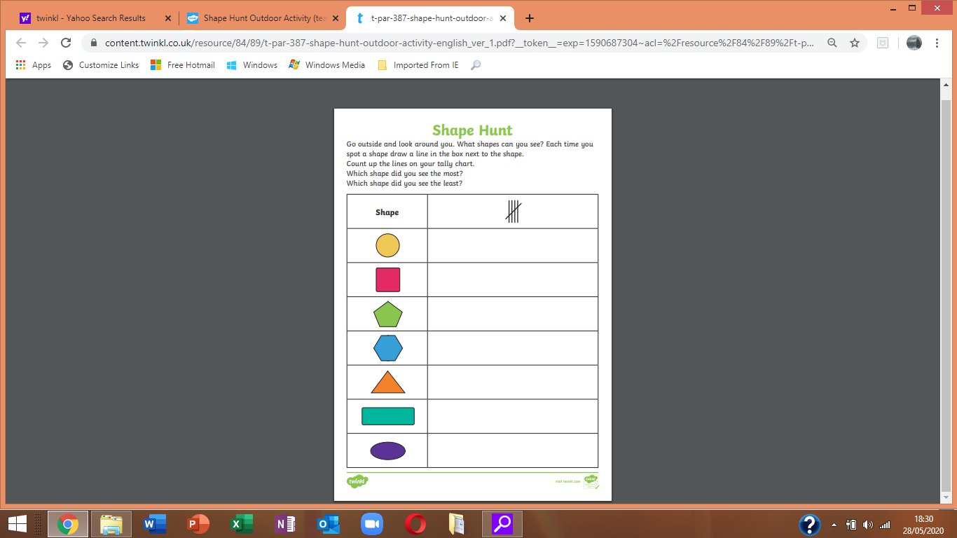

Number words
Use the number words and symbols from your homelearning pack or make some by simply cutting up an old cereal box, your child can help with this, if they help make it they ll want to play with it!
Play pairs/ snap to match each number word to each symbol , with number symbols and words to 20
You could also put these in numeriacal order too.

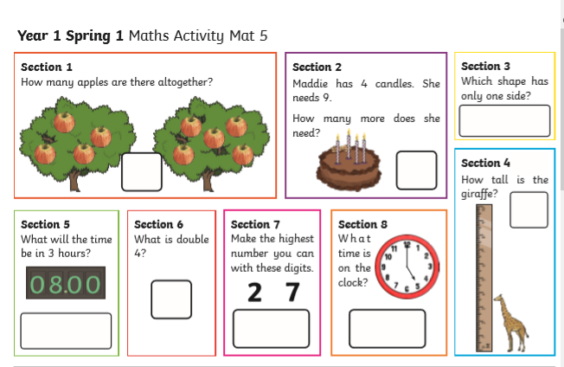
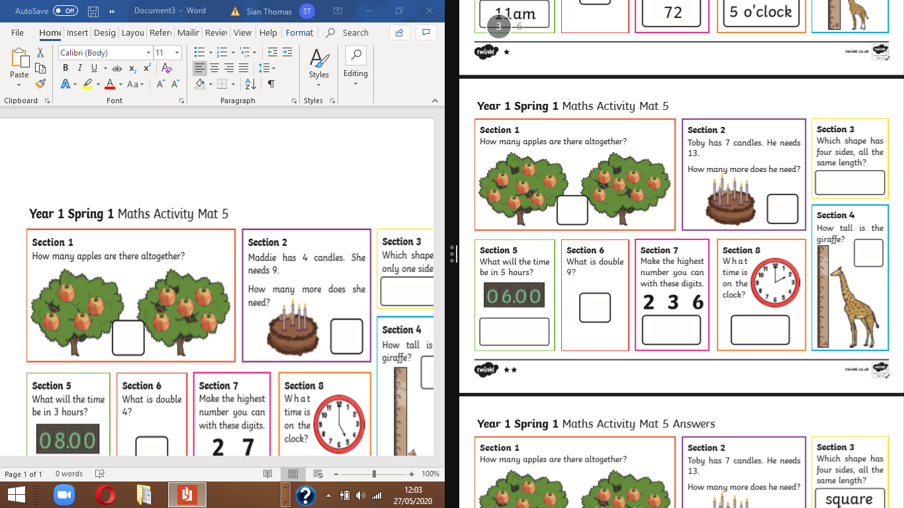

TIME
Time is an activity that needs to be continually revisited. Upload one response this week but please keep revising, use some of the activities below every day if possible.
This week - Make a time diary of your day . Ensure to use both, 'o' clock' and 'half past' the hour times in your diary.
Additional activities
*Set an alarm on your clock and stop to write down what you are doing at that time .
*Play on the topmarks time game (not the 24 hour clock section) work either from a full hour or half hour points .

Here are some youtube / topmark links to help you .
https://youtu.be/1fx7URfIGh8 number jacks time trouble
https://www.youtube.com/watch?v=5TA5z_DE204
https://www.topmarks.co.uk/time/teaching-clock
https://www.youtube.com/watch?v=r2K1Py9U87I

Place value
Our final activity is sorting 2 digit numbers into tens and units (little ones)

Heres a video from Number blocks to help demonstrate this learning and hopefully refresh your child’s memory https://youtu.be/oqasY-BAeEY
In class we use sorting frames similar to the ones below to work practically to partition 2 digit numbers. Pick any 2 digit number (I’d start with teen nos and slowly increase) and partition the number to demonstrate its value. Try this activity with 6 different 2 digit numbers.
My Number is ……..

I have ……..little ones (units)
I have …… towers of 10



