Williamstown Primary

Home School Learning Pack Year 3 W-C 1/6/2020

Useful Websites
TWINKL- free code 1 month = PARENTSTWINKLHELPS
BBC BITESIZE TOPMARKS- Hit the button
SCHOLASTIC HWB
Hello Year 3, I hope you are all safe and well, still working hard but also having as much fun as possible
Here is your new pack for this week including English work, spellings, and maths challenges!
Remember to keep reading, stay safe and keep in touch with your friends when you can
Miss Thomas x

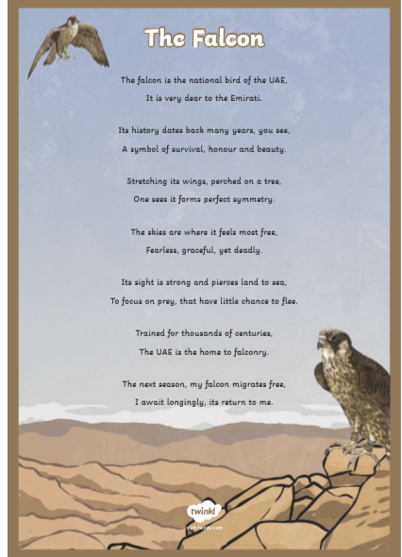
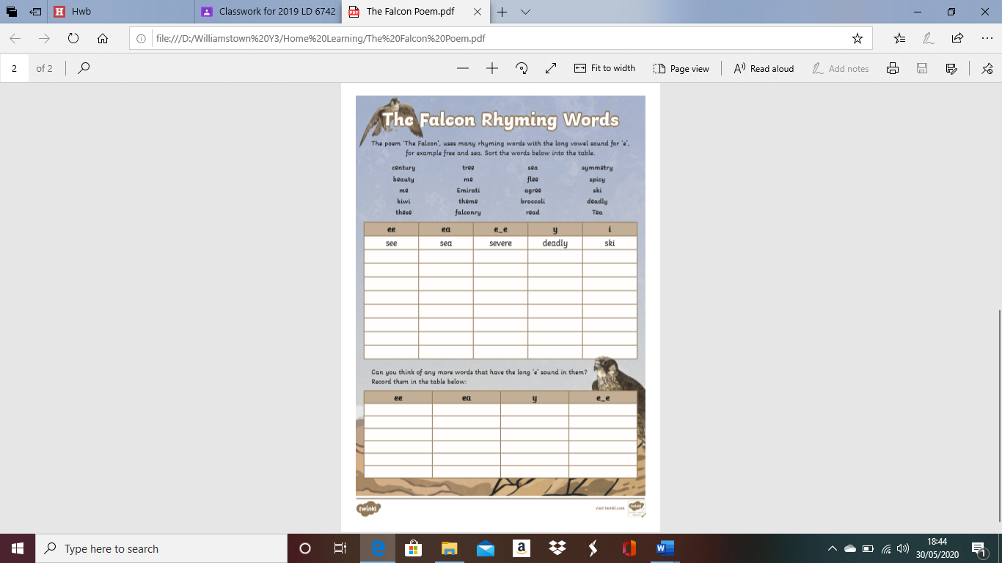
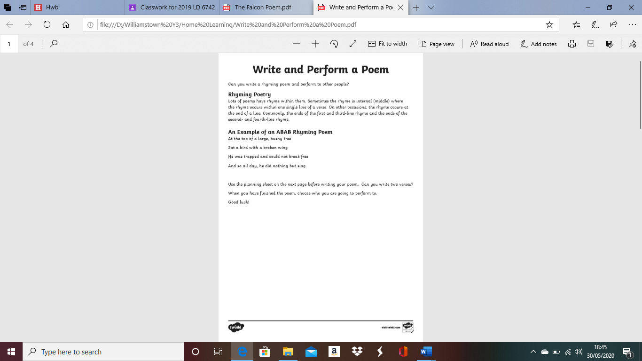

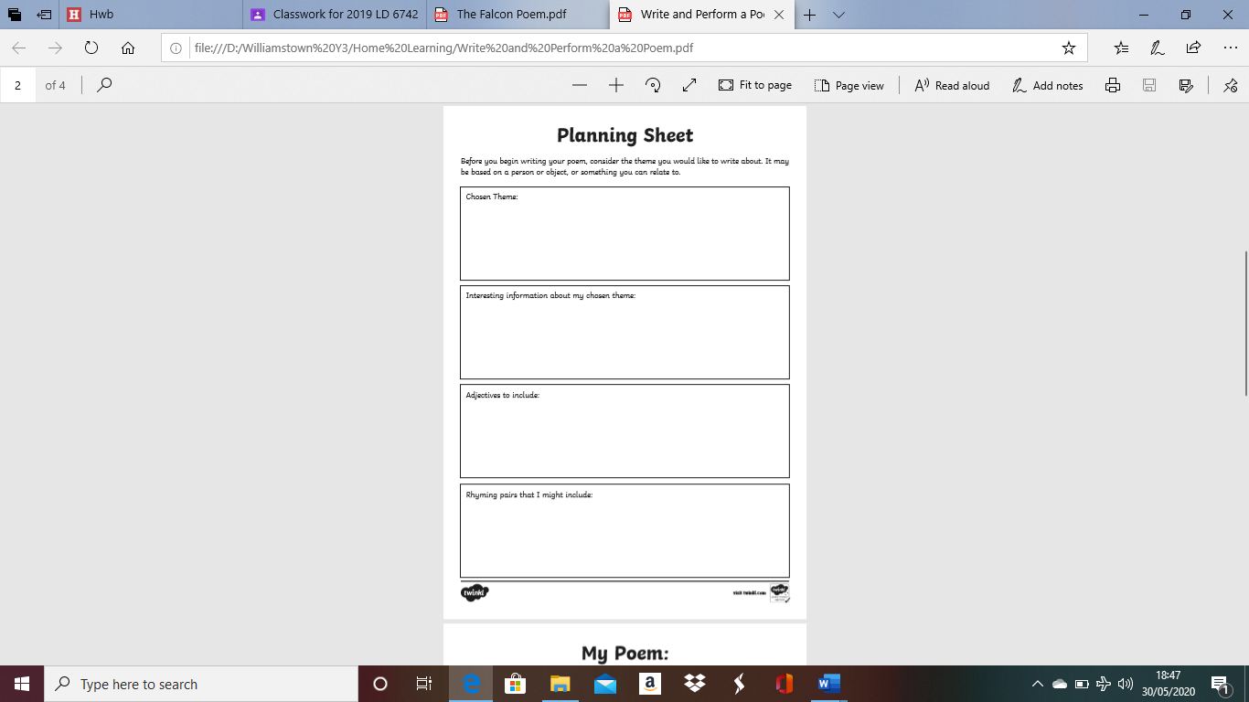
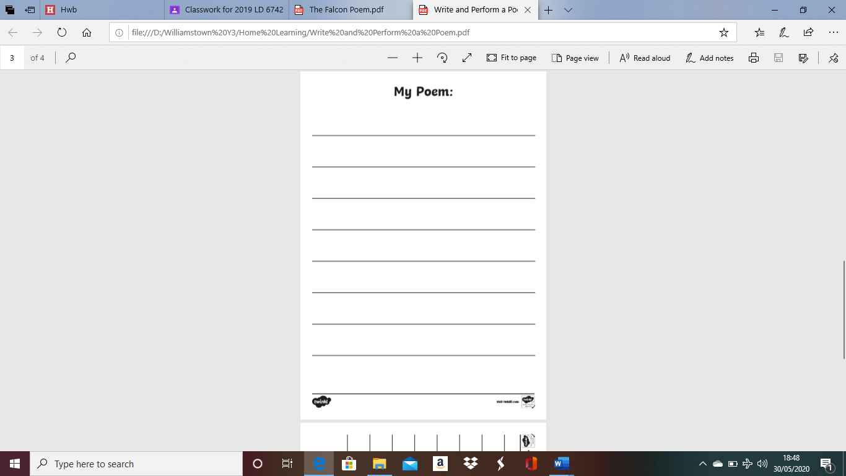
Undertake research on a famous children's poet! You can choose from 1) Roald Dahl 2) Edward Lear or
3) Robert Louis Stevenson.

Use the writing frame to help you research your chosen poet.

Extra Task: See if you can find any of their poems and read through them carefully. Can you identify any rhyming words? How are they different to other poems you have read before?

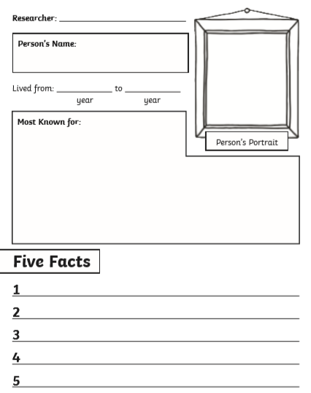
For this weeks spellings I would like you to practise these common exception words that children often misspell or find tricky.

Remember to practise writing them out 3 times and then use the word in a full sentence!
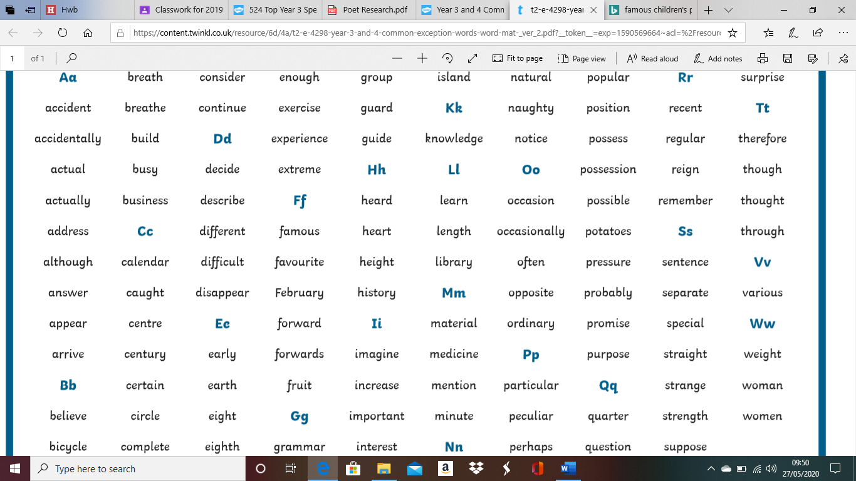
BBC Bitesize English links!

Follow the link for this great activity on using formal and informal language. This can really help your understanding and improve your writing.

https://www.bbc.co.uk/bitesize/articles/zkkj2sg

Follow the link to have a go at this great reading activity on BBC Bitesize!

https://www.bbc.co.uk/bitesize/articles/zkttpg8

BBC Bitesize Maths Link!

Follow this link to learn about tenths!
https://www.bbc.co.uk/bitesize/articles/zmcny9q

BBC Bitesize Fractions!
Follow this link to learn more about shading fractions!
https://www.bbc.co.uk/bitesize/articles/zkmg47h

Use the BBC Bitesize activity and your own knowledge to help you to complete the shading fractions worksheet. You can choose mild, medium or hot.

Mild= 1 star at the bottom of the sheet Medium= 2 Stars Hot= 3 Stars

Remember if the question asks you to shade 1/4 of a shape that means 1 out of the 4 sections the shape has been split into. If it asks you for 2/6 that's 2 out of the 6 sections etc.

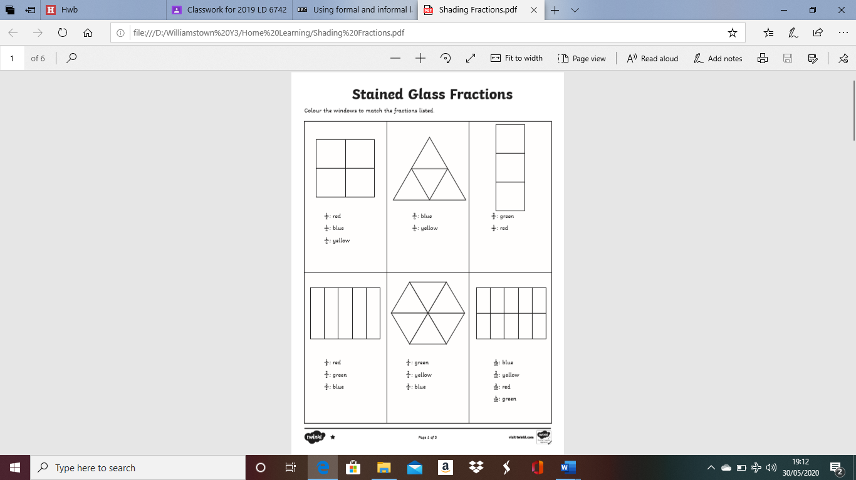
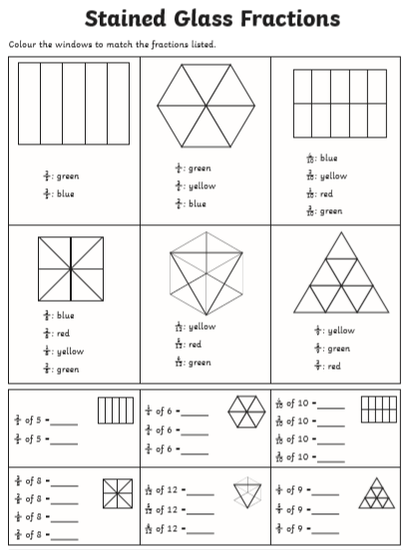
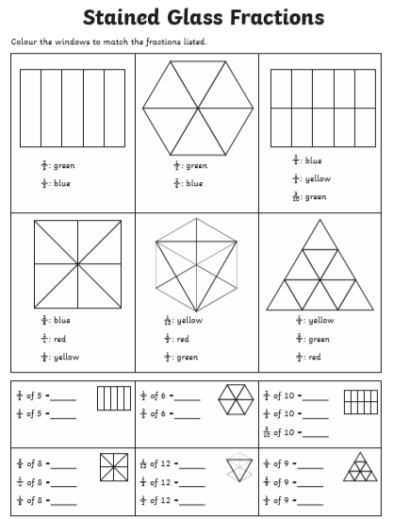
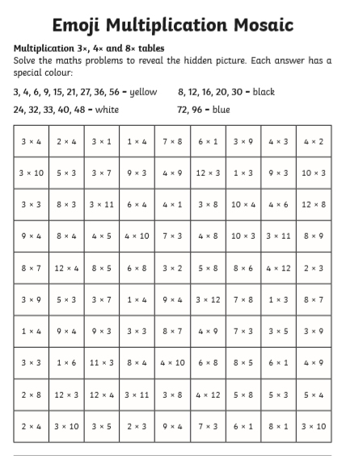
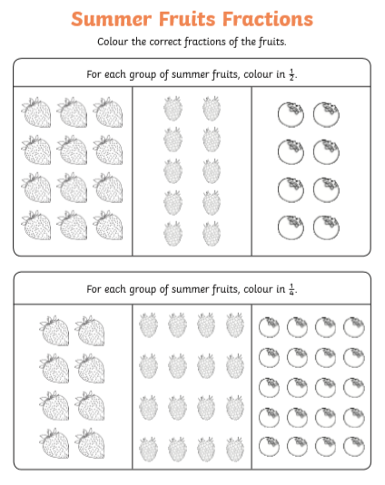
Have a go at these carrot themed addition and subtraction challenge cards! There are mild, medium and hot ones to choose from!

Mild= 1 star Medium= 2 stars Hot= 3 stars


