
W/C 1st June 2020

Hello,
I hope you all had a lovely half term break. Williamstown primary have decided to start using Google classroom through Hwb to teach online. Over the next few weeks I hope that all of you will have a go at downloading the ‘Google Classroom’ app onto your mobile phones or signing on using a laptop/PC. When you want to hand in work you will be able to upload files from your computer or take photographs of your work and sent them to me by posting them online.
In maths this week, I would like you to have a go at the temperature worksheets. Although you have all done temperature with Mrs Clement, I would like you to have a go at learning about ‘negative numbers’. It is very tricky and on Google classroom there are some videos and PowerPoint’s to help you. You could draw a number line in chalk on the floor and jump the correct number to work out the answers to the questions.
In Literacy, I have introduced apostrophes to make words shorter. Have a go at the worksheets. There is also a PowerPoint on Google classroom to work through. This week I have not given you the next set of spellings. Please can you ask someone in your family to test you on words so far? If you wanted, you could send me your score out of 10 for each set of words on Google classroom. You can send it as a ‘private comment.’
From now on, I will put Maths and English work in these packs, but there will also be a range of topic activities for you to choose from in Google classroom. Please do not worry if you don’t get all the activities completed over the next four weeks, we are all learning how to use Google classroom together. Try and download the app and message me when you are logged on. There are lots of videos on you Tube on how to use Google classroom and I have attached two links on the next page.
Take care and I hope to see you all soon,
Mrs Jones.
Important Information!
We have decided to introduce Google Classroom to continue to deliver online teaching from June 2020.
Please watch the following links to find out how to log onto Hwb and then Google Classroom.

‘Logging in to HWB + Google Classroom’ on You Tube

https://www.youtube.com/watch?v=rMP_v_tC6Ko

‘HWB & Google Classroom Tutorial Video’ on You Tube

https://www.youtube.com/watch?v=LhCjrTteqxo
If you do not have your Hwb login details, please let either myself or Mrs Webber know when we telephone you and we will be able to give you this information. There will still be learning packs put on the school website until July, but please try and log on to Google classroom as soon as possible. The attached poster gives some information about the benefits. We will be able to communicate with each other as a class and you will also be able to show me what activities you have completed.
The first assignment for after half term has already been set. Please can you upload a photograph of your favourite animal?

Mrs Jones

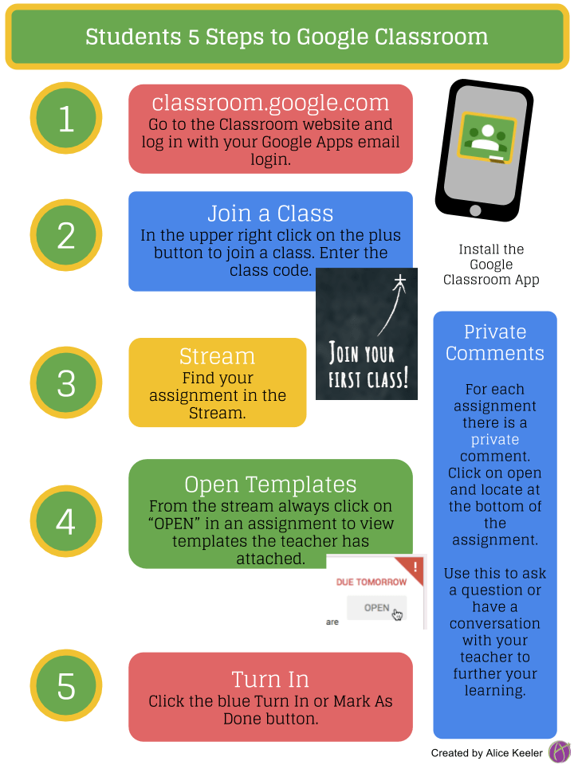
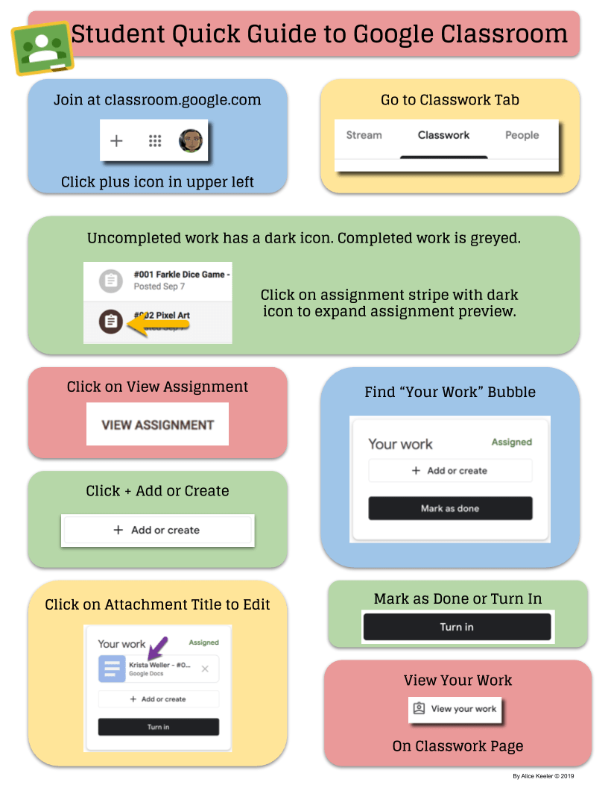
Numeracy
Medium Chilli Challenge

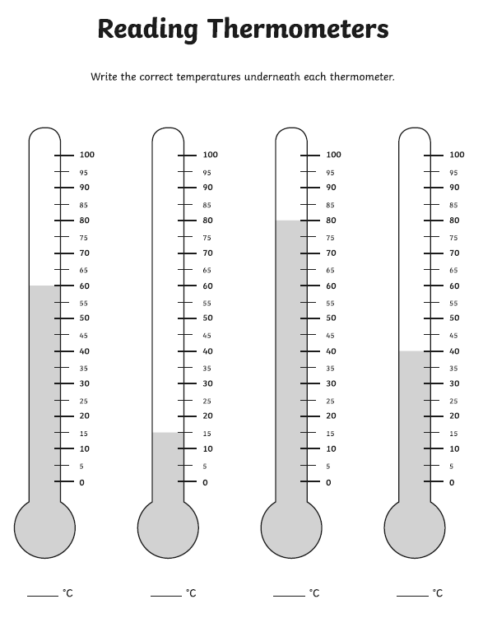
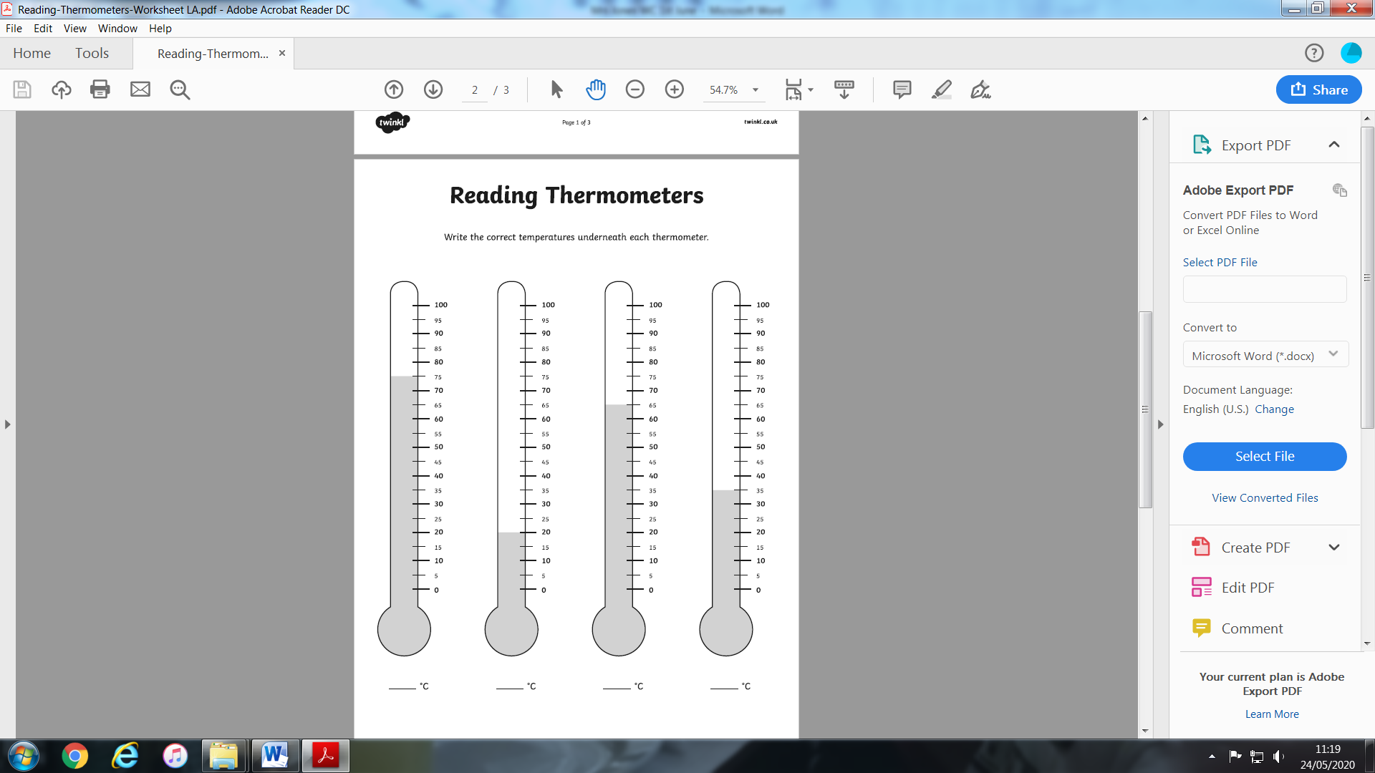
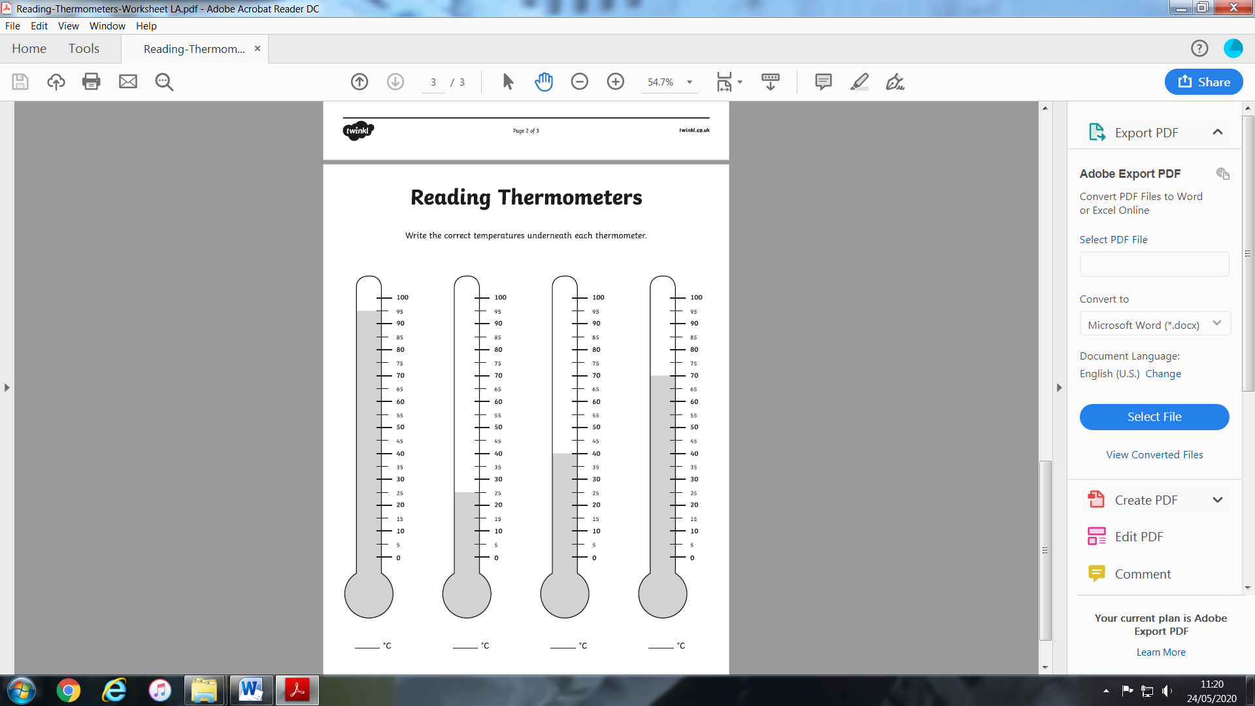
Hot Chilli Challenge

What are positive and negative numbers?
Any number above zero is a positive number. Positive numbers are written with no sign or a ' ' sign in front of them and they are counted up from zero to the right on a number line.
Any number below zero is a negative number. Negative numbers are always written with a ' ' sign in front of them and they are counted down from zero to the left on a number line.
Always look at the sign in front of a number to see if it is positive or negative.
Zero, , is neither positive nor negative.
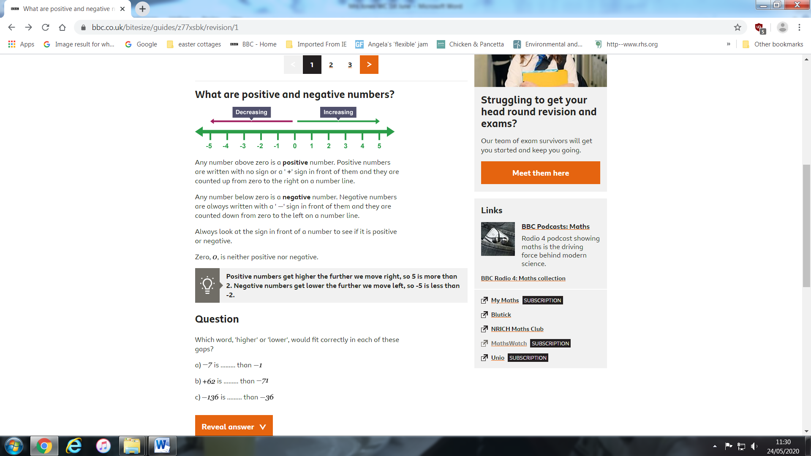
ADD
TAKE-AWAY

Remember when you ‘add’ you have to make the number bigger (move up the green arrow). When you ‘take-away’ you move down the red arrow.
Put a tick next to the correct answers:
- 0 + 4 = 4 5. 5 – 2 = 3
- -2 + 4 = 4 6. 2 – 4 = - 2
- -5 + 3 = -2 7. 1 – 5 = -4
- -2 + 5 = 7 8. -1 – 2 = -5

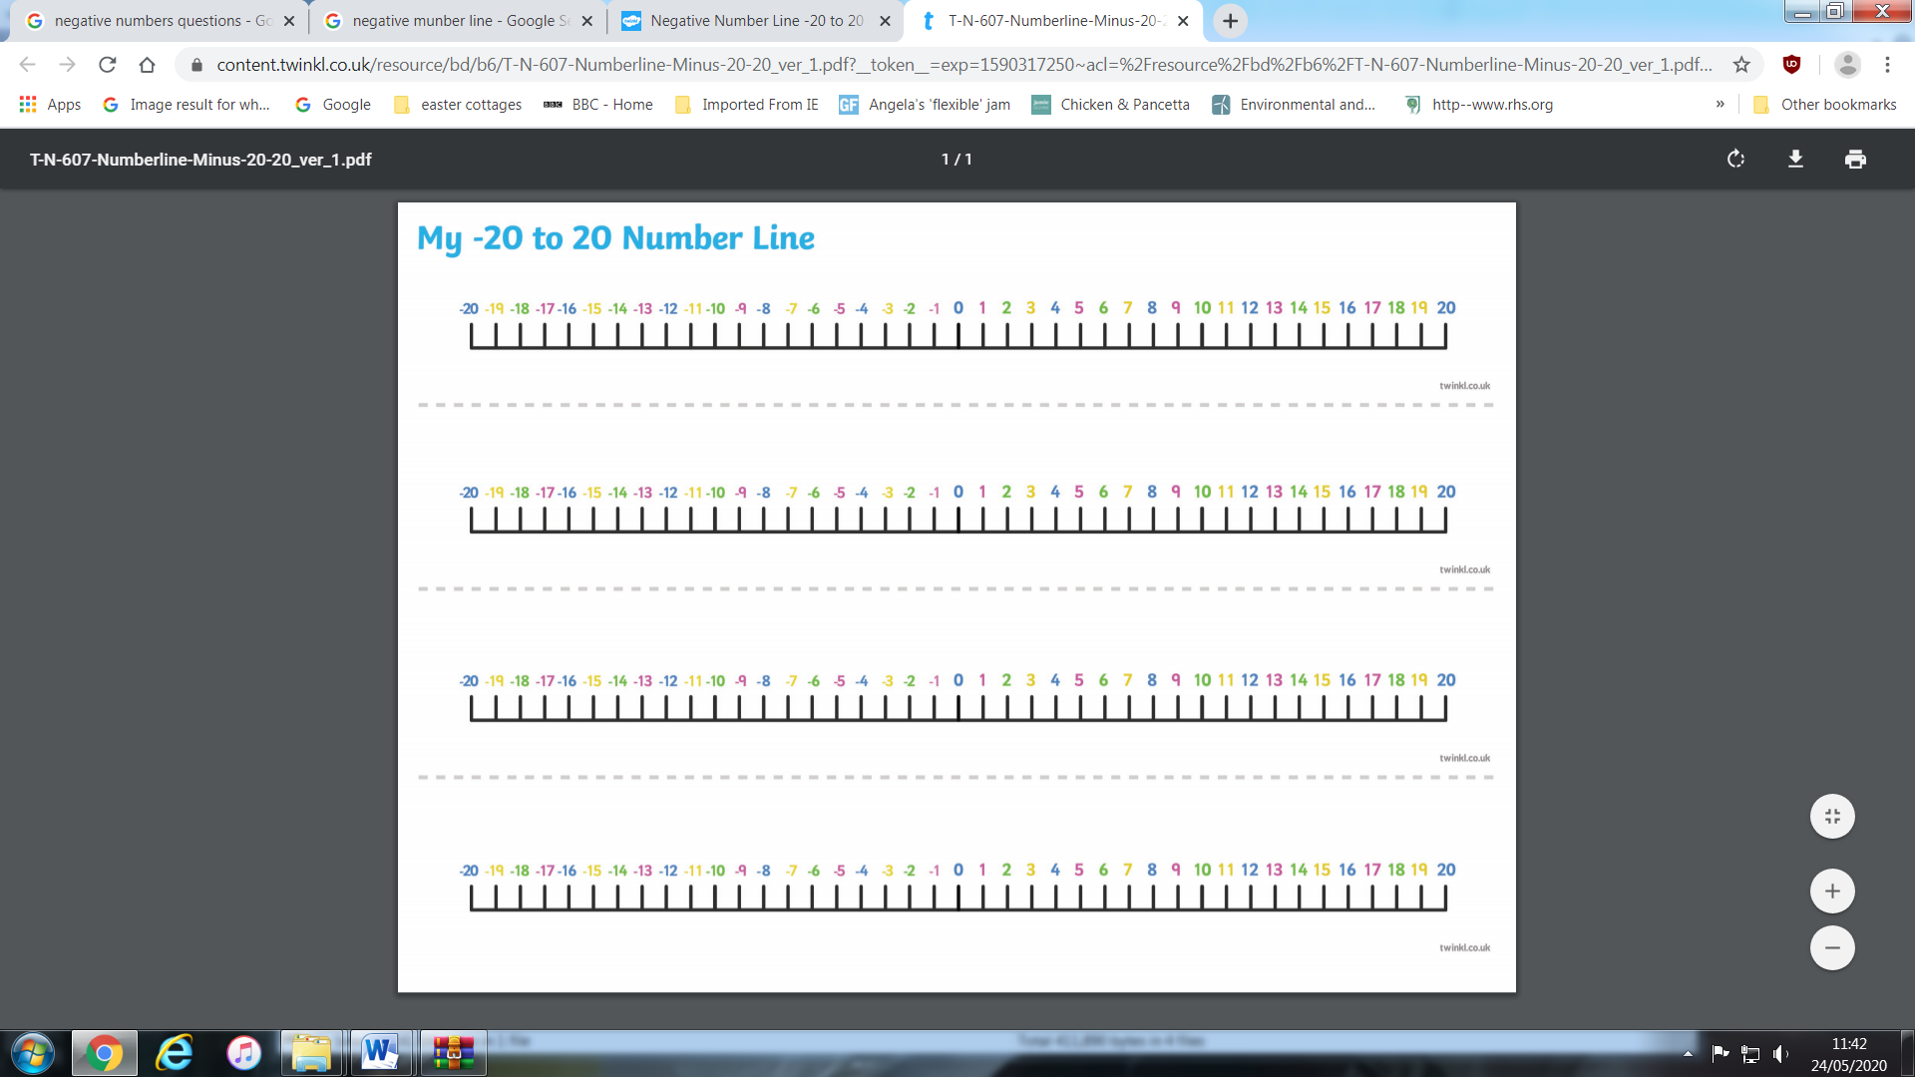
1) Use your number line to help you answer the following:
a) 4 – 7 b) 3 – 10 c) 4 - 5
d) -2 – 5 e) -4 + 8 f) -2 – 7
g) -4 – 4 h) – 5 + 3 i) -4 – 2
j) -6 + 2 k) -6 – 2 l) -5 - 5

2) Use your number line to help you answer the following:
a) -4 + 2 b) -4 – 6 c) -5 – 2
d) -5 + -1 e) 5 + -2 f) 6 + -3
g) 4 - -2 h) 3 - -4 i) -2 + -3
j) -2 + -5 k) -3 - -6 l) -4 - -2

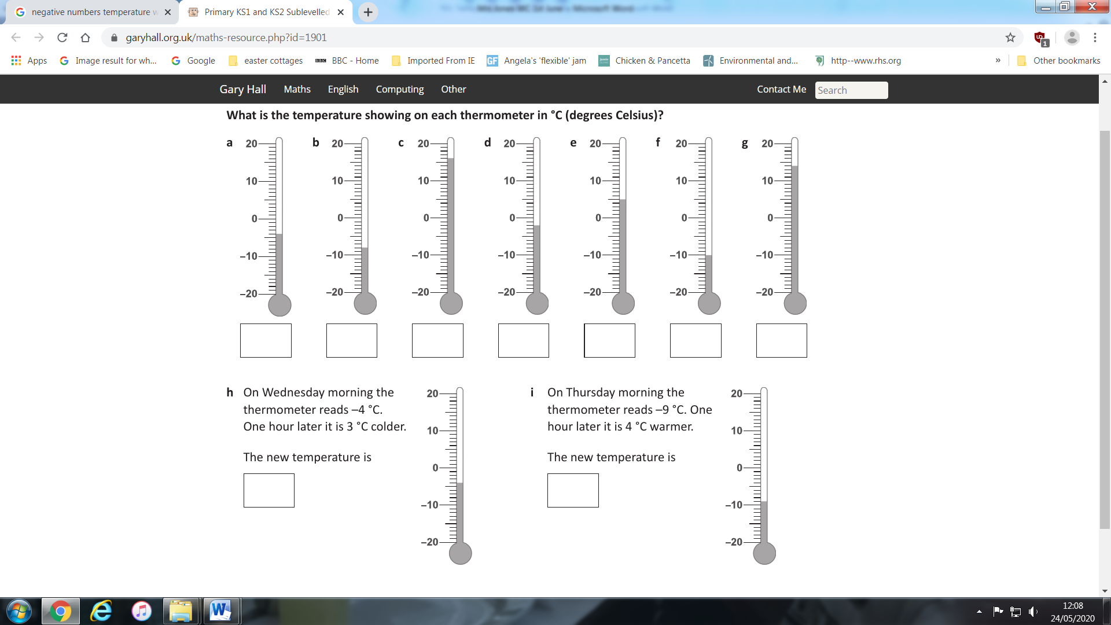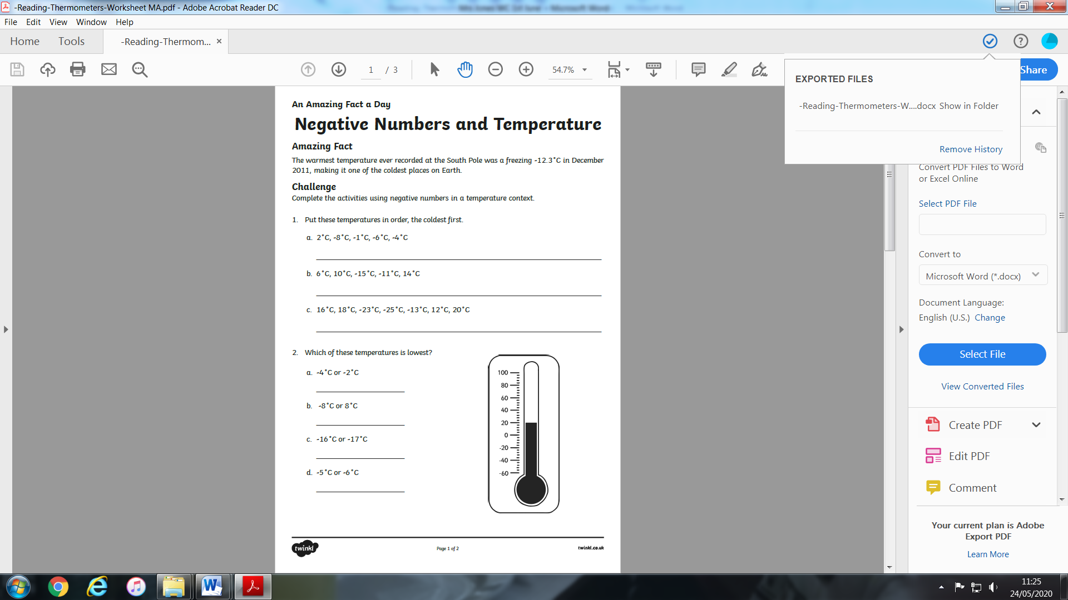
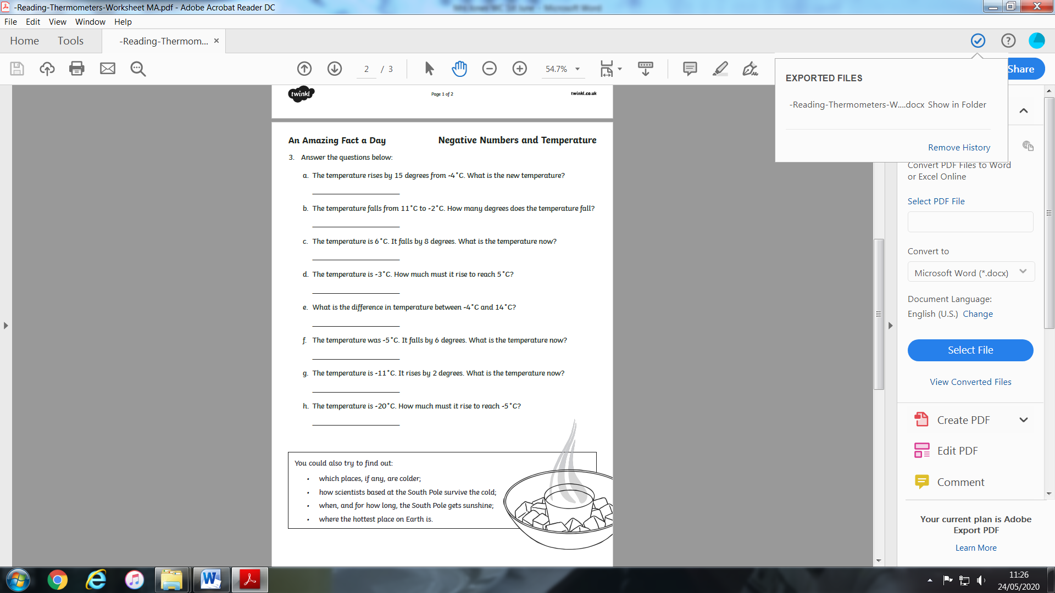
Literacy

Non-fiction reading and comprehension.

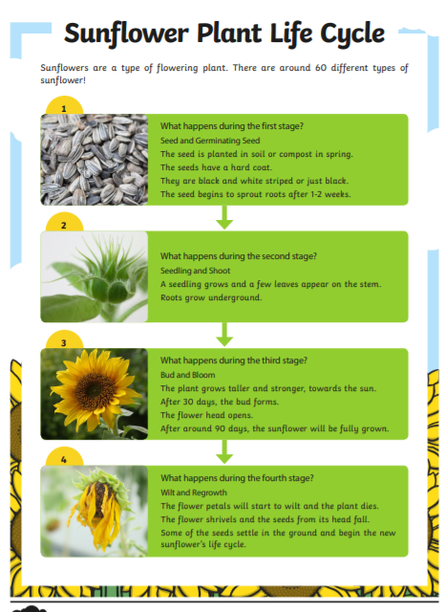

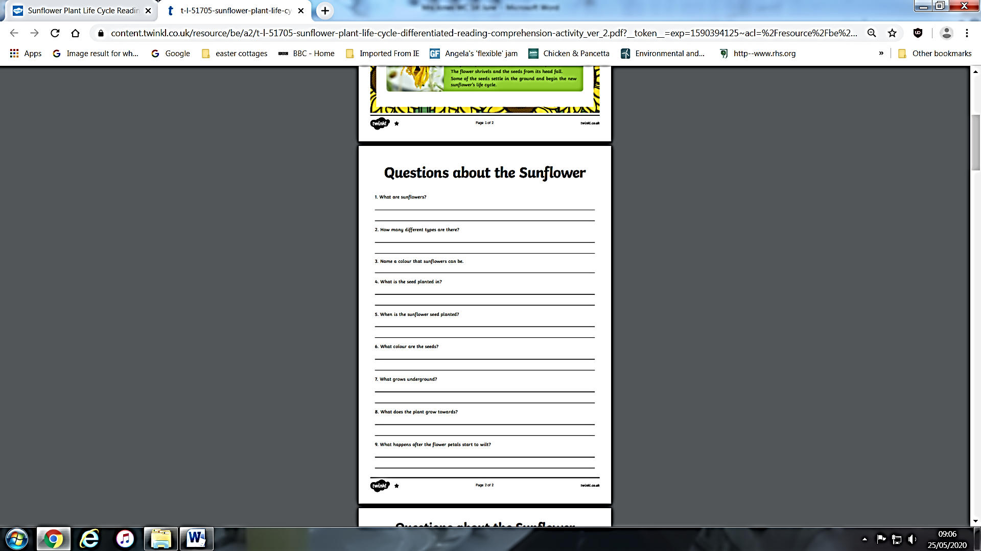

Grammer - Contractions
You can use apostrophes to show that you have omitted (left out) some letters when you are joining words together.
For example, you can join the words ‘you’ and ‘are’ together. You + are = you're. The apostrophe takes the place of the removed letters. In this example, the letter a.
Sometimes, however, you need to rearrange the letters a bit when you contract the words. For example: will + not = won't.
Using contractions like these makes your writing easier to read and more friendly.

A simple way to explain it is to say that a contraction is “a shorter way to say two words.” Oh, and that apostrophe– it fills the space of those missing letters.



