Week 8
Week Beginning 01-06-20

Hello everyone. I hope you have been staying safe and enjoyed the beautiful weather we have had over half term.
Can I say a huge thank you to those of you who have been using the google classroom app. I have loved seeing all of your children engaging and having fun with their learning. You are all doing a brilliant job.
The first part of this term we are moving on to learn about ‘Farm Animals’
Some children have sent me their videos of which animal they would like to learn about, I have selected one randomly. The first animal we are going to learn about is the ‘Chicken’ The children have asked
“Where do they come from and what do the eat?”

Below is a link to help your child understand where a chicken comes from:
Ctrl and Click or copy and paste
https://www.youtube.com/watch?v=7jvbsZGGe6s

If you are out for your exercise and come across some allotments or small holdings, with chickens on them. See if your child can find the answer to what they eat by asking the question.
Alternatively, please can you help your child use the internet to find the answer.
When they have the answer please can you send me a video of them, telling me what they have found.

Language and Literacy

- Read, watch or listen to the story of Chicken Licken. There are lots of versions available, some have happier endings than others, so you may want to watch it before your child does. However, I have found this one on You Tube that does have a happy ending. Ctrl & click the link below :
https://www.youtube.com/watch?v=gzZbtMFP-_I

- Ask your child open ended questions about the story.

- Can they remember the sequence of the animal’s Chicken Liken met on his way to visit the king?

Here are some visual prompts to help.
If you have a printer you could print these and make puppets by sticking them onto lollipop sticks or twigs. This would enable your child to retell the story using the props in the correct order.
Alternatively, your child might have similar characters in their toy farm animals which could be used to retell the story.

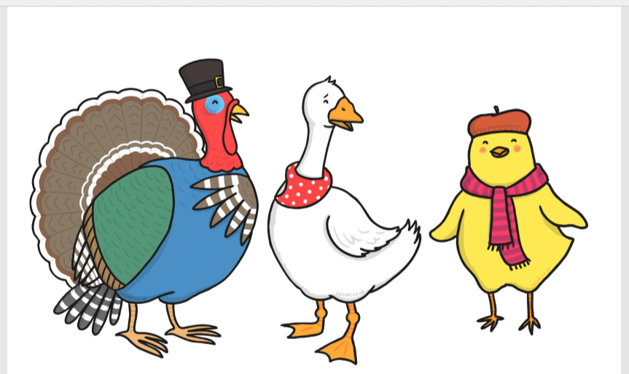

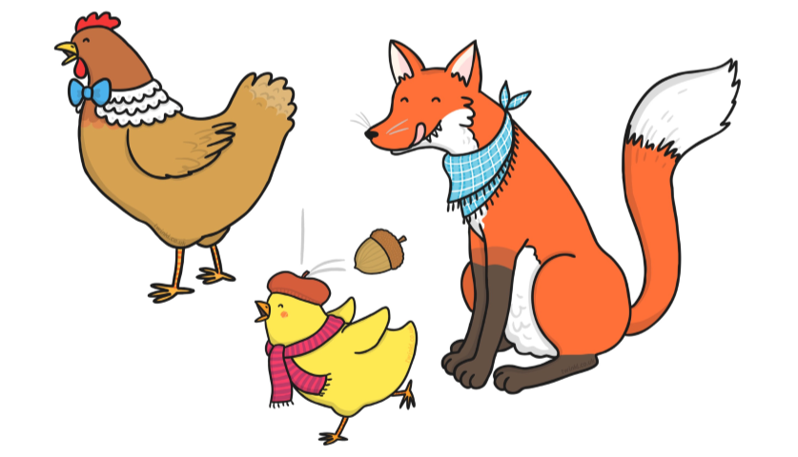
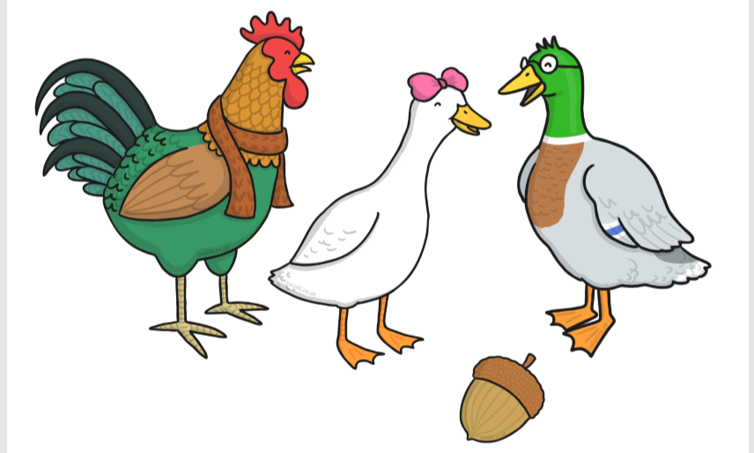

- Ask your child to draw a picture of the story, trying to include all of the characters.
When they have finished ask them what they have drawn? and write their answer on the picture. Hopefully they will be able to tell you in a clear sentence. If not ask them what each individual picture is and label it for me to see. Some children may also want to attempt writing the animal names their selves, this is fine and should be encouraged.
This is an important aspect of their learning showing that they have understanding of what they have created. Send a picture of their creation to me on goggle classroom please.

- Please continue to help your child to recognise all of the jolly phonic sounds.

- Also please continue to help your child recognise their name and other common logos in the home and environment.

Mathematical development

- Ask your child if they know whether a chicken has feathers or fur?
Can they think of any other animals which have feathers?
Help them make a list of these either by drawing, cutting out pictures or using their toys. Send me a picture of the list on google classroom please.

- Play a game of which do you think is heavier/lighter?
You think of two animals and ask your child which is heavier or lighter?
You might be surprised by their answer.

- Fill a bowl with some water
Use a fresh egg, hard boiled, and a blown egg.
Ask your child which ones will float or sink. You can also use any house hold items or toys for this experiment. Again, I think you might be surprised by some of their answers.
Please send pictures or video evidence on Google classroom to allow me to monitor your child’s progress.

- Below are some shapes for your child to cut out and make a 2D chick.
If you don’t have a printer you could draw the shapes on paper for your child to colour and cut.
This time of year in Nursery we would start discussing simple symmetry with the children.
An easy way to introduce this could be once they have completed their chick, to fold it perfectly in half. Show your child how it is symmetrical.
The children also love experimenting with half pictures held against a mirror to make it complete.

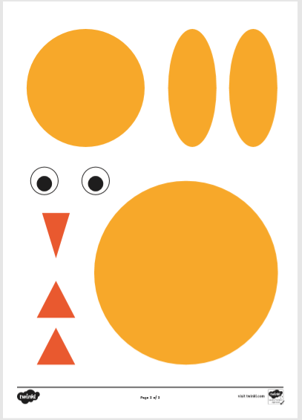

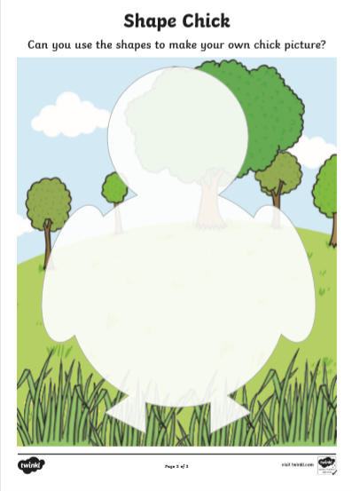

Creative Development

- As chicks hatch from eggs why not get creative with empty egg shells.
- Please Send me your creative results.

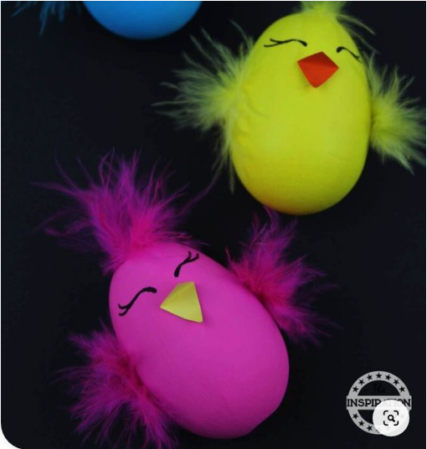
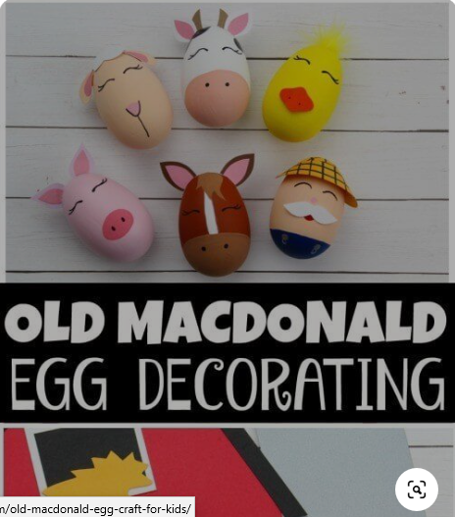

- Humpty Dumpty was an egg. Ask your child to sing it to you. We sing 3 different verses in school. Can your child remember them?

- Here is a link for a song that we would also have been learning in school at this time. Please help your child to learn it. See if they can add any fun actions to the song and send them over on google classroom please.
https://www.youtube.com/watch?v=IEey4LZLeGw

- As our theme is Farm Animals ask you child to sing old Macdonald has a farm with you. Can they put actions with the words for each animal?

Physical Development
To help with your child’s physical and mental wellbeing try this
‘On the Farm Cosmic Yoga’
https://youtu.be/YKmRB2Z3g2s

Lots of the parents are saying how much their child enjoys these sessions

The joy of Google classroom is that you can send me pictures or videos of your child’s many achievements. Which in turn allows me to return feedback which can be passed on to your child. Please keep them coming to allow me to monitor their progress and plan appropriate activities for them to enjoy.

Have lots of fun
Be as creative as you like.
Please continue to stay safe.
Huge Hugs
From Mrs Edwards and the Nursery Team xx

