Summer 2 Week 2
Reception- Topic

Hello everyone,

This week has brought some good news about us returning to school. You will be emailed regarding arrangements for this, we are currently waiting for updated guidance from the welsh assembly but have already had several meetings to put plan in place. I have put quite a lot in the topic work in this week but don’t panic do it over two. Weeks and I won’t add much topic next week.

This weeks learning

Literacy/ language:

This week in both Reading and Oracy we are going to be focussing on rhyming words and making sure you can identify sounds and words that rhyme.
Activity 1: To kick start this off I have collected some poems/ rhyming songs for you to learn and say at home related to the seaside. When you do these can you add actions.
At the top of each one it tells you which tune you need to say the song or poem to.

- The sun cream song

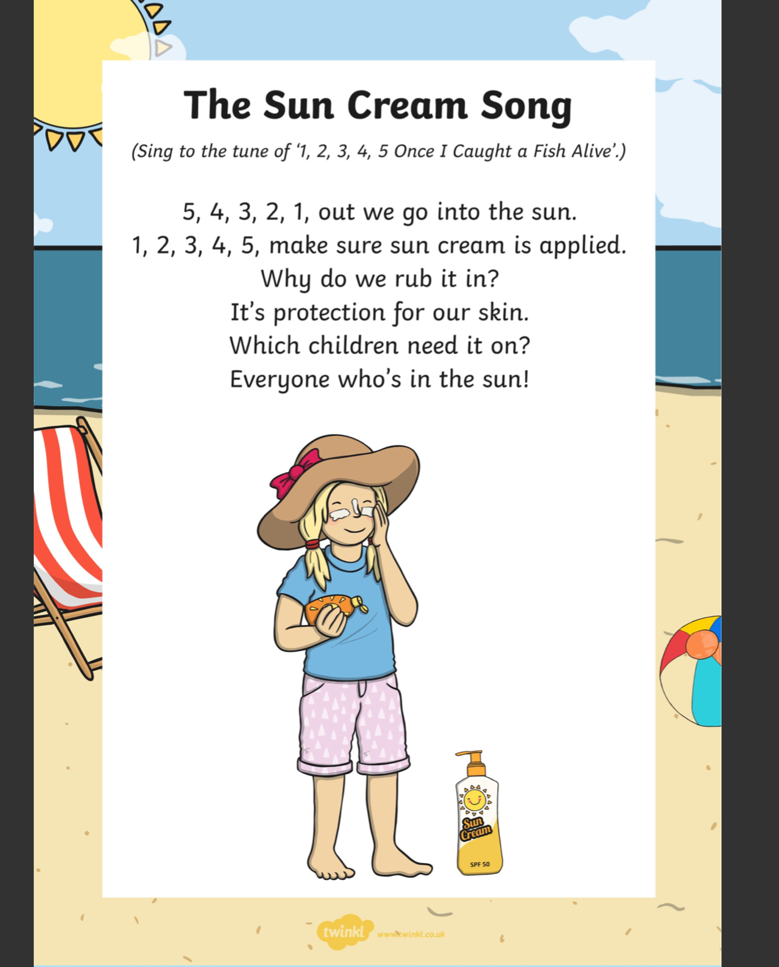
- Summer Clothes Song

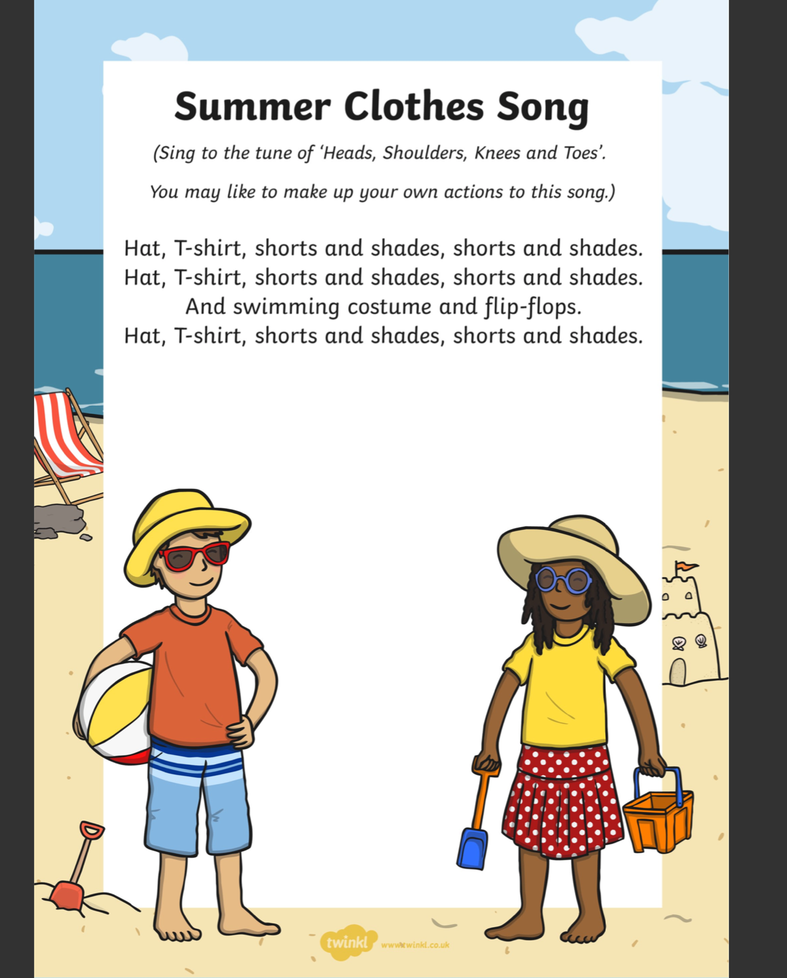

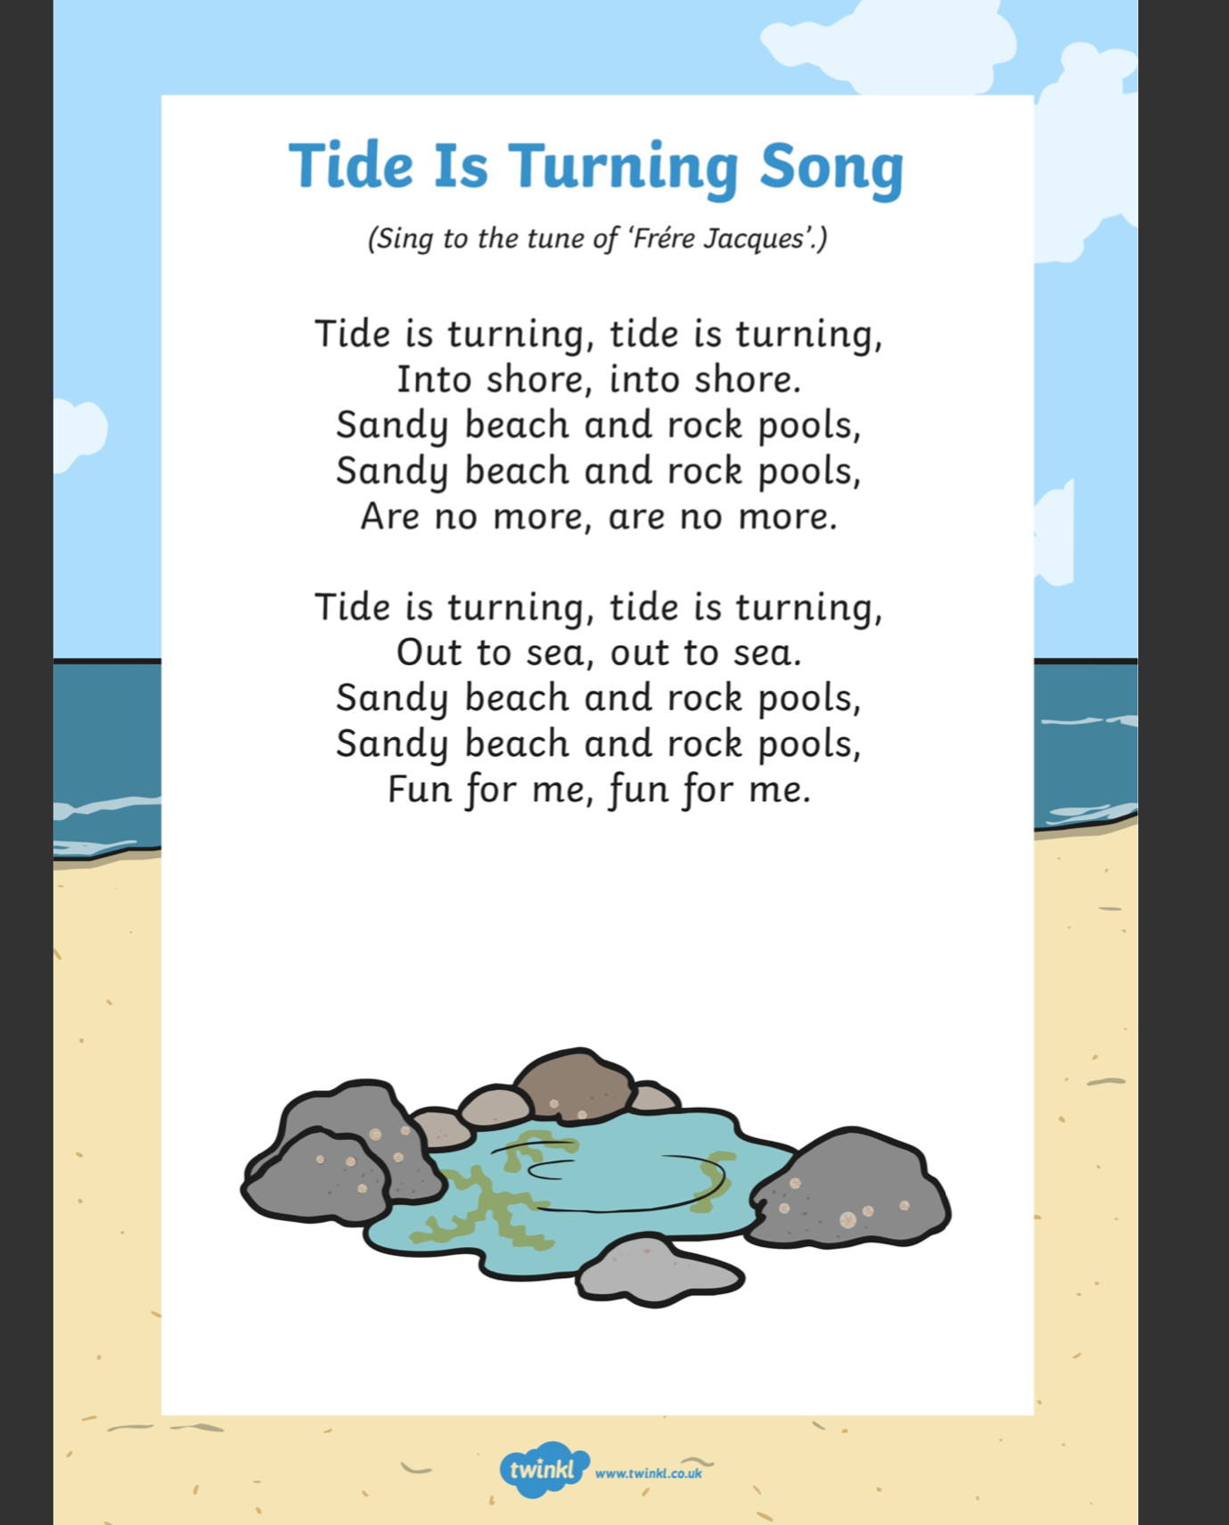
- Tide is Turning

Activity 2-
After learning the songs/ rhymes and performing them, can you teach them to someone else?

AND

Activity 3-
Can you make a list on paper or in your book which words are the rhyming ones eg: ‘skin’ and ‘in’ and ‘shore’ and ‘more’.

Activity 4-

Can you think of any rhyming words for this seaside vocabulary and write them down?

- SEA
- SAND
- SPADE
- SUN
- BALL

Numeracy

This week we will be looking at measuring and in particular length.
To introduce you to this -view the powerpoint. Attached to this link.

https://www.twinkl.co.uk/resource/t-n-2545213-ks1-seaside-measuring-powerpoint

This week we are looking at measuring length using non-standard measures.

Activities to try at home
How long are we

The Activity
The child lies down and the adult ‘measures’ the child, by putting a marker by head and feet, then stretching a piece of tape as long as the child. They find out how many pens will match this, carefully placed end to end, making sure they are straight, with no gaps or overlaps. Repeat with other things of uniform length, some long, some short (such as rolled up sheets of newspaper, spoons, buttons, Lego or Duplo bricks) to make several ‘trails’ of equal length and compare the results.

Sock washing line

The Activity
Set up a long washing line with pegs and a washing basket of different sized socks, so that children can find pairs and peg them up. For this activity the focus is on size and length, rather than colour or pattern, providing opportunities for comparing and ordering. Include some odd socks.

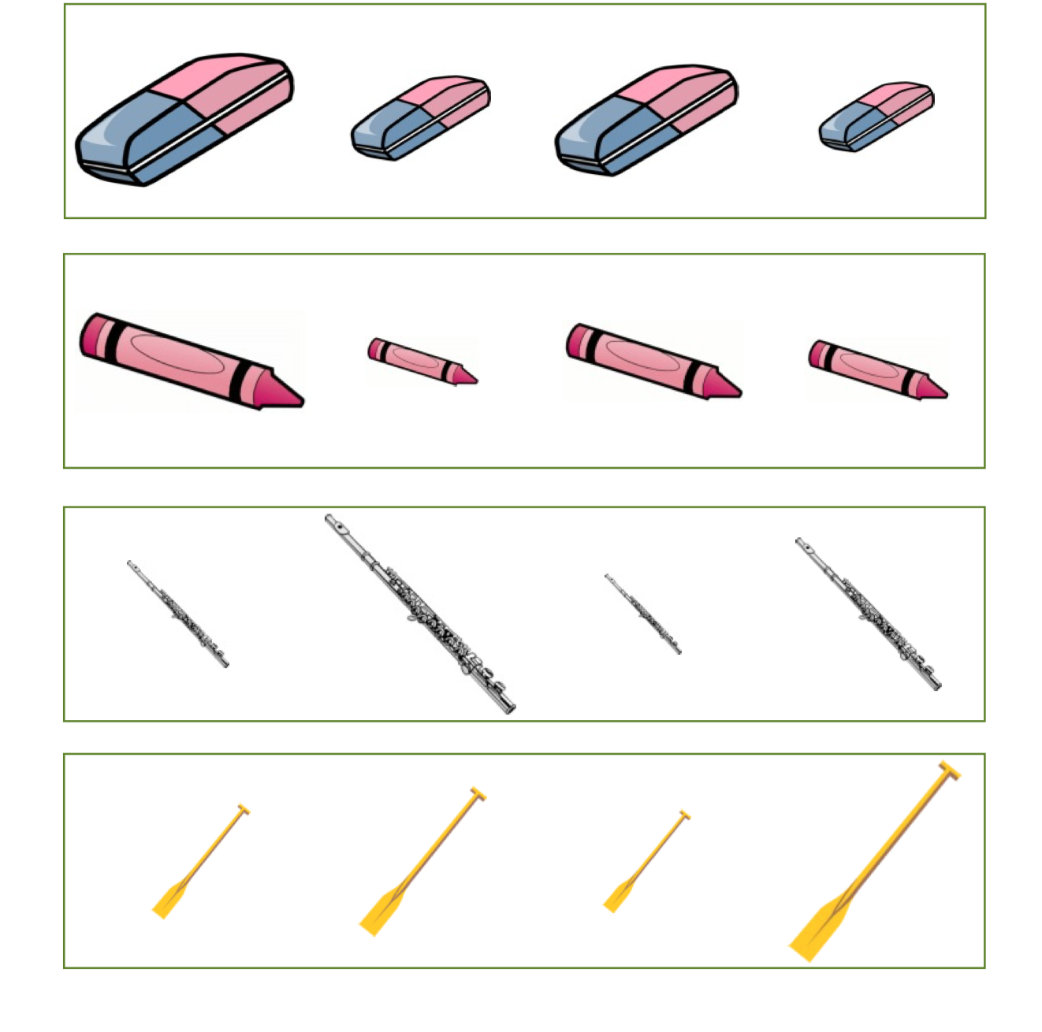

Topic:

What are you going to pack to go to the seaside?

Draw or write what you would take, think about things such as goggles, sunglasses, sun cream and not just clothes!

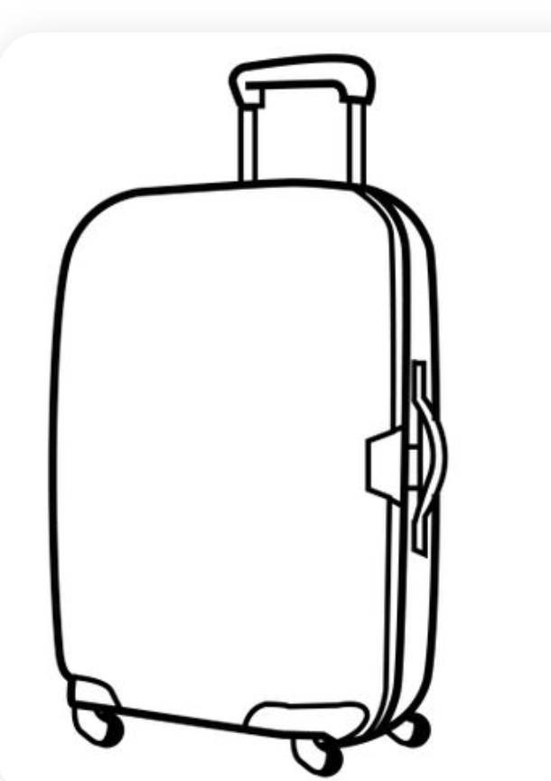

Rock Pool Habitats

Exploring rock pools and creatures that live in them.
This week we will be exploring creatures that make the ‘Rock Pool’ their habitat. A habitat is a place you live so your habitat is your house, a worms habitat would be in the mud in the garden and a squirrels habitat would be in the woods with lots of trees around.
Watch this clip with us just over 3 minutes where two people find some creatures who have made the Rock Pool their habitat ( home) it also explains that a rock pool is a pretty tricky environment to live in.
At the end of the clip can you name any of the creatures you heard about, some of them have funny names which you may never have heard of so this is all new vocabulary that your learning. Get an adult or big brother or sister to write them down for you and see how many you remember

https://www.bbc.co.uk/bitesize/clips/zpfnvcw

What else lives in a rock pool?
The next PowerPoint will tell you about even more creatures which make the rock pool their home.
You will need an adult to read this to you and discuss.
At the end chose one of the rock pool creatures that you find the most interesting. Can you draw it? Use the pictures in the presentation to help you.
Can you remember three things about it?
You could record yourself saying them an upload a video. Really simple facts ( things that are true) like,
A starfish:
A starfish is not a fish
A starfish doesn’t have a heart
A starfish eats mussels
You could hold up your picture as you say them. You could then send this on WhatsApp (as it’s free) on your parents’ phone maybe to a friend, or another family member so that they get to learn something about a creature who’s’ habitat is a rock pool. Posting the videos on here will mean your classmates can learn about rock pool creature from you!!

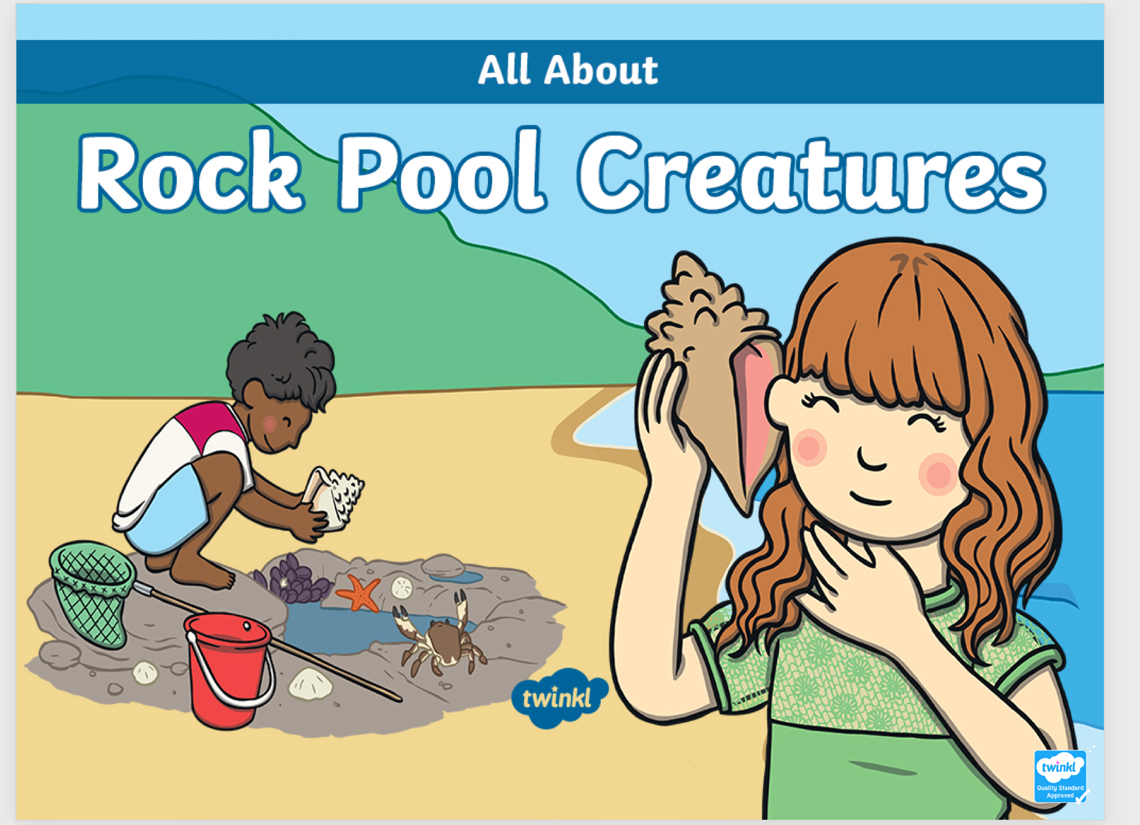

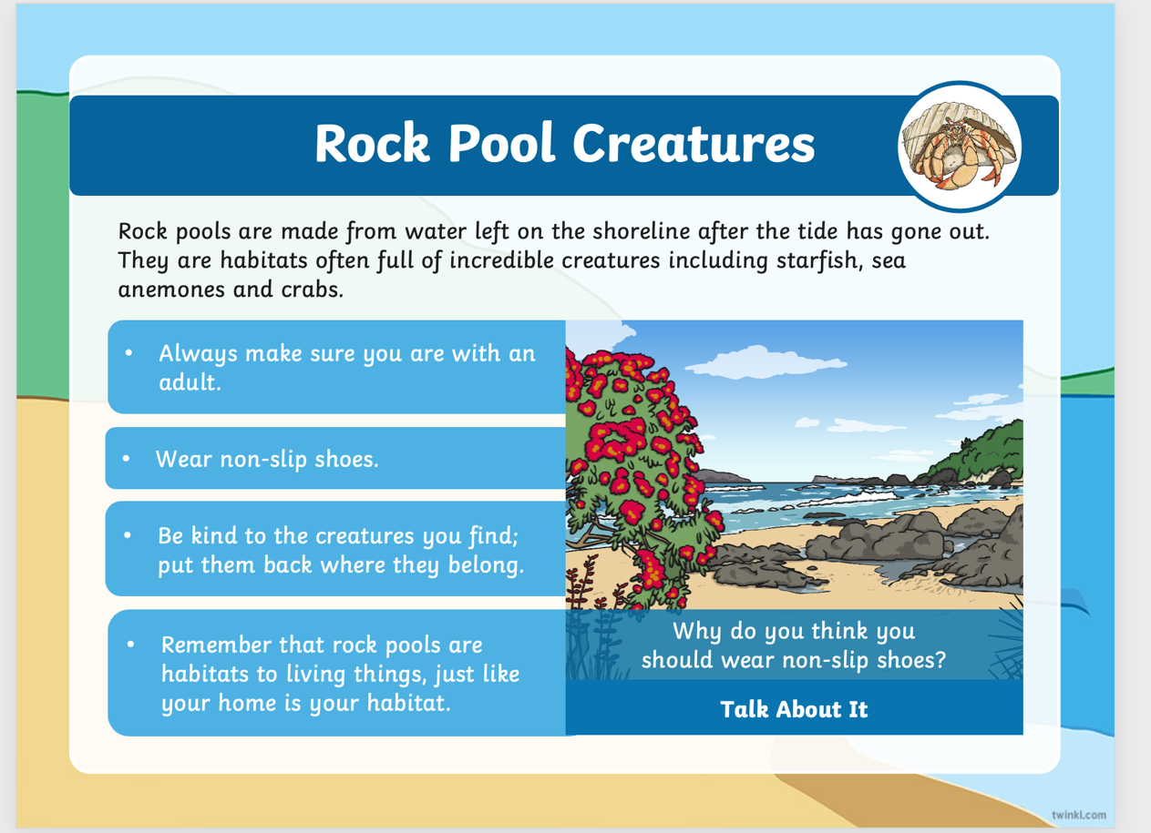

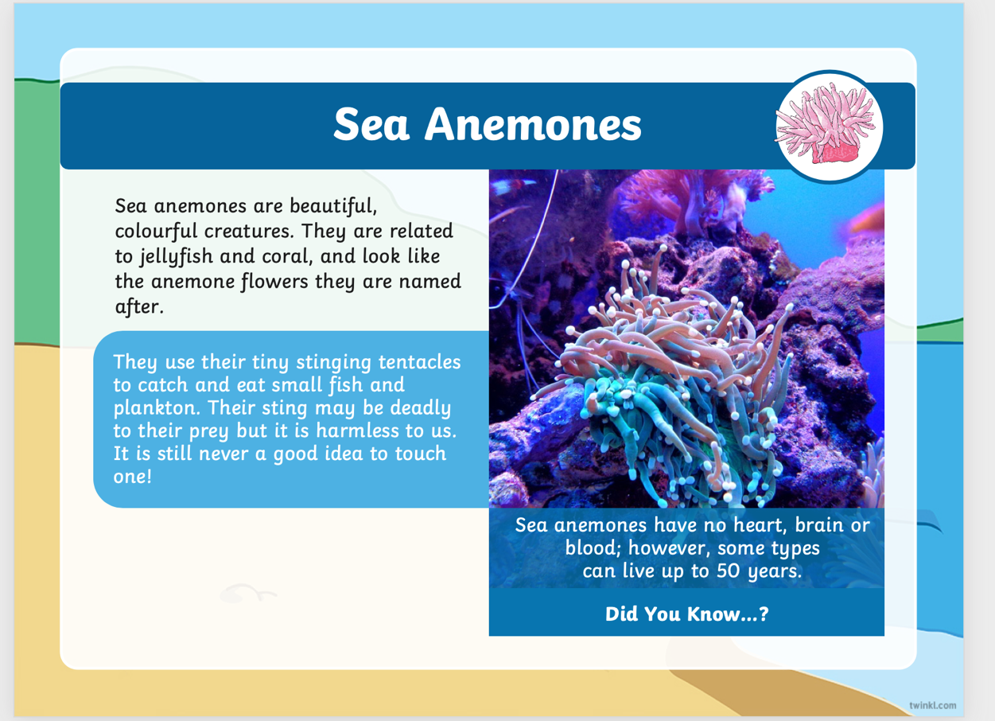

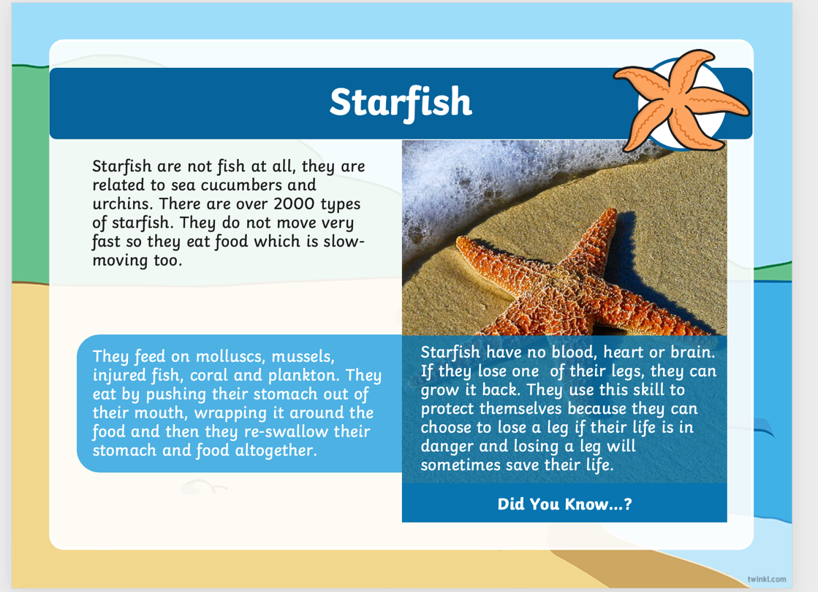

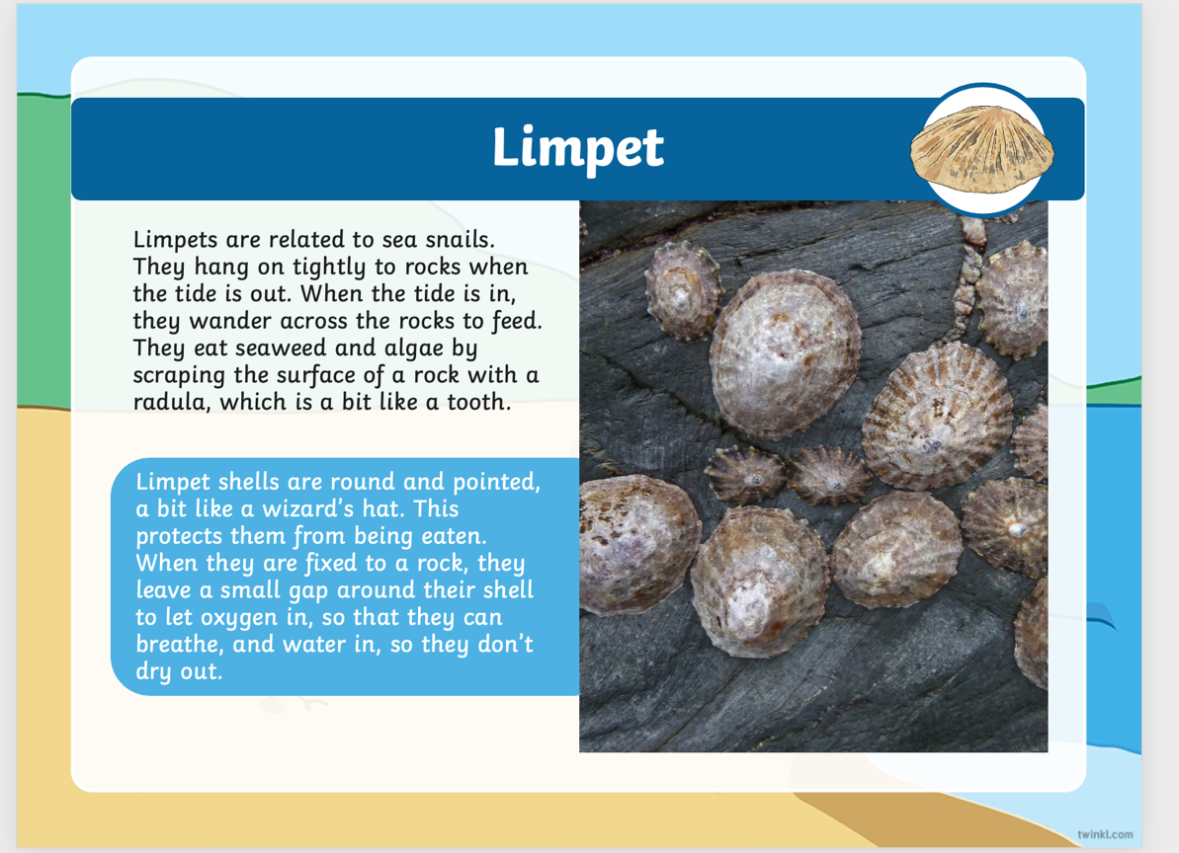

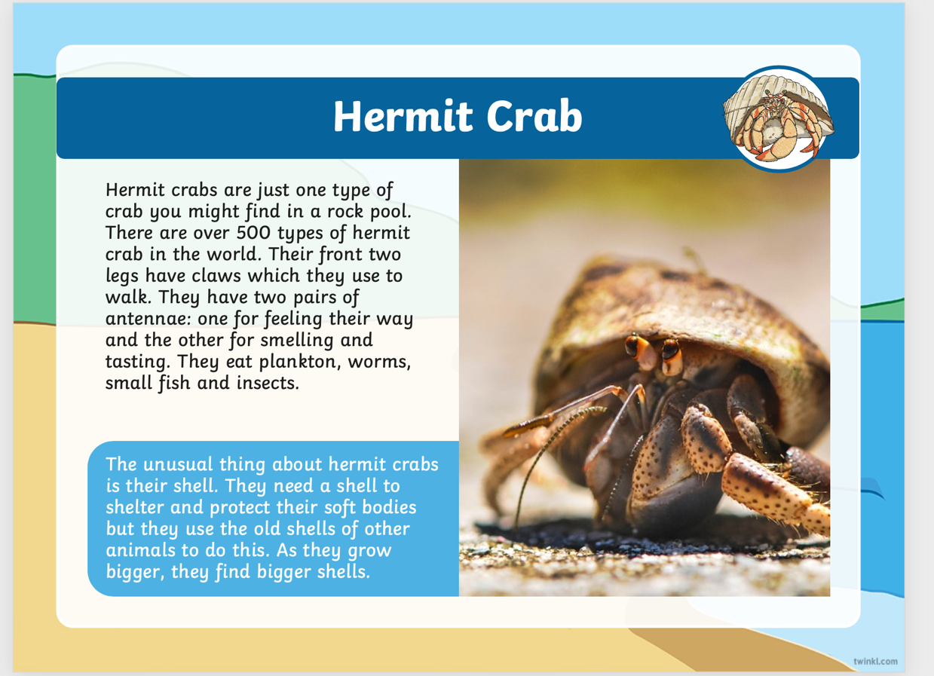
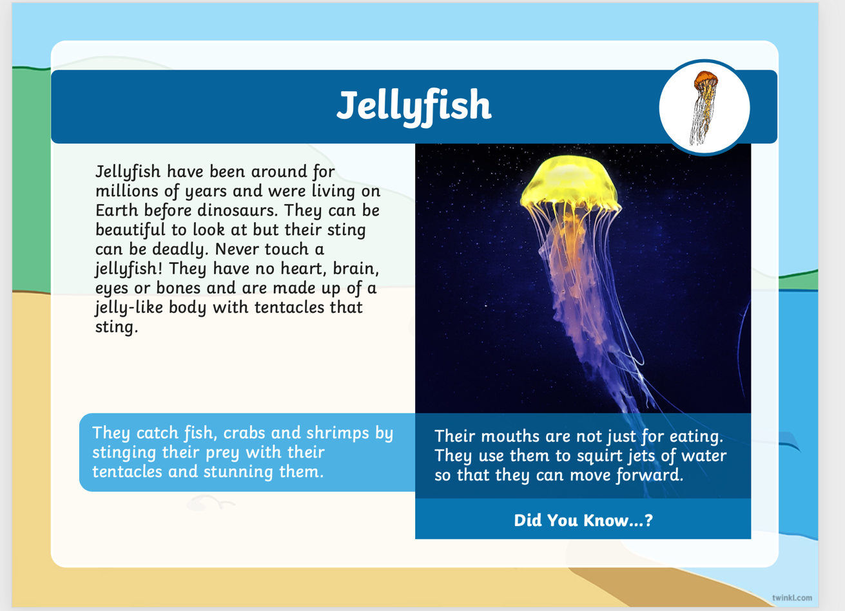

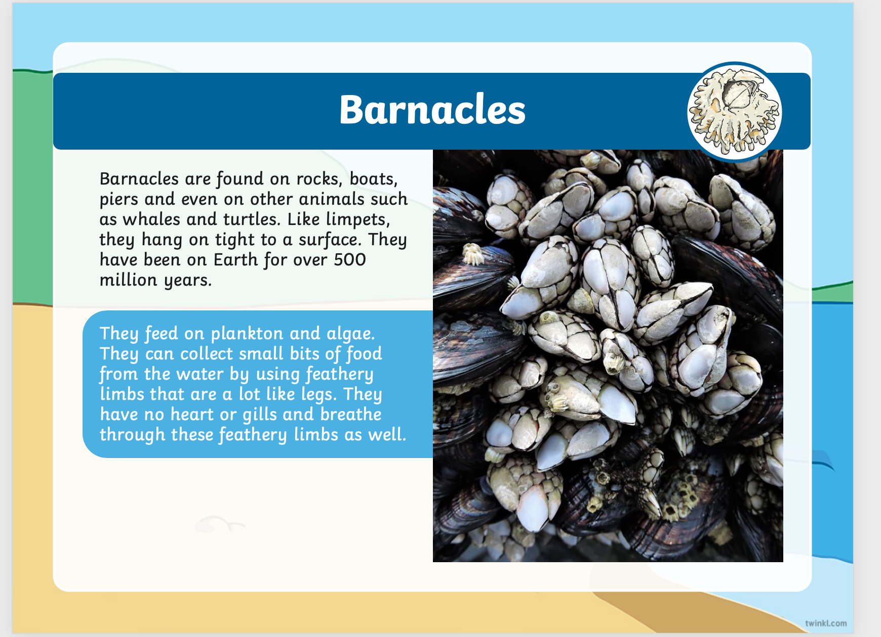

Just for fun!
Here are some fun seaside jokes to learn and tell others. Do you know a seaside joke, why don’t you film yourself saying it and upload it to google classroom so everyone can hear it and have a laugh.
Here are some I know:
What do you call a lazy crayfish?
– A slobster!
What do sea monsters eat?
-Fish and ships!
What kind of hair do oceans have?
– Wavy!
What can you come up with or maybe you already know one someone has told you.
Keeeeepppppppp laughing xxx
What can you spot?
Now that you know more of the creatures name have a look at the picture. What can you spot living in there?
Now remember plants are living things too! Make a little list of what you can spot and see if you know the right name for it.


