
Clean Teeth, Happy Smile
From that amazing time when your first tooth burst through your gum, your teeth have been very special. They have a very important role to play but before we look at that role, we will firstly look at our teeth. As you know, you are at an age when you milk teeth – or baby teeth – are falling out. These are being replaced by your adult teeth, and these little pearls will have to last you a lifetime.

A toothy exploration
So, how many teeth do you have? Are they milk teeth or adult teeth? Let’s find out.

You will need: A partner, your mam or dad, brother or sister
A mirror

Look at your partner’s teeth. Use the diagram below to show what teeth they have. Cross out any missing teeth. If you recognise any milk (baby) teeth, write ‘M’ on them. If you recognise any adult teeth, write ‘A’ on them. If any teeth are missing, cross them out X.

My partner’s teeth My teeth
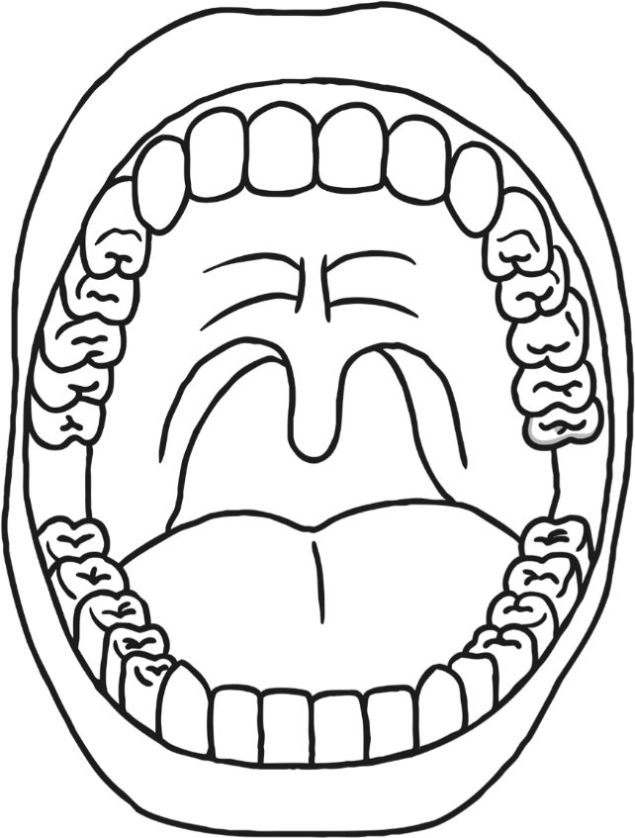

What do you notice about your partner’s teeth? What do they notice about yours? Discuss this with your partner.
- Are they all the same size?
- Are they all the same shape?
- Are they all look smooth?
- Are they are bumpy?
- What colour are they?
- Have they been brushed today? I hope so!

You will notice that your teeth do not all look alike. In fact, they mostly look quite different. They have unusual names and different functions (jobs to do).
Their names are…
Incisor

Canine

Pre-molar

Molar

Molar
Pre-molar
Canine
Incisor

…but, what are their functions?

You can research by looking in an
Let’s Research!
encyclopaedia, asking someone you think will know or using the internet. Record your answers below.

Tooth | Function
incisor

canine

molar

pre-molar

Wisdom Teeth
These are also known as the 3rd molar. Not every adult has wisdom teeth. If fact they have no real function!
Year 2 Revision
Can you remember what Mrs Walters taught you? If you can’t remember, don’t worry you can research the answers to these 3 questions.
What foods should you avoid to help prevent tooth decay?

What does sugar encourage to grow in our mouths?

What is plaque?
Amazing fact…

Can you find amazing fact about teeth?

It’s All AboutThe Music

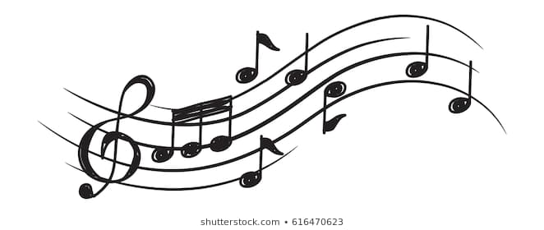

Listen to your favourite song. Close your eyes and let it wash over you, taking time to listen. Think about why you like it and what it reminds you of. What images do you see in your mind’s eye?
Listen to this piece again. This time, using your choice of media (pencils/crayons/pens etc.), draw a picture that reflects how you feel.
Relax and enjoy!

My Favourite Song: ____________________________________________________
Performed by: ____________________________________________________

Musical Challenge

What can you tell us about the song or the performer/s?
Can you perform the song?
Why not have a go, you may surprise yourself!

Let music bring out the artist in you

Just because….

Here’s a second little kindness challenge for you. Remembering kindness costs us nothing, we’re kind just because…
Ask your parents for a chore that would really help them out.
Help them with a happy heart, it will make you and them feel really good.

Take care, enjoy learning and have a great week!

