Williamstown Primary

Home School Learning Pack Year 3 W-C 1/6/2020

Useful Websites
TWINKL- free code 1 month = PARENTSTWINKLHELPS
BBC BITESIZE TOPMARKS- Hit the button
SCHOLASTIC HWB
Hello Year 3, I hope you are all safe and well, still working hard but also having as much fun as possible
Here is your new pack for this week including English work, spellings, and maths challenges!
Remember to keep reading, stay safe and keep in touch with your friends when you can
Miss Thomas x

Letter to your Teacher!
As we've been in lockdown for a long time now, this week your task is to write a letter to your teacher. Here are a few things you could include:

- A cool book you've read during lockdown.
- A walk/ adventure you have gone on.
- A new skill you have learned.
- Tell us about one or two of your favourite home tasks.
- A new game you've played.
- Some fun facts you've found out about our new topic.
- How you are keeping healthy through lockdown! :)

Letter Starter: Dear Miss/ Sir…

Spellings
Practise each spelling 3 times and then use each word in a sentence.
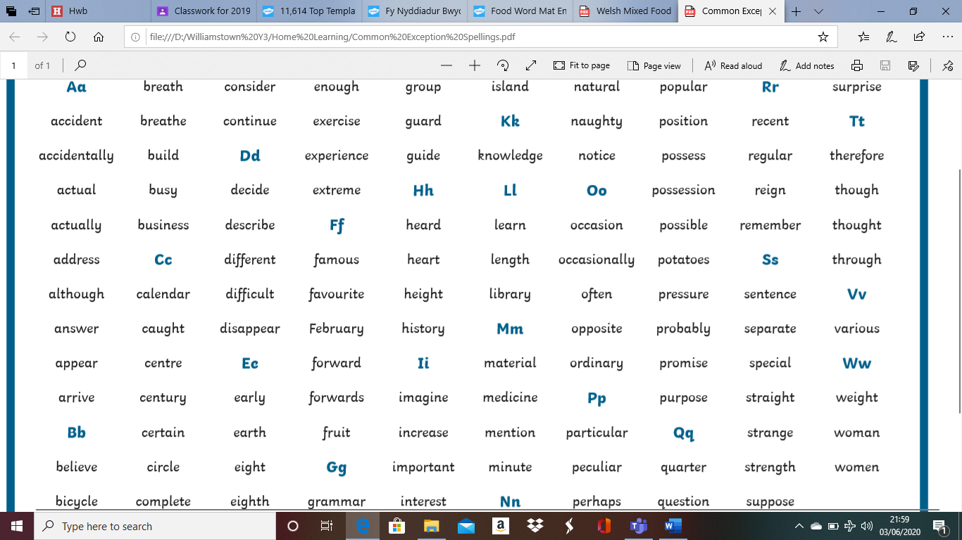
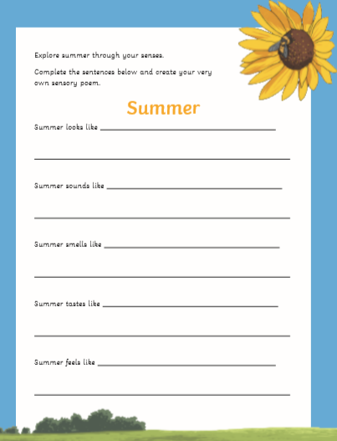
Welsh
Use the welsh food word maps below to complete the healthy eating food diary. Complete the food diary in welsh using the word maps to help you with spellings. Try to be as accurate as possible.

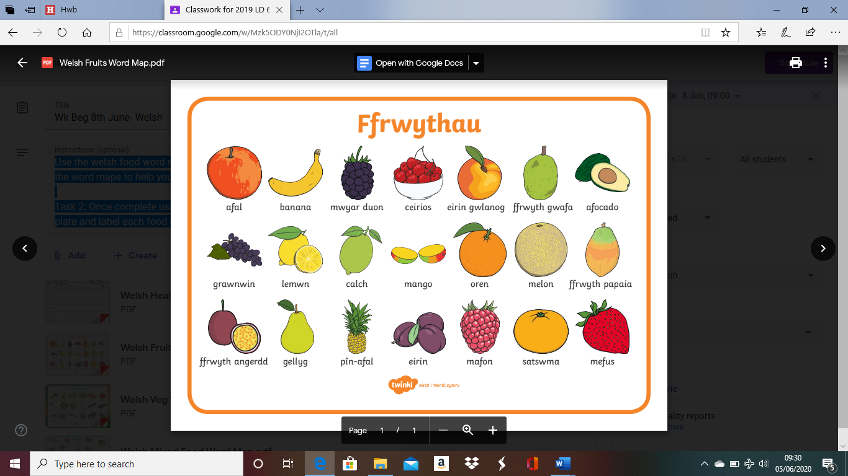
Task 2: Once complete use the food diary to choose your favourite meal of the week. Draw a picture of your meal on a plate and label each food on your plate in Welsh. Use the food word maps to help you!
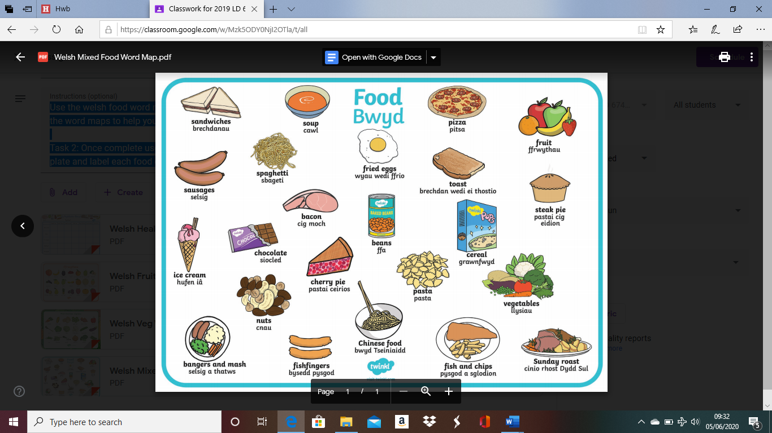
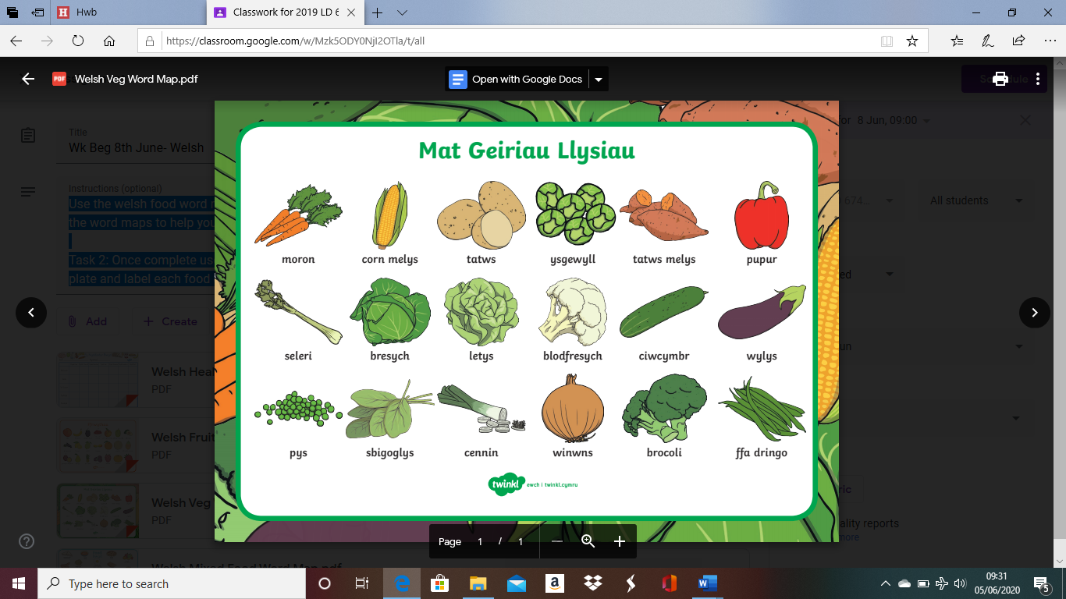

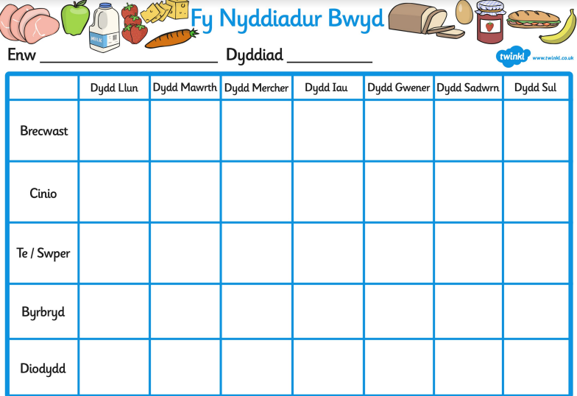

Rhyming Words Challenge

Make a list of Rhyming Word Pairs. E.g Car and Far Hot and Not Heat and Seat

Chilli Challenge
Mild= 10+ pairs Medium= 15+ pairs Hot= 20+ pairs

BBC Bitesize English
Complete the activity on similies and metaphors by following this link!

https://www.bbc.co.uk/bitesize/articles/zmg6pg8

Maths!
Use the BBC Bitesize Link to enhance your knowledge of finding fractions of amounts. Complete the activities on the website.
https://www.bbc.co.uk/bitesize/articles/zrytnrd

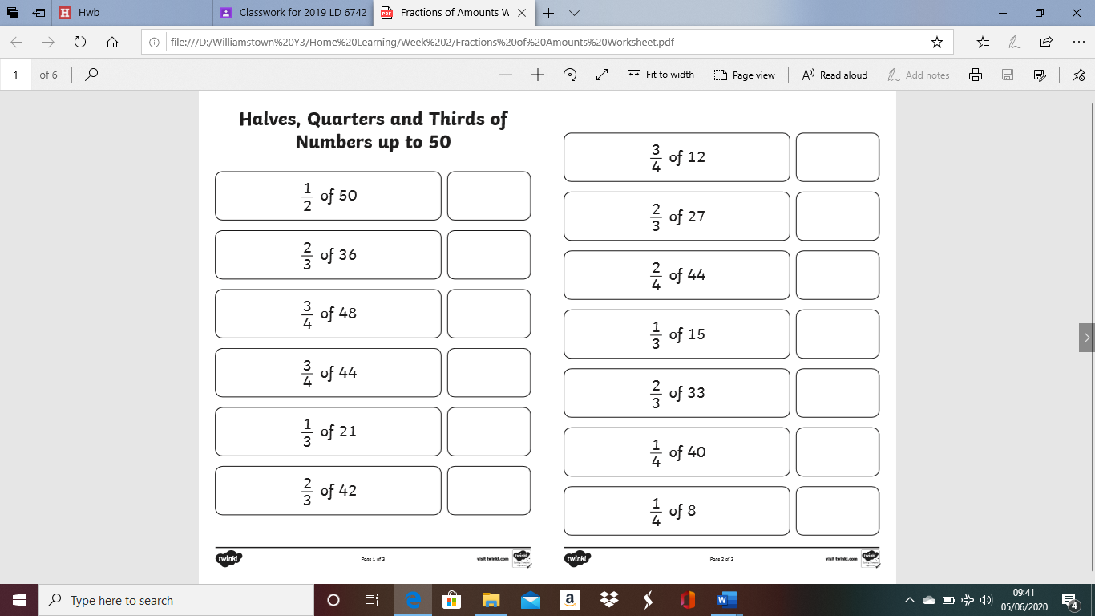
Then complete the fractions of amounts worksheet below.
Have a go at filling in the missing numbers on these fractions worksheets! Use your knowledge of halves, quarters and thirds to help you!
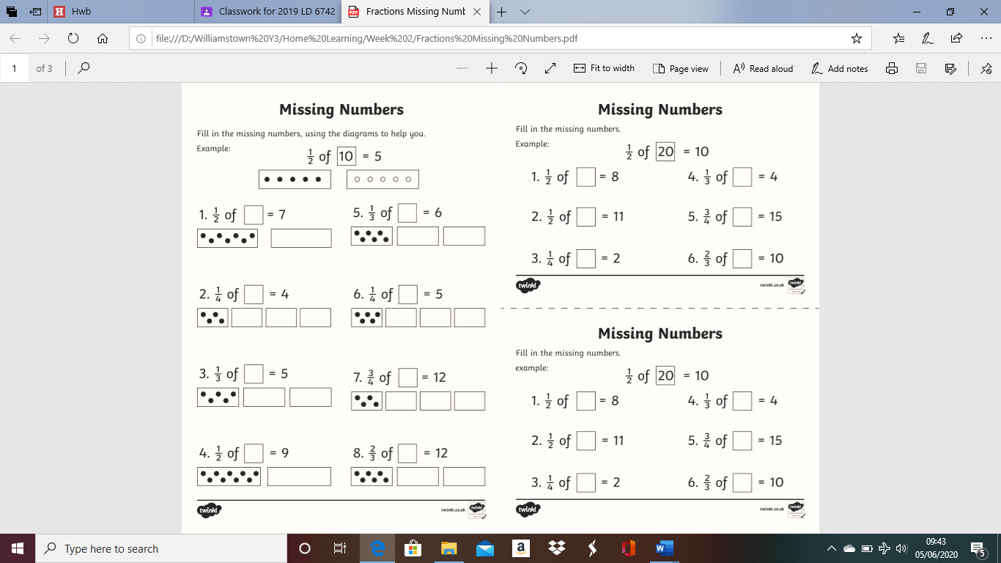
Watch the youtube video to find out how to calculate the area of a shape. You can watch the video however many times you need to. When you are comfortable, have a go at the two worksheets below. Complete worksheet one first and then worksheet two. REMEMBER to show your WORKINGS OUT.

You are learning a new maths skill today by calculating area. I know we haven't done this in class before but give it a try:) It doesn't matter if you don't understand or may get it wrong on your first couple of tries. Keep going, practise makes perfect!

https://www.youtube.com/watch?v=_uKKl8R1xBM

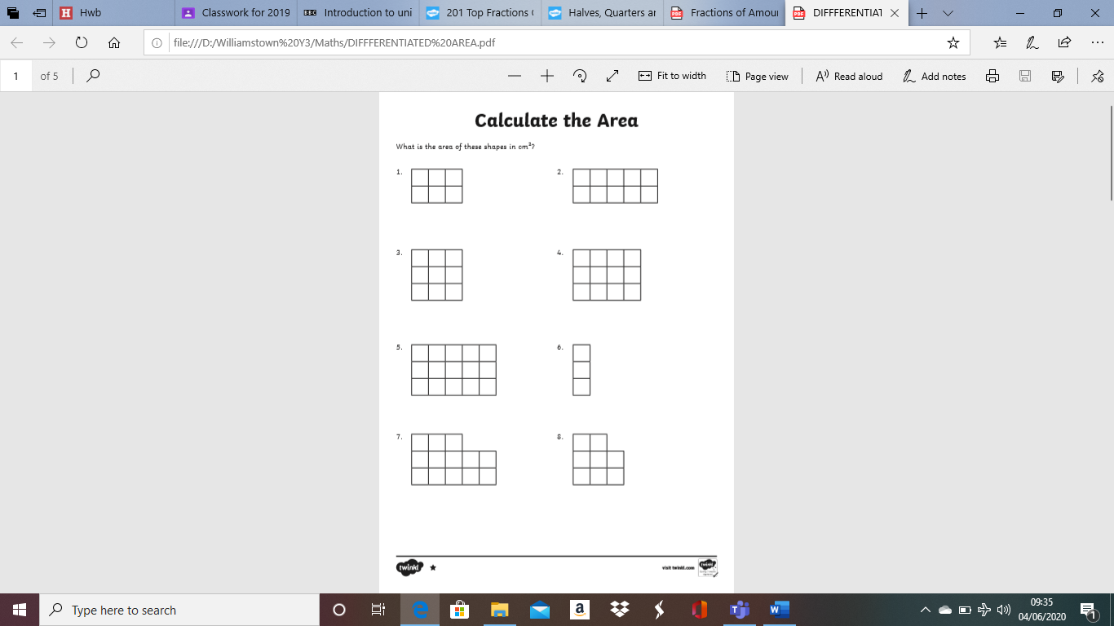
Worksheet 1
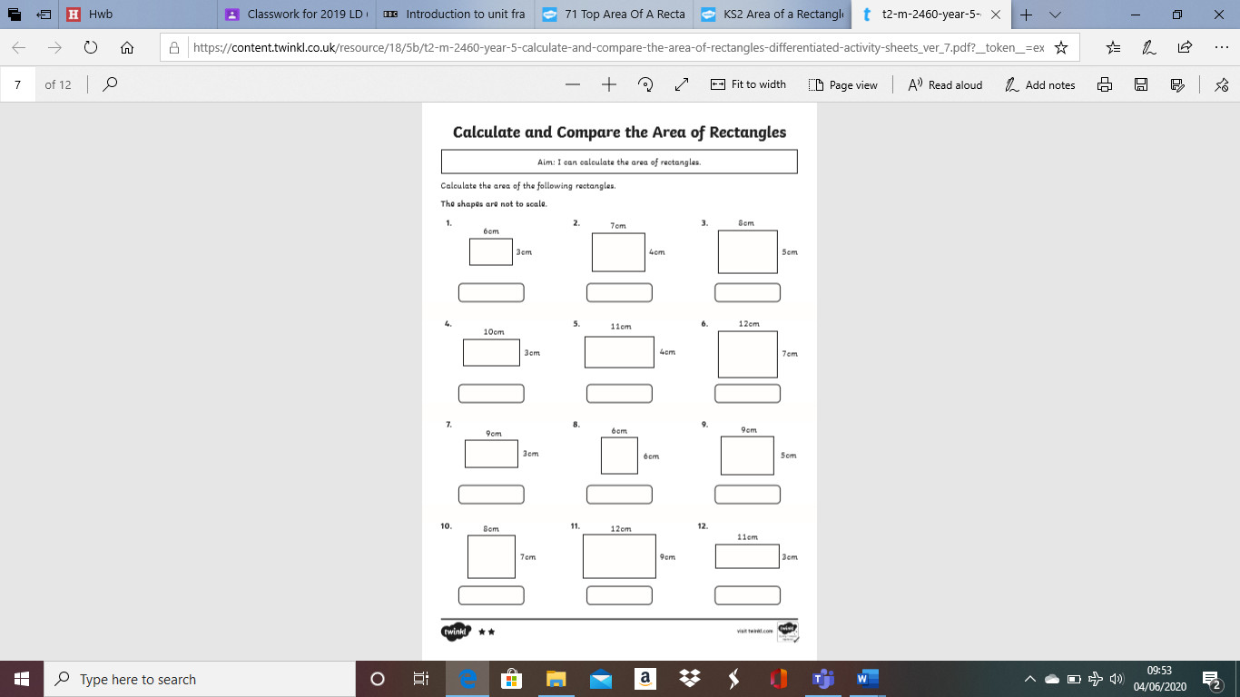
Worksheet 2


