
If any of you are struggling to login to Google classroom it may ask you for a classroom code. Here is our code:
6jvmy3g

W/C 8th June 2020
Hello,
I hope you are all staying safe and well at home. By now you should all have your Hwb login and password details.
I was really pleased to see that some of you have already submitted some work and I have enjoyed seeing your pictures and messaging you. Please can everyone try to logon to Google classroom or download the app on your phones and sign in. I would really appreciate a quick message from you when you have done this, so I know that I can pass information to you over the coming weeks.
Please try and do the Numeracy and Literacy tasks. You can choose which other activities you decide to do from the other topic work. In this pack, I have put only the numeracy and literacy tasks.
I know that some of you are doing the work on printouts or on a piece of paper. If you would like me to look at it, please take a photograph and upload it to Google Classroom. I’ve already had some lovely photos and amazing work from some of you.
Best Wishes,
Mrs Jones

Numeracy
This week I have decided to look at time. Again we did not have the ‘time’ to look at this before we stopped going to school and so this is an introduction to many of you. Please do not worry if you find this too easy or too difficult (it gets harder as you go through, so start where you feel confident). We will recap again in school. This week please focus on ‘O’Clock, half-past, quarter-to and quarter-past. I hope you remember the work we did on half and quarter turns. If you have a wall clock that you can take the battery out of, this would help, otherwise you could try making a clock yourself (instructions on the following link).
https://www.youtube.com/watch?v=WVe3V3gcSDk
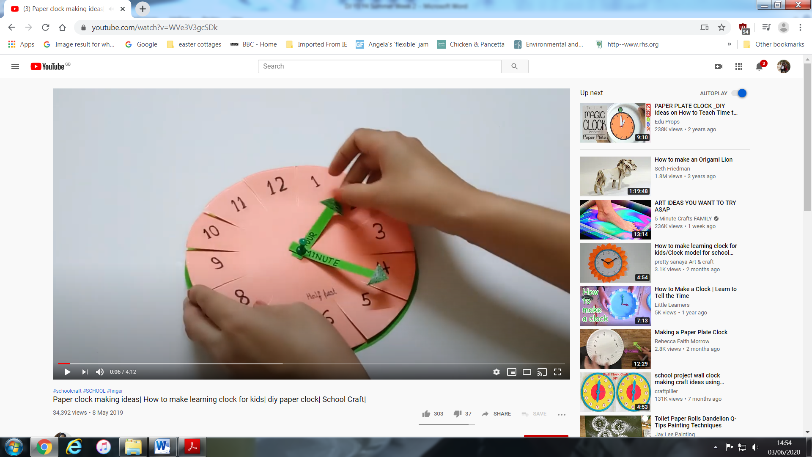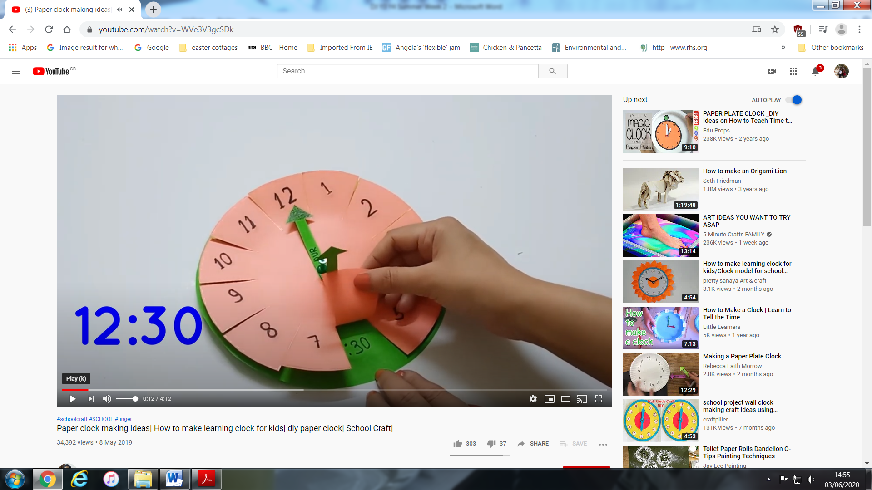
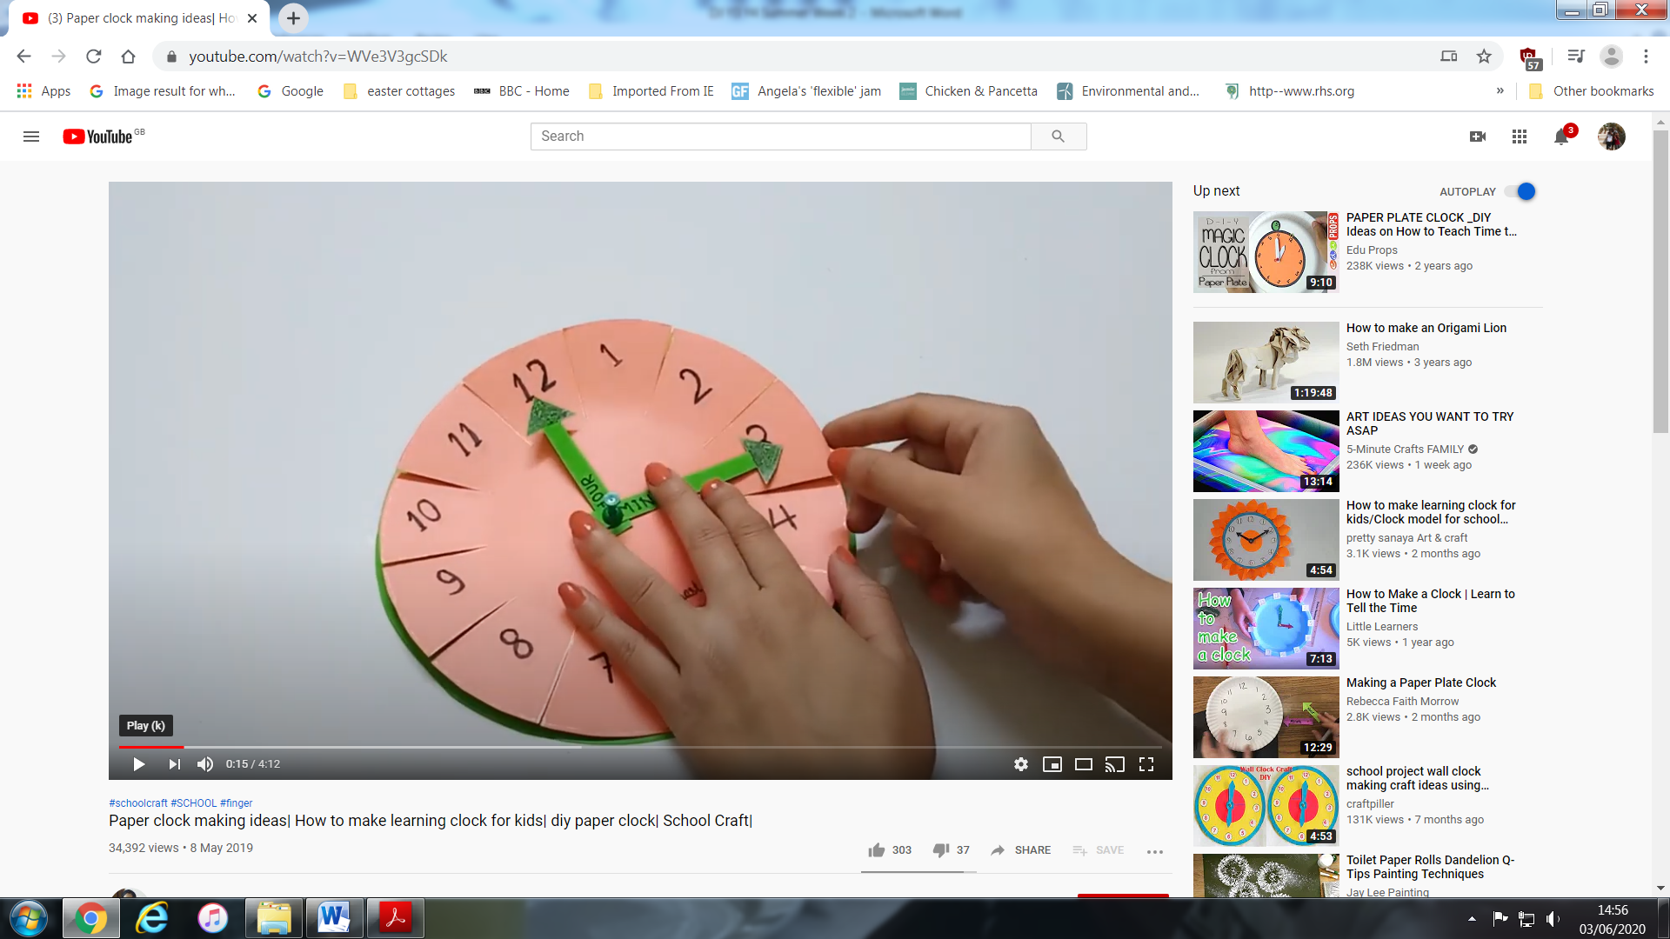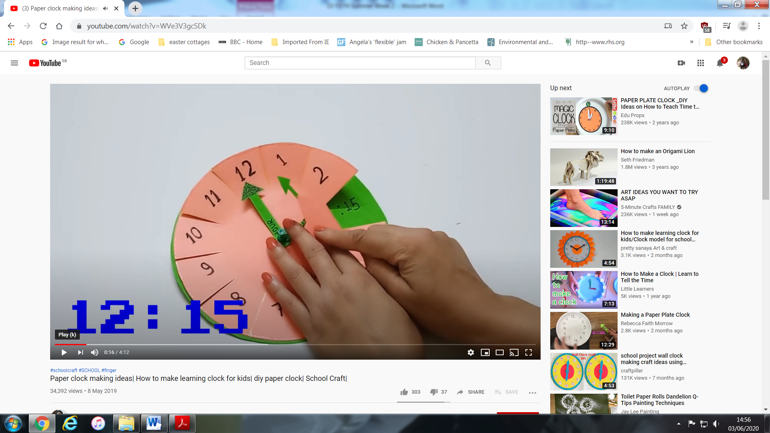

Make sure you add the minutes by counting on in 5’s
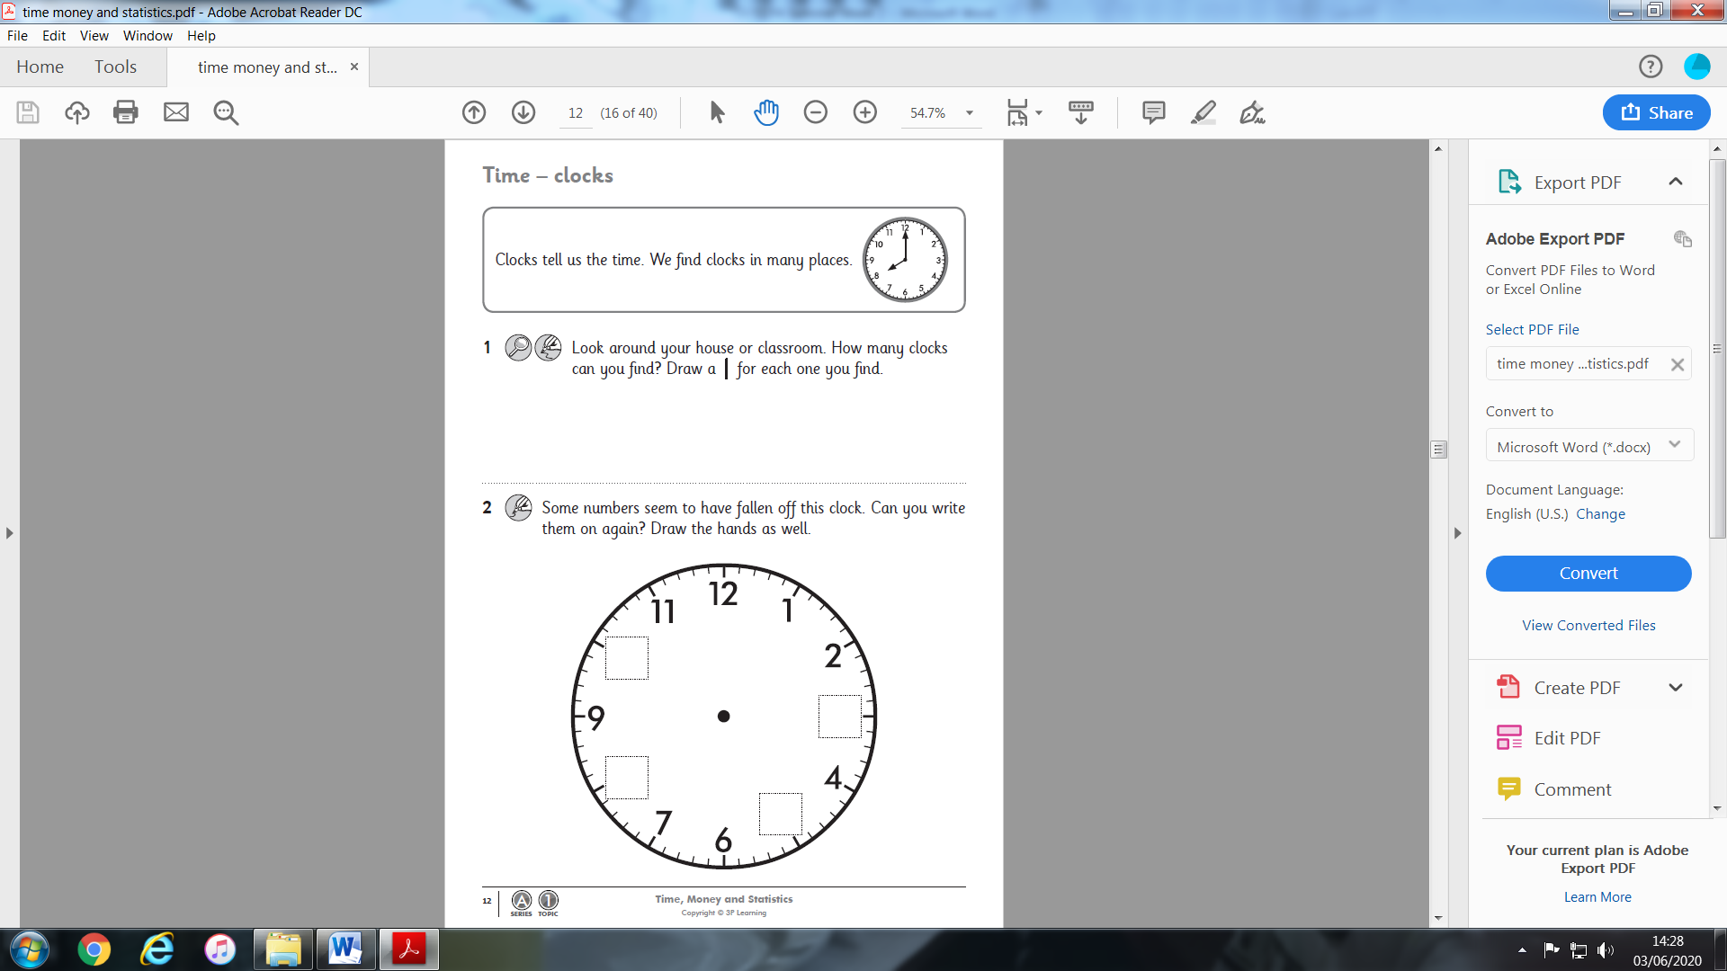

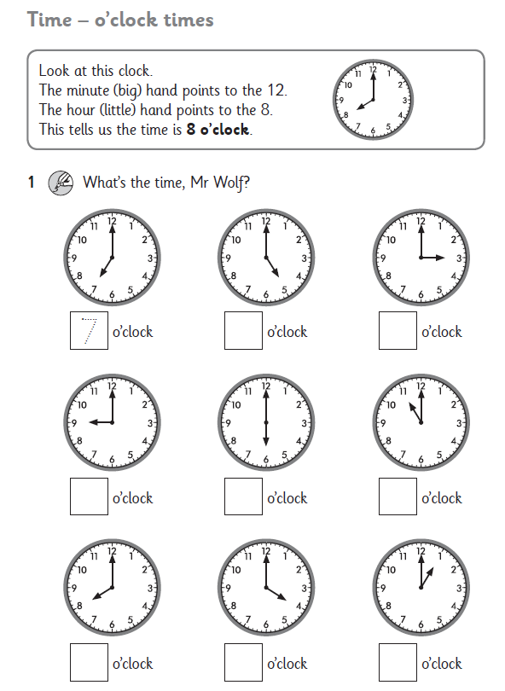

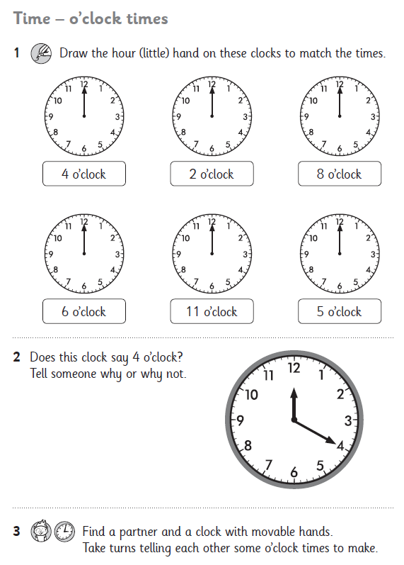
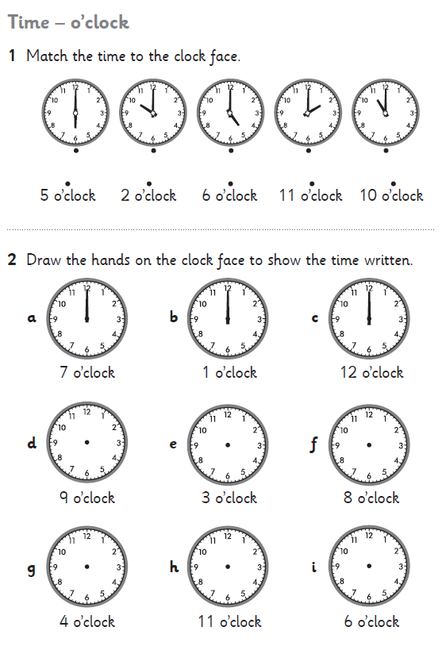
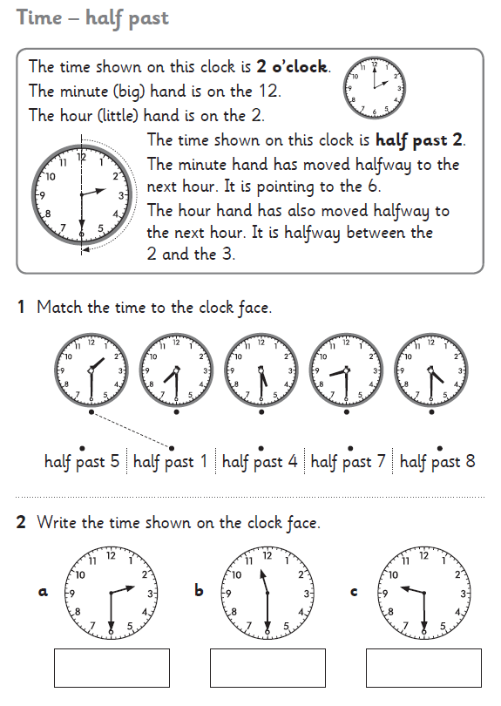
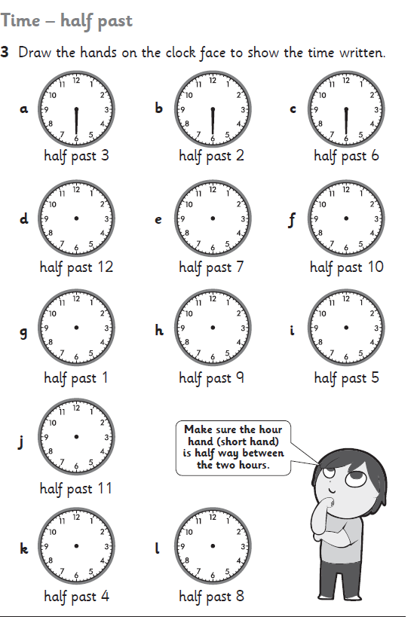

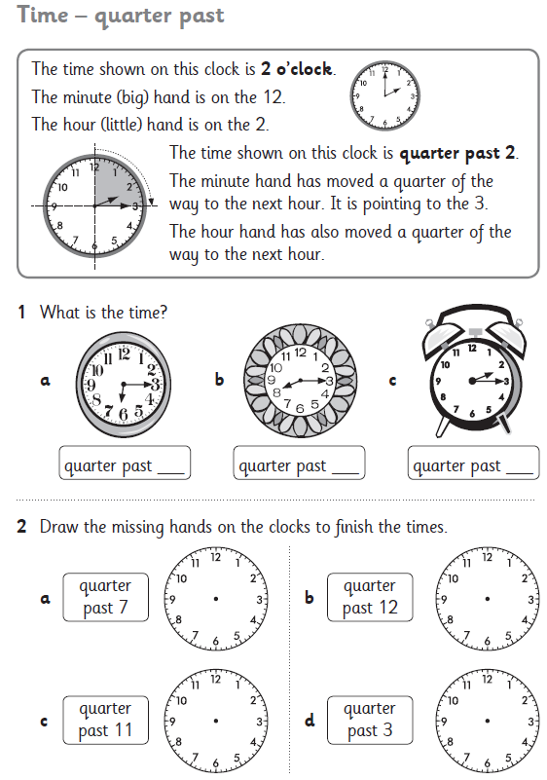
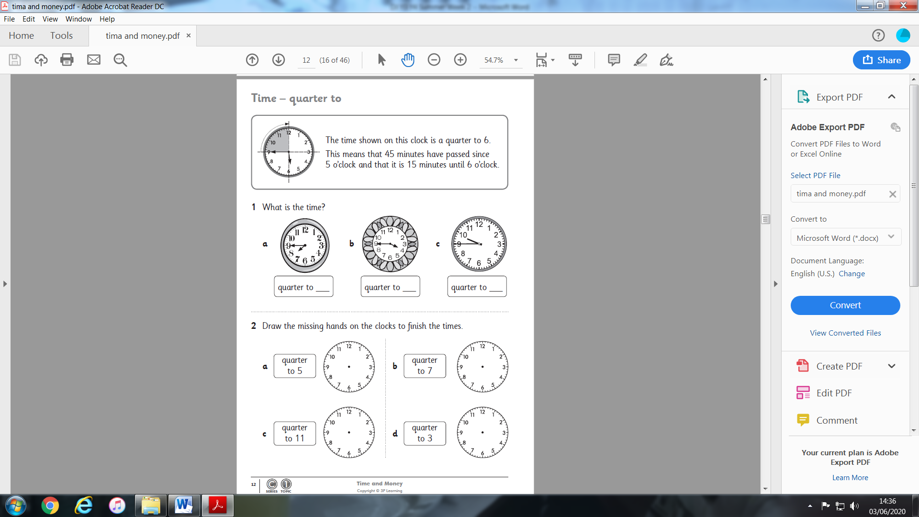
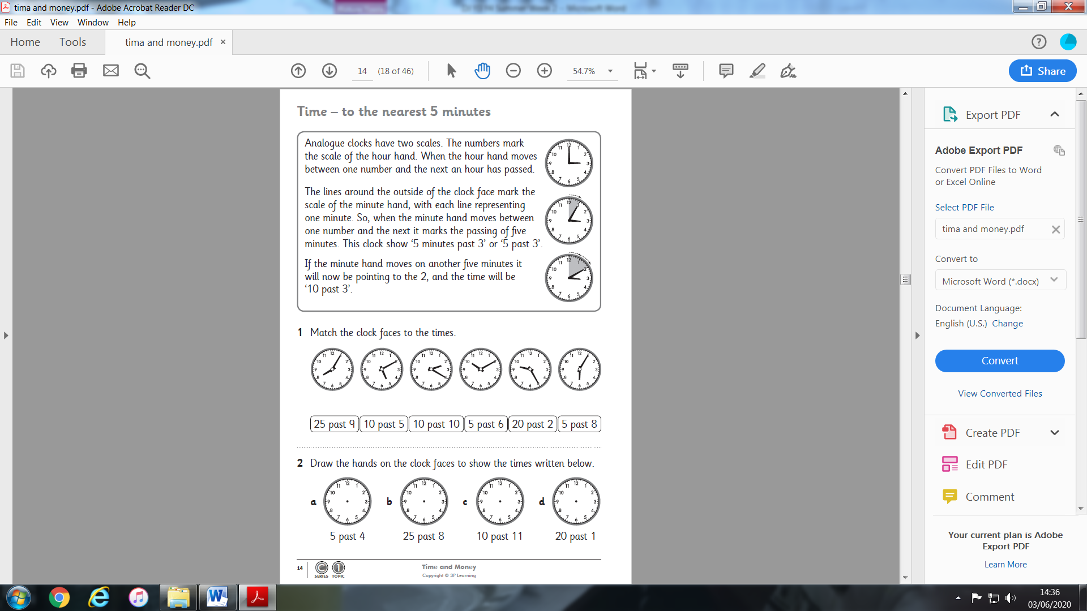
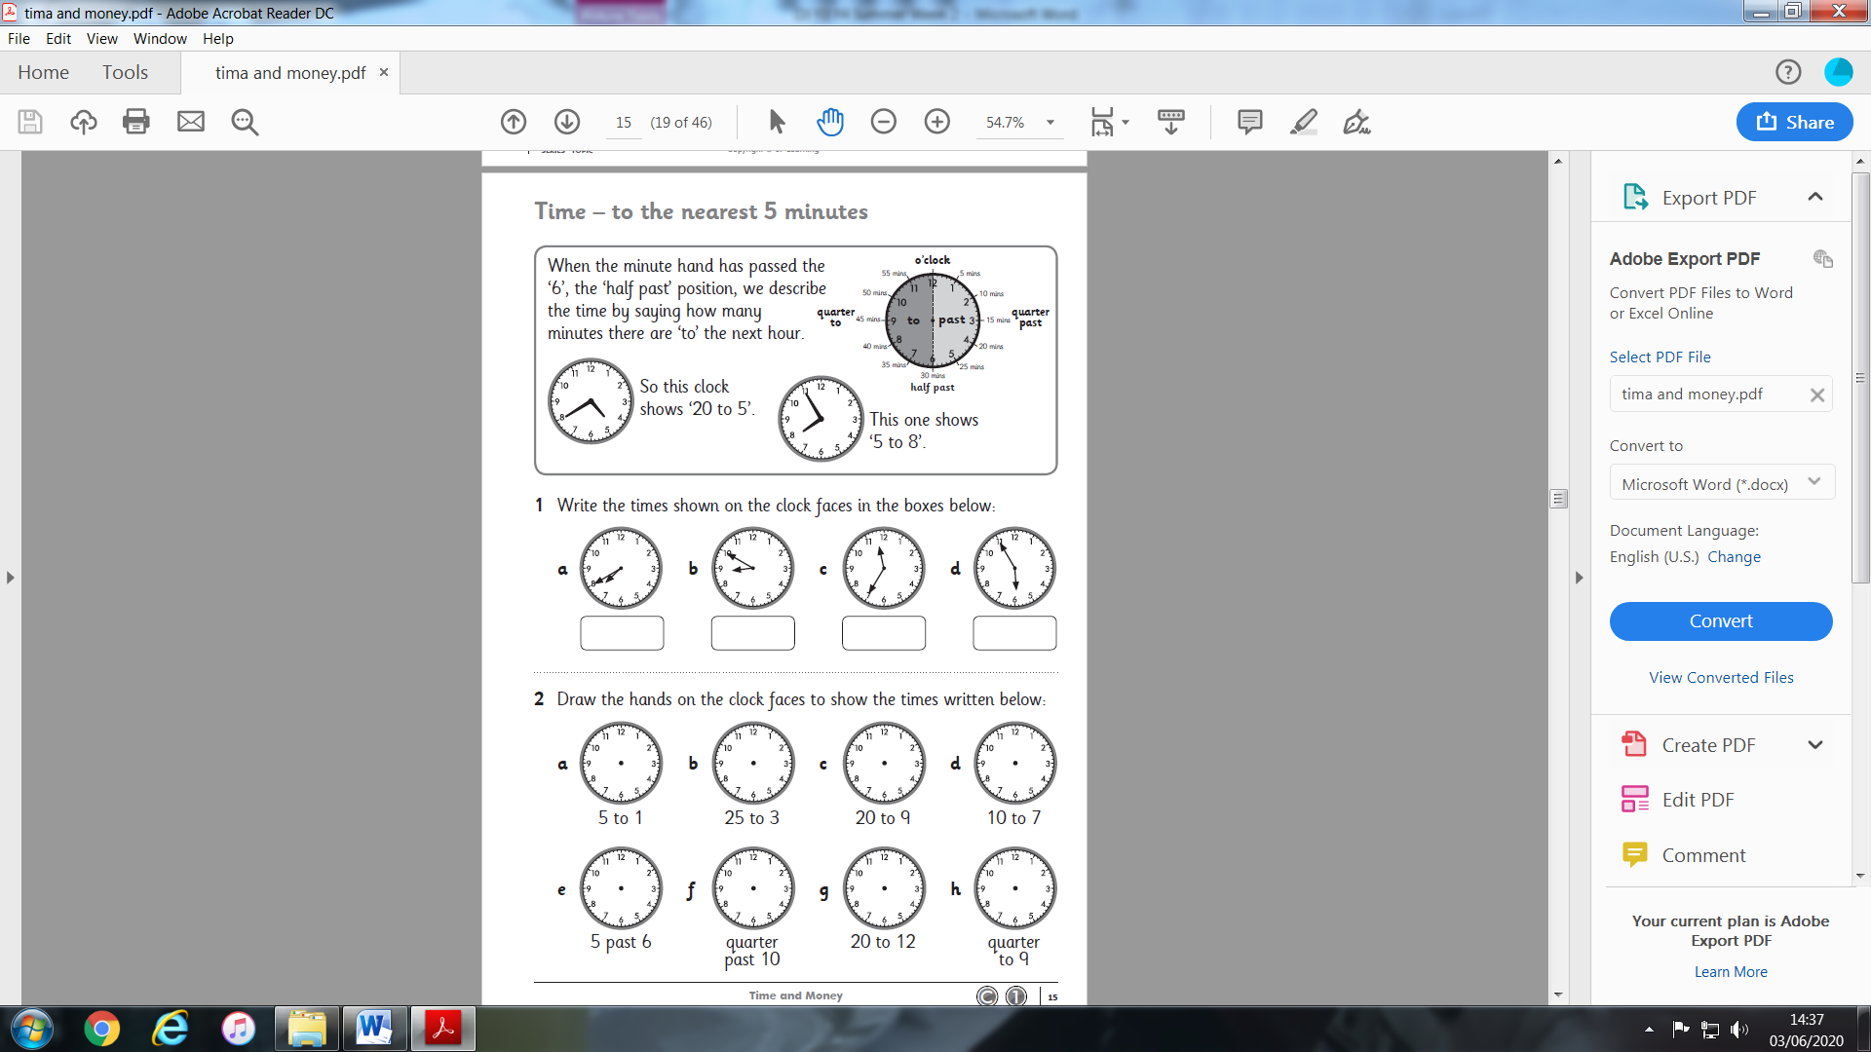
Have a go at the stop the clock game!

Stop the Clock for Two

Age 5 to 7
Here’s a game to play with an adult!
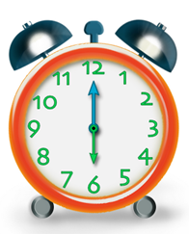
How do you play?
You'll need an adult to play with.
You will also need a clock face (you could use the one you have made) or you could use the interactive version (see the link below).
Set the time on the clock to 6 o’clock to start the game.
Starting with the adult, take it in turns to move the hands of the clock on by 1/2 hour or 1 hour. For example, the adult could choose 1/2 hour, so the clock hands move to 6.30, then you might choose 1 hour, moving the clock hands to 7.30, and so on.
The winner is the person who moves the hands exactly onto 12 o’clock. You can only go up in ½ hour or 1 hour increments.
Does it make a difference if you go first instead?
What happens if the adult gets to 10.30? Why?
Can you work out a winning strategy?
https://nrich.maths.org/approachingMidnight/#/

If you do not have a partner, you can play the computer at the link above. I played it three times and the computer kept beating me!!!

Literacy

Go onto the Google Classroom account to see the whole power point.

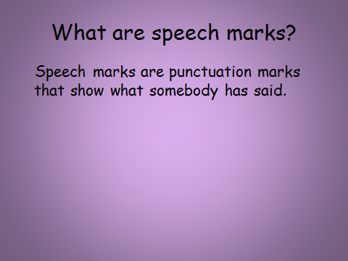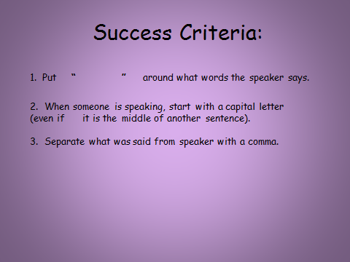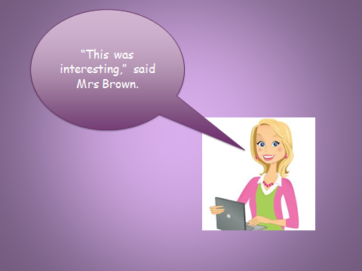
Now put the speech marks and correct punctuation in the correct places in these sentences.

- don’t listen to me, said Mark

- jack whispered, are we safe yet

- the manager called, bring me that bag

4. i need another drink, gasped Louis

“Speech Marks”
We use speech marks when we are writing to show what somebody has said. It is very important to also write who has been talking.
Example :
I love this book

“I love this book,” said Lucy

Put the speech marks in the correct places in the sentences below:
- What time is it? asked Angel.
2) I want chicken for dinner, said Monica.
3) Can I play on the computer Mum? asked Kayla.
4) I would like an ice cream please, said Sarah.
5) That costs 12 pounds, said the shop-keeper.
6) Would you like to read a book? asked the teacher.
7) John hit me, said Henry.
8) Where is the cheese? asked Kayleigh.
9) It is time to go to class, said the teacher.
10) What is 10 + 2? asked Miss Byrne.
11) Hooray, shouted the children
Remember to check your work when you are finished.

Another way of showing someone is speaking is by using Speech bubbles. Have a look at the following comic strip and then have a go at answering the comprehension questions.
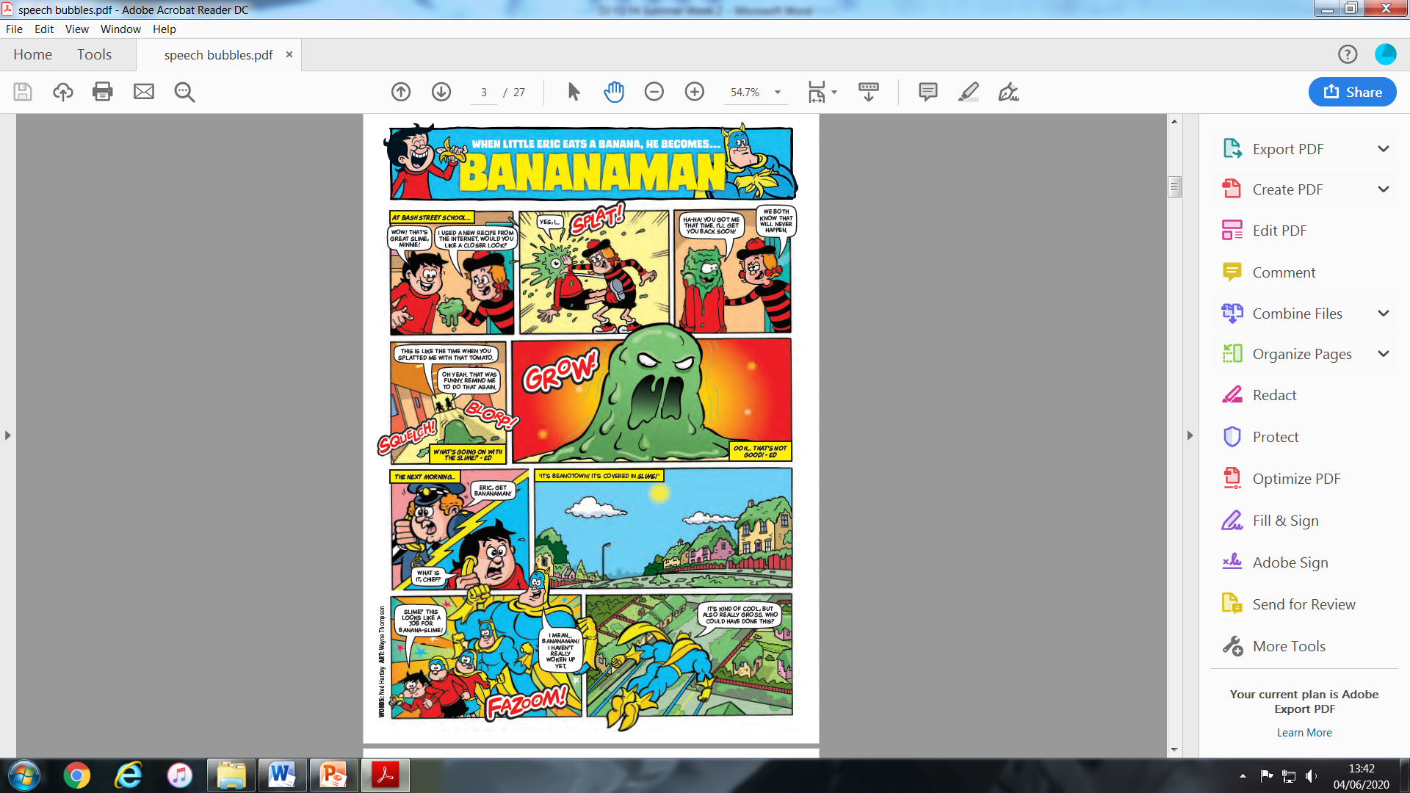

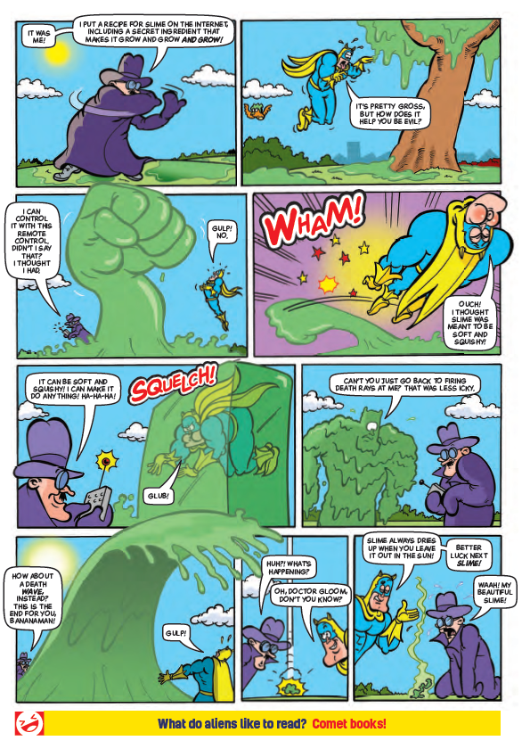
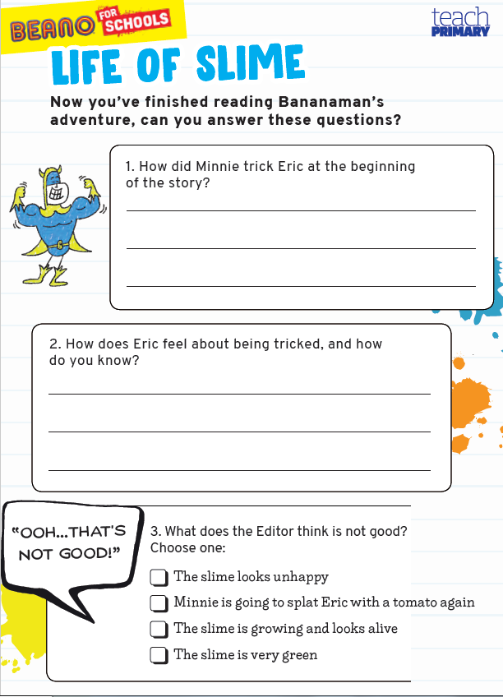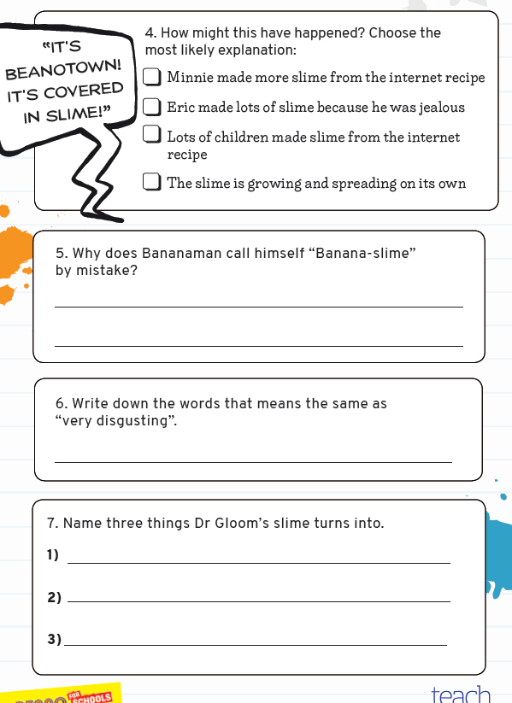
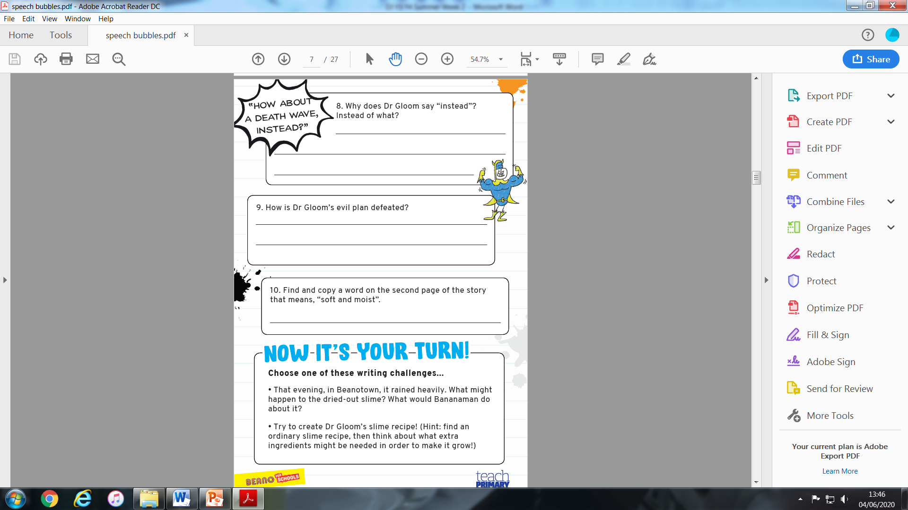
You could use a comic strip template or make your own.


