School Closure Home School Pack
Miss Densley’s Class
Week beginning 8.6.20
I’ve added some more ideas for another week of home learning. I’ve left the ongoing spelling/reading/times tables on there. This week’s English assignment will be on Google Classroom and can be handed in.
Literacy
- Practice the reading/spelling of high frequency words – you can do this in creative ways using different materials (e.g. paint, magnetic letters) and try timing yourself
- Carry on with your reading books – make sure someone asks you lots of questions about them and if you are reading Dockside practice those cover words
- I have included a sheet of general literacy activities and some paper to complete them on
- Here is a link for Oxford Owl’s free ebook library (you will have to create a login but it should all be free): https://www.oxfordowl.co.uk/for-home/find-a-book/library-page/?view=image&query=&type=book&age_group=Age+9-11&level=&level_select=&book_type=&series=#
- I’ve found a lovely free book to download about coming to terms with school shutdown: https://parsleymimblewood.wordpress.com/

- I have attached the next pages from the ‘Amazing Aliens’ workbook below for you to complete.

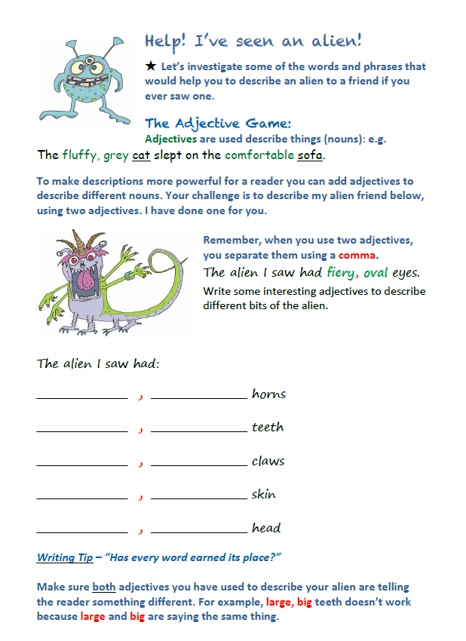
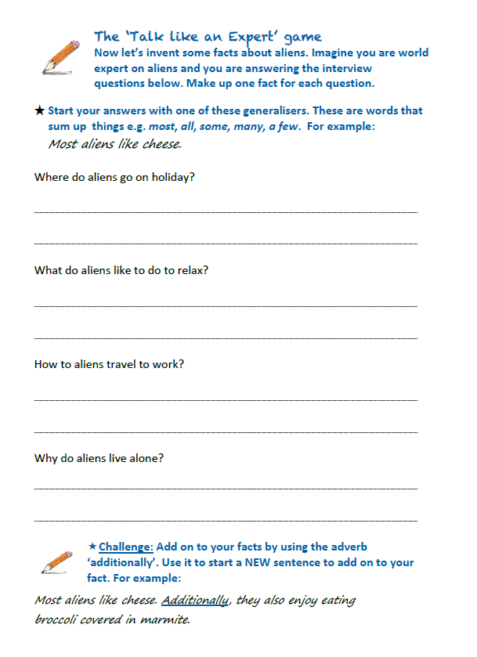
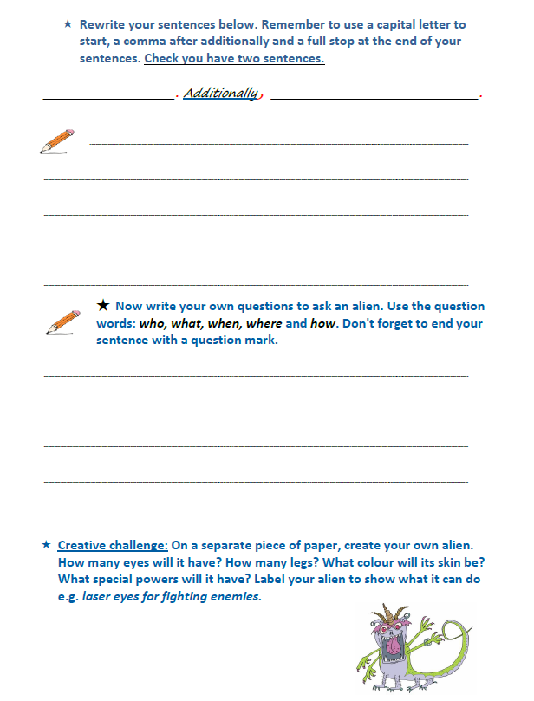
Maths
- Practice your times tables (in class we have practised the 2, 5, 10, 3, 4, 6, 8 and 9). A great tool for this is J2Blast on Hwb (I can see some of you have already had a go at this!)
- Practice telling the time on analogue (clock faces) and digital clocks
- Topmarks is a fantastic website to help with both of these

- This week’s topic is to use one and two step function machines to generate input and output using all four operations. I have included some slides from a Powerpoint to explain how to do this. Work through the slides then when you feel confident have a go at the sheet below. If you find it tricky have a go at the first sheet or if you feel more confident try the second sheet (you only need to do one of them).

Good websites to help with any of the above include Letters and Sounds for phonic practice, Topmarks, Crickweb for problem solving practice, Twinkl, Espresso, Hwb, BBC Bitesize and Primary Resources.

Here are some more great links I’ve found for home learning: https://www.tes.com/teaching-resources/teacher-essentials/home-learning
www.collins.co.uk/learnathome
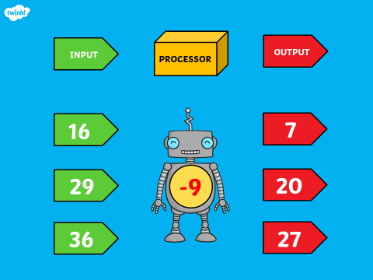
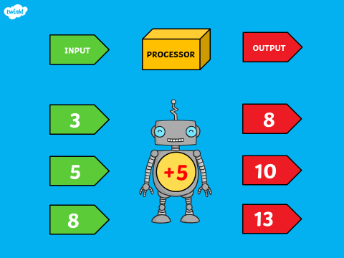

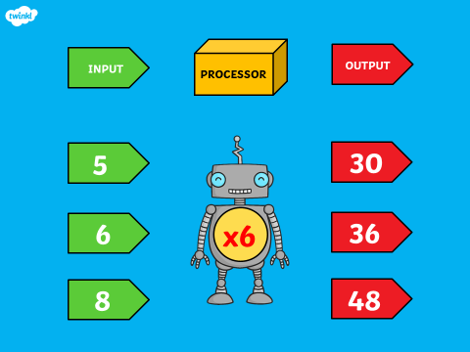

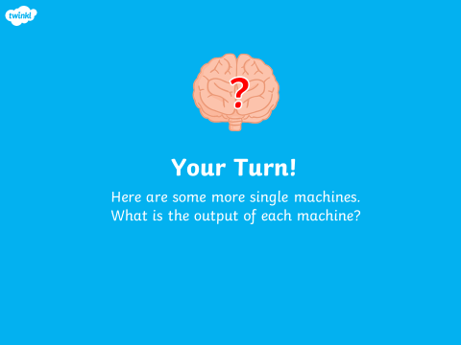
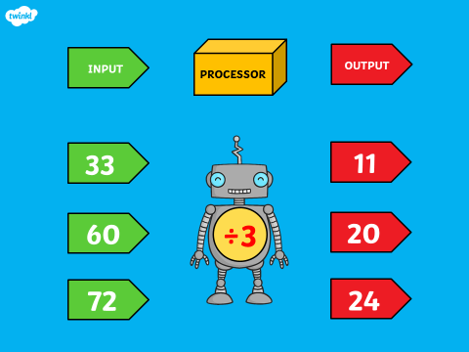

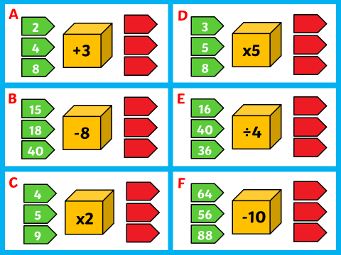

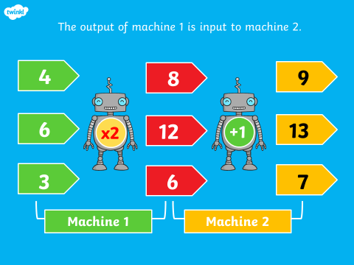

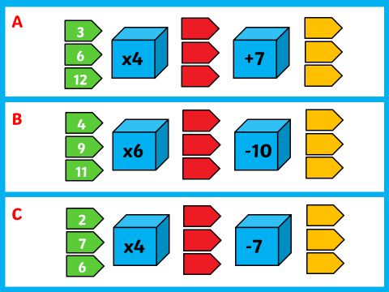
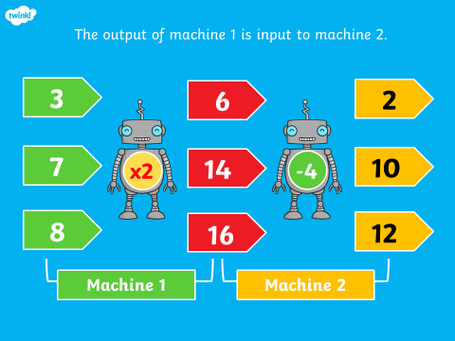

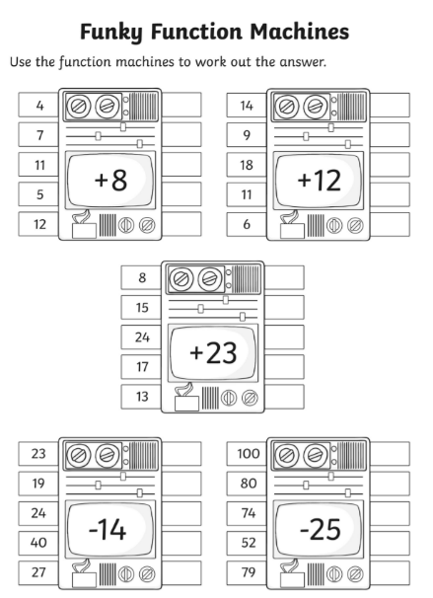

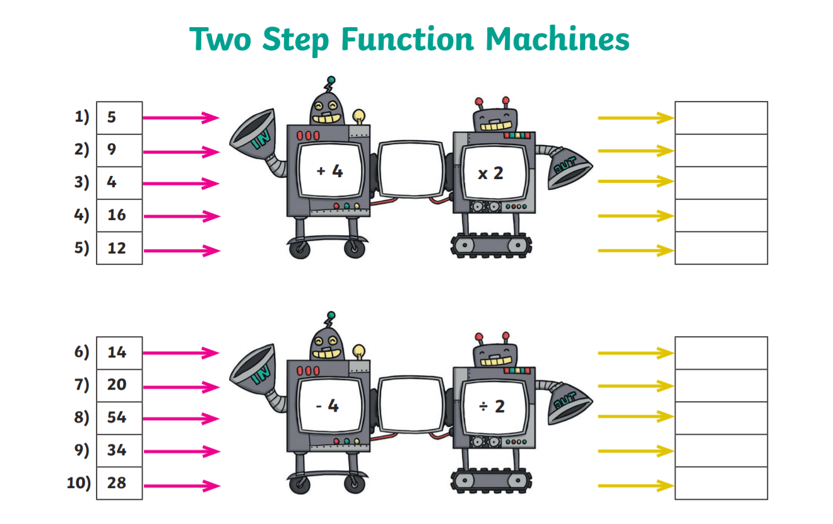
History
For the final part of our topic on Ancient Greece I have included a Powerpoint on the Trojan War for you to have a look at. Refer to slide 4 and have a look at the pictures of the treasure below. See if you can guess what each artefact is and who it belonged to (don’t look at the information cards below before you’ve done this bit). Try and come up with a list of questions you would like to ask about the artefacts.
Below the pictures of treasure are some information cards for you to check your answers (refer to slide 5). See if you can come up with 3 facts you have learned so far and 1 thing you would still like to find out.
We’ll be looking at the story of the Trojan Horse and having a go at writing a diary entry next week.

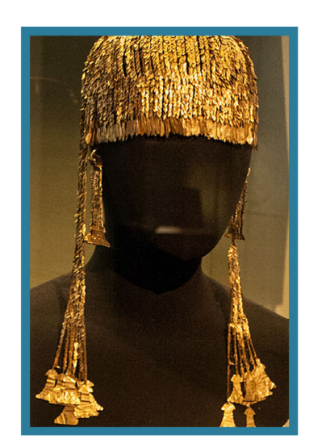
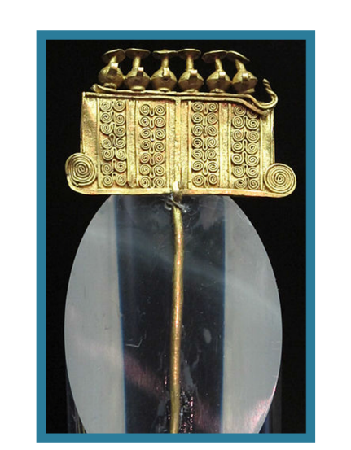

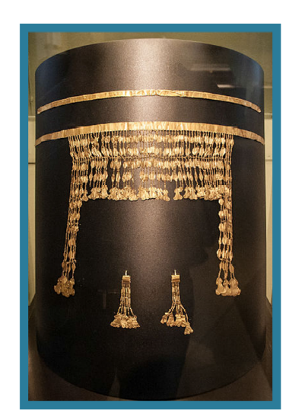
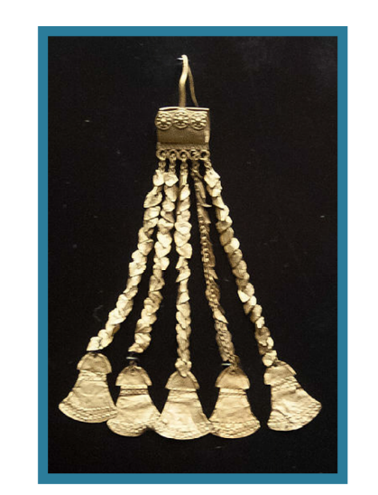
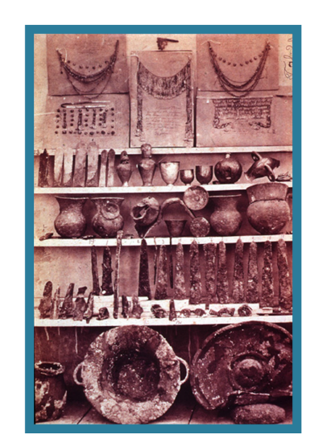

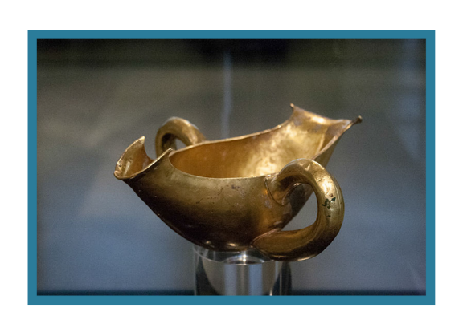

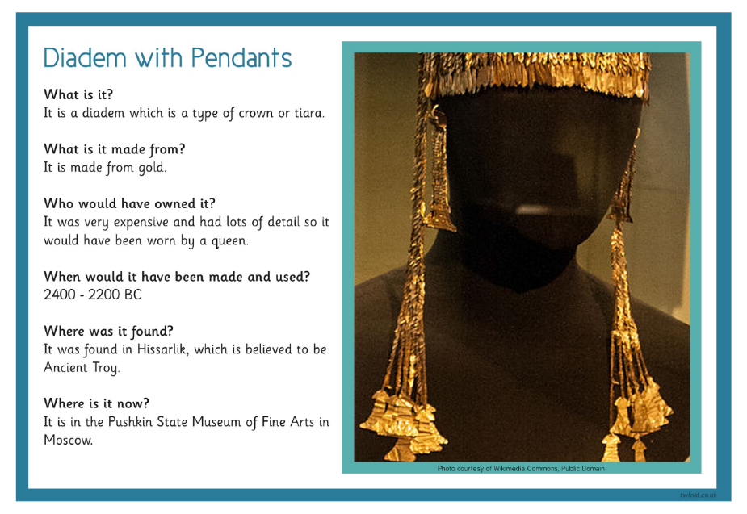
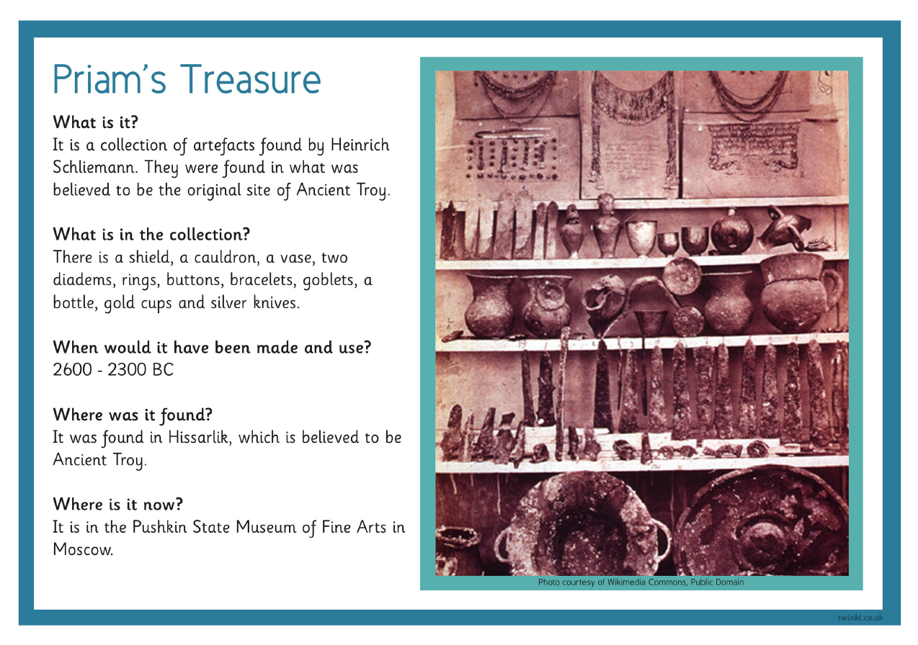

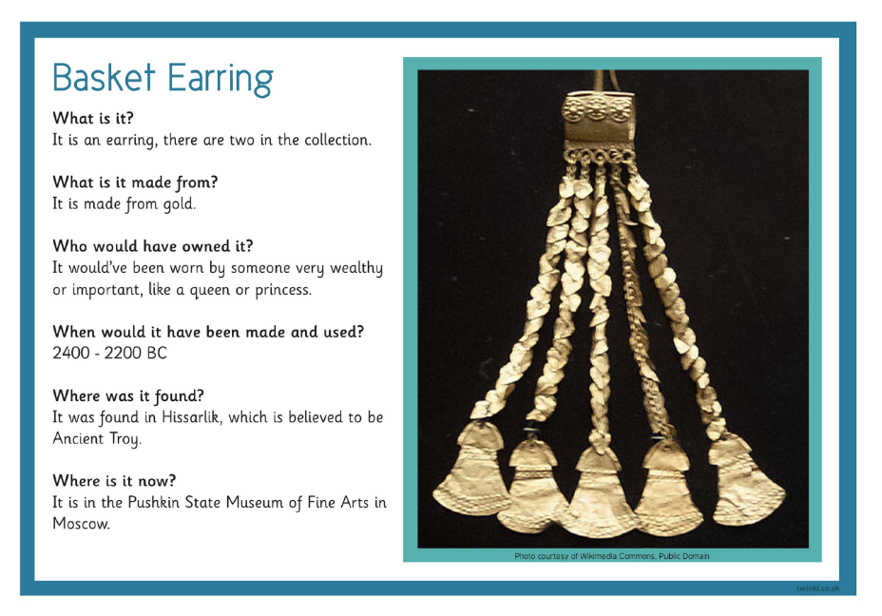
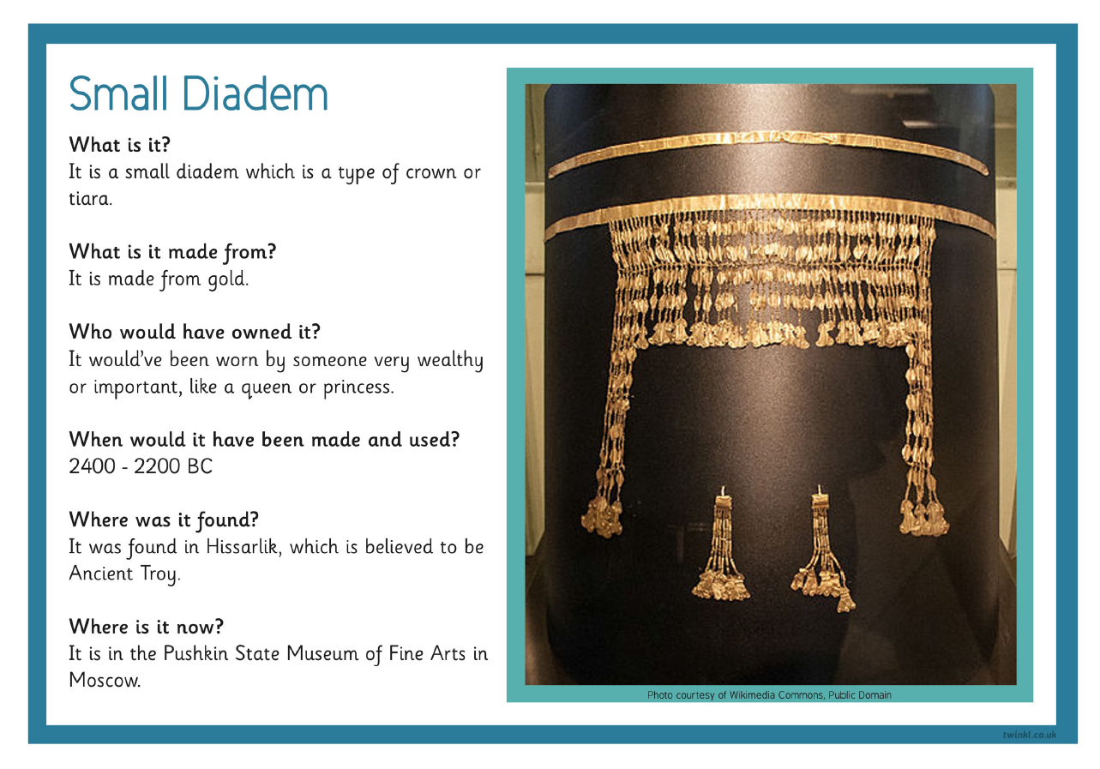
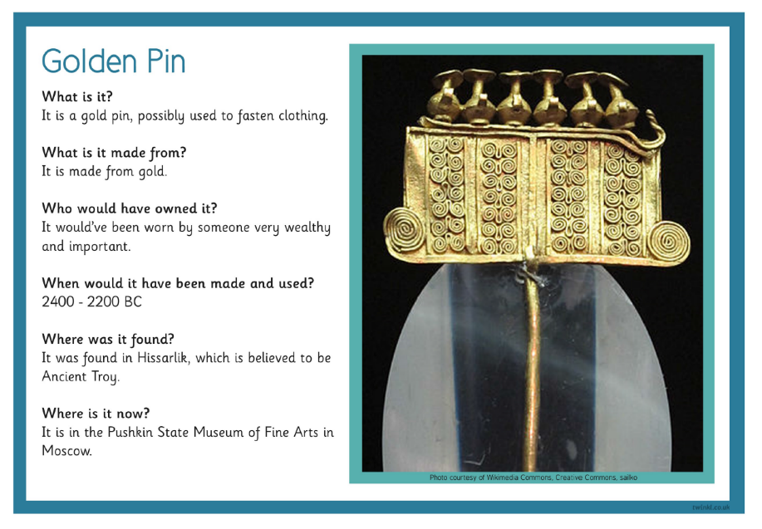
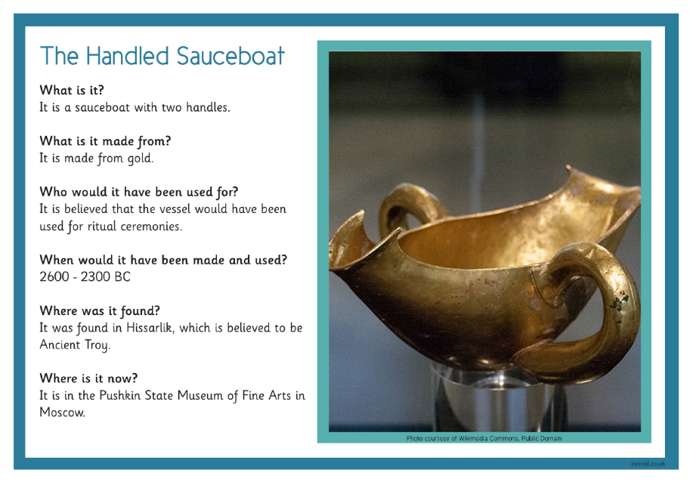

Welsh
Now you have mastered the o’clocks have a look at the slides below to practice “chwarter wedi” (quarter past), “hanner wedi” (half past) and “chwarter i” (quarter to). Have a go at filling out the sheet below it and don’t forget to use the Welsh phrases rather than just the numbers. Last week’s pack includes the Welsh numbers to help you.
Also here’s the link for the Cyw website where there are lots of activities for you to explore: https://cyw.cymru/en/

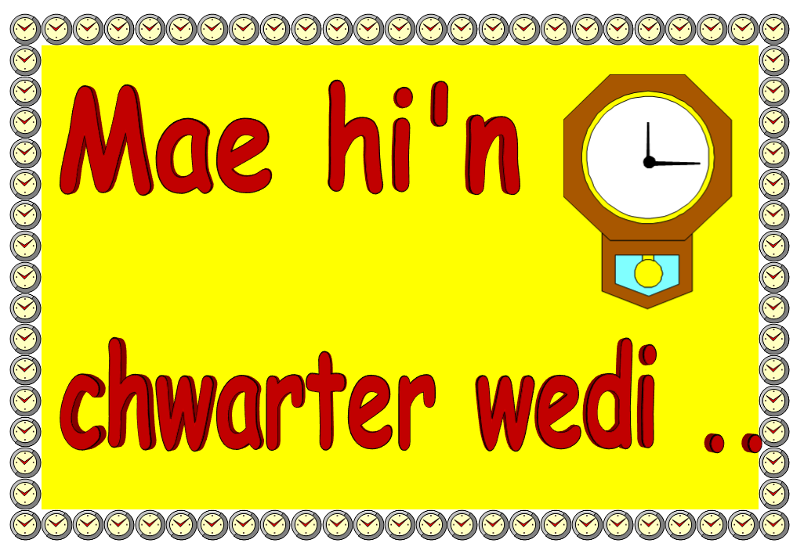

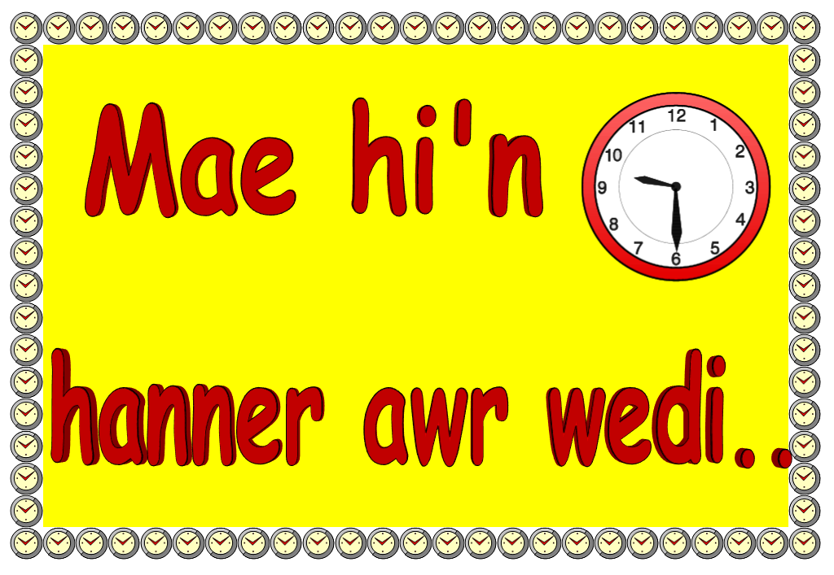

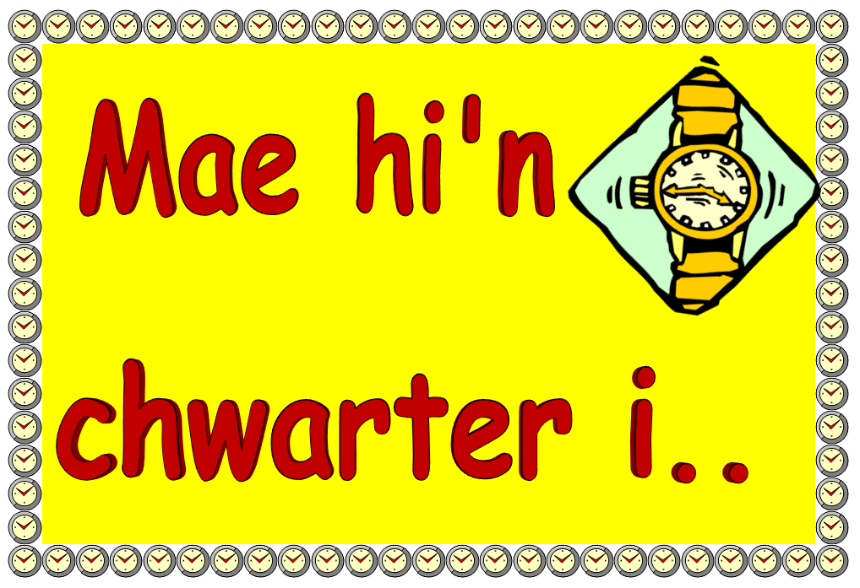

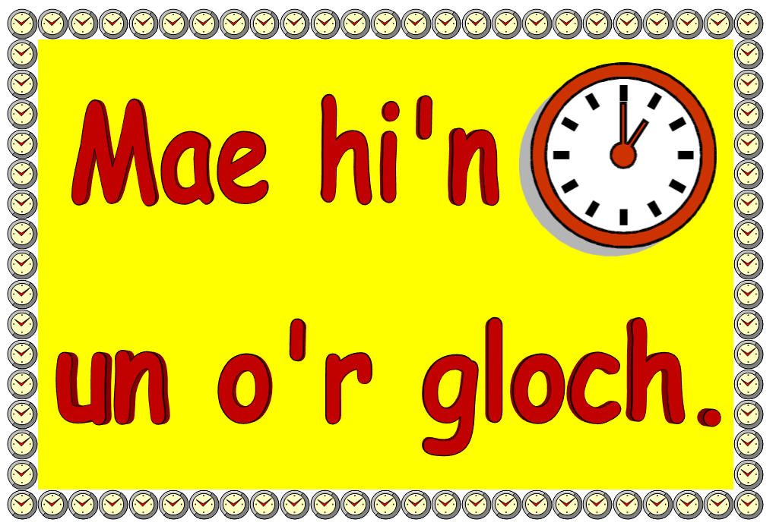

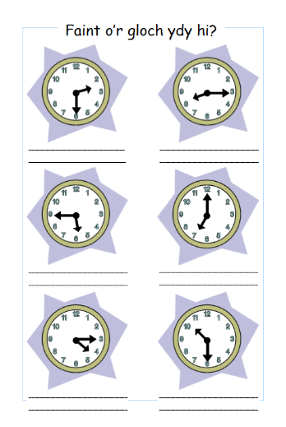
ICT
This week’s activity is to understand how a strong password can protect your privacy online. I would like you to define the word password and describe a password’s purpose, understanding why a strong password is important.
KEY VOCABULARY

Password

A secret string of letters, symbols, and numbers
that you can use to restrict who can access something digital

Have a go at completing the sheet below then check your answers with the slide below it.
When you have done this you can have a look at the following links to play some password games and practice creating your own memorable and strong password:
https://beinternetawesome.withgoogle.com/en_us/interland/landing/tower-of-treasure
https://www.digitalpassport.org/password-protect.html
https://howsecureismypassword.net/

Here is a useful link about online safety on Hwb – lots of relevant information for parents/carers and activities to complete: https://hwb.gov.wales/zones/online-safety/news/articles/42ae160b-7ab4-4510-8792-c70ef861c6d5

Directions
Follow the steps to create your own strong password.
Practice Round
- Start with a phrase. Think of a quote or group of words  that will be easy to remember. | Example: There's no way I'm  kissing a frog.
- Write down just the first letter of each word in the phrase.
- Capitalize some of the letters.
- Add one or two memorable numbers.
- Memorize it. Repeat your new password in your head so it sticks.
Your Turn
- Start with a phrase. Think of a quote or group of words
that will be easy to remember.
- Write down just the first letter of each word in the phrase.
- Capitalize some of the letters.
- Add one or two memorable numbers.
- Memorize it. Repeat your new password in your head so it sticks.

Password Tips to Remember
 | Start with a memorable ______________________.
 | Only your _________________ should know your password.
 | Never use any __________________ identity information in your password.
 | Create passwords with at least _____________ characters.
 | Use letters, numbers, and ___________________ in your password.

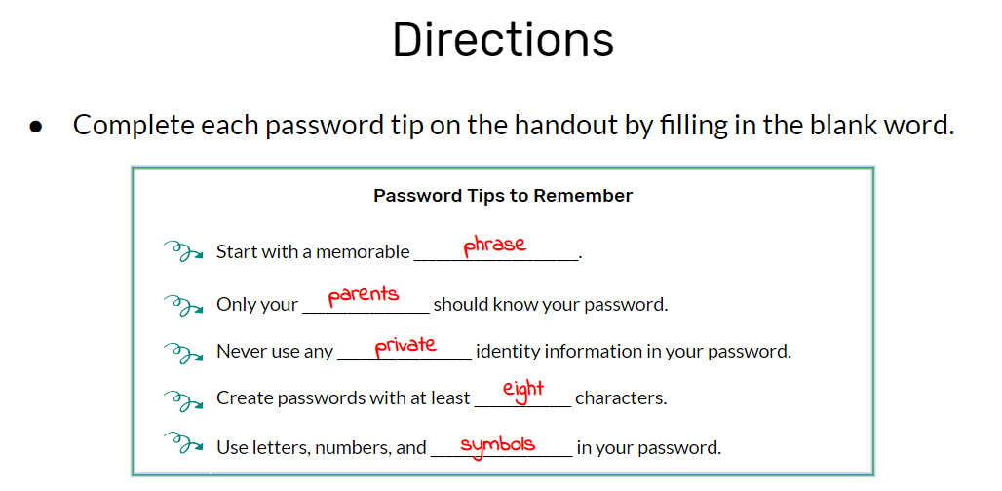

Try to include a bit of physical activity every day. Joe Wicks has proved really popular on his YouTube channel – you can have a look here: https://www.youtube.com/channel/UCAxW1XT0iEJo0TYlRfn6rYQ
Here is another useful link with ideas for keeping fit: https://www.twinkl.co.uk/resources/twinkl-move?utm_source=newsletter&utm_medium=email&utm_campaign=newsletter_2020-05-17_GB-WLS_KeyStage2&utm_content=custom9

Happy home learning! Hope you are all keeping safe and well,

Miss Densley

