Home Learning Pack Week 9 Year 6
Miss Kear & Miss Thomas’ class
Hi everyone! Hope you’re all ok. Well done to all of you who have managed to log in to Google Classroom! The last group of you will have had their email by now so with any luck by the end of the week we may all be able to access it. We will keep going with these work packs until that has been achieved.
A few people have had trouble logging in which appears to happen if your computer has another email associated with it. Make sure that you log in with your HWB email not your parents’ or brother’s/sister’s email or the class code won’t work. Just in case you need it the CLASS CODE is psugv5q. Don’t leave any gaps in your email address.
This Week we have:
Maths
Drawing reflected shapes – chilli challenge is back this week! Remember you will have mild, medium and hot. We would like you to complete at least two of these worksheets, if you’re feeling confident give them all a go!
What shape can you see?
Emoji challenge cards – make sure you look at the symbols, do you need to add, take away or multiply?
Mental maths – ask someone to test you
English: Reading comprehension. You may notice I’ve blanked out a few questions which were unsuitable.
Book Review
Prefixes and suffixes
Boost your brainpower challenge
Art:
Make your own jellybean and little round monsters.

Keep up your hard work,
Miss Thomas & Miss Kear
Drawing Reflected Shapes Mild:
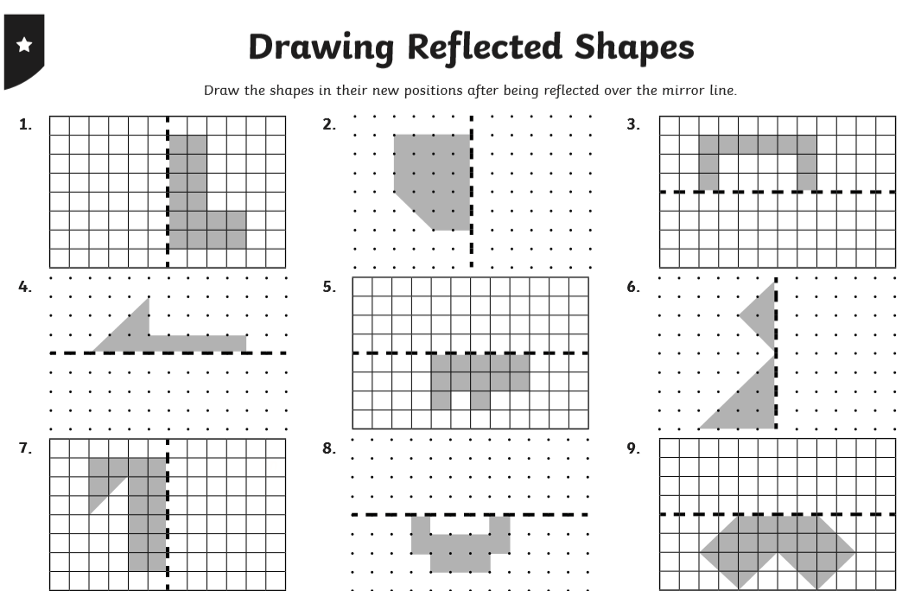
Medium:
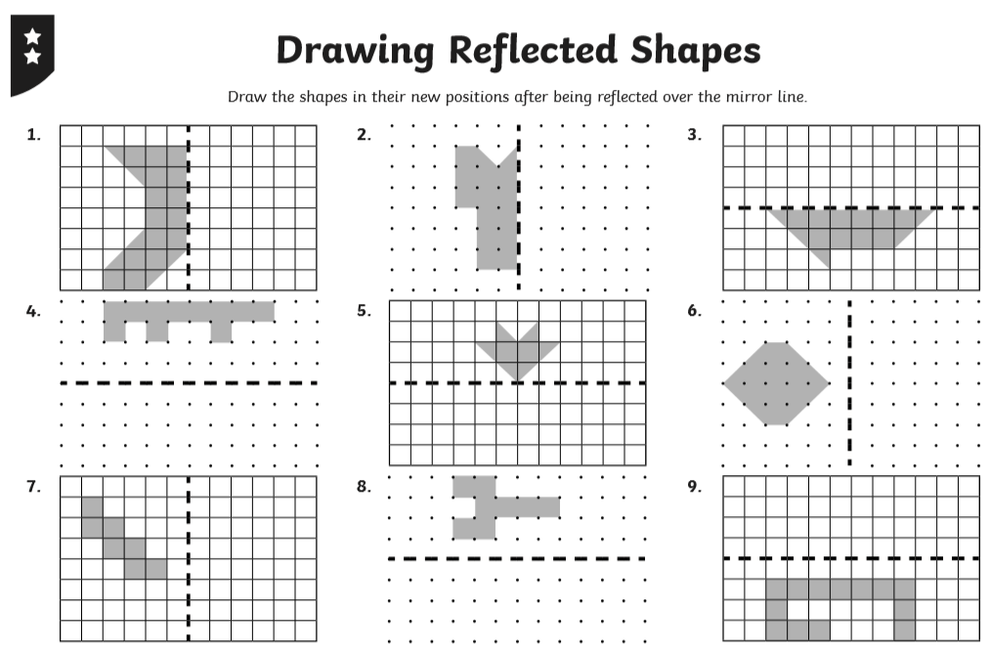

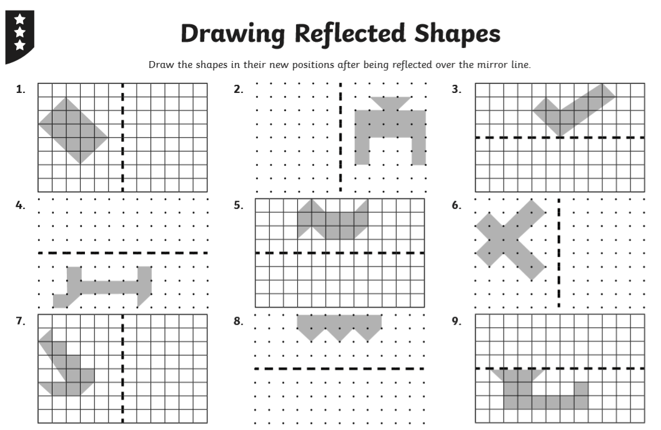
Hot:
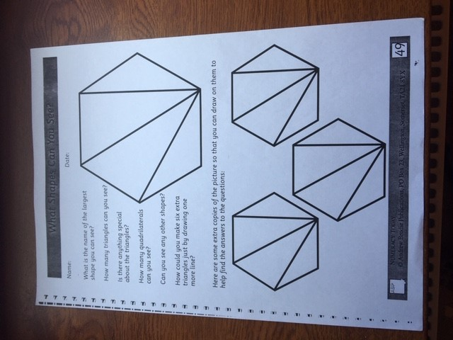
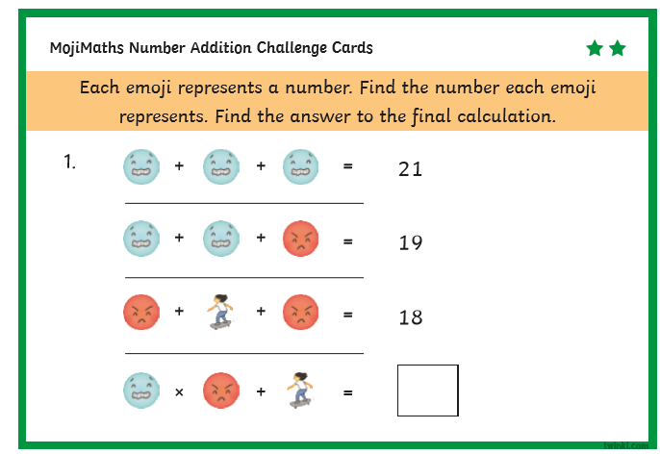
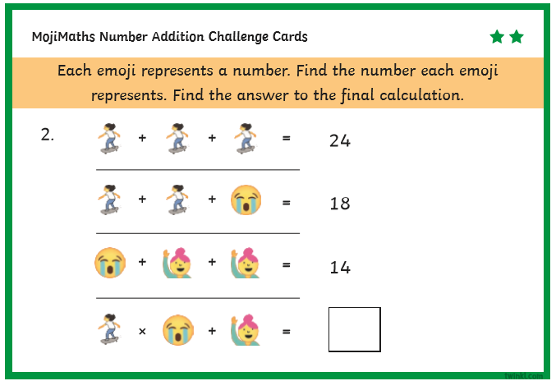
Emoji Challenge cards. Make sure you look at the symbols, do you need to add, multiply or take away?
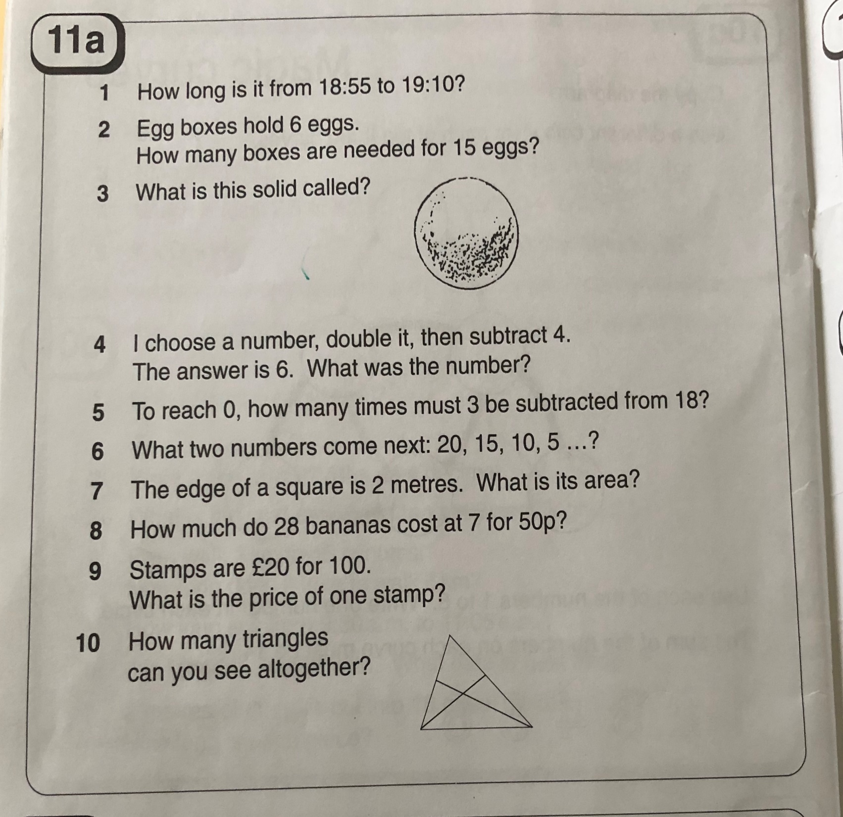
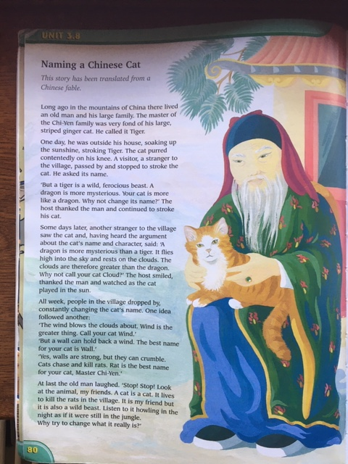
Reading comprehension

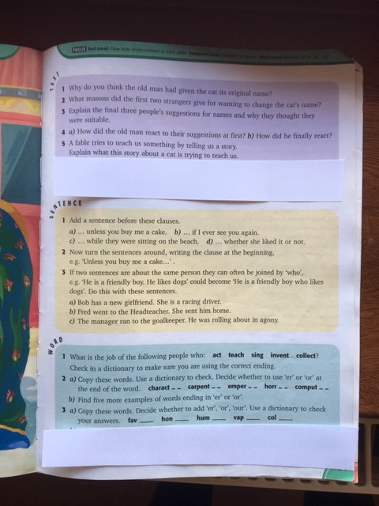
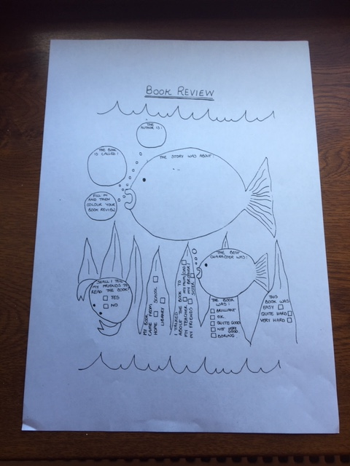

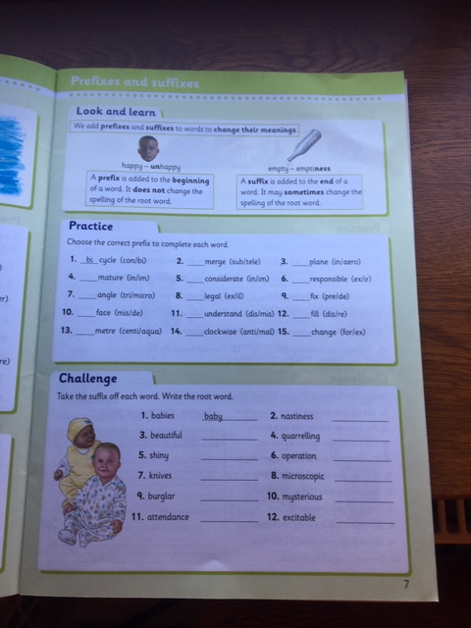
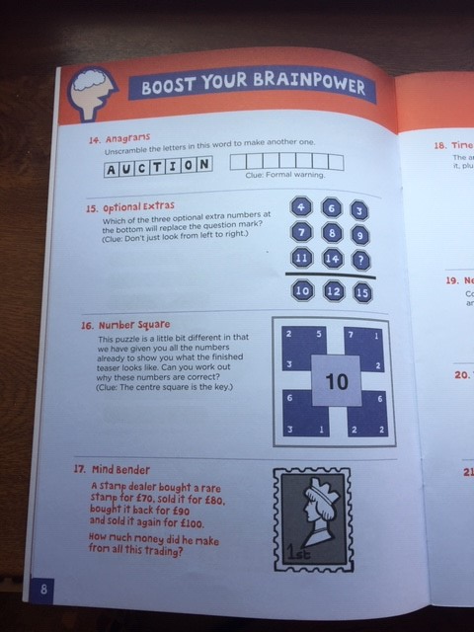
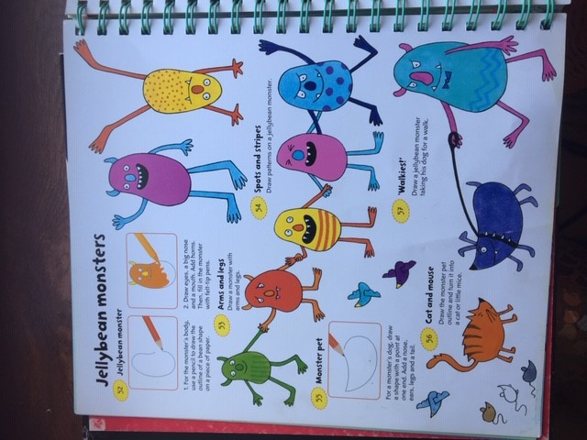
Art:



