Reception- Summer 2
Week 3 (The seaside)

Hi Everyone,
week 3 of the second Summer Term, it is going fast. Little heads-up, keep an eye on your emails for update regarding returning to school this week, we hope to send you more specific information about days and timetables on Friday. Last week I set you A LOT of Topic work and some of you may still be covering concepts of literacy and numeracy too, that is no problem I really wouldn't expect you to be doing more than an hour a day Monday -Friday. Or if you just do a couple of hours one day and have other days off, just see how things go, you know your child best! This week in literacy I have attached a lovely story about Paddington Bear going to the seaside which the children can watch independently if you are busy with things to do. So, this week I have set Literacy, Numeracy and Welsh. Please look at the seaside vocabulary and create little welsh dictionary with the vocabulary and a small pictures of the seaside objects.

Literacy
(Oracy speaking and listening)
Adventure at the seaside story to listen to:
Click on the link below to see what Paddington gets up to on his day at the seaside. When you have finished watching it can you tell someone else all about it, or even draw a little story map of little pictures of something that happens in the beginning, middle and end.

https://www.youtube.com/watch?v=2MK8OGNiTG8

Can you match the beginning sounds correctly to the picture. Many of the sounds are created by two letters blended together. After you have finished can you think go any other words that begin with these sounds, they don't all have to be seaside related.
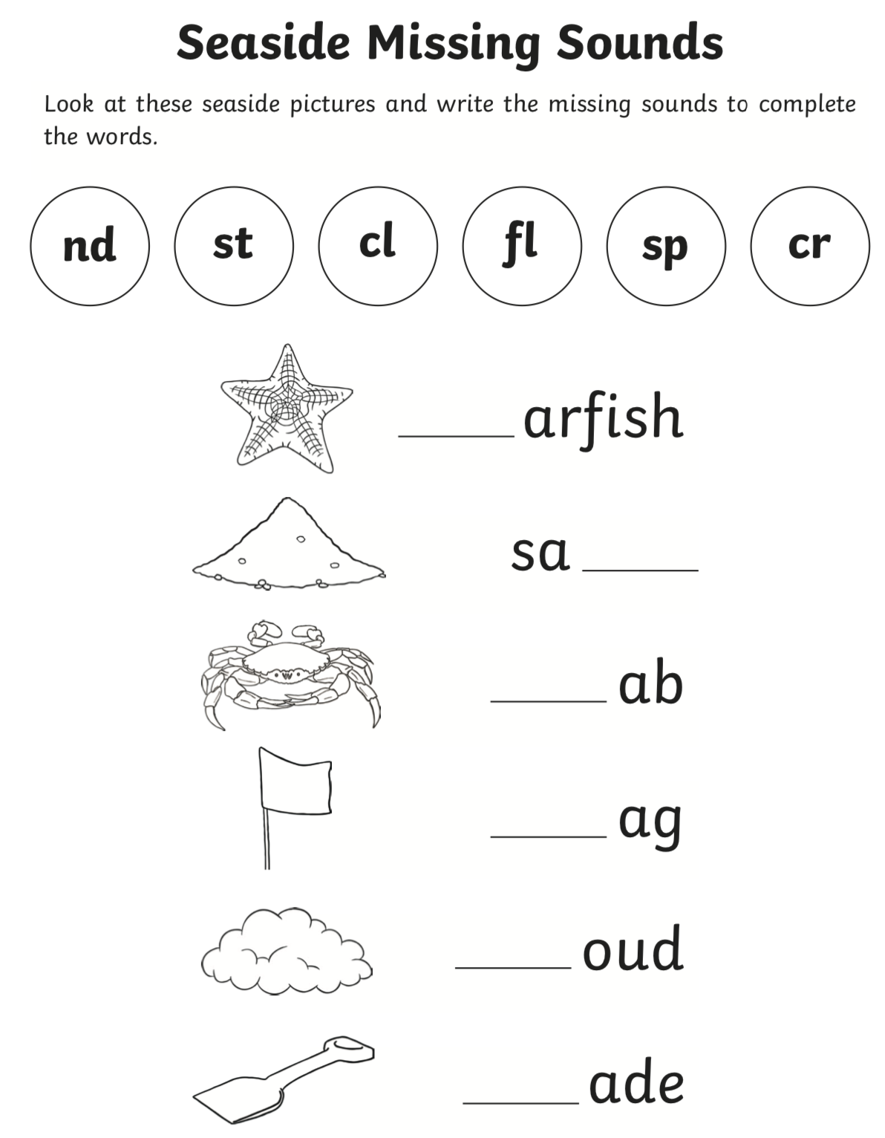
Reading simple sentences- the children do not have to be able to read the whole sentence, but can they recognise any sounds or blends, can they break down any words?

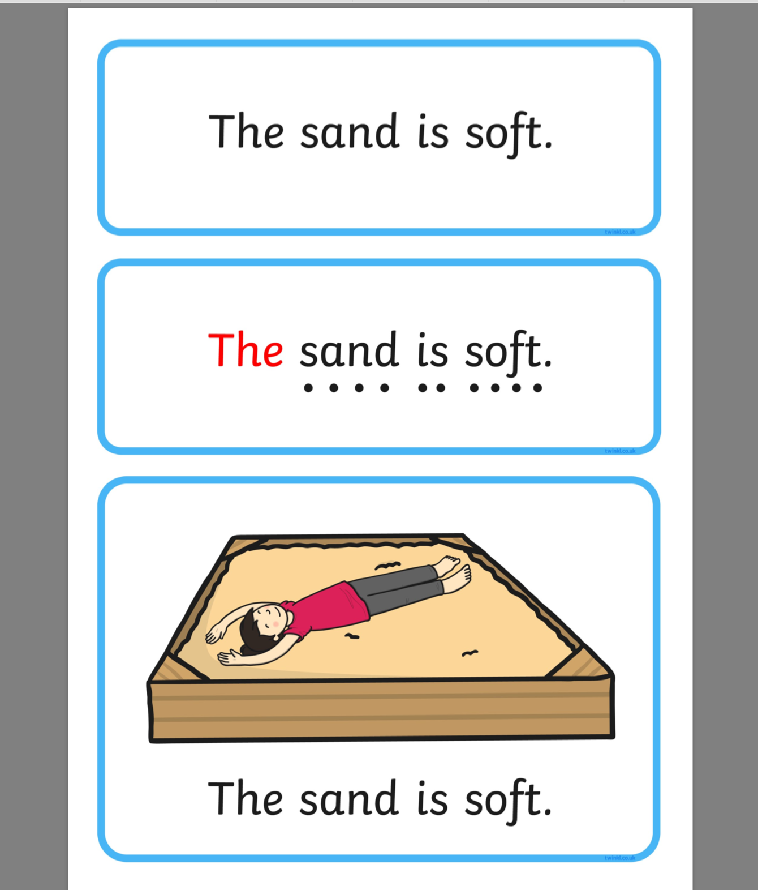
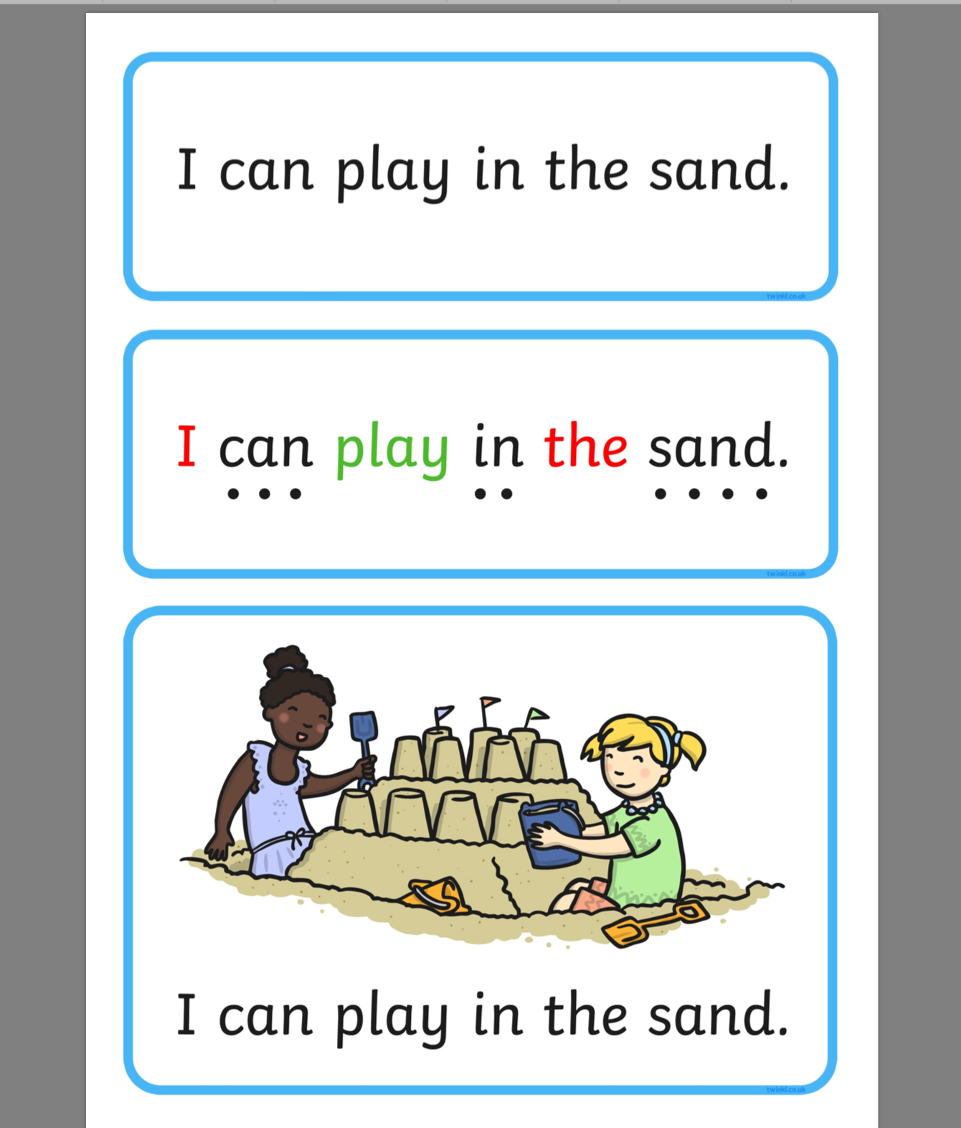

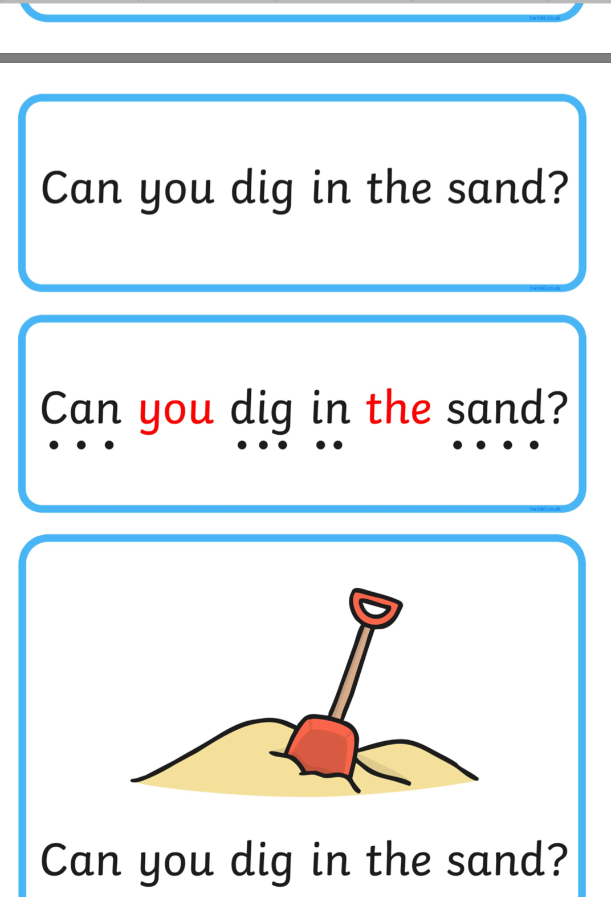

Numeracy – weeks theme- Measuring Weight

Look at the attached pictures which show weight related vocabulary, the balances show the concepts of heavier, lighter and balanced (the same weight). Please go on a little hunt around the house or garden after exploring these and see if you can find some items and see if you child can decide which one is 'heavier' or 'lighter' than the others.

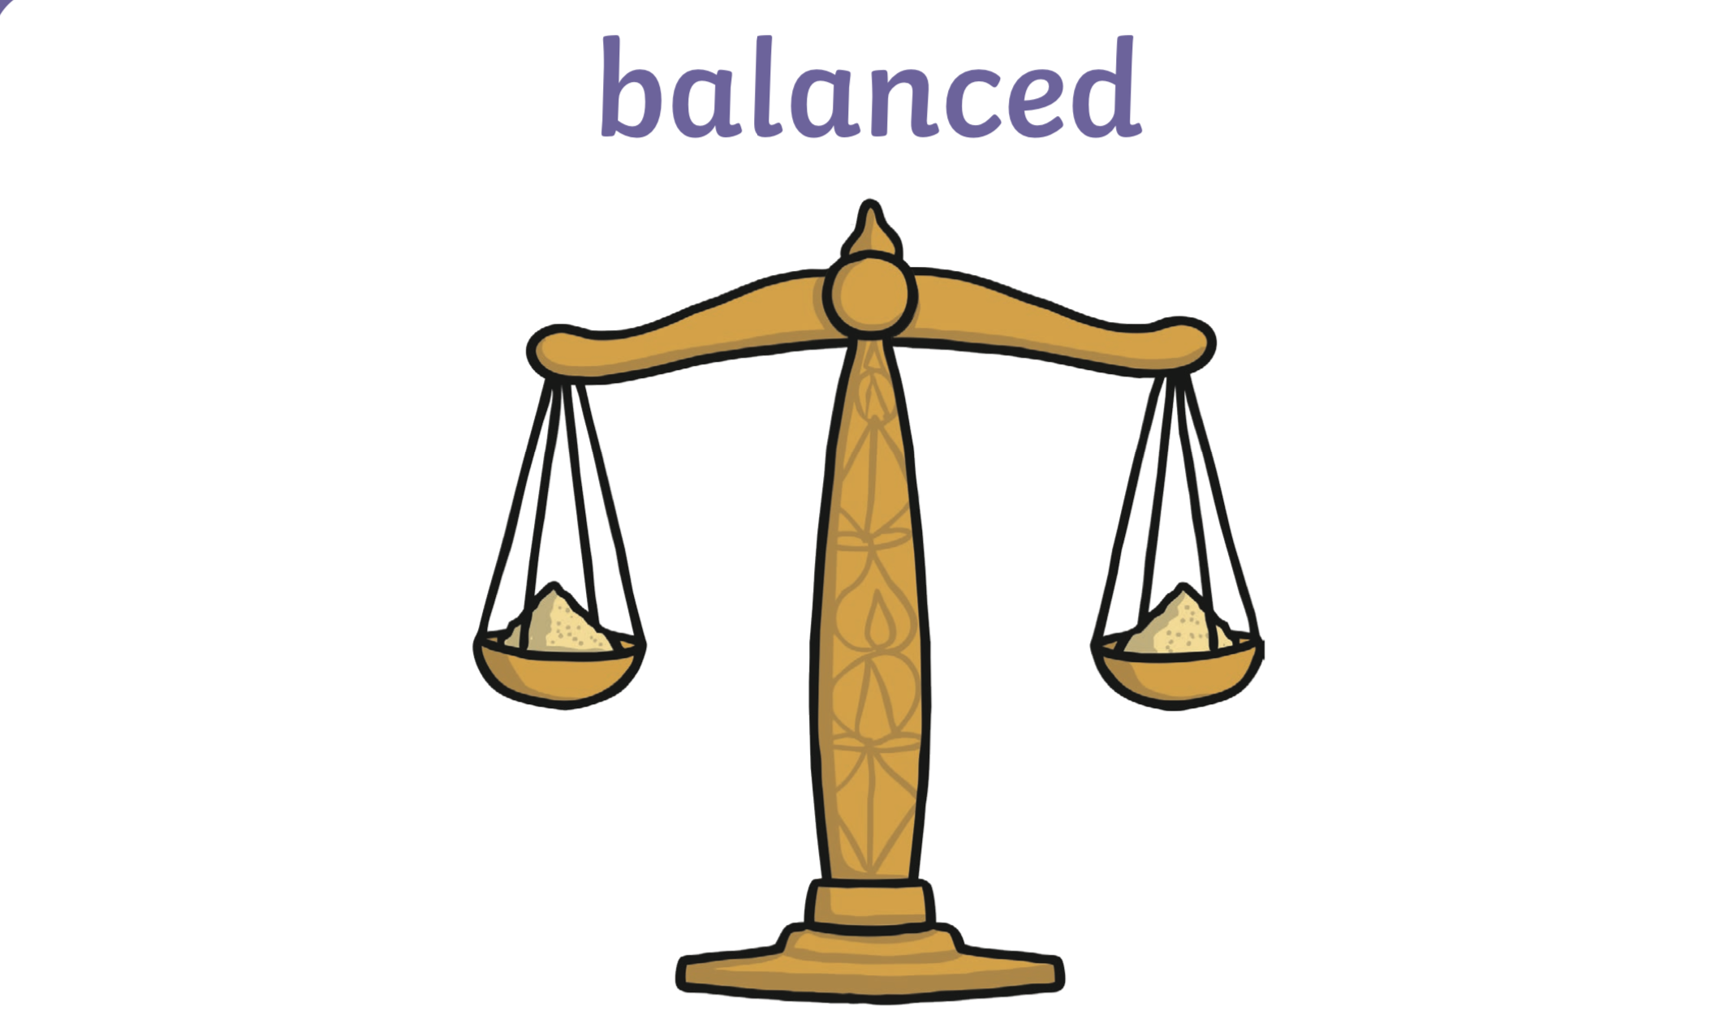

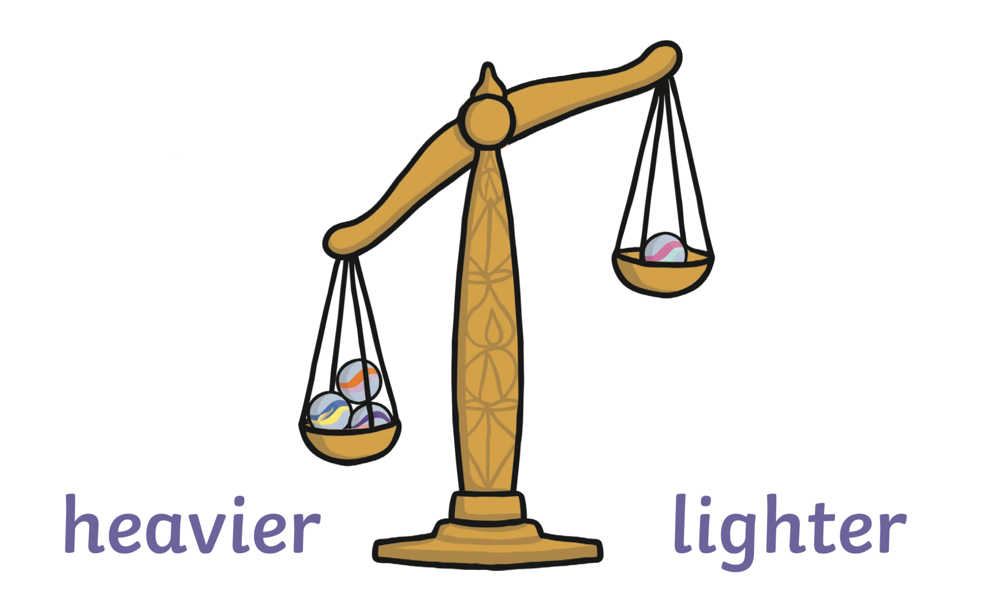

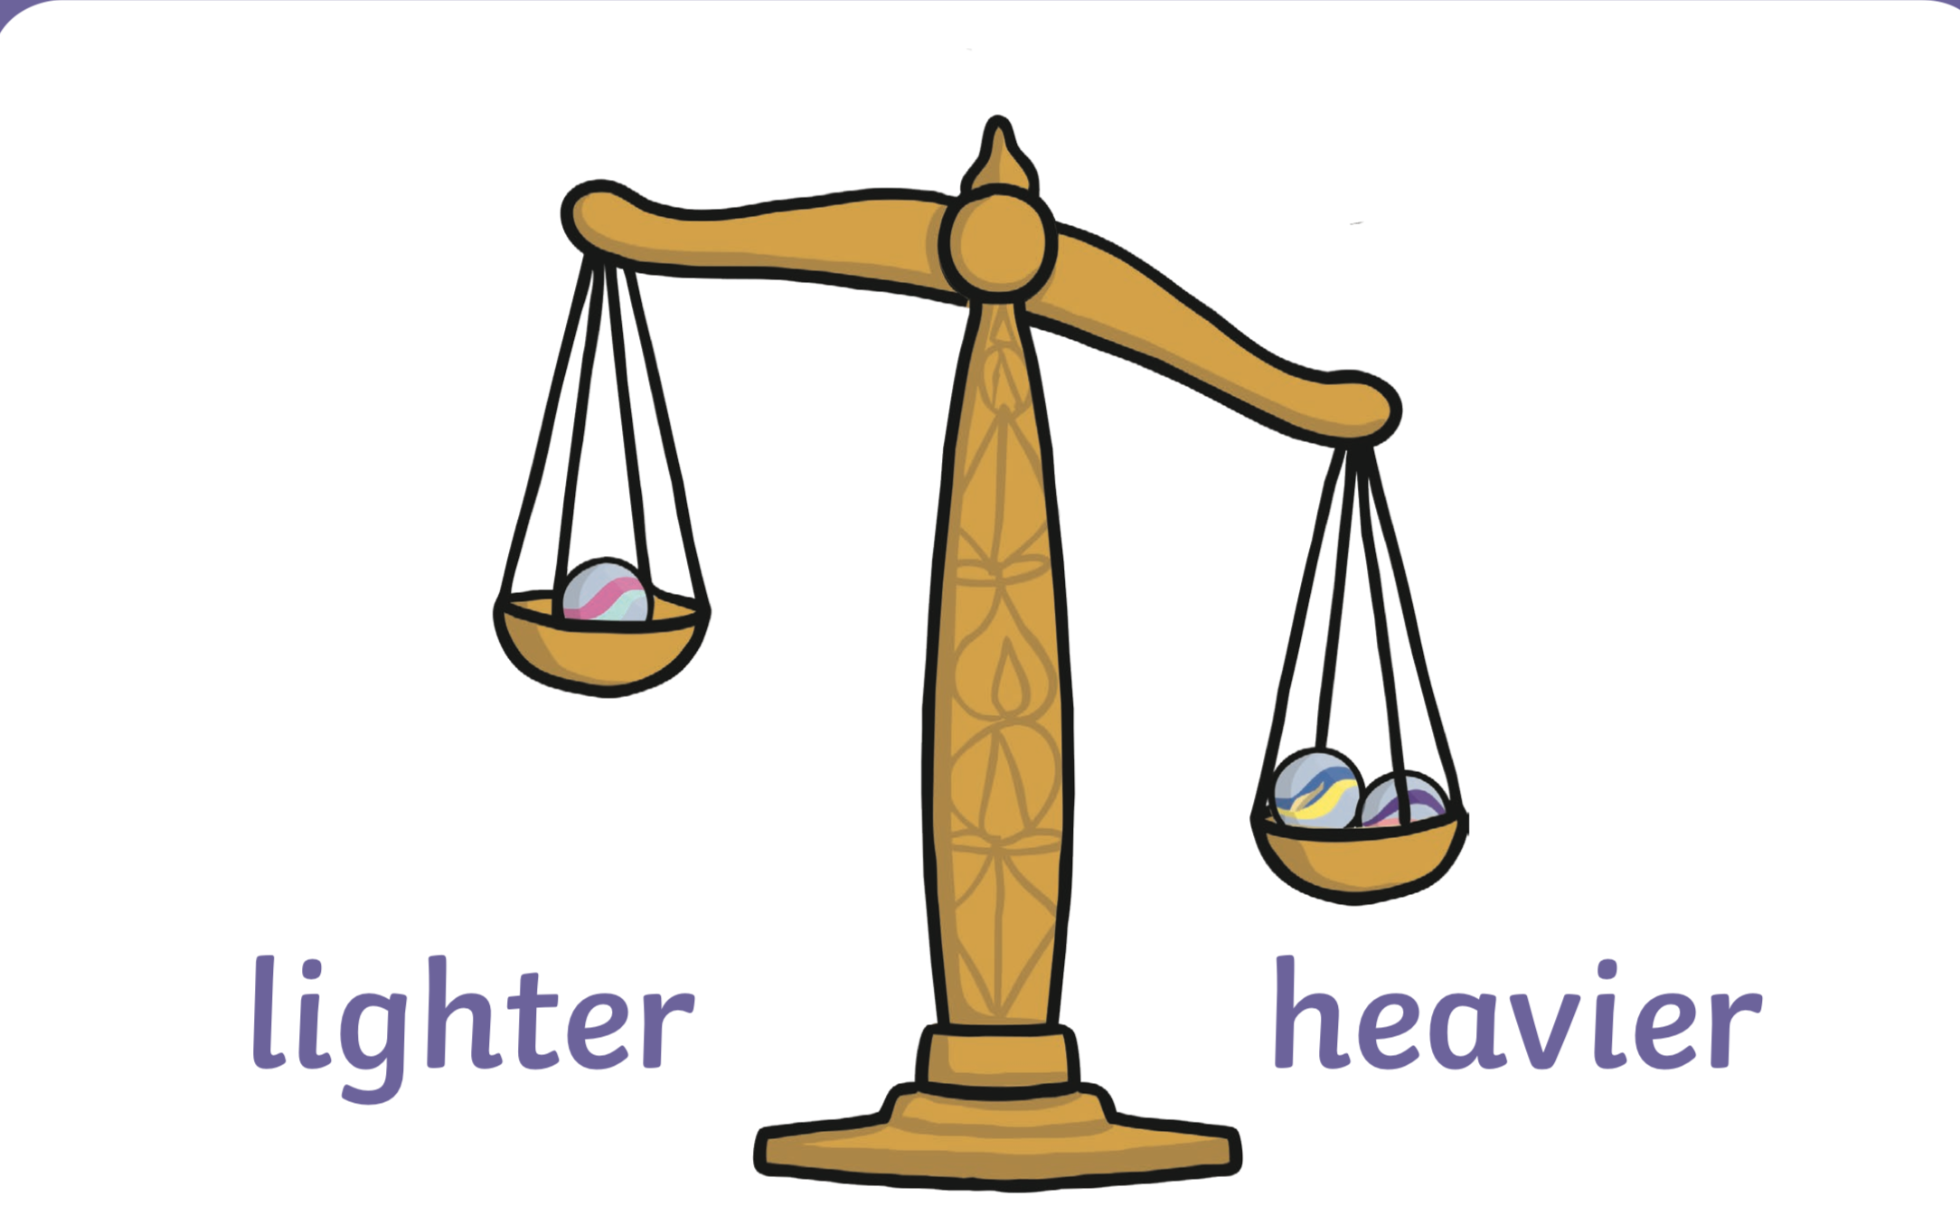

A fun game to play with weight

Click on the link to play the fun interactive weight game, see if you can get them all right, it will let you know if it’s right or wrong.

https://pbskids.org/peg/games/happy-camel

Heaviest/ lightest worksheet- Can you cut them out and sequence them from lightest to heaviest?

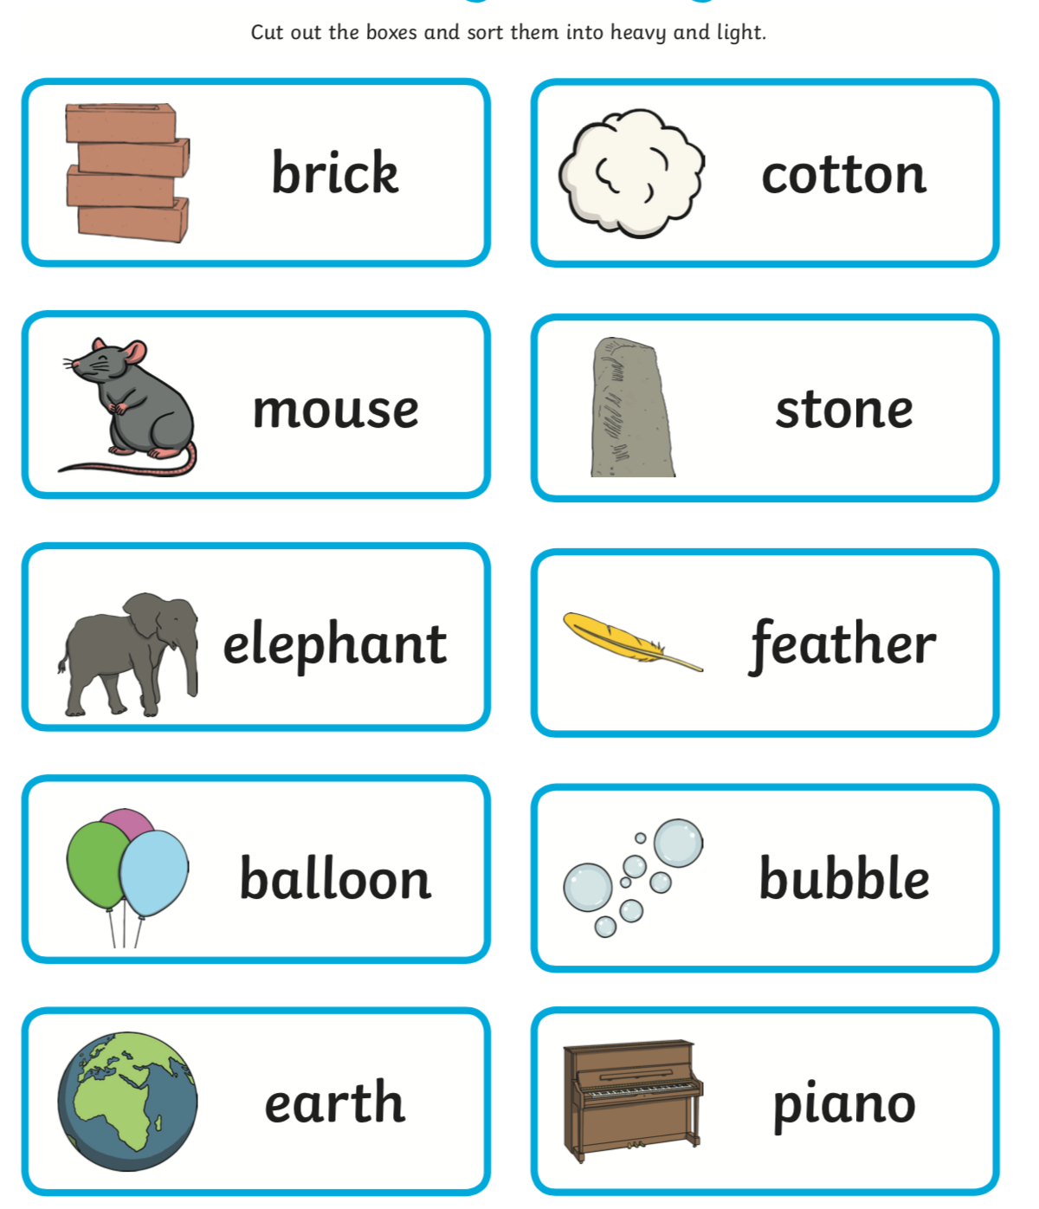

Topic- safety at the seaside:

The seaside is a great place to spend the day, just like Paddington did in his story, however the seaside can be a dangerous place if you do not keep yourself safe.
For example, you could get in trouble in the sea, get lost as the beach can be very crowded or end up with bad sunburn attached are two videos about staying safe at the seaside. Here are two videos which give advice and information about keeping safe at the seaside.
Task – after watching both of these can you create a ‘Keeping safe at the Seaside Poster’.

Think about all the tips you heard in the videos.

https://www.youtube.com/watch?v=6qO0mu6YJW8

bear at the seaside

https://www.youtube.com/watch?v=_8-R_6Lynsg

safety at the seaside video by RNLI

Take care everyone, remember you can take pictures of your work and upload to google classroom. Also don’t forget we are moving all of our learning to google classroom at the start of July and will not be adding the home learning tasks to our website.

Miss you all and hopefully see you soon,

Mrs Brown, Mrs Lane and Mrs Chapman
xx

